Tufts Medicine: Shields PET-CT Determination of Need Attachments

Application for a Determination of Need for Required Equipment

Application # NA-22091411-RE

September 14, 2022

Shields Healthcare of Cambridge, Inc.
700 Congress Street, Suite 204
Quincy, Massachusetts 02169

Tufts Medicine: Shields PET-CT Determination of Need Application

Table of Contents Exhibits

- Determination of Need Application
- Determination of Need Attachments
  - Determination of Need Narrative
  - Copy of Notice of Intent
  - Affidavit of Truthfulness Form
  - Filing Fee - Scanned copy of Application Filing Fee
  - Affiliated Parties Table Question 1.9
  - Change in Service Tables Questions 2.2 & 2.3
  - Certification from an Independent Certified Public Accountant
  - Evidence of Community Engagement for Factor 1- Information Session Power Point Presentation to the MelroseWakefield Hospital Patient and Family Advisory Council and Community Engagement Meeting
  - Limited Liability Company Documents
    - Certificate of Organization
  - Notification of Material Change
    - HPC Approval

Exhibit B Determination of Need Attachments

Exhibit B.b
Copy of Notice of Intent

Notice

Title:
Public Announcement Concerning a Proposed Health Care Project

Body:
Tufts Medicine: Shields PET-CT, LLC (“Applicant”) located at 700 Congress Street, Suite 204, Quincy, Massachusetts 02169 intends to file a Notice of Determination of Need (“Application”) with the Massachusetts Department of Public Health (“DPH”) for the addition of a Positron Emission Tomography - Computed Tomography (PET/CT) mobile unit at the MelroseWakefield Medical Building located at 888 Main Street, Wakefield, Massachusetts 01880. The total value of the Project is $1,095,687. The Applicant does not anticipate any price or service impacts to the Applicant’s existing patient panel as a result of the Project. Any ten Taxpayers of Massachusetts may register in connection with the intended Application no later than September 12, 2022 or 30 days of the Filing Date, whichever is later, by contacting the Department of Public Health, Determination of Need Program, 250 Washington Street, 6th floor, Boston, MA 02108 or dph.don@state.ma.us

Exhibit B.d
Scanned Copy of Application Filing Fee Check

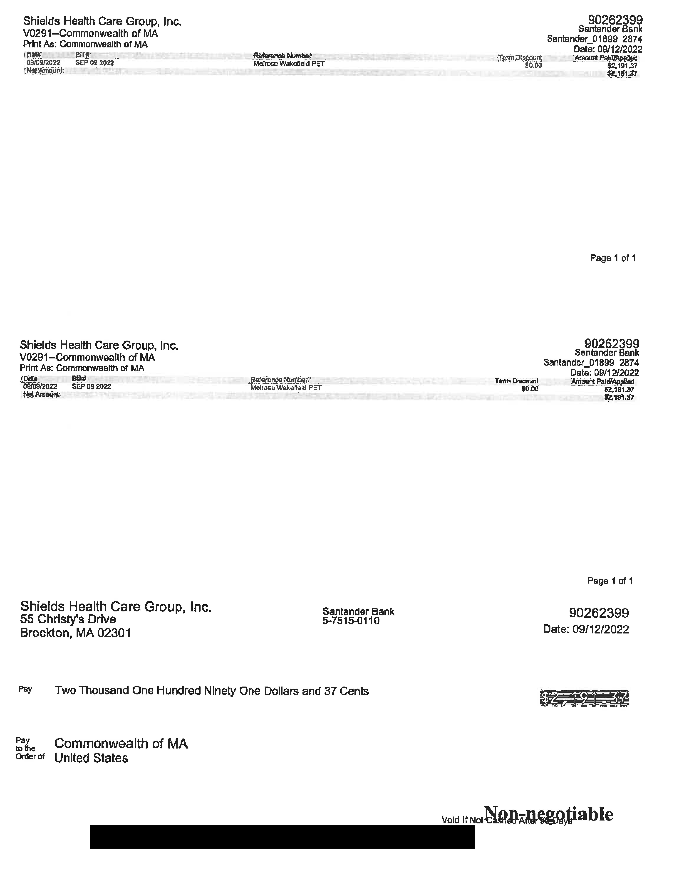

Exhibit B.h
Evidence of Community Engagement for Factor 1

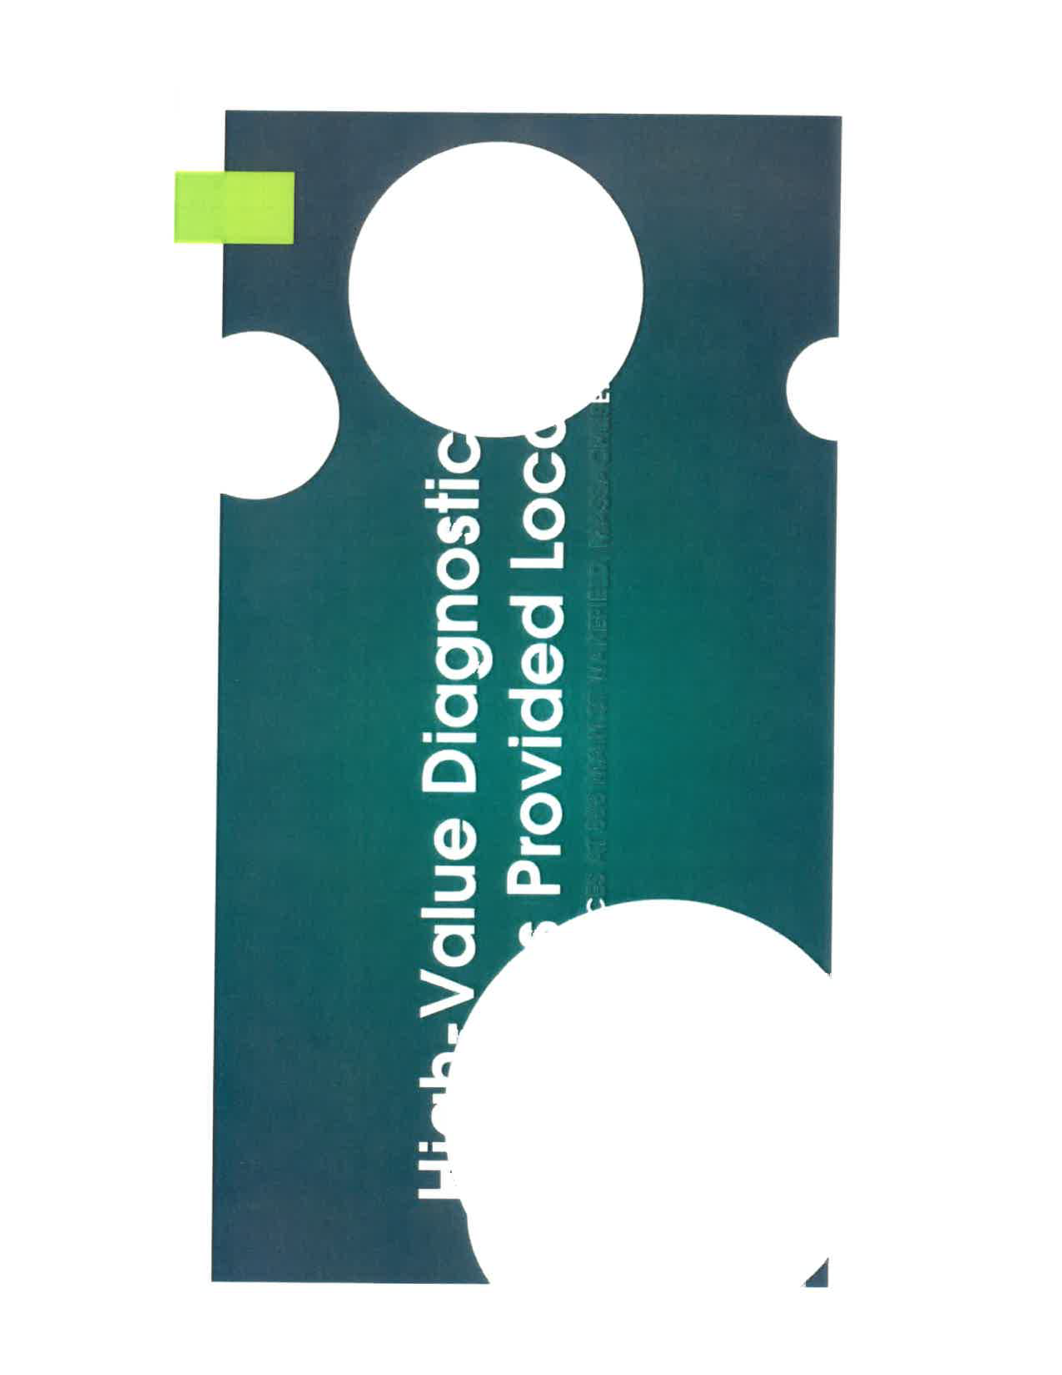

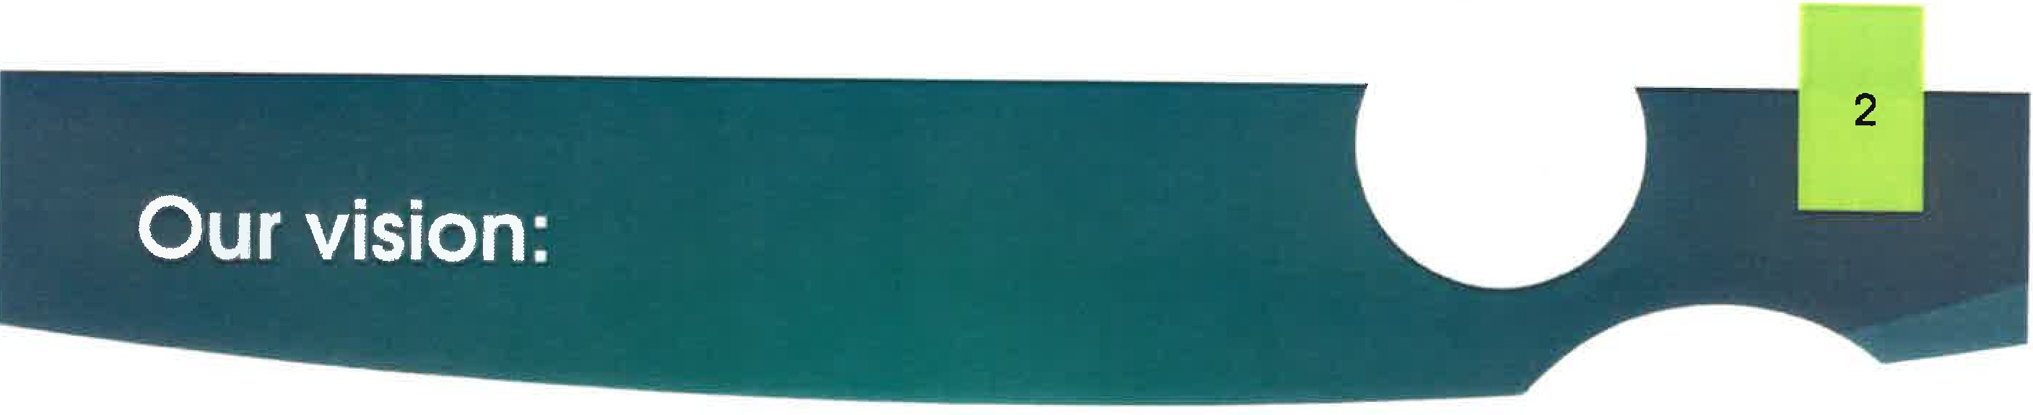

Welcome and thank you for your interest in this project

We are excited to share our plans to add mobile PET/CT services at 888 Main St, Wakefield

This protect will use a combination of inside space and a mobile PETCT unit aligned with the building one day per week PET/CT services will complement the cancer treatment and breast services currently provided at Melrose Wakefield Hospital The service will operate on an outpatient fee schedule which will lower the cost of services
This is an opportunity to introduce you to some of the individuals Involved, solicit your feedback & any answer questions



PET/CT Is a radiology based Imaging tool which is valuable in staging cancer, evaluating Alzheimer's disease, and also has cardiac applications

With a growing demand for cancer care, timeliness to treatment is critical and is commonly referenced as a quality measure. Melrose Wakefield Hospital and Shields Healthcare will collectively focus on timeliness and quality outcomes with this new service

Providing PET/CT in a mobile environment allows community hospitals with less demand provide this care locally in a shared use model

A Joint Venture between Tufts Medicine and Shields Health Care Group has current services located in in Boston at
Tufts Medical Center

Patients would enter the a suite in 888 Main St for PET/CT patients and would enter the mobile environment that is temporarily attached to the building, enclosed from the outside elements

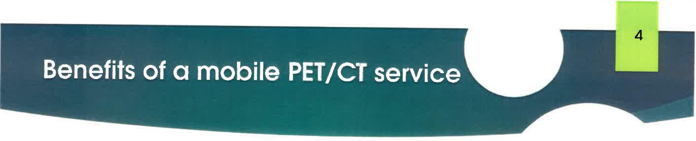


- Outpatient reimbursement with a high value service creates high patient satisfaction with lower out of pocket responsibility


  - greater scheduling flexibility
  - Highly experienced technical &faff
  - State of the art equipment


  - easy, convenient location
  - Transportation assistance
  - provides local option for physicians and patients

 • Efficient weekly offered care minimizes time to treatment
  - • shifts appropriate care from inpatient to outpatient

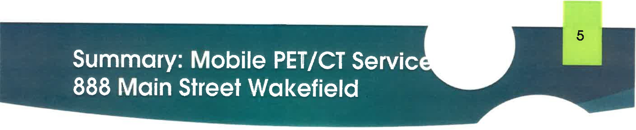

Shields Health Care

Services
- PET/CT Service one midweek day per week
- Cancer staging, Alzheimer's disease evaluation, cardiac applications
·- - -
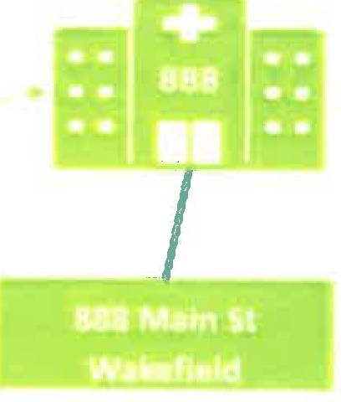
l



Facility
- Existing Melrose Wakefield facility
- Mobile PET/Cf with weather tight connector- lower cost of care





WE WANT YOUR INPUT
on the concept of mobile PET/CT
WE WILL KEEP YOU INFORMED
as project progresses with DPH




Our vision:
- Welcome and thank you for your interest in this project

- We are excited to share our plans to add mobile PET/CT services at 888 Main St, Wakefield in partnership with Shields Health Care

- This project will use a combination of inside space and a mobile PET/CT unit, aligned with the building, one day per week

- PET/CT services will complement the cancer treatment and breast services currently provided at Tufts Medicine

- The service will operate on an outpatient fee schedule, which will lower the cost of services

- This is an opportunity to introduce you to some of the individuals involved, solicit your feedback and any answer questions


What is a mobile PET/CT?
  - PET/CT is a radiology based imaging tool which is valuable in staging cancer, evaluating Alzheimer's disease, and also has cardiac applications

  - With a growing demand for cancer care, timeliness to treatment is critical and is commonly referenced as a quality measure. MelroseWakefield Hospital and Shields Healthcare will collectively focus on timeliness and quality outcomes with this new service.

  - Providing PET/CT in a mobile environment allows community hospitals with less demand to conveniently provide this care locally in a shared use model

  - A Joint Venture between Tufts Medicine and Shields Health Care Group has current services located in in Boston at Tufts Medical Center


What is a mobile PET/CT?

Patients will enter the PET/CT office suite at 888 Main St. via the main entrance and then proceed to the mobile environment, that is temporarily attached to the building, and enclosed from the outside elements

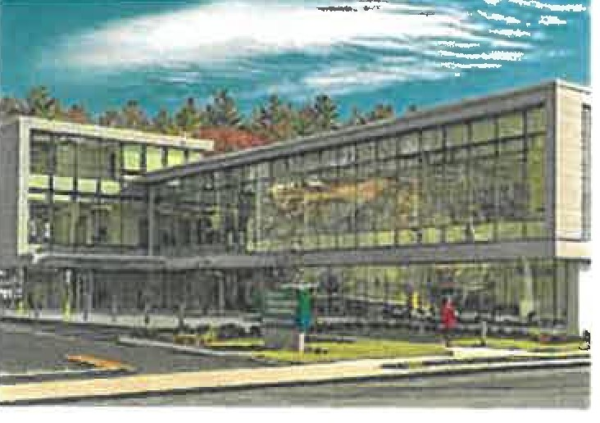
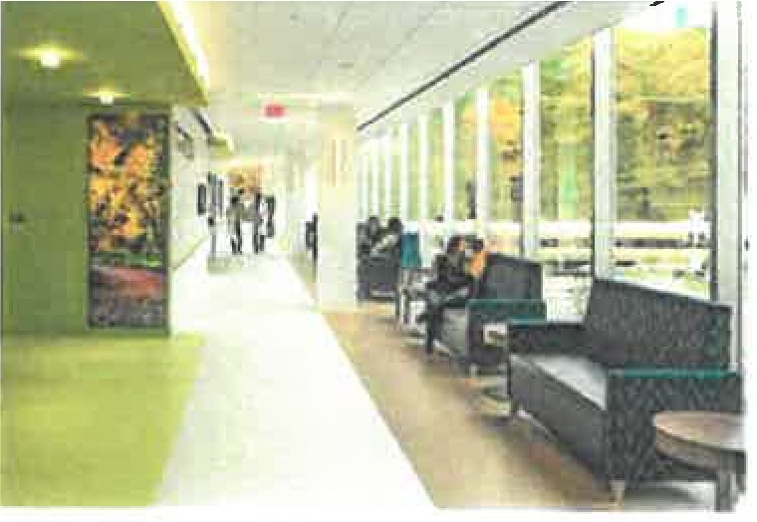
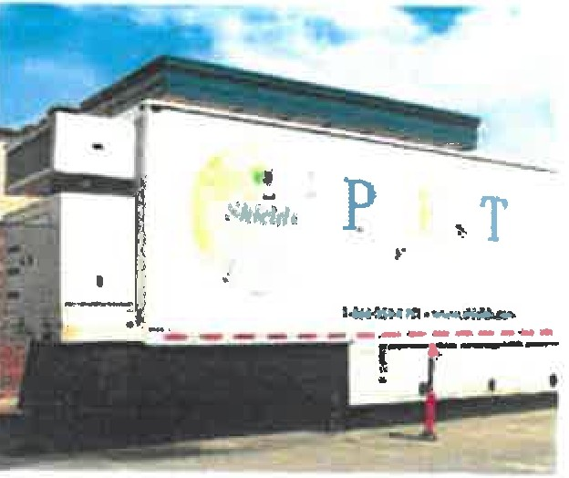


Trailer logistics & operations

    - Operations
      - Anticipate trailer being on site one day a week
      - Day of service not determined yet, but will be a weekday
      - Hours of operation between 7 a.m. and 7 p.m.

    - Trailer logistics
      - Arrival the day before service in the evening
      - Setup takes about 30 - 60 mins
      - Leaves the next day after cases are complete and remaining cars allow for exit
      - Will run off building power

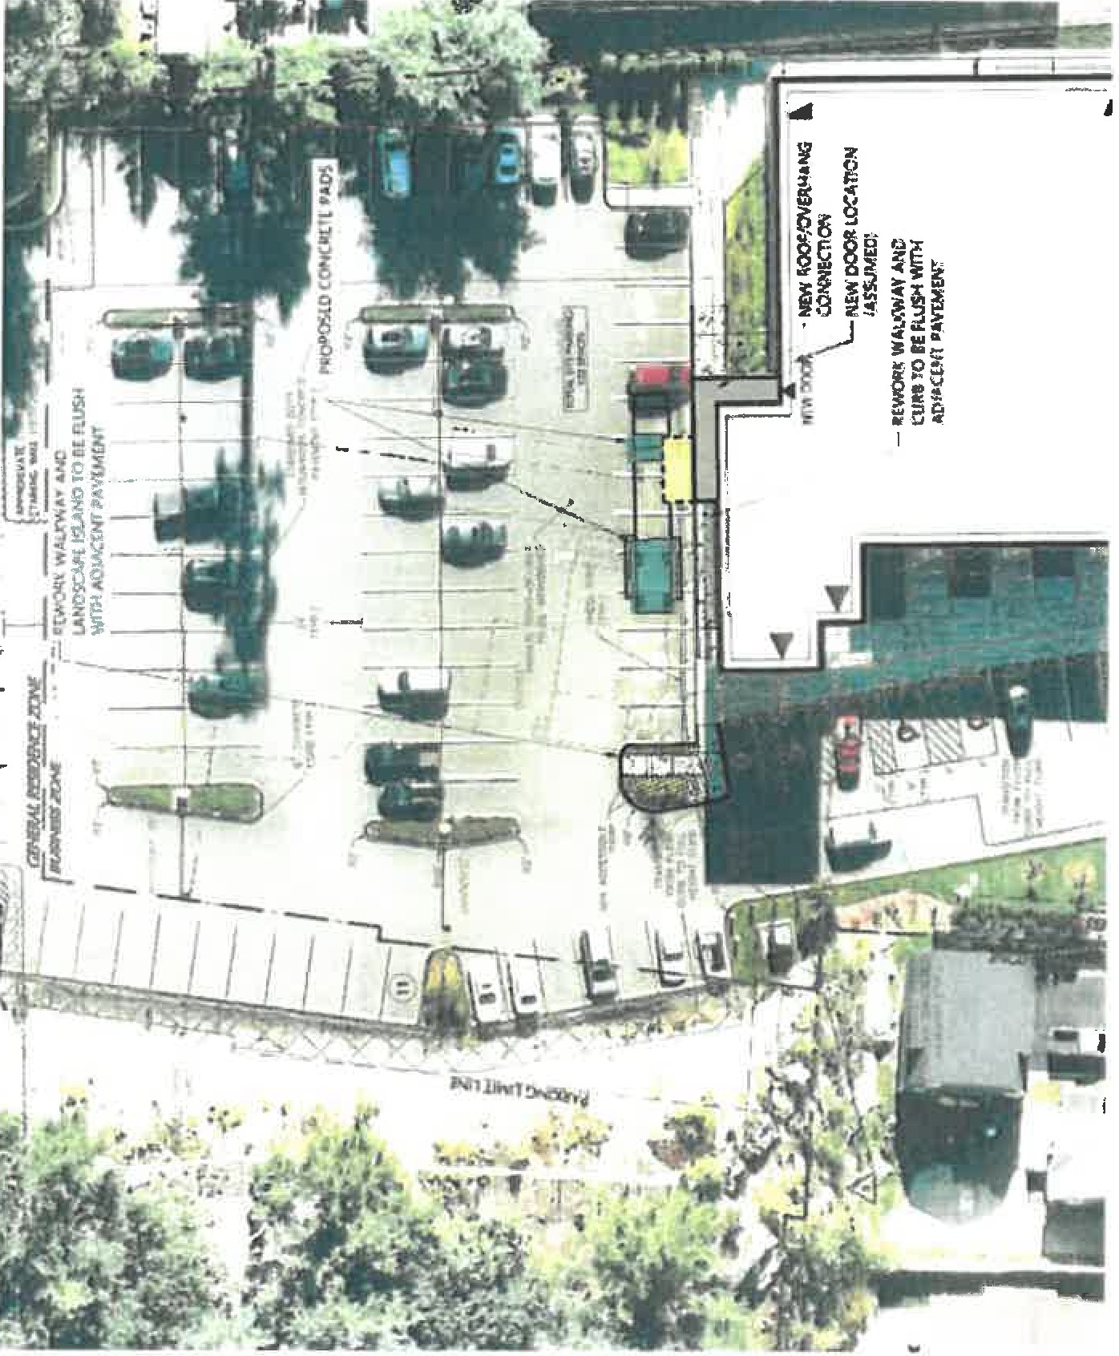




Next steps

    - Determination of need filing - Fall 2022
    - Special Permit application with Town of Wakefield - Fall 2022
    - Construction - Spring 2023
    - Opening - Summer 2023


Benefits of a mobile PET/CT service


      - Outpatient reimbursement with a high value service creates high patient satisfaction with lower out of pocket responsibility

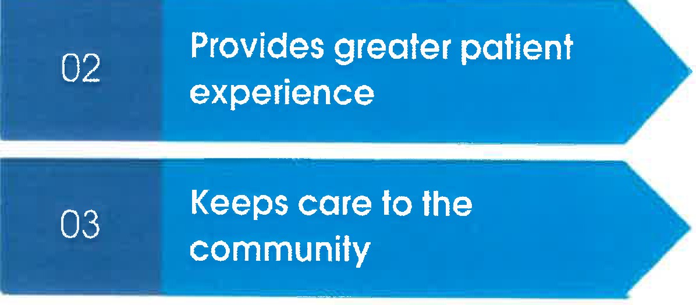
        - Greater scheduling flexibility
        - Highly experienced technical staff
        - State of the art equipment

        - Easy, convenient location
        - Transportation assistance
        - Provides local option for physicians and patients

- Efficient weekly offered care minimizes time to treatment
- Shifts appropriate care from Inpatient to outpatient

Exhibit B.1
Limited Liability Company Documents: Certificate of Organization

Per instruction from the Department of Public Health, Tufts Medicine: Shields PET-CT (“Applicant”), is providing a link to its corporate documents on the Massachusetts Secretary of State’s website for accessibility purposes. Please use the following link to access the Applicant’s Articles of Organization on the Secretary of State’s website:
https://corp.sec.state.ma.us/CorpWeb/CorpSearch/CorpSummary.aspx?sysvalue=hbGcIHWPy6DVt0_E7m9n_cn8S0AB7AJ6kalVJmSul1w-

Exhibit B.j
Material Change -Approval

From: Selz, David: HPC;
To: kerry@shields.com; snetishen@shields.com; Courtney Pasay Vaughan
Cc: Mills, Katherine: HPC; Wulff, Megan (HPC); Hayes-Rusnov, Sasha (HPC); Johnson, Lois (HPC)
Subject: HPC Review of Recent Material Change Notice
Data: Monday, July.25, 2022 8:57:13 AM

Good Morning,

The Health Policy Commission (HPC} recently received completed notices of material change concerning a proposed joint venture between MelroseWakefield Healthcare and Shields Health care Group. The HPC conducted a preliminary review of the notices based on available information and has elected not to proceed with a cost and market impact review.
Thank you.
David Seltz
Executive Director
Health Policy Commission

cc:
Katherine Mills, Senior Director, Market Oversight and Transparency, Health Policy Commission Megan Wulff, Director, Market Oversight and Monitoring, Health Policy Commission
Sasha Hayes-Rusnov, Associate Director, Market Oversight and Monitoring, Health Policy Commission
Lois Johnson, General Counsel, Health Policy Commission

