APPENDIX 4

ORIGINAL DoN NOTICE OF APPROVAL



CHARLES D. BAKER
Governor
KARYN E. POLITO
Lieutenant Governor
The Commonwealth of Massachusetts
Executive Office of Health and Human Services Department of Public Health
250 Washington Street, Boston, MA 02108-4619

MARYLOU SUDDERS
Secretary
MARGRET R. COOKE
Commissioner

Tel: 617-624-6000
www.mass.gov/dph

November 18, 2022

Crystal Bloom, Partner Husch Blackwell LLP
One Beacon Street, Suite 1320 Boston, MA 02108-3106

VIA electronic mail: Crystal.Bloom@huschblackwell.com

RE: Notice of Final Action DON Application #UMMHC-22042514-HE Dear Attorney Bloom,
At their meeting of November 9, 2022, the Commissioner and the Public Health Council, acting together as the Department, voted pursuant to M.G.L. c.111, §25{c) and the regulations adopted thereunder, to approve the Determination of Need application filed by UMass Memorial Health Care, Inc. {Applicant) located at One Biotech Park, 365 Plantation Street Worcester, MA for a Substantial Capital Expenditure and Substantial Change in Service at UMass Memorial Medical Center {UMMMC) for the following:
- Renovation of a six-story building adjacent to UMMMC's University Campus that will contain 72 additional medical/surgical (M/S) beds, one additional computed tomography {CT) unit, and shell space for future build out to accommodate clinical services.
- The addition of 19 M/S beds on UMMMC's Memorial Campus.
- Other renovation projects at UMMMC's Memorial Campus to improve the existing services and facilities.

This Notice of Final Action incorporates by reference the Staff Report, and the Public Health Council proceedings concerning this application, all of which are incorporated herein by reference.

This Determination of Need Application was reviewed pursuant to M.G.L. c. 111, § 25{c), and the regulatory provisions of 105 CMR 100.000 et seq. Based upon a review of the materials, the

Department found that the Applicant has met each DoN factor with conditions and approves this Determination of Need application for a substantial capital expenditure for the Proposed Project of
$143,242,167.00. The total required Community Health Initiative (CHI) contribution is $7,162,108.35.

In compliance with the provisions of 105 CMR 100.310 A (2) and (11) the Holder shall submit an acknowledgment of receipt to the Department (attached) and include a written attestation of participation or intent to participate in MassHealth.

In compliance with 105 CMR 100.310(A)(12), which requires a report to the Department, at a minimum on an annual basis, including the measures related to achievement of the DoN factors for a period of five years from completion of the Proposed Project, the Holder shall address its assertions with respect to all the factors.

Other Conditions to the DoN

- Of the total required CHI contribution of $7,162,108.35
  - $1,754,716.54 will be directed to the CHI Statewide Initiative
  - $5,264,149.64 will be dedicated to local approaches to the DoN Health Priorities
  - $143,242.17 will be designated as the administrative fee.
- To comply with the Holder's obligation to contribute to the Statewide CHI Initiative, the Holder must submit a check for $1,754,716.54 to Health Resources in Action (the fiscal agent for the CHI Statewide Initiative).
- The Holder must submit the funds to HRiA within 30 days from the date of the Notice of Approval.
- The Holder must promptly notify DPH (CHI contact staff) when the payment has been made.

Payment should be sent to:
Health Resources in Action, Inc.( HRiA) 2 Boylston Street, 4th Floor
Boston, MA 02116 Attn: Ms. Bora Toro

Ongoing compliance with the conditions and all terms of the DoN is, pursuant to the Regulation, a precondition to the filing of any future DoN by the Holder.

Sincerely,
[signature on file
Dennis Renaud
Director, Determination of Need Program

cc:
Elizabeth D. Kelley, Director, Bureau of Health Care Safety and Quality Stephen Davis, Division of Health Care Facility Licensure and Certification Daniel Gent, Division of Health Care Facility Licensure and Certification Rebecca Rodman, General Counsel's Office
Samuel Louis, Office of Health Equity
Jennica Allen, Division of Community Health Planning and 68Engagement Elizabeth Maffei, Division of Community Health Planning and Engagement Katelyn Teague, Division of Community Health Planning and Engagement Elizabeth Almanzor, Center for Health Information Analysis
Katherine Mills, Health Policy Commission Eric Gold, Attorney General's Office
Pavel Terpelets, MassHealth
Christopher King, Executive Office of Health and Human Services Tomaso Calicchio, Executive Office of Health and Human Services Hai Nguyen, Executive Office of Health and Human Services Karina Mejias, Executive Office of Health and Human Services Priscilla Portis, Executive Office of Health and Human Services

APPENDIX 5 NOTICE OF INTENT

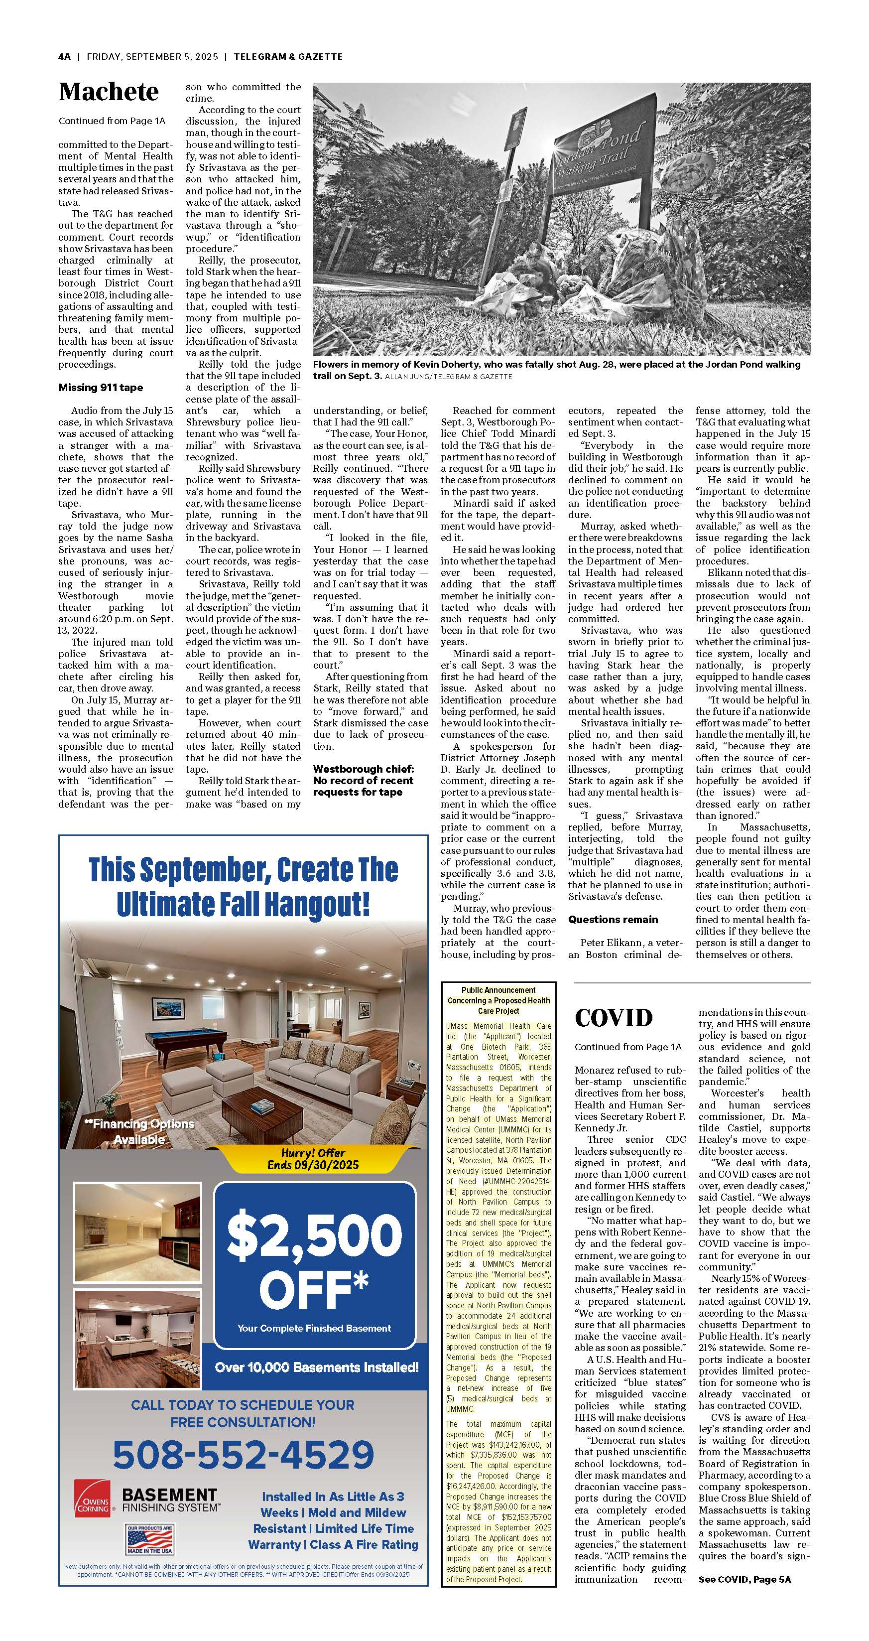
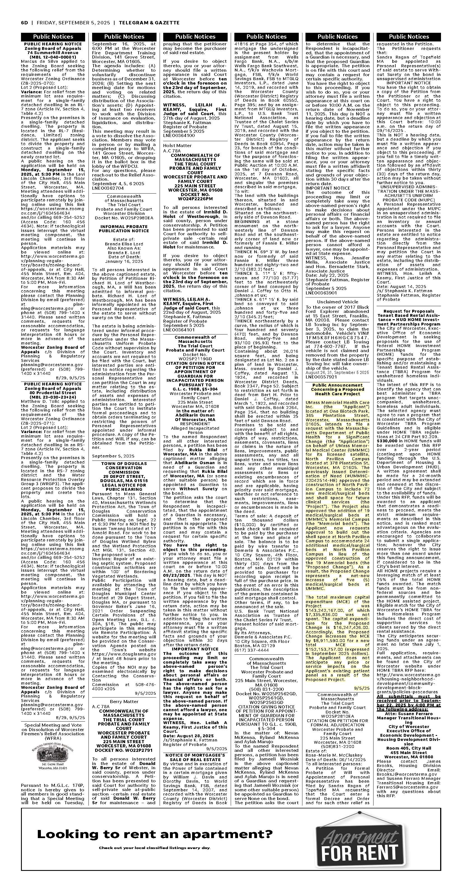

APPENDIX 8

ARTICLES OF INCORPORATION

APPENDIX 8 ARTICLES OF INCORPORATION
UMass Memorial Medical Center, Inc.:

https://corp.sec.state.ma.us/CorpWeb/CorpSearch/CorpSearchRedirector.aspx?Action=PDF&Pat h=CORP_DRIVE1/2013/1008/000486333/0030/020502817260_1.pdf

https://corp.sec.state.ma.us/CorpWeb/CorpSearch/CorpSearchRedirector.aspx?Action=PDF&Pat h=CORP_DRIVE1/2009/0713/000291523/0008/020503061638_1.pdf

https://corp.sec.state.ma.us/CorpWeb/CorpSearch/CorpSearchRedirector.aspx?Action=PDF&Pat h=CORP_DRIVE1/2019/1212/000000000/1760/201945425600_1.pdf

https://corp.sec.state.ma.us/CorpWeb/CorpSearch/CorpSearchRedirector.aspx?Action=PDF&Pat h=CORP_DRIVE1/2020/0611/000000000/9121/202093556910_1.pdf

APPENDIX 9

AFFIDAVIT

 Version: 7-6-17

Massachusetts Department of Public Health

Determination of Need

Affidavit of Truthfulness and Compliance

with Law and Disclosure Form 100.405 (B)
Instructions: Complete Information below. When complete check the box "This document is ready to print:". This will date stamp and lock the form. Print Form. Each person must sign and date the form. When all signatures have been collected, scan the document and e-mail to: dph.don@state.ma.us Include all attachments as requested.
Application Number: UMMH-25041715-AM
Original Application Date: 10/03/2025
Applicant Name: UMass Memorial Health Care, Inc.
Application Type: Amendment Significant
Applicant's Business Type: Corporation
Is the Applicant the sole member or sole shareholder of the Health Facility(ies) that are the subject of this Application? Yes
The undersigned certifies under the pains and penalties of perjury:
- The Applicant is the sole corporate member or sole shareholder of the Health Facility(ies) that are the subject of this Application;
- I have read [been informed of the contents of] 105 CMR 100.000, the Massachusetts Determination of Need Regulation;
- I understand and agree to the expected and appropriate conduct of the Applicant pursuant to 105 CMR 100.800;
- I have read [been informed of the contents of] this application for Determination of Need including all exhibits and attachments, and certify that [have been informed that] all of the information contained herein is accurate and true;
- I have submitted the correct Filing Fee and understand it is nonrefundable pursuant to 105 CMR 100.405(B);
- I have submitted the required copies of this application to the Determination of Need Program, and, as applicable, to all Parties of Record and other parties as required pursuant to 105 CMR 100.405(B);
- I have caused, as required, notices of intent to be published and duplicate copies to be submitted to all Parties of Record, and all carriers or third-party administrators, public and commercial, for the payment of health care services with which the Applicant contracts, and with Medicare and Medicaid, as required by 105 CMR 100.405(C), et seq.;
- I have caused [have been informed that] proper notification and submissions to the Secretary of Environmental Affairs pursuant to 105 CMR 100.405(E) and 301 CMR 11.00;
- If subject to M.G.L. c. 6D, § 13 and 958 CMR 7.00, I have submitted such Notice of Material Change to the HPC - in accordance with 105 CMR 100.405(G);
- Pursuant to 105 CMR 100.210(A)(3), I certify that both the Applicant and the Proposed Project are in material and substantial compliance and good standing with relevant federal, state, and local laws and regulations, as well as with all previously issued Notices of Determination of Need and the terms and Conditions attached therein; [issued in compliance with 105 CMR 100.00, the Massachusetts Determination of Need Regulation effective January 27, 2017 and amended December 28, 2018]
- I have read [been informed of the contents of] and understand the limitations on solicitation of funding from the general public prior to receiving a Notice of Determination of Need as established in 105 CMR 100.415;
- I understand that, if Approved, the Applicant, as Holder of the DoN, shall become obligated to all Standard Conditions pursuant to 105 CMR 100.310, as well as any applicable Other Conditions as outlined within 105 CMR 100.000 or that otherwise become a part of the Final Action pursuant to 105 CMR 100.360;
- Pursuant to 105 CMR 100.705(A), I certify that the Applicant has Sufficient Interest in the Site or facility; and
- Pursuant to 105 CMR 100.705(A), I certify that the Proposed Project is authorized under applicable zoning by-laws or ordinances, whether or not a special permit is required; or,
  - If the Proposed Project is not authorized under applicable zoning by-laws or ordinances, a variance has been received to permit such Proposed Project; or,
  - The Proposed Project is exempt from zoning by-laws or ordinances.

Corporation
Attach a copy of Articles of Organization/Incorporation, as amended

Eric W. Dickson, MD <Signature on File> 09/24/2025
CEO for Corporation Name: Signature: Date:

Lynda Young <Signature on File> 09/24/2025
Board Chair for Corporation Name: Signature: Date:

This document is ready to print? [blank] Date/time Stamp: [blank]

Shell space: 2,180 square feet represents net/interior square footage, but the total amount of gross square footage is 2,280.
The other renovation projects consist of the expansion of morgue services, and the replacement of a Nuclear Medicine Machine with a larger machine, and renovations of existing space to accommodate the larger machine.

