

December 20, 2024 Caryn Sweeney
UMass Memorial Health, Inc. 365 Plantation Street, 3rd Floor Worcester, MA 01605

RE: ACO LEAP Re-Certification Dear Ms. Sweeney:
Congratulations! The Health Policy Commission (HPC) is pleased to inform you that UMass Memorial Health, Inc. meets the requirements for ACO Certification under our Learning, Equity, and Patient-Centeredness (LEAP) standards. This certification is effective from January 1, 2025, through December 31, 2026.
The ACO Certification program, in alignment with other state agencies including MassHealth, is designed to accelerate care delivery transformation in Massachusetts and promote a high quality, efficient health system. ACOs participating in the program have met a set of objective criteria focused on core ACO capabilities demonstrating dedication to patient-centered care, use of evidence-based and data-driven strategies to improve care delivery, and commitment to addressing long-standing health inequities. UMass Memorial Health, Inc. meets those criteria.

The HPC will promote UMass Memorial Health, Inc. as a Certified ACO on our website and in our marketing and public materials. Enclosed you will find an ACO Certification logo for your organization to use in accordance with the attached Terms of Use. We hope you will use the logo on promotional materials when you highlight your ACO Certification to your patients, payers, and others.

The HPC looks forward to your continued engagement in the ACO Certification program over the next two years.

Thank you for your dedication to providing accountable, coordinated health care to your patients, and to continued learning and improvement over time. If you have any questions about this letter or the ACO Certification program, please do not hesitate to contact Mike Stanek, Deputy Director, at HPC-Certification@mass.gov or (617) 757-1649.
Best wishes,

David Seltz Executive Director

UMass Memorial Health Care, Inc.

Determination of Need Application # UMMH-25021208-HE

Attachments

Substantial Change in Service Substantial Capital Expenditure Addition of Proton Therapy Service

March 4, 2025

Submitted By

UMass Memorial Health Care, Inc.
One Biotech Park 365 Plantation Street
Worcester, Massachusetts 01605

Table of Contents
- Narrative Introduction Project Description
Factor 1 - Patient Panel, Need, Public Health Values and Operational Objectives Factor 2 – Health Priorities
Factor 5 – Relative Merit
Factor 6 – Community-Based Health Initiatives Exhibits
- Certification from an Independent Certified Public Accountant
- Notice of Intent
- Articles of Organization
- Affidavit of Truthfulness and Compliance
- Filing Fee Check
- Affiliated Parties Form
- Change in Service Form

Page 2

EXHIBIT I: COMMUNITY ENGAGEMENT DOCUMENTATION



PFAC Meeting Agenda – January 15, 2024

  - Attendance and Review of Minutes
  - Expanding Services in our Community
  - Hospital Update
  - Recent personal health care experiences (ALL)
  - Adjournment

Next meeting February 12, 2025



Community Benefits Advisory Council Quarterly Meeting January 15, 2025
8:30am Webex and In-person

- Expanding Services to Our Community Charles Cavagnaro, III MD FACP Interim President
Marlborough Hospital

- Review and Vote to Accept the Charter

- Review of September Meeting Feedback Exercise

- Calendar of Events for Sharing

- Open Discussion

- Adjournment

COMMUNITY BENEFITS ADVISORY COUNCIL MINUTES OF MEETING

DATE: January 15, 2025 PRESENT: L. Antonelli, E. Dorian, C. Duane, L. Faust, C. Harrington, J. Michaels, A. O’Malley, J. Zieff

LOCATION: Leahy Conference Room and via Webex VIRTUAL: E. Duprey, S. Forest, S. Manganelli, M. Murphy, B.
Reagan, P. Pope

EXCUSED: M. Board, C. Dumais, J. Emanuelson, H. Gutierrez, M. Jose, B. LaGrande, K. Leonard, N. Roman

STAFF: E. Carlucci, C. Cavagnaro, MD, J. Kelly, R. Osterfield
NEXT MEETING: March 26, 2025 at 8:30 am

ITEM | DISCUSSION | ACTION | RESPONSIBLE | DATE
Call to Order |  | Informational | E. Carlucci
Introductions | - Introductions completed | So, noted | All
Expanding Services to Our Community | - Thank you all for making it to this meeting and for all for the work that you do in our community.  - Investing in the future of Marlborough Hospital  - Merger of Marlborough Hospital with Medical Center  - A Regional Destination for Cancer Care  - Proton Therapy  - ED, Multi-D, CT Technology, Inpatient Rooms  - Expansion is based on regulatory approval.  - Expansion enables “us” to continue our mission.  - Complete presentation is attached for the meeting minutes. | Informational | Charles Cavagnaro, III MD FACP  Interim President Marlborough Hospital

ADMINISTRATOR RECORDER DATE

Discussion:
- Will there be discontinued or a pause in care/services while the expansion project is going? As a result of the merger?
- Is the multi-d clinic inpatient or outpatient?
- Will expanding the ED help or not help boarders in the emergency department? If we are not adding more inpatient beds, will patients get stuck in the ED?
- Is there a plan to provide more preventative services so chronic care isn’t needed?
- What is the timeline for construction?
Review and Vote to Accept the Charter | - Review of charter  - Vote to approve charter.  Upon motion, the Community Benefits Advisory Council Charter was approved. | Informational | E. Carlucci
Review of September Meeting Feedback Exercise | - Health issues in our community activity:  - Do you live, work or both in our community?  - What is our role in our community?  - What are your top health priorities for this community?  - What is the overall health in our community?  - Complete presentation is attached for the meeting minutes. | Informational | E. Carlucci
Calendar of Events for Sharing | - Marlborough Hospital “Keeping Your Options and Your Arteries Open” Community Education Program on February 5  - UMass Memorial Medical Center Care Mobile Schedule  - Health insurance registration sessions  - TENTATIVE: Hudson Public School Health Fair 4/14/25 |  | R. Osterfield  J. Michaels  A. O’Malley
Open Discussion | - Setting a goal for monthly health education programs  - Virtual  - In-person  - Hybrid |  | All

 | - Proposed topics:  - Substance use disorder  - Mental health  - Financial health  - Preventative care  - Hoarding  - Healthy aging  - Identify content experts for topics  - Develop calendar of programs  - Main Street Bank is willing to host at their facility which has virtual and in-person capability. |  | All  All All  E. Dorian
Adjournment | Meeting was adjourned at 9:37 am | So, noted

From: | Raia, Yvonne
Sent: | Friday, January 17, 2025 12:43 PM
To: | Elvira Guardiola | ; Flotte, Terrence; Jean McMurray
 | ; Marco Rodrigues | ; Nikki Nixon
; Sue Mailman
Cc: Florez, Mario; Mccandless, Victoria; Pistone, Patricia; Somda, Emile; Looney, John; Muller, Michelle
Subject: Community Benefits Committee Update: Investing in Marlborough Hospital and Keeping High-Quality Care Local

The following is a message from Mario:

Dear Committee Members,

I want to share with you some exciting news about plans for UMass Memorial Health to invest, pending regulatory approval, in Marlborough Hospital. Below is a message sent by Dr. Eric Dickson, President and CEO of UMass Memorial Health, to all employees across our system. I look forward to keeping you informed about these efforts at future meetings.

Please feel free to reach out with any questions.

Thank you,

MJF

Mario J. Florez
UMass Memorial Health
Senior Director, Community Benefits

www.ummhealth.org

From: Eric.Dickson.System.CEO
Sent: Wednesday, January 8, 2025 10:00 AM

To: Eric.Dickson.System.CEO
Subject: Investing in Marlborough Hospital and Keeping High-Quality Care Local



As a designated safety net health system and the largest health care provider in Central Massachusetts, UMass Memorial Health is continually seeking new ways to advance its mission to provide best-in-class, compassionate care to the communities we serve.

Today, I am delighted to share with you an update on steps we are taking as a system to pursue an even deeper relationship with Marlborough Hospital through a series of separately proposed clinical improvements and capital investments that will enhance the hospital’s integration with UMass Memorial Medical Center, modernize the hospital’s facilities, and further support the availability of high-quality care in the local community.

Pending regulatory approval, we plan to undertake a $36 million expansion of Marlborough Hospital’s Emergency Department to alleviate overcrowding, reduce patient wait times and improve the patient care experience. To be located on the second floor of the expanded Emergency Department, we intend to build a $6 million Multidisciplinary Clinic, which will treat patients with complex and chronic conditions. This clinic will bring together health care professionals from various specialties within the UMass Memorial Medical Group, providing patients with comprehensive, coordinated care closer to where they live. Pending regulatory approval, we also intend to invest $4 million in a more sophisticated Spectral Computed Tomography (CT) system that will provide improved image quality, supporting the more precise detection of tumors, fractures, and heart and vascular disease.

Additionally, we hope to place Marlborough Hospital on the medical license of the Medical Center and operate Marlborough Hospital as a campus of the Medical Center. To make this possible, we will be seeking regulatory approval from the Massachusetts Department of Public Health. Our main priority with this licensure transition is to improve access to critical resources for both caregivers and patients, while preserving the culture that

makes Marlborough Hospital so special. Expanding the Medical Center’s license to include Marlborough Hospital will:
- Promote enhanced care coordination and transfer pathways between the Medical Center and the Marlborough campus, leading to optimized operating room and inpatient bed utilization at Marlborough.
- Improve patient and caregiver access to cutting-edge technologies, medical specialists, and tertiary services that are available through the Medical Center, keeping more care local and helping patients avoid the need to seek more expensive care in Boston.
- Bring other innovative programs such as UMass Memorial Medical Center’s award- winning Hospital at Home program to Marlborough, helping patients receive high- quality, hospital-level care in the comfort and familiarity of their homes.

Additionally, and subject to regulatory review and approval, we are planning to build on the success of The UMass Memorial Cancer Center at Marlborough Hospital with a $55 million investment in a proton therapy system to expand the lifesaving care we provide. Proton therapy is an advanced, FDA-approved cancer treatment that improves the precision of radiation in targeting tumors – reducing potential damage to healthy tissue in the body, the amount of radiation needed, and side effects from treatment. While this groundbreaking technology improves clinical outcomes for all patients, proton therapy is particularly effective for treating children, whose long-term growth and development can be disproportionately impacted by unintended cell damage.

Proton therapy – which requires daily treatment – has historically been challenging for patients in New England to access. Patients who need to travel to Boston to seek care are burdened with the additional expense of traveling and often staying overnight far from home, as well as heavy traffic and parking limitations. Our hope is to bring this treatment to Marlborough to meet existing patient demand, while expanding access to patients who may benefit from proton therapy in a more cost-effective, convenient, and low-stress environment.

We also have a vision to invest another $100 million to refurbish and modernize the hospital’s inpatient rooms. Like other capital investments, this project would be subject to regulatory review and approval.

We are immensely proud to continue to advance our mission to provide best-in-class, compassionate care to the patient communities we serve. As these projects advance, we will continue to provide you with updates.

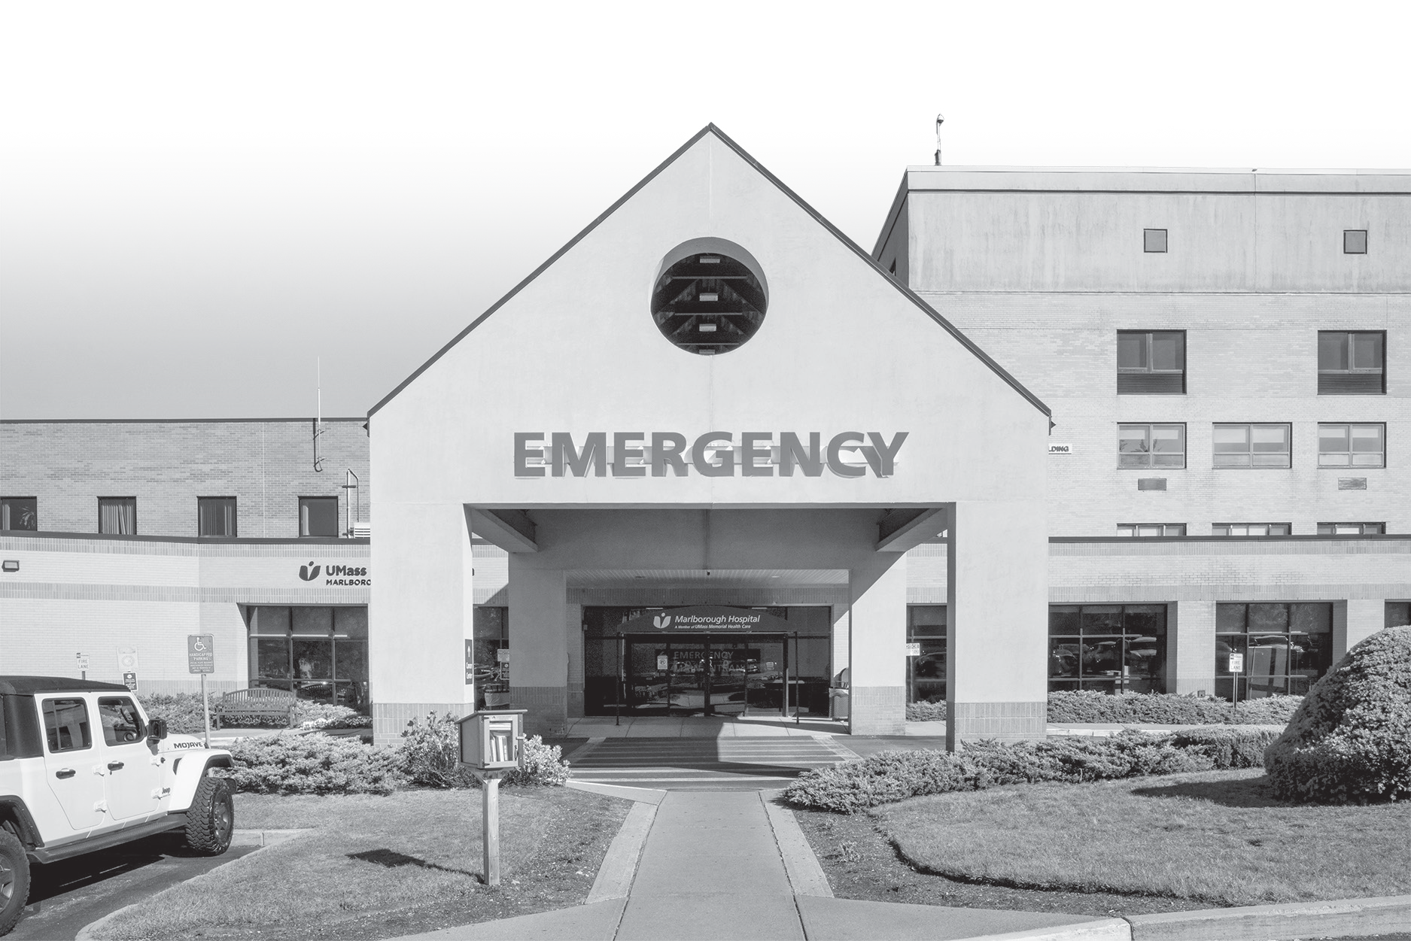


Please join Marlborough Hospital Interim President, Charles Cavagnaro III, MD to learn about
UMass Memorial Health’s Improvement Plans for Marlborough Hospital
January 21 or 23 | 6 pm - 7 pm Marlborough Hospital | Leahy Conference Room
157 Union Street, Marlborough

RSVP to Ellen Carlucci,
Vice President, Marketing, Communications, Development

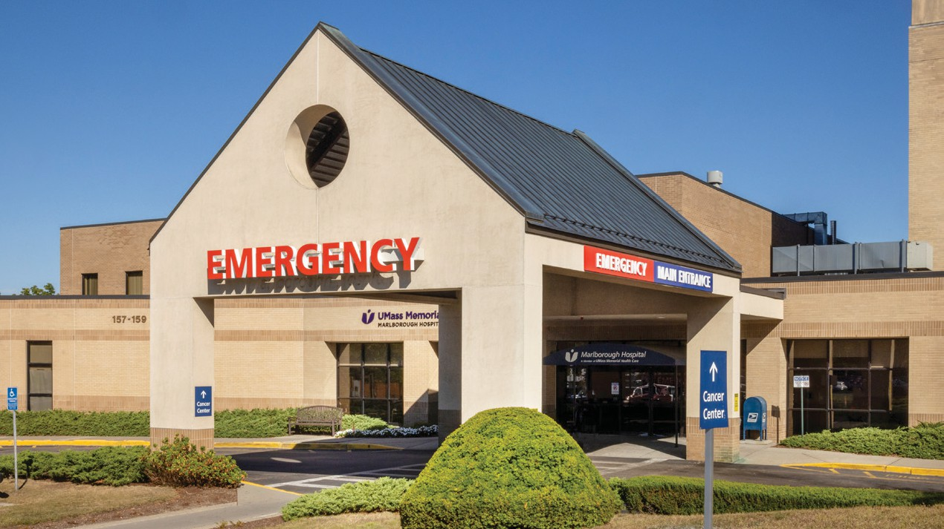

Investing in the Future of Marlborough Hospital and the
Marlborough Community and Keeping High Quality Care Local
WHAT’S PLANNED FOR MARLBOROUGH HOSPITAL?
Through a series of separately proposed clinical improvements and capital investments, UMass Memorial Health will modernize the hospital’s facilities, deepen Marlborough Hospital’s relationship with UMass Memorial Medical Center, and further support the availability of high-quality care locally.
Pending regulatory approval, UMass Memorial Health intends to:
- Undertake an expansion of Marlborough Hospital’s Emergency Department to alleviate overcrowding, reduce patient wait times, improve the patient care experience, and enhance staff satisfaction;
- Build a Multidisciplinary Clinic, which will treat patients with complex and chronic conditions;
- Purchase a more sophisticated Spectral Computed Tomography (CT) system due to a significant increase in patient demand;
- Expand the UMass Memorial Medical Center medical license to include the entirety of Marlborough Hospital;
- And acquire a proton beam machine and offer proton therapy – an FDA-approved cancer treatment that improves the precision of radiation in targeting tumors – at the UMass Memorial Cancer Center at Marlborough Hospital to expand the life-saving care offered in Marlborough.
HOW WILL THESE INVESTMENTS IMPACT PATIENTS AND THE COMMUNITY?
These projects will lead to better patient health outcomes, enhance the patient care experience and caregiver satisfaction, and strengthen health care in Central Massachusetts by:
- Improving transfer pathways between the Medical Center and the Marlborough campus, leading to optimized operating room and inpatient bed utilization at Marlborough;
- Transforming UMass Memorial Cancer Center at Marlborough into a world-class center of cancer care that can meet existing patient demand, while expanding access to patients who may benefit from proton therapy in a more cost-effective, convenient, and low-stress environment;
- Enhancing patient and caregiver access to cutting-edge technologies, medical specialists, and tertiary services that are available through the Medical Center, keeping more care local and helping patients avoid the need to seek more expensive care in Boston;
- And bringing other innovative programs to Marlborough, such as UMass Memorial Medical Center’s award-winning Hospital at Home program.
HOW CAN I GET INVOLVED?
- If you have questions, feedback, or would like to get involved in advocating for any of these projects, please email Ellen Carlucci, Vice President, Marketing, Communications and Development UMass Memorial Health - Marlborough Hospital, at ellen.carlucci@umassmemorial.org.







INVESTING IN THE FUTURE OF MARLBOROUGH HOSPITAL

Keeping High-Quality Care Local

Charles E. Cavagnaro, III, MD
Interim President, Marlborough Hospital

The hospitals and services of UMass Memorial Health
UMass Memorial Medical Center | UMass Memorial Medical Group
Harrington | HealthAlliance-Clinton Hospital | Marlborough Hospital | Milford Regional | Community Healthlink

K E E P I N G H I G H - Q U A L I T Y C A R E L O C A L

INVESTING IN THE FUTURE OF MARLBOROUGH HOSPITAL
UMass Memorial Health’s mission is to provide best-in-class, compassionate care to the communities we serve

We are enthusiastically pursuing an even deeper relationship with Marlborough Hospital and the Marlborough community through a series of separately proposed clinical improvements and capital investments (all pending regulatory approval) that will:
Enhance the hospital’s integration with UMass Memorial Medical Center
Modernize the hospital’s facilities
Further support the availability of high-quality care locally

These projects will lead to better patient health outcomes, improve the care experience and access to tertiary care, enhance caregiver satisfaction, and strengthen health care in Central Massachusetts

These projects will also contribute significantly to the economic development of the Marlborough community and broader region

K E E P I N G H I G H - Q U A L I T Y C A R E L O C A L

ED EXPANSION, MULTI- D CLINIC, CT TECHNOLOGY, INPATIENT ROOMS

A $36 million expansion of the Emergency Department to alleviate overcrowding, reduce patient wait times, improve the patient care experience, and enhance staff morale

To be located on the second floor of the expanded Emergency Department, we intend to build a $6 million Multidisciplinary Clinic, which will treat patients with complex and chronic conditions and bring together health care professionals from various specialties within the UMMH Medical Group

We intend to invest in a more sophisticated $4 million Spectral Computed Tomography (CT) system to support the more precise detection of tumors, fractures, and heart and vascular diseases

We have a vision to invest another $100 million to refurbish and modernize the hospital’s inpatient

rooms

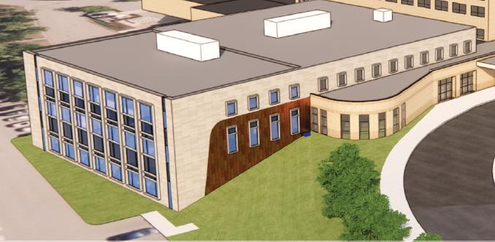

K E E P I N G H I G H - Q U A L I T Y C A R E L O C A L

MERGER OF MARLBOROUGH WITH MEDICAL CENTER
To help further stabilize and strengthen healthcare across our region, we hope to place Marlborough Hospital on the medical license of UMass Memorial Medical Center through a corporate merger and operate Marlborough Hospital as a campus of the Medical Center

Expanding UMass Memorial Medical Center’s license to include the entirety of Marlborough
Hospital would:
Promote enhanced care coordination and transfer pathways between the Medical Center and the
Marlborough campus, leading to optimized operating room and inpatient bed utilization at Marlborough

Improve patient and caregiver access to cutting-edge technologies, medical specialists, and tertiary services that are available through the Medical Center, keeping more care local and helping patients avoid the need to seek more expensive care in Boston

Bring other innovative programs such as UMass Memorial Medical Center’s award-winning Hospital at Home program to Marlborough, helping patients receive high-quality, hospital-level care in the comfort and familiarity of their homes

K E E P I N G H I G H - Q U A L I T Y C A R E L O C A L

A REGIONAL DESTINATION FOR CANCER CARE

The UMass Memorial Cancer Center at Marlborough Hospital has been operating within the Medical Center license since its opening in October 2013, and the partnership has been a tremendous success
Key features include linear accelerator and CT simulator technology for radiation therapy, medical oncology, and access to a fully integrated, systemwide electronic health record system

This strong foundation for advanced cancer care in the Marlborough community has laid the groundwork for even more new and exciting opportunities to enhance cancer care treatment regionally and throughout the state

We are hoping to acquire a proton therapy system for the UMass Memorial Cancer Center at
Marlborough Hospital to expand the life-saving care offered at the Marlborough campus

K E E P I N G H I G H - Q U A L I T Y C A R E L O C A L

PROTON THERAPY
An advanced, proven cancer treatment that improves the precision of radiation in targeting tumors – reducing potential damage to healthy tissue in the body, the amount of radiation needed, and side effects
Particularly effective for treating children, whose long-term growth and development can be disproportionately impacted by unintended cell damage
Requires daily treatment and has historically been extremely challenging for patients in New
England to access with only site at Mass General Hospital
Patients who need to travel to Boston to seek care are burdened with the additional expense of traveling and often staying overnight far from home, as well as heavy traffic and parking limitations

With this technology, we can meet existing patient demand, while expanding access to patients who may benefit from proton therapy in a more cost-effective, convenient, and low-stress environment
This step will make Marlborough Hospital a world-class center of cancer care that stands to touch the lives of many more patients seeking compassionate, effective treatment

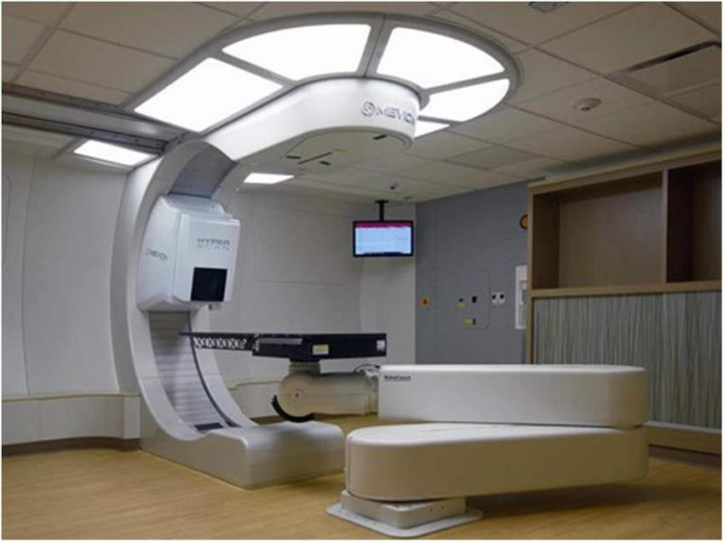

Mevion 250i

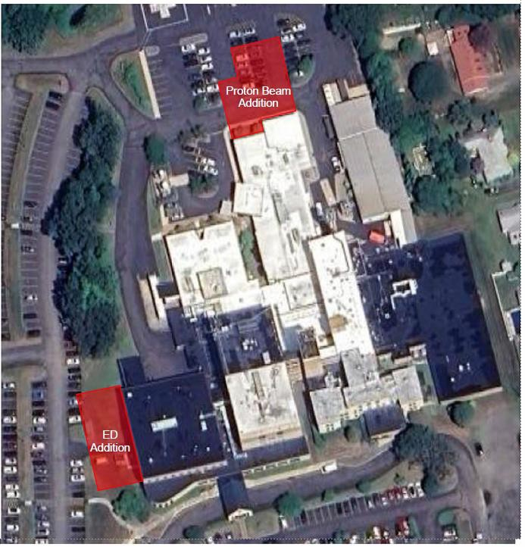

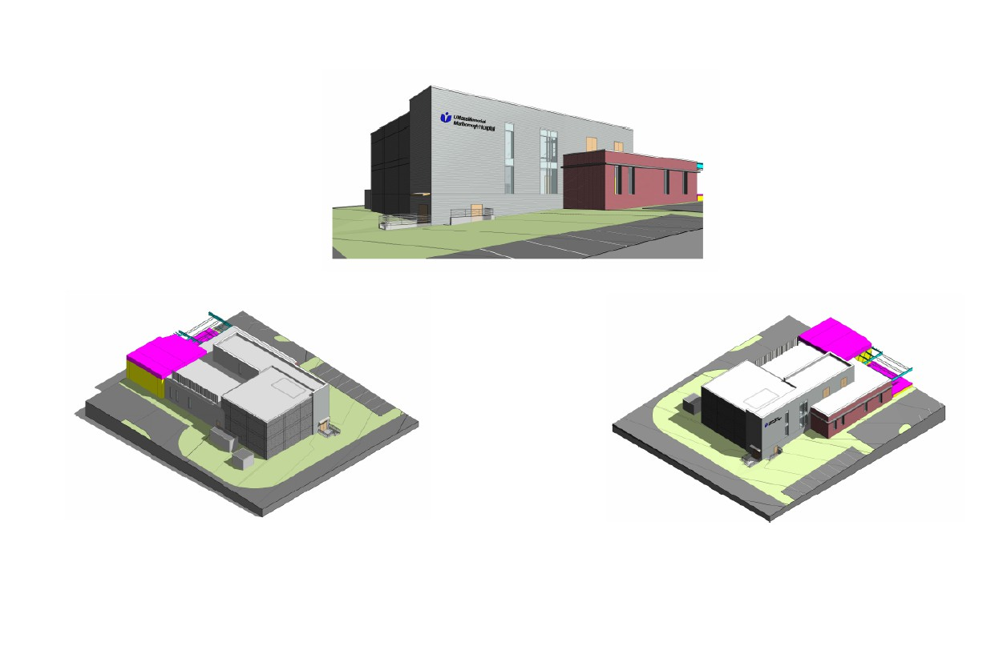
UMass Memorial Medical Center Cancer Center at Marlborough Hospital
10




IF YOU HAVE QUESTIONS, FEEDBACK, OR
WOULD LIKE TO GET INVOLVED IN ADVOCATING FOR ANY OF THESE PROJECTS, PLEASE EMAIL:

11





THANK YOU!

UMASS MEMORIAL HEALTH

Community Healthlink | Harrington | HealthAlliance-Clinton Hospital | Marlborough Hospital
UMass Memorial Medical Center | UMass Memorial Medical Group | UMass Memorial Accountable Care Organization
12

INVESTING IN THE FUTURE OF MARLBOROUGH HOSPITAL

Keeping High-Quality Care Local

Charles E. Cavagnaro, III, MD
Interim President, Marlborough Hospital

The hospitals and services of UMass Memorial Health
UMass Memorial Medical Center | UMass Memorial Medical Group
Harrington | HealthAlliance-Clinton Hospital | Marlborough Hospital | Milford Regional | Community Healthlink

K E E P I N G H I G H - Q U A L I T Y C A R E L O C A L

INVESTING IN THE FUTURE OF MARLBOROUGH HOSPITAL
UMass Memorial Health’s mission is to provide best-in-class, compassionate care to the communities we serve

We are enthusiastically pursuing an even deeper relationship with Marlborough Hospital and the Marlborough community through a series of separately proposed clinical improvements and capital investments (all pending regulatory approval) that will:
Enhance the hospital’s integration with UMass Memorial Medical Center
Modernize the hospital’s facilities
Further support the availability of high-quality care locally

These projects will lead to better patient health outcomes, improve the care experience and access to tertiary care, enhance caregiver satisfaction, and strengthen health care in Central Massachusetts

These projects will also contribute significantly to the economic development of the Marlborough community and broader region

K E E P I N G H I G H - Q U A L I T Y C A R E L O C A L

MERGER OF MARLBOROUGH WITH MEDICAL CENTER
To help further stabilize and strengthen healthcare across our region, we hope to place Marlborough Hospital on the medical license of UMass Memorial Medical Center through a corporate merger and operate Marlborough Hospital as a campus of the Medical Center

Expanding UMass Memorial Medical Center’s license to include the entirety of Marlborough
Hospital would:
Promote enhanced care coordination and transfer pathways between the Medical Center and the
Marlborough campus, leading to optimized operating room and inpatient bed utilization at Marlborough

Improve patient and caregiver access to cutting-edge technologies, medical specialists, and tertiary services that are available through the Medical Center, keeping more care local and helping patients avoid the need to seek more expensive care in Boston

Bring other innovative programs such as UMass Memorial Medical Center’s award-winning Hospital at Home program to Marlborough, helping patients receive high-quality, hospital-level care in the comfort and familiarity of their homes

K E E P I N G H I G H - Q U A L I T Y C A R E L O C A L

A REGIONAL DESTINATION FOR CANCER CARE

The UMass Memorial Cancer Center at Marlborough Hospital has been operating within the Medical Center license since its opening in October 2013, and the partnership has been a tremendous success
Key features include linear accelerator and CT simulator technology for radiation therapy, medical oncology, and access to a fully integrated, systemwide electronic health record system

This strong foundation for advanced cancer care in the Marlborough community has laid the groundwork for even more new and exciting opportunities to enhance cancer care treatment regionally and throughout the state

We are hoping to acquire a proton therapy system for the UMass Memorial Cancer Center at
Marlborough Hospital to expand the life-saving care offered at the Marlborough campus

K E E P I N G H I G H - Q U A L I T Y C A R E L O C A L

PROTON THERAPY
An advanced, proven cancer treatment that improves the precision of radiation in targeting tumors – reducing potential damage to healthy tissue in the body, the amount of radiation needed, and side effects
Particularly effective for treating children, whose long-term growth and development can be disproportionately impacted by unintended cell damage
Requires daily treatment and has historically been extremely challenging for patients in New
England to access with only site at Mass General Hospital
Patients who need to travel to Boston to seek care are burdened with the additional expense of traveling and often staying overnight far from home, as well as heavy traffic and parking limitations

With this technology, we can meet existing patient demand, while expanding access to patients who may benefit from proton therapy in a more cost-effective, convenient, and low-stress environment
This step will make Marlborough Hospital a world-class center of cancer care that stands to touch the lives of many more patients seeking compassionate, effective treatment

K E E P I N G H I G H - Q U A L I T Y C A R E L O C A L

AND MORE : ED, MULTI-D, CT TECHNOLOGY, INPATIENT ROOMS
A $36 million expansion of the Emergency Department to alleviate overcrowding, reduce patient wait times, improve the patient care experience, and enhance staff morale

To be located on the second floor of the expanded Emergency Department, we intend to build a $6 million Multidisciplinary Clinic, which will treat patients with complex and chronic conditions and bring together health care professionals from various specialties within the UMMH Medical Group

We intend to invest in a more sophisticated $4 million Spectral Computed Tomography (CT) system to support the more precise detection of tumors, fractures, and heart and vascular diseases

We have a vision to invest another $100 million to refurbish and modernize the hospital’s inpatient
rooms

IF YOU HAVE QUESTIONS, FEEDBACK, OR
WOULD LIKE TO GET INVOLVED IN ADVOCATING FOR ANY OF THESE PROJECTS, PLEASE EMAIL:

7

THANK YOU!

UMASS MEMORIAL HEALTH

Community Healthlink | Harrington | HealthAlliance-Clinton Hospital | Marlborough Hospital
UMass Memorial Medical Center | UMass Memorial Medical Group | UMass Memorial Accountable Care Organization
8

From: Looney, John
Sent: Monday, January 27, 2025 6:05 PM
To: Looney, John
Subject: [EXTERNAL] Worcester Together TODAY; Please join us!

------------------------------------------------------------------------------------------------
From: Tim Garvin
Sent: Thursday, January 23, 2025 6:16 AM

To:

Subject: [EXTERNAL] Worcester Together TODAY; Please join us!

While email attachments are a popular and convenient way to send documents, they are also a common source of viruses. Use caution when opening attachments, even if they appear to have been sent by someone you know.

Good, GOOD Morning!!!!!

It is Thursday, Worcester Together will be meeting today at 8:30 this morning.

It continues to be cold – just 11 degrees right now. I am PROUD that the City of Worcester opened warming stations for the past two days. THANK YOU to the Worcester Senior Center. THANK YOU to our Worcester Public Library. Let us all continue to work together to ensure that everyone is sheltered, safe, warm, and treated with dignity and respect.

Today also happens to be our United Way’s 105th Anniversary; we were founded in/at the Worcester Chamber of Commerce on January 23 of 1920. We gently solicited a number of quotes from partners – contributors, Board members, elected officials, community

leaders, volunteers, nonprofit agency leaders, Business owners, policy makers, participants, residents. I hope that you will log on to different social media – Facebook or Instagram, LinkedIn or X (formerly Twitter) and take a look OR – post a comment of your own. We are using hashtag #uwcm105.

Today’s working agenda:

Welcome, greetings, comments Mayor Petty. (Sarai is not able to join, she sent a beautiful message last evening)
Health Jim, Dr. Charles Cavagnaro
Fly, COVID, Norovirus
UMass Memorial Health updates
Education Rachel, Deborah, Casey
Schools as safe places for children
Youth Development David and Pam, Liz, Youth Connect, others
February Vacation Summer prep
Housing Leah
Day Resource Center
Safety Net Shelter Tasia
WHA
Safe Exit
Supports and Resources Maydee VITA/EITC

Utility Assistance
Food Security Casey and Maydee
New Arrivals Jillian, Trish, Meg
Worcester RISE for Health Olga Executive Orders
Employment and Training Jeff and Janice
Mental Health Amy
Seniors Cheryl, Karin, Claudia
Parent’s Voice
Business Peter and Karen
Clergy Rev. Talley and Lou
Culture

Please post any cultural celebrations, exhibits, or events into the chat so that all may participate

Here is the zoom link:

I look forward to seeing all of you today at 8:30.

Tim #uwcm105

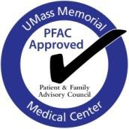

Medical Center PFAC Meeting

Date: Tuesday, January 28, 2502
Meeting Ground Rules:
- Patient = “Patient plus Family”
- Hear everyone, and challenge respectfully
- Respect confidentiality
- See through the patient’s eyes, walk in their shoes
Time: 6:00 – 7:30 pm
Location: Remote via Zoom
Co-Chairs: Staff Co-Chair: Stacy Keddy, RN, Nurse Manager, PACU/SACU
Volunteer Co-Chairs: Donna Boulay and Shmulik Fogelman
PFAC Liaison: Billie Adler, PFAC Program Manager and Patient Experience Specialist
Guests: Karen Uttaro, Allen Chang, MD, Kyle Dean, Charles Cavagnaro, MD, Amanda Laflamme
Zoom link:

Agenda Item | Person | Time
Welcome • Introductions | Billie Adler | All | 10 min.
Patient Voices | Donna Boulay | 5 min.
Pathway to Excellence Initiative | Karen Uttaro, DNP, RN  Sr. Director, Professional Practice, Quality & Regulatory Readiness | 20 min.
AI Tool To Improve MyChart Responsiveness | Allen Chang, MD  Kyle Dean, Senior Strategic Enterprise Project Manager, CITC | 20 min.
Marlborough Hospital Update:  - Medical Center Investment in Marlborough Hospital  - Determination of Need for New Proton Therapy | Charles Cavagnaro, MD  President, UMMH HealthAlliance-Clinton Hospital and Marlborough Hospital | 20 min.
Announcements | Billie Adler | 5 min.
Updates: Committee Report-outs, new business | All | 5 min.
Closing | All | 5 min.
Next Meeting – February 25th – In person at WBC

ATTACHMENT 3

COPY OF NOTICE OF INTENT

2/15/25, 9:28 AM Marlborough Hospital | UMass Memorial Health
1.20.25 | Metrowest Daily News | In the Media

Public Announcement Concerning a Proposed Health Care Project
The public announcement of the intent to transfer ownership of Marlborough Hospital to UMass Memorial Medical Center, Inc., making Marlborough Hospital a licensed campus of UMass Memorial Medical Center.

2.7.25 | Worcester Telegram & Gazette | Human Interest

Trump targets transgender care: What does it mean for Worcester families, providers?
Mentions UMass Memorial Health (UMMH) will continue to provide transgender health care services, including for adolescents and young adults.

2.5.25 | Boston Globe | In the Community

When ICE comes to the hospital: AG Campbell reassures health care facilities of their rights to provide care
Includes statement from UMass Memorial Health on guidance provided to employees on what to do if Immigration and Customs Enforcement enter medical facilities in an article about ICE in hospitals.

7.22.22 | Awards/Recognition

Marlborough Hospital Is Nationally Recognized as a Top Hospital by Money and the Leapfrog Group

2/15/25, 9:28 AM Marlborough Hospital | UMass Memorial Health


2.4.25 | Becker's Hospital Review | Innovations

How UMass Memorial's digital hub is redefining patient care
UMass Memorial Health has launched a digital hub to centralize digital medicine capabilities and improve patient care across inpatient, outpatient, and home settings.

View All News View All Events

Public Announcement Concerning a Proposed Health Care Project UMass Memorial Health Care Inc. (“Applicant”) located at One Biotech Park, 365 Plantation Street, Worcester, Massachusetts 01605, intends to file a Notice of Determination of Need with the Massachusetts Department of Public Health for the Transfer of Ownership of Marlborough Hospital, located at 157 Union Street, Marlborough, MA 01752 to UMass Memorial Medical Center, Inc, a licensed hospital. Learn more about this notice.

Public Announcement Concerning a Proposed Health Care Project UMass Memorial Health Care, Inc. (“Applicant”), located at One Biotech Park, 365 Plantation Street, Worcester, MA 01605, intends to file a Notice of Determination of Need Application with the Massachusetts Department of Public Health with respect to a Proposed Project involving Substantial Capital Expenditures and Substantial Change in Services at UMass Memorial Medical Center’s Marlborough Cancer Center (“Hospital”), located at 157 Union Street, Marlborough, MA 01752. Pursuant to the Proposed Project, the Applicant will expand access to high-quality cancer treatment by adding proton beam therapy, a DoN-Required Service, and expanding the Hospital’s Cancer Center building to include a Proton Therapy Center. The Total Value of this Proposed Project is
$59,184,749. The Applicant anticipates that the Proposed Project will not have a material increase on prices and will improve access to advanced proton beam

2/15/25, 9:29 AM UMass Memorial Medical Center | UMass Memorial Health
Department 119 Belmont Street ED, Worcester, MA 01605
55 Lake Avenue North ED, Worcester, MA 01655
508-334-6481
508-421-5741
Patients
UMASS MEMORIAL
Get
About
and Locations
MEDICAL CENTER
Care
Us
Visitors

Recent News

Featured
1.20.25 | Metrowest Daily News | In the Media

Public Announcement Concerning a Proposed Health Care Project
The public announcement of the intent to transfer ownership of Marlborough Hospital to UMass Memorial Medical Center, Inc., making Marlborough Hospital a licensed campus of UMass Memorial Medical Center.

2.7.25 | Spectrum News 1 | Human Interest

National Wear Red Day aims to raise awareness for women's heart health
Features caregivers at UMass Memorial Medical Center wearing read for National Wear Red Day to raise awareness for women’s heart health.

2.7.25 | Worcester Telegram & Gazette | Human Interest

Trump targets transgender care: What does it mean for Worcester families, providers?
Mentions UMass Memorial Health (UMMH) will continue to provide transgender health care services, including for adolescents and young adults.

2.5.25 | Boston Globe | In the Community

When ICE comes to the hospital: AG Campbell reassures health care facilities of their rights to

2/15/25, 9:29 AM UMass Memorial Medical Center | UMass Memorial Health
provide care
Includes statement from UMass Memorial Health on guidance provided to employees on what to do if Immigration and Customs Enforcement enter medical

UMASS MEMORIAL MEDICAL CENTER
Get Care
Patients and Visitors

Locations
About Us

facilities in an article about ICE in hospitals.

2.4.25 | Becker's Hospital Review | Innovations

How UMass Memorial's digital hub is redefining patient care
UMass Memorial Health has launched a digital hub to centralize digital medicine capabilities and improve patient care across inpatient, outpatient, and home settings.

View All News View All Events

Public Announcement Concerning a Proposed Health Care Project UMass Memorial Health Care Inc. (“Applicant”) located at One Biotech Park, 365 Plantation Street, Worcester, Massachusetts 01605, intends to file a Notice of Determination of Need with the Massachusetts Department of Public Health for the Transfer of Ownership of Marlborough Hospital, located at 157 Union Street, Marlborough, MA 01752 to UMass Memorial Medical Center, Inc, a licensed hospital. Learn more about this notice.
Public Announcement Concerning a Proposed Health Care Project UMass Memorial Health Care, Inc. (“Applicant”), located at One Biotech Park, 365 Plantation Street, Worcester, MA 01605, intends to file a Notice of Determination of Need Application with the Massachusetts Department of Public Health with respect to a Proposed Project involving Substantial Capital Expenditures and Substantial Change in Services at UMass Memorial Medical Center’s Marlborough Cancer Center (“Hospital”), located at 157 Union Street, Marlborough, MA 01752. Pursuant to the Proposed Project, the Applicant will expand access to high-quality cancer treatment by adding proton beam therapy, a DoN-Required Service, and expanding the Hospital’s Cancer Center building to include a Proton Therapy Center. The Total Value of this Proposed Project is
$59,184,749. The Applicant anticipates that the Proposed Project will not have a material increase on prices and will improve access to advanced proton beam therapy cancer services for the Applicant’s existing patient panel. Any ten Taxpayers of Massachusetts may register in connection with the intended Application by no later than April 2, 2025 or 30 days from the Filing Date, whichever is later, by contacting the Department of Public Health Determination of Need Program at DPH.DON@mass.gov or 67 Forest St, Marlborough, MA 01752.

Donate to UMass Memorial Medical Center

2/15/25, 9:29 AM UMass Memorial Medical Center | UMass Memorial Health
Learn more about giving to the Medical Center.

Donate Now

UMASS MEMORIAL MEDICAL CENTER
Get Care
Patients and Visitors

Locations
About Us

Connect with us


855-UMASS-MD (855-862-7763)

The Clinical Partner of UMass Chan Medical School

Patients and Visitors

About Us

Our System of Care

For Health Professionals

Terms of Use SMS Terms of Use

Copyright © 2025 UMass Memorial Health. All rights reserved.


Exclusive Health Care Provider of the Worcester Red Sox.

ATTACHMENT 4 ARTICLES OF ORGANIZATION
UMMHC Articles of Organization 3/4/1997: https://corp.sec.state.ma.us/CorpWeb/CorpSearch/CorpSearchRedirector.aspx?Acti on=PDF&Path=CORP_DRIVE1/2013/1008/000486333/0030/020502817260_1.pd
f

Articles of Merger (MHC into UMMHC) 4/1/1998: https://corp.sec.state.ma.us/CorpWeb/CorpSearch/CorpSearchRedirector.aspx?Acti on=PDF&Path=CORP_DRIVE1/2009/0713/000291523/0008/020503061638_1.pd
f

UMMHC Articles of Amendment 12/12/2019: https://corp.sec.state.ma.us/CorpWeb/CorpSearch/CorpSearchRedirector.aspx?Acti on=PDF&Path=CORP_DRIVE1/2019/1212/000000000/1760/201945425600_1.pd
f
UMMHC Articles of Amendment 6/11/2020: https://corp.sec.state.ma.us/CorpWeb/CorpSearch/CorpSearchRedirector.aspx?Acti on=PDF&Path=CORP_DRIVE1/2020/0611/000000000/9121/202093556910_1.pd
f

ATTACHMENT 5 AFFIDAVIT OF TRUTHFULNESS

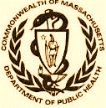 Version: 7-6-17

Massachusetts Department of Public Health

Determination of Need

Affidavit of Truthfulness and Compliance

with Law and Disclosure Form 100.405 (B)
Instructions: Complete Information below. When complete check the box "This document is ready to print:". This will date stamp and lock the form. Print Form. Each person must sign and date the form. When all signatures have been collected, scan the document and e-mail to: dph.don@state.ma.us Include all attachments as requested.
Application Number: UMMH-25021208-HE
Original Application Date: 3/4/2025
Applicant Name: UMass Memorial Health Care, Inc.
Application Type: DoN-Required Service
Applicant's Business Type: Corporation
Is the Applicant the sole member or sole shareholder of the Health Facility(ies) that are the subject of this Application? Yes

The undersigned certifies under the pains and penalties of perjury:
- The Applicant is the sole corporate member or sole shareholder of the Health Facility(ies) that are the subject of this Application;
- I have read [been informed of the contents of] 105 CMR 100.000, the Massachusetts Determination of Need Regulation;
- I understand and agree to the expected and appropriate conduct of the Applicant pursuant to 105 CMR 100.800;
- I have read this application for Determination of Need including all exhibits and attachments, and certify that all of the information contained herein is accurate and true;
- I have submitted the correct Filing Fee and understand it is nonrefundable pursuant to 105 CMR 100.405(B);
- I have submitted the required copies of this application to the Determination of Need Program, and, as applicable, to all Parties of Record and other parties as required pursuant to 105 CMR 100.405(B);
- I have caused, as required, notices of intent to be published and duplicate copies to be submitted to all Parties of Record, and all carriers or third-party administrators, public and commercial, for the payment of health care services with which the Applicant contracts, and with Medicare and Medicaid, as required by 105 CMR 100.40S(C), et seq.;
- I have caused proper notification and submissions to the Secretary of Environmental Affairs pursuant to 105 CMR 100.405(E) and 301 CMR 11.00;
- If subject to M.G.L c. 6D, § 13 and 958 CMR 7 .00, I have submitted such Notice of Material Change to the HPC – in accordance with 105 CMR 100.40S(G);
- Pursuant to 105 CMR 100.210(A)(3), I certify that both the Applicant and the Proposed Project are in material and substantial compliance and good standing with relevant federal, state, and local laws and regulations, as well as with all previously issued Notices of Determination of Need and the terms and Conditions attached therein; [issued in compliance with 105 CMR 100.00, the Massachusetts Determination of Need Regulation effective January 27, 2017 and amended December 28, 2018]
- I have read and understand the limitations on solicitation of funding from the general public prior to receiving a Notice of Determination of Need as established in 105 CMR 100.415;
- I understand that, if Approved, the Applicant, as Holder of the DoN, shall become obligated to all Standard Conditions pursuant to 105 CMR 100310, as well as any applicable Other Conditions as outlined within 105 CMR 100.000 or that otherwise become a part of the final Action pursuant to 105 CMR 100.360;
- Pursuant to 105 CMR 100.705(A), I certify that the Applicant has Sufficient Interest in the Site or facility; and
- Pursuant to 105 CMR 100.70S(A), I certify that the Proposed Project is authorized under applicable zoning by-laws or ordinances, whether or not a special permit is required; or,
  - If the Proposed Project is not authorized under applicable zoning by-laws or ordinances, a variance has been received to permit such Proposed Project; or,
  - The Proposed Project is exempt from zoning by-laws or ordinances.

Corporation
All parties must sign. Add additional names as needed.

Eric Dickson, M.D. <Signature on File> 02/27/2025
CEO for Corporation Name: Signature: Date:

Lynda Young, M.D. <Signature on File> 02/27/2025
Board Chair for Corporation Name: Signature: Date:

This document is ready to print: Yes Date/time Stamp: [blank]

Affidavit of Truthfulness UMass Memorial Health Care, Inc. Page 1 of 1

ATTACHMENT 6
COPY OF FILING FEE CHECK

