ATTACHMENT 2

Exhibits

UMMHC PATIENT PANEL Exhibit A
FY21-FY23 Actual

The following tables present demographic results for UMMHC Hospital facilities, including UMMHC Data Results, Harrington Data Results, and UMMHC Top 75% of Milford Towns Data Results.
Results do not combine Harrington patient panel with UMMHC patient panel due to a potential overlap of patients in both patient panels, which cannot be identified due to each system having their own unique Medical Record numbers for each patient.
Counts reflect the number of patients, not number of visits to a UMMHC facility.

Source: UMMHC EPSI patient data results; includes all hospitals

UMMHC Data Results
 | FY21 |  |  |  | FY22 |  |  |  | FY23
 | Count |  | % |  | Count |  | % |  | Count |  | %
Gender
FEMALE | 218,434 |  | 55.5% |  | 214,413 |  | 55.9% |  | 216,449 |  | 56.2%
MALE | 174,530 |  | 44.4% |  | 168,753 |  | 44.0% |  | 168,695 |  | 43.8%
UNKNOWN | 465 |  | 0.1% |  | 354 |  | 0.1% |  | 325 |  | 0.1%
Total Gender | 393,429 |  | 100.0% |  | 383,520 |  | 100.0% |  | 385,469 |  | 100.0%
Age
0-17 | 72,425 |  | 18.4% |  | 71,902 |  | 18.7% |  | 69,378 |  | 18.0%
18-64 | 237,664 |  | 60.4% |  | 223,308 |  | 58.2% |  | 222,647 |  | 57.8%
65+ | 83,332 |  | 21.2% |  | 88,299 |  | 23.0% |  | 93,443 |  | 24.2%
Total Age | 393,421 |  | 100.0% |  | 383,509 |  | 100.0% |  | 385,468 |  | 100.0%
Race
American Indian or Alaska Native | 906 |  | 0.2% |  | 1,017 |  | 0.3% |  | 1,070 |  | 0.3%
Asian | 15,037 |  | 3.8% |  | 14,683 |  | 3.8% |  | 14,886 |  | 3.9%
Black or African American | 23,397 |  | 5.9% |  | 25,028 |  | 6.5% |  | 26,118 |  | 6.8%
Declined | 3,282 |  | 0.8% |  | 3,713 |  | 1.0% |  | 3,998 |  | 1.0%
Other/Unknown | 53,096 |  | 13.5% |  | 55,759 |  | 14.5% |  | 57,905 |  | 15.0%
White | 297,711 |  | 75.7% |  | 283,320 |  | 73.9% |  | 281,492 |  | 73.0%
Total Race | 393,429 |  | 100.0% |  | 383,520 |  | 100.0% |  | 385,469 |  | 100.0%
Ethnicity
Decline to Answer | 6,415 |  | 1.6% |  | 6,108 |  | 1.6% |  | 6,652 |  | 1.7%
Hispanic or Latino | 59,249 |  | 15.1% |  | 63,074 |  | 16.4% |  | 66,327 |  | 17.2%
Not Hispanic or Latino | 317,652 |  | 80.7% |  | 307,064 |  | 80.1% |  | 306,086 |  | 79.4%
Unknown | 10,113 |  | 2.6% |  | 7,274 |  | 1.9% |  | 6,404 |  | 1.7%
Total Ethnicity | 393,429 |  | 100.0% |  | 383,520 |  | 100.0% |  | 385,469 |  | 100.0%
Patient Origin
Central Mass | 352,496 |  | 89.6% |  | 344,284 |  | 89.8% |  | 348,069 |  | 90.3%
Eastern Mass | 19,587 |  | 5.0% |  | 15,553 |  | 4.1% |  | 14,595 |  | 3.8%
Western Mass | 8,881 |  | 2.3% |  | 9,078 |  | 2.4% |  | 9,607 |  | 2.5%
Out of State | 12,465 |  | 3.2% |  | 14,605 |  | 3.8% |  | 13,198 |  | 3.4%
Total Patient Origin | 393,429 |  | 100.0% |  | 383,520 |  | 100.0% |  | 385,469 |  | 100.0%

 | Harrington Data Results
 | FY21 |  |  |  | FY22 |  |  |  | FY23
 | Count |  | % |  | Count |  | % |  | Count |  | %
Gender
FEMALE | 44,485 |  | 54.4% |  | 36,927 |  | 54.6% |  | 36,225 |  | 54.9%
MALE | 37,352 |  | 45.6% |  | 30,672 |  | 45.4% |  | 29,762 |  | 45.1%
Total Gender | 81,837 |  | 100.0% |  | 67,599 |  | 100.0% |  | 65,987 |  | 100.0%
Age
0-17 | 8,092 |  | 9.9% |  | 8,291 |  | 12.3% |  | 7,643 |  | 11.6%
18-64 | 52,439 |  | 64.1% |  | 41,949 |  | 62.1% |  | 40,029 |  | 60.7%
65+ | 21,316 |  | 26.0% |  | 17,360 |  | 25.7% |  | 18,320 |  | 27.8%
Total Age | 81,847 |  | 100.0% |  | 67,600 |  | 100.0% |  | 65,992 |  | 100.0%
Race
American Indian or Alaska Native | 100 |  | 0.1% |  | 79 |  | 0.1% |  | 79 |  | 0.1%
Asian | 775 |  | 0.9% |  | 546 |  | 0.8% |  | 498 |  | 0.8%
Black or African American | 1,208 |  | 1.5% |  | 1,149 |  | 1.7% |  | 1,211 |  | 1.8%
Declined | 0 |  | 0.0% |  | 0 |  | 0.0% |  | 0 |  | 0.0%
Other/Unknown | 14,865 |  | 18.2% |  | 12,899 |  | 19.1% |  | 12,350 |  | 18.7%
White | 64,899 |  | 79.3% |  | 52,927 |  | 78.3% |  | 51,854 |  | 78.6%
Total Race | 81,847 |  | 100.0% |  | 67,600 |  | 100.0% |  | 65,992 |  | 100.0%
Ethnicity
Decline to Answer | 0 |  | 0.0% |  | 0 |  | 0.0% |  | 0 |  | 0.0%
Hispanic or Latino | 7,569 |  | 9.2% |  | 7,363 |  | 10.9% |  | 7,145 |  | 10.8%
Not Hispanic or Latino | 66,998 |  | 81.9% |  | 54,709 |  | 80.9% |  | 53,654 |  | 81.3%
Unknown | 7,280 |  | 8.9% |  | 5,528 |  | 8.2% |  | 5,193 |  | 7.9%
Total Ethnicity | 81,847 |  | 100.0% |  | 67,600 |  | 100.0% |  | 65,992 |  | 100.0%
Patient Origin
Central Mass | 66,163 |  | 80.8% |  | 55,041 |  | 81.4% |  | 53,770 |  | 81.5%
Eastern Mass | 2,033 |  | 2.5% |  | 813 |  | 1.2% |  | 764 |  | 1.2%
Western Mass | 6,346 |  | 7.8% |  | 5,393 |  | 8.0% |  | 5,285 |  | 8.0%
Out of State | 7,305 |  | 8.9% |  | 6,353 |  | 9.4% |  | 6,173 |  | 9.4%
Total Patient Origin | 81,847 |  | 100.0% |  | 67,600 |  | 100.0% |  | 65,992 |  | 100.0%

 | UMMHC Top 75% of Milford Towns Data Results
 | FY21 |  |  |  | FY22 |  |  |  | FY23
 | Count |  | % |  | Count |  | % |  | Count |  | %
Gender
FEMALE | 12,047 |  | 54.4% |  | 11,878 |  | 54.6% |  | 11,963 |  | 54.7%
MALE | 10,114 |  | 45.6% |  | 9,892 |  | 45.4% |  | 9,896 |  | 45.3%
Total Gender | 22,161 |  | 100.0% |  | 21,770 |  | 100.0% |  | 21,859 |  | 100.0%
Age
0-17 | 5,318 |  | 24.0% |  | 4,877 |  | 22.4% |  | 4,784 |  | 21.9%
18-64 | 12,513 |  | 56.5% |  | 12,306 |  | 56.5% |  | 12,183 |  | 55.7%
65+ | 4,332 |  | 19.5% |  | 4,587 |  | 21.1% |  | 4,895 |  | 22.4%
Total Age | 22,163 |  | 100.0% |  | 21,770 |  | 100.0% |  | 21,862 |  | 100.0%
Race
American Indian or Alaska Native | 48 |  | 0.2% |  | 46 |  | 0.2% |  | 45 |  | 0.2%
Asian | 630 |  | 2.8% |  | 591 |  | 2.7% |  | 591 |  | 2.7%
Black or African American | 360 |  | 1.6% |  | 373 |  | 1.7% |  | 404 |  | 1.8%
Declined | 230 |  | 1.0% |  | 198 |  | 0.9% |  | 214 |  | 1.0%
Other/Unknown | 1,519 |  | 6.9% |  | 1,749 |  | 8.0% |  | 1,851 |  | 8.5%
White | 19,376 |  | 87.4% |  | 18,813 |  | 86.4% |  | 18,757 |  | 85.8%
Total Race | 22,163 |  | 100.0% |  | 21,770 |  | 100.0% |  | 21,862 |  | 100.0%
Ethnicity
Decline to Answer | 463 |  | 2.1% |  | 398 |  | 1.8% |  | 440 |  | 2.0%
Hispanic or Latino | 1,419 |  | 6.4% |  | 1,578 |  | 7.2% |  | 1,748 |  | 8.0%
Not Hispanic or Latino | 19,970 |  | 90.1% |  | 19,477 |  | 89.5% |  | 19,372 |  | 88.6%
Unknown | 311 |  | 1.4% |  | 317 |  | 1.5% |  | 302 |  | 1.4%
Total Ethnicity | 22,163 |  | 100.0% |  | 21,770 |  | 100.0% |  | 21,862 |  | 100.0%
Patient Origin
Central Mass | 18,019 |  | 81.3% |  | 17,941 |  | 82.4% |  | 18,045 |  | 82.5%
Eastern Mass | 4,144 |  | 18.7% |  | 3,829 |  | 17.6% |  | 3,817 |  | 17.5%
Western Mass | 0 |  | 0.0% |  | 0 |  | 0.0% |  | 0 |  | 0.0%
Out of State | 0 |  | 0.0% |  | 0 |  | 0.0% |  | 0 |  | 0.0%
Total Patient Origin | 22,163 |  | 100.0% |  | 21,770 |  | 100.0% |  | 21,862 |  | 100.0%

MRMC PATIENT PANEL Exhibit B
FY21-FY23 Actual
Demographic results for MRMC Hospital facilities.
Count reflects the number of patients, not number of visits to a MRMC facility

 | Milford Data Results
 | FY21 |  |  | FY22 |  |  |  | FY23
 | Count | % |  | Count |  | % |  | Count |  | %
Gender
FEMALE | 70,519 | 56.7% |  | 76,809 |  | 57.2% |  | 77,697 |  | 57.6%
MALE | 53,673 | 43.2% |  | 57,145 |  | 42.6% |  | 56,886 |  | 42.2%
UNKNOWN | 195 | 0.2% |  | 329 |  | 0.2% |  | 253 |  | 0.2%
Total Gender | 124,387 | 100.0% |  | 134,283 |  | 100.0% |  | 134,836 |  | 100.0%
Age
0-17 | 7,941 | 6.4% |  | 10,069 |  | 7.5% |  | 10,185 |  | 7.6%
18-64 | 80,941 | 65.1% |  | 87,549 |  | 65.2% |  | 87,728 |  | 65.1%
65+ | 35,505 | 28.5% |  | 36,665 |  | 27.3% |  | 36,923 |  | 27.4%
Total Age | 124,387 | 100.0% |  | 134,283 |  | 100.0% |  | 134,836 |  | 100.0%
Race
American Indian or Alaska Native | 117 | 0.1% |  | 125 |  | 0.1% |  | 136 |  | 0.1%
Asian | 2,770 | 2.2% |  | 3,488 |  | 2.6% |  | 3,763 |  | 2.8%
Black or African American | 1,998 | 1.6% |  | 2,345 |  | 1.7% |  | 2,312 |  | 1.7%
Declined | 287 | 0.2% |  | 373 |  | 0.3% |  | 394 |  | 0.3%
Other/Unknown | 12,386 | 10.0% |  | 13,917 |  | 10.4% |  | 14,673 |  | 10.9%
White | 106,829 | 85.9% |  | 114,035 |  | 84.9% |  | 113,558 |  | 84.2%
Total Race | 124,387 | 100.0% |  | 134,283 |  | 100.0% |  | 134,836 |  | 100.0%
Ethnicity
Decline to Answer | 0 | 0.0% |  | 0 |  | 0.0% |  | 0 |  | 0.0%
Hispanic or Latino | 4,335 | 3.5% |  | 5,147 |  | 3.8% |  | 5,835 |  | 4.3%
Not Hispanic or Latino | 90,256 | 72.6% |  | 95,613 |  | 71.2% |  | 103,640 |  | 76.9%
Unknown | 29,796 | 24.0% |  | 33,523 |  | 25.0% |  | 25,361 |  | 18.8%
Total Ethnicity | 124,387 | 100.0% |  | 134,283 |  | 100.0% |  | 134,836 |  | 100.0%
Patient Origin
Central Mass | 71,713 | 57.7% |  | 77,793 |  | 57.9% |  | 78,813 |  | 58.5%
Eastern Mass | 45,914 | 36.9% |  | 49,626 |  | 37.0% |  | 49,619 |  | 36.8%
Western Mass | 304 | 0.2% |  | 280 |  | 0.2% |  | 261 |  | 0.2%
Out of State | 6,456 | 5.2% |  | 6,584 |  | 4.9% |  | 6,143 |  | 4.6%
Total Patient Origin | 124,387 | 100.0% |  | 134,283 |  | 100.0% |  | 134,836 |  | 100.0%
Source: Milford Regional Medical Center patient data results from Meditech billing system

UMMHC AND MRMC PAYOR MIX Exhibit C

Hospital Payor Mix based on GPSR for FY23 (draft)
 | UMMHC | Milford |  | UMMHC |  |  | Milford
Commercial Total | 28.8% | 38.4% |  | 2,629,480,557 |  |  | 247,134,343
Commercial PPO/Indemnity | 4.4% | 18.6% |  | 405,200,518 |  |  | 119,466,962
Commercial HMO/POS | 24.4% | 19.8% |  | 2,224,280,039 |  |  | 127,667,381
Medicaid Total | 24.1% | 15.0% |  | 2,194,962,142 |  |  | 96,492,053
MassHealth FFS | 15.0% | 8.3% |  | 1,371,131,153 |  |  | 53,286,662
Managed Medicaid | 9.0% | 6.7% |  | 823,830,989 |  |  | 43,205,391
Medicare Total | 43.7% | 44.5% |  | 3,980,767,450 |  |  | 286,297,421
Medicare FFS | 25.9% | 28.8% |  | 2,361,223,265 |  |  | 185,155,408
Managed Medicare | 17.8% | 15.7% |  | 1,619,544,185 |  |  | 101,142,013
All other | 3.4% | 2.2% |  | 311,888,169 |  |  | 13,947,288
Subtotal Non-Commercial | 71.2% | 61.6% |  | 6,487,617,761 |  |  | 396,736,762
TOTAL | 100.0% |  | 100.0% |  | 9,117,098,318 | 643,871,105
Managed Medicaid: Private Medicaid/Medicaid MCOs
Managed Medicare: Private Medicare/Medicare Advantage
All other: e.g. HSN, self-pay, TriCare

Source: UMMHCand Milford GL Results

UMMHC FY22 TO FY23 PAYOR MIX: BASED ON GDSR Exhibit D

 | FY22 Total Payor Mix | FY22 Total Payor Mix | FY22 Total Payor Mix | FY22 Total Payor Mix | FY22 Total Payor Mix | FY22 Total Payor Mix | FY22 Total Payor Mix | FY23 Total Payor Mix | FY23 Total Payor Mix | FY23 Total Payor Mix | FY23 Total Payor Mix | FY23 Total Payor Mix | FY23 Total Payor Mix | FY23 Total Payor Mix
 | Medical  Center | HealthAlliance-  Clinton | Harrington | Marlborough | UMMHC  Total | Milford | Grand  Total | Medical  Center | HealthAlliance-  Clinton | Harrington | Marlborough | UMMHC  Total | Milford | Grand  Total
Payer Mix-List
·Commercial
If possible, by
o Commercial PPO/ Indemnity | 3.9% | 1.3% | 3.0% | 1.2% | 3.5% | 18.4% | 4.6% | 5.1% | 0.9% | 3.0% | 1.0% | 4.4% | 18.6% | 5.4%
o Commercial HMO/ POS | 25.5% | 21.9% | 22.3% | 26.3% | 25.0% | 20.5% | 24.7% | 24.7% | 22.0% | 21.7% | 27.0% | 24.4% | 19.8% | 24.1%
·MassHealth | 19.5% | 14.1% | 7.5% | 14.2% | 18.1% | 9.6% | 17.5% | 16.0% | 12.0% | 6.2% | 13.8% | 15.0% | 8.3% | 14.6%
·Managed Medicaid (Private Medicaid/ Medicaid MCOs) | 5.5% | 8.0% | 18.1% | 7.5% | 6.5% | 5.0% | 6.4% | 8.3% | 9.5% | 19.0% | 9.8% | 9.0% | 6.7% | 8.9%
·Commercial Medicare (Private  Medicare/Medicare Advantage) | 15.1% | 22.7% | 21.4% | 18.8% | 16.3% | 13.7% | 16.1% | 16.6% | 23.9% | 23.7% | 19.1% | 17.8% | 15.7% | 17.6%
·Medicare FFS | 27.0% | 28.5% | 23.7% | 27.4% | 27.0% | 29.9% | 27.2% | 25.9% | 28.1% | 22.4% | 25.4% | 25.9% | 28.8% | 26.1%
·All other (e.g. HSN, self-pay, TriCare) | 3.5% | 3.6% | 4.0% | 4.6% | 3.6% | 2.9% | 3.6% | 3.3% | 3.7% | 4.0% | 4.0% | 3.4% | 2.2% | 3.3%
Total | 100.0% | 100.0% | 100.0% | 100.0% | 100.0% | 100.0% | 100.0% | 100.0% | 100.0% | 100.0% | 100.0% | 100.0% | 100.0% | 100.0%

Source: UMMHC and Milford GL

MRMC – TRI RIVER FAMILY HEALTH CENTER PROXIMITY Exhibit E
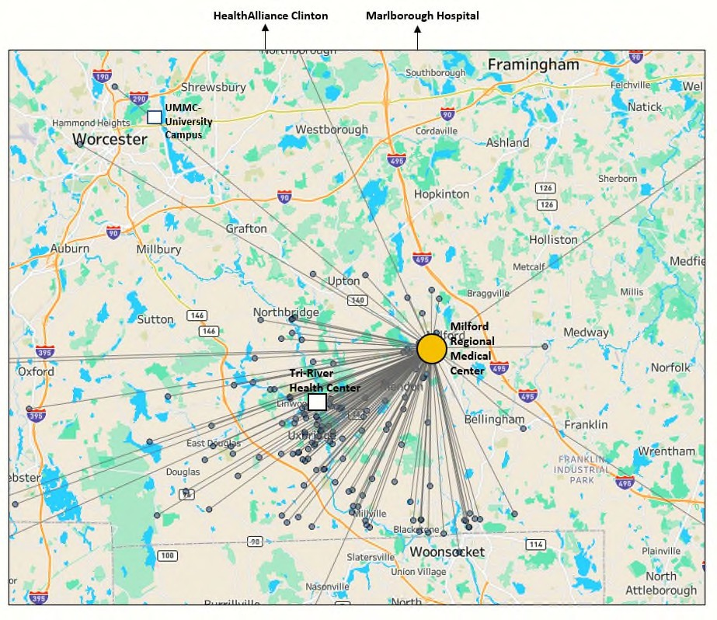Map Notes:
The grey dots represent the home addresses of patients who have been admitted to MRMC, and the grey lines represent the distance to MRMC in Milford. The orange dot in which all lines are converging towards is MRMC. Geographically, UMMHC Tri-River patients are closer to MRMC than other facilities.

Data Notes:
- Tri-River Int Med or Peds PCP
- Patients in UMMHC VBC MSSP or Commercial programs
- Geocoding must be available for the patient in MPP
- Inpatient Admits at MRMC only between 2022-11-18 and 2023-11-18

Dates Sources:
- Optum DataMart December Refresh
- Master Patient Panel (MPP) – Dec 2023

Exhibit F

MRMC – TRI-RIVER FAMILY HEALTH CENTER MASTER PATIENT PANEL
Out-Of-Network Facility | Admits
MILFORD REGIONAL MEDICAL CENTER INC, | 283
In-Network Facility | Admits
UMASS MEMORIAL MEDICAL CENTER, INC., UMASS MEMORIAL HEALTH-HARRINGTON HOSPITAL INC & UMASS MEMORIAL HEALTHALLIANCE CLINTON HOSPITAL INC | 166
Out-Of-Network Facility | DRG | Admits
MILFORD REGIONAL MEDICAL CENTER INC, | Simple Pneumonia and Pleurisy with MCC | 15
MILFORD REGIONAL MEDICAL CENTER INC, | Heart Failure and Shock with MCC | 14
MILFORD REGIONAL MEDICAL CENTER INC, | Esophagitis, Gastroenteritis and Miscellaneous Digestive Disorders without MCC | 12
MILFORD REGIONAL MEDICAL CENTER INC, | Respiratory Infections and Inflammations with MCC | 11
MILFORD REGIONAL MEDICAL CENTER INC, | Septicemia or Severe Sepsis without Mechanical Ventilation >96 Hours with MCC | 11
MILFORD REGIONAL MEDICAL CENTER INC, | Vaginal Delivery without Sterilization or D&C without CC/MCC | 11
MILFORD REGIONAL MEDICAL CENTER INC, | Kidney and Urinary Tract Infections without MCC, Miscellaneous Disorders of Nutrition, Metabolism, and Fluids and Electrolytes without MCC, Pulmonary Edema and Respiratory Failure, and  Respiratory Infections and Inflammations with CC | 24
In-Network Facility | DRG | Admits
UMASS MEMORIAL MEDICAL CENTER, INC., | Vaginal Delivery without Sterilization or D&C without CC/MCC,  Septicemia or Severe Sepsis without Mechanical Ventilation >96 Hours with MCC,  Disorders of Personality and Impulse Control,  Hip and Femur Procedures Except Major Joint with MCC,  Miscellaneous Disorders of Nutrition, Metabolism, and Fluids and Electrolytes without MCC, and  Percutaneous Cardiovascular Procedures with Drug-Eluting Stent without MCC | 33
UMASS MEMORIAL HEALTH-HARRINGTON HOSPITAL INC, | Angina Pectoris,  Gastrointestinal Obstruction without CC/MCC, Heart Failure and Shock with MCC, and  Major Small and Large Bowel Procedures without CC/MCC | 28
Data Notes:
- Tri-River Int Med or Peds PCP
- Patients in UMMHC VBC MSSP or Commercial programs
- Inpatient Admits between 2022-11-18 and 2023-11-18
- Spend is based on normalized service pricing made available by Optum

- DRG tables only list the Top 10 admits

Dates Sources:
- Optum DataMart December Refresh
- Master Patient Panel (MPP) – Dec 2023

CONSULTATION LETTERS EXHIBIT G

Kathleen G. Healy

One Boston Place, 25th floor Boston, MA 02108-4404
Main (617) 557-5900
Fax (617) 557-5999
khealy@rc.com Direct (617) 557-5995
January 22, 2024

Via E-Mail –lois.johnson@mass.gov

Lois H. Johnson, General Counsel Health Policy Commission
50 Milk Street, 8th Floor Boston, Massachusetts 02109

Re: Request for Consultation: UMass Memorial Health Care, Inc. and Milford Regional Medical Center, Inc.

Dear Ms. Johnson:

Pursuant to 105 CMR 100.210(A)(1)(d), UMass Memorial Health Care, Inc. (“Applicant”) hereby requests consultation with the Health Policy Commission regarding a proposed corporate affiliation between the Applicant and Milford Regional Medical Center, Inc. (“MRMC”) pursuant to which UMass Memorial Community Hospitals, Inc. (“UMMCH”) will become the sole corporate member of MRMC. The Applicant intends to submit an application to the Department of Public Health for a Determination of Need under 105 CMR 100.000 et seq (“DoN Application”) in connection with a transfer of ownership of MRMC, including its affiliated physician organization and foundation. As you are aware, evidence that the Applicant has consulted with all government agencies with relevant licensure, certification, or other regulatory oversight of the Applicant is required as part of the application process.

Applicant is a nonprofit corporation that owns and operates an integrated health care system comprised of a network of hospitals and other service providers that serve residents of the greater Worcester area. Applicant is the sole corporate member of UMMCH and certain other affiliates.
MRMC is a Massachusetts nonprofit corporation that owns and operates a healthcare foundation, an acute care community hospital in Milford, Massachusetts, and an affiliated physician organization, serving a primary service area of the Towns of Milford, Franklin, Bellingham, Northbridge (including the village of Whitinsville), Uxbridge, Blackstone, Hopedale, Medway, Hopkinton, and Mendon, Massachusetts. MRMC is the sole corporate member of the affiliated physician organization and healthcare foundation.
The Applicant and MRMC executed an Affiliation Agreement on January 12, 2024, pursuant to which UMMCH will become the sole corporate member of the MRMC
28568212-v1


Page 2
January 22, 2024

(“Transaction”). The Applicant and MRMC believe that the proposed Transaction will allow each party to further their common nonprofit mission of promoting the health of the communities they serve, and will enhance MRMC’s ability to maintain its status as a high quality, financially secure community hospital, which will allow it to continue to meet and better respond to the health care needs of patients and the community in its service area.
The Applicant plans to file a DoN Application in February 2024. The Applicant and MRMC would welcome the opportunity to discuss this proposed affiliation in more detail. If you have any questions related to the DoN Application or the Transaction, please contact me by e-mail at khealy@rc.com.

Very truly yours,

[signature on file]

Kathleen G. Healy

cc: Kate Eshghi, Senior Vice President & General Counsel, UMass Memorial Health Care John R. Glassburn, Associate General Counsel, UMass Memorial Health Care
Charles W. Normand, Hinckley, Allen & Snyder, LLP

Kathleen G. Healy

One Boston Place, 25th floor Boston, MA 02108-4404
Main (617) 557-5900
Fax (617) 557-5999
khealy@rc.com Direct (617) 557-5995

January 22, 2024

Via E-Mail –CHIA-Legal@state.ma.us

Center for Health Information and Analysis

Re: Request for Consultation: UMass Memorial Health Care, Inc. and Milford Regional Medical Center, Inc.

Dear Sir or Madame:

Pursuant to 105 CMR 100.210(A)(1)(d), UMass Memorial Health Care, Inc. (“Applicant”) hereby requests consultation with the Center for Health Information and Analysis regarding a proposed corporate affiliation between the Applicant and Milford Regional Medical Center, Inc. (“MRMC”) pursuant to which UMass Memorial Community Hospitals, Inc. (“UMMCH”) will become the sole corporate member of MRMC. The Applicant intends to submit an application to the Department of Public Health for a Determination of Need under 105 CMR 100.000 et seq (“DoN Application”) in connection with a transfer of ownership of MRMC, including its affiliated physician organization and foundation. As you are aware, evidence that the Applicant has consulted with all government agencies with relevant licensure, certification, or other regulatory oversight of the Applicant is required as part of the application process.

Applicant is a nonprofit corporation that owns and operates an integrated health care system comprised of a network of hospitals and other service providers that serve residents of the greater Worcester area. Applicant is the sole corporate member of UMMCH and certain other affiliates.
MRMC is a Massachusetts nonprofit corporation that owns and operates a healthcare foundation, an acute care community hospital in Milford, Massachusetts, and an affiliated physician organization, serving a primary service area of the Towns of Milford, Franklin, Bellingham, Northbridge (including the village of Whitinsville), Uxbridge, Blackstone, Hopedale, Medway, Hopkinton, and Mendon, Massachusetts. MRMC is the sole corporate member of the affiliated physician organization and healthcare foundation.
The Applicant and MRMC executed an Affiliation Agreement on January 12, 2024, pursuant to which UMMCH will become the sole corporate member of the MRMC (“Transaction”). The Applicant and MRMC believe that the proposed Transaction will allow each party to further their common nonprofit mission of promoting the health of the communities
28567914-v1


Page 2
January 22, 2024

they serve, and will enhance MRMC’s ability to maintain its status as a high quality, financially secure community hospital, which will allow it to continue to meet and better respond to the health care needs of patients and the community in its service area.
The Applicant plans to file a DoN Application in early February 2024. The Applicant and MRMC would welcome the opportunity to discuss this proposed affiliation in more detail. If you have any questions related to the DoN Application or the Transaction, please contact me by e-mail at khealy@rc.com.

Very truly yours,

[signature on file]

Kathleen G. Healy

cc: Kate Eshghi, Senior Vice President & General Counsel, UMass Memorial Health Care John R. Glassburn, Associate General Counsel, UMass Memorial Health Care
Charles W. Normand, Hinckley, Allen & Snyder, LLP

Kathleen G. Healy

One Boston Place, 25th floor Boston, MA 02108-4404
Main (617) 557-5900
Fax (617) 557-5999
khealy@rc.com Direct (617) 557-5995

January 22, 2024

Via E-Mail –william.matlack@state.ma.us

William T. Matlack, Chief, Antitrust Division Commonwealth of Massachusetts
Office of the Attorney General Andrea Joy Campbell One Ashburton Place, 18th Floor
Boston, Massachusetts 02108

Re: Request for Consultation: UMass Memorial Health Care, Inc. and Milford Regional Medical Center, Inc.

Dear Mr. Matlack:

Pursuant to 105 CMR 100.210(A)(1)(d), UMass Memorial Health Care, Inc. (“Applicant”) hereby requests consultation with the Office of the Attorney General regarding a proposed corporate affiliation between the Applicant and Milford Regional Medical Center, Inc. (“MRMC”) pursuant to which UMass Memorial Community Hospitals, Inc. (“UMMCH”) will become the sole corporate member of MRMC. The Applicant intends to submit an application to the Department of Public Health for a Determination of Need under 105 CMR 100.000 et seq (“DoN Application”) in connection with a transfer of ownership of MRMC, including its affiliated physician organization and foundation. As you are aware, evidence that the Applicant has consulted with all government agencies with relevant licensure, certification, or other regulatory oversight of the Applicant is required as part of the application process.

Applicant is a nonprofit corporation that owns and operates an integrated health care system comprised of a network of hospitals and other service providers that serve residents of the greater Worcester area. Applicant is the sole corporate member of UMMCH and certain other affiliates.
MRMC is a Massachusetts nonprofit corporation that owns and operates a healthcare foundation, an acute care community hospital in Milford, Massachusetts, and an affiliated physician organization, serving a primary service area of the Towns of Milford, Franklin, Bellingham, Northbridge (including the village of Whitinsville), Uxbridge, Blackstone, Hopedale, Medway, Hopkinton, and Mendon, Massachusetts. MRMC is the sole corporate member of the affiliated physician organization and healthcare foundation.

28567803-v1

Page 2
January 22, 2024

The Applicant and MRMC executed an Affiliation Agreement on January 12, 2024, pursuant to which UMMCH will become the sole corporate member of MRMC (“Transaction”). The Applicant and MRMC believe that the proposed Transaction will allow each party to further their common nonprofit mission of promoting the health of the communities they serve, and will enhance MRMC’s ability to maintain its status as a high quality, financially secure community hospital, which will allow it to continue to meet and better respond to the health care needs of patients and the community in its service area.
The Applicant plans to file a DoN Application in February 2024. The Applicant and MRMC would welcome the opportunity to discuss this proposed affiliation in more detail. If you have any questions related to the DoN Application or the Transaction, please contact me by e-mail at khealy@rc.com.
Very truly yours,
[signature on file]

Kathleen G. Healy

cc: Kate Eshghi, Senior Vice President & General Counsel, UMass Memorial Health Care John R. Glassburn, Associate General Counsel, UMass Memorial Health Care
Charles W. Normand, Hinckley, Allen & Snyder, LLP
Michael MacKenzie, MA AGO, Deputy Chief, Antitrust Division – michael.mackenzie@state.ma.us
Courtney Aladro, MA AGO, Chief, Healthcare and Fair Competition Bureau – courtney.aladro@state.ma.us
Sandra Wolitzky, MA AGO, Chief, Healthcare Division – Sandra.wolitzky@state.ma.us

Kathleen G. Healy

One Boston Place, 25th floor Boston, MA 02108-4404
Main (617) 557-5900
Fax (617) 557-5999
khealy@rc.com Direct (617) 557-5995

January 22, 2024

Via E-Mail – Steven.sauter@state.ma.us

Steven Sauter, Director
Executive Office of Health and Human Services MassHealth Office of Providers and Plans
100 Hancock Street, 6th Floor Quincy, Massachusetts 02171

Re: Request for Consultation: UMass Memorial Health Care, Inc. and Milford Regional Medical Center, Inc.

Dear Mr. Sauter:

Pursuant to 105 CMR 100.210(A)(1)(d), UMass Memorial Health Care, Inc. (“Applicant”) hereby requests consultation with the Executive Office of Health and Human Services regarding a proposed corporate affiliation between the Applicant and Milford Regional Medical Center, Inc. (“MRMC”) pursuant to which UMass Memorial Community Hospitals, Inc. (“UMMCH”) will become the sole corporate member of MRMC. The Applicant intends to submit an application to the Department of Public Health for a Determination of Need under 105 CMR 100.000 et seq (“DoN Application”) in connection with a transfer of ownership of MRMC, including its affiliated physician organization and foundation. As you are aware, evidence that the Applicant has consulted with all government agencies with relevant licensure, certification, or other regulatory oversight of the Applicant is required as part of the application process.

Applicant is a nonprofit corporation that owns and operates an integrated health care system comprised of a network of hospitals and other service providers that serve residents of the greater Worcester area. Applicant is the sole corporate member of UMMCH and certain other affiliates.
MRMC is a Massachusetts nonprofit corporation that owns and operates a healthcare foundation, an acute care community hospital in Milford, Massachusetts, and an affiliated physician organization, serving a primary service area of the Towns of Milford, Franklin, Bellingham, Northbridge (including the village of Whitinsville), Uxbridge, Blackstone, Hopedale, Medway, Hopkinton, and Mendon, Massachusetts. MRMC is the sole corporate member of the affiliated physician organization and healthcare foundation.

28567073-v1

Page 2
January 22, 2024

The Applicant and MRMC executed an Affiliation Agreement on January 12, 2024, pursuant to which UMMCH will become the sole corporate member of MRMC (“Transaction”). The Applicant and MRMC believe that the proposed Transaction will allow each party to further their common nonprofit mission of promoting the health of the communities they serve, and will enhance MRMC’s ability to maintain its status as a high quality, financially secure community hospital, which will allow it to continue to meet and better respond to the health care needs of patients and the community in its service area.
The Applicant plans to file a DoN Application in February 2024. The Applicant and MRMC would welcome the opportunity to discuss this proposed affiliation in more detail. If you have any questions related to the DoN Application or the Transaction, please contact me by e-mail at khealy@rc.com.
Very truly yours,
[signature on file]

Kathleen G. Healy

cc: Kate Eshghi, Senior Vice President & General Counsel, UMass Memorial Health Care John R. Glassburn, Associate General Counsel, UMass Memorial Health Care
Charles W. Normand, Hinckley, Allen & Snyder, LLP

Kathleen G. Healy

One Boston Place, 25th floor Boston, MA 02108-4404
Main (617) 557-5900
Fax (617) 557-5999
khealy@rc.com Direct (617) 557-5995

January 22, 2024

Via E-Mail –Dennis.Renaud@state.ma.us

Dennis Renaud, Director Determination of Need Program
Massachusetts Department of Public Health Boston, Massachusetts 02108

Re: Request for Consultation: UMass Memorial Health Care, Inc. and Milford Regional Medical Center, Inc.

Dear Mr. Renaud:

Pursuant to 105 CMR 100.210(A)(1)(d), UMass Memorial Health Care, Inc. (“Applicant”) hereby requests consultation with the Determination of Need Program regarding a proposed corporate affiliation between the Applicant and Milford Regional Medical Center, Inc. (“MRMC”) pursuant to which UMass Memorial Community Hospitals, Inc. (“UMMCH”) will become the sole corporate member of MRMC. The Applicant intends to submit an application to the Department of Public Health for a Determination of Need under 105 CMR 100.000 et seq (“DoN Application”) in connection with a transfer of ownership of MRMC, including its affiliated physician organization and foundation. As you are aware, evidence that the Applicant has consulted with all government agencies with relevant licensure, certification, or other regulatory oversight of the Applicant is required as part of the application process.

Applicant is a nonprofit corporation that owns and operates an integrated health care system comprised of a network of hospitals and other service providers that serve residents of the greater Worcester area. Applicant is the sole corporate member of UMMCH and certain other affiliates.
MRMC is a Massachusetts nonprofit corporation that owns and operates a healthcare foundation, an acute care community hospital in Milford, Massachusetts, and an affiliated physician organization, serving a primary service area of the Towns of Milford, Franklin, Bellingham, Northbridge (including the village of Whitinsville), Uxbridge, Blackstone, Hopedale, Medway, Hopkinton, and Mendon, Massachusetts. MRMC is the sole corporate member of an affiliated physician organization and a healthcare foundation.

28567421-v2

Page 2
January 22, 2024

The Applicant and MRMC executed an Affiliation Agreement on January 12, 2024, pursuant to which UMMCH will become the sole corporate member of MRMC (“Transaction”). The Applicant and MRMC believe that the proposed Transaction will allow each party to further their common nonprofit mission of promoting the health of the communities they serve, and will enhance MRMC’s ability to maintain its status as a high quality, financially secure community hospital, which will allow it to continue to meet and better respond to the health care needs of patients and the community in its service area.
The Applicant plans to file a DoN Application in early February 2024. The Applicant and MRMC would welcome the opportunity to discuss this proposed affiliation in more detail. If you have any questions related to the DoN Application or the Transaction, please contact me by e-mail at khealy@rc.com.
Very truly yours,

[signature on file]

Kathleen G. Healy

cc: Kate Eshghi, Senior Vice President & General Counsel, UMass Memorial Health Care John R. Glassburn, Associate General Counsel, UMass Memorial Health Care
Charles W. Normand, Hinckley, Allen & Snyder, LLP
Rebecca Kaye, Senior Deputy General Counsel, Department of Public Health – Rebecca.kaye@mass.gov
Stephen Davis - stephen.davis@mass.gov; Judy Bernice - judy.bernice@mass.gov Walter Mackie - walter.mackie@mass.gov Jennica F. Allen - jennica.f.allen@mass.gov Katelyn Teague - Katelyn.Teague@mass.gov
Elizabeth Maffei - elizabeth.maffei@mass.gov Samuel Louis - samuel.louis@mass.gov

PFAC MEETING PRESENTATION SLIDES – DEC. 6, 2023 Exhibit H
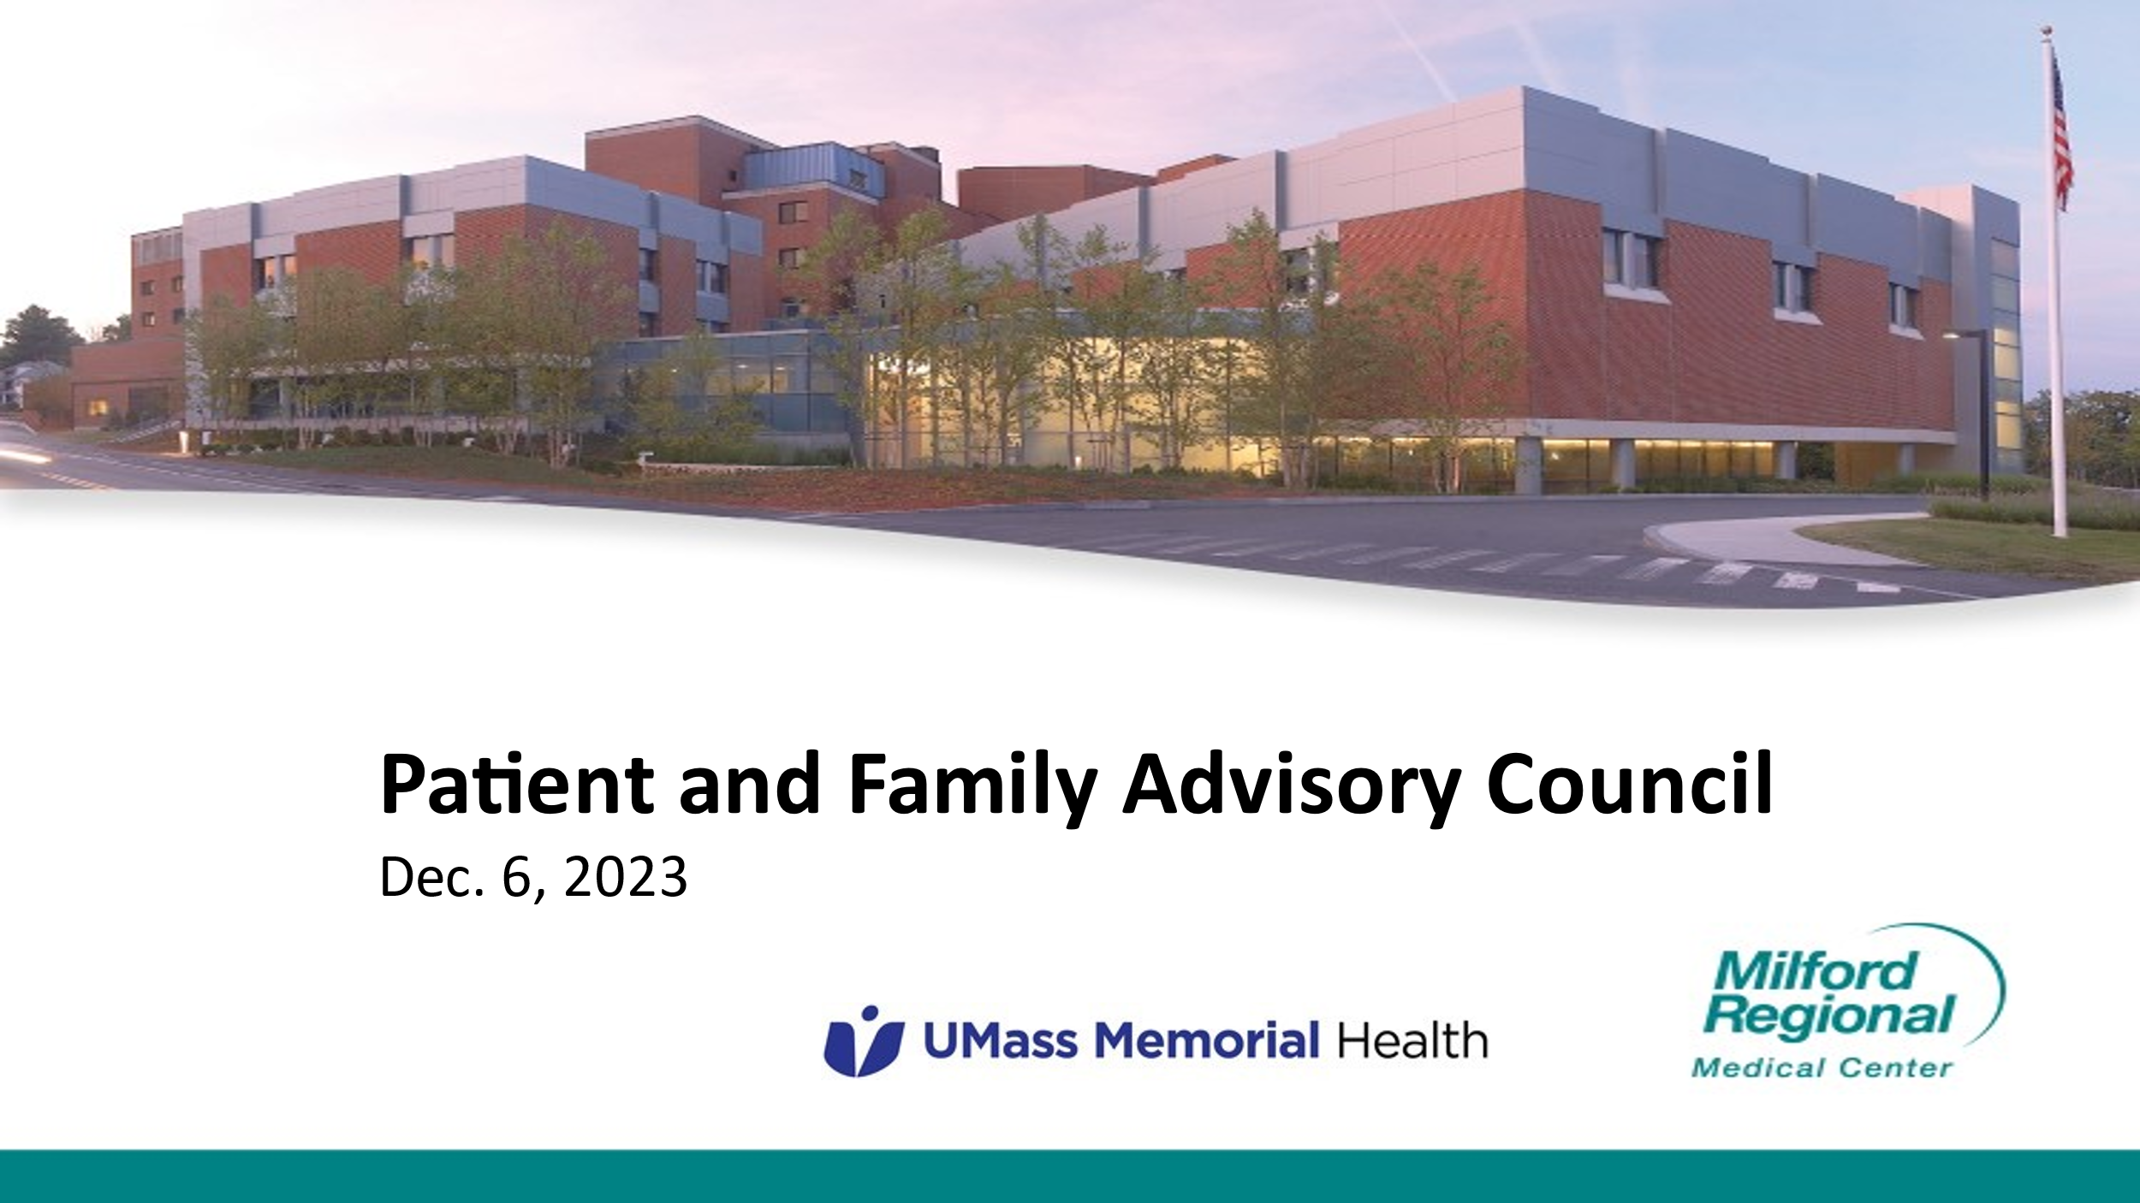

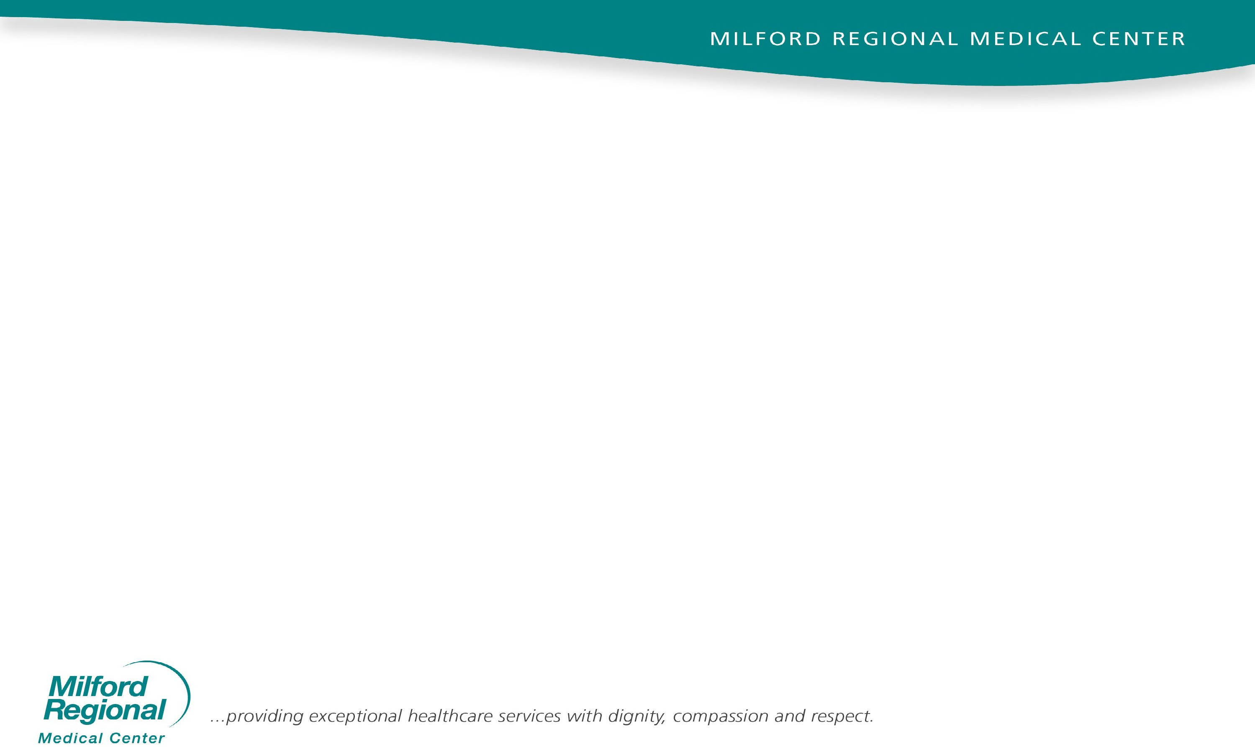

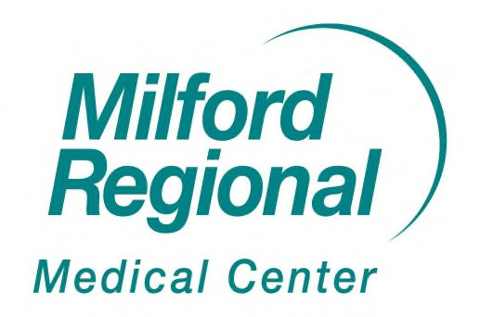
Agenda

- Background
- Letter of intent
- Timeline
- Mutual goals/benefits
- Q&A

Background

  - Milford Regional overall history
  - Milford Regional Physician Group
  - Collaboration with academic medical centers
  - Expansion

Right Time, Right Partner, Right Deal

Letter of Intent (LOI)

LOI is a non-binding agreement that allows organizations to explore a potential corporate affiliation.

Milford Regional Medical Center/Milford Regional Physician Group Board of Trustees and UMass Memorial Health Board of Trustees both approved this measure in September 2023.

Timeline

  - Currently: Due diligence is taking place; communication regarding potential clinical affiliation is ongoing internally/externally
  - End of CY23: Definitive Agreement
• +6-9 months: Regulatory approval process
  - Summer/Fall 2024: MRMC & MRPG become a member of UMass Memorial Health

Mutual Goals/Benefits

  - Maintaining Milford Regional’s position as provider of choice in the community
  - Enhancing opportunities and strengthening retention of employees and providers
  - Making capital investments to enhance services, equipment & care delivery
  - Maintaining clinical programs & services that are valued by the community

Goals/Benefits (cont.)

  - Bolster community hospital to increase access & keep care local
  - Low cost, affordable system
  - Shared governance model that vests fiduciary responsibilities with the local community hospital board
  - Increase financial stability of & investments in community hospital to advance social determinants of health
  - Enhanced physician recruitment & retention at Milford and improved opportunities for retention of employees in the local community

Questions & Answers

COMMUNITY BENEFITS LEADERSHIP AND ADVISORY COMMITTEES
(CBLT AND CBAC) – MEETING MINUTES – Jan. 19, 2024 Exhibit I

Community Benefits Leadership and Advisory Committees (CBLT and CBAC)
Friday, January 19, 2024 Zoom Meeting

Present: Donna Boynton, MRMC; Michelle Sanford, MRMC; Lori Hout, Family Continuity; Anna Spencer, Wayside; Cheryl Bardetti, MRMC; Heather Elster, Whitin Community Center; Rose Galimi-Hayes, MRMC; Lisa Kingkade, Milford Public Schools; Cathleen Liberty, Franklin Dept of Public Health; Kim Mu-Chow, New England Chapel; Christine O’Connell, CMHA; Magaly Barbato, MRMC; Christina Waldo, EMK Community Health Center; Ana Guilarducci, MRMC; Jessica Melo, Blackstone Valley Emergency Shelter; Leslie Reichert, Blackstone Valley Emergency Shelter; Elaine Wiley, MRMC; Maureen Harris, MRMC; Bert Thurlo-Walsh, MRMC; Ed Kelly, MRMC; and Doug Brown, UMMH
Minutes: The minutes for November 10, 2023, were approved as submitted.

Update on UMass Memorial Health/Milford Regional Corporate Affiliation
Ed Kelly, President/CEO, MRMC and Doug Brown, President, UMass Memorial Community Hospitals and Chief Administrative Officer were introduced to the committee and gave an update on the UMass Memorial Health/Milford Regional Corporate Affiliation.
- Ed Kelly has been at MRMC for 31 years. During this period, MRMC has been a growing system with a large physician practice. MRMC’s mission is to be a community partner with academic partners in Worcester and Boston. Their academic partners include UMass Memorial, Children’s Hospital, Brigham and Women’s Hospital and Dana Farber Cancer Institute.
  - During COVID-19, MRMC experienced financial losses
  - MRMC’s corporate affiliation with UMMH is the right partner to grow with now and in the future
- Doug Brown discussed the great relationship between UMMH and MRMC over the last 30 years.
  - Currently, there is a brutal environment in healthcare.
  - Over the next five years, he sees more changes than the previous 50 years as a result of technology and artificial intelligence
  - Plan to install Epic, a cloud-based electronic health records system for hospitals. UMMH has received a top score in installing EPIC
  - The corporate affiliation will be similar to the agreement with Harrington Hospital approximately 2 years ago
    - Local leadership and board members were retained
    - Local leadership was invited to serve on UMMH committees
  - UMMH is the lowest cost academic medical center in Massachusetts
  - The definitive agreement has been signed
  - Next will be the determination of need hearing the Commonwealth’s Department of Public Health
    - Anticipate taking 6-9 months to complete the regulatory process with an anticipated completion by late summer or early fall 2024
- Questions
  - Lori Hout, Family Continuity, asked about the insurance piece for mental health and substance use. UMMC has joined the MassHealth ACO
    - Ed Kelly – many physicians are contracted through MGB so specialists can see all patients; MRMC plans to join MassHealth ACO but noted that it will take time for this to happen
    - Doug Brown – Harrington is developing a behavioral health plan and is looking at behavioral health across the UMMC system
- Ed and Doug were thanked for their update on the UMass Memorial Health/Milford Regional Corporate Affiliation.

Introductions
Bert Thurlo-Walsh, Chief Quality Officer and Vice President of Milford Regional was introduced as the new Chair of the Leadership Committee. He has been at MRMC for five years was an RN. Prior to coming to MRMC, he was at Newton Wellesley Hospital. Bert has served as the moderator for the mental health seminars and webinar put together by our committee.

Other members of the committee introduced themselves.

Health Care Access
- Childbirth Education
  - Rose, Laura Laird, and Michelle met to discuss regional teen childbirth education classes
  - Laura educated several teens in Milford Public Schools last year
  - Rose has received high praise for Laura’s program for Milford Public Schools; Laura is impressive and is committed to childbirth education and goes beyond the needs of the teens
  - Researching the development of childbirth education program for pregnant teens from 13 surrounding communities:
    - Thinking about an abbreviated class versus 8 hr. weekend class or evening classes
    - Idea is to have the schools bring all the pregnant teens to MRMC during school time weekly for 1 hour, three times per month
    - If education is done at MRMC, they can also have an OB/GYN physician, a pediatrician, and social services also participate in the education
  - Potential problem – transporting the pregnant teens to MRMC during school hours

Mental Health/Substance Use
- Update on November 16, 20232 Webinar - Opening Doors to Youth Mental Health: Helping Parents Identify the Early Signs of ADHA, Anxiety, and Depression
  - Panelists:
    - Dr. Mary Lyons, Pediatrician at Milford Regional Physician Group and Director of Pediatrics
    - Kate Rose, Licensed Mental Health Counselor at Family Continuity
    - Destiny O’Connell, Peer Support Specialist/Peer Mentor at Wayside Youth & Family Support Network
  - Moderator:
    - Bert Thurlo-Walsh, Chief Quality Officer, and Vice President at Milford Regional Medical Center
  - More than 30 individuals signed onto the webinar.
  - Participant comments were that it was a very well-balanced, informative webinar.
- LGBTQ+ webinar Discussion
  - Parents of LGBTQ+ adolescents/children are reaching out as they may struggle with how to support and manage their adolescent/child
  - Possible topics to include
    - Safety issues for LGBTQ+ youth
    - Transitioning
    - There is a connection between homelessness, LBGTQ+, and trafficking.
  - Potential speakers
    - Wayside has a support group for LGBTQ+
    - CHHA has youth homelessness project
    - Fenway Health has a lot of research and funding
    - Meghan Casey, LBGTQ+ Liaison for Medway Police Department
  - Potential date – possibly in April or May 2024
  - If interested in joining the mental health subcommittee, please contact Michelle Sanford
- New Breastfeeding Support Group
  - MRMC is starting a breastfeeding support group in April
  - The group will meet monthly on Fridays
  - Lactation specialist Danielle Donovan will facilitate the group
- MRMC’s Support Groups
  - Dementia
  - Cancer
  - Post partum depression
  - Parents
- Create a list of community support groups
  - Interested in creating a list of community support groups
  - Suggestions included contacting local senior centers and Susan Salisbury of TriValley for their support groups
Homelessness
- Update/Discussion Homelessness Subcommittee Meeting/Idea for Campaign
  - Multiple causes for homelessness including single moms, couch surfers, grandparents, immigrants, migrants

  - Looking for people who might be willing to share their story
    - Cathleen has worked with Tom who was living in the woods and got him to Safe Coalition for help. He was down on luck and lost his job and housing. They were able to help him apply for jobs, by using Safe Coalition as his address. He got a job at Amazon and got an apartment in Bellingham which he lost as his check was late. They are currently waiting for another apartment to open up for him and they continue to work with him
    - In December, Safe Coalition worked with a mom, her mother, and her nephew. They applied for help and were told they “weren’t homeless enough.”
    - Jessica – possible individuals still to need to build relationships
    - Chris – CMHA has a COC planning group for service providers, She can poll that group to see if they have any potential candidates to share their story
    - Lori – noted that mental health issues including past trauma may contribute to homelessness
    - Lisa – works with homeless families in Milford and sees many barriers; she can reach out to families
    - Bert – Attleborough/Sturdy Memorial Migrant Task Force – Bert will reach out to this coalition who is focusing on building self sufficiency with food, migrants, and homelessness
  - Hard to build relationship with people when you’re homeless.
  - Where should these stories be shared?
    - Town officials
    - Landlords
    - Residents

Better Health Outcomes in Worcester County
- Update on translation initiative
  - In the process of updating the information in English and then plan to translate the information into Spanish, Portuguese, and Arabic
2023 Community Benefits Report
- Michelle is starting on the 2023 Community Benefits Report and will be reaching out to committee members for information
- Report is due April 1, 2024

Community Health Needs Assessment
- The Community Health Assessment with Holleran has been started. Michelle will be reaching out to the subcommittee members
- Anna Spencer, Christina Waldo, Heather Elster, and Kim Mu-Chow have volunteered to assist with the Community Health Needs Assessment
Other Topics
- Michelle congratulated Heather for her 100-year anniversary, renovated gym with air conditioning, ribbon cutting on Thursday, January 18, 2024, at Whitin Community Center
- Lori brought up the Blackstone Valley Opiate Task Force that supports individuals with substance use
  - They are looking at the opiate settlement funds and where the funds can make the most impact
  - They are creating a map of services that are available and please email Lori at lhout@familycontinuity.org if you are interested in adding your organization’s information to their database
  - The task force is finding it challenging to make connections at MRMC
    - Ann Wilkins with Director of Case Management
    - Bert will get the appropriate contact information to Lori
- Michelle proposed recording our meetings in the future. There were no objections to the proposal.

Next Meetings
- Friday, March 15, 2024
- Friday, May 10, 2024
- Friday, July 12, 2024
- Friday, September 22, 2024 (Annual Meeting)

Respectfully submitted, Kimberly Mu-Chow, Pharm.D.

Annual Meeting of the Corporation – Agenda – Jan 22. 2024

Exhibit J
Annual Meeting
of the
Corporation

Milford Regional Medical Center, Inc.
Monday, January 22 , 2024
Atrium Café – Milford Regional Medical Center

Welcome and Call to Order
Anthony M. Consigli
Chair, Board of Trustees

Milford Regional Medical Center/
Milford Regional Physician Group Board of Trustees Report
Anthony M. Consigli
Chair, Board of Trustees

Milford Regional Medical Center Report
Edward J. Kelly
President and Chief Executive Oficer
Milford Regional Medical Center & Healthcare System

Milford Regional Physician Group Report
Patrick R. McSweeney, MD
President
Milford Regional Physician Group

UMass Memorial Health Update and Discussion
Eric W. Dickson, MD, MHCM, FACEP
President and Chief Executive Oficer
UMass Memorial Health

Annual Meeting Adjournment
Anthony M. Consigli
Chair, Board of Trustees

Milford Regional Medical Center Board of Trustees Appointments
Gerald L. Gaudette lll Barbara J. Gilmore Andrew R. Willment, MD

Milford Regional Healthcare Foundation Board of Trustees Appointments
Vascen J. Bogigian Elizabeth A. Loftus

Corporator Appointments
Christina J. Hein Tina T. Powderly Glenn D. Trindade Shadia R. Velez Michael K. Walsh, Sr.
Paul G. Yorkis

Medical Staff Appointments

Hamza Al Atassi, DMD
Oral & Maxillofacial Surgery
Emad Awa, MD
Pediatrics
Monzolesso J. Bagah-Kognagba, MD
Adult Hospital Medicine
Catherine B. Boisvert, MD
Orthopedic Surgery
Sudha Bolla, MD
HematologyIOncology
Lee C. Campano, MD
Internal Medicine
Yilin Cao, MD
Radiation Oncology
Marc D. Christensen, MD, PhD
Neurosurgery
Emily Y. Fan, MD
Vascular Surgery
Elizabeth Gebhard, DO
Family Medicine
Kartika Gourneni, MD
Adult Hospital Medicine
Katherine M. Johnson, MD
Maternal Fetal Medicine
Adalia H. Jun-O’Connell, MD, MBA
Neurology
Andrew Kamilaris, MD
Emergency Medicine
Seth D. Lampert, MD
Emergency Medicine
Janelle C. Laudone, MD
Pediatrics
Cheryl Y. Levin, MD
Dermatology
Dan Liu, MD
Ophthalmology
Dongqi Liu, MD
Nephrology
Cailin McDeed, DO
Family Medicine
Ravi Menon, MD
Internal Medicine
Aditi Mohankumar, MD
Otorhinolaryngology
Bennett A. Peterson, MD
Adult Hospital Medicine
Kathleen F. Peterson, MD
Anesthesia
Taylor E. Purvis, MD
Anesthesia
Konstantin Ravvin, MD
Adult Hospital Medicine
Mohammad K. Salajegheh, MD
Neurology
Anurag Saraf, MD
Radiation Oncology
Sonjay Sethi, MD
Neurology
Tarek A. El Sharkawy, MD, FACP
Internal Medicine
Alexei Shimanovsky, MD
HematologyIOncology
Hande H. Tuncer, MD
HematologyIOncology
John C. Wain, Jr., MD
Thoracic Surgery
Seth E. Wakefeld, MD
Adult Hospital Medicine
Ravinder K. Wali, MD
Nephrology

In Memory of Members of our Milford Regional Family

Auxiliary
Elaine T. O’Toole

Corporators
John L. Daddario, Sr. Jeanne A. Gould John S. Hamilton Marilyn C. Holman
Employees
Andrea M. Herrick James LeClair Elzbieta A. Slanda
Volunteers
Janet A. Alberti Diana Carter Anna L. Nardi Claire F. Zacchilli

Milford Regional Annual Report
annualreport-milfordregional.org


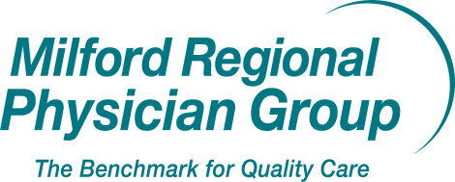
M ed i ca l C e nter

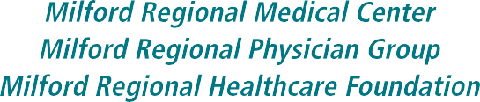

14 Prospect Street • Milford • MA 01757 • 508-473-1190 • milfordregional.org

ATTACHMENT 4

Notice of Intent

gannett local market paper logo

Originally published at milforddailynews.com on 01/18/2024
LEGAL NOTICE
Public Announcement Concerning a Proposed Health Care Project
UMASS MEMORIAL HEALTH CARE, INC. ("Applicant"),
located at One Biotech Park, 365 Plantation Street, Worcester, Massachusetts, 01605, intends to file a Notice of Determination of Need Application with the Massachusetts Department of Public Health with respect to a Proposed Project involving a Transfer of Ownership of Milford Regional Medical Center, Inc. ("Hospital"), and its affiliated physician organization and foundation, located at 14 Prospect Street, Milford, MA 01757. The Total Value of this Proposed Project is $368,744,992. The Applicant does not anticipate that the Proposed Project will have a material price or service impact on the Hospital's existing patient panel.
Any ten Taxpayers of Massachusetts may register in connection with the intended Application by no later than March 7, 2024 or 30 days from the Filing Date, whichever is later, by contacting the Department of Public Health Determination of Need Program at DPH.DON@mass.gov or 67 Forest St, Marlborough, Massachusetts 01752.
NW-38461567

gannett local market paper logo

Public Notices

Originally published at milforddailynews.com on 01/18/2024

UMASS MEMORIAL HEALTH CARE LEGAL NOTICE
Public Announcement Concerning a Proposed Health Care Project

UMass Memorial Health Care, Inc. ("Applicant"), located at One Biotech Park, 365 Plantation Street, Worcester, Massachusetts, 01605, intends to file a Notice of Determination of Need Application with the Massachusetts Department of Public Health with respect to a Proposed Project involving a Transfer of Ownership of Milford Regional Medical Center, Inc. ("Hospital"), and its affiliated physician organization and foundation, located at 14 Prospect Street, Milford, MA 01757. The Total Value of this Proposed Project is $368,744,992. The Applicant does not anticipate that the Proposed Project will have a material price or service impact on the Hospital's existing patient panel.

Any ten Taxpayers of Massachusetts may register in connection with the intended Application by no later than March 7, 2024 or 30 days from the Filing Date, whichever is later, by contacting the Department of Public Health Determination of Need Program at DPH.DON@mass.gov or 67 Forest St, Marlborough, Massachusetts 01752.

AD#9738735 ON 1/18/2024

UMass Memorial Health System

UMass Memorial Health (https://www.ummhealth.org/)
UMass Memorial Health - Community Healthlink (/community-healthlink) UMass Memorial Health - Harrington Hospital (/about-us/about-harrington)
UMass Memorial Health - HealthAlliance-Clinton Hospital (/healthalliance-clinton-hospital)
UMass Memorial Health - Marlborough Hospital (/marlborough-hospital) UMass Memorial Medical Center (/umass-memorial-medical-center) UMass Memorial Medical Group (/umass-memorial-medical-group)

About Us (/umass-memorial-health/about-us)
COVID-19 Resources (/patients-visitors/covid-19-latest-information-and-resources) For Physicians (/physicians)
Clinical Trials (https://www.conqueringdiseases.org/)
Careers (https://www.ummhealth.org/grow-your-career-here) Newsroom (/news)
Contact News Team (/umass-memorial-medical-center/newsroom/contact-news-team) Press Releases (/about-us/news)
Directions & Parking (/umass-memorial-medical-center/patients-visitors/plan-your-visit/directions-parking)
Media Relations Policy (/umass-memorial-health-care/newsroom/media-relations-policy) Patient Status (/umass-memorial-medical-center/newsroom/patient-status)
Contact (/contact) Return to Homepage



(/)
The clinical partner of UMass Chan Medical School
NEWSROOM

In this Section

Back to Newsroom (/news)

Public Announcement Concerning a Proposed Health Care Project

Home(/)> Newsroom (/news)> Public Announcement Concerning a Proposed Health Care Project

Public Announcement Concerning a Proposed Health Care Project
Notice of Intent - January 18, 2024

UMass Memorial Health Care, Inc. ("Applicant"), located at One Biotech Park, 365 Plantation Street, Worcester, Massachusetts, 01605, intends to file a Notice of Determination of Need Application with the Massachusetts Department of Public Health with respect to a Proposed Project involving a Transfer of Ownership of Milford Regional Medical Center, Inc. “Hospital"), and its affiliated physician organization and foundation, located at 14 Prospect Street, Milford, MA 01757. The Total Value of this Proposed Project is
$368,744,992. The Applicant does not anticipate that the Proposed Project will have a material price or service impact on the Hospital's existing patient panel.

Any ten Taxpayers of Massachusetts may register in connection with the intended Application by no later than March 7, 2024 or 30 days from the Filing Date, whichever is later, by contacting the Department of Public Health Determination of Need Program at DPH.DON@mass.gov (mailto:DPH.DON@mass.gov) or 67 Forest St, Marlborough, Massachusetts 01752.

(https://www.umassmed.edu/default/)

Open link to f (https://www.facebook.com/umassmemorialhealth) Open link to X (https://twitter.com/umassmemorial) Open link to@ (https://www.instagram.com/umassmemorial/) Open link to in
(https://www.linkedin.com/company/umassmemorialhealth)Open link to @ (https://www.threads.net/@umassmemorial)

855-UMASS-MD / 855-862-7763 (tel:8558627763)

I Want To...
Find a Doctor (https://physicians.umassmemorial.org/)
Make an Appointment (/patients-visitors/make-appointment)
Book Online (https://mychartonline.umassmemorial.org/MyChart/openscheduling?_ga=2.217241886.947778685.1604442925-307585128.1587496127)



Published on January 18, 2024
LEGAL NOTICE AND LOCAL NEWS OR INTEREST SECTIONS
Public Announcement Concerning a Proposed Health Care Project

UMass Memorial Health Care, Inc. ("Applicant"), located at One Biotech Park, 365 Plantation Street, Worcester, Massachusetts, 01605, intends to file a Notice of Determination of Need Application with the Massachusetts Department of Public Health with respect to a Proposed Project involving a Transfer of Ownership of Milford Regional Medical Center, Inc. “Hospital"), and its affiliated physician organization and foundation, located at 14 Prospect Street, Milford, MA 01757. The Total Value of this Proposed Project is $368,744,992. The Applicant does not anticipate that the Proposed Project will have a material price or service impact on the Hospital's existing patient panel.

Any ten Taxpayers of Massachusetts may register in connection with the intended Application by no later than March 7, 2024 or 30 days from the Filing Date, whichever is later, by contacting the Department of Public Health Determination of Need Program at DPH.DON@mass.gov or 67 Forest St, Marlborough, Massachusetts 01752.





Privacy Terms

Attachment 5 Articles of Organization

UMMHC Articles of Organization 3/4/1997: https://corp.sec.state.ma.us/CorpWeb/CorpSearch/CorpSearchRedirector.aspx?Action=P DF&Path=CORP_DRIVE1/2013/1008/000486333/0030/020502817260_1.pdf
Articles of Merger (MHC into UMMHC) 4/1/1998: https://corp.sec.state.ma.us/CorpWeb/CorpSearch/CorpSearchRedirector.aspx?Action=P DF&Path=CORP_DRIVE1/2009/0713/000291523/0008/020503061638_1.pdf

UMMHC Articles of Amendment 12/12/2019: https://corp.sec.state.ma.us/CorpWeb/CorpSearch/CorpSearchRedirector.aspx?Action=P DF&Path=CORP_DRIVE1/2019/1212/000000000/1760/201945425600_1.pdf

UMMHC Articles of Amendment 6/11/2020: https://corp.sec.state.ma.us/CorpWeb/CorpSearch/CorpSearchRedirector.aspx?Action=P DF&Path=CORP_DRIVE1/2020/0611/000000000/9121/202093556910_1.pdf

ATTACHMENT 6

Affidavit of Truthfulness and Compliance

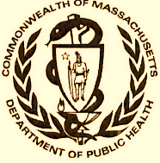 Version: 7-6-17

Massachusetts Department of Public Health

Determination of Need

Affidavit of Truthfulness and Compliance

with Law and Disclosure Form 100.405 (B)
Instructions: Complete Information below. When complete check the box "This document is ready to print:". This will date stamp and lock the form. Print Form. Each person must sign and date the form. When all signatures have been collected, scan the document and e-mail to: dph.don@state.ma.us Include all attachments as requested.
Application Number: UMMHC 24021420-TO
Original Application Date: 2/15/2024
Applicant Name: UMass Memorial Health Care, Inc.
Application Type: Transfer of Ownership
Applicant's Business Type: Corporation
Is the Applicant the sole member or sole shareholder of the Health Facility(ies) that are the subject of this Application? Yes

The undersigned certifies under the pains and penalties of perjury:
- The Applicant is the sole corporate member or sole shareholder of the Health Facility(ies) that are the subject of this Application;
- I have read [been informed of] 105 CMR 100.000, the Massachusetts Determination of Need Regulation;
- I understand and agree to the expected and appropriate conduct of the Applicant pursuant to 105 CMR 100.800;
- I have read this application for Determination of Need including all exhibits and attachments, and certify that all of the information contained herein is accurate and true;
- I have submitted the correct Filing Fee and understand it is nonrefundable pursuant to 105 CMR 100.405(B);
- I have submitted the required copies of this application to the Determination of Need Program, and, as applicable, to all Parties of Record and other parties as required pursuant to 105 CMR 100.405(B);
- I have caused, as required, notices of intent to be published and duplicate copies to be submitted to all Parties of Record, and all carriers or third-party administrators, public and commercial, for the payment of health care services with which the Applicant contracts, and with Medicare and Medicaid, as required by 105 CMR 100.405(C), et seq.;
- I have caused proper notification and submissions to the Secretary of Environmental Affairs pursuant to 105 CMR 100.405(E) and 301 CMR 11.00; will be made, if applicable.
- If subject to M.G.L. c. 6D, § 13 and 958 CMR 7.00, I have submitted such Notice of Material Change to the HPC - in accordance with 105 CMR 100.405(G);
- Pursuant to 105 CMR 100.210(A)(3), I certify that both the Applicant and the Proposed Project are in material and substantial compliance and good standing with relevant federal, state, and local laws and regulations, as well as with all previously issued Notices of Determination of Need and the terms and Conditions attached therein [issued in compliance with 105 CMR 100.00, the Massachusetts Determination of Need Regulation effective January 27, 2017 and amended December 28, 2018];
- I have read and understand the limitations on solicitation of funding from the general public prior to receiving a Notice of Determination of Need as established in 105 CMR 100.415;
- I understand that, if Approved, the Applicant, as Holder of the DoN, shall become obligated to all Standard Conditions pursuant to 105 CMR 100.310, as well as any applicable Other Conditions as outlined within 105 CMR 100.000 or that otherwise become a part of the Final Action pursuant to 105 CMR 100.360;
- Pursuant to 105 CMR 100.705(A), I certify that the Applicant has Sufficient Interest in the Site or facility; and
- Pursuant to 105 CMR 100.705(A), I certify that the Proposed Project is authorized under applicable zoning by-laws or ordinances, whether or not a special permit is required; or,
  - If the Proposed Project is not authorized under applicable zoning by-laws or ordinances, a variance has been received to permit such Proposed Project; or,
  - The Proposed Project is exempt from zoning by-laws or ordinances.

Corporation
Attach a copy of Articles of Organization/Incorporation, as amended

Eric W. Dickson, MD <Signature on File> 2/14/24
CEO for Corporation Name Signature: Date:

Lynda Young, MD <Signature on File> 2/15/24
Board Chair for Corporation Name Signature: Date:

This document is ready to print: yes Date/time Stamp: 02/14/2024 11:54 am

ATTACHMENT 7

Filing Fee Check

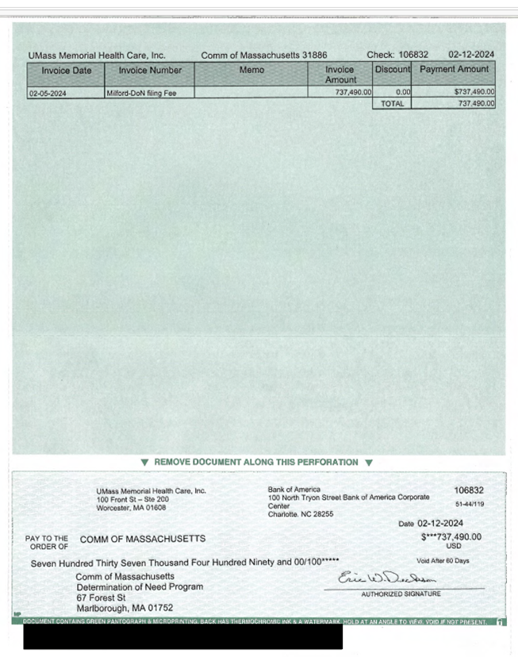

Attachment 8
Notice of Material Change Forms

UMass Memorial Health Care, Inc.:
https://www.mass.gov/doc/umass-memorial-health-care-inc-milford-mcn- 2142024/download

Milford Regional Medical Center, Inc.:
https://www.mass.gov/doc/milford-regional-medical-center-inc-umass-mcn- 2142024/download

