UMASS MEMORIAL HEALTH CARE, INC.

DON APPLICATION #UMMHC-22042514-HE SUBSTANTIAL CAPITAL EXPENDITURE SUBSTANTIAL CHANGE IN SERVICE UMASS MEMORIAL MEDICAL CENTER

JUNE 10, 2022

BY

UMASS MEMORIAL HEALTH CARE 55 LAKE AVE NORTH WORCESTER, MA 01655

UMASS MEMORIAL HEALTH CARE, INC. DON APPLICATION # UMMHC-22042514-HE

TABLE OF CONTENTS

Appendix 1 Application Form Appendix 2 Narrative
Appendix 3 Factor 1 - Community Engagement Presentations Appendix 4 Factor 4 - CPA Report
Appendix 5 Factor 6 - Supplemental Documents
  - CHI Narrative
  - Community Engagement Plan Form
  - Community Engagement Supplement
  - Community Health Assessment
  - Community Health Improvement Plan Appendix 6 Affiliated Parties
Appendix 7 Change in Service Appendix 8 Notice of Intent Appendix 9 Articles of Organization Appendix 10 Affidavit of Truthfulness Appendix 11 Filing Fee

APPENDIX 3

FACTOR 1
COMMUNITY ENGAGEMENT PRESENTATIONS


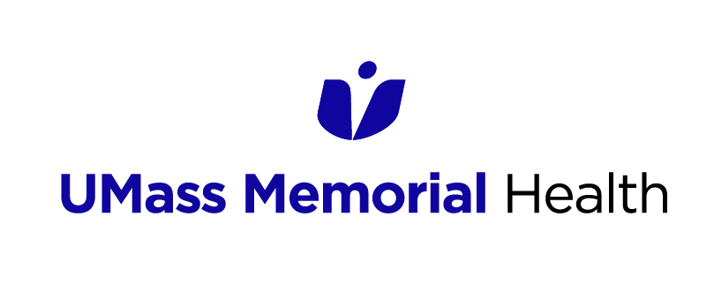

NEW INPATIENT BUILDING

March 15, 2022
Michael Gustafson, MD, MBA President

UMASS MEMORIAL HEALTH

Community Healthlink | Harrington | HealthAlliance-Clinton Hospital | Marlborough Hospital
UMass Memorial Medical Center | UMass Memorial Medical Group | UMass Memorial Accountable Care Organization

OUR UMASS MEMORIAL HEALTH SYSTEM

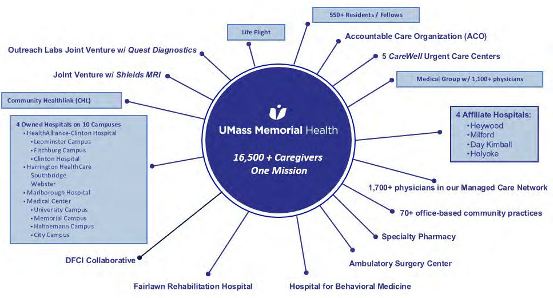

UMASS MEMORIAL MEDICAL CENTER –

UNIQUELY SERVING CENTRAL MASS

800 bed Academic Medical Center, serving as clinical partner of UMass Chan Medical School
    - Level 1 Trauma Center (adults & kids)
    - Worcester & Shrewsbury EMS & helicopter ambulance (Lifeflight)
    - Children’s Medical Center
      - Pediatric ED, ICU, Inpatient unit
      - Level 3 Neonatal ICU
    - High-Risk OB & NEW IVF Program!
    - Liver & Kidney Transplants
    - Cardiovascular Care, including novel care for Atrial fib, Valve disease
    - Center for Complex Aortic Disease
    - Comprehensive Stroke Center
    - Cancer Center / Bone Marrow Transplant
    - Advanced GI Endoscopy
    - Gene Therapy
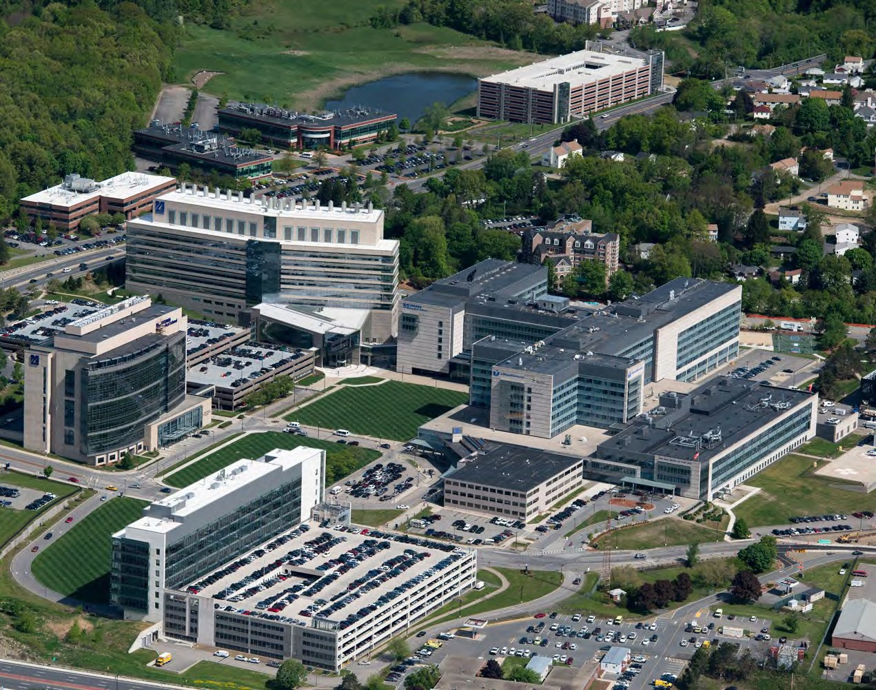

NATIONALLY RECOGNIZED CLINICAL CARE





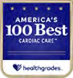

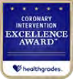
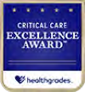

Joint Commission Certification
- Advanced Comprehensive Stroke
- Ventricular Assisted Device (VAD)

Blue Center of Distinction presented by Blue Cross Blue Shield
o Bariatric surgery
o Cardiac care
o Knee & hip replacement
o Maternity care




100 Great Hospitals in America

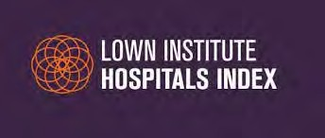
Ranked 24th in Nation
High performing in:
- Colon cancer surgery
- Aortic valve surgery
- Heart bypass surgery
- Heart failure

PROUD HISTORY OF COMMUNITY HEALTH IMPROVEMENT
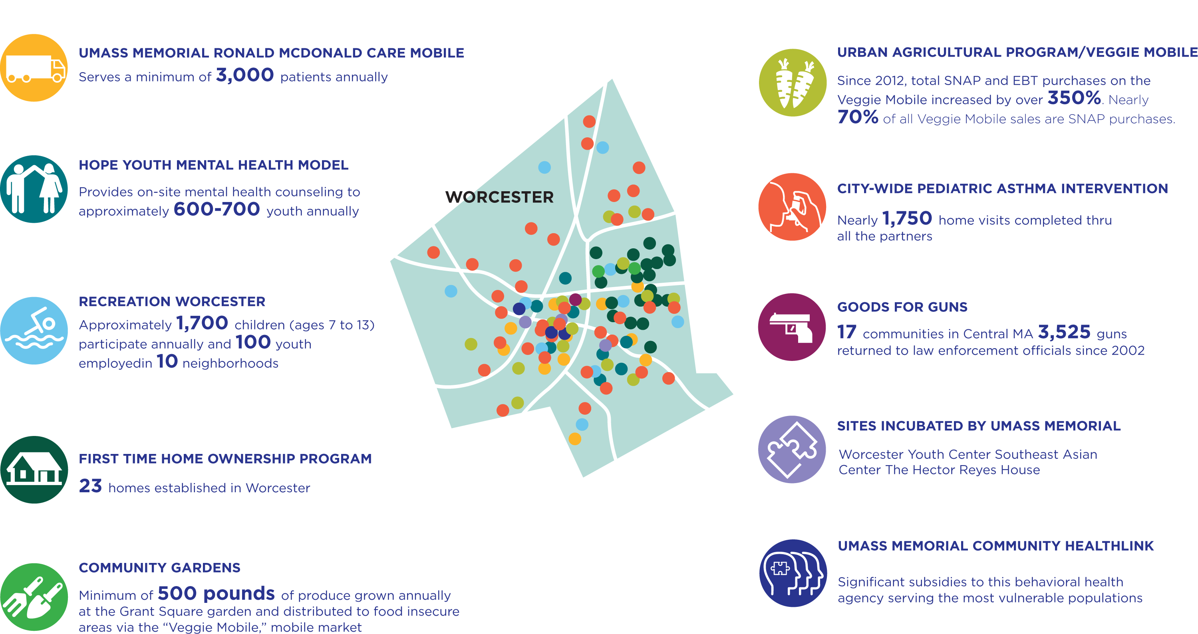

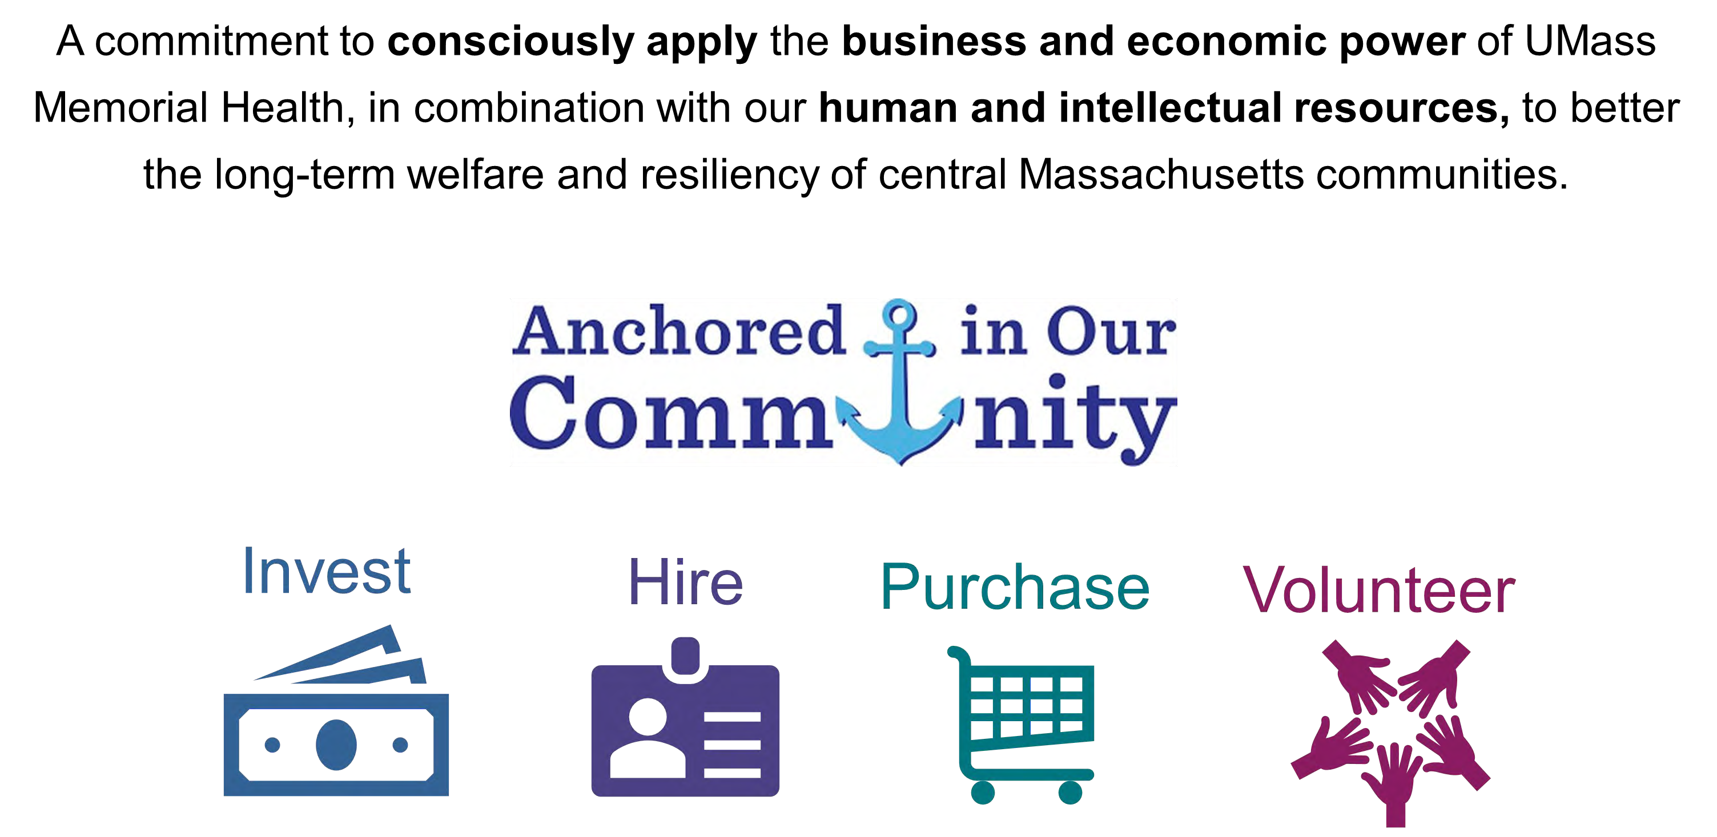
ANCHOR MISSION

BACKGROUND



CENTRAL MASS IS UNDER-BEDDED –

DEFICIT OF ABOUT 350 BEDS!

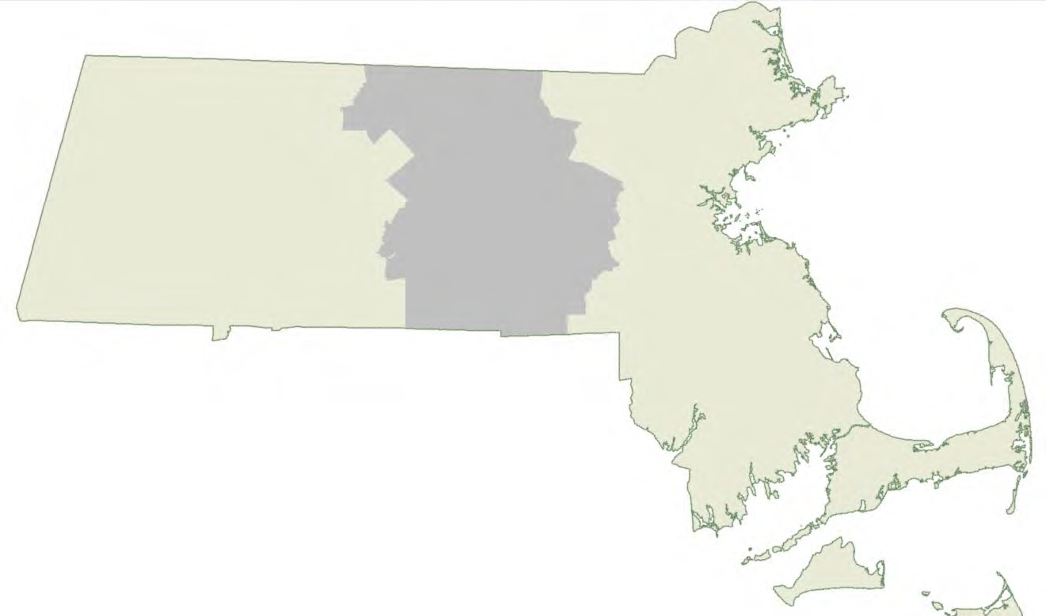
East Mass (incl Cape & Islands): 40 Hospitals
10, 985 IP Lic Beds
5 AMCs
2.19 Beds/1,000 Pop
15% more beds per capita

West Mass:
9 Hospitals 1,875 IP Lic Beds 1 AMC
2.28 Beds/1,000 Pop 20% more beds per capita
Central Mass: 11 Hospitals
2,058 IP Lic Beds 1 AMC
1.90 Beds/1,000 Pop

Licensed beds based on CHIA 2019 cost report data; excludes nursery. Projected 2019 population using UMass Donohue Institute population estimates. Physician estimates based on ratios of physicians to population in AHA Statistical Guide, by nation and state

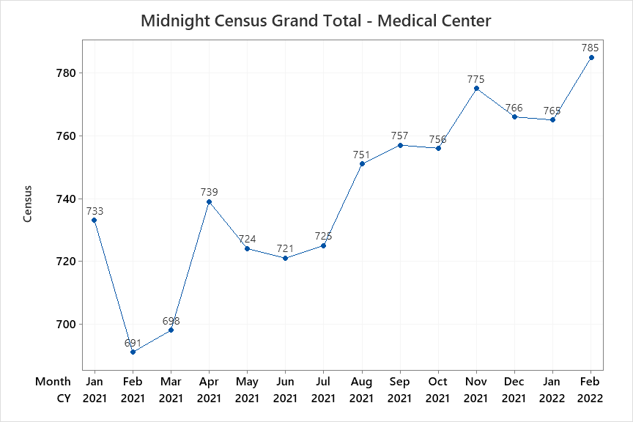
WHY IT MATTERS NOW

WHY IT MATTERS NOW
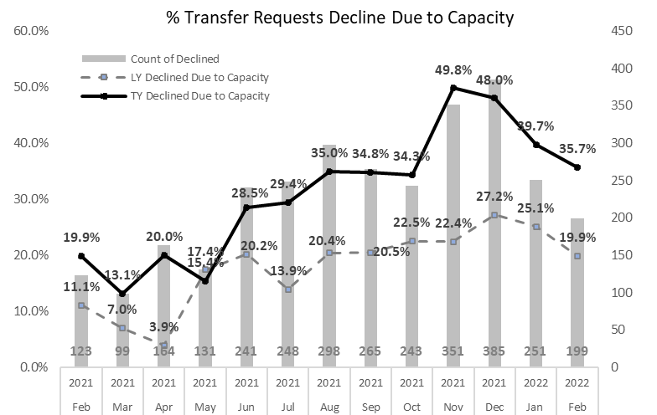

WHAT ELSE WE ARE DOING

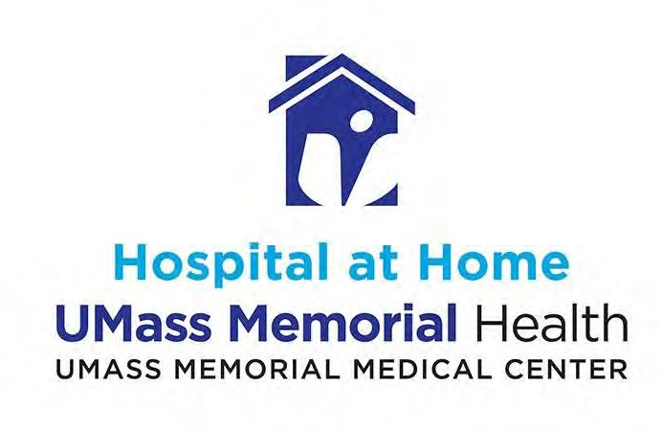

  - An innovative way for you to receive high-quality, hospital-level care in the comfort and familiarity of your own home. With our outstanding clinicians visiting your home several times a day and telehealth technology keeping you connected to your health care team, we bring the hospital to you.

  - Studies show that Hospital at Home programs improve patient outcomes and increase patient satisfaction. It’s all part of our relentless pursuit of healing, and our desire to improve the lives of our patients.

WHAT ELSE WE ARE DOING

ED REDESIGN
    - Invested in more technology (i.e. CT scanner) & staff to expedite flow of patients through the ER
    - Created a new ED Rapid Flow Process/Unit, which helps to expedite diagnostic workup (i.e. labs, tests, etc.) on lower acuity patients, to reduce waiting
    - ED Observation & Transition units for shorter stay & boarding patients

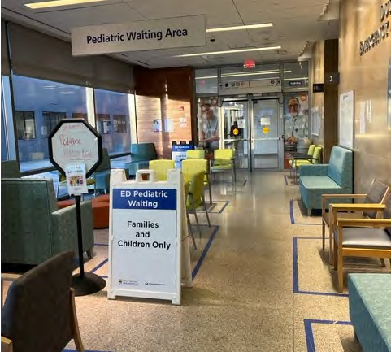

PROPOSED PROJECT

WHAT ELSE WE ARE DOING

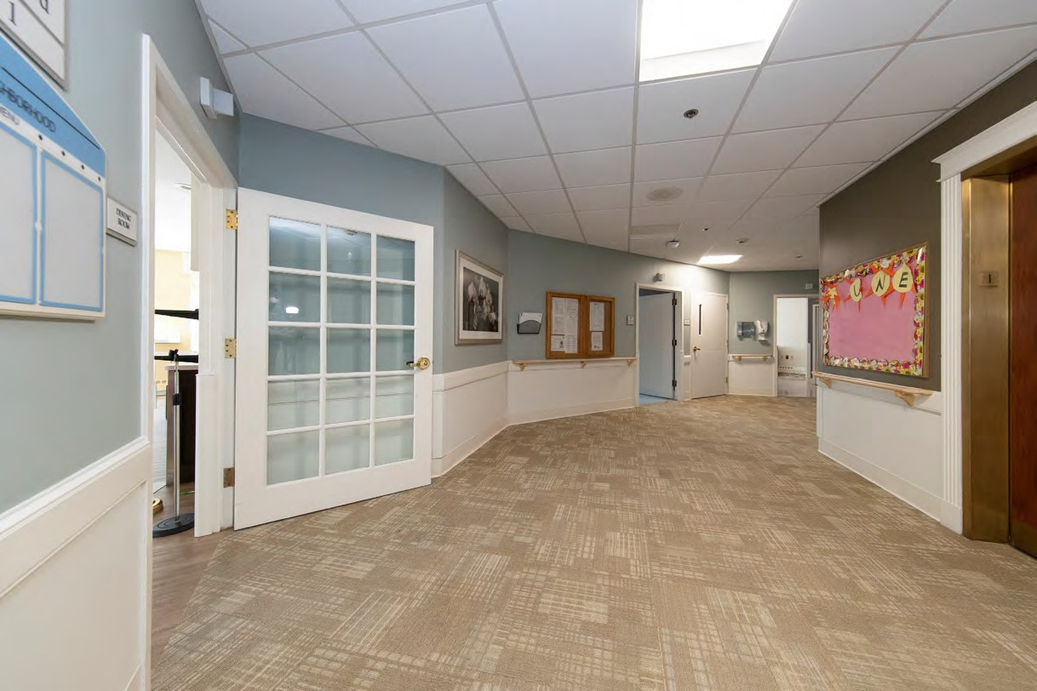
      - 72 new medical/surgical beds that will ease our capacity constraints
      - Single rooms
      - Extensive interior renovations & infrastructure upgrades needed
      - Focus on modern healing environment & digital technology
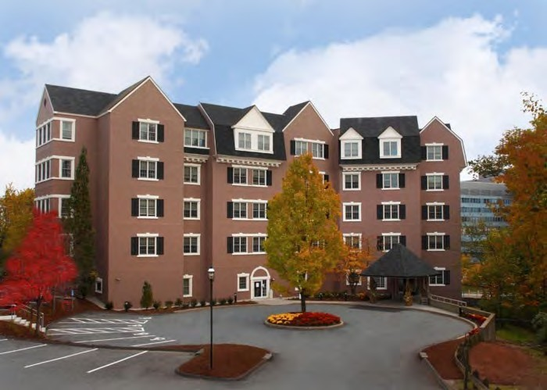
      - Patients will be transferred via ambulance
      - Anticipated opening: 2024
      - Proposed zone change submitted to City of Worcester; filing of Determination of Need forthcoming
      - Design firm: Perkins & Will, Boston

PROCESS OF
COMMUNITY HEALTH INITIATIVE (CHI)
- Upon approval, UMass Memorial Health will fund a CHI equal to 5% of the Project’s maximum capital expenditure
- Approximately 66% of the CHI will fund local priorities
- UMass Memorial Health’s CHI Committee will select priorities based on our most recent CHNA and in alignment with the DoN Health Priorities
- Social Environment
- Built Environment
- Housing
- Violence and Trauma
- Employment
- Education

  - UMass Memorial Health anticipates contributing money over several years to fund the selected CHI priorities and strategies

COMMUNITY ENGAGEMENT TIMELINE

- Community Engagement

  - Coalition for a Healthy Greater Worcester—March 15, 2022 at 3:00 p.m.

  - PFAC—March 22, 2022 at 6:00 p.m.

  - Worcester Together Coalition—March 24, 2022 at 8:30 a.m.

  - Public Forum—TBD

- DoN Submission: June 1, 2022 (target)

- DoN Approva: December 2, 2022 (estimate)

DISCUSSION

NEW INPATIENT BUILDING

March 22, 2022
David D. McManus, MD ScM
Richard M. Haidack Professor and Chair, Department of Medicine
University of Massachusetts Chan Medical School and UMassMemorial Health

Monica Lowell
Vice President Community Health Transformation/Community Benefits

UMASS MEMORIAL HEALTH

Community Healthlink | Harrington | HealthAlliance-Clinton Hospital | Marlborough Hospital
UMass Memorial Medical Center | UMass Memorial Medical Group | UMass Memorial Accountable Care Organization

OUR UMASS MEMORIAL HEALTH SYSTEM

UMASS MEMORIAL MEDICAL CENTER –

UNIQUELY SERVING CENTRAL MASS

800 bed Academic Medical Center, serving as clinical partner of UMass Chan Medical School
    - Level 1 Trauma Center (adults & kids)
    - Worcester & Shrewsbury EMS & helicopter ambulance (Lifeflight)
    - Children’s Medical Center
      - Pediatric ED, ICU, Inpatient unit
      - Level 3 Neonatal ICU
    - High-Risk OB & NEW IVF Program!
    - Liver & Kidney Transplants
    - Cardiovascular Care, including novel care for Atrial fib, Valve disease
    - Center for Complex Aortic Disease
    - Comprehensive Stroke Center
    - Cancer Center / Bone Marrow Transplant
    - Advanced GI Endoscopy
    - Gene Therapy

NATIONALLY RECOGNIZED CLINICAL CARE

Joint Commission Certification
- Advanced Comprehensive Stroke
- Ventricular Assisted Device (VAD)

Blue Center of Distinction presented by Blue Cross Blue Shield
o Bariatric surgery
o Cardiac care
o Knee & hip replacement
o Maternity care

100 Great Hospitals in America

Ranked 24th in Nation
High performing in:
- Colon cancer surgery
- Aortic valve surgery
- Heart bypass surgery
- Heart failure

PROUD HISTORY OF COMMUNITY HEALTH IMPROVEMENT

ANCHOR MISSION

BACKGROUND

CENTRAL MASS IS UNDER-BEDDED –

DEFICIT OF ABOUT 350 BEDS!

East Mass (incl Cape & Islands): 40 Hospitals
10, 985 IP Lic Beds
5 AMCs
2.19 Beds/1,000 Pop
15% more beds per capita

West Mass:
9 Hospitals 1,875 IP Lic Beds 1 AMC
2.28 Beds/1,000 Pop
20% more beds per capita
Central Mass: 11 Hospitals
2,058 IP Lic Beds 1 AMC
1.90 Beds/1,000 Pop

Licensed beds based on CHIA 2019 cost report data; excludes nursery. Projected 2019 population using UMass Donohue Institute population estimates. Physician estimates based on ratios of physicians to population in AHA Statistical Guide, by nation and state

WHY IT MATTERS NOW

WHY IT MATTERS NOW

WHAT ELSE WE ARE DOING

  - An innovative way for you to receive high-quality, hospital-level care in the comfort and familiarity of your own home. With our outstanding clinicians visiting your home several times a day and telehealth technology keeping you connected to your health care team, we bring the hospital to you.

  - Studies show that Hospital at Home programs improve patient outcomes and increase patient satisfaction. It’s all part of our relentless pursuit of healing, and our desire to improve the lives of our patients.

WHAT ELSE WE ARE DOING

ED REDESIGN

Invested in more technology (i.e. CT scanner) & staff to expedite flow of patients through the ER

Created a new ED Rapid Flow Process/Unit, which helps to expedite diagnostic workup (i.e. labs, tests, etc.) on lower acuity patients, to reduce waiting

ED Observation & Transition units for shorter stay & boarding patients

PROPOSED PROJECT

WHAT ELSE WE ARE DOING

      - 72 new medical/surgical beds that will ease our capacity constraints
      - Single rooms
      - Extensive interior renovations & infrastructure upgrades needed
      - Focus on modern healing environment & digital technology
      - Patients will be transferred via ambulance
      - Anticipated opening: 2024
      - Proposed zone change submitted to City of Worcester; filing of Determination of Need forthcoming
      - Design firm: Perkins & Will, Boston

PROCESS OF
COMMUNITY HEALTH INITIATIVE (CHI)
- Upon approval, UMass Memorial Health will fund a CHI equal to 5% of the Project’s maximum capital expenditure
- Approximately 66% of the CHI will fund local priorities
- UMass Memorial Health’s CHI Committee will select priorities based on our most recent CHNA and in alignment with the DoN Health Priorities
- Social Environment
- Built Environment
- Housing
- Violence and Trauma
- Employment
- Education

  - UMass Memorial Health anticipates contributing money over several years to fund the selected CHI priorities and strategies

COMMUNITY ENGAGEMENT TIMELINE

- Community Engagement

  - Coalition for a Healthy Greater Worcester—March 15, 2022 at 3:00 p.m.

  - PFAC—March 22, 2022 at 6:00 p.m.

  - Worcester Together Coalition—March 24, 2022 at 8:30 a.m.

  - Public Forum—TBD

- DoN Submission: June 1, 2022 (target)

- DoN Approval: December 2, 2022 (estimate)

DISCUSSION

NEW INPATIENT BUILDING

March 24, 2022
Michael Gustafson, MD, MBA President

UMASS MEMORIAL HEALTH

Community Healthlink | Harrington | HealthAlliance-Clinton Hospital | Marlborough Hospital
UMass Memorial Medical Center | UMass Memorial Medical Group | UMass Memorial Accountable Care Organization

ABOUT UMASS MEMORIAL MEDICAL CENTER
- Clinical partner of UMass Memorial Medical School
- 733-bed (plus 69 bassinets)
acute care, academic hospital

The region’s only:
- Level I Trauma Center for adults
- Hospital-based air ambulance (the first in New England)
- Level III Neonatal Intensive Care Unit

  - Named on of America’s Top 50 Teaching Hospitals by The Washington Monthly

ABOUT UMASS MEMORIAL MEDICAL CENTER
- Recognized by US News & World Report as high performing in colon cancer surgery, aortic valve surgery, heart bypass surgery and heart failure.
- Ranked 24th in the nation’s top hospitals by the Lown Institute. 
- Recognized by Healthgrades with the following awards and designations: Critical Care Excellence Award, Coronary Intervention Excellence Award, America’s 100 Best Hospitals for Cardiac Care Award, America’s 50 Best Hospitals for Cardiac Surgery Award.

- Blue Center of Distinction presented by Blue Cross Blue Shield
    - Bariatric surgery
    - Cardiac care
    - Knee and hip replacement
    - Maternity care

U M A S S M E M O R I A L H E A L T H ’ S
PROUD HISTORY OF
COMMUNITY HEALTH IMPROVEMENT

ANCHOR MISSION

BACKGROUND

CENTRAL MA HAS THE LOWEST BED/ POPULATION RATIO WITH FULL BREADTH OF PHYSICIAN SPECIALISTS

  - Central Mass market not overbuilt compared to Eastern or Western markets and only includes one AMC
  - Broad spectrum of specialties well represented by ~2,400 doctors

East Mass (incl Cape & Islands): 40 Hospitals
10, 985 IP Lic Beds
5 AMCs
2.19 Beds/1,000 Pop
~27,100 Physicians
5.41 Phys/1,000 Pop 15% more beds per capita

West Mass:
9 Hospitals 1,875 IP Lic Beds 0 AMC
2.28 Beds/1,000 Pop
~1,900 Physicians
2.31 Phys/1,000 Pop 20% more beds per capita
Central Mass:
11 Hospitals 2,058 IP Lic Beds 1 AMC
1.90 Beds/1,000 Pop
~2,400 Physicians
2.22 Phys/1,000 Pop

Licensed beds based on CHIA 2019 cost report data; excludes nursery. Projected 2019 population using UMass Donohue Institute population estimates. Physician estimates based on ratios of physicians to population in AHA Statistical Guide, by nation and state

WHY IT MATTERS NOW

WHY IT MATTERS NOW

WHAT ELSE WE ARE DOING

7-8
830-930
- An innovative way for you to receive high-quality, hospital-level care in
the comfort andMficahmalieliawraitlkyinogfwyiothupr oorwpcnorhnome. With our outstanding clinicians visiting your home several times a day and telehealth technology keeping you connected to your health care team, we bring the hospital to you.

- Studies show that Hospital at Home programs improve patient outcomes and increase patient satisfaction. It’s all part of our relentless pursuit of healing, and our desire to improve the lives of our patients.

EMERGENCY DEPARTMENT REDESIGN

  - Invested in more technology (i.e. CT scanner) and staff to expedite the flow of patients through the emergency room.

  - Created a new ED Transition Unit, which helps staff to expedite routine diagnostic care (i.e. labs, tests, etc.) that they know from experience will be necessary when you are seen by a provider.

    - This leads to the efficient identification of serious medical concerns and reduces how long a patient waits in the ED.

PROPOSED PROJECT

NEW INPATIENT BUILDING
      - 72 new medical/surgical beds that will ease our capacity constraints
      - Single rooms
      - Extensive interior renovations needed
      - Focus on modern healing and technological environment
      - Patients will be transferred via ambulance
      - Anticipated opening: 2024
      - Proposed zone change submitted to City of Worcester, filing of Determination of Need forthcoming
      - Design firm: Perkins&Will, Boston

DETERMINATION OF NEED

DISCUSSION

NEW INPATIENT BUILDING

April 12, 2022
Michael Gustafson, MD, MBA President

Monica Lowell
Vice President Community Health Transformation/Community Benefits

UMASS MEMORIAL HEALTH

Community Healthlink | Harrington | HealthAlliance-Clinton Hospital | Marlborough Hospital
UMass Memorial Medical Center | UMass Memorial Medical Group | UMass Memorial Accountable Care Organization

OUR UMASS MEMORIAL HEALTH SYSTEM

UMASS MEMORIAL MEDICAL CENTER –

UNIQUELY SERVING CENTRAL MASS

800 bed Academic Medical Center, serving as clinical partner of UMass Chan Medical School
    - Level 1 Trauma Center (adults & kids)
    - Worcester & Shrewsbury EMS & helicopter ambulance (Lifeflight)
    - Children’s Medical Center
      - Pediatric ED, ICU, Inpatient unit
      - Level 3 Neonatal ICU
    - High-Risk OB & NEW IVF Program!
    - Liver & Kidney Transplants
    - Cardiovascular Care, including novel care for Atrial fib, Valve disease
    - Center for Complex Aortic Disease
    - Comprehensive Stroke Center
    - Cancer Center / Bone Marrow Transplant
    - Advanced GI Endoscopy
    - Gene Therapy

NATIONALLY RECOGNIZED CLINICAL CARE

Joint Commission Certification
- Advanced Comprehensive Stroke
- Ventricular Assisted Device (VAD)

Blue Center of Distinction presented by Blue Cross Blue Shield
o Bariatric surgery
o Cardiac care
o Knee & hip replacement
o Maternity care

100 Great Hospitals in America

Ranked 24th in Nation
High performing in:
- Colon cancer surgery
- Aortic valve surgery
- Heart bypass surgery
- Heart failure

PROUD HISTORY OF COMMUNITY HEALTH IMPROVEMENT

ANCHOR MISSION

BACKGROUND

CENTRAL MASS IS UNDER-BEDDED –

DEFICIT OF ABOUT 350 BEDS!

East Mass (incl Cape & Islands): 40 Hospitals
10, 985 IP Lic Beds
5 AMCs
2.19 Beds/1,000 Pop
15% more beds per capita

West Mass:
9 Hospitals 1,875 IP Lic Beds 1 AMC
2.28 Beds/1,000 Pop 20% more beds per capita
Central Mass: 11 Hospitals
2,058 IP Lic Beds 1 AMC
1.90 Beds/1,000 Pop

Licensed beds based on CHIA 2019 cost report data; excludes nursery. Projected 2019 population using UMass Donohue Institute population estimates. Physician estimates based on ratios of physicians to population in AHA Statistical Guide, by nation and state

WHY IT MATTERS NOW

WHY IT MATTERS NOW

WHAT ELSE WE ARE DOING

  - An innovative way for you to receive high-quality, hospital-level care in the comfort and familiarity of your own home. With our outstanding clinicians visiting your home several times a day and telehealth technology keeping you connected to your health care team, we bring the hospital to you.

  - Studies show that Hospital at Home programs improve patient outcomes and increase patient satisfaction. It’s all part of our relentless pursuit of healing, and our desire to improve the lives of our patients.

WHAT ELSE WE ARE DOING

ED REDESIGN
    - Invested in more technology (i.e. CT scanner) & staff to expedite flow of patients through the ER
    - Created a new ED Rapid Flow
Process/Unit, which helps to expedite diagnostic workup (i.e. labs, tests, etc.) on lower acuity patients, to reduce waiting
    - ED Observation & Transition units for shorter stay & boarding patients

PROPOSED PROJECT

WHAT ELSE WE ARE DOING

      - 72 new medical/surgical beds that will ease our capacity constraints
      - Single rooms
      - Extensive interior renovations & infrastructure upgrades needed
      - Focus on modern healing environment & digital technology
      - Patients will be transferred via ambulance
      - Approx. 400-500 NEW jobs
      - Design firm: Perkins & Will, Boston
      - Proposed zone change submitted to City of Worcester; filing of Determination of Need forthcoming
      - Anticipated opening: 2024

PROCESS OF
COMMUNITY HEALTH INITIATIVE (CHI)
- Upon approval, UMass Memorial Health will fund a CHI equal to 5% of the Project’s maximum capital expenditure
- Approximately 66% of the CHI will fund local priorities
- UMass Memorial Health’s CHI Committee will select priorities based on our most recent CHNA and in alignment with the DoN Health Priorities
- Social Environment
- Built Environment
- Housing
- Violence and Trauma
- Employment
- Education

  - UMass Memorial Health anticipates contributing money over several years to fund the selected CHI priorities and strategies

COMMUNITY ENGAGEMENT TIMELINE

- Community Engagement

  - Coalition for a Healthy Greater Worcester—March 15, 2022 at 3:00 p.m.

  - PFAC—March 22, 2022 at 6:00 p.m.

  - Worcester Together Coalition—March 24, 2022 at 8:30 a.m.

  - Public Forum—TBD

- DoN Submission: June 1, 2022 (target)

- DoN Approval: December 2, 2022 (estimate)

DISCUSSION

APPENDIX 5.1 CHI NARRATIVE

UMMMC
Pavilion DoN Narrative
- Community Health Initiative Monies

The breakdown of Community Health Initiative (“CHI”) monies for the Proposed Project is as follows. Please note, all totals are presented in the order calculated, beginning with the Maximum Capital Expenditure (“MCE”).

 | Total | Description
MCE | $143,242,167
Total CHI | $7,162,108.38 | (5% of Maximum Capital Expenditure)
Administrative Fee | $143,242.17 | (2% of the CHI Monies, retained by UMMHC)
Remaining Monies | $7,018,866.21 | (CHI Monies minus the Administrative fee)
Statewide Initiative | $1,754,716.55 | (25% of remaining monies, paid to State-wide fund)
Local Initiative | $5,264,149.66 | (90% of remaining monies)
Evaluation Monies | $526,414.97 | (10% of Local Initiative Monies, retained by UMMHC)
Local Disbursement | $4,737,734.69

- Overview and Discussion of CHNA/CHI Processes

The CHI for the Proposed Project will be led by UMass Memorial Health Care, Inc (“UMMHC” or the “Applicant”). Earlier this year, the Applicant received DoN approval for the acquisition of one computed tomography unit to be located in the Department at UMass Memorial Medical Center (“UMMMC”) - University Campus (the “Hospital”. Due the timing of the applications submitted on behalf of UMMMC, the Applicant received approval from the DoN Program to combine the CHI dollars for both applications and distribute the dollars through one CHI, if the current Proposed Project is approved. The total CHI for both projects would be $7,353,751.48

The Applicant participated in the 2021 Greater Worcester Regional Community Health Needs Assessment (the “CHNA”) which will serve as the basis for the CHI. The CHNA was collaboratively developed and carried out by the Worcester Division of Public Health, Fallon Health, The Hanover Insurance Group Foundation, and the Applicant. The entities have collaborated since 2008 to plan and conduct regional assessments aimed at identifying community health issues, barriers to care, inequities in care and disparities in outcomes, and gaps in the health service system.

In order to understand the health issues facing Greater Worcester, the CHNA utilized a mixed-methods assessment approach that integrates quantitative and qualitative data and sought information on the lived experiences of the community’s diverse populations. The full CHNA 2021 effort focused on compiling information through an extensive community engagement effort that involved stakeholder interviews, focus groups, and a community health survey, as described below. Data and findings from recent local assessment and planning efforts were also incorporated into the CHNA. Accordingly, the CHNA was completed in close partnership with local stakeholders, including health and social service providers, advocates, elected and appointed officials, faith leaders, community organizations, Boards and Commissions, and community residents.

The CHNA sought to include an engaged and representative sample of individuals from Greater Worcester residents. To that end, hundreds of individuals participated through 45 interviews, nine (9) focus groups, and one (1) Community Health Survey. Furthermore, the CHNA was used to inform the Greater Worcester

UMMMC
Pavilion DoN Narrative
Community Health Improvement Plan (“CHIP”) and strategies, which was led by the Coalition for a Healthy Greater Worcester.

- Oversight of the CHI Process

The Applicant will leverage its robust and well-represented Determination of Need Committee (the “Advisory Committee”) to oversee the development and implementation of the CHI. The Committee is comprised of community members, leaders, and stakeholders, as well as key employees across the Applicant’s organization.

- Advisory Committee Duties

The Advisory Committee’s scope of work includes:

  - Selecting the CHI’s Health Priorities based upon the needs identified in the 2021 CHNA and in alignment with DPH’s and EOHHS’s Health Priorities and Focus Areas.
  - Providing oversight of the evaluation of CHI-funded projects.
  - Conducting a conflict of interest disclosure process to determine which members also will comprise the Allocation Committee.
  - Ongoing monitoring and reporting to DPH.

- Allocation Committee Duties

The Allocation Committee will be comprised of individuals from the Advisory Committee who do not have a conflict of interest with respect to funding CHI strategies. The scope of work that the Allocation Committee will carry out includes:

  - Selecting Strategies for the noted Health Priorities consistent with DPH’s CHI guidelines.
  - Carrying out a formal request for proposal (“RFP”) process (or an equivalent, transparent process) for the disbursement of CHI funds.
  - Engaging resources that can support and assist applicants with their responses to the RFP.
  - Disbursement of CHI funding.
  - Providing oversight to the evaluation process.

- Timeline for CHI Activities

Upon a Notice of Determination of Need being issued by the Public Health Council, the Advisory Committee will commence meeting and begin the CHI Process. The timeline for CHI activities is as follows:

  - Six weeks post-approval: The Advisory Committee will meet to review their responsibilities and the 2021 CHNA in furtherance of selecting Health Priorities.
  - Three months post-approval: The Advisory Committee determines Health Priorities and Strategies for funding.
  - Four months post-approval: The Advisory Committee conducts a Conflicts of Interest process to determine which members will form the Allocation Committee.
  - Five months post-approval: The Allocation Committee develops the funding process for the selected strategies.
  - Six months post-approval: The RFP for funding is released.
  - Eight months post-approval: Responses are due for the RFP.

UMMMC
Pavilion DoN Narrative
  - Nine to ten months post-approval: Funding decisions are made, and the disbursement of funds begins.
  - Eighteen months to two years post-approval: Ongoing evaluation efforts and reporting to DPH.

- Request for Multi-Year Funding

The Applicant is requesting the flexibility to extend the life of the CHI grants up to five (5) years depending on the number and nature of applications received and ultimately funded.

- Administrative Monies

UMMHC is requesting to use up to $143,242.17 in administrative funding. These monies will be used to fund support staff, provide support to Advisory Committee and Allocation Committee members, and assist with the development of community communication materials, including publicizing and facilitating the RFP process.

- Evaluation Overview

The Applicant anticipates using the allowed 10% of local CHI funding ($526,414.97) for evaluation efforts. The money will be used to develop and implement an evaluation plan for CHI-funded projects.

APPENDIX 5.2

COMMUNITY ENGAGEMENT PLAN FORM

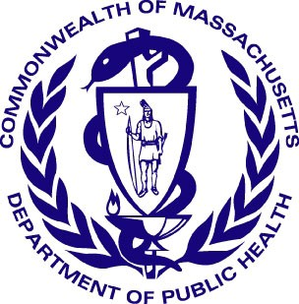 Version: 8-1-17
Massachusetts Department of Public Health
Determination of Need
Community Health Initiative
Community Engagement Plan
The Community Engagement Plan is intended for those Applicants with CHIs that require further engagement above and beyond the regular and routine CHNA/CHIP processes. For further guidance, please see the Community Engagement Standards for Community Health Planning Guidelines and its appendices for clarification around any of the following terms and questions.

All questions in the form, unless otherwise stated, must be completed

Approximate DoN Application Date: 06/10/2022
DoN Application Type: Hospital/Clinic Substantial Capital Expenditure
Applicant Name: UMass Memorial Health Care, Inc
What CHI Tier is the project? Tier 3

1. Community Engagement Contact Person
Contact Person: Kimberly Rickert
Title: Director, Community Health Transformation
Mailing Address: 16 Shaffner Street
City: Worcester State: Massachusetts Zip Code: 01605
Phone: 7743299856 Ext: none
Email: Kimberly.Reckert@umassmemorial.org

2. Name of CHI Engagement Process
Please indicate what community engagement process (e.g. the name DoN CHI Initiative associated with the CHI amount) the following form relates to. This will be use as a point of reference for the following questions.
(please limit the name to the following field length as this will be used throughout this form): UMMMC Plantation Street Project

3. CHI Engagement Process Overview and Synergies with Broader CHNA /CHIP
Please briefly describe your overall plans for the CHI engagement process and specific how this effort that will build off of the CHNA / CHIP community engagement process as is stated in the DoN Community-Based Health Initiative Planning Guideline.: See attached Addendum.

4. CHI Advisory Committee
In the CHNA/CHIP Self Assessment, you listed (or will list) the community partners that will be involved in the CHI Advisory Committee to guide the UMMMC Plantation Street Project. As a reminder:

For Tier 2 DON CHI Applicants: The CHI Advisory Committee is tasked with helping select DoN Health Priorities based on the CHNA / CHIP unless the Applicant is directed by DPH to conduct additional community engagement. If so, the advisory committee's role is to guide that additional work.

For Tier 3 DON CHI Applicants: The CHI Advisory Committee is to select DoN Health Priorities based on, but not exclusive to, the CHNA / CHIP. This includes the additional community engagement that must occur to develop the issue priorities.

5. Focus Communities for CHI Engagement
Within the UMMMC Plantation Street Project, please specify the target community(ies), please consider the community(ies) represented in the CHNA / CHIP processes where the Applicant is involved.
Add/Del Rows | Municipality | If engagement occurs in specific neighborhoods, please list those specific neighborhoods:
+ / - | Worcester

6. Reducing Barriers
Identify the resources needed to reduce participation barriers (e.g. translation, interpreters, child care, transportation, stipend). For more information on participation barriers that could exist, please see Appendix A from the Community Engagement Standards for Community Health Planning Guidelines:
When coordinating participation and community engagement, UMMMC will follow recognized standards and best practices to reduce participation barriers. The strategies we will employ will address issues surrounding accommodations, which will mitigate potential barriers related to communication, location, time, and childcare. This includes the following:
• Trained interpreters to provide culturally sensitive interpretations that reflect the linguistic diversity of the community.
• Meeting locations that are centrally located, ADA-compliant facility with free parking, where community members feel safe from crime but also safe to voice their opinions. As such, locations will rotate to reflect the diversity of the community.
• Hybrid format (in-person/virtual) meetings at a time identified to accommodate accessibility and availability for participants.
• Childcare, food, and stipends as appropriate as a way to encourage community engagement and recognize the value that participants bring to the process.
• Identify and address transportation barriers for some hard-to-reach groups, including young people, seniors and/or disabled people.
• Diversify publicity materials and dissemination of information by varying modes/methods of communication to maximize transparency among the community that will ensure broad community engagement and access to timely information/feedback.
• Define clear objectives and expectations while ensuring that all participants have equitable access to pertinent information and materials

7. Communication
Identify the communication channels that will be used to increase awareness of this project or activity:
UMMMC’s communication regarding this Determination of Need and proposed project has already begun. We informed key community stakeholders through a virtual presentation with PFAC and to the Steering Committee of the Coalition for a Greater Healthy Worcester.
In addition, UMMMC hosted a Public Forum which was announced through local and social media [Telegram & Gazette, Spectrum News, Worcester Business Journal, MassLive] in the days leading up to the event. UMMMC sent a newsletter inviting elected officials to the Public Forum, including our State Senators and Representatives, Mayor of Worcester, and City Councilors. Moving forward, UMMMC's
communication efforts will expand to increase awareness further and maximize community engagement of this project. By leveraging existing partnerships, anticipated channels for communication will include:
Media outlets:
• WICN: a community radio station
• WCCATV: Worcester’s local community cable access station
• Local community cable stations: this will increase awareness in Worcester’s neighboring towns
• Vocero Hispano Newspaper: a Spanish language newspaper that is also digital
• Worcester Public Health Department and Public Health Alliance: municipal communication

Community network and coalition communication channels:
• Worcester Public Health Department and Public Health Alliance: municipal communication
• Coalition of a Healthy Greater Worcester: e-newsletters and communications to Steering Committee members, CHIP Working Groups, and the community at-large via email and website postings
• Worcester Together: a strong coalition that emerged during the pandemic that issues regular communications to its over 50 members
• Worcester Community Connections: E-newsletter listing with an internal distribution list
• Worcester Community Action Council: internal distribution list
• Seven Hills Foundation Newsletter
• Worcester Housing Authority resident communications
• Other community-based organizations communication channels/e-newsletters as possible

UMass Memorial communication channels:
• UMass Memorial Health: e-distribution list community sites as well as UMMH’s social media pages and website
• UMass Memorial Community Benefits key stakeholders direct email distribution list, which includes over 300 individuals
• UMass Memorial Community Benefits community COVID distribution list

8. Build Leadership Capacity
Are there opportunities with this project or activity to build community leadership capacity? Yes
If yes, please describe how.: To develop shared ownership among the CHI Committee we will rotate facilitation of the meeting among members. UMMMC will invest in offering a training on facilitation for all members.

9. Evaluation
Identify the mechanisms that will be used to evaluate the planning process, engagement outcome, and partner perception and experience:
UMMMC will work together with the CHI DoN Committee to ensure there is a strong evaluation plan and
that we are transparent with the community on key findings including through formats such as community forums conducted in hybrid in person/virtual format to ensure maximum participation and to address barriers to attendance such as transportation, childcare, parking accessibility and others. We will also ensure communications regarding key findings and CHI initiatives via other formats such as electronic communications.

To ensure CHI DoN processes are functioning effectively and as intended, the CHI DoN Committee will embed an ongoing evaluation process. This will include meeting evaluations to be completed by Committee members at the end of each meeting as well as a final overarching evaluation to be completed at the end of each year of the CHI process. UMMMC will engage CHI DoN Committee members as key monitoring actors in this process. The process will also include ensuring that there are metrics and reported outcomes for each CHI project that is funded. Each CHI funded project will be required to provide a solid evaluation plan with metrics and timeline for completion which will be reviewed by the CHI DoN Committee.

10. Reporting
Identify the mechanisms that will be used for reporting the outcomes of this project or activity to different groups within the community:
Residents of Color: UMMMC has a long history of working with residents of color and to this end, we will build upon these relationships. These relationships include capitalizing on the neighborhood work we have done in some of the most economically challenged areas in the City of Worcester; Bell Hill and Main South. In Bell Hill, we have had an outreach liaison that works closely with the Green Hill Neighborhood Association, and prior to the pandemic, she worked closely with the PTA at Belmont Community School. In addition, we are connected with the residents of this highly-distressed area via a community garden that UMMMC Community Benefits helped to established. In Main South, our most recent effort includes the development of an Anchor District. In this highly community engaged process we conducted a total of 64 listening sessions with a broad spectrum of community stakeholders. These consisted of one-on-interviews as well as focus group discussions. Interviews and focus groups were conducted with a broad range of representation including residents living in subsidized housing and stakeholders from various organizations including: faith based organizations (including an African American Baptist Church), Community Development Corporations, public housing authorities, small business owners, an elementary school, food pantries, a Latino CBO, and a Latino supermarket to name a few. In other neighborhoods across the city, we are connected through our UMass Memorial Ronald McDonald Care Mobile program which has a presence through regular stops in the Anchor District area. UMMMC's Care Mobile program has been delivering medical care to vulnerable populations at 10 neighborhood sites and preventive dental services at 23 elementary schools across the City of Worcester for over 20 years. As such, UMMMC has trusted relationships and communication channels for its Care Mobile program and outreach efforts that can be utilized for CHI DoN communications to the community at large.
Residents who speak a primary language other than English: UMMMC has established linkages with a range of ethnic groups over the years. For example, UMass Memorial Community Benefits helped to establish and incubated the Southeast Asian Center (SEAC) which has served the Vietnamese and other Asian groups for more than 15 years. As such, it has a strong working relationship with SEAC and reach out to them for various opportunities for the population they serve. Currently with the influx of Afghan refugees, UMMMC is part of an Afghanistan Health group that is working on decreasing barriers to care and as such in this group there are representatives from the two resettlement agencies (Ascentria Care Alliance, Ansaar of Worcester, and Refugee and Immigrant Assistant Center (RIAC) and we will certainly work with them throughout the CHI DoN process. In addition, our provider, Dr. Mohammed Ranzam coordinates a free clinic at a large Mosque in the City of Worcester that targets different groups from Arab countries. In addition, we are funding weekly transportation from two hotels where the Afghanis are residing to the Mosque in order to address isolation and mental health issues. In terms of the Latino population, we have partnered with CENTRO, a Latino community-based organization during the pandemic and have conducted COVID education and outreach efforts at their food pantry and a vaccination program. During the pandemic, UMMMC worked closely with several Black and African churches to provide COVID education, outreach, testing and vaccinations. Additionally, it worked with this population in addressing cultural and linguistic barriers to food resources and food insecurity.
Aging population: UMMMC has worked closely over the years with the Executive Director of the Worcester Senior Center, in particularly in funding an on-site health clinic. Previously it worked closely with the Worcester Senior Center as part of a Prevention and Wellness Trust Fund award to the City on falls prevention efforts. During the pandemic, and currently, UMMMC works with the Executive Director of the Central Massachusetts Agency on Aging (CMAA). In 2021, UMMMC held several COVID-19 vaccination programs through its Mobile Vaccination Equity Expansion program whereby the Agency brought hundreds of elders to get vaccinated. Through this connection, UMMMC vaccinated homebound older adults. UMMMC is also working with CMAA on an initiative that focuses on grandparents raising their grandchildren.
Youth: Over twenty years ago, UMass Memorial Community Benefits incubated the Worcester Youth Center which was spearheaded as the result of an ‘SOS’ call put forward by the Worcester City Manager and Worcester youth asking UMass Memorial leadership to help with a serious public health problem- youth violence prevention. Youth needed a place to go that offered after school activities, academic counseling and enrichment, and workforce training and opportunities. In addition, UMMMC coordinated the HOPE Coaliton, a group led by older youth that addresses public health problems impacting youth of color. In partnership with the Regional Environmental Council, UMMMC established the Urban Agricultural Program in Bell Hill which offers training on organic farming and employment opportunities during the summer months to address food insecurity in Worcester. Through this effort and other youth related programming including our Worcester ACTS, where Community Health Worker Intervention is addressing children/households that have been exposed to violence we have established solid channels of communications to reach the youth population.
Residents Living with Disabilities: UMMMC will establish a relationship with the City of Worcester Disability Office in reaching this population.
GLBTQ Community: UMMMC will work with the GLBTQ group that is part of the Coalition for a Healthy Greater Worcester, and will engage the recently elected City of Worcester City Council Vietnamese GLBTQ member to help develop an outreach strategy.
Residents with Low Incomes: UMMMC has developed strong working relations with a number of subsidized housing organizations. Most recently, UMMMC partnered with several organizations during the pandemic to deliver free COVID testing and vaccinations. They include the Worcester Housing Authority, Winn Affordable Housing, Beacon Properties, the City of Worcester HUD and Healthy Homes departments, as well as three community development corporations: Worcester Common Ground, Main South CDC, and East South CDC. We have also provided pediatric asthma education at some of this sites.
Other Residents: [blank]

11. Engaging the Community At Large
Which of the stages of a CHNA/CHIP process will the UMMMC Plantation Street Project focus on? Please describe specific activities within each stage and what level the community will be engaged during the UMMMC Plantation Street Project. While the step(s) you focus on are dependent upon your specific community engagement needs as a result of your previous CHNA/CHIP work, for tier 3 applicants the CHI community engagement process must at a minimum include the “Focus on What's Important,” “Choose Effective Policies and Programs” and “Act on What's Important” stages. (For definitions of each step, please see pages 12-14 in the
Community Engagement Standards for Community Health Planning Guidelines
Assess Needs and Resources? Yes, Collaborate
Please describe the engagement process employed during the “Assess Needs and Resources” phase.: Working with the CHI DoN Committee we will assess the needs and resources through our highly community engaged CHNA/CHIP process. The DoN CHI Committee will review the CHNA and CHIP strategies and will also utilize the most recent information that has been identified in the community specifically looking at Social Determinants of Health, identified inequities and gaps in resources. We will provide training to CHI DoN Committee members on meeting facilitation and rotate lead facilitators for meetings in order to provide diversity and equitable leadership opportunities among committee members.
Focus on What's Important? Yes, Collaborate
Please describe the engagement process employed during the “Focus on What’s Important” phase.: The DoN CHI Committee will review the CHA and CHIP strategies and will utilize the most recent information that has been identified in the community specifically looking at Social Determinants of Health, identified
inequities. Our committee is very diversified and includes a cross sector which will provide very useful information to addressing these needs. We will be working with the committee to identify if there is any additional data that is needed and to identify any additional pressing issues that need to be addressed. In addition to the Coalition for a Healthy Greater Worcester, UMass Memorial is additionally highly engaged in a number of diverse and robust community coalitions and task force groups that are actively focused on current and emerging community health needs. These include focus areas such as mental health, transportation, food insecurity and access, oral health and others. As such, the hospital and the CHI DoN
Committee will be informed on an ongoing basis on identified priority health areas and emerging needs.
Choose Effective Policies and Programs? Yes, Community-Driven/-Led
Please describe the engagement process employed during the “Choose Effective Policies and Programs” phase.: The CHI DoN Committee will review health outcomes data and assess gaps in which policy advocacy and efforts aligned with priorities can be engaged in, particularly those addressing vulnerable populations and health inequities. In addition to the Coalition for a Healthy Greater Worcester, UMass Memorial is additionally highly engaged in a number of diverse and robust community coalitions and task force groups that are actively focused on current and emerging community health needs. These include focus areas such as mental health, transportation, food insecurity and access, oral health and others. As such, the hospital and the CHI DoN Committee will be informed on an ongoing basis on identified policy and advocacy opportunities and needs.
Act on What's Important? Yes, Collaborate
Please describe the engagement process employed during the “Act on What's Important” phase.: Working with our CHI DoN Committee, we will be looking at existing assets, resources and opportunities that can be leveraged and built upon. The CHI Committee will review and come to consensus regarding narrowing the scope of identified needs to priority focus areas for funding. The CHI DoN Committee will review and score all community applications for funding based on an agreed upon criteria. To ensure a fair and equitable selection process applications for funding and the review process of applications by the CHI DoN Committee will be managed and processed within the Foundant for Grantmakers software. Additionally, community-based organizations lacking capacity to complete the application process will be provided with technical assistance as needed in order to submit. Once grant awardees are selected by the CHI Committee UMass Memorial will administer the CHI funds for the implementation of CHI projects.
Evaluate Actions? Yes, Collaborate
Please describe the engagement process employed during the “Act on What's Important” phase.: We will work together with the CHI DoN Committee to ensure there is a strong evaluation plan and that we are transparent with the community on key findings including through formats such as community forums and
electronic communications.

12. Document Ready for Filing
When document is complete click on "document is ready to file". This will lock in the responses and date/time stamp the form. To make changes to the document un-check the "document is ready to file" box.
Edit document then lock file and submit. Keep a copy for your records. Click on the "Save" button at the bottom of the page. To submit the application electronically, click on the "E-mail submission to DPH" button.

This document is ready to file? Unchecked
Date/time Stamp: [blank]
E-mail submission to DPH

APPENDIX 5.3

COMMUNITY ENGAGEMENT SUPPLEMENT

- CHI Engagement Process Overview and Synergies with Broader CHNA/CHIP
Please briefly describe your overall plans for the CHI engagement process and specific how this effort that will build off of the CHNA / CHIP community engagement process as is stated in the DoN Community-Based Health Initiative Planning Guideline.
UMass Memorial Medical Center (UMMMC) CHI Community Engagement Process
UMMMC’s community benefits/community health improvement approach is grounded in its commitment to partner with community stakeholders to identify needs and leverage resources. Since 2007, UMMMC has worked closely with the Worcester Division of Public Health (“WDPH”). Its work is guided by a Community Health Needs Assessment (“CHNA”) and Community Health Improvement Plan (“CHIP”) process completed in partnership with WDPH, Fallon Health, the Hanover Insurance Group, and a multi-sectoral group of stakeholders. The CHNA process also involves significant participation from the Coalition for a Healthy Greater Worcester (the “Coalition”), a community coalition that serves in an advisory role. UMMMC was one of the founding partners and has been its primary funder since 2008. The Coalition includes a spectrum of public, non-profit, and private sector stakeholders including the WDPH and serves as the critical scaffolding supporting the implementation of the Greater Worcester CHIP including the convening of CHIP Working Groups. UMMMC Community Benefits staff serve on the Coalition’s Steering Committee and participate in CHIP Working Groups. The Coalition encompasses a total of over 200 engaged “CHIPed- In” community-based organizations and residents.
The CHNA process incorporates a broad spectrum of primary and secondary data to identify community health needs and priority areas. In order to understand the health issues facing Greater Worcester, the CHNA utilizes a mixed-methods assessment approach that integrates quantitative and qualitative data and sought information on the lived experiences of the community’s diverse populations. The full CHNA process focuses on compiling information through an extensive community engagement effort that involved stakeholder interviews, focus groups, and a community health survey. Data and findings from recent local assessment and planning efforts are also incorporated into the CHNA. Accordingly, the CHNA is completed in close partnership with local stakeholders, including health and social service providers, advocates, elected and appointed officials, faith leaders, community organizations, Boards and Commissions, and community residents.
Findings of the CHNA inform and serve as the basis for the Greater Worcester CHIP. Developed in collaboration with multisectoral community stakeholders, the CHIP includes strategies to addressing priority focus areas as well as data tracking of outcomes. The CHIP serves as a roadmap for health improvement over a three- to five-year period and guides the investment of resources of not only the WDPH, hospitals, philanthropic organizations focused on community health and health plans, but also of any and all organizations that have a stake in improving health for the residents of Worcester and the surrounding communities.
UMMMC recently completed its updated 2021 Greater Worcester CHNA in collaboration with the partners discussed above. Following the completion of the 2021 CHNA, an updated 2021-2026 CHIP was completed in collaboration with community stakeholders through the CHIP Working Groups.
The CHNA includes significant community engagement and input from a broad and diverse group of community stakeholders.
The CHNA included:
- 45 Key Informant interviews
- Nine Focus Groups: Focus Groups included:
  - The Worcester Together Coalition: (Worcester Together At-Large Committee; Undocumented Working Group; Worcester Together Food Insecurity Group; Worcester Together Logistics Committee; Worcester Together Older Adults Group)
  - The Coalition for a Healthy Greater Worcester Steering Committee
  - The City of Worcester Mayor’s Mental Health Task Force & Worcester Together: Mental Health Committee (combined)

  - UMass Memorial Medical Center: Interpreter Services
  - City of Worcester Accessibility Advisory Commission
- CHIP community Conversations; and
- An online health survey available in multiple languages that was completed by 909 community members
UMMMC Community Benefits adheres to the following guiding principles and approach for the completion of CHNA and CHIP reports and all of its community health improvement efforts:
  - Health Equity is at the core of UMMMC’s work
  - UMMMC must identify community health needs through a robust assessment process in partnership with community
  - Addressing Social Determinants of Health/Root Cause Issues
  - Partnering with Public Health and community-based organizations
  - Developing authentic cross/multi-sectoral partnerships
  - The Hospital cannot do this work alone. The community knows best. Everyone can contribute to developing and implementing efforts to address root causes of health inequities
  - The use of accurate data must be incorporated
  - Development of a Community Health Improvement Plan with targeted strategies and outcome measures to address health priority areas identified through the assessment process
In addition to the Coalition, UMMMC Community Benefits places a strong focus on coalition building and collaborating with coalitions and community task forces to address identified health needs and priority areas. The Hospital’s long history of working with coalitions includes the following:
  - The Central Massachusetts Oral Health Task Force to address the oral health needs including high rates of tooth decay of ethnically diverse children in 22 elementary schools due to a lack a fluoridation in the City of Worcester’s water supply.
  - The UMMMC City-Wide Pediatric Asthma Task Force to address the high prevalence of pediatric asthma among at risk, ethnically diverse children.
  - The Food is Medicine Massachusetts (“FIMMA”) statewide Task Force to develop policies and innovative approaches to address food insecurity.
  - City of Worcester Food Policy Council & City Worcester Mayor’s Task Force on Food Insecurity to address food insecurity locally.
  - Worcester Together Coalition & Worcester Together Food Group to address food insecurity issues among vulnerable populations resulting from the pandemic.
  - City of Worcester COVID Health Equity Task Force to share and analyze data with community stakeholders and address neighborhood-based low vaccination rates and high positivity rates among people of color and at-risk populations.
  - Health Equity Fund Committee, a partnership with the City of Worcester Health and Human Service Department and UMass Memorial to address data sharing and the identification of a health indictor dashboard.
  - Worcester Youth Violence Prevention Coalition to address violence among youth and develop interventions.
  - Other:

    - At the community’s request, UMMMC incubated the Worcester Youth Center and the Southeast Asian Center which are now free standing after 20 years and four years respectively.
    - Additionally, UMMMC’s Injury Prevention established a Goods for Guns gun reclamation program that works with the Worcester District Attorney’s Office and police departments in 17 Worcester and 16 additional surrounding communities.
    - UMMH established a diverse Task force to assess and establish an Anchor District in the Main South neighborhood, one of the most economically-challenged areas in the City of Worcester.
    - The UMMH CommunityHELP Advisory Committee supports efforts to promote accessibility and use of CommunityHELP (Aunt Bertha, a dashboard that provides information on community resources and social determinants of health). The advisory committee includes community representation from community-based organizations and other health care providers.
In 2018, UMMH adopted a system-wide Anchor Mission to leverage its assets in a more concerted way to address upstream factors impacting health such as poverty, housing, education, nutrition and physical environment. The Anchor Mission focuses on four pillars: Investment, Local Procurement, Hiring and Employee Volunteerism. UMMH has committed 1% of its investment portfolio ($4M) to place-based investments in areas with low life expectancy and a high Social Vulnerability Index. The UMMH Anchor Mission builds upon its Community Health Improvement work.
Furthering the Anchor Mission efforts, significant planning and community engagement processes are being utilized for the creation of an Anchor District in an area that has the lowest life expectancy and most at-risk for social vulnerability, identified utilizing Social Vulnerability Index (SVI) data. Consistent with the Anchor Mission approach, strategies in the District Area will capitalize on bringing the resources of all of the four Anchor Mission pillars into this area as well as community health improvement efforts through UMMMC’s Community Benefits department. Community Benefits programs such as UMMMC’s Care Mobile already have a significant presence in the Anchor District area.
UMMMC always strives to incorporate community engagement and input into its community health improvement strategies. In line with this approach, our Anchor District planning committee includes representation from community stakeholders including the City of Worcester Healthy Homes Office and the Worcester Business Development Corporation. In this process to date, the Anchor District effort has completed a total of 35 community key stakeholder interviews/listening sessions with a total 62 people using an interviewing tool developed to capture authentic community input and voice regarding the health needs, challenges, barriers and opportunities in the Anchor District area. Those interviewed included government officials, city counselors, business owners, faith-based organizations, Community Development Corporations, area Task Force groups, residents, and service providers. Three Focus Groups were also conducted. These included residents in collaboration with the Worcester Common Ground CDC, senior and disabled living at a public housing site and youth with the YMCA. The Anchor District area intentionally includes a significant number of hospital employees as residents who are part of the community some of whom additionally were interviewed. The UMMH Office of Clinical Integration in addition to scoring neighborhoods in the Anchor District area based on health and SVI data, mapped key assets and opportunities identified through data and community input.

APPENDIX 5.4 COMMUNITY HEALTH ASSESSMENT

Greater Worcester 2021 Community Health Assessment

Available at:

https://www.ummhealth.org/sites/umass-memorial- hospital/files/Documents/About/Community_benefits/2021_CHA_UMassMemorialEvalOfImpa ct.pdf

APPENDIX 5.5

COMMUNITY HEALTH IMPROVEMENT PLAN

2021 - 2026 Community Health Improvement Plan

Available at:

https://storymaps.arcgis.com/stories/5a11a1e621ed4694ad0637cc059d8d7a

APPENDIX 8 NOTICE OF INTENT

Notice of Intent: Telegram & Gazette, page 12B, Friday May 27, 2022
Text of Notice:

Public Announcement Concerning a Proposed Health Care Project
UMass Memorial Health Care, Inc. (the “Applicant”), with a principal place of business at One Biotech Park, 365 Plantation Street, Worcester, MA 01605, intends to file a Notice of Determination of Need (“DoN”) with the Massachusetts Department of Public Health for a substantial change in service and substantial capital expenditure by UMass Memorial Medical Center (“UMMMC”), located at 55 Lake Avenue North, Worcester MA 01655. This Application includes the following: (A) the renovation of a 6-story building adjacent to UMMMC’s University Campus, located at 378 Plantation St, Worcester, MA 01605, that will contain 72 additional medical-surgical beds, one (1) additional computed tomography unit, and shell space for future build out to accommodate clinical services; (B) 19 additional medical-surgical beds on UMMMC’s Memorial Campus; and (C) other renovation projects to improve the existing services and facilities across UMMMC’s Memorial and University Campuses (the “Proposed Project”). The total value of the Proposed project based on the maximum capital expenditure is $143,242,167. The Applicant does not anticipate any price or service impacts on the Applicant’s existing patient panel as a result of the Proposed Project. Any ten Taxpayers of Massachusetts may register in connection with the intended Application by no later than July 9, 2022 or 30 days from the Filing Date, whichever is later, by contacting the Department of Public Health, Determination of Need Program, 250 Washington Street, 6th Floor, Boston, MA 02108.
5/27/2022

Image of Notice:

NATION & WORLD
TELEGRAM.COM | FRIDAY, MAY 27, 2022 | 15A

Gunﬁre at schools hits all-time record in US
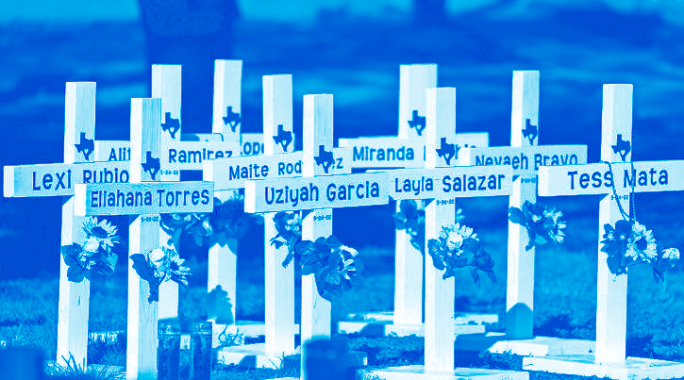
Tougher security after shootings hasn’t helped
Grace Hauck
USA TODAY
New Okla. law nearly bans all abortions
Sean Murphy
ASSOCIATED PRESS

Children on lockdown. Armed oﬃ- cers rushing into a school. Parents and loved ones in tears waiting outside.
It’s an all-too-common scene in the United States, where gunﬁre on school grounds is at a historic level. And it’s not just after mass shootings – smaller- scale incidents at schools are also hap- pening at alarming rates.
“All types of gunﬁre on school prop- erty are at an all-time high,” said David Riedman, lead researcher at the K-12 School Shooting Database at the Naval Postgraduate School’s Center for Home- land Defense and Security, which docu-

Crosses with the names of Tuesday’s shooting victims are placed outside Robb Elementary School in Uvalde, Texas, Thursday. JAE C. HONG/AP
OKLAHOMA CITY – Oklahoma Gov. Kevin Stitt on Wednesday signed into law the nation’s strictest abortion ban, making the state the ﬁrst in the nation to eﬀectively end availability of the procedure.
State lawmakers approved the ban enforced by civil lawsuits rather than criminal prosecution, similar to a Tex- as law that was passed last year. The law takes eﬀect immediately upon Stitt’s signature and prohibits all abor- tions with few exceptions. Abortion providers have said they will stop per- forming the procedure as soon as the

ments every instance a gun is bran- dished or ﬁred or a bullet hits school property for any reason.
There were 249 shootings on school grounds last year – more than any other year since at least 1970, Riedman said. This year, there have been 137 incidents of gunﬁre on school grounds, including
39 involving students during school hours, sports or activities, he said.
On Tuesday, a gunman killed 19 stu- dents and two teachers at Robb Elemen- tary School in Uvalde, Texas.
Prior to Tuesday, there had been 27 people killed, 77 wounded and 21 with other injuries in shootings on school grounds in 2022, Riedman said. Of the victims injured or wounded, 68 were students, he said.
Education Week, which uses a diﬀer- ent metric, reports there have been 27 school shootings in 2022. The outlet tracks shootings on K-12 school proper- ty or on a school bus that resulted in
ﬁrearm-related injuries or deaths and occurred while school was in session or during a school-sponsored event.
Indiscriminate attacks at a school, where the shooter targeted random vic- tims with the intent to kill or injure as many as possible, make up a small por- tion of more than 2,000 school shooting incidents since 1970, Riedman said. Most are disputes that escalate into shootings, he said.
Odis Johnson, executive director of the Johns Hopkins Center for Safe and Healthy Schools, noted that the Nation- al Center for Education Statistics re- ports the number of school shootings with injuries or fatalities has increased steadily for the last seven years and is higher than ever recorded. While policy- makers have allocated tax dollars to hire more school police after each shooting, school safety policy “has not slowed the occurrence of school shootings in U.S. schools,” Johnson said.
Everytown for Gun Safety, a gun control advocacy group, released a re- port this year that found at least 136 in- stances of gunﬁre on school grounds between Aug. 1 and Dec. 31 – a ﬁgure nearly four times the average for that period since Everytown began track- ing gunﬁre on school grounds in 2013. “Whether it’s in class, at gradua- tion, on sports ﬁelds or everywhere else, students across this country have to live in constant fear of gun violence because gun violence is all around us,” said Sari Kaufman of Everytown’s Stu- dents Demand Action, a survivor of the Marjory Stoneman Douglas High shooting in Parkland, Florida, in 2018. In 2020, ﬁrearms became the lead- ing cause of death among children and teenagers in the U.S., overtaking mo- tor vehicle accidents, according to re- cent research using data from the Cen- ters for Disease Control and Preven-
tion.
bill is signed.
“I promised Oklahomans that as governor I would sign every piece of pro-life legislation that came across my desk and I am proud to keep that promise today,” the ﬁrst-term Repub- lican said in a statement. “From the moment life begins at conception is when we have a responsibility as hu- man beings to do everything we can to protect that baby’s life and the life of the mother. That is what I believe and that is what the majority of Oklaho- mans believe.”
Abortion providers across the coun- try have been bracing for the possibil- ity that the U.S. Supreme Court’s new conservative majority might further restrict the practice.
The only exceptions in the Oklaho- ma law are to save the life of a pregnant woman or if the pregnancy is the result of rape or incest that has been reported to law enforcement.

US economy shrank by 1.5% in Q1

Palestinian oﬃcials: Israel

Paul Wiseman
ASSOCIATED PRESS

WASHINGTON – The U.S. economy shrank in the ﬁrst three months of the year even though consumers and busi- nesses kept spending at a solid pace, the government reported Thursday in a slight downgrade of its previous esti- mate for the January-March quarter.
Last quarter’s drop in the U.S. gross domestic product – the broadest gauge of economic output – does not likely sig- nal the start of a recession. The contrac- tion was caused, in part, by a wider trade gap: The nation spent more on im- ports than other countries did on U.S. exports. The trade gap slashed ﬁrst- quarter GDP by 3.2 percentage points.
And a slower restocking of goods in stores and warehouses, which had built up their inventories in the previous quarter for the 2021 holiday shopping season, knocked nearly 1.1 percentage points oﬀ the January-March GDP.
Analysts say the economy has likely resumed growing in the current April- June quarter.
The Commerce Department estimat- ed that the economy contracted at a 1.5% annual pace from January through March, a slight downward revision from its ﬁrst estimate of 1.4%, which it issued last month. It was the ﬁrst drop in GDP since the second quarter of 2020 – in the depths of the COVID-19 recession –

The Commerce Department estimated the economy shrank at a 1.5% annual pace from January through March.
DAVID ZALUBOWSKI/AP FILE

and followed a robust 6.9% expansion in the ﬁnal three months of 2021.
The nation remains stuck in the pain- ful grip of high inﬂation, which has caused particularly severe hardships for lower-income households, many of them people of color. Though many U.S. workers have been receiving sizable pay raises, their wages in most cases haven’t kept pace with inﬂation. In April, con- sumer prices jumped 8.3% from a year earlier, just below the fastest such rise in four decades, set one month earlier.
High inﬂation is also posing a politi- cal threat to President Joe Biden and Democrats in Congress as midterm elections draw near.
Still, by most measures, the econo-
my as a whole remains healthy, though likely weakening. Consumer spending
– the heart of the economy – is still sol- id: It grew at a 3.1% annual pace from January through March. Business in- vestment in equipment, software and other items that are intended to im- prove productivity rose at a healthy 6.8% annual rate last quarter.
And a strong job market is giving people the money and conﬁdence to spend. Employers have added more than 400,000 jobs for 12 straight months, and the unemployment rate is near a half-century low. Businesses are advertising so many jobs that there are now roughly two openings, on av- erage, for every unemployed Ameri- can.
The economy is widely believed to have resumed its growth in the current quarter: In a survey released this month, 34 economists told the Federal Reserve Bank of Philadelphia that they expect GDP to grow at a 2.3% annual pace from April through June and 2.5% for all of 2022. Still, their forecast marked a sharp drop from the 4.2% growth estimate for the current quar- ter in the Philadelphia Fed’s previous survey in February.
In the meantime, higher borrowing rates appear to be slowing at least one crucial sector of the economy – the housing market.

killed reporter
ASSOCIATED PRESS

RAMALLAH, West Bank – The Pal- estinian Authority on Thursday said its investigation into the shooting death of Al Jazeera journalist Shireen Abu Akleh proves she was deliberately killed by Israeli forces.
Israel is likely to reject the ﬁndings as biased and unfounded.
Abu Akleh, a veteran Palestinian- American reporter for Al Jazeera’s Ara- bic service, was shot in the head on May 11 during an Israeli military raid in the occupied West Bank.
Witnesses and Palestinian oﬃcials have said she was hit by Israeli ﬁre. Is- rael says she was shot during a battle between its soldiers and Palestinian militants. It says that only a ballistic analysis of the bullet – which is held by the Palestinian Authority – and the soldiers’ guns can determine who ﬁred the fatal shot.
Palestinian attorney general Akram Al Khateeb said his investigation had determined there were no militants in the area and claimed the army saw Abu Akleh and other journalists and knew they were journalists.
He claimed that Abu Akleh was shot “directly and deliberately” as she tried to escape.

NATION & WORLD WATCH FROM WIRE REPORTS
Public Announcement Concerning a Proposed Health Care Project
UMass Memorial Health Care, Inc. (the “Applicant”), with a principal place
of business at One Biotech Park, 365 Plantation Street, Worcester, MA
01605, intends to file a Notice of Determination of Need (“DoN”) with the
Massachusetts Department of Public Health for a substantial change in
service and substantial capital expenditure by UMass Memorial Medical
Center (“UMMMC”), located at 55 Lake Avenue North, Worcester, MA 01655.
This Application includes the following: (A) the renovation of a 6-story
building adjacent to UMMMC’s University Campus, located at 378 Plantation
St, Worcester, MA 01605, that will contain 72 additional medical-surgical
beds, one (1) additional computed tomography unit, and shell space for
future build out to accommodate clinical services; (B) 19 additional medical-
surgical beds on UMMMC’s Memorial Campus; and (C) other renovation
projects to improve the existing services and facilities across UMMMC’s
Memorial and University Campuses (the “Proposed Project”). The total
value of the Proposed Project based on the maximum capital expenditure
is $143,242,167. The Applicant does not anticipate any price or service
impacts on the Applicant’s existing patient panel as a result of the Proposed
Project. Any ten Taxpayers of Massachusetts may register in connection
with the intended Application by no later than July 9, 2022 or 30 days from
the Filing Date, whichever is later, by contacting the Department of Public
Health, Determination of Need Program, 250 Washington Street, 6th Floor,
Boston, MA 02108. | WM-30495229

Texas court spares man
who killed girl, 11, from execution

FORT WORTH, Texas – Texas’ top criminal appeals court on Wednesday ordered a man convicted of kill- ing an 11-year-old girl be removed from the state’s death row. The Texas Court of Criminal Appeals ruled by a 6-3 vote that Juan Ramon Meza Segundo does not qualify for execution because of intellectual disability under a recent Supreme Court standard. The appeals court reformed his death sentence to life imprison- ment with parole possible, the only alternative sen- tence for capital murder available at Segundo’s 2006 sentencing.
Japan, US fly ﬁghters after China drill, N. Korean missiles

TOKYO – Japanese and U.S. forces conducted a joint ﬁghter jet ﬂight over the Sea of Japan, Japan’s military said Thursday, in an apparent response to a Russia-China joint bomber ﬂight while President Joe Biden was in Tokyo. The Japan-U.S. joint ﬂight on Wednesday involved eight warplanes based in Japan, the Joint Staﬀ of the Japan Self-Defense Forces said. The joint ﬂight was meant to conﬁrm the combined ca- pabilities of the two militaries and further strengthen the Japan-U.S. alliance, it said in a statement.

APPENDIX 9 ARTICLES OF INCORPORATION

Articles of Organization
UMass Memorial Health Care, Inc.
Available at:

https://corp.sec.state.ma.us/CorpWeb/CorpSearch/CorpSearchRedirector.aspx?Action=PDF&Pat h=CORP_DRIVE1/2013/1008/000486333/0030/020502817260_1.pdf

APPENDIX 11 FILING FEE



Capital Planning & Management

MEMO

To: | Elizabeth Kelly, Interim DoN Program Director
From: | Scott Reynolds, Director of Design and Construction
Date: | 6/9/22
RE: | DoN Filing

Elizabeth,

Attached is a check in the amount of $286,484.33 for the Determination of Need filing for UMass Memorial Health Care, Inc. The DoN Application number is UMMHC-22042514-HE. Please let me know if you have any questions.
Thank you, Scott Reynolds
Director of Design and Construction Capital Planning and Management 508-334-5216

UMass Memorial Medical Center, Hahnemann Campus, Grosvenor Building, 281 Lincoln St., Worcester, MA 01605
508-334-8168 Fax: 508-334-8172

The Proposed Project includes the following: (A) the renovation of a 6-story building adjacent to UMMMC’s University Campus, located at 378 Plantation St, Worcester, MA 01605, that will contain 72 additional medical/surgical beds, one (1) additional computed tomography unit, and shell space for future build out to accommodate clinical services; (B) 19 additional medical/surgical beds on UMMMC’s Memorial Campus; and (C) other renovation projects to improve the existing services and facilities across UMMMC’s Memorial and University Campuses.

