##### Determination of Need Application

**Table of Contents Exhibits**

1. Determination of Need Application
2. Determination of Need Attachments
   1. Determination of Need Narrative
   2. Copy of Notice of Intent
   3. Affidavit of Truthfulness Form
   4. Filing Fee – Scanned copy of Application Filing Fee
   5. Affiliated Parties Table Question 1.9
   6. Change in Service Tables Questions 2.2 & 2.3
   7. Certification from an Independent Certified Public Accountant
   8. Evidence of Community Engagement for Factor 1 – Information Session Power Point Presentation to the Marlborough Hospital Patient and Family Advisory Council and Marlborough Hospital Board of Trustees (list of Trustees included herein)
   9. Limited Liability Company Documents
      1. Certificate of Organization
      2. Three (3) Certificates of Amendment
      3. Corporate Document Access

**Exhibit B.b**

Copy of Notice of Intent

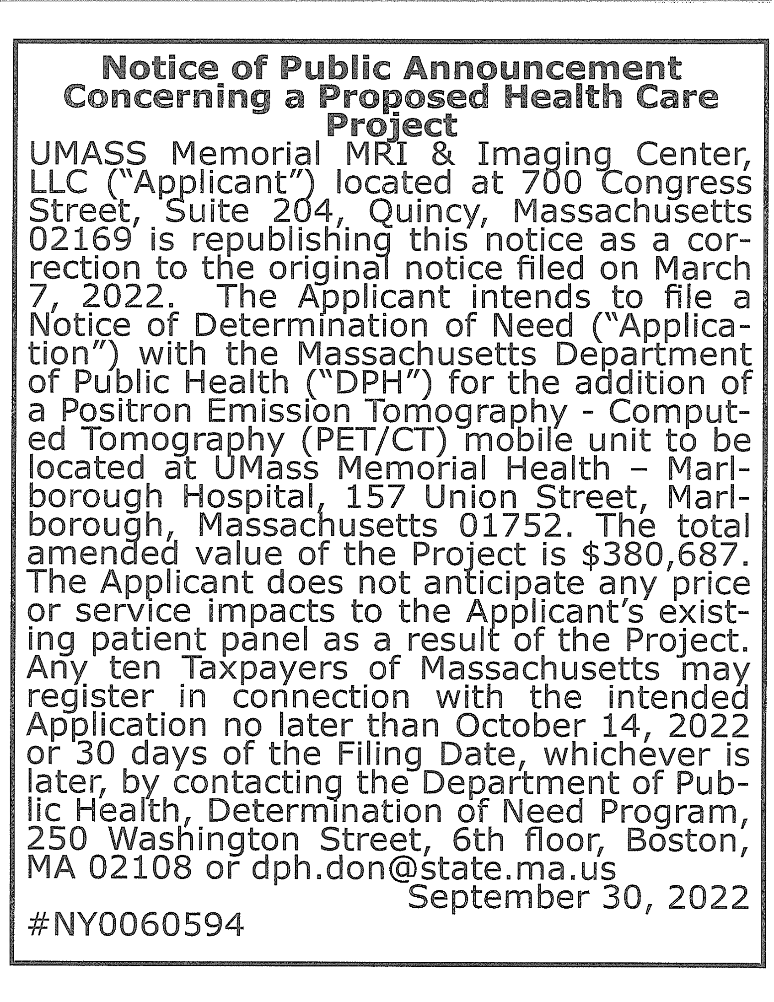

[https://www.masspublicnotices.org/DetailsPrint.aspx?SID=kcl4k12vnobgbglibwqmqus2&1D=359776](http://www.masspublicnotices.org/DetailsPrint.aspx?SID=kcl4k12vnobgbglibwqmqus2&1D=359776)

**Boston Herald**

**bostonherald.com**

Publication Name:

**Boston Herald**

Publication URL:

[**www.bostonherald.com/**](http://www.bostonherald.com/)

Publication City and State:

**Boston, MA**

Publication County:

**Suffolk**

Notice Popular Keyword Category:

Notice Keywords:

**UMASS Memorial MRI**

Notice Authentication Number:

**202210071145167153994**

**1239652448**

Notice URL:

Back

Notice File: Notice Publish Date:

Adobe PDF symbolUSR82 l U826 09302022 2383338.pdf Friday, September 30, 2022

**Notice Content**

***PLEASE NOTE:*** *The following text was electronically converted from the PDF document above, and may not be 100% accurate. Because of this, please view the PDF for the most accurate information.*

**Notice of Public Announcement Concerning a Proposed Health Care Project UMASS Memorial MRI & Imaging Center, LLC ("Applicant") located at 700 Congress Street, Suite 204, Quincy, Massachusetts 02169 is republishing this notice as a car- rection to the original notice filed on March 7, 2022. The Applicant intends to file a Notice of Determination of Need ("Application") with the Massachusetts Department of Public Health ("DPH") for the addition of a Positron Emission Tomography - Computed Tomography (PET/CT) mobile unit to be located at UMass Memorial Health - Marl- borough Hospital, 157 Union Street, Marl- borough, Massachusetts 01752. The total amended value of the Project is**

**$380,687. The Applicant does not anticipate any price or service impacts to the Applicant1s existing patient panel as a result of the Project. Any ten Taxpayers of Massachusetts may register in connection with the intended Application no later than October**

*Web display limited to 1,000 characters. Please view the PDF for the complete Public Notice.*

**Back**

[https://www.masspublicnotices.org/DetailsPrint.aspx?SID=kcl4k12vnobgbglibwqmqus2&1D=359776](http://www.masspublicnotices.org/DetailsPrint.aspx?SID=kcl4k12vnobgbglibwqmqus2&1D=359776) 1/1

Exhibit B.c

Affidavit of Truthfulness Form

 Version: 7-6-17

**Massachusetts Department of Public Health**

**Determination of Need**

**Affidavit of Truthfulness and Compliance**

**with Law and Disclosure Form 100.405 (B)**

**Instructions:** Complete Information below. When complete check the box "This document is ready to print:". This will date stamp and lock the form. Print Form. Each person must sign and date the form. When all signatures have been collected, scan the document and e-mail to: [**dph.don@state.ma.us**](mailto:dph.don@state.ma.us)Include all attachments as requested.

Application Number: UMMIC-22062409-RE

Original Application Date: 6/24/2022

Applicant Name: UMASS Memorial MRI & Imaging Center

Application Type: DoN-Required Equipment

Applicant's Business Type: LLC

Is the Applicant the sole member or sole shareholder of the Health Facility(ies) that are the subject of this Application? Yes

The undersigned certifies under the pains and penalties of perjury:

1. The Applicant is the sole corporate member or sole shareholder of the Health Facility(ies) that are the subject of this Application;
2. I have read 105 CMR 100.000, the Massachusetts Determination of Need Regulation;
3. I understand and agree to the expected and appropriate conduct of the Applicant pursuant to 105 CMR 100.800;
4. I have read this application for Determination of Need including all exhibits and attachments, and certify that all of the information contained herein is accurate and true;
5. I have submitted the correct Filing Fee and understand it is nonrefundable pursuant to 105 CMR 100.405(B);
6. I have submitted the required copies of this application to the Determination of Need Program, and, as applicable, to all Parties of Record and other parties as required pursuant to 105 CMR 100.405(B);
7. I have caused, as required, notices of intent to be published and duplicate copies to be submitted to all Parties of Record, and all carriers or third-party administrators, public and commercial, for the payment of health care services with which the Applicant contracts, and with Medicare and Medicaid, as required by 105 CMR 100.405(C), et seq.;
8. I have caused proper notification and submissions to the Secretary of Environmental Affairs pursuant to 105 CMR 100.405(E) and 301 CMR 11.00;
9. If subject to M.G.L. c. 6D, § 13 and 958 CMR 7.00, I have submitted such Notice of Material Change to the HPC - in accordance with 105 CMR 100.405(G);
10. Pursuant to 105 CMR 100.210(A)(3), I certify that both the Applicant and the Proposed Project are in material and substantial compliance and good standing with relevant federal, state, and local laws and regulations, as well as with all previously issued Notices of Determination of Need and the terms and Conditions attached therein;
11. I have read and understand the limitations on solicitation of funding from the general public prior to receiving a Notice of Determination of Need as established in 105 CMR 100.415;
12. I understand that, if Approved, the Applicant, as Holder of the DoN, shall become obligated to all Standard Conditions pursuant to 105 CMR 100.310, as well as any applicable Other Conditions as outlined within 105 CMR 100.000 or that otherwise become a part of the Final Action pursuant to 105 CMR 100.360;
13. Pursuant to 105 CMR 100.705(A), I certify that the Applicant has Sufficient Interest in the Site or facility; and
14. Pursuant to 105 CMR 100.705(A), I certify that the Proposed Project is authorized under applicable zoning by-laws or ordinances, whether or not a special permit is required; or,
    1. If the Proposed Project is not authorized under applicable zoning by-laws or ordinances, a variance has been received to permit such Proposed Project; or,
    2. The Proposed Project is exempt from zoning by-laws or ordinances.

|  |
| --- |
| **LLC**  All parties must sign. Add additional names as needed  Thomas A. Shields <Signature on File> 08/28/2022  Name: Signature: Date: |

**This document is ready to print?** Yes Date/time Stamp: 06/24/2022 10:13 am

**Exhibit B.d**

Scanned Copy of Application Filing Fee Check

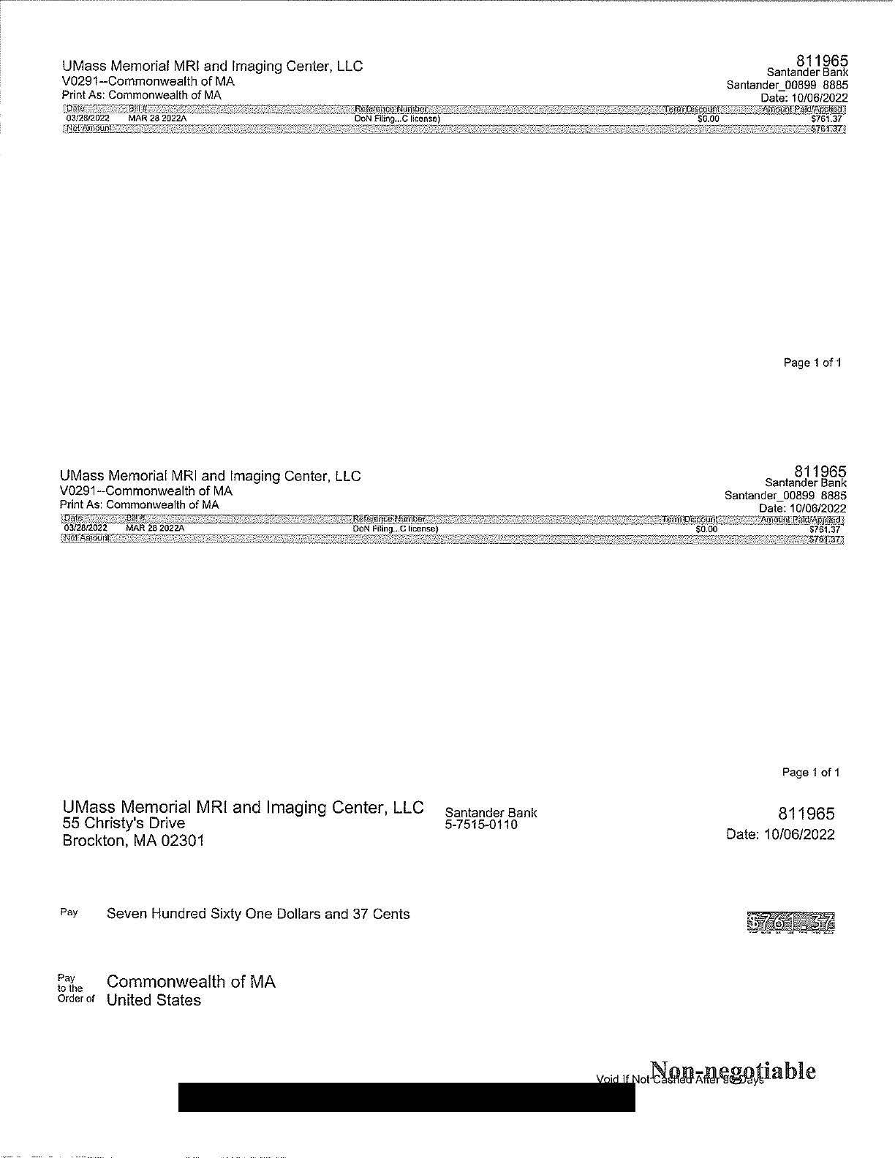

**Exhibit B.e**

Affiliated Parties Table Question 1.9

 draft version 3-15-2017

**Massachusetts Department of Public Health**

**Determination of Need**

**Affiliated Parties**

Application Date: 6/24/2022

Application Number: UMMIC-22062409-RE

**Applicant Information**

Applicant Name: UMass Memorial MRI & Imaging Center, LLC

Contact Person: Courtney Pasay Vaughan

Title: Attorney

Phone: 9789982464

E-mail: cpvaughan@publicpolicylaw.com

**Affiliated Parties**

1.9 Affiliated Parties: List all officers, members of the board of directors, trustees, stockholders, partners, and other Persons who have an equity or otherwise controlling interest in the application.

| **Add/ Del Rows** | **Name (Last)** | **Name (First)** | **Mailing Address** | **City** | **State** | **Affiliation** | **Position with affiliated entity (or with Applicant)** | **Stock, shares, or partnership** | **Percent Equity (numbers only)** | **Convictions or violations** | **List other health care facilities affiliated with** | **Business relationship with Applicant** |
| --- | --- | --- | --- | --- | --- | --- | --- | --- | --- | --- | --- | --- |
| +/- | Shields | Thomas | 700 Congress Street Suite 204 | Quincy | MA | Shields Health Care Group | Chief Executive Officer | Partnership |  | No | Please See Attached List | No |

**Document Ready for Filing**

When document is complete click on "document is ready to file". This will lock in the responses and date and time stamp the form. To make changes to the document un-check the "document is ready to file" box.

Edit document then lock file and submit Keep a copy for your records. Click on the "Save" button at the bottom of the page. To submit the application electronically, click on the "E-mail submission to Determination of Need" button.

This document is ready to file? Yes

Date/time Stamp: 10/04/2022 9:20 am

E-mail submission to Determination of Need

|  |  |  |  |  |  |  |
| --- | --- | --- | --- | --- | --- | --- |
| **Legal Name** | **DBA** | **Service Location Address** | **City/Town** | **State** | **Zip** | **Medicare**  **PTAN** |
| Southeastern Massachusetts Regional MRI Limited  Partnership | Shields MRI Brockton | 265 Westgate Dr | Brockton | MA | 02301-1817 | 016469 |
| Fall River-New Bedford Regional MRI Limited Partnership | Shields MRI Dartmouth | 313 Faunce Corner Rd | Dartmouth | MA | 02747-1252 | 018869 |
| Fall River-New Bedford Regional MRI Limited Partnership | Shields MRI at St Luke's Hospital | 361 Allen St | New Bedford | MA | 02740-2107 | 0028894 |
| Shields Healthcare of Cambridge Inc | Shields MRI Brighton | 385 Western Ave | Brighton | MA | 02135-1005 | 020369 |
| South Shore MRI Limited Partnership | Shields MRI Weymouth | 26 Rockway Ave | Weymouth | MA | 02188-3906 | 327033 |
| Massachusetts Bay Regional MRI Limited Partnership | Shields MRI Boston | 161 Granite Ave | Dorchester | MA | 02124-5492 | 020169 |
| Massachusetts Bay Regional MRI Limited Partnership | Shields MRI Dedham | 40 Allied Dr - Ste 112 | Dedham | MA | 02026-6146 | 0034538 |
| Shields MRI & Imaging Center of Cape Cod LLC | Shields MRI & Imaging Center of Cape Cod | 2 Iyanough Rd - Rt 28 | W Yarmouth | MA | 02673-8135 | 327057 |
| U Mass Memorial MRI & Imaging Center LLC | Shields MRI at UMass Memorial Shrewsbury  St | 214 Shrewsbury St | Worcester | MA | 01604-4629 | 002737301 |
| U Mass Memorial MRI & Imaging Center LLC | Shields MRI at UMass Memorial Memorial  Campus | 119 Belmont St-U Mass Memorial  Campus | Worcester | MA | 01605-2903 | 002737302 |
| U Mass Memorial MRI & Imaging Center LLC | Shields MRI at Wing Hospital | 40 Wright St | Palmer | MA | 01069-1138 | 327040 |
| U Mass Memorial MRI & Imaging Center LLC | Shields PETCT at UMass Memorial Burbank | 275 Nichols Rd | Fitchburg | MA | 01420-1919 | 0027373 |
| U Mass Memorial MRI & Imaging Center LLC | Shields MRI at UMass Memorial University  Campus Ste B | 55 Lake Ave North Ste H1-713B | Worcester | MA | 01655-0002 | S300166800 |
| U Mass Memorial MRI & Imaging Center LLC | Shields MRI at UMass Memorial University  Campus Ste A | 55 Lake Ave North Ste H1-351A | Worcester | MA | 01655-0002 | S300563649 |
| Baystate MRI & Imaging Center LLC | Shields MRI and Baystate Health | 80 Wason Ave | Springfield | MA | 01107-1132 | 0018589 |
| Shields Imaging of Eastern Massachusetts LLC | Shields Imaging of Eastern Massachusetts | 55 Fogg Rd | S Weymouth | MA | 02190-2432 | 327088 |
| U Mass Memorial HealthAlliance MRI Center LLC | Shields MRI at UMass Memorial Health  Alliance Campus | 100 Hospital Rd-Ste 1A | Leominster | MA | 01453-2253 | 327082 |
| Shields MRI of Framingham LLC | Shields MRI of Framingham | 14 Cochituate Rd | Framingham | MA | 01701-7915 | 327116 |
| U Mass Memorial MRI-Marlborough LLC | Shields MRI at UMass Memorial Marlborough  Campus | 157 Union St | Marlborough | MA | 01752-1228 | 327115 |
| Frankin MRI Center LLC | Shields MRI at Baystate Franklin Medical  Center | 164 High St | Greenfield | MA | 01301-2613 | 0010942 |
| Radiation Therapy of Winchester LLC | Winchester Hospital Radiation Oncology  Center | 620 Washington St | Winchester | MA | 01890-1328 | 0000272 |
| Cape Cod PET-CT Services LLC | Shields PET Service of Cape Cod Harwich | 525 Long Pond Dr | Harwich | MA | 02645-1227 | 0010594 |
| Cape Cod PET-CT Services LLC | Shields PET Service of Cape Cod Sandwich | 2 Jan Sebastian Dr | Sandwich | MA | 02563-2377 | 001059401 |
| PET-CT Services By Tufts Medical Center and Shields LLC | Shields PETCT at Tufts Medical Center | 800 Washington St | Boston | MA | 02111-1552 | 0024437 |
| PET-CT Services By Tufts Medical Center and Shields LLC | Metrowest PET-CT at Shields Framingham in Affiliation with Tufts Medical Center | 14 Cochituate Rd-Ste 1A | Framingham | MA | 01701-7915 | S300129479 |
| Shields Imaging of Lowell General Hospital LLC | Shields MRI at Lowell General Hospital | 295 Varnum Ave | Lowell | MA | 01854-2134 | 0025829 |
| Shields Imaging of Lowell General Hospital LLC | Shields MRI at Lowell General Hospital  Chelmsford | 10 Research Pl | N Chelmsford | MA | 01863-2456 | 002582901 |
| Shields Imaging of Lowell General Hospital LLC | Shields MRI at Lowell General Hospital Saints  Campus | 1 Hospital Dr | Lowell | MA | 01852-1311 | S100138677 |
| Winchester Hospital-Shields MRI LLC | Shields MRI Winchester Hospital at Unicorn  Park | 200 Unicord Park Dr-Ste 402 | Woburn | MA | 01801-3342 | 0033808 |
| Winchester Hospital – Shields MRI | Winchester Hospital/Shields MRI | 41 Highland Ave - Ste G1 | Winchester | MA | 01890-1446 | S300634235 |
| Shields Signature Imaging LLC | Shields Signature Imaging | 680 Centre St | Brockton | MA | 02302-3308 | S300291877 |
| Shields Sturdy PETCT LLC | Shields Sturdy PETCT | 211 Park St | Attleboro | MA | 02703-3143 | S300305002 |
| Shields PETCT at Cooley Dickinson Hospital LLC | Shields PETCT at Cooley Dickinson Hospital | 30 Locust St | Northampton | MA | 01060-2052 | S300333217 |
| Shields Imaging at Anna Jaques Hospital LLC | Shields Imaging at Anna Jaques Hospital | 25 Highland Ave | Newburyport | MA | 01950-3867 | S300357534 |
| Shields PET-CT at CMMC LLC | Shields PETCT at CMMC | 300 Main St | Lewiston | ME | 04240-7027 | E300352765 |
| Shields PET-CT at CMMC LLC | Shields PETCT at CMMC @ Topsham | 105 Topsham Fair Mall Rd | Topsham | ME | 04086-1773 | E300511797 |
| Shields Imaging at York Hospital LLC | Shields Imaging at York Hospital | 114 Sanford Rd | Wells | ME | 04090-5533 | E100388241 |
| Shields PETCT at Berkshire Medical Center LLC | Shields PETCT at Berkshire Medical Center | 165 Tor Court | Pittsfield | MA | 01201-3001 | S300426507 |
| Shields Imaging of Portsmouth LLC | Shields MRI Portsmouth | 1900 Lafayette Rd | Portsmouth | NH | 03801-5679 | n/a |
| Healthcare Enterprises LLC | The Surgery Center at Shrewsbury | 151 Main St | Shrewsbury | MA | 01545-2101 | S300494903 |
| Shields Imaging with Central Maine Health LLC | Shields Imaging at Central Maine Health,  Topsham | 105 Topsham Fair Mall Rd | Topsham | ME | 04086-1773 | E300498988 |
| Shields Imaging with Central Maine Health LLC | Shields Imaging at Central Maine Health,  Auburn | 690 Minot Ave, Ste 1 | Auburn | ME | 4210 | E300520539 |
| Baystate Health Urgent Care Center LLC | Baystate Health Urgent Care Longmeadow | 688 Bliss Rd | Longmeadow | MA | 01106-1534 | S100483242 |
| Baystate Health Urgent Care Center LLC | Baystate Health Urgent Care Feeding Hills | 241 S Westfield St | Feeding Hills | MA | 01030-2713 | S100483242 |
| Baystate Health Urgent Care Center LLC | Baystate Health Urgent Care Westfield | 24 Union Street | Westfield | MA | 01085 | S100483242 |
| Natick Surgery Center, LLC | New England Surgical Suites | 313 Speen St - Ste 200 | Natick | MA | 01760 | S300693361 |
| Medford Surgery Center, LLC | Medford Surgery Center | 170 Govenors Ave -Ste 100 | Medford | MA | 02155 | S300777754 |
| Shields Radiology Assoc |  | 214 Shrewsbury St | Worcester | MA | 01604-4629 |  |
| Shields Tufts Medical Center Imaging Management LLC |  | 800 Washington St | Boston | MA | 02111 |  |
| Shields Imaging Management at Emerson Hospital LLC |  | 133 Old Road to 9 Acre Corner | Concord | MA | 01742 |  |
| Shields Imaging Management at Emerson Hospital LLC |  | 133 Littleton Road | Westford | MA | 01886 |  |
| Maine Imaging Services LLC |  | 128 State Street - #3 | Augusta | ME | 04330 |  |
| Cape Cod Imaging Services LLC |  | 27 Park St | Hyannis | MA | 02601 |  |
| Cape Cod Imaging Services LLC |  | 525 Pond Drive | Harwich | MA | 02645 |  |
| Cape Cod Imaging Services LLC |  | 35 Wilkens Lane | Hyannis | MA | 02601 |  |
| Cape Cod Radiation Therapy Services LLC |  | 1 Ter Heun Drive, 1st floor | Falmouth | MA | 02540 |  |
| Chelmsford Surgery Center LLC | The Surgery Center of the Merrimack Valley | 10 Research Pl, Suite 10 | N Chelmsford | MA | 01863 | S300817670 |

Exhibit B.f

Change in Service Tables Questions 2.2 & 2.3

 Version 6-14-17

**Massachusetts Department of Public Health**

**Determination of Need Change in Service**

Application Number: UMMIC-22062409-RE

Original Application Date: 06/24/2022

**Applicant Information:**

Applicant Name: UMass Memorial MRI & Imaging Center, LLC

Contact Person: Courtney Pasay Vaughan

Title: Attorney

Phone: 9789982464

E-mail: [cpvaughan@publicpolicylaw.com](mailto:cpvaughan@publicpolicylaw.com)

**Facility:**

Complete the tables below for each facility listed in the Application Form

1 Facility Name: UMass Memorial MRI & Imaging Center (@ Marlborough Hospital)

CMS Number: 327115

Facility Type: Clinic

**Change in Service:**

2.2 Complete the chart below with existing and planned service changes. Add additional services within each grouping if applicable.

| **Add/ Del Rows** |  | **Licensed Beds** | **Operating Beds** | **Change in Number of Beds (+/-)** | | **Number of Beds After Project Completion (calculated)** | | **Patient Days** | **Patient Days** | **Occupancy Rate for Operating Beds** | | **Average Length of Stay** | **Number of Discharges** | **Number of Discharges** |
| --- | --- | --- | --- | --- | --- | --- | --- | --- | --- | --- | --- | --- | --- | --- |
|  |  | Existing | Existing | Licensed | Operating | Licensed | Operating | (Current/ Actual) | Projected | Current Beds | Projected | (Days) | Actual | Projected |
|  | **Acute** |  |  |  |  |  |  |  |  |  |  |  |  |  |
|  | Medical/ Surgical |  |  |  |  |  |  |  |  | 0% | 0% |  |  |  |
|  | Obstetrics (Maternity) |  |  |  |  |  |  |  |  | 0% | 0% |  |  |  |
|  | Pediatrics |  |  |  |  |  |  |  |  | 0% | 0% |  |  |  |
|  | Neonatal Intensive Care |  |  |  |  |  |  |  |  | 0% | 0% |  |  |  |
|  | ICU/CCU/SICU |  |  |  |  |  |  |  |  | 0% | 0% |  |  |  |
| +/- |  |  |  |  |  |  |  |  |  | 0% | 0% |  |  |  |
|  | Total Acute |  |  |  |  |  |  |  |  | 0% | 0% |  |  |  |
|  | **Acute Rehabilitation** |  |  |  |  |  |  |  |  | 0% | 0% |  |  |  |
| +/- |  |  |  |  |  |  |  |  |  | 0% | 0% |  |  |  |
|  | Total Rehabilitation |  |  |  |  |  |  |  |  | 0% | 0% |  |  |  |
|  | **Acute Psychiatric** |  |  |  |  |  |  |  |  |  |  |  |  |  |
|  | Adult |  |  |  |  |  |  |  |  | 0% | 0% |  |  |  |
|  | Adolescent |  |  |  |  |  |  |  |  | 0% | 0% |  |  |  |
|  | Pediatric |  |  |  |  |  |  |  |  | 0% | 0% |  |  |  |
|  | Geriatric |  |  |  |  |  |  |  |  | 0% | 0% |  |  |  |
| +/- |  |  |  |  |  |  |  |  |  |  |  |  |  |  |
|  | Total Acute Psychiatric |  |  |  |  |  |  |  |  | 0% | 0% |  |  |  |
|  | **Chronic Disease** |  |  |  |  |  |  |  |  | 0% | 0% |  |  |  |
| +/- |  |  |  |  |  |  |  |  |  | 0% | 0% |  |  |  |
|  | Total Chronic Disease |  |  |  |  |  |  |  |  | 0% | 0% |  |  |  |
|  | **Substance Abuse** |  |  |  |  |  |  |  |  |  |  |  |  |  |
|  | Detoxification |  |  |  |  |  |  |  |  | 0% | 0% |  |  |  |
|  | Short-term intensive |  |  |  |  |  |  |  |  | 0% | 0% |  |  |  |
| +/- |  |  |  |  |  |  |  |  |  | 0% | 0% |  |  |  |
|  | Total Substance Abuse |  |  |  |  |  |  |  |  | 0% | 0% |  |  |  |
|  | **Skilled Nursing Facility** |  |  |  |  |  |  |  |  |  |  |  |  |  |
|  | Level II |  |  |  |  |  |  |  |  | 0% | 0% |  |  |  |
|  | Level III |  |  |  |  |  |  |  |  | 0% | 0% |  |  |  |
|  | Level IV |  |  |  |  |  |  |  |  | 0% | 0% |  |  |  |
| +/- |  |  |  |  |  |  |  |  |  | 0% | 0% |  |  |  |
|  | Total Skilled Nursing |  |  |  |  |  |  |  |  | 0% | 0% |  |  |  |

Complete the chart below If there are changes other than those listed in table above.

|  |  |  |  |  |  |  |
| --- | --- | --- | --- | --- | --- | --- |
| **Add/Del Rows** | **List other services if Changing e.g. OR, MRI, etc** | **Existing Number of Units** | **Change in Number +/-** | **Proposed Number of Units** | **Existing Volume** | **Proposed Volume** |
| +/- | PET-CT | 0 | 1 | 1 |  | 165 |

**Document Ready for Filing**

When document is complete click on "document is ready to file". This will lock in the responses and date and time stamp the form. To make changes to the document un-check the "document is ready to file" box.

Edit document then lock file and submit. Keep a copy for your records. Click on the "Save" button at the bottom of the page.

To submit the application electronically, click on the "E-mail submission to Determination of Need" button.

This document is ready to file? Yes

Date/Time Stamp: 09/16/2022 11:42 am

Email Submission to Determination of Need

**Exhibit B.h**

Evidence of Community Engagement for Factor 1: Information Session Presentation to PFAC and Board of Trustees

+ Board of Trustee Members

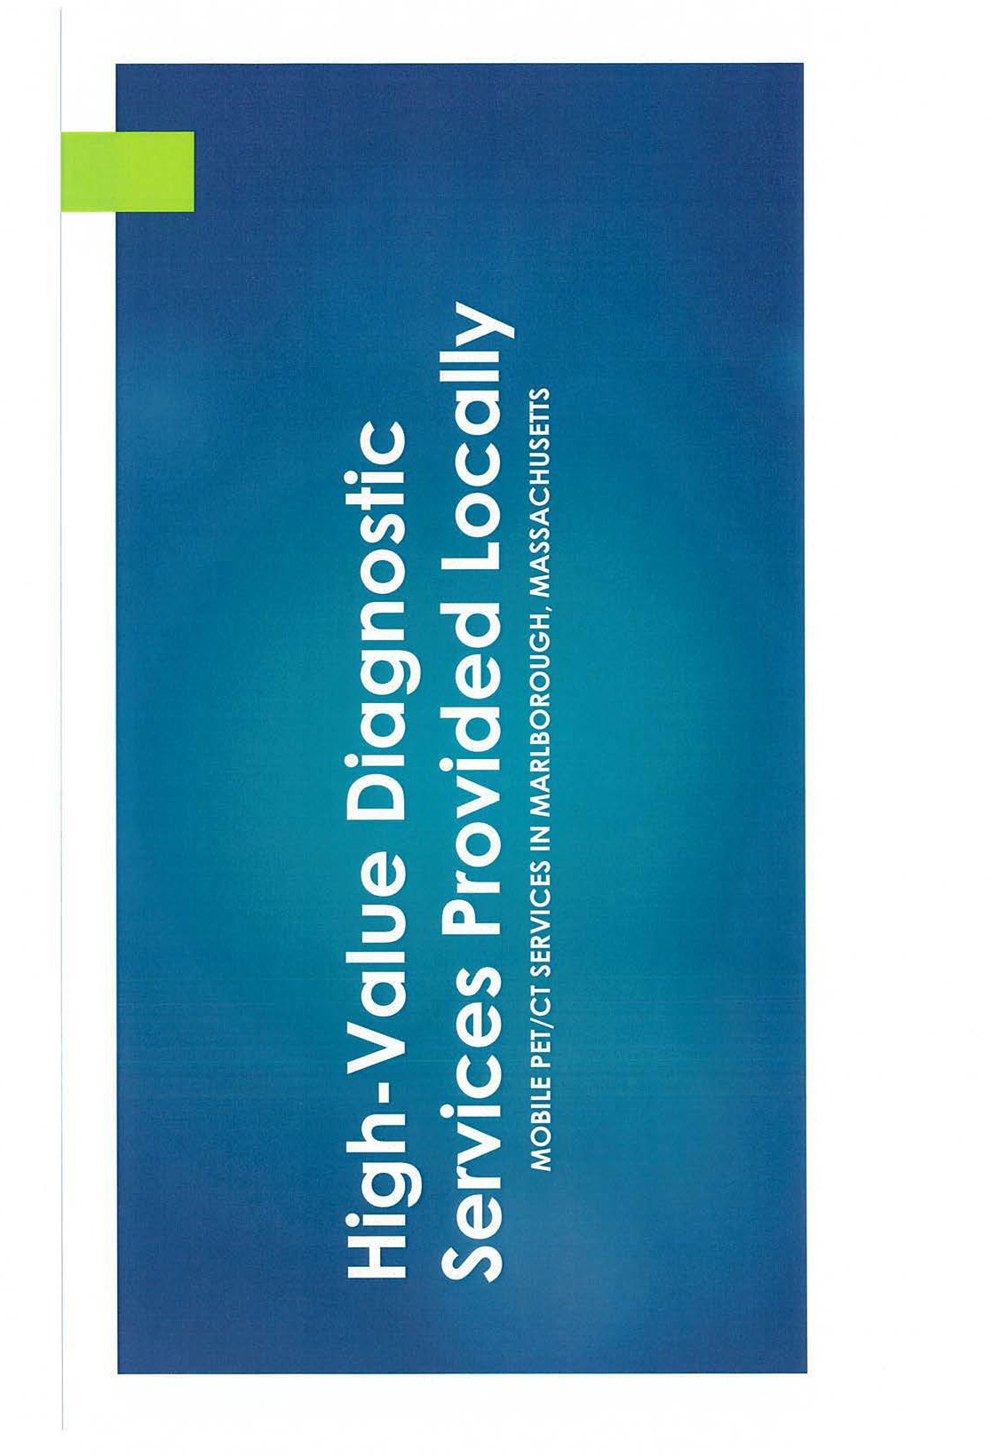

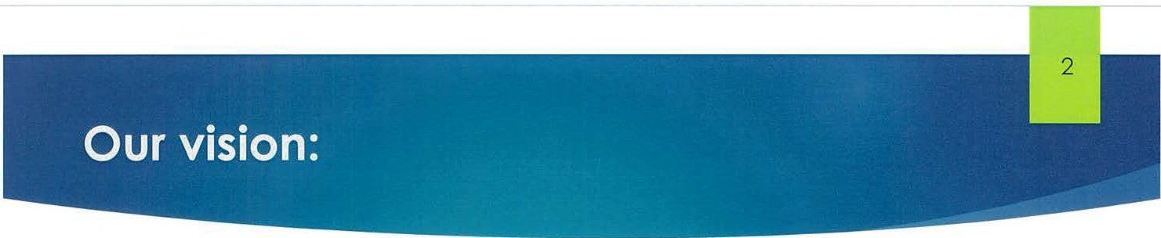

Welcome and thank you for your interest in this project

We are excited to share our plans to add mobile PET/CT services at Marlborough Hospital

This project will share existing imaging space with the mobile MRI service on its dormant day (Sunday)

PET/CT services will complement the cancer treatment and breast services currently provided at Marlborough Hospital The service will operate on an outpatient fee schedule which will lower the cost of services

This is an opportunity to introduce you to some of the individuals involved, solicit your feedback & any answer questions

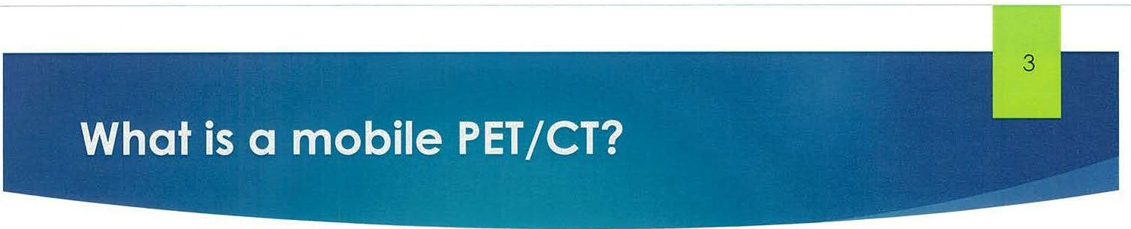

###### PET/CT is a radiology based imaging tool which is valuable in staging cancer, evaluating Alzheimer's disease, and also has cardiac applications

###### Patients in the Marlborough community currently seek treatment services like chemotherapy and radiation therapy at Marlborough Hospital but must currently travel outside the community to have a PET/CT which would aid in determining these treatments

###### Providing PET/CT in a mobile environment allows community hospitals with less demand provide this care locally in a shared use model

###### The Joint Venture between **UMASS** Memorial and Shields Health Care Group has current services located in Worcester and Fitchburg

###### Patients would enter the hospital radiology department and would enter the mobile environment that is temporarily attached to the building, enclosed from the outside elements

###### Current patient experience surveys at the current joint venture locations is 98% or better.



* Outpatient reimbursement with a high value service creates high patient satisfaction with lower out of pocket responsibility
  + 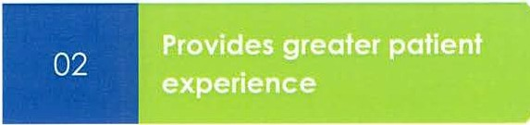greater scheduling flexibility
  + Highly experienced technical staff
  + State of the art equipment
  + 03: Keeps care to the community
    04: Increases accessibility of careeasy, convenient location
  + Transportation assistance
  + provides local option for physicians and patients
  + Efficient weekly offered care minimizes time to treatment
  + shifts appropriate care from inpatient to outpatient

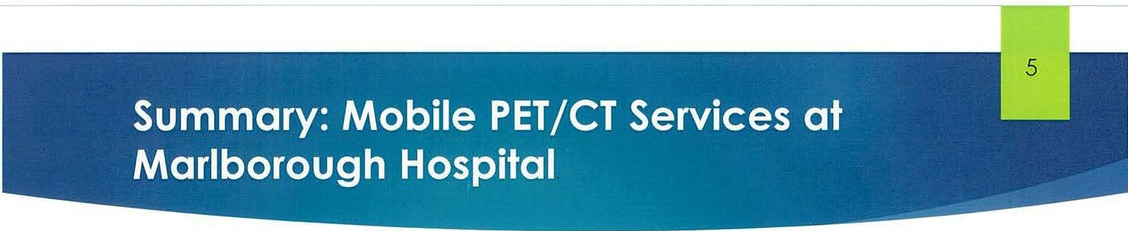

Icon of hospital in center, labeled Marlborough hospital. Flanked on either side with arrows pointing toward the icon are Shields Health Care (left) and UMASS Memorial Healthcare (right)

**Services**

**Facility**

* PET/CT Service every Sunday
* Cancer staging Alzheimer's disease evaluation, cardiac applications
* Shared space with mobile MRI
* same convenient location - lower cost of care

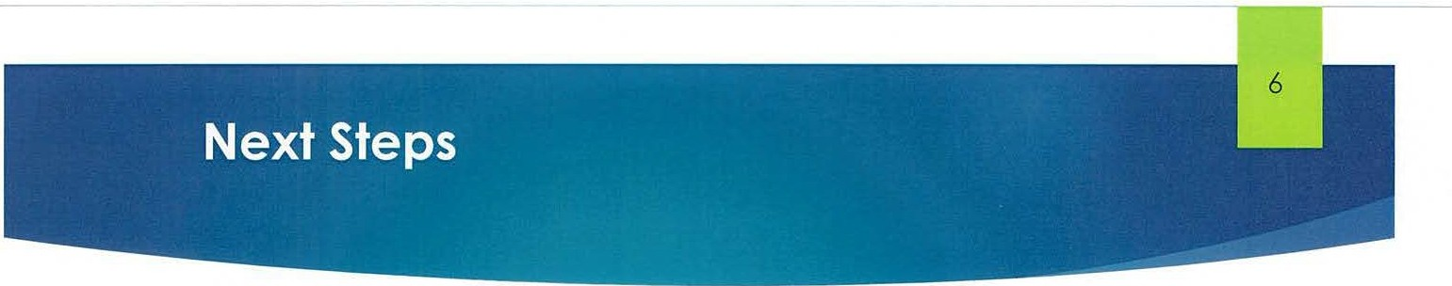



WE WANT YOUR INPUT

on the concept of mobile PET/CT

WE WILL KEEP YOU INFORMED

as project progresses with DPH

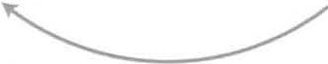

**UMass Memorial Health Marlborough Hospital**

**Board of Trustees 2022**

* Brian Bouvier
  + President
  + Bouvier Pharmacy
* Douglas Brown (ex-officio)
  + President, UMass Memorial Community Hospitals, Inc.
  + Chief Administrative Officer, UMass Memorial Health Care
* Charles Cavagnaro, MD (ex-officio)
  + Chief Medical Officer
  + UMass Memorial - Marlborough Hospital
  + UMass Memorial - HealthAlliance-Clinton
* Ellen Dorian
  + President
  + Main Street Bank
* William Fischer
  + Community member
* John Gobron (ex-officio)
  + Co-chair
  + Marlborough Hospital Patient Family Advisory Council
* Kimi Kobayashi, MD
  + Chief Quality Officer
  + UMass Memorial Health
* Joseph Leandres
  + Community member
* Ann Molloy, Esq., Vice Chair
  + Partner
  + Mountain, Dearborn & Whiting
* Michael Murphy, Chair
  + President
  + Murphy Insurance Agency
* Bhalchandra Parulkar, MD
  + President
  + Marlborough Hospital Medical Staff
* Philip Purcell
  + Vice President
  + Hanscom Federal Credit Union
* Gerard Richer Esq.
  + Community member
* Steve Roach, President
  + Marlborough Hospital
  + HealthAlliance-Clinton
* Kimberly Robinson, MD
  + Director, Intensive Care Unit
  + Marlborough Hospital
* Vibha Sharma, MD
  + Chief, Infectious Disease
  + Marlborough Hospital

**Exhibit B.i**

Limited Liability Company Documents

Per instruction from the Department of Public Health, UMass Memorial MRI & Imaging Center, LLC

("Applicant") is providing a link to its corporate documents on the Massachusetts Secretary of State's

website for accessibility purposes. Please use the following link to access the Applicant's Articles of

Organization and three (3) Certificates of Amendment on the Secretary of State's website:

<https://corp.sec.state.ma.us/CorpWeb/CorpSearch/CorpSummary.aspx?sysvalue-uyDGbk61ALuXbZIDiRgKKzyV36rR2zR0GWWfWITL9Cs>