West Bridgewater MA Endoscopy ASC, LLC
DoN Application # CEC-24082115-AS

Application for Determination of Need
for: Substantial Change in Service and Transfer of Site
Date: August 30, 2024

ATTACHMENTS

Attachment 1: Materials from Community Meetings
Attachment 2: Notice of Intent
Attachment 3: Independent CPA Report
Attachment 4: Affidavit of Truthfulness
Attachment 5: Scanned copy of Application Fee Check
Attachment 6: Affiliated Parties Form Question 1.9
Attachment 7: Change in Service Tables Questions 2.2 and 2.3

Attachment 1: Materials from Community Meetings

Easton Economic Development Council Meeting July 11, 2024

Commonwealth Endoscopy Center 3 Washington Place, Easton, MA
1

Meeting details
- This community meeting is being held as part of the Determination of Need (DoN) process required by the Department of Public Health (DPH) for an ambulatory surgery center that will be located at 3 Washington Place in Easton
- We have notified elected officials, including the Board of Selectmen, as well as health and other service providers
- The purpose of this community meeting is to educate the public about the proposed project, solicit feedback and answer any questions.
2

1

Agenda
- First, the project principals will introduce themselves and tell you more about the proposed facility.
- The presentation will be followed by a question & answer period to address any questions you may have.
3

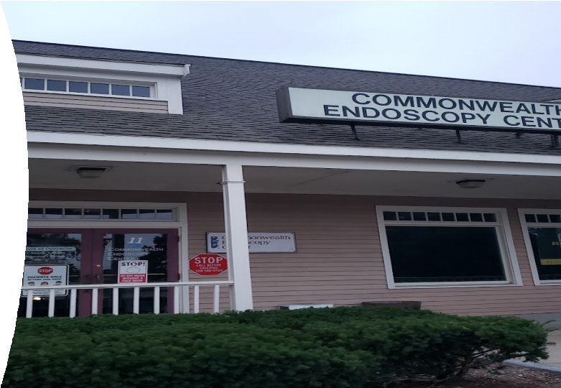

Commonwealth Endoscopy Center
(West Bridgewater MA Endoscopy ASC, LLC)

- Currently operating in West Bridgewater through a longstanding joint venture between AmSurg Holdings, Inc. (“AMSURG”) and Commonwealth Endoscopy Center, Inc.
- AMSURG is a nationally recognized leader in the strategic and operational management of surgery centers that deliver high quality, high value, same-day surgical services with superior patient experience.
- Commonwealth Endoscopy Center is owned by a group of physicians with longstanding relationships in the community. The physician owners have supplied specialized gastroenterology care to the Southeastern Massachusetts region for over 30 years.
4

2

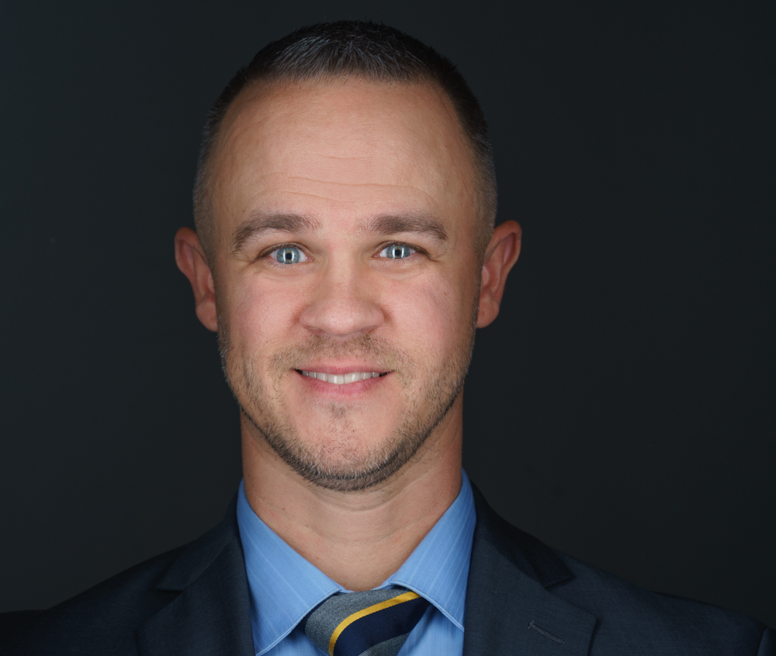
Project Principals
- Howard Salomons, MD
  - Gastroenterologist
  - Medical Director, Commonwealth Endoscopy Center
  - Board Member

- Chris Fenore
  - AmSurg Massachusetts Director of Operations
  - Chairman of the Board
5

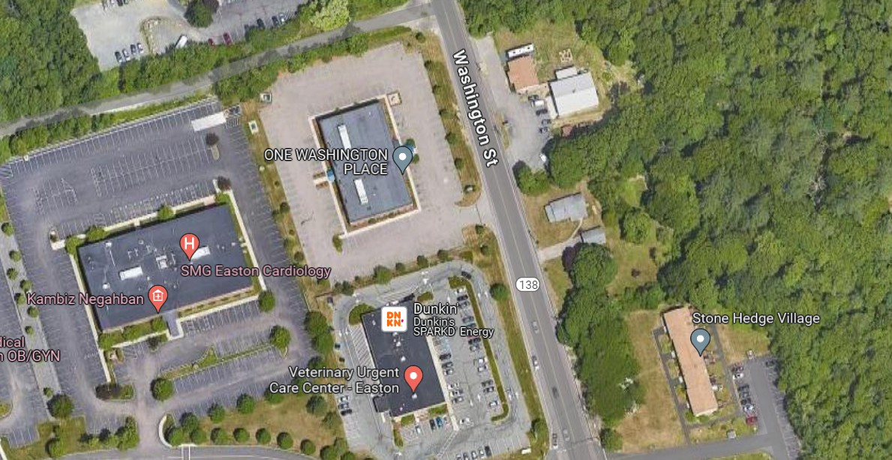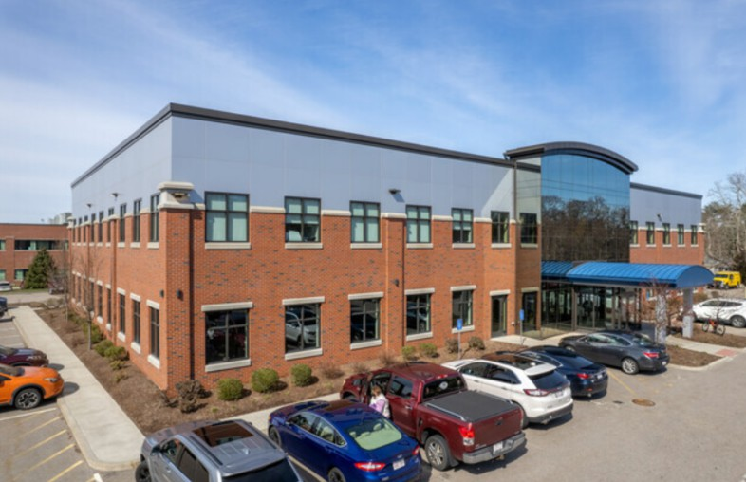
Project Information

- 2 Story State of the Art Medical Office Building (26,000 SF)
- Ambulatory Surgery Center specializing in Gastrointestinal Care
  - Convenient access from Rt. 24, Rt. 138, Rt 106 and Rt. 123.
  - 7,500 square feet of space in existing Medical Office Space
  - 4 procedure rooms
  - 12 pre-operative and post operative/recovery bays
  - Increasing access to state-of-the-art GI/endoscopy care to the region
  - Virtual access to interpreter services (100+ languages and sign-language)
  - Handicap accessible
  - Accepting majority of insurances including Medicare & MassHealth products
6

3

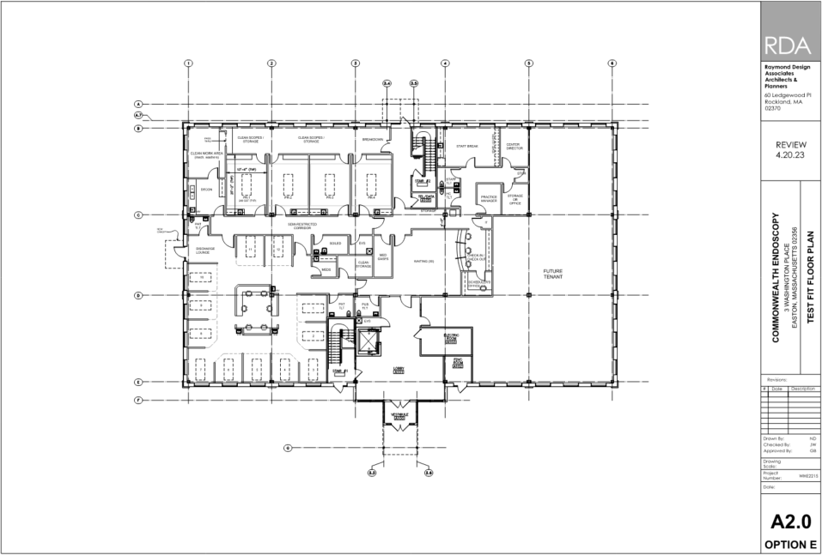
Project Information
- 4 Procedure Rooms

- 12 Pre-Op/PACU Beds

- Decon/Clean Work Room

- Administrative Area

- Staff Lounge
7

Questions and Comments
- Contact
  - Chris Fenore (Chris.Fenore@amsurg.com)
8

4

Easton Select Board Meeting July 15, 2024

Commonwealth Endoscopy Center 3 Washington Place, Easton, MA
1

Meeting details
- This community meeting is being held as part of the Determination of Need (DoN) process required by the Department of Public Health (DPH) for an ambulatory surgery center that will be located at 3 Washington Place in Easton
- We have notified elected officials, including the Board of Selectmen, as well as health and other service providers
- The purpose of this community meeting is to educate the public about the proposed project, solicit feedback and answer any questions.
2

1

Agenda
- First, the project principals will introduce themselves and tell you more about the proposed facility.
- The presentation will be followed by a question & answer period to address any questions you may have.
3

Commonwealth Endoscopy Center
(West Bridgewater MA Endoscopy ASC, LLC)

- Currently operating in West Bridgewater through a longstanding joint venture between AmSurg Holdings, Inc. (“AMSURG”) and Commonwealth Endoscopy Center, Inc.
- AMSURG is a nationally recognized leader in the strategic and operational management of surgery centers that deliver high quality, high value, same-day surgical services with superior patient experience.
- Commonwealth Endoscopy Center is owned by a group of physicians with longstanding relationships in the community. The physician owners have supplied specialized gastroenterology care to the Southeastern Massachusetts region for over 30 years.
4

2

Project Principals
- Howard Salomons, MD
  - Gastroenterologist
  - Medical Director, Commonwealth Endoscopy Center
  - Board Member

- Chris Fenore
  - AmSurg Massachusetts Director of Operations
  - Chairman of the Board
5

Project Information

- 2 Story State of the Art Medical Office Building (26,000 SF)
- Ambulatory Surgery Center specializing in Gastrointestinal Care
  - Convenient access from Rt. 24, Rt. 138, Rt 106 and Rt. 123.
  - 7,500 square feet of space in existing Medical Office Space
  - 4 procedure rooms
  - 12 pre-operative and post operative/recovery bays
  - Increasing access to state-of-the-art GI/endoscopy care to the region
  - Virtual access to interpreter services (100+ languages and sign-language)
  - Handicap accessible
  - Accepting majority of insurances including Medicare & MassHealth products
6

3

Project Information
- 4 Procedure Rooms

- 12 Pre-Op/PACU Beds

- Decon/Clean Work Room

- Administrative Area

- Staff Lounge
7

Questions and Comments
- Contact
  - Chris Fenore (Chris.Fenore@amsurg.com)
8

Easton Economic Development Council Meeting
July 11, 2024

Commonwealth Endoscopy Center
3 Washington Place, Easton, MA

Meeting details

- This community meeting is being held as part of the Determination of Need (DoN) process required by the Department of Public Health (DPH) for an ambulatory surgery center that will be located at 3 Washington Place in Easton
- We have notified elected officials, including the Board of Selectmen, as well as health and other service providers
- The purpose of this community meeting is to educate the public about the proposed project, solicit feedback and answer any questions.

Agenda

- First, the project principals will introduce themselves and tell you more about the proposed facility.
- The presentation will be followed by a question & answer period to address any questions you may have.

Commonwealth Endoscopy Center
(West Bridgewater MA Endoscopy ASC, LLC)

- Currently operating in West Bridgewater through a longstanding joint venture between AmSurg Holdings, Inc. (“AMSURG”) and Commonwealth Endoscopy Center, Inc.
- AMSURG is a nationally recognized leader in the strategic and operational management of surgery centers that deliver high quality, high value, same-day surgical services with superior patient experience.
- Commonwealth Endoscopy Center is owned by a group of physicians with longstanding relationships in the community. The physician owners have supplied specialized gastroenterology care to the Southeastern Massachusetts region for over 30 years.

Project Principals
- Howard Salomons, MD
              - Gastroenterologist
              - Medical Director, Commonwealth Endoscopy Center
              - Board Member

- Chris Fenore
              - AmSurg Massachusetts Director of Operations
              - Chairman of the Board

Project Information

- 2 Story State of the Art Medical Office Building (26,000 SF)
- Ambulatory Surgery Center specializing in Gastrointestinal Care
  - Convenient access from Rt. 24, Rt. 138, Rt 106 and Rt. 123.
  - 7,500 square feet of space in existing Medical Office Space
  - 4 procedure rooms
  - 12 pre-operative and post operative/recovery bays
  - Increasing access to state-of-the-art GI/endoscopy care to the region
  - Virtual access to interpreter services (100+ languages and sign-language)
  - Handicap accessible
  - Accepting majority of insurances including Medicare & MassHealth products

Project Information

- 4 Procedure Rooms
- 12 Pre-Op/PACU Beds
- Decon/Clean Work Room
- Administrative Area
- Staff Lounge

Questions and Comments
- Contact
  - Chris Fenore (Chris.Fenore@amsurg.com)

Easton Select Board Meeting
July 15, 2024

Commonwealth Endoscopy Center
3 Washington Place, Easton, MA

Meeting details

- This community meeting is being held as part of the Determination of Need (DoN) process required by the Department of Public Health (DPH) for an ambulatory surgery center that will be located at 3 Washington Place in Easton
- We have notified elected officials, including the Board of Selectmen, as well as health and other service providers
- The purpose of this community meeting is to educate the public about the proposed project, solicit feedback and answer any questions.

Agenda

- First, the project principals will introduce themselves and tell you more about the proposed facility.
- The presentation will be followed by a question & answer period to address any questions you may have.

Commonwealth Endoscopy Center
(West Bridgewater MA Endoscopy ASC, LLC)

- Currently operating in West Bridgewater through a longstanding joint venture between AmSurg Holdings, Inc. (“AMSURG”) and Commonwealth Endoscopy Center, Inc.
- AMSURG is a nationally recognized leader in the strategic and operational management of surgery centers that deliver high quality, high value, same-day surgical services with superior patient experience.
- Commonwealth Endoscopy Center is owned by a group of physicians with longstanding relationships in the community. The physician owners have supplied specialized gastroenterology care to the Southeastern Massachusetts region for over 30 years.

Project Principals
- Howard Salomons, MD
              - Gastroenterologist
              - Medical Director, Commonwealth Endoscopy Center
              - Board Member

- Chris Fenore
              - AmSurg Massachusetts Director of Operations
              - Chairman of the Board

Project Information

- 2 Story State of the Art Medical Office Building (26,000 SF)
- Ambulatory Surgery Center specializing in Gastrointestinal Care
  - Convenient access from Rt. 24, Rt. 138, Rt 106 and Rt. 123.
  - 7,500 square feet of space in existing Medical Office Space
  - 4 procedure rooms
  - 12 pre-operative and post operative/recovery bays
  - Increasing access to state-of-the-art GI/endoscopy care to the region
  - Virtual access to interpreter services (100+ languages and sign-language)
  - Handicap accessible
  - Accepting majority of insurances including Medicare & MassHealth products

Project Information

- 4 Procedure Rooms
- 12 Pre-Op/PACU Beds
- Decon/Clean Work Room
- Administrative Area
- Staff Lounge

Questions and Comments
- Contact
  - Chris Fenore (Chris.Fenore@amsurg.com)

Attachment 2: Notice of Intent



Public Announcement Concerning a Proposed Health Care Project

West Bridgewater MA Endoscopy ASC, LLC (the “Applicant”) which operates the ambulatory surgery center known as Commonwealth Endoscopy Center (the “Facility”) currently located at 120 West Center Street in West Bridgewater, MA, intends to file an application for a Notice of Determination of Need with the Massachusetts Department of Public Health for a substantial change in service and a transfer of site of the Facility to 3 Washington Place, Easton, MA (the “Proposed Project.”) The Proposed Project will expand the Applicant’s current procedure room capacity from two procedure rooms to four procedure rooms and will include 12 pre-operative and post-operative/recovery bays, administrative office, and a patient lobby and waiting area totaling 7500 square feet of space. The total value of the project based on the maximum capital expenditure is $10.4 million. The Applicant does not anticipate any price or service impacts on the Applicant’s existing patient panel as a result of the Proposed Project. Any ten taxpayers of Massachusetts may register in connection with the intended application by September 30, 2024 or 30 days from the filing date, whichever is later, by contacting the Department of Public Health, Determination of Need Program, 67 Forest Street, Marlboro, MA 01752.

Attachment 3: Independent CPA Report
West Bridgewater MA Endoscopy ASC, LLC

Analysis of the Reasonableness of
Assumptions Used For and
Feasibility of Projected Financials of
West Bridgewater MA Endoscopy ASC, LLC
For the Years Ending December 31, 2026
Through December 31, 2030

TABLE OF CONTENTS

Page I. EXECUTIVE SUMMARY 1
- RELEVANT BACKGROUND INFORMATION 2
- SCOPE OF REPORT 2
- PRIMARY SOURCES OF INFORMATION UTILIZED 2
- REVIEW OF THE PROJECTIONS 3
- FEASIBILITY 6

August 28, 2024

Ms. Libby Wylie, MHA
Vice President, Operations
AMSURG
1A Burton Hills Blvd, #300
Nashville, TN 37215

RE: Analysis of the Reasonableness of Assumptions and Projections Used to Support the
Financial Feasibility and Sustainability of the Proposed Endoscopy ASC in Easton, MA by West Bridgewater MA Endoscopy ASC, LLC

Dear Ms. Wylie:

I have performed an analysis of the financial projections prepared by Amsurg Holdings, Inc. (“AMSURG”) detailing the projected operations related to the expansion of services and transfer of site of West Bridgewater MA Endoscopy ASC, LLC (the “Center”) in Easton, MA. This report details my analysis and findings with regards to the reasonableness of assumptions used in the preparation and feasibility of the financial forecast prepared by the management of West Bridgewater MA Endoscopy ASC, LLC (“Management”) for the operation of the Center. This report is to be used by West Bridgewater MA Endoscopy ASC, LLC in its Determination of Need (“DoN”) Application – Factor 4(a) and should not be distributed for any other purpose.
- EXECUTIVE SUMMARY

The scope of my analysis was limited to an analysis of the five-year financial projections (the “Projections”) prepared by Management of West Bridgewater MA Endoscopy ASC, LLC for the operation of the Center as well as actual operating results for the fiscal year ended December 31, 2023, and the supporting documentation in order to render an opinion as to the reasonableness of assumptions used in the preparation and feasibility of the Projections with regards to the impact of the increase in the number procedure rooms and relocation of the Facility from West Bridgewater, MA to Easton, MA.

Within the projected financial information, the Projections exhibit a net pre-tax profit margin ranging from 24.4% to 33.6% for the years ending December 31, 2026 through 2030. Based upon my review of the relevant documents and analysis of the projected financial statements, I determined the project and continued operating surplus are reasonable expectations and are based upon feasible financial assumptions. Accordingly, I determined that the Projections are feasible and sustainable and not likely to have a negative impact on the Applicant’s patient panel or result in a liquidation of assets of the Center. A detailed explanation of the basis for my determination of reasonableness and feasibility is contained within this report.

- RELEVANT BACKGROUND INFORMATION

West Bridgewater MA Endoscopy ASC, LLC is a for-profit Tennessee limited liability company currently serving a patient population primarily from Plymouth and Bristol Counties. The Center, a joint venture between AMSURG and Commonwealth Endoscopy Center, Inc., currently provides endoscopy services in a facility consisting of 2 procedure rooms located at 120 West Center Street in West Bridgewater, MA. AMSURG is a national health care company that partners with physicians and health systems to plan, manage and operate ambulatory surgery centers (ASCs). Commonwealth Endoscopy Center, Inc. is owned by a group of physicians who have provided gastroenterology care to the Southeastern Massachusetts region for over 30 years.

The Proposed Project will relocate the Center to 3 Washington Place, Easton, MA and expand to 4 procedure rooms, specializing in gastrointestinal care. Please refer to the DoN application for a further description of the proposed project and the rationale for the expenditures.

- SCOPE OF REPORT

The scope of this report is limited to an analysis of the five-year financial projections prepared for West Bridgewater MA Endoscopy ASC, LLC (the “Projections”) and the supporting documentation in order to render an opinion as to the reasonableness of assumptions used in the preparation and feasibility of the Projections. My analysis of the Projections and conclusions contained within this report are based upon my detailed review of all relevant information (see Section IV which references the sources of information). I have gained an understanding of the Center through my review of the information provided as well as a review of AMSURG’s website, Gastrointestinal Specialists’ website, and the DoN application.

Reasonableness is defined within the context of this report as supportable and proper, given the underlying information. Feasibility is defined as based on the assumptions used, the plan is not likely to result in insufficient “funds available for capital and ongoing operating costs necessary to support the Proposed Project without negative impacts or consequences to the Applicant’s existing Patient Panel” (per Determination of Need, Factor 4(a)).

This report is based upon historical and prospective financial information provided to me by Management. If I had audited the underlying data, matters may have come to my attention that would have resulted in my using amounts that differ from those provided. Accordingly, I do not express an opinion or any other assurances on the underlying data or projections presented or relied upon in this report. I do not provide assurance on the achievability of the results forecasted by the Center because events and circumstances frequently do not occur as expected, and the achievement of the forecasted results is dependent on the actions, plans, and assumptions of Management. I reserve the right to update my analysis in the event that I am provided with additional information.
- PRIMARY SOURCES OF INFORMATION UTILIZED
In formulating my opinions and conclusions contained in this report, I reviewed documents produced by Management as well as other relevant information that is generally available. The documents and information upon which I relied are identified below or are otherwise referenced in this report:
- West Bridgewater MA Endoscopy ASC, LLC’s 5-Year Projected Financial Statements, and Assumptions, initially received from Management on July 10, 2024.
- Various documentation supporting calculations included in the projected financial statements, initially received from Management on July 10, 2024;
- West Bridgewater MA Endoscopy ASC, LLC’s balance sheets and income statements as of and for the years ended December 31, 2022 and 2023 and the trailing twelve months through February 28, 2024, initially received from Management on July 10, 2024;
- West Bridgewater GI relocation and expansion presented by AMSURG to the AMSURG Board of Directors, prepared as of March 28, 2024;
- West Bridgewater MA Endoscopy ASC, LLC DoN Application, draft provided July 10, 2024, final draft provided August 12, 2024;
- Determination of Need Application Instructions dated March 2017;
- CMS.gov (Medicare) Ambulatory Surgical Center Payment System website;
- Mass.gov Executive Office of Health and Human Services;
- Becker’s ASC website https://www.beckersasc.com;
- Intellimarker™ - by VMG Health, ASC benchmarking study, 2021-2022 data;
- AMSURG website https://amsurg.com.
- Gastrointestinal Specialists website https://gisdoc.com.
- REVIEW OF THE PROJECTIONS

This section of my report summarizes my review of the reasonableness of the assumptions used and feasibility of the Projections. The following table presents the Key Metrics, as defined below, which compares the operating results of the Projections for the first five years of operations to historical results for the year ended December 31, 2023.
Key Metric As Reported Key Metrics for Projected Periods
($ in thousands) | 2023 | 2026 | 2027 | 2028 | 2029 | 2030
Days in Accounts Receivables | 14.2 | 23.3 | 23.3 | 23.3 | 23.3 | 23.3
Days Cash on Hand | 38.0 | 19.0 | 30.0 | 42.0 | 54.9 | 68.8
EBITDA ($) | $1,772 | $2,835 | $3,020 | $3,217 | $3,426 | $3,648
EBITDA Margin | 45.2% | 42.4% | 42.6% | 42.7% | 42.9% | 43.1%
Net Profit Margin | 44.1% | 24.4% | 26.8% | 29.2% | 31.4% | 33.6%
Debt Service Coverage (ratio) | 20.6 | 1.6 | 1.9 | 2.0 | 2.2 | 2.3
Debt to Capitalization (%) | 1.5% | 34.0% | 28.5% | 21.5% | 12.3% | 0.0%
Members' Equity | $9,983 | $10,256 | $10,399 | $10,561 | $10,744 | $10,950

The Key Metrics fall into three primary categories: liquidity, operating and solvency. Liquidity metrics, such as Days in Accounts Receivable and Days Cash on Hand measure the quality and adequacy of assets to meet current obligations as they come due. Operating metrics, such as earnings before interest, taxes, depreciation and amortization (“EBITDA”), EBITDA Margin, Net Profit Margin and Debt Service Coverage are used to assist in the evaluation of management performance in how efficiently resources are utilized. Solvency metrics, such as Debt to Capitalization and Members’ Equity, measure the company’s ability to service debt obligations. Additionally, certain metrics can be applicable to multiple categories. The table below shows how each of the Key Metrics are calculated.
Key Metric | Definition
Days in Accounts Receivables | Accounts receivables divided by (net patient service revenue divided by 365 days)
Days Cash on Hand | (Cash & cash equivalents) divided by ((Total operating expenses - depreciation & amortization) divided by YTD days)
EBITDA ($) | Earnings before interest, taxes, depreciation and amortization
EBITDA Margin | EBITDA divided by net patient service revenue
Net Profit Margin | Net profit divided by net patient service revenue
Debt Service Coverage (ratio) | (Net income (loss) + depreciation expense + amortization expense + interest expense) divided by (Principal payments + interest expense)
Debt to Capitalization (%) | (Current portion of long-term obligation + long-term obligations) divided by (Current portion of long-term obligations + long-term obligations + members' equity)
Members' Equity | Net equity of the LLC

- Revenues

I analyzed the revenues identified by the Center in the Projections. Based upon my communications with Management, the projected volume was based on a ramp-up schedule developed from an analysis of current cases for the Center’s current location and based on the addition of physicians to service the additional procedure rooms at the new location. The ramp up schedule for years 2 through 5 (2027 to 2030) included a modest 3% increase over the previous years. The payer mix was based on the current payer mix of the Center as the new location is in the same patient catchment area. Reimbursement was based upon the historic overall payment per case, which takes into account all payers, including Medicare, Medicaid and commercial insurance payments. In order to determine the reasonableness of the projected revenues, I reviewed the underlying assumptions upon which Management relied.
I first reviewed the Projections to determine the reasonableness of the projected volume. AMSURG provided historical data of services at the current location. AMSURG then created a utilization table, using conservative estimates from the volume contributions and benchmark data for the procedure room average minutes to arrive at year 1 (2026) cases and procedures. These cases and procedures were then ramped up through year 5 (2030). I compared the Center’s benchmark data to an outside, independent survey of ambulatory surgery centers completed using 2021-2022 data (the latest study) and found that the Center’s benchmark data used was reasonable, and that the number of projected cases and procedures per procedure room in 2030 (year 5) were within the ranges of currently operating ambulatory surgery centers as determined by the independent survey.

Next, I reviewed the Projections to determine the reasonableness of the payer mix and reimbursement rates selected for the first five years of operations, starting in 2026. To determine the reasonableness of using the actual payer mix for the trailing twelve months ended February 2024 in the projections, I utilized the Gastrointestinal Specialists’ Productivity Analysis for the calendar year ended December 2023. This document provided units, charges and payments by the various payers for the calendar year. I separated Medicare, Medicaid, Self-Pay and All Others, including the various commercial insurance carriers and compared this payer mix to the aforementioned independent survey's payer mix for the Northeast United States, and found them to be within the ranges published by the survey.

AMSURG used as a starting point, an average reimbursement rate of $650.26 in the projections. This was calculated by dividing the actual net patient service revenue of the trailing twelve months ended February 2024 by the number of actual cases for the same period. This rate was then inflated by 3% in each year of the projections. To test the reasonableness of the starting average reimbursement rate, I again utilized the Gastrointestinal Specialists’ Productivity Analysis for the calendar year ended December 2023. Converting the total units (procedures) provided to cases, using the standard 1.21 ratio, I then divided total cases into the total payments to arrive at an average payment of $658.70. This compares favorably to the rate of $650.26 used in the projection.

Based upon the foregoing, it is my opinion that the revenue projected by Management reflects a reasonable estimation of future revenues of the Center.

- Expenses

I analyzed the Salary and Benefits, as well as the Other Operating Expenses for reasonableness and feasibility as related to the Projections of the Center.

AMSURG provided actual Salaries and Benefit data for the trailing twelve months ended February 2024. These amounts were adjusted for the increase in cases due to the change in procedure rooms from 2 to 4. Salaries were converted to a per case amount, and then multiplied by the total cases for each of the projection years. Salaries were also inflated by 3% each year. Benefits were increased each year based on the actual benefits to salaries ratio from the trailing twelve months ended February 2024 data. Salaries and Benefits amounts, as a percentage of total net revenue were compared to the previously mentioned independent survey and were found to be consistent with the survey results.

Medical Surgical Supplies included in the projections were compared to the previously mentioned independent survey and found to be consistent with the ranges included in the survey. Other expenses were also compared to the survey and found to be reasonable.
As mentioned above, salaries and benefits are projected to increase by 3% per year. Clinical expenses and other expenses are projected to increase by 3% per year after the baseline year (Year 2026).

Based upon the foregoing, it is my opinion that the operating expenses projected by Management are reasonable in nature.

- Lease Agreement, Capital Expenditures and Cash Flows

I reviewed the lease terms, projected capital expenditures and future cash flows of the Center in order to determine whether sufficient funds would be available to support the lease of the Center, payment of the financed construction and equipment debt service and whether the cash flow would be able to support the continued operations.

Based upon my review of the Projections, my communications with Management and having received a copy of the signed lease agreement, it is my understanding that up to 8,760 square feet of space at 3 Washington Place in Easton, MA will be leased by West Bridgewater MA Endoscopy ASC, LLC. Rent expense will be $24.50 per square foot or $214,620 per year. The lease will include a 3% increase every year. I also compared the total occupancy costs included in the projections to the independent survey and found them to be within the range in the survey.

The Projections also include capital costs for construction (build-out) and equipment at the 3 Washington Place, Easton, MA location. The total capital cost is $6,318,200 after tenant improvement allowance. Leasehold improvements are depreciated on a straight-line basis over a 15-year useful life and equipment is depreciated on a straight-line basis over a 7-year useful life. The capital cost for leasehold improvements and equipment are being financed via loans which carry an annual interest rate of 9.50% and repayment in sixty (60) equal monthly payments. The interest rate of 9.50% is reasonable for a commercial loan in the current interest rate environment. We also reviewed the loan amortization schedule for accuracy.

Accordingly, I determined that the pro-forma capital expenditures, facility lease, terms of construction, equipment and working capital financing and the resulting impact on the cash flows of the Center are reasonable.

- FEASIBILITY

I analyzed the Projections and Key Metrics for the West Bridgewater MA Endoscopy ASC, LLC as well as the impact of the proposed project. In preparing my analysis I considered multiple sources of information including historical and projected financial information for the Center.
It is important to note that the Projections do not account for any anticipated changes in accounting standards. These standards, which may have a material impact on individual future years, are not anticipated to have a material impact on the aggregate Projections. However, Management has informed me that it has not capitalized lease assets and obligations related to its real estate lease as required under Accounting Standards Update (ASU) 2016-02, Leases (ASC Topic 842) and subsequent amendments (i.e., US GAAP). The Center has reported lease payments as rent expense as incurred. The effects of this departure on the Center’s financial position, results of operations, and cash flows have not been determined. However, the only key metrics listed on page 3 that should be impacted by this GAAP departure are debt service coverage and debt to capitalization.
Based upon my review of the relevant documents and analysis of the projected financial statements, I determined the project and continued operating surplus are reasonable and are based upon feasible financial assumptions. Accordingly, I determined that the Projections are feasible and sustainable and not likely to have a negative impact on the patient panel or result in a liquidation of assets of West Bridgewater MA Endoscopy ASC, LLC.

Respectively submitted,

Bernard L. Donohue, III, CPA

Attachment 4: Affidavit of Truthfulness


Massachusetts Department of Public Health
Determination of Need
Affidavit of Truthfulness and Compliance
with Law and Disclosure Form 100.405(B) Version: 7-6-17

Instructions: Complete Information below. When complete check the box "This document is ready to print:". This will date stamp and lock the form. Print Form. Each person must sign and date the form. When all signatures have been collected, scan the document and e-mail to: dph.don@state.ma.us Include all attachments as requested.
Application Number: CEC-24082115-AS Original Application Date: 8/30/2024
Applicant Name: West Bridgewater MA Endoscopy ASC, LLC
Application Type: Ambulatory Surgery
Applicant's Business Type: LLC
Is the Applicant the sole member or sole shareholder of the Health Facility(ies) that are the subject of this Application? Yes
The undersigned certifies under the pains and penalties of perjury:
1. The Applicant is the sole corporate member or sole shareholder of the Health Facility[ies] that are the subject of this Application;
2. I have read 105 CMR 100.000, the Massachusetts Determination of Need Regulation;
3. I understand and agree to the expected and appropriate conduct of the Applicant pursuant to 105 CMR 100.800;
4. I have read this application for Determination of Need including all exhibits and attachments, and certify that all of the information contained herein is accurate and true;
5. I have submitted the correct Filing Fee and understand it is nonrefundable pursuant to 105 CMR 100.405(B);
6. I have submitted the required copies of this application to the Determination of Need Program, and, as applicable, to all Parties of Record and other parties as required pursuant to 105 CMR 100.405(B);
7. I have caused, as required, notices of intent to be published and duplicate copies to be submitted to all Parties of Record, and all carriers or third-party administrators, public and commercial, for the payment of health care services with which the Applicant contracts, and with Medicare and Medicaid, as required by 105 CMR 100.405(C), et seq.;
8. I have caused proper notification and submissions to the Secretary of Environmental Affairs pursuant to 105 CMR 100.405(E) and 301 CMR 11.00;
9. If subject to M.G.L. c. 6D, § 13 and 958 CMR 7.00, I have submitted such Notice of Material Change to the HPC - in accordance with 105 CMR 100.405(G);
10. Pursuant to 105 CMR 100.210(A)(3), I certify that both the Applicant and the Proposed Project are in material and substantial compliance and good standing with relevant federal, state, and local laws and regulations, as well as with all previously issued Notices of Determination of Need and the terms and Conditions attached therein;
11. I have read and understand the limitations on solicitation of funding from the general public prior to receiving a Notice of Determination of Need as established in 105 CMR 100.415;
12. I understand that, if Approved, the Applicant, as Holder of the DoN, shall become obligated to all Standard Conditions pursuant to 105 CMR 100.310, as well as any applicable Other Conditions as outlined within 105 CMR 100.000 or that otherwise become a part of the Final Action pursuant to 105 CMR 100.360;
13. Pursuant to 105 CMR 100.705(A), I certify that the Applicant has Sufficient Interest in the Site or facility; and
14. Pursuant to 105 CMR 100.705(A), I certify that the Proposed Project is authorized under applicable zoning by-laws or ordinances, whether or not a special permit is required; or,
a. If the Proposed Project is not authorized under applicable zoning by-laws or ordinances, a variance has been received to permit such Proposed Project; or,
b. The Proposed Project is exempt from zoning by-laws or ordinances.
LLC
All parties must sign. Add additional names as needed.
Jeff Snodgrass
Date 8/19/2024
This document is ready to print: ❑ Date/time Stamp:
Affidavit of Truthfulness West Bridgewater MA Endoscopy ASC, LLC Page 1 of 1

Attachment 5: Scanned copy of Application Fee Check
