**Weymouth Endoscopy, LLC**

**Determination of Need**

**DoN Application # WE-24062414-AS**

**Application for Determination of Need**

**Ambulatory Surgery Center**

**June 24, 2024**

**Table of Contents**

1. **Application Form\***
2. **Narrative\***
3. **Affiliated Parties Form\***
4. **Change in Service Form\***
5. **Certification from Independent Certified Public Accountant\***
6. **Certificate of Organization**
7. **Community Engagement Presentation**
8. **Notice of Intent**
9. **Affidavit of Truthfulness**
10. **Application Fee**

**\***certain sections listed in the Table of Contents are attached as a separate file for the submission

1. **Certificate of Organization**

<https://corp.sec.state.ma.us/CorpWeb/CorpSearch/CorpSearchRedirector.aspx?Action=PDF&Path=CORP_DRIVE1/2002/0405/000000000/7751/200212444270_1.pdf>

<https://corp.sec.state.ma.us/CorpWeb/CorpSearch/CorpSearchRedirector.aspx?Action=PDF&Path=CORP_DRIVE1/2022/0203/002094560/0001/202200822400_1.pdf>

1. **Community Engagement Presentation**

**Weymouth Endoscopy LLC**

Determination of Need Application:

New Expanded Ambulatory Surgery Center

(97 Libbey Industrial Parkway, Weymouth, Massachusetts)

May 5, 2024

# Who are we? History and Mission

* Founded in 2004, Greater Boston’s leading endoscopy center
* Owned and operated by 6 physicians
  + 4 of the physicians have 20+ years of practice experience on the South Shore
* Services provided: endoscopic services (colonoscopy, upper endoscopy, sigmoidoscopy, esophageal and colonic dilation) in its 3 procedure rooms.
* Highly trained support staff of nurses and endoscopic technicians
* All credentialed endoscopic physicians have privileges at South Shore Hospital:
  + 24 hour/day, 7 days/week coverage for emergency consultations for inpatients at the South Shore Hospital
  + Reserved block of time in one of the two endoscopy rooms at South Shore Hospital to accommodate overflow patients and for patients with a medical need for a hospital setting
* The Mission of Weymouth Endoscopy Center is to provide high quality of care to our patients in the most caring and cost-effective manner.

We will return the patient to their social environment within the shortest and safest time frame with the least psychological, emotional, or physical trauma possible.

Our Philosophy and Objectives

1. To render modern, excellent and safe care to patients requiring outpatient endoscopic procedures.
2. To provide skillful support to physicians.
3. To recruit and retain personnel with outstanding ability and positive, willing attitudes, organized into a competent and smoothly functioning team.
4. To provide experienced registered professional nurses for excellent quality patient care and the supervision, education, and evaluation of other professionals when appropriate.
5. To keep Weymouth Endoscopy Center well equipped and ready to meet/exceed the needs of patients and the attending staff physicians.
6. To accord caring, individual consideration and treatment to each patient.
7. Facilitate and provide educational programs for nurses and other personnel to assure Weymouth Endoscopy Center’s future capability to provide state of the art care.
8. To reduce health care costs without compromising the quality of care.
9. Weymouth Endoscopy Center will operate without limit to race, creed, sex, national origin, religion or disability.

# Purpose and Goals of this Presentation

* To discuss the future Plans of Weymouth Endoscopy
  + our lease is expiring
  + we are planning to move and expand to serve our existing and growing patient panel
  + our proposed new location will double our capacity to 6 procedure rooms (we are also in process of employing 2-3 new physicians)
* Weymouth Endoscopy must receive approval from the Department of Public Health through the Determination of Need review process
* Part of this process is to engage with our community in a meaningful discussion about the project and receive input and feedback

# Benefits of Performing More Procedures at ASC setting

Endoscopic procedures performed in ambulatory surgery centers are lower cost as compared to hospital-based procedures.



The quality of care, health outcomes and physician experience level in the outpatient surgical setting are equal to or better than hospital

Why is there a pressing need for the Proposed Project?

* + There is a 6-month scheduling delay at the ASC
    - South Shore Hospital also has greater need for their endoscopy rooms (WE still has some access at South Shore Hospital but our access is slightly reduced)
    - Urgent procedures are prioritized
  + Our volumes continue to increase as the need for colonoscopy and endoscopy is increasing. Colorectal Cancer (“CRC”) is the leading cause of death nationally1 and also in Massachusetts.2 Colonoscopy is the gold-standard for screening, diagnosing, and treating CRC.3 The recommended age for CRC screening has been lowered from age 50 to 45.4
  + Rates of esophageal cancer are increasing in younger people5 including in WE's patient population.
  + If detected early, CRC and esophageal cancer can be detected and treated more effectively, and the survival rate is high.6

Proposed New Site: 97 Libbey Park Drive, 3rd Floor

## What it has to offer

* 6 procedure rooms
* Spacious state-of-the-art facility , a medical building
* Clinically and operationally more efficient
* Timely access

## Accessibility

* Ample free parking
* Close to highway - 0.25 miles from Route 3
* Proximity to public transportation - 0.2 miles from MBTA bus stop

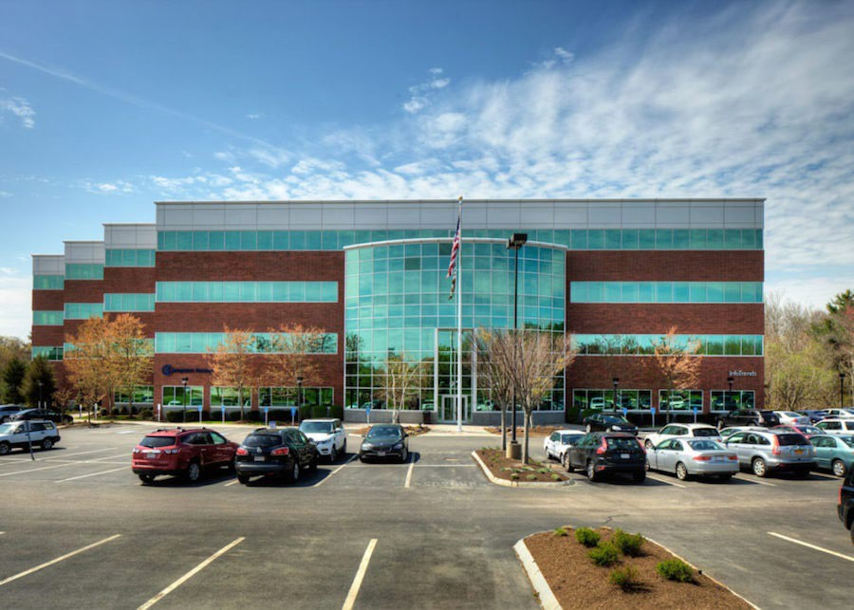

# Support for Local Community Providers

Local providers are supportive of this Proposed Project, including

1. South Shore Health
   * South Shore Hospital
   * South Shore Medical Center
2. Manet Community Health Center
3. Healthcare South P.C. and other area primary care practices

# Next Steps

* + Gather community input through this presentation
  + Keeping the public informed through news articles
  + Timeline of approval and construction
    - Official filing will occur on Spring 2024
    - The DON review process typically takes place over a 4-month period
    - If approved, we hope to move into the new center in January 2025

Questions or Feedback?

* We welcome and questions and feedback
* Contact: Mary Phillips

[Mary@WeymouthEndoscopy.com](mailto:Mary@WeymouthEndoscopy.com) 781-331-2922

Thank You!

# References

* + 1 - [Key Statistics for Colorectal Cancer](https://www.cancer.org/cancer/types/colon-rectal-%20cancer/about/key-%20statistics.html#:~:text=The%20American%20Cancer%20Society's%20estimates,men%20and%2018%2C890%20in%20women), AM. CANCER SOC. (last revised Jan. 29, 2024) ([https://www.cancer.org/cancer/types/colon-rectal-](https://www.cancer.org/cancer/types/colon-rectal-cancer/about/key-statistics.html#%3A%7E%3Atext%3DThe%20American%20Cancer%20Society%27s%20estimates%2Cmen%20and%2018%2C890%20in%20women) [cancer/about/key-](https://www.cancer.org/cancer/types/colon-rectal-cancer/about/key-statistics.html#%3A%7E%3Atext%3DThe%20American%20Cancer%20Society%27s%20estimates%2Cmen%20and%2018%2C890%20in%20women) [statistics.html#:~:text=The%20American%20Cancer%20Society's%20estimates,men%20and%2018%2C890%20in%20women](https://www.cancer.org/cancer/types/colon-rectal-cancer/about/key-statistics.html#%3A%7E%3Atext%3DThe%20American%20Cancer%20Society%27s%20estimates%2Cmen%20and%2018%2C890%20in%20women));
  + 2 - *See*, *Data Report November 2020 on Colorectal Cancer in Massachusetts*, MASS. DEPT. OF PUBLIC HEALTH (Nov. 2020) (available at: <https://www.mass.gov/doc/data-report-on-colorectal-cancer-in-massachusetts-november-2020/download>).
  + 3 - [Colorectal Cancer: What You Should Know About Screening](https://www.fda.gov/consumers/consumer-updates/colorectal-cancer-what-you-should-know-about-%20screening#:~:text=Your%20Colorectal%20Cancer%20Screening%20Choices&text=The%20gold%20standard%20for%20screening,no%20pr ecancerous%20changes%20are%20found), U.S. FOOD & DRUG ADMIN. (last revised Mar. 28, 2024), [https://www.fda.gov/consumers/consumer-updates/colorectal-cancer-what-you-should-know-about-](https://www.fda.gov/consumers/consumer-updates/colorectal-cancer-what-you-should-know-about-screening#%3A%7E%3Atext%3DYour%20Colorectal%20Cancer%20Screening%20Choices%26text%3DThe%20gold%20standard%20for%20screening%2Cno%20precancerous%20changes%20are%20found) [screening#:~:text=Your%20Colorectal%20Cancer%20Screening%20Choices&text=The%20gold%20standard%20for%20screening,no%20pr](https://www.fda.gov/consumers/consumer-updates/colorectal-cancer-what-you-should-know-about-screening#%3A%7E%3Atext%3DYour%20Colorectal%20Cancer%20Screening%20Choices%26text%3DThe%20gold%20standard%20for%20screening%2Cno%20precancerous%20changes%20are%20found) [ecancerous%20changes%20are%20found](https://www.fda.gov/consumers/consumer-updates/colorectal-cancer-what-you-should-know-about-screening#%3A%7E%3Atext%3DYour%20Colorectal%20Cancer%20Screening%20Choices%26text%3DThe%20gold%20standard%20for%20screening%2Cno%20precancerous%20changes%20are%20found).
  + 4 - *See*, Colorectal Cancer: Screening, U.S. PREVENTATIVE SERVICES TASK FORCE (May 18, 2021) (<https://www.uspreventiveservicestaskforce.org/uspstf/recommendation/colorectal-cancer-screening>).
  + 5 - [Key Statistics for Colorectal Cancer](https://www.cancer.org/cancer/types/colon-rectal-%20cancer/about/key-%20statistics.html#:~:text=The%20American%20Cancer%20Society's%20estimates,men%20and%2018%2C890%20in%20women), AM. CANCER SOC. (last revised Jan. 29, 2024) ([https://www.cancer.org/cancer/types/colon-rectal-](https://www.cancer.org/cancer/types/colon-rectal-cancer/about/key-statistics.html#%3A%7E%3Atext%3DThe%20American%20Cancer%20Society%27s%20estimates%2Cmen%20and%2018%2C890%20in%20women) [cancer/about/key-](https://www.cancer.org/cancer/types/colon-rectal-cancer/about/key-statistics.html#%3A%7E%3Atext%3DThe%20American%20Cancer%20Society%27s%20estimates%2Cmen%20and%2018%2C890%20in%20women) [statistics.html#:~:text=The%20American%20Cancer%20Society's%20estimates,men%20and%2018%2C890%20in%20women](https://www.cancer.org/cancer/types/colon-rectal-cancer/about/key-statistics.html#%3A%7E%3Atext%3DThe%20American%20Cancer%20Society%27s%20estimates%2Cmen%20and%2018%2C890%20in%20women)); [Incidence of Esophageal Adenocarcinoma is Increasing in Younger Adults](https://www.aacr.org/about-the-aacr/newsroom/news-releases/incidence-of-esophageal-adenocarcinoma-is-increasing-in-younger-%20adults/#:~:text=PHILADELPHIA%20%E2%80%93%20Esophageal%20adenocarcinoma%20is%20occurring,American%20Association%20 for%20Cancer%20Research), AM. ASS’N FOR CANCER RESEARCH (Dec. 16, 2020) (available at: https://[www.aacr.org/about-the-aacr/newsroom/news-releases/incidence-of-esophageal-adenocarcinoma-is-increasing-in-younger-](http://www.aacr.org/about-the-aacr/newsroom/news-releases/incidence-of-esophageal-adenocarcinoma-is-increasing-in-younger-) adults/#:~:text=PHILADELPHIA%20%E2%80%93%20Esophageal%20adenocarcinoma%20is%20occurring,American%20Association%20 for%20Cancer%20Research)
  + 6 - [Can Colorectal Polyps and Cancer Be Found Early](https://www.cancer.org/cancer/types/colon-rectal-cancer/detection-diagnosis-staging/detection.html)?, AM. CANCER SOC. (last revised Jan. 29, 2024) (<https://www.cancer.org/cancer/types/colon-rectal-cancer/detection-diagnosis-staging/detection.html>); [Survival Rates for Esophageal Cancer?,](https://www.cancer.org/cancer/types/esophagus-cancer/detection-diagnosis-%20staging/survival-rates.html) AM. CANCER SOC. (last revised Jan. 27, 2024) (https://[www.cancer.org/cancer/types/esophagus-cancer/detection-diagnosis-](http://www.cancer.org/cancer/types/esophagus-cancer/detection-diagnosis-) staging/survival-rates.html)

1. **Notice of Intent**

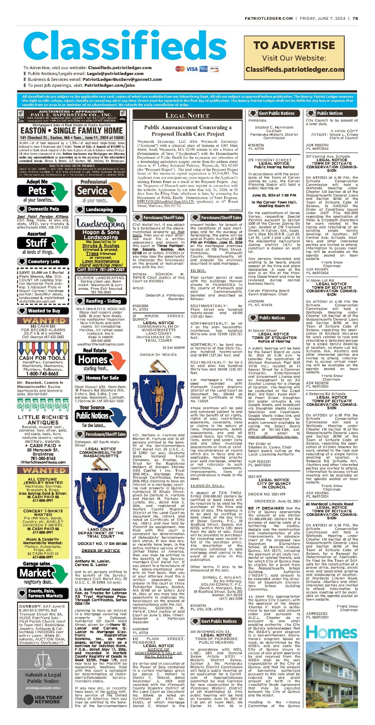

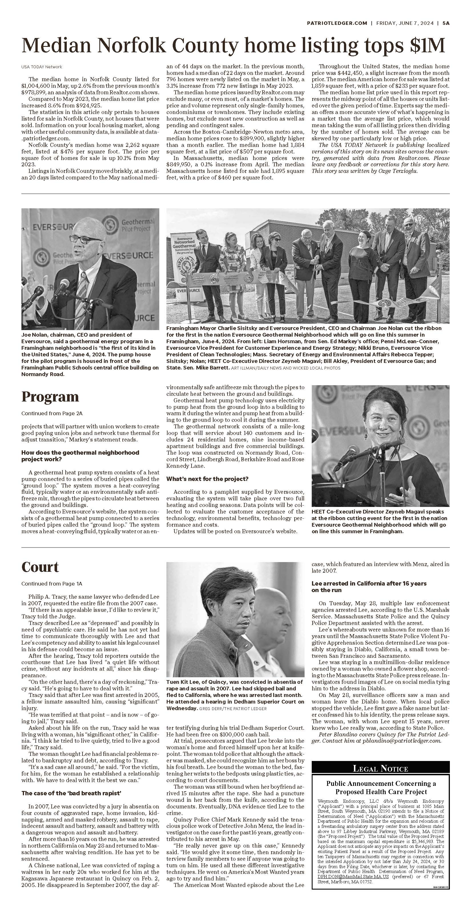

1. **Affidavit of Truthfulness**

 Version: 7-6-17

**Massachusetts Department of Public Health**

**Determination of Need**

**Affidavit of Truthfulness and Compliance**

**with Law and Disclosure Form 100.405 (B)**

**Instructions:** Complete Information below. When complete check the box "This document is ready to print:". This will date stamp and lock the form. Print Form. Each person must sign and date the form. When all signatures have been collected, scan the document and e-mail to: [**dph.don@state.ma.us**](mailto:dph.don@state.ma.us)Include all attachments as requested.

Application Number: WE-24062414-AS

Original Application Date: 6/24/2024

Applicant Name: Weymouth Endoscopy LLC

Application Type: Ambulatory Surgery

Applicant's Business Type: LLC

Is the Applicant the sole member or sole shareholder of the Health Facility(ies) that are the subject of this Application? No

Describe the role/relationship: The applicant is the sole owner/operator of the Health Facility that is the subject of the Application.

The undersigned certifies under the pains and penalties of perjury:

1. The Applicant is ;
2. I have ~~read~~ [been informed of the contents of] 105 CMR 100.000, the Massachusetts Determination of Need Regulation;
3. I understand and agree to the expected and appropriate conduct of the Applicant pursuant to 105 CMR 100.800;
4. I have ~~read~~ [been informed of the contents of] this application for Determination of Need including all exhibits and attachments, and ~~certify that~~ [have been informed that] all of the information contained herein is accurate and true;
5. I have submitted the correct Filing Fee and understand it is nonrefundable pursuant to 105 CMR 100.405(B);
6. I have submitted the required copies of this application to the Determination of Need Program, and, as applicable, to all Parties of Record and other parties as required pursuant to 105 CMR 100.405(B);
7. I have caused, as required, notices of intent to be published and duplicate copies to be submitted to all Parties of Record, and all carriers or third-party administrators, public and commercial, for the payment of health care services with which the Applicant contracts, and with Medicare and Medicaid, as required by 105 CMR 100.405(C), et seq.;
8. I ~~have caused~~ [have been informed that] proper notification and submissions to the Secretary of Environmental Affairs pursuant to 105 CMR 100.405(E) and 301 CMR 11.00; will be made, if applicable.
9. If subject to M.G.L. c. 6D, § 13 and 958 CMR 7.00, I have submitted such Notice of Material Change to the HPC - in accordance with 105 CMR 100.405(G);
10. Pursuant to 105 CMR 100.210(A)(3), I certify that both the Applicant and the Proposed Project are in material and substantial compliance and good standing with relevant federal, state, and local laws and regulations, as well as with all ~~previously issued~~ Notices of Determination of Need ~~and the terms and Conditions attached therein~~ [issued in compliance with 105 CMR 100.00, the Massachusetts Determination of Need Regulation effective January 27, 2017 and amended December 28, 2018];
11. I have ~~read~~ [been informed of the contents of] and understand the limitations on solicitation of funding from the general public prior to receiving a Notice of Determination of Need as established in 105 CMR 100.415;
12. I understand that, if Approved, the Applicant, as Holder of the DoN, shall become obligated to all Standard Conditions pursuant to 105 CMR 100.310, as well as any applicable Other Conditions as outlined within 105 CMR 100.000 or that otherwise become a part of the Final Action pursuant to 105 CMR 100.360;
13. Pursuant to 105 CMR 100.705(A), I certify that the Applicant has Sufficient Interest in the Site or facility; and
14. Pursuant to 105 CMR 100.705(A), I certify that the Proposed Project is authorized under applicable zoning by-laws or ordinances, whether or not a special permit is required; or,
    1. If the Proposed Project is not authorized under applicable zoning by-laws or ordinances, a variance has been received to permit such Proposed Project; or,
    2. The Proposed Project is exempt from zoning by-laws or ordinances.

|  |
| --- |
| **LLC**  All parties must sign. Add additional names as needed  Gregory Bolduc, MD <Signature on File> 6/19/2024  Name: Signature: Date: |

1. **Application Fee**

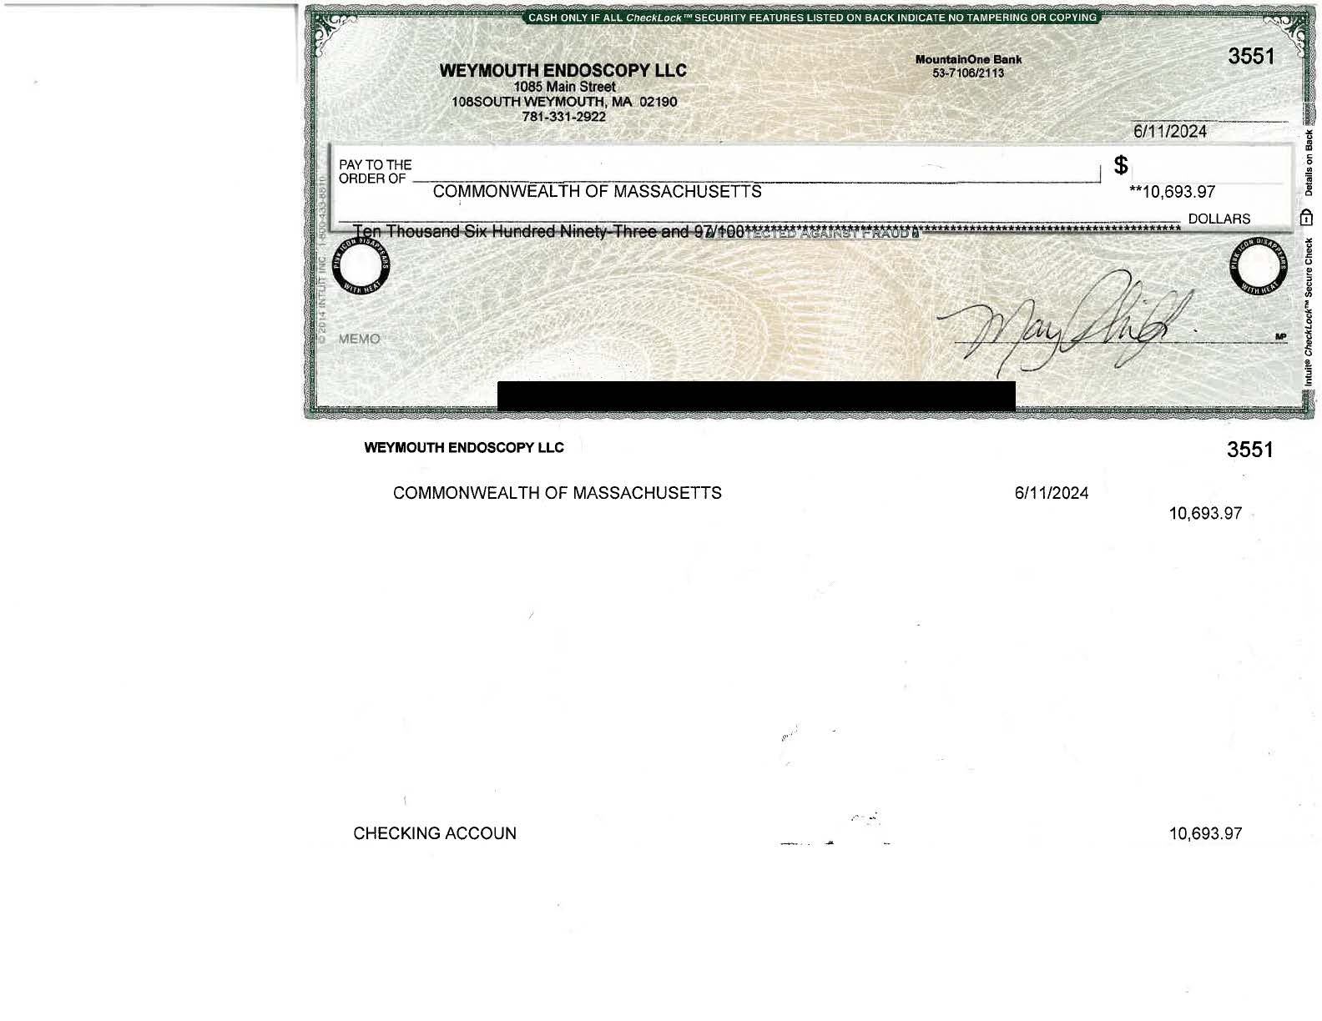

4000\0001\2109815.v1