INDOOR AIR QUALITY ASSESSMENT

City Hall Annex
77 Park Street
Attleboro, Massachusetts 02703



Prepared by:
Massachusetts Department of Public Health
Bureau of Environmental Health
Indoor Air Quality Program
October 2008

Background/Introduction
At the request of James Mooney, Director of the Attleboro Health Department (AHD), the Massachusetts Department of Public Health (MDPH), Bureau of Environmental Health (BEH), provided assistance and consultation regarding indoor air quality concerns at the City Hall Annex (CHA) located at 77 Park Street, Attleboro, Massachusetts. The request was prompted by mold concerns and respiratory irritation reported by building department staff. On July 22, 2008, a visit to the CHA to conduct an indoor air quality assessment was made by Cory Holmes, Environmental Analyst/Regional Inspector within BEH’s Indoor Air Quality (IAQ) Program. Mr. Holmes was accompanied for portions of the assessment by Mr. Mooney.
The City Hall Annex is located in the basement level of a former post office that was built in 1916, and is a historical site with the National Register. Offices located in the CHA include the building inspection department, emergency management and auxiliary police. The CHA has undergone interior renovations over the years. The building department has occupied the space since 2000. Windows are openable throughout the building CHA. Several months prior to the assessment the asphalt surrounding the building was reportedly removed, repaved and re-graded to improve drainage away from the building.

Methods
Air tests for carbon monoxide, carbon dioxide, temperature and relative humidity were conducted with the TSI, Q-Trak, IAQ Monitor, Model 8551. Air tests for airborne particle matter with a diameter less than 2.5 micrometers were taken with the TSI, DUSTTRAK™ Aerosol Monitor Model 8520. MDPH staff also performed visual inspection of building materials for water damage and/or microbial growth. Moisture content of porous building materials (e.g., wood, carpeting) was measured with Delmhorst, BD-2000 Model, Moisture Detector with a Delmhorst Standard Probe.

Results
The CHA has an employee population of 8 and may be visited by up to 75 members of the public daily. The tests were taken during normal operations and results appear in Table 1.

Discussion
Ventilation
It can be seen from Table 1 that carbon dioxide levels were above 800 ppm (parts per million) in all occupied areas surveyed, indicating poor air exchange at the time of the assessment. It is important to note that exterior doors and windows were shut due to several days of high heat and humidity; therefore, outside air intake was limited.
The CHA consists of a large meeting room with offices and the boiler room flanking the meeting room. Mechanical ventilation in the CHA is minimal and consists of: a ceiling-mounted air handling/air conditioning (AC) unit in the building department; a wall-mounted AC unit in the plans examiners office; a portable AC unit in the auxiliary police office; and, local exhaust ventilation in the restrooms that are activated by light switch. The large meeting room does not have any means of mechanical ventilation. The only means mechanical means to introduce fresh air into the CHA is via a small duct that is connected to the building department’s air handling unit (AHU); windows are used to introduce air into the remainder of the spaces.
Although the business department contains an air handling unit (AHU), maintaining temperature control/comfort may be difficult due to the configuration of the room and surrounding space. The building department has a roll-up business window and an interior door that opens into the unconditioned meeting room, and reportedly remains open over the course of the business day (Picture 1). In addition, the main entrance/foyer has no interior door, which allows for the introduction of unconditioned, outside air into the space every time the exterior door is opened (Pictures 1 and 2). Normally, entrance ways/foyers/exits have a set of interior doors that create a barrier between unconditioned transient areas and conditioned occupied areas.
The Massachusetts Building Code requires that each room have a minimum ventilation rate of 20 cubic feet per minute (cfm) per occupant of fresh outside air or openable windows (SBBRS, 1997; BOCA, 1993). The ventilation must be on at all times that the room is occupied. Providing adequate fresh air ventilation with open windows and maintaining the temperature in the comfort range during the cold weather season is impractical. Mechanical ventilation is usually required to provide adequate fresh air ventilation.
Carbon dioxide is not a problem in and of itself. It is used as an indicator of the adequacy of the fresh air ventilation. As carbon dioxide levels rise, it indicates that the ventilating system is malfunctioning or the design occupancy of the room is being exceeded. When this happens, a buildup of common indoor air pollutants can occur, leading to discomfort or health complaints. The Occupational Safety and Health Administration (OSHA) standard for carbon dioxide is 5,000 parts per million parts of air (ppm). Workers may be exposed to this level for 40 hours/week, based on a time-weighted average (OSHA, 1997).
The MDPH uses a guideline of 800 ppm for publicly occupied buildings. A guideline of 600 ppm or less is preferred in schools due to the fact that the majority of occupants are young and considered to be a more sensitive population in the evaluation of environmental health status. Inadequate ventilation and/or elevated temperatures are major causes of complaints such as respiratory, eye, nose and throat irritation, lethargy and headaches. For more information concerning carbon dioxide, consult Appendix A.
Temperature readings in occupied areas ranged from 72º F to 77º F, which were within the MDPH recommended comfort guidelines on the day of the assessment. The MDPH recommends that indoor air temperatures be maintained in a range of 70º F to 78º F in order to provide for the comfort of building occupants. In many cases concerning indoor air quality, fluctuations of temperature in occupied spaces are typically experienced, even in a building with an adequate fresh air supply.
At the time of the assessment, the relative humidity measurements in occupied areas ranged from 45 to 49 percent, which were within the MDPH comfort range. The MDPH recommends a comfort range of 40 to 60 percent for indoor air relative humidity. Relative humidity levels in the building would be expected to drop during the winter months due to heating. The sensation of dryness and irritation is common in a low relative humidity environment. Low relative humidity is a very common problem during the heating season in the northeast part of the United States.

Microbial/Moisture Concerns
Water damaged masonry walls, peeling paint and efflorescence were observed in the building department, plans examiner’s office and storeroom (Pictures 3 through 5).
Efflorescence is a characteristic sign of water damage to masonry (e.g., brick, concrete) and mortar, but it is not mold growth. As moisture penetrates and works its way through mortar and masonry, water-soluble compounds in mortar and masonry dissolve, creating a solution. As the solution moves to the surface of the mortar or masonry, the water evaporates, leaving behind white, powdery mineral deposits. Water damage is most likely the result of water penetration through the building envelope. The damage in the building department roughly corresponds to the level of an exterior drain at the bottom of a concrete-lined window well (Pictures 6 and 7). The drain appeared to be clogged with debris at the time of the assessment (Picture 7).
The damage in the plans examiner’s office and storeroom corresponds to the level of the parking lot as evidenced by the horizontal plane of water damage (Pictures 4 and 5). As previously mentioned, several months prior to the assessment the asphalt surrounding the building was reportedly removed, re-paved and re-graded to improve drainage away from the building (Pictures 8 and 9). No further water penetration issues were voiced at the time of the assessment.
In order for building materials to support mold growth, a source of water exposure is necessary. Identification and elimination of water moistening building materials is necessary to control mold growth. Materials with increased moisture content over normal concentrations may indicate the possible presence of mold growth. Elevated moisture readings were measured and visible water damage and/or mold growth was detected/observed beneath carpeting and wooden tack strips along exterior walls of the plans examiner’s office and storeroom (Picture 10).
The US Environmental Protection Agency and the American Conference of Governmental Industrial Hygienists (ACGIH) recommends that porous materials (carpeting, ceiling tiles, etc.) be dried with fans and heating within 24 to 48 hours of becoming wet (US EPA, 2001; ACGIH, 1989). If porous materials are not dried within this time frame, mold growth may occur. Water-damaged porous materials cannot be adequately cleaned to remove mold growth. The application of a mildewcide to moldy porous materials is not recommended.
Other water damaged porous items were also observed colonized with mold including framed pictures and cardboard boxes (Pictures 11 and 12). Many of which are stored in the boiler room directly on the concrete floor, which is an unconditioned area that is prone to elevated humidity and condensation.

Other IAQ Evaluations
Indoor air quality can be negatively influenced by the presence of respiratory irritants, such as products of combustion. The process of combustion produces a number of pollutants. Common combustion emissions include carbon monoxide, carbon dioxide, water vapor and smoke (fine airborne particle material). Of these materials, exposure to carbon monoxide and particulate matter with a diameter of 2.5 micrometers (μm) or less (PM2.5) can produce immediate, acute health effects upon exposure. To determine whether combustion products were present in the building environment, BEH staff obtained measurements for carbon monoxide and PM2.5.

Carbon Monoxide
Carbon monoxide is a by-product of incomplete combustion of organic matter (e.g., gasoline, wood and tobacco). Exposure to carbon monoxide can produce immediate and acute health affects. Several air quality standards have been established to address carbon monoxide and prevent symptoms from exposure to these substances. The MDPH established a corrective action level concerning carbon monoxide in ice skating rinks that use fossil-fueled ice resurfacing equipment. If an operator of an indoor ice rink measures a carbon monoxide level over 30 ppm, taken 20 minutes after resurfacing within a rink, that operator must take actions to reduce carbon monoxide levels (MDPH, 1997).
The American Society of Heating Refrigeration and Air-Conditioning Engineers (ASHRAE) has adopted the National Ambient Air Quality Standards (NAAQS) as one set of criteria for assessing indoor air quality and monitoring of fresh air introduced by HVAC systems (ASHRAE, 1989). The NAAQS are standards established by the US EPA to protect the public health from six criteria pollutants, including carbon monoxide and particulate matter (US EPA, 2006). As recommended by ASHRAE, pollutant levels of fresh air introduced to a building should not exceed the NAAQS levels (ASHRAE, 1989). The NAAQS were adopted by reference in the Building Officials & Code Administrators (BOCA) National Mechanical Code of 1993 (BOCA, 1993), which is now an HVAC standard included in the Massachusetts State Building Code (SBBRS, 1997). According to the NAAQS, carbon monoxide levels in outdoor air should not exceed 9 ppm in an eight-hour average (US EPA, 2006).
Carbon monoxide should not be present in a typical, indoor environment. If it is present, indoor carbon monoxide levels should be less than or equal to outdoor levels. On the day of assessment, outdoor carbon monoxide concentrations were non-detect (ND) (Table 1). Carbon monoxide levels measured in the building were also ND.

Particulate Matter (PM2.5)
The US EPA has established NAAQS limits for exposure to particulate matter. Particulate matter is airborne solids that can be irritating to the eyes, nose and throat. The NAAQS originally established exposure limits to particulate matter with a diameter of 10 μm or less (PM10). According to the NAAQS, PM10 levels should not exceed 150 microgram per cubic meter (μg/m³) in a 24-hour average (US EPA, 2006). These standards were adopted by both ASHRAE and BOCA. Since the issuance of the ASHRAE standard and BOCA Code, US EPA established a more protective standard for fine airborne particles. This more stringent PM2.5 standard requires outdoor air particle levels be maintained below 35 μg/m³ over a 24-hour average (US EPA, 2006). Although both the ASHRAE standard and BOCA Code adopted the PM10 standard for evaluating air quality, MDPH uses the more protective PM2.5 standard for evaluating airborne particulate matter concentrations in the indoor environment.
Outdoor PM2.5 concentrations were measured at 25 μg/m³ (Table 1). PM2.5 levels measured in the building ranged from 12 to 24 μg/m³ (Table 1). Both indoor and outdoor PM2.5 levels were below the NAAQS PM2.5 level of 35 μg/m³. Frequently, indoor air levels of particulates (including PM2.5) can be at higher levels than those measured outdoors. A number of mechanical devices and/or activities that occur in buildings can generate particulate during normal operations. Sources of indoor airborne particulates may include but are not limited to particles generated during the operation of fan belts in the HVAC system, cooking in the cafeteria stoves and microwave ovens; use of photocopiers, fax machines and computer printing devices; operation of an ordinary vacuum cleaner and heavy foot traffic indoors.

Other Conditions
Several other conditions that can potentially affect indoor air quality were identified during the assessment. In a number of areas, items were observed on the floor, windowsills, tabletops, counters, bookcases and desks. The large number of items stored provides a source for dusts to accumulate. These items (e.g., papers, folders, boxes) make it difficult for custodial staff to clean. Items should be relocated and/or be cleaned periodically to avoid excessive dust build up. In addition, these materials can accumulate on flat surfaces (e.g., desktops, windowsills and carpets) in occupied areas and subsequently be re-aerosolized causing further irritation. Finally, open utility holes were observed in the boiler room wall, which can serve as pathways for drafts, dust and debris into adjacent occupied areas (Pictures 13 and 14).

Conclusions/Recommendations
In view of the findings at the time of the visit, the following recommendations are made:
- Consider full removal and replacement of carpeting; carpeting is generally not recommended in below grade areas. If not feasible, remove carpeting approximately 2 to 3 feet from exterior walls. Remove and discard water damaged/mold colonized wooden tack strips. Disinfect floor beneath carpet with an appropriate antimicrobial agent, clean and dry. Consider replacing carpet with tile or other non-porous floor material.
- Discard water damaged/mold colonized porous items (e.g., pictures, cardboard boxes, books/papers).
- Clean, disinfect and repair/seal water damaged masonry walls.
- Operate the HVAC system continuously during periods of occupancy to maximize air exchange.
- Consult a heating, ventilation and air conditioning (HVAC) engineer concerning methods to increase the introduction of fresh air into the space.
- Consider installing timer on restroom exhaust vents to operate independent of the light switch and to provide a continuous source of air exchange.
- Use openable windows in conjunction with mechanical ventilation to supplement air exchange. Avoid opening windows during hot humid weather to avoid condensation problems. Care should also be taken to ensure windows are properly closed at night and weekends during winter months to avoid the freezing of pipes and potential flooding.
- Examine the feasibility of providing mechanical ventilation (supply and exhaust ventilation) to the remainder of the CHA space.
- For buildings in New England, periods of low relative humidity during the winter are often unavoidable. Therefore, scrupulous cleaning practices should be adopted to minimize common indoor air contaminants whose irritant effects can be enhanced when the relative humidity is low. To control for dusts, a high efficiency particulate arrestance (HEPA) filter equipped vacuum cleaner in conjunction with wet wiping of all surfaces is recommended. Drinking water during the day can help ease some symptoms associated with a dry environment (e.g., throat and sinus irritations).
- Repair any water leaks as they may occur and replace any remaining water damaged ceiling tiles. Examine the areas above and behind these areas for mold growth. Disinfect areas of water leaks with an appropriate antimicrobial.
- Unclog drain at bottom of window well outside of building department. Inspect periodically for proper drainage, make repairs as needed.
- Consider installing a sliding glass or other security window to maintain comfort in the building department.
- Keep door to building department closed.
- Install weather-stripping on bottom of exterior door.
- Consider installing interior doors at the main entrance to create a barrier between conditioned and unconditioned areas.
- Use portable dehumidifiers to supplement air-conditioning during periods of excessive relative humidity (e.g., over 70% for extended periods of time). Consider obtaining additional dehumidifiers due to the size of floor space.
- Clean and disinfect dehumidifiers/humidifiers as per the manufacture’s instructions to prevent microbial growth.
- Relocate or consider reducing the amount of stored materials to allow for more thorough cleaning. Clean items regularly with a wet cloth or sponge to prevent excessive dust build-up.
- Clean/change filters for the air handler and ACs as per the manufactures instructions or more frequently if needed.
- Seal open utility holes in boiler room walls to prevent migration of drafts, odors and particulates into adjacent areas.
- For more advice on mold please consult the document “Mold Remediation in Schools and Commercial Buildings” published by the US Environmental Protection Agency (US EPA, 2001). Copies of this document can be downloaded from the US EPA website at: http://www.epa.gov/mold/mold_remediation.html.
- Refer to resource manuals and other related indoor air quality documents located on the MDPH’s website for further building-wide evaluations and advice on maintaining public buildings. These documents are available at: http://mass.gov/dph/iaq.

References
ACGIH. 1989. Guidelines for the Assessment of Bioaerosols in the Indoor Environment. American Conference of Governmental Industrial Hygienists, Cincinnati, OH.
ASHRAE. 1989. Ventilation for Acceptable Indoor Air Quality. American Society of Heating, Refrigeration and Air Conditioning Engineers. ANSI/ASHRAE 62-1989
BOCA. 1993. The BOCA National Mechanical Code/1993. 8th ed. Building Officials & Code Administrators International, Inc., Country Club Hills, IL.

MDPH. 1997. Requirements to Maintain Air Quality in Indoor Skating Rinks (State Sanitary Code, Chapter XI). 105 CMR 675.000. Massachusetts Department of Public Health, Boston, MA.
OSHA. 1997. Limits for Air Contaminants. Occupational Safety and Health Administration. Code of Federal Regulations. 29 C.F.R 1910.1000 Table Z-1-A.

SBBRS. 1997. Mechanical Ventilation. State Board of Building Regulations and Standards. Code of Massachusetts Regulations. 780 CMR 1209.0

US EPA. 2001. Mold Remediation in Schools and Commercial Buildings. US Environmental Protection Agency, Office of Air and Radiation, Indoor Environments Division, Washington, DC. EPA 402-K-01-001. March 2001.

US EPA. 2006. National Ambient Air Quality Standards (NAAQS). US Environmental Protection Agency, Office of Air Quality Planning and Standards, Washington, DC. http://www.epa.gov/air/criteria.html.
Picture 1

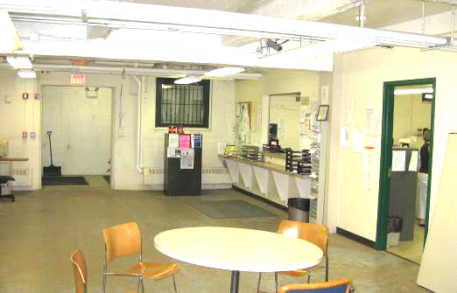

Open Business Window and Interior Door to Building Department,
Also Note Open Doorway to Main Entrance (Left)

Picture 2

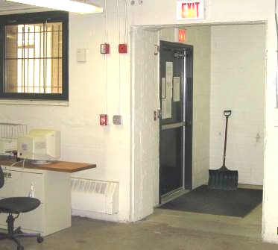

Exterior Door to Main Entrance CHA, Note no Door/Barrier between Entrance and Interior

Picture 3

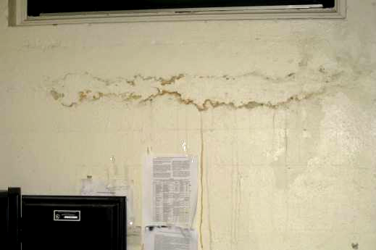

Evidence of Water Penetration through Exterior Foundation Wall in Building Department:
Water Damaged Masonry, Efflorescence and Stained Paint: Note Area of Water Damage Roughly Corresponds with the Level of an Exterior Drain Directly outside of Window

Picture 4

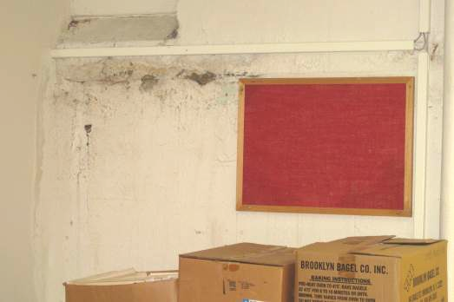

Evidence of Water Penetration through Exterior Foundation Wall in Plans Examiner’s Office:
Water Damaged Masonry, Efflorescence and Stained Paint: Note Horizontal Line, Which Roughly Corresponds with the Level of the Tarmac Outside

Picture 5

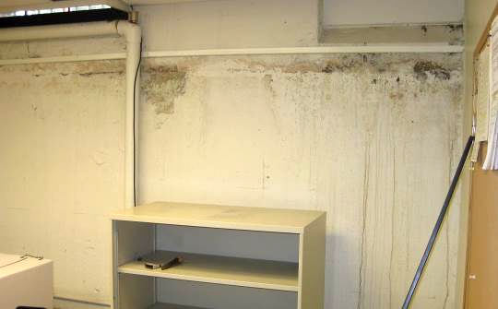

Evidence of Water Penetration through Exterior Foundation Wall in Storage Room (Plans Examiner’s Office): Water Damaged Masonry, Efflorescence and Stained Paint: Note Horizontal Line, Which Roughly Corresponds with the Level of the Tarmac Outside

Picture 6

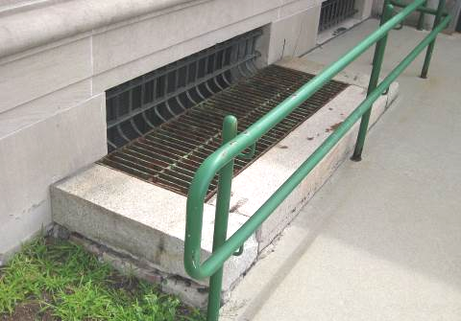

Window Well outside of Building Department

Picture 7

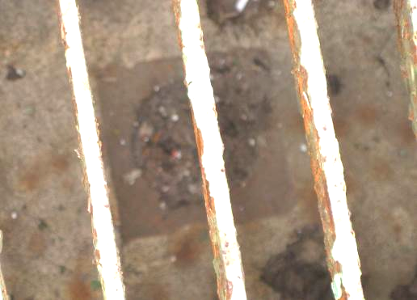

Clogged Drain at bottom of Window Well of outside Building Department (Shown in Previous Picture)

Picture 8

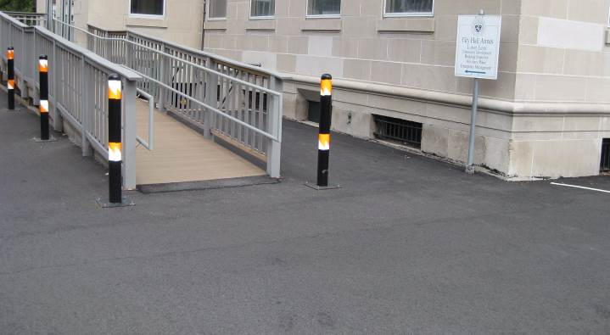

Tarmac Re-graded to Drain Away from Building

Picture 9

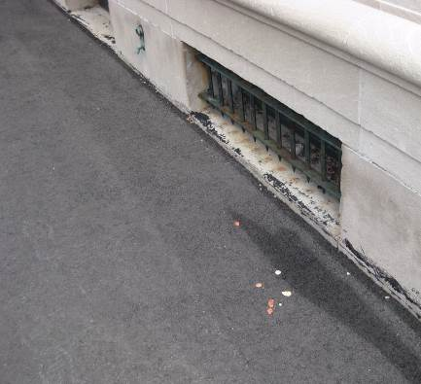

Tarmac Re-graded to Drain Away from Building

Picture 10

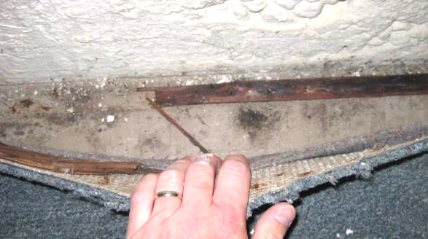

Water Damaged/Mold Colonized Wooden Tack Board, Carpeting and Backing in
Plans Examiner’s Storeroom

Picture 11

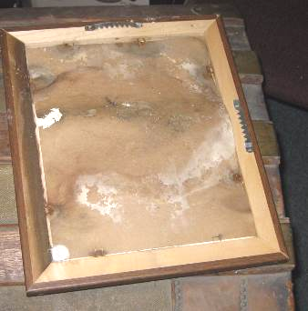

Water Damaged/Mold-Colonized Picture in Plans Examiner’s Storeroom

Picture 12

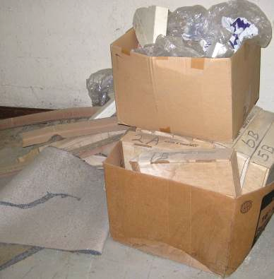

Water Damaged/Mold-Colonized Porous Items on Floor of the Boiler Room

Picture 13

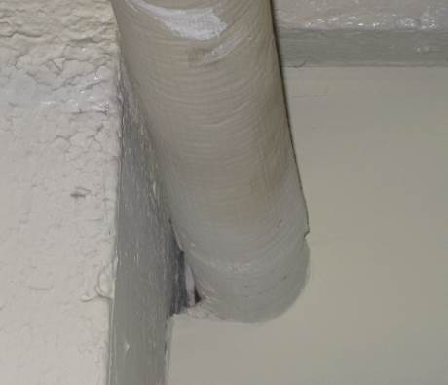

Space around Utility Pipe in Boiler Room Wall

Picture 14

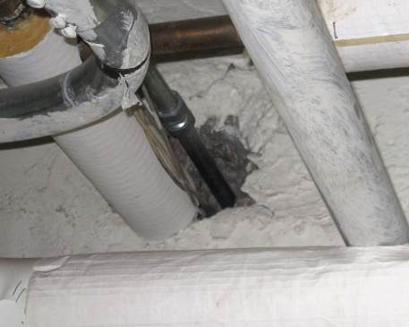

Space around Utility Pipe in Boiler Room Wall
Location/ Room | Occupants  in Room | Temp  (°F) | Relative  Humidity  (%) | Carbon  Dioxide  (ppm) | Carbon Monoxide  (ppm) | PM2.5  (µg/m³) | Windows  Openable | Ventilation |  |  | Remarks
 |  |  |  |  |  |  |  | Supply |  | Exhaust | Remarks
background |  | 80 | 75 | 376 | ND | 25 |  |  |  |  | Hazy, hot and humid
Meeting Room | 0 | 77 | 49 | 890 | ND | 16 | Y | N |  | N | Dehumidifier, no internal doors for main entrance, space under exterior door
Building Department | 3 | 74 | 45 | 931 | ND | 12 | Y | Y |  | N | AC unit ducted to outside, water damaged/stained walls/peeling paint, efflorescence, clogged drain outside of window well
Plans Examiner’s Office | 1 | 73 | 49 | 832 | ND | 14 | Y | N |  | N | Wall AC, wall to wall carpet, water damaged/stained walls/peeling paint, efflorescence, low moisture carpet
Store Room | 0 | 72 | 49 | 830 | ND | 14 | Y | N |  | N | wall to wall carpet, water damaged/stained walls/peeling paint, efflorescence, visible mold growth under edges of carpet and on wooden tack strips, elevated moisture measurements in carpet (edge) and wooden tack strips
Boiler Room | 0 | 75 | 68 | 492 | ND | 24 | N | Y | Y |  | Spaces around utility holes, water damaged cardboard and porous materials

