**INDOOR AIR QUALITY REASSESSMENT**

**Attleboro District Court**

**88 North Main Street**

**Attleboro, Massachusetts**

front view of the Attleboro District Court, 88 North Main Street, Attleboro, Massachusetts


Prepared by:

Massachusetts Department of Public Health

Bureau of Environmental Health

Indoor Air Quality Program

March 2017

# Background

|  |  |
| --- | --- |
| Building: | Attleboro District Court |
| Address: | 88 North Main Street, Attleboro, MA |
| Assessment Requested by: | Chris McQuaid, Administrative Attorney/Leased Property Manager |
| Reason for Request: | General indoor air quality (IAQ) assessment |
| Date of Assessment: | February 17, 2017 |
| Massachusetts Department of Public Health/Bureau of Environmental Health (MDPH/BEH) Staff Conducting Assessment: | Cory Holmes, Environmental Analyst, IAQ Program |
| Building Description: | Two-story brick/masonry building with occupied basement |
| Building Population: | Approximately 50-60 employees, with up to several hundred members of the public visiting daily |
| Windows: | Openable |

# Methods

Please refer to the IAQ Manual for methods, sampling procedures, and interpretation of results (MDPH, 2015).

# IAQ Testing Results

The following is a summary of indoor air testing results (Table 1).

* ***Carbon dioxide levels*** were above 800 parts per million (ppm) in 9 of 31 areas assessed, indicating a lack of air exchange in a quarter of areas tested.
* ***Temperature*** was within the recommended range of 70°F to 78°F in most areas assessed.
* ***Relative humidity*** was below the recommended range of 40% to 60% in all areas assessed, which is typical for weather conditions in the winter.
* ***Carbon monoxide*** levels were non-detectable in all indoor areas assessed.
* ***Fine particulate matter (PM2.5)*** concentrations measured were below the National Ambient Air Quality Standard (NAAQS) level of 35 micrograms per cubic meter (μg/m3) in all areas assessed.

## Ventilation

A heating, ventilating and air conditioning (HVAC) system has several functions. First it provides heating and, if equipped, cooling. Second, it is a source of fresh air. Finally, an HVAC system will dilute and remove normally-occurring indoor environmental pollutants by not only introducing fresh air, but by filtering the airstream and ejecting stale air to the outdoors via exhaust ventilation. Even if an HVAC system is operating as designed, point sources of respiratory irritation may exist and cause symptoms in sensitive individuals.

Mechanical ventilation in most areas is provided by unit ventilators (univents) that draw air from the exterior via a fresh air intake (Pictures 1and 2). The univents examined were equipped with metal/mesh filters that provide minimal filtration (Picture 3). Univents in the courtroom had a filter medium that needs to be physically cut to size (Picture 4). MDPH recommends filters of a Minimum Efficiency Reporting Value (MERV) of 8, which are adequate in filtering out pollen and mold spores (ASHRAE, 2012). As observed from the outside, it appeared that the univents had no louvers or intake controls to adjust the amount of airflow into the units (Picture 5). In addition, none of the areas were equipped with exhaust ventilation. Lack of air exchange/circulation can lead to the build-up of naturally occurring pollutants in the space, which can result in IAQ/comfort complaints.

It is also important to note that the univents are over 30 years old. Efficient function of equipment of this age is difficult to maintain, since compatible replacement parts are often unavailable. According to the American Society of Heating, Refrigeration and Air-Conditioning Engineering (ASHRAE), the service life[1] for a unit heater, hot water or steam is 20 years, assuming routine maintenance of the equipment (ASHRAE, 1991). Despite attempts to maintain the equipment, the optimal operational lifespan of this equipment has been exceeded.

Basement areas are mechanically ventilated by an air handling unit (AHU, Picture 6), controlled by a wall-mounted thermostat. Supply and return air is provided by ducted vents (Picture 7).

## Microbial/Moisture Concerns

Stained ceiling tiles were observed in several areas, including the Probation Department (Picture 8, Table 1). Water-damaged ceiling tiles can indicate roof or plumbing leaks. Any leaks should be reported promptly to building maintenance staff to ensure they can be repaired and materials can be dried. The United States Environmental Protection Agency (US EPA) and the American Conference of Governmental Industrial Hygienists (ACGIH) recommend that porous materials be dried with fans and heating within 24 to 48 hours of becoming wet (US EPA, 2008; ACGIH, 1989). If porous materials are not dried within this time frame, mold growth may occur. Once mold has colonized porous materials, they are difficult to clean and should be removed and discarded.

Plants were observed in a few areas (Table 1). Plants can be a source of pollen and mold, which can be respiratory irritants to some individuals. Plants should be properly maintained and equipped with drip pans and should be located away from air diffusers to prevent the aerosolization of dirt, pollen, and mold.

The bathroom in the basement had wall-to-wall carpeting (Picture 9). Carpeting in restrooms is not recommended because it can become easily moistened or contaminated, which would necessitate its removal.

## Other Concerns

In a number of areas, items were observed on the floor, windowsills, tabletops, counters, bookcases and desks. The large number of items stored provides a source for dusts to accumulate. These items (e.g., papers, folders, boxes) make it difficult for custodial staff to clean. Items should be relocated and/or be cleaned periodically to avoid excessive dust build up. In addition, these materials can accumulate on flat surfaces (e.g., desktops, windowsills and carpets) in occupied areas and subsequently be re-aerosolized causing further irritation.

Several univents, portable and stand-up fans were observed to have accumulated dust/debris (Picture 10). Operation of this equipment can re-aerosolize accumulated dust particles.

Many areas contained old, worn carpeting that appeared to be past its useful life (Picture 11). The Institute of Inspection, Cleaning, and Restoration Certification (IICRC), recommends that carpeting be cleaned annually, or semi-annually in high-traffic areas (IICRC, 2012). Since the average lifespan of carpeting is approximately eleven years (Bishop, 2002), consideration should be given to planning the installation of new flooring. In general, carpeting is not recommended in basement areas, especially if exposed to chronic moisture.

Exposed fiberglass insulation material was observed around windows on the second floor (Picture 12). Fiberglass can be irritating to the skin, eyes and respiratory system.

Finally, mercury-containing thermostats were observed in the Juvenile Probation area of the basement (Picture 13). The mercury in these thermostats is in an airtight glass ampoule. While the mercury is not evaporating into the environment when intact, these glass ampoules pose a hazard by accidental breakage. If broken, mercury could be released into the indoor environment resulting in building evacuation, exposure of occupants to mercury vapor, and a costly hazardous material clean up/remediation.

# Conclusions/Recommendations

Based on observations at the time of assessment, the following is recommended:

1. Operate mechanical ventilation continuously in all areas during occupied periods.
2. Have an HVAC engineering firm evaluate univents for proper operation and future replacement, including the addition of exhaust vents in rooms containing univents.
3. Clean univents and change filters 2 to 4 times a year. Determine if univents can be outfitted with more efficient filters, MERV 8 or higher.
4. Ensure univents, supply vents and personal fans are cleaned periodically to prevent buildup and re-circulation of dust and debris.
5. Replace water-damaged ceiling tiles once source of leak is repaired.
6. Keep plants in good condition, avoid overwatering, and remove from the airstream of heating and ventilation equipment.
7. Remove carpeting in basement restroom.
8. Replace old/stained/worn carpeting throughout the building; consider non-porous flooring such as tile for below-grade areas.
9. Clean existing carpeting annually (or semi-annually in soiled high traffic areas) as per the recommendations of the Institute of Inspection, Cleaning and Restoration Certification (IICRC).
10. Consider replacing mercury-containing thermostats with digital/programmable thermostats to improve temperature control. Have the mercury-containing items removed for proper disposal.
11. For buildings in New England, periods of low relative humidity during the winter are often unavoidable. Therefore, scrupulous cleaning practices should be adopted to minimize common indoor air contaminants whose irritant effects can be enhanced when the relative humidity is low. To control for dusts, a high efficiency particulate arrestance (HEPA) filter equipped vacuum cleaner in conjunction with wet wiping of all surfaces is recommended. Drinking water during the day can help ease some symptoms associated with a dry environment (e.g., throat and sinus irritations).
12. Remove or cover exposed fiberglass insulation around windows on the second floor.
13. Refer to resource manual and other related IAQ documents located on the MDPH’s website for further building-wide evaluations and advice on maintaining public buildings. These documents are available at: <http://mass.gov/dph/iaq>.

# References

ACGIH. 1989. Guidelines for the Assessment of Bioaerosols in the Indoor Environment. American Conference of Governmental Industrial Hygienists, Cincinnati, OH.

ASHRAE. 1991. ASHRAE Applications Handbook, Chapter 33 “Owning and Operating Costs”. American Society of Heating, Refrigeration and Air Conditioning Engineers, Atlanta, GA.

ASHRAE. 2012. American Society of Heating, Refrigeration and Air Conditioning Engineers (ASHRAE) Standard 52.2-2012 -- Method of Testing General Ventilation Air-Cleaning Devices for Removal Efficiency by Particle Size (ANSI Approved). 2012.

Bishop. 2002. Bishop, J. & Institute of Inspection, Cleaning and Restoration Certification. A Life Cycle Cost Analysis for Floor Coverings in School Facilities.

IICRC. 2012. Institute of Inspection Cleaning and Restoration Certification. Institute of Inspection, Cleaning and Restoration Certification. Carpet Cleaning: FAQ. Retrieved from <http://www.iicrc.org/consumers/care/carpet-cleaning>.

MDPH. 2015. Massachusetts Department of Public Health. Massachusetts Department of Public Health Indoor Air Quality Manual: Chapters I-III. Available at: <http://www.mass.gov/eohhs/gov/departments/dph/programs/environmental-health/exposure-topics/iaq/iaq-manual/>.

US EPA. 2008. “Mold Remediation in Schools and Commercial Buildings”. Office of Air and Radiation, Indoor Environments Division, Washington, DC. EPA 402-K-01-001. September 2008. Available at: <http://www.epa.gov/mold/mold-remediation-schools-and-commercial-buildings-guide>.

**Picture 1**

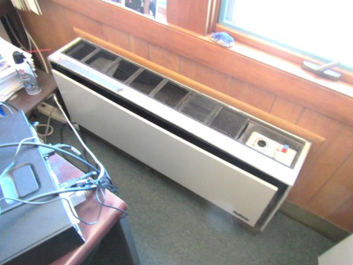

**Univent in Probation Department, 30 or more years old**

**Picture 2**

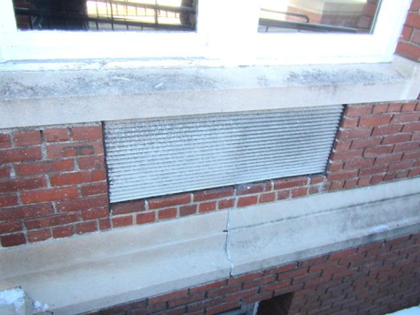

**Outside air intake for univents**

**Picture 3**

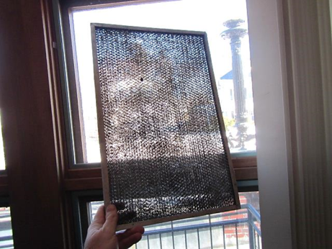

**Metal-mesh filter for univent**

**Picture 4**

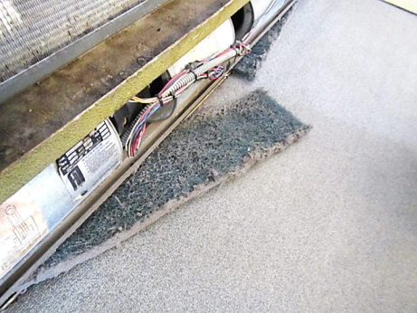

**Loose filter media in Courtroom univent**

**Picture 5**

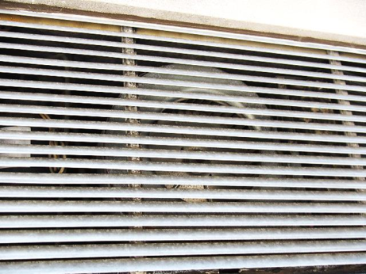

**Univent air intake, note no mechanism/movable louvers for adjusting air intake**

**Picture 6**

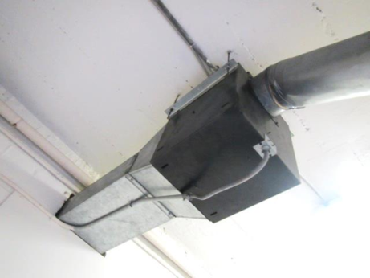

**Basement air handling unit**

**Picture 7**

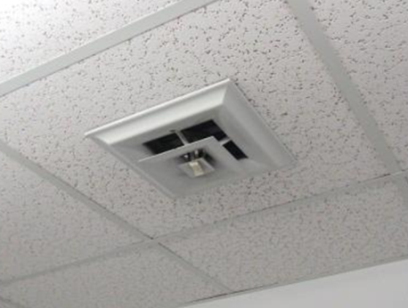

**Basement supply vent**

**Picture 8**

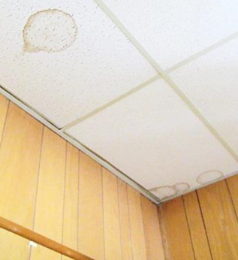

**Water-damaged ceiling tiles in the Probation Department**

**Picture 9**

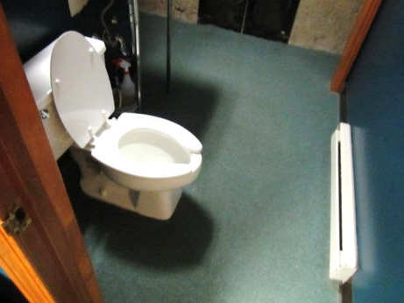

**Carpeting in basement bathroom**

**Picture 10**

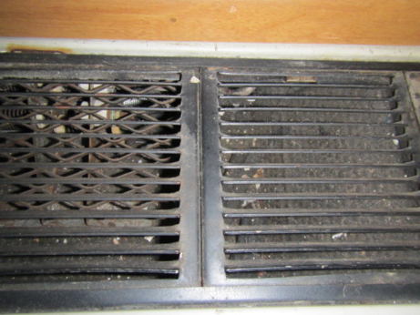

**Dust/debris inside univent grill**

**Picture 11**

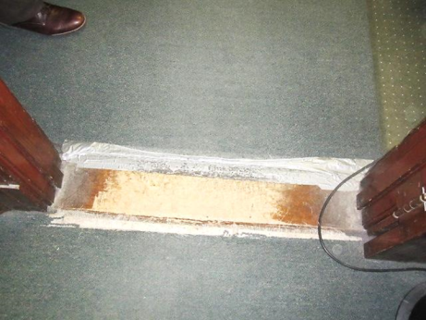

**Old/worn carpeting held by duct tape**

**Picture 12**

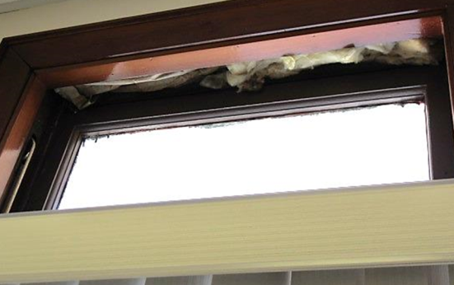

**Exposed fiberglass insulation around windows on the 2nd floor**

**Picture 13**

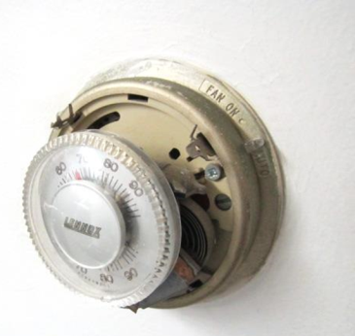

**Mercury-containing thermostat in Juvenile Probation area**

| **Location** | **Carbon**  **Dioxide**  **(ppm)** | **Carbon Monoxide**  **(ppm)** | **Temp**  **(°F)** | **Relative**  **Humidity**  **(%)** | **PM2.5**  **(µg/m3)** | **Occupants**  **in Room** | **Windows**  **Openable** | **Ventilation** | | | **Remarks** |
| --- | --- | --- | --- | --- | --- | --- | --- | --- | --- | --- | --- |
| **Intake** | **Exhaust** | |
| Background | 395 | ND | <32 | 23 | 7 |  |  |  | |  | Clear, cold, windy |
| **Probation Department** |  |  |  |  |  |  |  |  | |  |  |
| Cotter Office | 636 | ND | 73 | 22 | 5 | 0 | Y | Y | | N | Old/worn wall-to-wall carpeting |
| Deslauriers Office | 912 | ND | 74 | 21 | 3 | 0 | N | N | | N | Radiator, old/worn wall-to-wall carpeting, missing light cover |
| Adams Office | 891 | ND | 74 | 20 | 13 |  | N | Y | | N |  |
| Probation File Area | 945 | ND | 74 | 21 | 4 | 0 | N | N | | N | WD CT-old/historic stain |
| Probation Officers Area | 964 | ND | 75 | 20 | 3 | 4 | Y | Y | | N | Tile floor, 5 WD CT |
| Probation Front/Reception | 975 | ND | 75 | 19 | 7 | 1 | Y | Y | | N | 2 PC |
| Bookkeeping | 990 | ND | 77 | 19 | 7 | 1 | N | N | | N | Water cooler on carpet, fan-dusty, old/worn carpeting |
| Superior Probation Office | 779 | ND | 77 | 15 | 11 | 0 | Y | N | | N | Carpet, plants, window AC |
| **1st Floor** |  |  |  |  |  |  |  |  | |  |  |
| DA’s Office | 658 | ND | 76 | 11 | 10 | 6 | Y | N | | N | Window AC, radiator |
| DA Meeting Room | 466 | ND | 71 | 10 | 6 | 0 | Y | N | | N | Carpeting |
| Court Room 1 | 1191 | ND | 74 | 22 | 10 | ~50 | Y | Y | | N | Carpeting |
| Magistrate Work Area (left) | 891 | ND | 75 | 21 | 4 | 5 | Y | Y | | N | WD CT near window |
| Magistrate Office | 757 | ND | 75 | 18 | 5 | 1 | Y | Y | | N |  |
| Magistrate Work Area (right) | 895 | ND | 75 | 20 | 5 | 3 | Y | Y | | N |  |
| Perkoski Office | 797 | ND | 78 | 17 | 6 | 0 | N | N | | N | PF |
| Judge’s Lobby | 504 | ND | 78 | 13 | 3 | 0 | Y | Y | | N | Carpeting |
| Cashier Office | 656 | ND | 78 | 14 | 6 | 1 | Y Open | N | | N |  |
| 2nd Floor |  |  |  |  |  |  |  |  | |  |  |
| Judge’s Office | 738 | ND | 80 | 14 | 4 | 0 | Y | N | | N | AC, exposed fiberglass insulation over windows, carpeting |
| Civil Department | 796 | ND | 79 | 16 | 5 | 3 | Y | N | | N | ACs |
| Court Room 3 | 617 | ND | 76 | 13 | 5 | 0 | Y | N | | N | Exposed fiberglass insulation over windows |
| File Room Civil | 788 | ND | 76 | 18 | 6 | 0 | Y | N | | N | AC |
| Judge’s Lobby | 795 | ND | 74 | 18 | 5 | 0 | Y | N | | N |  |
| **Basement** |  |  |  |  |  |  |  |  | |  |  |
| Juvenile Probation | 682 | ND | 74 | 19 | 3 | 2 | N | Y | | N |  |
| Juvenile Court | 438 | ND | 71 | 14 | 4 | 0 | Y | Y | | N |  |
| Bathroom |  |  |  |  |  |  |  |  | |  | Carpeting |
| Juvenile Court Room | 481 | ND | 72 | 18 | 3 | 0 | Y | Y | | N | Carpeting |
| Juvenile Lockup | 549 | ND | 79 | 20 | 4 | 0 | N | Y | | N |  |
| Basement Record Room | 698 | ND | 73 | 25 | 3 | 0 | Y | N | | N | No climate control |
| Maintenance Office | 477 | ND | 80 | 15 | 3 | 0 | N | N | | N | WD CT, carpeting |
| Lockup | 604 | ND | 77 | 15 | 4 | 0 | N | N | | N |  |
| Security Office | 582 | ND | 72 | 14 | 4 | 1 | Y Open | N | | N |  |
| Jury Pool | 412 | ND | 75 | 10 | 4 | 0 | Y | N | | N | AC |

1. The service life is the median time during which a particular system or component of …[an HVAC]… system remains in its original service application and then is replaced. Replacement may occur for any reason, including, but not limited to, failure, general obsolescence, reduced reliability, excessive maintenance cost, and changed system requirements due to such influences as building characteristics or energy prices (ASHRAE, 1991).