INDOOR AIR QUALITY ASSESSMENT

Massachusetts Attorney General Office
10 Mechanic Street
Worcester, MA

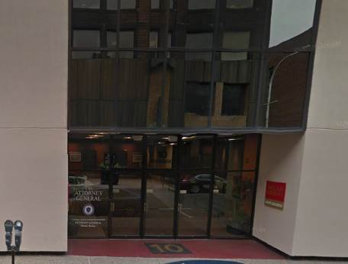

Prepared by:
Massachusetts Department of Public Health
Bureau of Environmental Health
Indoor Air Quality Program
April 2016

Background
Building: | Attorney General Office (AGO)
Address: | 10 Mechanic Street, Worcester, MA
Assessment Requested by: | Jim Donovan, Director of Operations,  Office of Attorney General
Reason for Request: | Recent renovations and general indoor air quality (IAQ) concerns.
Date of Assessment: | March 29, 2016
Massachusetts Department of Public Health/Bureau of Environmental Health (MDPH/BEH) Staff Conducting Assessment: | Ruth Alfasso, Environmental Engineer/Inspector, IAQ Program
Building Description: | Three-story plus penthouse building on the corner of Main/Mechanic Streets with glass/steel exterior and rubber membrane roof. The Attorney General’s Office occupies a portion of the third floor. Other non-state tenants occupy other areas. Food services are located on part of the first floor.
Building Population: | Approximately 10 staff
Windows: | Not openable

METHODS
Please refer to the IAQ Manual for methods, sampling procedures, and interpretation of results (MDPH, 2015).

IAQ Testing Results
The following is a summary of indoor air testing results (Table 1).
- Carbon dioxide levels were below 800 parts per million (ppm) all 37 areas tested, indicating adequate fresh air supply for the space.
- Temperature was within the recommended range of 70°F to 78°F in almost all areas tested.
- Relative humidity was below the recommended range of 40 to 60% in all areas tested.
- Carbon monoxide levels were non-detectable in all indoor areas tested.
- Fine particulate matter (PM2.5) concentrations measured were below the National Ambient Air Quality Standard (NAAQS) level of 35 μg/m³ in all areas tested.

This sampling indicates that the ventilation system is providing adequate fresh air for the occupancy in the building. However, please note that many areas were empty or sparsely occupied, which reduces the creation of carbon dioxide in the space. One thermostat was observed, and it was found in the “off” setting (Picture 1). To maximize air exchange, the BEH recommends that mechanical ventilation systems operate continuously during periods of occupancy. Without the system operating as designed, normally occurring pollutants cannot be diluted or removed, allowing them to build up and lead to IAQ/comfort complaints.

Ventilation
A heating, ventilating and air conditioning (HVAC) system has several functions. First it provides heating and, if equipped, cooling. Second, it is a source of fresh air. Finally, an HVAC system will dilute and remove normally occurring indoor environmental pollutants by not only introducing fresh air, but by filtering the airstream and ejecting stale air to the outdoors via exhaust ventilation. Even if an HVAC system is operating as designed, point sources of respiratory irritants may exist and cause symptoms in sensitive individuals. The following analysis examines and identifies components of the HVAC system and likely sources of respiratory irritant/allergen exposure due to water damage, aerosolized dust and/or chemicals found in the indoor environment.
Fresh air is provided by two air handling units (AHUs) located on the roof (Picture 2). Air from the AHUs is filtered, heated/cooled and delivered to rooms via ducted supply vents (Picture 3). Return vents are located on ceilings (Picture 4) and are ducted back to the AHU. Additional exhaust vents are located in toilet rooms and other areas with direct venting to a fan on the roof. Building maintenance staff reported that the HVAC system was balanced when the renovations were complete. It is recommended that HVAC systems be re-balanced every five years to ensure adequate air systems function (SMACNA, 1994).
Note that many offices did not have either a supply or an exhaust vent (Table 1) which may make temperature control difficult. Although temperatures were all within the MDPH recommended range during the visit, some occupants expressed concerns regarding temperature control. In one office, strong sunlight was streaming through the windows. Solar gain may make some areas much warmer, and in turn make other areas too cold as the HVAC system attempts to compensate. The use of blinds to moderate heat from sunlight may help with temperature control.
A vent in one office appeared to be damaged or improperly installed (Picture 5). This discontinuity in the vent system may lead to improper circulation and should be repaired.

Microbial/Moisture Concerns
Stained ceiling tiles were observed in one area (Picture 6; Table 1). AGO staff reported that the roof had leaked in the past. Water-damaged ceiling tiles can be a source of mold and should be replaced after a water leak is discovered and repaired.
The roof of the building was examined. Water was observed pooling on the roof in a few areas (Picture 7), which makes leaking more likely. Procedures should be implemented to report suspected leaks (e.g., wet ceiling tiles) as well as to periodically examine and clean the roof as needed. It was reported that the roof may be the end of its at its service life and may need to be replaced soon.
Plants were observed in a few areas (Picture 8; Table 1) including on porous surfaces (e.g. carpet). Plants can be a source of pollen and mold, which can be respiratory irritants to some individuals. Plants should be properly maintained and equipped with drip pans to prevent water damage to porous materials. Plants should also be located away from air diffusers to prevent the aerosolization of dirt, pollen and mold.

Other IAQ Evaluations
Exposure to low levels of total volatile organic compounds (TVOCs) may produce eye, nose, throat, and/or respiratory irritation in some sensitive individuals. To determine if VOCs were present, BEH/IAQ staff examined rooms for products containing VOCs. BEH/IAQ staff noted air fresheners, hand sanitizers, cleaners, and dry erase materials in use within the building (Table 1). All of these products have the potential to be irritants to the eyes, nose, throat, and respiratory system of sensitive individuals.
Filters in the AHUs were examined. They were reportedly changed recently and appeared clean, well-fitted and in good condition (Picture 9). However, they appear to be of a mesh type that provides less filtration than the recommended pleated filters. A Minimum Efficiency Reporting Value (MERV) value of at least 9 is recommended for use in AHUs.
Accumulated items were found stored on floors and other flat surfaces in some areas. These items (e.g., papers, folders, boxes) make it difficult for custodial staff to clean. Items should be relocated and/or be cleaned periodically to avoid excessive dust build up.
The office suite is carpeted. Carpets should be cleaned regularly in accordance with Institute of Inspection, Cleaning and Restoration Certification (IICRC) recommendations (IICRC, 2012).
Part of the reason for this assessment was recent renovations conducted to expand the space into an adjacent suite. At the time of the visit, no dusts or odors attributable to construction were noted. When construction needs to take place in an occupied space, the MDPH guideline “Methods Used to Reduce/Prevent Exposure to Construction/Renovation Generated Pollutants in Occupied Buildings” (Appendix A) should be consulted.

Conclusions/Recommendations
The following recommendations are made to assist in improving IAQ:
- Operate supply and exhaust ventilation in all areas during occupied periods. Work with building occupants to resolve comfort concerns without reducing fresh air supply, which may include relocating supply and exhaust vents in some areas.
- Repair the vent shown in Picture 5.
- Use blinds to moderate temperature in areas subject to direct sunlight.
- Repair roof/plumbing leaks and replace stained ceiling tiles. Ensure that the roof gets examined regularly for deterioration and leaks, and that debris is removed regularly.
- Keep plants in good condition, avoid overwatering, and avoid placing them on porous items such as carpets or paper.
- Reduce the use of VOC-containing cleaners and sanitizers.
- Change HVAC filters regularly (2 to 4 times a year). Consider upgrading to pleated filters with a MERV 9 rating.
- Clean supply and exhaust vents and personal fans regularly to prevent aerosolization of debris.
- Clean carpeting and upholstered items regularly in accordance with IICRC recommendations (IICRC, 2012).
- Consider reducing the amount of items stored in offices to make cleaning easier. Periodically move items to clean flat surfaces.
- Refer to resource manual and other related IAQ documents located on the MDPH’s website for further building-wide evaluations and advice on maintaining public buildings. These documents are available at: http://mass.gov/dph/iaq.

References
IICRC. 2012. Institute of Inspection, Cleaning and Restoration Certification. Carpet Cleaning: FAQ. Retrieved from http://www.iicrc.org/consumers/care/carpet-cleaning/#faq.
MDPH. 2015. Massachusetts Department of Public Health. Indoor Air Quality Manual: Chapters I-III. Available at: http://www.mass.gov/eohhs/gov/departments/dph/programs/environmental-health/exposure-topics/iaq/iaq-manual/.
SMACNA. 1994. HVAC Systems Commissioning Manual. 1st ed. Sheet Metal and Air Conditioning Contractors’ National Association, Inc., Chantilly, VA.
Picture

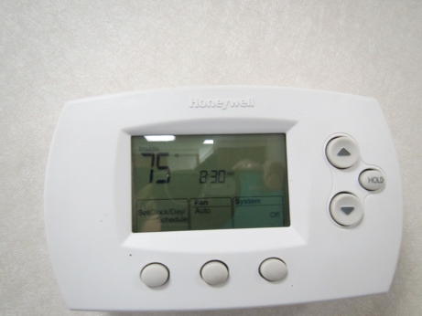

Thermostat set to “off”

Picture 2

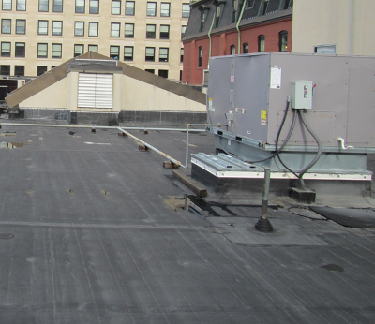

Air handling unit
Picture 3

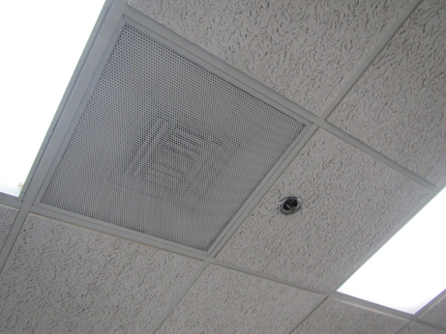

Supply vent

Picture 4

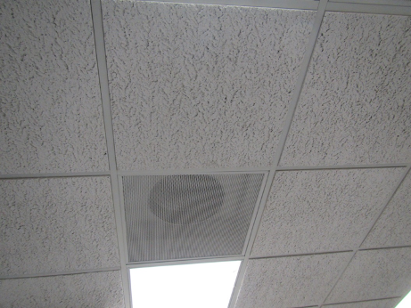

Return vent (direct)
Picture 5

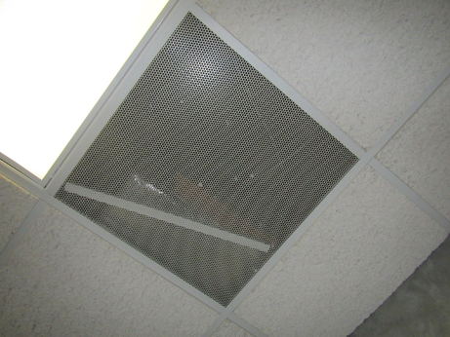

Broken vent in office

Picture 6

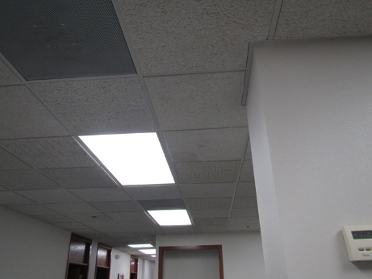

Water-damaged ceiling tiles
Picture 7

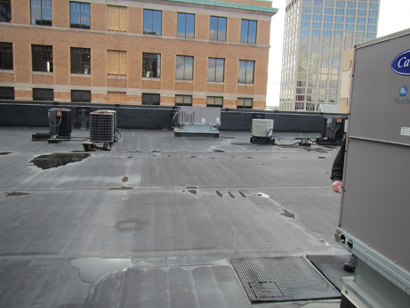

Pools of water on the roof

Picture 8

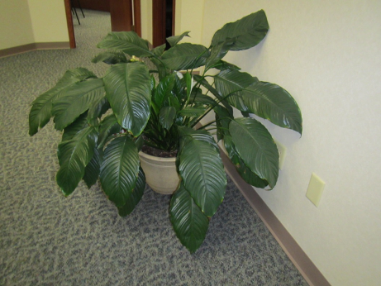

Plant on carpet (porous surface)
Picture 9

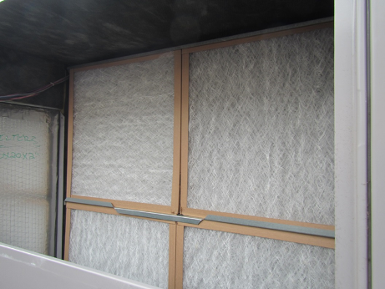

Mesh-type filter in AHU

Location | Carbon  Dioxide  (ppm) | Carbon Monoxide  (ppm) | Temp  (°F) | Relative  Humidity  (%) | PM2.5  (µg/m³) | Occupants  in Room | Windows  Openable | Ventilation |  | Remarks
 |  |  |  |  |  |  |  | Supply | Exhaust
Background | 331 | ND | 45 | 41 | 30 |  |  |  |  | Windy, sunny, sample collected on roof
Front conference room | 652 | ND | 68 | 35 | 3 | 1-2 | N | N | Y | Carpeted
Receptionist area | 508 | ND | 71 | 30 | 1 | 0 | N | N | N | 2 plants, thermostat off
Small conference room | 507 | ND | 72 | 29 | 1 | 0 | N | N | Y
Office | 542 | ND | 72 | 28 | 1 | 0 | N | Y | Y | Plant
Cheryl Donnini | 521 | ND | 73 | 28 | 25 | 1 | N | Y | N
Cube behind Donnini | 525 | ND | 73 | 28 | 2 | 1 | N | Y | Y
Office | 571 | ND | 73 | 26 | 2 | 1 | N | Y | N | Temperature concerns, DO
3rd cube | 629 | ND | 74 | 26 | 2 | 1 | N | Y | N
Office | 561 | ND | 74 | 26 | 1 | 1 | N | Y | N
Gonaga Office | 583 | ND | 74 | 26 | 17 | 1 | N | Y | N | Plants, solar gain, DO
Office | 544 | ND | 74 | 25 | 1 | 0 | N | Y | N | DO, items on floor, plants
Office | 547 | ND | 74 | 26 | 3 | 1 | N | Y | N | DO, plant
Cube | 588 | ND | 74 | 26 | 1 | 1 | N | Y | Y | Plants
Cube | 596 | ND | 74 | 26 | 1 | 1 | N | Y | Y | DO
Office | 580 | ND | 74 | 26 | 5 | 1 | N | Y | N
2 cubes (empty) | 567 | ND | 74 | 25 | 1 | 0 | N | Y | N | DO, plant
Denise Long | 524 | ND | 74 | 25 | 5 | 0 | N | Y | N
Cube | 598 | ND | 74 | 26 | 5 | 0 | N | Y | Y | Plant
Allison O’Neill office | 533 | ND | 74 | 25 | 1 | 0 | N | Y | N
Lauren McCarthy cube | 517 | ND | 74 | 25 | 5 | 0 | N | Y | Y
Cassandra Arraiza office | 562 | ND | 74 | 25 | 1 | 0 | N | Y | N
Cube | 494 | ND | 74 | 25 | 4 | 1 | N | Y
Conference (4459) | 492 | ND | 75 | 25 | 1 | 0 | N | Y | Y | DO, WD CT
Office | 491 | ND | 75 | 24 | 2 | 0 | N | Y | N
Copy room | 476 | ND | 75 | 24 | 10 | 0 | N | Y | N | PC, 2 supply vents not exhaust, NC
Multi-cube office | 475 | ND | 74 | 24 | 2 | 0 | N | Y | N
Empty storage | 466 | ND | 74 | 24 | 3 | 0 | N | Y | N | NC
Open library area | 485 | ND | 74 | 25 | 5 | 0 | N | Y | Y | Plants, old books
Office off hallway | 455 | ND | 74 | 25 | 3 | 0 | N | Y
Small kitchen | 476 | ND | 74 | 25 | 11 | 0 | N | Y | N | NC, small fridge, microwave, toaster
Office next to kitchen | 505 | ND | 75 | 24 | 12 | 0 | N | Y | N | DO, broken duct/supply vent
Storage |  |  |  |  |  |  | N | Y | N | Items on floor
Office | 568 | ND | 75 | 24 | 9 | 0 | N | Y | N
Office | 513 | ND | 75 | 25 | 3 | 0 | N | Y | N
Office | 501 | ND | 75 | 23 | ND | 0 | N | Y | Y | Plants
Kitchen | 534 | ND | 75 | 25 | ND | 0 | N | Y | N | Fridge, microwave and toaster
Director’s office | 617 | ND | 75 | 24 | 2 | 1 | N | Y | Y | Plant
Waiting area | 546 | ND | 75 | 25 | 4 | 0 | N | Y | N

