INDOOR AIR QUALITY ASSESSMENT

Attorney General’s Southeastern Office
105 William Street
New Bedford, Massachusetts



Prepared by:
Massachusetts Department of Public Health
Bureau of Environmental Health
Indoor Air Quality Program
September 2012

Background/Introduction
In response to a request from Bruce Tebo, Project Manager, Division of Capital Asset Management (DCAM), the Massachusetts Department of Public Health (MDPH), Bureau of Environmental Health (BEH) conducted a pre-lease renewal indoor air quality (IAQ) assessment at the Attorney General’s (AG) Southeastern Office, located at 105 William Street, New Bedford, Massachusetts. This evaluation was conducted as part of enhanced efforts to ensure acceptable IAQ in office space leased by Massachusetts state agencies. On August 3, 2012, a visit to conduct an assessment was made by Cory Holmes, Environmental Analyst/Inspector for BEH’s IAQ Program.
The AGs office is located in downtown New Bedford on the first floor of a brick building in that was constructed in 1891. The AG has reportedly been occupying this space since 2000. The space is composed of private offices, open work areas and conference rooms. It has wall-to-wall carpeting and dropped ceiling tiles. Windows are not openable in the space.

Methods
Air tests for carbon monoxide, carbon dioxide, temperature and relative humidity were conducted with the TSI, Q-Trak, IAQ Monitor, Model 7565. Air tests for airborne particle matter with a diameter less than 2.5 micrometers were taken with the TSI, DUSTTRAK™ Aerosol Monitor Model 8520. BEH/IAQ staff also performed visual inspection of building materials for water damage and/or microbial growth.

Results
The tests were taken during normal operations. Test results appear in Table 1 and correspond to numerical designations listed on Figure 1.

Discussion

Ventilation
It can be seen from Table 1 that carbon dioxide levels were below 800 parts per million (ppm) in all areas indicating optimal air exchange at the time of testing (Table 1). Mechanical ventilation is provided by a heating, ventilation and air conditioning (HVAC) system. The air handling units (AHUs) are located in the ceiling plenum. Fresh air is drawn through vents on the exterior of the building. Ductwork connects the AHU to ceiling-mounted supply diffusers (Picture 1). By design, diffusers are equipped with fixed louvers that direct air along the ceiling to flow down the walls and create airflow. Air returns to the AHUs through ceiling or wall-mounted return vents via ductwork (Pictures 2 and 3).
To maximize air exchange, the MDPH recommends that both supply and exhaust ventilation operate continuously during periods of occupancy. In order to have proper ventilation with a mechanical supply and exhaust system, the systems must be balanced to provide an adequate amount of fresh air to the interior of a room while removing stale air from the room. It is recommended that HVAC systems be re-balanced every five years to ensure adequate air systems function (SMACNA, 1994). The HVAC system was reportedly balanced within the last several months.
The Massachusetts Building Code requires that each room have a minimum ventilation rate of 20 cubic feet per minute (cfm) per occupant of fresh outside air or openable windows (SBBRS, 1997; BOCA, 1993). The ventilation must be on at all times that the room is occupied. Providing adequate fresh air ventilation with open windows and maintaining the temperature in the comfort range during the cold weather season is impractical. Mechanical ventilation is usually required to provide adequate fresh air ventilation.
Carbon dioxide is not a problem in and of itself. It is used as an indicator of the adequacy of the fresh air ventilation. As carbon dioxide levels rise, it indicates that the ventilating system is malfunctioning or the design occupancy of the room is being exceeded. When this happens, a buildup of common indoor air pollutants can occur, leading to discomfort or health complaints. The Occupational Safety and Health Administration (OSHA) standard for carbon dioxide is 5,000 parts per million parts of air (ppm). Workers may be exposed to this level for 40 hours/week, based on a time-weighted average (OSHA, 1997).
The MDPH uses a guideline of 800 ppm for publicly occupied buildings. A guideline of 600 ppm or less is preferred in schools due to the fact that the majority of occupants are young and considered to be a more sensitive population in the evaluation of environmental health status. Inadequate ventilation and/or elevated temperatures are major causes of complaints such as respiratory, eye, nose and throat irritation, lethargy and headaches. For more information concerning carbon dioxide, consult Appendix A.
Indoor temperatures ranged from 70º F to 78º F, which were within the MDPH recommended comfort range (Table 1). The MDPH recommends that indoor air temperatures be maintained in a range of 70º F to 78º F in order to provide for the comfort of building occupants. In many cases concerning indoor air quality, fluctuations of temperature in occupied spaces are typically experienced, even in a building with an adequate fresh air supply.
The relative humidity measured in the building ranged from 45 to 50 percent, which was also within the MDPH recommended comfort range during the assessment. The MDPH recommends a comfort range of 40 to 60 percent for indoor air relative humidity. Relative humidity levels in the building would be expected to drop during the winter months due to heating. The sensation of dryness and irritation is common in a low relative humidity environment. Low relative humidity is a very common problem during the heating season in the northeast part of the United States.

Microbial/Moisture Concerns
Water-damaged ceiling tiles were observed in a few areas (Table 1). Occupants did not report any current leaks so these tiles most likely indicate historic water damage. Water-damaged ceiling tiles can provide a source of mold and should be replaced after a water leak is discovered and repaired.
The US Environmental Protection Agency (US EPA) and the American Conference of Governmental Industrial Hygienists (ACGIH) recommend that porous materials be dried with fans and heating within 24 to 48 hours of becoming wet (US EPA, 2001; ACGIH, 1989). If not dried within this time frame, mold growth may occur. Once mold has colonized porous materials, they are difficult to clean and should be removed and discarded.

Other Indoor Air Evaluations
Indoor air quality can be negatively influenced by the presence of respiratory irritants, such as products of combustion. The process of combustion produces a number of pollutants. Common combustion emissions include carbon monoxide, carbon dioxide, water vapor, and smoke (fine airborne particle material). Of these materials, exposure to carbon monoxide and particulate matter with a diameter of 2.5 micrometers (μm) or less (PM2.5) can produce immediate, acute health effects upon exposure. To determine whether combustion products were present in the building environment, BEH/IAQ staff obtained measurements for carbon monoxide and PM2.5.

Carbon Monoxide
Carbon monoxide is a by-product of incomplete combustion of organic matter (e.g., gasoline, wood and tobacco). Exposure to carbon monoxide can produce immediate and acute health effects. Several air quality standards have been established to address carbon monoxide and prevent symptoms from exposure to these substances. The MDPH established a corrective action level concerning carbon monoxide in ice skating rinks that use fossil-fueled ice resurfacing equipment. If an operator of an indoor ice rink measures a carbon monoxide level over 30 ppm, taken 20 minutes after resurfacing within a rink, that operator must take actions to reduce carbon monoxide levels (MDPH, 1997).
The American Society of Heating, Refrigerating and Air-Conditioning Engineers (ASHRAE) has adopted the National Ambient Air Quality Standards (NAAQS) as one set of criteria for assessing indoor air quality and monitoring of fresh air introduced by HVAC systems (ASHRAE, 1989). The NAAQS are standards established by the US EPA to protect the public health from six criteria pollutants, including carbon monoxide and particulate matter (US EPA, 2006). As recommended by ASHRAE, pollutant levels of fresh air introduced to a building should not exceed the NAAQS levels (ASHRAE, 1989). The NAAQS were adopted by reference in the Building Officials & Code Administrators (BOCA) National Mechanical Code of 1993 (BOCA, 1993), which is now an HVAC standard included in the Massachusetts State Building Code (SBBRS, 1997). According to the NAAQS, carbon monoxide levels in outdoor air should not exceed 9 ppm in an eight-hour average (US EPA, 2006).
Carbon monoxide should not be present in a typical, indoor environment. If it is present, indoor carbon monoxide levels should be less than or equal to outdoor levels. Outdoor carbon monoxide concentrations were non-detect (ND) the day of the assessment (Table 1). No measureable levels of carbon monoxide were detected in the building during the assessment (Table 1).

Particulate Matter
The US EPA has established NAAQS limits for exposure to particulate matter. Particulate matter is airborne solids that can be irritating to the eyes, nose and throat. The NAAQS originally established exposure limits to particulate matter with a diameter of 10 μm or less (PM10). According to the NAAQS, PM10 levels should not exceed 150 micrograms per cubic meter (μg/m³) in a 24-hour average (US EPA, 2006). These standards were adopted by both ASHRAE and BOCA. Since the issuance of the ASHRAE standard and BOCA Code, US EPA established a more protective standard for fine airborne particles. This more stringent PM2.5 standard requires outdoor air particle levels be maintained below 35 μg/m³ over a 24-hour average (US EPA, 2006). Although both the ASHRAE standard and BOCA Code adopted the PM10 standard for evaluating air quality, MDPH uses the more protective PM2.5 standard for evaluating airborne particulate matter concentrations in the indoor environment.
The outdoor PM2.5 concentration was measured at 57 μg/m³ (Table 1), which was above the NAAQS PM2.5 level of 35 μg/m³. The most likely sources of elevated particulates in the area were elevated pollen conditions and moderate to heavy traffic nearby. PM2.5 levels measured indoors ranged from 19 to 22 μg/m³ (Table 1), which were below the NAAQS PM2.5 level of 35 μg/m³. Frequently, indoor air levels of particulates (including PM2.5) can be at higher levels than those measured outdoors. A number of activities that occur indoors and/or mechanical devices can generate particulate during normal operations. Sources of indoor airborne particulates may include but are not limited to particles generated during the operation of fan belts in the HVAC system, use of stoves and/or microwave ovens in kitchen areas; use of photocopiers, fax machines and computer printing devices; operation of an ordinary vacuum cleaner and heavy foot traffic indoors.

Other Conditions
In area 4 (Figure 1), BEH/IAQ staff observed a hole in the wall temporarily sealed with clear tape (Picture 4). This breach into the wall cavity can provide a pathway for drafts, dust, odors and particulates to migrate into occupied areas.

Conclusions/Recommendations
In view of the findings at the time of the visit, the following recommendations are made:
- Ensure any leaks are repaired and replace water-damaged ceiling tiles. Examine the area above these tiles for mold growth. Disinfect areas of water leaks with an appropriate antimicrobial, as needed.
- Clean air diffusers, exhaust/return vents and personal fans periodically of accumulated dust.
- Seal any open holes/breaches in interior walls (Picture 4) to prevent the migration of drafts, odors, particulates from wall cavities into occupied areas.
- Consider adopting a balancing schedule of every 5 years for all mechanical ventilation systems, as recommended by ventilation industrial standards (SMACNA, 1994).
- Refer to resource manual and other related indoor air quality documents located on the MDPH’s website for further building-wide evaluations and advice on maintaining public buildings. These documents are available at: http://mass.gov/dph/iaq.

References
ACGIH. 1989. Guidelines for the Assessment of Bioaerosols in the Indoor Environment. American Conference of Governmental Industrial Hygienists, Cincinnati, OH.
ASHRAE. 1989. Ventilation for Acceptable Indoor Air Quality. American Society of Heating, Refrigerating and Air Conditioning Engineers. ANSI/ASHRAE 62-1989.
BOCA. 1993. The BOCA National Mechanical Code/1993. 8th ed. Building Officials and Code Administrators International, Inc., Country Club Hill, IL.
MDPH. 1997. Requirements to Maintain Air Quality in Indoor Skating Rinks (State Sanitary Code, Chapter XI). 105 CMR 675.000. Massachusetts Department of Public Health, Boston, MA.
OSHA. 1997. Limits for Air Contaminants. Occupational Safety and Health Administration. Code of Federal Regulations. 29 C.F.R 1910.1000 Table Z-1-A.
SBBRS. 1997. Mechanical Ventilation. State Board of Building Regulations and Standards. Code of Massachusetts Regulations. 780 CMR 1209.0
SMACNA. 1994. HVAC Systems Commissioning Manual. 1st ed. Sheet Metal and Air Conditioning Contractors’ National Association, Inc., Chantilly, VA.
US EPA. 2001. “Mold Remediation in Schools and Commercial Buildings”. Office of Air and Radiation, Indoor Environments Division, Washington, DC. EPA 402-K-01-001. March 2001. Available at: http://www.epa.gov/iaq/molds/mold_remediation.html.
US EPA. 2006. National Ambient Air Quality Standards (NAAQS). US Environmental Protection Agency, Office of Air Quality Planning and Standards, Washington, DC. http://www.epa.gov/air/criteria.html.
Figure 1
Testing Locations for AG’s Office as Indicated by Numerical Designation

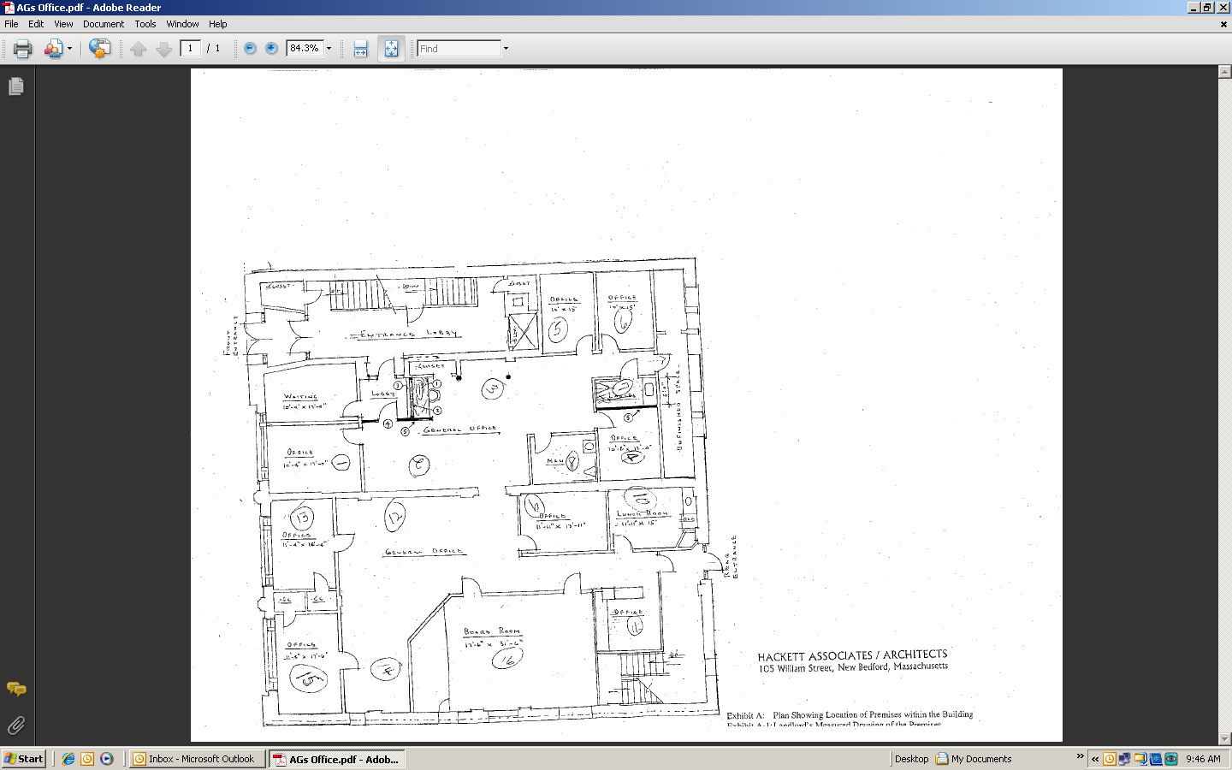
Picture 1

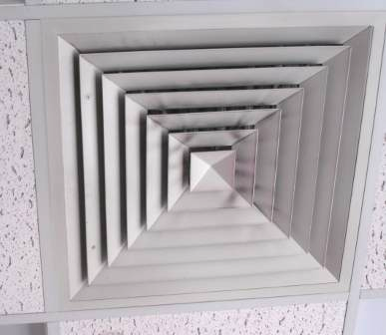

Ceiling-mounted air diffuser, note dust/debris accumulation on louvers

Picture 2

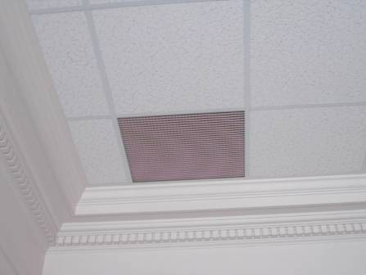

Ceiling-mounted return vent/grill

Picture 3

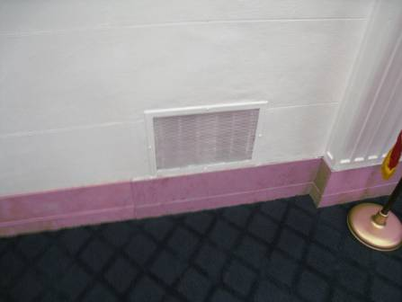

Wall-mounted return vent

Picture 4

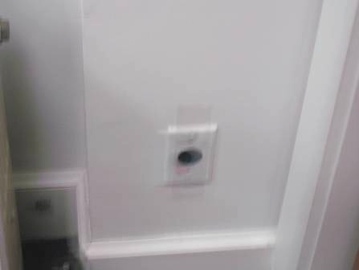

Hole in wall temporarily sealed with clear tape in area 4 (Figure 1)
Location/ Room | Occupants  in Room | Temp  (°F) | Relative  Humidity  (%) | Carbon  Dioxide  (ppm) | Carbon Monoxide  (ppm) | PM2.5  (µg/m³) | Windows  Openable | Ventilation |  | Remarks
 |  |  |  |  |  |  |  | Supply | Exhaust | Remarks
Background |  | 86 | 68 | 402 | ND | 57 |  |  |  | Mostly sunny, hot/humid, downtown traffic, idling cars
1 | 0 | 78 | 45 | 456 | ND | 21 | N | Y | Y | DO
2 | 2 | 75 | 48 | 632 | ND | 22 | N | Y | Y
3 | 1 | 75 | 48 | 500 | ND | 22 | N | Y | Y
4 | 0 | 74 | 50 | 550 | ND | 20 | N | Y | Y | 2 WD CT, vents dusty, wall hole, DO
5 | 0 | 74 | 49 | 511 | ND | 22 | N | Y | Y | DO
6 | 0 | 74 | 50 | 510 | ND | 22 | N | Y | Y
7 Men’s Restroom |  |  |  |  |  |  | N | Y | Y | Vent clogged with debris
8 Women’s Restroom |  |  |  |  |  |  | N | Y | Y | Vent dirty
9 | 0 | 74 | 48 | 502 | ND | 21 | N | Y | Y | DO
10 Kitchen | 0 | 73 | 48 | 560 | ND | 19 | N | Y | Y | Water cooler on carpet, soiled vent
11 Server Room | 0 | 74 | 49 | 523 | ND | 20 | N | Y | N
12 | 1 | 74 | 50 | 518 | ND | 20 | N | Y | Y
13 | 1 | 74 | 49 | 512 | ND | 20 | N | Y | Y | DO, dusty vent
14 | 1 | 73 | 49 | 494 | ND | 21 | N | Y | Y
15 | 0 | 72 | 49 | 453 | ND | 20 | N | Y | N | DO, dusty vent
16 Conference Room | 0 | 70 | 49 | 480 | ND | 19 | N | Y | Y | Dusty vents

