COMMONWEALTH OF MASSACHUSETTS

SUFFOLK COUNTY BOARD OF REGISTRATION
IN PHARMACY

In the Matter of ) Aucella Drug ) DS1213 )

PHA-2015-0111

CONSENT AGREEMENT FOR VOLUNTARY SURRENDER

The Massachusetts Board of Registration in Pharmacy ("Board") and Aucella Drug ("Licensee'; or "Pharmacy"); a pharmacy registered by the Board, DS1213, do hereby stipulate and agree that the following information shall be entered into and become a permanent part of the Licensee's record maintained by the Board:

1. The Pharmacy acknowledges that the Board opened a complaint against its Massachusetts pharmacy license ("license") related to the conduct set forth in Paragraph 2, identified as Docket No. PHA-2015- 0111("the Complaint").l

- The Board and the Pharmacy acknowledge and agree to the following facts:

  - On July 20, 2015, Board Investigators and DEA investigators inspected the Pharmacy;

  - Board Investigators observed numerous deficiencies pertaining to controlled substances inventories, including but not limited to the following:

- The Pharmacy failed to maintain an accurate inventory of controlled substances in Schedules II through V;
ii. The Pharmacy failed to maintain an accurate perpetual
inventory of Schedule II controlled substances;
iii. The Pharmacy could not account for a loss of 376 tablets of alprazolam 1mg;
iv. The Pharmacy could not account for a loss of 469 tablets of alprazolam 2 mg;

The term “licensee” applies to both a current license and the right to renew an expired license.

v. The Pharmacy could not account for a loss of 154 tablets of diazepam 5 mg;
vi. The Pharmacy could not account for a loss of 516 tablets
of tramadol;
vii. The Pharmacy could not explain extra oxycodone tablets
in a manufacturer stock bottle.

  - As a result of the deficiencies described in Paragraph 2a & 2b, the Pharmacy surrendered its DEA registration, number AA3181891, on July 20, 2015.

- The Board and Licensee acknowledge and agree that the Pharmacy's conduct described in Paragraph 2 is a violation M.G.L. c. 94C, § 17,247 CMR 6.07 (1)(b), and 247 CMR 9.01(14) and warrants disciplinary action by the Board under M.G.L. c. 112, §§ 42A and 61.

- The Pharmacy agrees to SURRENDER its pharmacy license for an indefinite period of time and to refrain from dispensing any controlled substance, commencing with the date on which the Board signs this Agreement ("Effective Date"). The Pharmacy further agrees to immediately return its original Massachusetts pharmacy license to the Board.

5. The Board agrees that in return for the Pharmacy's execution of this Agreement it will not prosecute the Complaint.

- The Pharmacy understands that it has a right to formal adjudicatory hearing concerning the allegations against it and that during said adjudication it would possess the right to confront and cross-examine witnesses, to call witnesses, to present evidence, to testify on its own behalf, to contest the allegations, to present oral argument, to appeal to the courts, and all other rights as set forth in the Massachusetts Administrative Procedures Act, M.G.L. c. 30A, and the Standard Adjudicatory Rules of Practice and Procedure, 801 CMR 1.01 et seq. The Pharmacy further understands that by executing this Agreement it is knowingly and voluntarily waiving its right to a formal adjudication of the Complaint.

- The Pharmacy acknowledges that it has been at all times free to seek and use legal counsel in connection with the Complaint and this Agreement.

- The Pharmacy acknowledges that after the Effective Date, the Agreement constitutes a public record of disciplinary action by the

Aucella Drug
DS1213
PHA-2015-0111
Board. The Board may forward a copy of this Agreement to other licensing boards, law enforcement entities, and other individuals or entities as required or permitted by law.

- The individual signing this Agreement certifies that he/she is authorized to enter into this Agreement on behalf of the Pharmacy, and that he/she has read this Agreement.

Witness’s (sign and date)

Frank A. Frantz
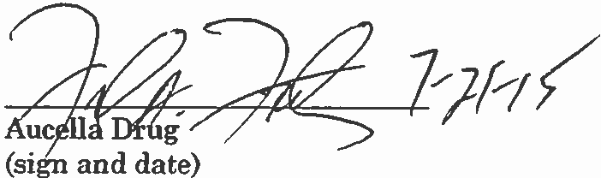

Print Name

David Sencabaugh, R.Ph
Executive Director
Board of Registration in Pharmacy

Effective Date of Surrender Agreement

Fully Signed Agreement Sent to Licensee on 8/6/2015 by
Certified Mail No. 70140510000103752251

Aucella Drug
DS1213
PHA-2015-0111

