Commonwealth of Massachusetts
Executive Office of Health and Human Services

Office of Medicaid
www.mass.gov/masshealth
MassHealth
Audiologist Bulletin 5
September 2015

TO: Audiologists Participating in MassHealth
FROM: Daniel Tsai, Assistant Secretary for MassHealth 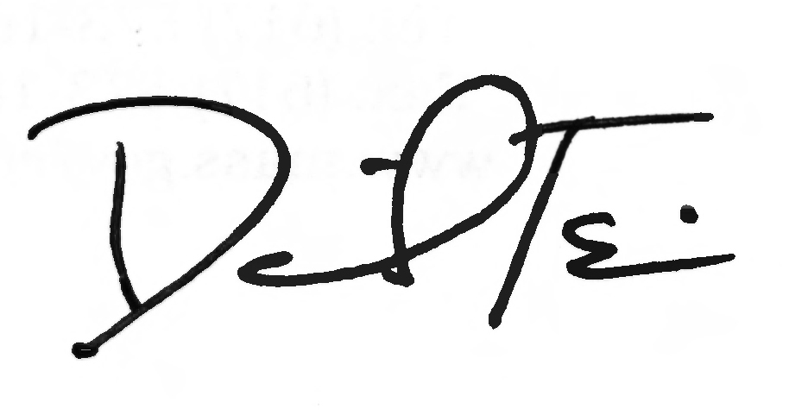

RE: Billing Policy for Audiology Procedures

Summary

This bulletin clarifies the billing policy and coding in Subchapter 6 of the MassHealth Audiologist Manual.

Service Code Clarifications

The following codes should be used to bill for the services indicated.

V5011 – Hearing aid fitting/checking. These services include refitting of the aid, orientation, counseling with the member or member’s family, contact with interpreters, fitting of a loaner aid, and similar services. To qualify as a covered service, the service must include a face-to-face encounter with the member. MassHealth pays for a maximum of one unit per date of service. Use for programming.

V5020 – Conformity evaluation. An evaluation consists of real ear evaluation and functional gain testing.

92592 – Hearing-aid check; monaural. Use for listening check and in-office minor repairs.

92593 – Hearing-aid check; binaural. Use for listening check and in-office minor repairs.

V5267 – Hearing-aid supplies/accessories (individual consideration). Prior authorization (PA) is now required when the adjusted acquisition cost exceeds $300.00.

92590/92591 – Hearing-aid examination and selection; monaural/binaural. Use for initial consultation with patient on current hearing loss and communication.

L7510 – Repair of prosthetic device, repair or replace minor parts. Use for processor repair.

L7510MS – With MS modifier, use for cochlear implant service contract in accordance with 130 CMR 426.416. Cochlear implant service contracts should include loss and repair.

L9900 – Orthotic and prosthetic supply, accessory, and/or service component of another HCPCS L code. Use for cochlear implant small supplies.

(continued on next page)

MassHealth

Audiologist Bulletin 5

September 2015

Page 2

Covered Hearing-Aid Accessories

Below are examples of hearing-aid accessories that are payable through MassHealth using code V5267. The list includes but is not limited to
- hearing-aid clips
- hearing-aid retention clips/wires
- dry aids
- domes
- RITE (Receiver-in-the-Ear) Speakers
- RIC (Receiver-in-the-Canal) Speakers

Noncovered Hearing-Aid Accessories

Below are examples of hearing-aid accessories that are NOT payable through MassHealth. The list includes but is not limited to
- Bluetooth
- remote control
- circuitry
- wireless TV

Other Reminders

Effective for dates of service on and after August 1, 2006, providers must use modifier LT (for left ear) or RT (for right ear) when billing for the following services codes: V5030, V5040, V5050, V5060, V5241, V5243, V5245, V5246, V5247, V5256, and V5257.

Questions

If you have any questions about the information in this bulletin, please contact the MassHealth Customer Service Center at 1-800-841-2900, e-mail your inquiry to providersupport@mahealth.net, or fax your inquiry to 617-988-8974.

