MASSACHUSETTS RARE DISEASE ADVISORY COUNCIL (RDAC)
STEERING COMMITTEE

REMOTE MEETING: Thursday August 15, 2024
Meeting Time 10:30 am – 11:30 pm
Approved 10.17.24

Meeting Minutes

Welcome: Dr Tierney welcomed all and called the meeting to order at 10:36
He then conducted a roll call for attendance.

Member | Present
Representative Jay Livingstone | No
Guadalupe Hayes-Mota | NA
Jenn McNary | Yes
Dr. David Miller | Yes
Tai Pasquini | Yes
Dr. Ryan Thompson | No
Dr. Dylan Tierney | Yes

D Tierney let everyone know that although we were down a few members, he would work on recruiting new members for our steering committee. He welcomed Tai Pasquini as the newest member of the steering committee.
He then reviewed the agenda for the meeting and asked if everyone was able to review the minutes from the last meeting on June 20 and if anyone had any edits. All responded that they received the minutes, and no one had edits. He then asked for a motion to vote to accept the minutes as presented. J McNary made a motion to accept the minutes and Tai Pasquini seconded. The minutes were unanimously approved.

Roll Call Vote to approve minutes from 4.11.24 Steering Committee

Member | Approve
Tai Pasquini | abstained
Dr. David Miller | abstained
Jenn McNary | yes
Dr. Ryan Thompson | yes
Dr. Dylan Tierney | yes

D Tierney summarized his thoughts on the last full council meeting about NBS ad hoc meeting. He stated that he thought the meeting went very well. He then presented a draft of recommendations (below) that were discussed at the meeting and asked for feedback. .

Massachusetts Rare Disease Advisory Council (RDAC)
Newborn Screening Recommendations
DRAFT (8.14.24)

The RDAC has spent extensive time reviewing and discussing the process for blood screening of newborns for treatable diseases and disorders in Massachusetts and has drafted the following recommendations.

General Recommendations

- Increase transparency
- Update the website to make as much information as possible available to the public
- Ensure compliance with Open Meeting Law
- Re-evaluate the education materials for NBS. Think about including webinars, videos, and other modes of communication for explaining the program. Simplify the parental brochure according to health literacy, ADA and plain language principles.
- Consider broader definitions of treatment benefits to be used as criteria for acceptance or rejection of a given condition for adoption on the Massachusetts newborn screening panel
- Investigate any new technologies to modernize the program annually and report findings to DPH commissioner
Recommendations for the Department of Public Health

- Revise regulation 105 CMR 27.000 to include but not limited to:
  - 105 CMR 27.005(B)
    - The Newborn Blood Screening Advisory Committee can meet virtually
    - Update the membership language to include a minimum number of members, the length of the term and number of terms allowed.
    - Include a member of the Massachusetts Rare Disease Advisory Council and a member representing emerging technologies in NBS.
  - 105 CCMR 27.005 (C)
    - The NBSAC shall submit an annual report by December 31 to commissioner of public health and make public on the NBS website to include;
      - The committee’s review and guidance of quality assurance and control measures utilized for the operation of the Newborn Screening Program
      - The committee’s review and guidance on new or emerging technologies in NBS
      - Summary and recommendation for any new diseases or disorders evaluated during the year. This should include the reasons for or against adding the condition to the mandate or pilot study.
      - Summary of screenings and results
      - Recommendations for any modernization of the program.

Recommendations for the Newborn Screening Advisory Committee

- Fill all open/vacant member positions asap
- Develop a meeting schedule and make it public
- Post all past meetings and minutes for the past 5 years
- Adopt a policy of requiring expert consultation on any Recommended Uniform Screening Panel (RUSP) condition being considered for inclusion on the required screening panel. Included in this policy, the NBSAC will make a reasonable attempt to invite the sponsor of the federal packet for the RUSP condition under consideration.
- Develop and make public standard operating procedures (SOP) for the committee. SOP should include, but not limited to:
  - Purpose
  - Scope
  - Membership
    - Membership roles and responsibilities
    - nomination process for appointing, maintaining, and replacing membership
    - term (including the number of terms allowed)
  - Meeting Cadence including how often and when the committee is required to meet
  - Nomination process for submitting a new disease or disorder to be evaluated for inclusion on the required panel or pilot study, including but not limited to: what should be included in the packet submission and timeline for review.
    - Provide an explanation for NBSAC decisions to accept or reject conditions on the Recommended Uniform Screening Panel (RUSP) including; the reasons for acceptance/rejection and a description of the path for future acceptance of rejected RUSP conditions
    - Make all reviews and decisions public and transparent

D Tierney explained that the ad hoc committee met for two hours and had a robust discussion. The committee agreed to send their draft recommendations to the steering committee for comment. Dylan then let everyone know that the Newborn Screening Advisory Council had planned to meet this fall and would be working on some administrative changes. He then asked for some feedback about the proposed document.
J McNary stated that she had reached out to a few other states to ask for samples of their nomination forms. She is waiting to hear back and will share as soon as she gets them. She hopes to have them by Monday.
D Tierney questioned who the recommendation should go to. Should the recommendations go to DPH or directly to the newborn screening advisory committee (NBSAC).
J McNary asked who oversees the NBSAC.
D Tierney stated that DPH oversees the regulations and the NBSAC. In his conversations with DPH leadership it seemed unclear who managed this process. We still need to clarify the process of how our recommendations would be implemented. He also noted that getting access to legal advice is very difficult.
D Tierney then walked through the general recommendations.
J McNary asked if we could change bullet 5 by adding “diagnosis benefit” as well as treatment benefit. She stated that one of the primary benefits of screening is access to early diagnosis. Although the treatment benefit was important, it’s also important for getting an early diagnosis.
T Pasquini added that in Minnesota, they added legislation that allowed a rare disease patient to access out of network specialty care. This is why it’s really important to have a diagnosis to get access to these providers. This may be an action that we want to do in Massachusetts.
D Tierney suggested changing the language to newborn screening benefit instead of treatment or diagnosis.
T Pasquini and J McNary agreed.
T Pasquini then asked if we could change the title of the document to delete the word “blood”. We wouldn’t want to limit ourselves if there are new technologies that don’t use blood. Could the title just say “screening of newborns for treatable diseases and disorders” This would allow modernization in the future that may be other than blood.
J McNary and T Pasquini agreed to the change.

T Pasquini then asked if we wanted to clarify what type of transparency we are looking for. Should we be clearer about what we want to know about. Is it just logistics or getting the answers to nomination reviews?
J McNary added that she wanted there to be more transparency about allowing public input. We want the process to be transparent so that people outside the committee can give input and feedback. We do want transparency on the process as well.
D Tierney asked if J McNary wanted to work on the language in bullet 5.
J McNary expressed that she was working on getting feedback from other states about what is on their nomination forms. Some of the forms are very simple.
D Tierney asked if we wanted to delineate the different process for reviewing nominations of condition on the RUSP and conditions that are nominated by the public but are not currently on the RUSP. We agree that we want the committee to be clear on their process of reviewing a nomination.
T Pasquini stated that maybe we needed to be clear that when a new condition was added to the RUSP, the Massachusetts NBSAC needs to review the data in a specific timeframe. Do we know if all new conditions need an have an external nomination before it will be reviewed?
J McNary proposed that we allow the Massachusetts NBSAC to just accept a condition that was added to the RUSP and add it to the required screening panel in MA.

D Tierney stated that all should review these recommendations and make edits then pass it along to him or Mary Lou. We will plan to review this at the full council meeting in September.

J McNary summarized by stating that she would send any edits to Dylan and Mary Lou by early next week.
D Tierney stated that we planned to have a final draft of our recommendations by August 30th. We would then send it around for final review before the full council meeting.
He then stated that he wanted to review the timeline and the outline for the annual report. He shared the following slide:

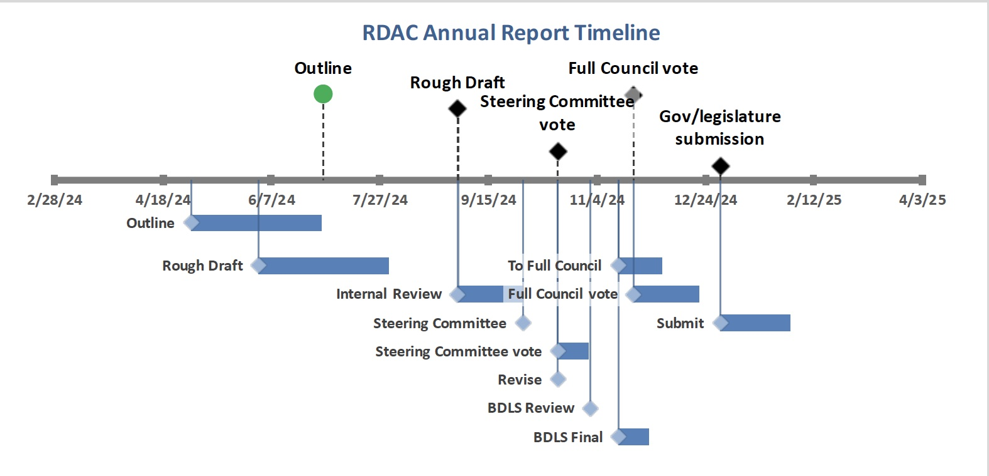

D Tierney reviewed the timeline with all. Stating that we were working on a draft and the plan was for the steering committee to review and vote on at their next meeting. He emphasize that one of the primary goals of our report was to provider recommendations. He stated that after steering committee review, it would go through DPH review and final review and vote would be with the full council in November. He let all know that the DPH commissioner was planning to attend our November council meeting. The report would be submitted on time at the end of December.
He then went on to let all know about the agenda for the September full council meeting. He explained that medical nutrition would be the topic for our meeting. Someone from NORD will come to explain how they measured medical nutrition on the scorecard.
He expressed that we have thought about meeting with NORD about their screening criteria. We want to revisit their grading criteria for telehealth, medical nutrition and newborn screening. He believes that NORD is willing to discuss any recommendations from us.
He then asked for an update on the legislative initiative workgroup from Jenn McNary.
J McNary stated that she has been working hard with her workgroup, co-chaired by Glenda Thomas. She stated that the group first thought that they could only education about the legislative process and legislative priorities. She stated that the work has involved creating criteria for what legislation we should look at. The workgroup finalized criteria and keywords to use in the search process. The representatives on the committee have been very helpful in providing the workgroup with process recommendations. Their primary recommendation was to only spend time on “active bills” as all others would probably not move forward. Rep Livingstone’s office offered to share a spreadsheet that they use to track legislation. The workgroup reviewed and finalized the spreadsheet. She then shared that Rep McKenna suggested reaching out to the sponsor of the legislation to learn more about what the bill is actually saying. This would also be a good time to see if the sponsor needed any help, for example any testimonials or more facts about how the bill may impact the rare disease community. She said the it was explained that sometimes there is nothing to do and other times there is a lot that can be done. She summarized by stating that the workgroup would be submitting a revised version of the goals, objectives and outcomes for the workgroup so that Dylan could review it with DPH legal.
J McNary added that the group would like to be able to comment on whether or not a bill is helpful for the rare disease community. She stated that other state RDACs have participated in legislation. She wants our council to be able to respond and write a letter of support. She stated that their goals and objectives are forward thinking. She also added that if the group feels that legislation is a possible solution to a problem, we should be able to participate.
We decided that we wanted to send a document for DPH legal review with our pie in the sky. We want to be able to participate and be active in legislative actions that will improve the lives of those with a rare disease.
She stated that this document would be sent to Dylan by next week with hopes for a review with reasons why we can or cannot do a specific legislative action.
D Tierney asked how the committee would determine the pros and cons of a bill.
J McNary stated that this part was easy. We reach out to our community and hold a briefing for legislators or send support letters. We need guidance on how we can do this.
T Pasquini added that the committee can create a framework for guiding our recommendations. She is willing to create a framework for this review. She expanded on the conversation by saying that we can bring in the experts. We don’t have to be expert on everything but we can find an expert in the community to testify.
D Tierney stated that one of the challenges is the legal risk. If we say that we support a bill and there are some unintended consequences we may be held accountable for our comments.
J McNary added that we are an advisory council appointed by the legislature to give our opinion. There are some very educated professionals on this council and we were appointed for our opinions. She feels that we should be able to make opinions.

D Tierney responded by stating that legal will most likely want to have a clear idea of how we came up with our opinions. The clearer we are on the framework we use to develop and write opinions the better it will be. He stated that it was past 11:30 then asked for a motion to adjourn.
T Pasqini made a motion to adjourn, J McNary seconded.
D Tierney thanked all for their participation and adjourned the meeting at 11:33 am.

