
Occupational Lung Disease Bulletin

Massachusetts Department of Public Health

Occupational Health Surveillance Program, 250 Washington St, 6th Fl, Boston, MA 02108
Tel: (617) 624-5632  Fax: (617) 624-5696  www.mass.gov/dph/ohsp

SENSOR
August 2010

Dear Healthcare Provider,

Work-Related Asthma Surveillance Categories
1. Work-aggravated asthma
2. New-onset asthma
a) Occupational asthma
b) Reactive airways dysfunction syndrome (RADS)

This issue of the Bulletin includes a summary of cases of work-related asthma (WRA) identified in Massachusetts from 1995-2008. Although the number of cases identified by the surveillance system is believed to be only a small fraction of the total number of persons with WRA in the Commonwealth, the data provide important information about the industries and occupations where workers are at risk and about workplace exposures that need to be addressed.

A copy of the “Occupational Disease and Injury Reporting Form” is also provided. Please continue to report confirmed and suspected cases of WRA using the enclosed form.

To receive your Bulletin by e-mail, to provide comments, or to contribute an article to the Bulletin, contact us at Occupational.Asthma@state.ma.us

Sincerely,
Kathleen Fitzsimmons, MPH
Epidemiologist

Work-Related Asthma Surveillance
Massachusetts
1995 – 2008

Cases of work-related asthma (WRA) are sentinel health events that indicate the need for preventive intervention. Massachusetts and four other states conduct surveillance to identify cases of WRA and describe industries, occupations and exposures that need attention. For surveillance purposes, a case of WRA is defined as an individual with a physician’s diagnosis of asthma and an association between the asthma symptoms and work. WRA includes two main categories: 1) pre-existing asthma aggravated by workplace exposures, and 2) new-onset asthma caused by sensitizers or irritants in the workplace. Reactive Airways Dysfunction Syndrome (RADS) is a subset of new-onset asthma distinguished by persistent asthma symptoms caused by a one-time high level irritant exposure.

Since 1993, physicians in Massachusetts (and since 2003, all healthcare providers) have been required by public health regulations to report confirmed and suspected cases of WRA to the Massachusetts Department of Public Health (MDPH). In addition to healthcare provider reports, multiple supplementary data sources are used by the MDPH Occupational Health Surveillance Program (OHSP) to identify possible cases of WRA. Since 1996, OHSP has utilized the statewide inpatient hospital discharge dataset. In 2005, OHSP incorporated the statewide emergency department visit dataset for WRA surveillance after piloting its use in 2003. Most recently, in 2008, OHSP began ascertaining possible cases of WRA from workers’ compensation records.

OHSP staff conduct follow-up telephone interviews with possible cases to learn more about them and to confirm the association of asthma with work. Information from interviews is used to identify suspect asthma-causing agents and inform intervention activities.

Work-Related Asthma Cases at a Glance

Between January 1995 and December 2008 OHSP ascertained 1,247 possible cases of WRA. As shown in Figure 1, while healthcare provider reports accounted for the overall majority of possible WRA cases ascertained (n=863), the number reported to MDPH by healthcare providers has declined over time. Rather than a true drop in WRA incidence, this observed decline likely reflects reduced reporting. This may, in part, be due to increasing provider workloads, as well as the closing of several occupational medicine clinics around the state. The use in recent years of additional data sources for WRA case ascertainment, most notably emergency department data, has helped offset this decline.

Interviews were completed with 620 (49.7%) individuals, of whom 596 met the criteria for WRA. Following are summary findings on the 596 confirmed cases of WRA.

Table 1. Distribution of confirmed WRA cases
by industry, Massachusetts, 1995-2008, N=596

INDUSTRYª | # | %
Services | 310 | 52.0
Healthcare | 171
Hospitals | 131
Educational Services | 79
Elementary & Secondary | 60
All other | 60
Manufacturing | 138 | 23.2
Chemicals & Allied Products | 21
Misc Manufacturing | 16
Electrical Equip & Components | 14
Food & Kindred Products | 13
Industrial Machinery & Computer Equip | 11
Fabricated Metal Products | 10
All Other | 53
Public Administration | 54 | 9.1
Justice, Public order, & Safety | 23
All other | 31
Trade (wholesale/retail) | 44 | 7.4
Food Stores | 10
Eating & Drinking Places | 9
All Other | 13
Construction | 21 | 3.5
Transportation^{b} | 15 | 2.5
Other^{c} | 14 | 2.4
Total | 596 | 100.0
a Industries coded to 1987 Standard Industrial Classification system.
b Includes Transportation, Communication, Gas, Electric, Sanitation.
c Includes 2 missing.
Confirmed cases had a median age of 45 years, were predominantly female (64.9%) and white (82.9%); seven percent were Hispanic. The majority of cases (82.4%) were new-onset asthma, and 15.3% of these were cases of RADS. Work-aggravated asthma accounted for 15.3% of cases. In the years since OHSP began using emergency department data for case ascertainment, a higher proportion of WRA cases have been work-aggravated asthma and RADS.
Figure 1: Number of possible WRA cases ascertained
by source & year, Massachusetts, 1995-2008, N=1,247

As shown in Table 1, over half of all WRA cases (52.0%) were employed in the service industry sector, mostly in healthcare (28.7% of all cases) and education (13.3%). Manufacturing accounted for 23.2% of all cases, with cases distributed among many different industries within this sector. Public administration employed another 9.1% of cases, followed by the retail and wholesale trade industries (7.4%).

Table 2: Distribution of confirmed WRA cases by occupation, Massachusetts, 1995-2008, N=596

OCCUPATIONª | # | %
Healthcare Practitioners, Technical & Support | 142 | 23.8
Nurses | 81
Nursing Aides Orderlies & Attendants | 18
All Other | 43
Production | 120 | 20.1
Painting Coating & Decorating Workers | 16
Bakers & Food Batchmakers | 8
Welders, Cutters, Solderers, & Brazers | 7
All Others | 89
Office & Administrative Support | 76 | 12.8
Education, Training, & Library | 53 | 8.9
Teachers | 44
All Others | 9
Food Service/Sales/Personal Care | 35 | 5.9
Construction & Extraction | 22 | 3.7
Carpenters | 8
All Others | 14
Installation, Repair, & Maintenance | 22 | 3.7
Building & Grounds Cleaning & Maintenance | 21 | 3.5
Management | 21 | 3.5
Transportation & Material Moving | 19 | 3.2
Firefighters & Other Protective Service | 18 | 3.0
Community & Social Services | 14 | 2.3
Life, Physical, & Social Scientists | 10 | 1.7
Other^{b} | 23 | 3.9
Total | 596 | 100.0
a Occupations coded to 2000 Census Occupation Coding system.
b Includes 4 missing.

Table 2 presents occupations of the WRA cases. Almost a quarter (23.8%) worked in healthcare as practitioners or in technical and support roles; nurses were the most frequently reported occupation within this group. One-fifth of WRA cases (20.1%) worked in a broad range of production occupations. Office and administrative support workers accounted for 12.8% of cases. Education, training and library occupations were reported by 8.9% of cases. Teachers accounted for 83.0% of this category, and followed nurses as the most frequently reported occupation overall.

During the interviews, individuals were asked about the exposures associated with their breathing problems. Up to three suspected agents were recorded for each case. As shown in Table 3, the most frequently reported exposures included cleaning products (13.2%) and poor indoor air quality (13.0%), indicating that individuals were often unable to identify a specific agent of concern. Dusts, fibers and talcs (12.2%), unspecified chemicals (8.9%), mold (7.0%), and solvents (5.8%) were also frequently reported. The leading exposures among RADS cases differed somewhat from exposures reported by new-onset and work-aggravated asthma
Table 3: Most frequently reported exposures among confirmed cases by WRA classification, Massachusetts, 1995-2008, N=1,184

EXPOSURE ª | New-Onset Asthma^{b} |  |  | Reactive Airways Dysfunction Syndrome (RADS) |  |  | Work- Aggravated Asthma |  |  | Total^{c}
 | # | %^{d} |  | # | % |  | # | % |  | # | %
Cleaning Products | 91 | 11.0 |  | 33 | 22.3 |  | 27 | 14.7 |  | 156 | 13.2
Indoor Air Quality^{e} | 113 | 13.7 |  | 11 | 7.4 |  | 26 | 14.1 |  | 154 | 13.0
Dust, Fibers, & Talcs | 102 | 12.3 |  | 13 | 8.8 |  | 27 | 14.7 |  | 145 | 12.2
Chemicals, unspecified | 63 | 7.6 |  | 20 | 13.5 |  | 17 | 9.2 |  | 105 | 8.9
Mold | 64 | 7.7 |  | 2 | 1.4 |  | 17 | 9.2 |  | 83 | 7.0
Solvents | 45 | 5.4 |  | 14 | 9.5 |  | 9 | 4.9 |  | 69 | 5.8
Products of Combustion | 34 | 4.1 |  | 8 | 5.4 |  | 11 | 6.0 |  | 54 | 4.6
Isocyanates | 33 | 4.0 |  | 3 | 2.0 |  | 0 | 0.0 |  | 36 | 3.0
Latex | 30 | 3.6 |  | 1 | 0.7 |  | 4 | 2.2 |  | 35 | 3.0
Formaldehyde & Glutaraldehyde | 25 | 3.0 |  | 0 | 0.0 |  | 2 | 1.1 |  | 27 | 2.3
Metals | 25 | 3.0 |  | 2 | 1.4 |  | 2 | 1.1 |  | 29 | 2.4
Paints & Lacquers | 18 | 2.2 |  | 1 | 0.7 |  | 5 | 2.7 |  | 26 | 2.2
Acids & Bases | 15 | 1.8 |  | 9 | 6.1 |  | 1 | 0.5 |  | 25 | 2.1
Plastics & Other Polymers | 15 | 1.8 |  | 3 | 2.0 |  | 3 | 1.6 |  | 21 | 1.8
Other | 154 | 18.6 |  | 28 | 18.9 |  | 33 | 17.9 |  | 219 | 18.5
Total | 827 | 100.0 |  | 148 | 100.0 |  | 184 | 100.0 |  | 1,184 | 100.0
a Exposures coded according to Association of Occupational and Environmental Clinics criteria. At least one exposure reported for each case; a maximum of three reported per case.
b Excludes RADS cases.
c Exposure data for 14 unclassified WRA cases included in totals.
d Percentages may not add up to 100% due to rounding.
e Includes cases who report "bad air", "indoor air pollutants", “poor ventilation” or "sick building syndrome". Specific agents associated w/ indoor air pollution, (eg. dust and mold) coded separately.
cases, with unspecified chemicals and solvents noted more frequently than poor indoor air quality or dust, fibers and talcs.

Known asthma-causing agents (asthmagens) were identified using criteria developed by the Association of Occupational and Environmental Clinics. The most frequently reported asthmagens were latex, isocyanates, formaldehyde, glutaraldehyde, epoxy resins, metal working oils, baking flour, AMT, quaternary ammonium compounds in cleaning products, nickel, and monoethanolamine.

WRA can have serious health and financial impacts on working adults. Eighty-five percent (n=508) of WRA cases still had breathing problems at the time of the interview; 25.2% of those reported that their symptoms had become “more severe” since the initial diagnosis. More than half of the cases (58.7%) reported at least one emergency room visit; 21.6% had been treated overnight in the hospital for asthma symptoms.

Only half of all confirmed WRA cases (52.7%) reported that they had applied for workers’ compensation. One-third of cases (33.6%) reported leaving the job that caused their breathing problems, including 21 cases who reported that they had been fired because of their breathing problems. On the other hand, among those still working for the same employer, 42.3% (n=164) reported that they were no longer exposed to the substance that caused their asthma because of changes, such as job transfer within the company, chemical substitution or improved ventilation.

Data to Action

Work-related asthma is common. Approximately 40% of the estimated 500,000 Massachusetts adults with current asthma reported to the 2006-2007 Behavioral Risk Factor Surveillance System that their asthma was caused or exacerbated by exposures in the workplace. It is well recognized that only a small proportion of WRA cases are captured by MDPH and that findings from sentinel surveillance may not be representative of the underlying population with WRA in Massachusetts. Despite this, findings provide important information about industries and occupations where workers are at risk for WRA and about workplace exposures that need to be addressed.

OHSP continues to use WRA surveillance findings to target intervention and prevention activities, to provide guidance to asthma programs in other states, and to educate the community—healthcare providers and the public alike—about WRA and the potential for asthma prevention.

In particular, during the last few years OHSP:

- Took the lead in nationwide efforts to make cleaning products safer and more healthy, advocating that known asthmagens be prohibited from products certified by third party environmental standards, such as those developed by Green Seal.

- Used success in certification to promote purchasing of safer products by state agencies, cities and towns through adoption of Green Seal and Ecologo third party certification by the state’s procurement agency.

- Conducted worksite investigations and made referrals to other agencies for worksite follow-up. Exposures investigated include isocyanates in golf ball manufacturing, rosin core soldering, wheat flour and amylase in commercial baking, amines and epoxies in foam manufacturing, and quaternary ammonium disinfectants in hospitals.

- Collaborated with the MDPH Working on Wellness Initiative to include information about asthma and WRA in the Worksite Wellness Program Toolkit, a resource for employers developing worksite wellness programs.

- Included WRA surveillance findings in the MDPH Burden of Asthma in Massachusetts report (2009) and ensured that WRA was identified as a priority for the Massachusetts Asthma Action Partnership and in the Strategic Plan for Asthma in Massachusetts (2009).

Healthcare providers play an essential role in the effort to address WRA in Massachusetts. Providers should ask each adult patient with asthma about potential associations between symptoms and work., This information could be used to better manage the patient’s disease, to promote changes in his/her workplace that may also protect coworkers, and to direct broad-based prevention activities of MDPH and other public health partners.

Educational Brochure:
Asthma and Cleaning Products at Work

OHSP has developed an educational brochure for people who work with or around cleaning products and are having breathing problems. It is now available in English, Spanish, and Portuguese on our website: www.mass.gov/dph/ohsp.
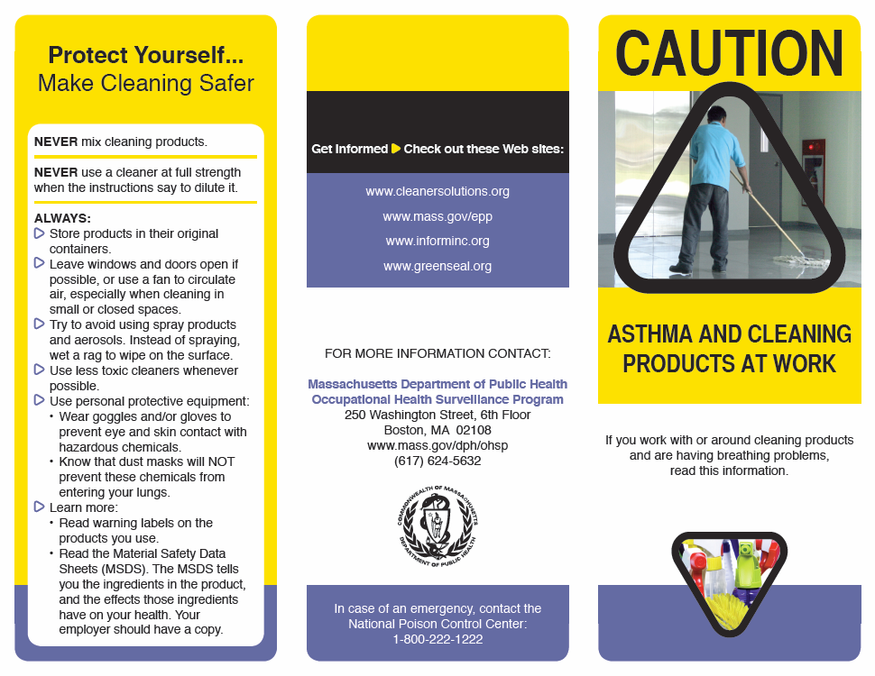

http://www.aoec.org/tools.htm
3-Amino-5-mercapto-1,2,4-triazole
Expert Panel Report 3 (EPR-3) Full Report 2007: Guidelines for the Diagnosis and Management of Asthma. http://www.nhlbi.nih.gov/guidelines/asthma/asthgdln.htm
American College of Chest Physicians Consensus Statement. http://chestjournal.chestpubs.org/content/134/3_suppl/1S.full.pdf+html

