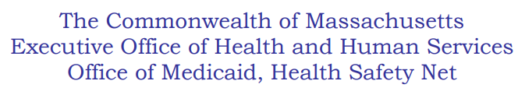

August 27, 2024

HEALTH SAFETY NET AUGUST 2024 REMITTANCE ADVICE CORRECTIONS
August 2024

The Health Safety Net has discovered an internal problem with the August 2024 837P remittance advice for the pay period June 2024 currently posted in INET.
The issue pertains to the adjustment reasons which had been truncated resulting in report users not able to view the full report content. Our IT team has corrected the issue and recreated these remittance reports.
The Health Safety Net recommends that your facility access INET and download the second remit so you will have the latest updated copy available for your use.
Please note, do not post these payments a second time as this updated report has only been reloaded to provide the complete adjustment reason language for your use.
As a reminder, if your facility utilizes a Billing Intermediary, please ensure that you have communicated the above issue and the updated remittances available within INET.

