INDOOR AIR QUALITY ASSESSMENT

Augustine Belmonte Middle School
25 Dow Street
Saugus, MA 01906

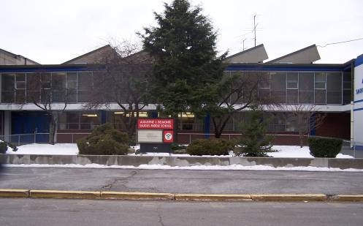

Prepared by:
Massachusetts Department of Public Health
Center for Environmental Health
Emergency Response/Indoor Air Quality Program
January 2007

Background/Introduction
At the request of parents, the Massachusetts Department of Public Health (MDPH), Center for Environmental Health (CEH) provides assistance and consultation regarding indoor air quality at each of Saugus’s public schools. These assessments were jointly coordinated through Sharon McCabe, Director of the Saugus Health Department, and Ralph Materissi, Building Maintenance Director, Town of Saugus.
On November 1, 2006, a visit to conduct an assessment at the Belmonte Middle School (BMS) was made by Cory Holmes and Sharon Lee, Environmental Analysts in CEH’s Emergency Response/Indoor Air Quality (ER/IAQ) Program. In addition to the MDPH IAQ assessment, at the time of the visit the town’s hazardous abatement specialist was conducting an inspection of asbestos containing materials in the building.
MDPH previously visited the school in February 2000 to conduct a general IAQ assessment (MDPH, 2000). CEH staff returned to the BMS in February 2002, to investigate concerns about potential carbon monoxide exposure and soot resulting from an incident with the school’s mechanical plant. For each visit, reports were issued describing conditions in the building at that time and recommendations on steps to correct problems (MDPH, 2000; MDPH, 2002). This most recent visit by MDPH was prompted by concerns of possible mold growth on building materials observed by a parent.
The school was visited in January 2006 by RFP Associates, Inc., Environmental Health & Safety (RFP EH&S) for IAQ testing. RFP EH&S recommended: cleaning of all surfaces of accumulated dust using vacuums equipped with high efficiency particulate air (HEPA) filters; implementing and maintaining an ongoing preventative maintenance program for HVAC equipment, increasing the introduction of fresh outside air; upgrading the efficiency of HVAC filters; inspecting proper seating for air filters to help eliminate potential air bypass; documenting and tracking complaints/concerns from staff to aid in diagnosing future IAQ problems and inspecting building materials for the presence of asbestos prior to any demolition or renovation (RFP EH&S, 2006).

Methods
CEH staff performed a visual inspection of building materials for water damage and/or microbial growth as part of the current MDPH assessment. Air tests for carbon monoxide, carbon dioxide, temperature and relative humidity were taken with the TSI, Q-Trak, IAQ Monitor, Model 8551. Air tests for airborne particle matter with a diameter less than 2.5 micrometers were taken with the TSI, DUSTTRAK™ Aerosol Monitor Model 8520. Screening for total volatile organic compounds (TVOCs) was conducted using a Hnu, Model 102 Snap-on Photo Ionization Detector (PID).

Results
This school has a student population of approximately 800 and a staff of approximately 80. The tests were taken under normal operating conditions. Test results appear in Table1.

Discussion
Ventilation
It can be seen from the Table 1 that carbon dioxide levels were above 800 parts per million (ppm) in twenty of fifty-seven areas surveyed, indicating a lack of adequate air exchange in those areas. Fresh air in classrooms is supplied by unit ventilator (univent) systems (Figure 1). A univent draws air from the outdoors through a fresh air intake located on the exterior wall of the building and returns air through an air intake located at the base of the unit. Fresh and return air are mixed, filtered, heated and provided to classrooms through an air diffuser located in the top of the unit. Adjustable louvers control the ratio of outside to recirculated air. Univents were found deactivated in some rooms, however several of those were reported by Mr. Materissi to be on a repair list (Table 1). Obstructions to airflow, such as items stored on or in front of univents were seen in some areas (Table 1). In order for univents to provide fresh air as designed, units must be activated while rooms are occupied and air diffusers should remain free of obstructions.
The mechanical exhaust ventilation system consists of unit exhaust ventilators. As with the univents, some exhaust vents were not operating and said to be on a repair list. Without sufficient supply and exhaust ventilation, environmental pollutants can build up and lead to indoor air quality/comfort complaints.
To maximize air exchange, the MDPH recommends that both supply and exhaust ventilation operate continuously during periods of school occupancy. In order to have proper ventilation with a mechanical supply and exhaust system, the systems must be balanced to provide an adequate amount of fresh air to the interior of a room while removing stale air from the room. It is recommended that existing ventilation systems be re-balanced every five years to ensure adequate air systems function (SMACNA, 1994). At the time of the assessment, Mr. Materissi reported that Saugus School Department was working with an HVAC engineering firm, Johnson Controls Inc., to inspect and make recommendation for repair of mechanical ventilation systems.
The Massachusetts Building Code requires that each area have a minimum ventilation rate of 15 cubic feet per minute (cfm) per occupant of fresh outside air or openable windows (SBBRS, 1997; BOCA, 1993). The ventilation must be on at all times that the room is occupied. Providing adequate fresh air ventilation with open windows and maintaining the temperature in the comfort range during the cold weather season is impractical. Mechanical ventilation is usually required to provide adequate fresh air ventilation.
Carbon dioxide is not a problem in and of itself. It is used as an indicator of the adequacy of the fresh air ventilation. As carbon dioxide levels rise, it indicates that the ventilating system is malfunctioning or the design occupancy of the room is being exceeded. When this happens a buildup of common indoor air pollutants can occur, leading to discomfort or health complaints. The Occupational Safety and Health Administration (OSHA) standard for carbon dioxide is 5,000 parts per million parts of air (ppm). Workers may be exposed to this level for 40 hours/week based on a time weighted average (OSHA, 1997).
The MDPH uses a guideline of 800 ppm for publicly occupied buildings. A guideline of 600 ppm or less is preferred in schools due to the fact that the majority of occupants are young and considered to be a more sensitive population in the evaluation of environmental health status. Inadequate ventilation and/or elevated temperatures are major causes of complaints such as respiratory, eye, nose and throat irritation, lethargy and headaches. For more information concerning carbon dioxide, please see Appendix A.
Temperature measurements ranged from 69º F to 79º F, which were within or very close to the lower end of the MDPH recommended comfort guidelines in all areas surveyed during the assessment. The MDPH recommends that indoor air temperatures be maintained in a range of 70 º F to 78 º F in order to provide for the comfort of building occupants. In many cases concerning indoor air quality, fluctuations of temperature in occupied spaces are typically experienced, even in a building with an adequate fresh air supply.
The relative humidity ranged from 32 to 59 percent during the assessment, with most of the measurements within the MDPH recommended comfort range. The MDPH recommends that indoor air relative humidity is comfortable in a range of 40 to 60 percent. During the heating season, relative humidity levels would be expected to drop below the recommended comfort range. The sensation of dryness and irritation is common in a low relative humidity environment. For buildings in New England, periods of low relative humidity during the winter are often unavoidable.

Microbial/Moisture Concerns
As discussed, the assessment was prompted by reports of potential sources of mold growth observed in the building. CEH staff were asked in particular, to examine the sink cabinet in classroom 116 for mold growth. Although no visible mold was observed, evidence of historic water damage was seen in the form of rust (Picture 1). The area was dry at the time of the assessment and no further leaks were reported or observed.
Concerns were raised regarding mold growth from a pipe leak in room 111. No water damaged materials were observed around or beneath the (overhead) pipe in this area; however, the surface of the plastic pipe covering was discolored (Picture 2). CEH staff recommended that the surface of the plastic pipe covering be cleaned and disinfected.
The building has had water infiltration issues through the roof and window systems over the years as evidenced by water stained concrete ceilings/tiles (Picture 3) and efflorescence on interior brick/plaster (Pictures 4 and 5). Efflorescence is a characteristic sign of water damage to building materials, but it is not mold growth. As moisture penetrates and works its way through building materials (e.g., plaster), water-soluble compounds dissolve, creating a solution. As this solution moves to the surface, the water evaporates, leaving behind white, powdery mineral deposits.
To prevent further water penetration the roof was reportedly repaired and attempts were made to seal windows. However, ongoing water penetration issues were reported in the 200/300-wing, particularly room 306-A, where standing water and loose floor tiles were observed (Pictures 6 and 7). In several rooms, building occupants were storing porous items in the general areas of window leaks, which caused the stored materials to become water-damaged (Picture 8). Water-damaged porous materials can serve as a medium for mold and should be discarded or relocated away from moisture sources.
In order for building materials to support mold growth, a source of water exposure is necessary. Identification and elimination of water moistening building materials is necessary to control mold growth. Materials with increased moisture content over normal concentrations may indicate the possible presence of mold growth. As indicated, moisture content was measured with a Delmhorst Moisture Detector equipped with a Delmhorst Standard Probe. The Delmhorst probe is equipped with three lights that function as visual aids that indicate moisture level. Readings that activate the green light indicate a sufficiently dry or low moisture level, those that activate the yellow light indicate borderline conditions and those that activate the red light indicate elevated moisture content. Elevated moisture readings were measured from a wooden cabinet located near windows in room 306-A (Pictures 9 and 10).
The US Environmental Protection Agency (US EPA) and the American Conference of Governmental Industrial Hygienists (ACGIH) recommend that porous materials be dried with fans and heating within 24 to 48 hours of becoming wet (US EPA, 2001; ACGIH, 1989). If porous materials are not dried within this time frame, mold growth may occur.
Plants were located in a number of areas. Plants, soil and drip pans can serve as sources of mold growth, thus should be properly maintained. Over-watering of plants should be avoided and drip pans should be inspected periodically for mold growth. Plants and related materials should also be located away porous materials (e.g., carpeting, paper products) to prevent damage and potential microbial growth in/on these materials.
Breaches were observed between the counter and sink backsplashes in some classrooms (Table 1). If not watertight, water can penetrate through these seams. Water penetration and chronic exposure of porous and wood-based materials can cause these materials to swell and show signs of water damage. As discussed, moistened materials that are not dried within 24 to 48 hours can become potential sources for mold growth.

Other IAQ Evaluations
Indoor air quality can be negatively influenced by the presence of respiratory irritants, such as products of combustion. The process of combustion produces a number of pollutants. Common combustion emissions include carbon monoxide, carbon dioxide, water vapor and smoke (fine airborne particle material). Of these materials, exposure to carbon monoxide and particulate matter with a diameter of 2.5 micrometers (μm) or less (PM2.5) can produce immediate, acute health effects upon exposure. To determine whether combustion products were present in the school environment, CEH staff obtained measurements for carbon monoxide and PM2.5.
Carbon monoxide is a by-product of incomplete combustion of organic matter (e.g., gasoline, wood and tobacco). Exposure to carbon monoxide can produce immediate and acute health affects. Several air quality standards have been established to address carbon monoxide and prevent symptoms from exposure to these substances. The MDPH established a corrective action level concerning carbon monoxide in ice skating rinks that use fossil-fueled ice resurfacing equipment. If an operator of an indoor ice rink measures a carbon monoxide level over 30 ppm, taken 20 minutes after resurfacing within a rink, that operator must take actions to reduce carbon monoxide levels (MDPH, 1997).
The American Society of Heating Refrigeration and Air-Conditioning Engineers (ASHRAE) has adopted the National Ambient Air Quality Standards (NAAQS) as one set of criteria for assessing indoor air quality and monitoring of fresh air introduced by HVAC systems (ASHRAE, 1989). The NAAQS are standards established by the US EPA to protect the public health from six criteria pollutants, including carbon monoxide and particulate matter (US EPA, 2006). As recommended by ASHRAE, pollutant levels of fresh air introduced to a building should not exceed the NAAQS levels (ASHRAE, 1989). The NAAQS were adopted by reference in the Building Officials & Code Administrators (BOCA) National Mechanical Code of 1993 (BOCA, 1993), which is now an HVAC standard included in the Massachusetts State Building Code (SBBRS, 1997). According to the NAAQS, carbon monoxide levels in outdoor air should not exceed 9 ppm in an eight-hour average (US EPA, 2006).
Carbon monoxide should not be present in a typical, indoor environment. If it is present, indoor carbon monoxide levels should be less than or equal to outdoor levels. On the day of assessment, outdoor carbon monoxide concentrations were non-detect (ND). Carbon monoxide levels measured in the school were also ND (Table 1).
The US EPA has established NAAQS limits for exposure to particulate matter. Particulate matter is airborne solids that can be irritating to the eyes, nose and throat. The NAAQS originally established exposure limits to particulate matter with a diameter of 10 μm or less (PM10). According to the NAAQS, PM10 levels should not exceed 150 microgram per cubic meter (μg/m³) in a 24-hour average (US EPA, 2006). These standards were adopted by both ASHRAE and BOCA. Since the issuance of the ASHRAE standard and BOCA Code, US EPA proposed a more protective standard for fine airborne particles. This more stringent PM2.5 standard requires outdoor air particle levels be maintained below 35 μg/m³ over a 24-hour average (US EPA, 2006). Although both the ASHRAE standard and BOCA Code adopted the PM10 standard for evaluating air quality, MDPH uses the more protective proposed PM2.5 standard for evaluating airborne particulate matter concentrations in the indoor environment.
Particulate matter is composed of airborne solids that can be irritating to the eyes, nose and throat. Outdoor PM2.5 concentrations were measured at 47 μg/m³, which were above the NAAQS of 35 μg/m³ the day of the assessment. PM2.5 levels measured in the school were between 19 to 41 μg/m³, which were below background levels and below the NAAQS in the majority of areas (52 of 57) surveyed (Table 1). Frequently, indoor air levels of particulates can be at higher levels than those measured outdoors. A number of mechanical devices and/or activities that occur in schools can generate particulates during normal operation. Sources of indoor airborne particulate may include but are not limited to particles generated during the operation of fan belts in the HVAC system, cooking in the cafeteria stoves and microwave ovens; use of photocopiers, fax machines and computer printing devices, operating an ordinary vacuum cleaner and heavy foot traffic indoors.
Indoor air quality can also be negatively influenced by the presence of materials containing volatile organic compounds (VOCs). VOCs are carbon-containing substances that have the ability to evaporate at room temperature. Frequently, exposure to low levels of total VOCs (TVOCs) may produce eye, nose, throat and/or respiratory irritation in some sensitive individuals. For example, chemicals evaporating from a paint can stored at room temperature would most likely contain VOCs. In an effort to determine whether VOCs were present in the building, air monitoring for TVOCs was conducted. An outdoor air sample was taken for comparison. Outdoor TVOC concentrations were ND. Indoor TVOC concentrations were ND, with one exception. A slight measurement of 0.2 ppm was detected in room 206-A, which was likely from an operating photocopier that uses a wet toner.
Please note, TVOC air measurements are only reflective of the indoor air concentrations present at the time of sampling. Indoor air concentrations can be greatly impacted by the use of TVOC containing products. In an effort to identify materials that can potentially increase indoor TVOC concentrations, CEH staff examined classrooms for products containing these respiratory irritants. Several classrooms contained dry erase boards and dry erase board markers. Materials such as dry erase markers and dry erase board cleaners may contain VOCs, such as methyl isobutyl ketone, n-butyl acetate and butyl-cellusolve (Sanford, 1999), which can be irritating to the eyes, nose and throat.
Cleaning products were found on countertops and in unlocked cabinets beneath sinks in some classrooms. Many of these products appeared to be brought from home possibly without the knowledge of school personnel who maintain material data safety sheets (MSDS) for chemicals used in the school. Therefore it is unlikely that MSDSs for these materials are available on site. Like dry erase materials, cleaning products contain VOCs and other chemicals that can be irritating to the eyes, nose and throat of sensitive individuals.

Other IAQ Evaluations
Several other conditions that can affect indoor air quality were noted during the assessment. In some classrooms, items were observed on windowsills, tabletops, counters, bookcases and desks. The large number of items stored in classrooms provides a source for dusts to accumulate. These items (e.g., papers, folders, boxes) make it difficult for custodial staff to clean. Items should be relocated and/or be cleaned periodically to avoid excessive dust build up.
A number of univent return vents and personal fans had accumulated dust (Pictures 11 to13). If univents are not functioning, backdrafting can occur, which can re-aerosolize dust particles. Fans can also aerosolize dust and particulates when activated.
Several rooms had open holes in walls (Pictures 14/Table 1). Breaches in walls can provide a pathway for the movement of drafts, dusts, odors and particulate matter from wall cavities into occupied areas. Another potential source of particulate matter includes curtains in classrooms which appeared to be old and disintegrating (Picture 15). Particulate matter can be entrained and suspended in air by univents, which can be irritating to the eyes, nose and throat.
Open utility holes were observed around univent pipes (Picture 16). Efflorescence and rust was observed on the cement floor and pipes, indicating moisture penetration to the area. Light from the outside was also observed penetrating through a seam in the exterior wall (Picture 17). As with breaches, utility holes can provide pathways for drafts, dust, odors and moisture. These utility holes should be sealed to prevent drafts, moisture and movement of materials to the interior of the building.
Finally a pungent organic odor was reported by the occupant in classroom 103. CEH staff determined the odor was strongest near the unit ventilator. The univent cabinet was opened and an unidentified material that appeared to be oil/fluid was observed inside the cabinet (Pictures 18 and 19). The strength of odors would be exacerbated by heat created by the univent. These odors could then be drawn into the unit and distributed throughout the classroom via the univent fan. The source of the odors shared with BMS maintenance staff, and CEH staff recommended that it be cleaned prior to reactivating the univent.
Accumulated chalk dust was noted in some classrooms (Table 1). Chalk dust is a fine particulate, which can be easily aerosolized and is an eye and respiratory irritant. Similarly, pencil shavings were observed accumulated at the base of pencil sharpeners and other surfaces. Pencil shavings can become airborne, providing a source for eye and respiratory irritation.

Conclusions/Recommendations
In view of the findings at the time of the assessment, the following recommendations are made:
- Operate all ventilation systems throughout the building (e.g., gym, auditorium, classrooms) continuously during periods of school occupancy independent of thermostat control to maximize air exchange. To increase airflow in classrooms, set univent controls to “high”.
- Continue with plans to make repairs to univents and exhaust vents that are on the repair list.
- Use openable windows in conjunction with classroom univents and exhaust vents to increase air exchange. Care should be taken to ensure windows are properly closed at night and weekends to avoid the freezing of pipes and potential flooding.
- Remove all blockages from univents and exhaust vents to ensure adequate airflow.
- Continue to balance mechanical ventilation systems as funds become available. Consider adopting a balancing schedule of every 5 years for mechanical ventilation systems, as recommended by ventilation industrial standards (SMACNA, 1994).
- Ensure oil/fluid is cleaned from the interior of univent cabinet in classroom 103. Monitor for continuing leaks, make repairs as needed.
- Continue to make repairs to window systems to eliminate/reduce water infiltration (e.g., 300 wing and 306-A, in particular).
- Ensure wooden storage cabinet in 306-A is dried completely to prevent mold growth. Remove items inside cabinet, inspect and discard if water damaged.
- Remediate any water damaged materials in room 306-A (and in any other areas) in a manner consistent with recommendations found in “Mold Remediation in Schools and Commercial Buildings” published by the US EPA (US EPA, 2001). Copies of this document can be downloaded from the US EPA website at: http://www.epa.gov/iaq/molds/mold_remediation.html.
- Due to the age of the building, certain building materials (e.g., floor tiles, window caulking) may contain asbestos. Contact the Massachusetts Department of Labor and Workforce Development, Division of Occupational Safety (DOS), Asbestos Program and/or a licensed asbestos abatement contractor to identify and remediate potential asbestos containing materials in conformance with all applicable Massachusetts asbestos abatement and hazardous materials disposal laws.
- Clean/vacuum areas of efflorescence (mineral deposits) with a HEPA filtered vacuum cleaner. Monitor for reappearance to determine if current water penetration issues exist.
- Clean and disinfect surface of plastic pipe insulation in classroom 111. Remove insulation to inspect for moisture/mold, replace if mold growth is found.
- Work with school staff to identify window leaks and make repairs to prevent further water infiltration.
- Refrain from storing porous items (boxes, papers, books, etc.) in areas of suspected water leaks.
- Continue to remove/replace water damaged ceiling tiles.
- Ensure all plants are equipped with drip pans. Examine drip pans periodically for mold growth and disinfect with an appropriate antimicrobial where necessary. Remove plants from univents.
- Examine sink countertop and backsplash areas for water damage and/or mold growth. Disinfect and replace as necessary. Seal breaches to prevent damage.
- For buildings in New England, periods of low relative humidity during the winter are often unavoidable. Therefore, scrupulous cleaning practices should be adopted to minimize common indoor air contaminants whose irritant effects can be enhanced when the relative humidity is low. To control for dusts, a high efficiency particulate arrestance (HEPA) filter equipped vacuum cleaner in conjunction with wet wiping of all surfaces is recommended. Drinking water during the day can help ease some symptoms associated with a dry environment (e.g., throat and sinus irritations).
- Relocate or consider reducing the amount of materials stored in classrooms to allow for more thorough cleaning. Clean items regularly with a wet cloth or sponge to prevent excessive dust build-up.
- Clean fans blades, exhaust and univent return vents periodically to prevent excessive dust build-up.
- Clean chalk dust trays and pencil sharpeners periodically to prevent dust aerosolization.
- Replace old/disintegrating textile curtains.
- Ensure windows are utilized during photocopying to provide air exchange in room 206-A. Consider installing local exhaust fan in this area.
- Consider adopting the US EPA (2000) document, “Tools for Schools”, to maintain a good indoor air quality environment on the building. This document can be downloaded from the Internet at: http://www.epa.gov/iaq/schools/index.html.
- Refer to resource manuals and other related indoor air quality documents for further building-wide evaluations and advice on maintaining public buildings. These materials are located on the MDPH’s website: http://mass.gov/dph/indoor_air.
References
ACGIH. 1989. Guidelines for the Assessment of Bioaerosols in the Indoor Environment. American Conference of Governmental Industrial Hygienists, Cincinnati, OH.
ASHRAE. 1989. Ventilation for Acceptable Indoor Air Quality. American Society of Heating, Refrigeration and Air Conditioning Engineers. ANSI/ASHRAE 62-1989
BOCA. 1993. The BOCA National Mechanical Code-1993. 8th ed. Building Officials & Code Administrators International, Inc., Country Club Hills, IL.
MDPH. 1997. Requirements to Maintain Air Quality in Indoor Skating Rinks (State Sanitary Code, Chapter XI). 105 CMR 675.000. Massachusetts Department of Public Health, Boston, MA.
MDPH. 2000. Indoor Air Quality Assessment Belmonte Middle School, Saugus, MA. Massachusetts Department of Public Health, Bureau of Environmental Health Assessment, Boston, MA. March 2000.

MDPH. 2002. Indoor Air Quality Investigation concerning Carbon Monoxide and Soot, Belmonte Middle School, Saugus, MA. Massachusetts Department of Public Health, Bureau of Environmental Health Assessment, Boston, MA. March 2002.

OSHA. 1997. Limits for Air Contaminants. Occupational Safety and Health Administration. Code of Federal Regulations. 29 C.F.R 1910.1000 Table Z-1-A.

RPF EH&S. 2006. RPF Associates, Inc. Environmental Health & Safety. Preliminary Indoor Air Quality Testing Survey, Augustine Belmonte Middle School, RPF Project No. 06.1969. March 10, 2006.
Sanford. 1999. Material Safety Data Sheet (MSDS No: 198-17). Expo® Dry Erase Markers Bullet, Chisel, and Ultra Fine Tip. Sanford Corporation. Bellwood, IL.
SBBRS. 1997. Mechanical Ventilation. State Board of Building Regulations and Standards. Code of Massachusetts Regulations. 780 CMR 1209.0
SMACNA. 1994. HVAC Systems Commissioning Manual. 1st ed. Sheet Metal and Air Conditioning Contractors’ National Association, Inc., Chantilly, VA.
US EPA. 2000. Tools for Schools. Office of Air and Radiation, Office of Radiation and Indoor Air, Indoor Environments Division (6609J). EPA 402-K-95-001, Second Edition. http://www.epa.gov/iaq/schools/tools4s2.html

US EPA. 2001. “Mold Remediation in Schools and Commercial Buildings”. Office of Air and Radiation, Indoor Environments Division, Washington, DC. EPA 402-K-01-001. March 2001. Available at: http://www.epa.gov/iaq/molds/mold_remediation.html
US EPA. 2006. National Ambient Air Quality Standards (NAAQS). US Environmental Protection Agency, Office of Air Quality Planning and Standards, Washington, DC. http://www.epa.gov/air/criteria.html
Picture 1

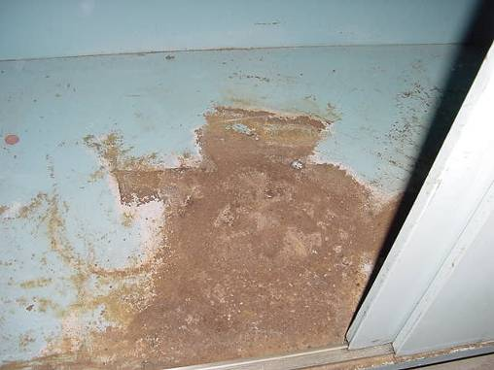

Rusted Interior of Sink in Classroom

Picture 2

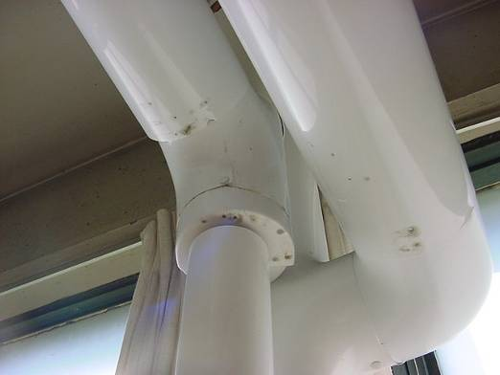

Discoloration (as Indicated by Dark Stains) on Pipe Insulation in Room 111 Indicating a Historic Leak

Picture 3

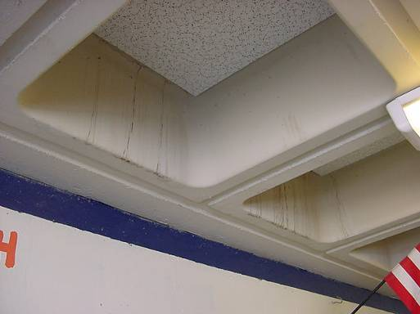

Water Stains on Concrete Ceilings Indicating Former Areas of Leaks

Picture 4

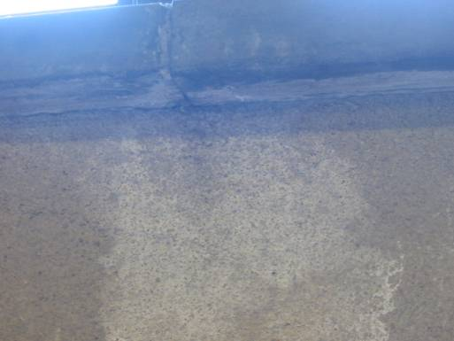

Efflorescence (White Mineral Deposits) on Interior Wall Indicating Water Penetration
Picture 5

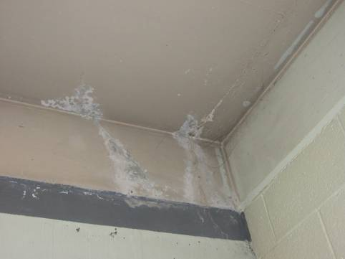

Peeling Paint and Efflorescence (White Mineral Deposits) on Interior Wall/Ceiling Indicating Water Penetration

Picture 6

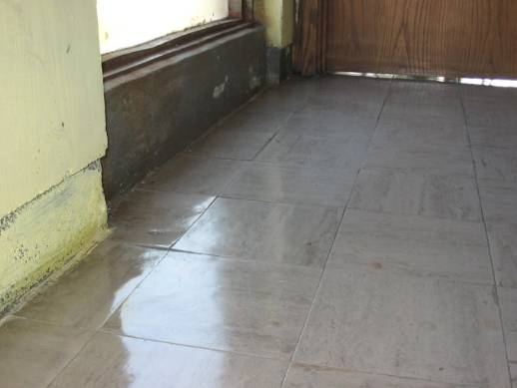

Loosened Floor Tiles in Room 306-A along Windows/Exterior Wall
Picture 7

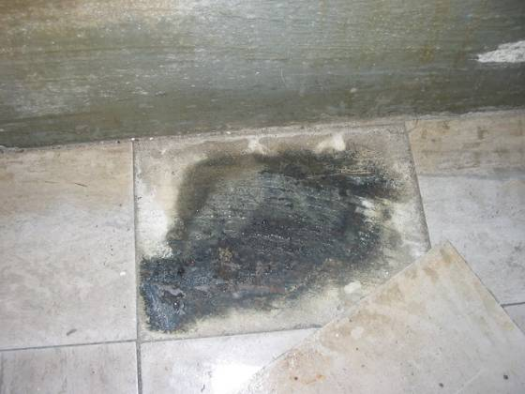

Close-Up of Beaded Water/Loosened Floor Tile in Room 306-A

Picture 8

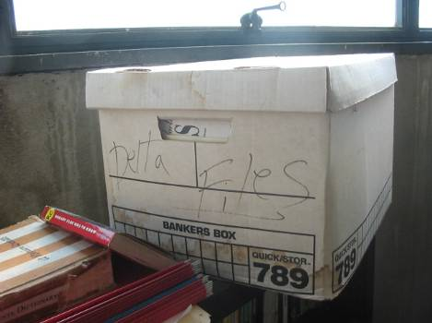

Water Damaged Porous Materials
Picture 9

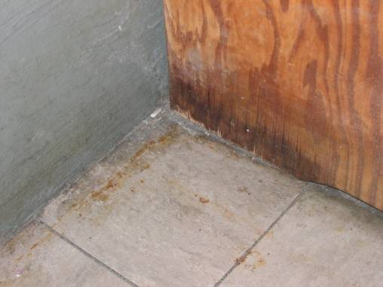

Moistened Wooden Cabinet in Room 306-A

Picture 10

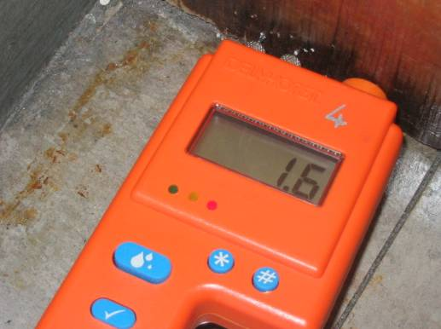

Elevated Moisture Measurement Wooden Cabinet in Room 306-A
Picture 11

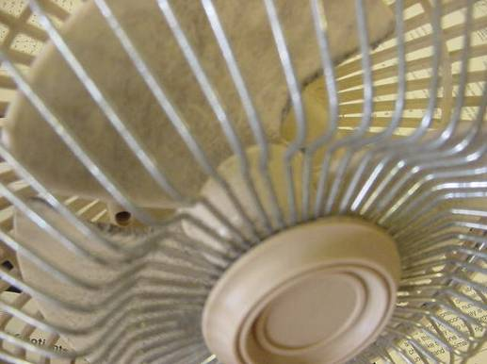

Accumulated Dust and Debris on Surface of Fan Blades in Classroom

Picture 12

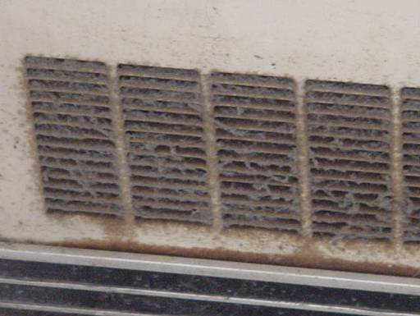

Accumulated Dust and Debris on Univent Return Vent in Classroom
Picture 13

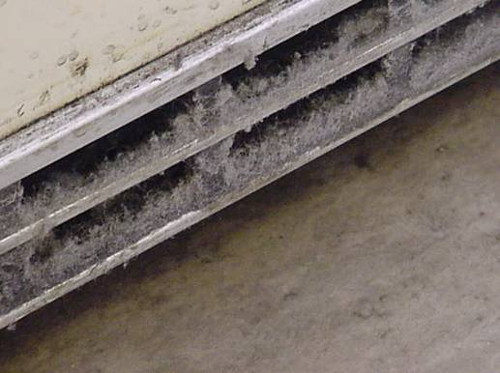

Accumulated Dust and Debris on Univent Return Vent in Classroom

Picture 14

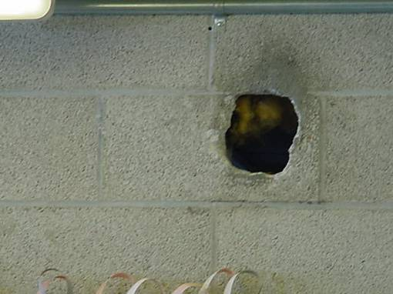

Hole in Interior Wall in Classroom
Picture 15

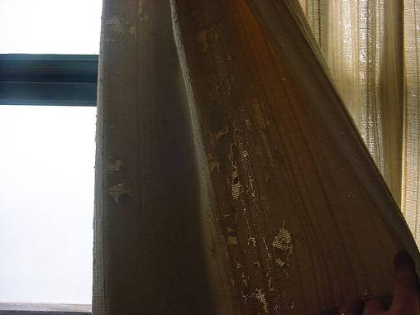

Disintegrating Textiles Classroom Curtain

Picture 16

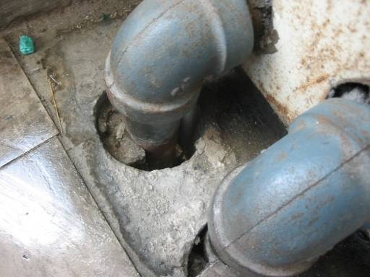

Open Utility Holes around Univent Pipes
Picture 17

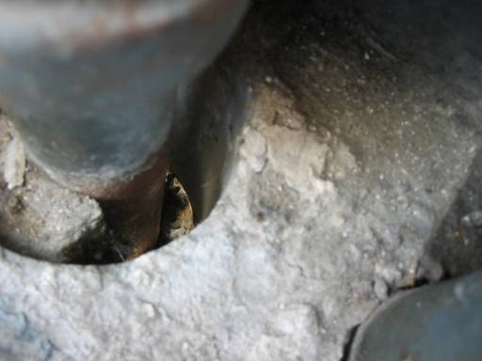

Open Utility Holes around Univent Pipes, note Light Penetrating from Exterior

Picture 18

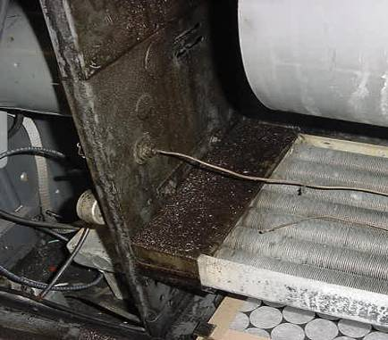

Oil/Fluid inside Univent Air Handling Chamber Classroom 103 (Dark Accumulation on Left)
Picture 19

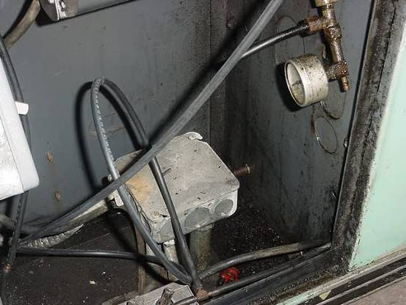

Oil/Fluid inside Univent Classroom 103 (Dark Accumulation on Right Bottom/Sides)

Location/ Room | Occupants  in Room | Temp  (°F) | Relative  Humidity  (%) | Carbon  Dioxide  (ppm) | Carbon Monoxide  (ppm) | TVOCs  (ppm) | PM2.5  (µg/m3) | Windows  Openable | Ventilation |  | Remarks
 |  |  |  |  |  |  |  |  | Supply | Exhaust | Remarks
background |  | 66 | 62 | 335 | ND | ND | 47 |  |  |  | Clear, sunny, winds WSW 5-15 mph
116 | 13 | 71 | 59 | 2044 | ND | ND | 41 | Y  # open: 0  # total: 6 | Y  univent  off | Y  off | DEM, exhaust obstructed
115 | 17 | 73 | 51 | 1065 | ND | ND | 33 | Y  # open: 0  # total: 6 | Y  univent | Y  off | DEM, DO
114 | 0 | 73 | 47 | 670 | ND | ND | 33 | Y  # open: 0  # total: 6 | Y  univent | Y
113 | 19 | 75 | 48 | 1003 | ND | ND | 31 | Y  # open: 0  # total: 6 | Y  univent | Y | DEM
112 | 23 | 75 | 46 | 939 | ND | ND | 30 | Y  # open: 0  # total: 6 | Y  univent | Y | DEM, DO
111 | 18 | 75 | 46 | 926 | ND | ND | 29 | Y  # open: 0  # total: 6 | Y  univent | Y  off | 1 CT, DEM, DO
110 | 1 | 76 | 40 | 545 | ND | ND | 32 | Y  # open: 4  # total: 6 | Y  univent | Y | Occupants at lunch 2 mins, DEM, DO
109 | 0 | 74 | 36 | 375 | ND | ND | 27 | Y  # open: 6  # total: 6 | Y  univent | Y | Aprox 13 occupants @ lunch approx 20 mins.
108 | 1 | 75 | 36 | 375 | ND | ND | 27 | Y  # open: 3  # total: 6 | Y  univent | Y | 19 occupants gone approx. 25 mins., DO
104 | 20 | 75 | 42 | 1320 | ND | ND | 28 | Y  # open: 0  # total: 6 | Y  univent | Y | DEM, DO, dust/debris accumulation on exhaust vent
105 | 11 | 74 | 39 | 852 | ND | ND | 22 | Y  # open: 0  # total: 6 | Y  univent | Y | DEM
106 | 10 | 74 | 38 | 771 | ND | ND | 24 | Y  # open: 0  # total: 6 | Y  univent | Y | DEM
103 | 18 | 75 | 46 | 1852 | ND | ND | 31 | Y  # open: 0  # total: 6 | Y  univent | Y | DEM, organic odor-oil/fluid accumulation in univent
205 | 1 | 73 | 36 | 437 | ND | ND | 33 | Y  # open: 0  # total: 6 | Y  univent | Y | DEM, CD, 1CT
204 | 0 | 72 | 34 | 411 | ND | ND | 22 | Y  # open: 1  # total: 6 | Y  univent | Y | DEM, PF
203 | 3 | 73 | 34 | 489 | ND | ND | 26 | Y  # open: 0  # total: 6 | Y  univent | Y | 12 CT, utility hole around pipe
201 | 3 | 73 | 34 | 452 | ND | ND | 24 | Y  # open: 0  # total: 6 | Y  univent | Y  off | DEM, dust/debris-univent, accumulated items, spaces around sink-caulking, efflorescence-wall
cafeteria A | 15 | 73 | 42 | 749 | ND | ND | 30 | Y  # open: 0  # total: 12 | Y  ceiling  off | Y  ceiling  off | PF
cafeteria B | 1 | 73 | 43 | 754 | ND | ND | 33 | N |  | Y  wall | DO
Vice Principal office 3rd fl | 1 | 77 | 36 | 592 | ND | ND | 27 | N | N | Y  wall | PF
Library | 27 | 74 | 44 | 1029 | ND | ND | 40 | N | Y  univent  off | Y  wall  off | Ceiling fans
208 | 1 | 75 | 33 | 486 | ND | ND | 23 | Y  # open: 3  # total: 6 | Y  univent | Y  off | Univent obstructed, DEM, CD, PF, damaged window seal, efflorescence
207 | 1 | 74 | 34 | 433 | ND | ND | 21 | Y  # open: 0  # total: 6 | Y  univent | Y | DEM
206-A | 0 | 73 | 35 | 452 | ND | 0.2 | 25 | Y  # open: 1  # total: 1 | N | N | Wet toner-copier
206 | 1 | 72 | 37 | 449 | ND | ND | 27 | Y  # open: 1  # total: 6 | Y  univent | Y | DO. CD, plants, efflorescence, 3 CT
211 | 0 | 74 | 32 | 383 | ND | ND | 28 | Y  # open: 6  # total: 6 | Y  univent  off | Y | CD, DEM, CTs, DO, efflorescence
210-A | 0 | 74 | 35 | 529 | ND | ND | 29 | Y  # open: 0  # total 1 | N | N | 9 CT
210 | 23 | 76 | 43 | 1191 | ND | ND | 28 | Y  # open: 1  # total: 6 | Y  univent | Y | DEM, CD, missing damaged window seal, plants, efflorescence, water damaged pipe wrapping
209 | 26 | 76 | 39 | 876 | ND | ND | 26 | Y  # open: 4  # total: 6 | Y  univent  off | Y  off | Efflorescence, water damaged wall plaster DEM, CD, DO
214 | 20 | 77 | 33 | 640 | ND | ND | 25 | Y  # open: 4  # total: 6 | Y  univent | Y | CD, dust accum-univent, 2 CT, PS
213 | 22 | 78 | 34 | 791 | ND | ND | 26 | Y  # open: 2  # total: 6 | Y  univent | Y | DEM, dust/debris-univet/exhaust, CD
212 | 23 | 76 | 34 | 797 | ND | ND | 34 | Y  # open: 0  # total: 6 | Y  univent | Y  off | Slight odor from univent, 2 CT, DEM
Faculty 2 | 0 | 76 | 32 | 521 | ND | ND | 24 | N | N | Y  wall
249 | 17 | 73 | 43 | 619 | ND | ND | 26 | Y  # open: 0  # total: 4 | Y  univent | Y  wall | DEM, DO, plants
216 | 23 | 76 | 36 | 745 | ND | ND | 27 | Y  # open: 0  # total: 6 | Y  univent | Y | Univent obstructed, CD, DEM, breach sink-counter, efflorescence
215 | 25 | 79 | 38 | 1073 | ND | ND | 35 | Y  # open: 0  # total: 6 | Y  univent  off | Y | DEM, CD, damaged/missing window seal, efflorescence, water damaged pipe insulation
218 | 0 | 77 | 35 | 810 | ND | ND | 30 | N | Y  wall  off |  | 7 computers
224 | 17 | 73 | 49 | 1173 | ND | ND | 20 | Y  # open: 0  # total: 2 | Y  univent  off |  | Univent obstructed, exhaust could not be located, CD, DEM, PF, breach sink-countertop, water damaged ceiling/wall plaster, efflorescence, window AC
246 art | 0 | 73 | 43 | 575 | ND | ND | 31 | Y  # open: 0  # total: 4 | Y  univent | Y  wall  off | DO
247 | 0 | 72 | 43 | 593 | ND | ND | 33 | Y  # open: 0  # total: 4 | Y  univent | Y  wall  off | Efflorescence, dust/debris-exhaust, PF, water damaged ceiling plaster, DO
248 | 14 | 72 | 40 | 600 | ND | ND | 23 | Y  # open: 0  # total: 4 | Y  univent | Y  wall | Univent dusty/obstructed, PF, DO
301 | 26 | 71 | 54 | 954 | ND | ND | 33 | Y  # open: 0  # total: 6 | Y  univent | Y  off | Univent-dusty, DEM, CD, breach sink/countertop
302 | 27 | 73 | 53 | 1221 | ND | ND | 35 | Y  # open: 0  # total: 6 | Y  univent | Y | Univent-dusty, DEM, CD, missing/damaged window seal, water damaged ceiling plaster, leak through windows, efflorescence
303 | 25 | 72 | 46 | 883 | ND | ND | 31 | Y  # open: 0  # total: 6 | Y  univent | Y  off | exhaust-dusty, DEM, CD, missing/damaged window seal, leak through windows, efflorescence, water damaged wall plaster
304 | 1 | 74 | 45 | 660 | ND | ND | 25 | Y  # open: 0  # total: 6 | Y  univent | Y  weak | DO, CD, missing/damaged window seal, water damaged wall/ceiling plaster, leak through windows, efflorescence, water damaged wall plaster, porous materials stored near areas of leakage
305 | 12 | 74 | 44 | 862 | ND | ND | 24 | Y  # open: 0  # total: 6 | Y  univent | Y  off | Univent obstructed, exhaust-dusty, missing/damaged window seal, water damaged wall/ceiling plaster, efflorescence, water damaged wall plaster, accumulated items in classroom
306 | 0 | 71 | 39 | 399 | ND | ND | 28 | Y  # open: 2  # total: 6 | Y  univent | Y  weak | DO, exhaust vent-dusty, AD, DEM, cleaners, water damaged ceiling/wall plaster
306-A | 0 | 69 | 43 | 416 | ND | ND | 29 | Y  # open: 0  # total: 1 | N | N | Active leaks through windows, loosened floor tiles, water damaged wooden cabinet-elevated moisture measurement, water damaged ceiling plaster, efflorescence
307 | 1 | 73 | 44 | 499 | ND | ND | 23 | Y  # open: 0  # total: 6 | Y  univent | Y | DEM, efflorescence, water damaged box/ceiling plaster, DO
308 | 18 | 77 | 40 | 753 | ND | ND | 25 | Y  # open: 0  # total: 6 | Y  univent | Y  off | CD, DEM, plants, spaces around univent pipes, efflorescence, water damaged ceiling, floor and wall plaster
309 | 26 | 77 | 40 | 806 | ND | ND | 27 | Y  # open: 0  # total: 6 | Y  univent | Y  off | Univent obstructed, DO, DEM, water damaged wall/ceiling plaster
310 | 22 | 76 | 39 | 705 | ND | ND | 24 | Y  # open: 4  # total: 6 | Y  univent | Y | DO, CD, water damaged floor tiles, missing/damaged window gasket, efflorescence
310-A | 3 | 77 | 43 | 1206 | ND | ND | 45 | Y  # open:0  # total: 1 | N | N | Water infiltration through windows-damaged floor, missing/damaged window gasket, efflorescence, CD
311 | 0 | 75 | 36 | 546 | ND | ND | 27 | Y  # open: 0  # total: 6 | Y  univent | Y | PS, broken window, efflorescence, missing/damaged window gasket
312 | 1 | 74 | 38 | 467 | ND | ND | 28 | Y  # open: 3  # total: 6 | Y  univent | Y | Water damaged ceiling plaster, CD, water infiltration through windows-damaged floor, efflorescence
313 | 1 | 75 | 37 | 515 | ND | ND | 24 | Y  # open: 0  # total: 6 | Y  univent | Y | water infiltration through windows-damaged floor, water damaged ceiling/wall plaster, CD, DEM
314 | 0 | 76 | 34 | 512 | ND | ND | 19 | Y  # open: 0  # total: 6 | Y  univent | Y  off | water infiltration through windows-damaged floor, CD, DEM, water damaged ceiling/wall plaster

