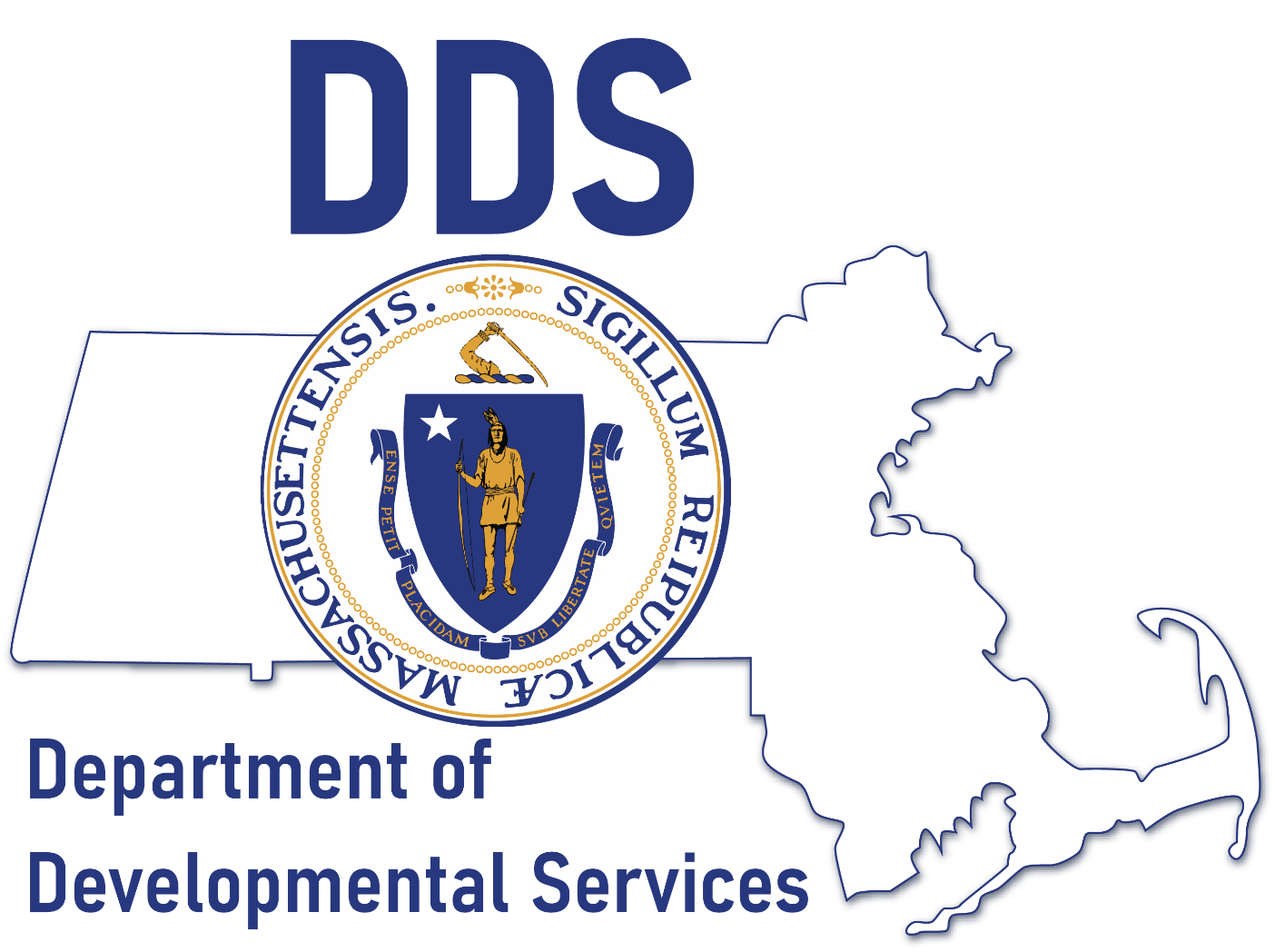

Children’s Autism Unit

- 5 new Autism Clinical Coordinators were hired which brings the total to 10
- 2 additional ACM positions posted
- 332 participants as of 9/18/23

Children’s Autism Waiver Expansion

First Waiver Amendment
- Added 75 slots* per year for 3 years:
  - 10/1/22 – 9/30/23: 75
  - 10/1/23 – 9/30/24: 75
  - 10/1/24 – 9/30/25: 75
  - ARPA Funding
*In addition to the 10 added each year in the original waiver

Children’s Autism Waiver Expansion

Second Waiver Amendment
  - Raised the age through the 9th birthday
  - Continue with telehealth for certain services past the end of Appendix K.
  - Raised the cap of the step-down portion of the AWP from $8,500 to $9,000
  - Changed the cap for home modifications (fences) to an AWP lifetime cap of $15,000 versus a $5,000 cap per year for 3 years
  - Increased the one-time emergency provision from $5,000 to $6,000

Children’s Waiver

- Open Request runs from 10/16/23 through 10/31/23.
- Multiple Languages available on the DDS website in multiple languages
- Social media campaigns and direct mail/email start next week.

Autism Support Centers

Seven Autism Support Centers support the Children’s Autism Waiver
Added 1 FTE to 6 of the 7 this year.

Adult Autism Supports

- Two new Adult Autism Managers
- 4533 Eligible as of 9/18/23

Growth in ASD Adults Eligible

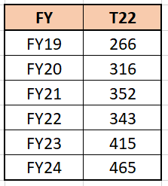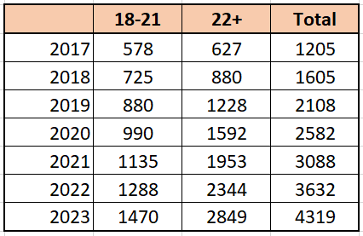

Exploring New Services

Housing
- Increasing knowledge and connections to Housing entities
- Researching a Housing Coordination and Stabilization service
- Meeting with EOHLC
- Trained Tenancy Preservation Program Managers
Service Dogs
- Creating guidelines
- Planning a Pilot Spring 2024

EHS Collaborations

- DMH to develop two APRA proof of concept projects; Intensive Community Wrap and Residential Homes for individuals with ASD and Significant Mental Illness.
- MBTA/WRTA - provided training and resources to MBTA and their Mobility Team on the needs of riders with ASD. MBTA is collaborating with DDS Director of Supportive Technology Jennifer Petersen to discuss apps that can be used for travel training. MBTA is providing training to DDS staff.
- Behavioral Health Workforce Training Clearinghouse @ UMass Chan Medical School -collaborating with the Behavior Health Clearinghouse at UMass on developing ASD-specific training and the sharing of already existing training resources for DDS & EHS staff.
- MRC – started meeting with MRC regional teams around sharing resources and training opportunities around serving autistic individuals and their families.
- Aging Services, DESE, EOHLC …

