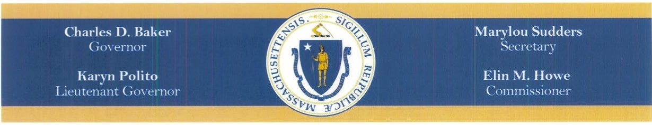

FY16 Quarter Four Report On The

DDS Services for Newly Eligible lndividu11ls with Autism, Smith­ Magenis Syndrome, and Prader-Willi Syndrome



The Honorable Karen E. Spilka, Chair Senate Committee on Ways and Means State House, Room 212
Boston, MA 02133

The Honorable Brian S. Dempsey, Chair House Committee on Ways and Means State House, Room 243
Boston, MA 02133

Dear Chairwoman Spilka and Chairman Dempsey:

Line item 5920-3020 of Chapter 165 of the Acts of 2016 requires that the "...department shall submit a quarterly report to the house and senate committees on ways and means on the number of individuals served, type of services provided and the cost per indi vidual...".

The Department of Developmental Services has been working diligently to implement the expanded eligibility requirements which were signed into Law in August 2014. The Department has designed a number of new materials including new applications, fact sheets, and assessment processes to support this expansion. To support the eligibility changes, DDS has trained its Regional Eligibility Teams in these new activities. Most importantly, the Department of Developmental Services has new regulations, pending promulgation, that provide the administrative framework for the statute.

As of 6/30/16, 737 adults (18+) have been found DDS eligible with 733 as adult Autism eligible and 4 adult Prader Willi eligible. 339 of these individuals are currently still in school, are exploring DDS services or are not requesting DDS services at this time. 398 are receiving a total of 918 services broken out on the following chart, with many receiving more than one service. To date, the average Fy16 cost per individual is $19,584.

Sincerely,

.H/
Elin M. Howe
Commissioner

Total# Receiving Services (Cumulative) | 105 | 180 | 322 | 398
Adult Autism Services Enrolled (Age 18+) | Ql | Q2 | Q3 | Q4
3150 SHARED LIVING/HOME SHARE | 3 | 3 | 5 | 7
3153 RESIDENTIAL SUPPORTS | 4 | 7 | 9 | 12
3163 COMMUNITY BASED DAY  SUPPORTS | 19 | 39 | 46 | 59
3164 MASS HEALTH DAY HABILITATION | 5 | 9 | 10 | 13
3168 EMPLOYMENT SUPPORTS | 15 | 35 | 58 | 85
3170 CLINICAL TEAM | 1 | 6 | 8 | 8
3180 CEIS-COMPETITIVE INTEG EMP SRV | 5 | 7 | 8 | 11
3181GROUP SUPPORTED EMPLOYMENT | 10 | 25 | 33 | 38
3182 RESPITE FACILITY | 2 | 2 | 3 | 2
3196 TRANSPORTATION | 11 | 24 | 30 | 41
3285 DAY HAB SUPPLEMENT | 5 | 5 | 5 | 6
3700 FAMILY SUPPORT NAVIGATION | 13 | 44 | 52 | 63
3703 INDIVIDUAL HOME SUPPORTS | 11 | 22 | 39 | 47
3707 ADULT COMPANION | 2 | 8 | 14 | 20
3731Respite in Recipient's Home | 8 | 17 | 24 | 34
3759 RESPITE - ADULT - SITE-BASED | 2 | 2 | 2 | 2
3770 FAMILY SUPPORT CENTERS | 4 | 33 | 43 | 45
3779 STIPENDS | 21 | 59 | 78 | 90
3780 FINANCIAL ASSISTANCE | 3 | 7 | 18 | 17
3781FINANCIAL ASSISTANCE ADMIN | 29 | 60 | 84 | 98
3798 INDIV SUPPORT AND COMM HAB | 6 | 21 | 35 | 51
5300 NON-WAIVER | 9 | 11 | 12 | 14
5400 NON -WAIVER FINANCIAL | 10 | 12 | 11 | 17
5703 INDIVIDUAL HOME SUPPORTS- SO | 2 | 4 | 10 | 12
57041NDIVIDUAL DAY SUPPORTS- SO | 2 | 2 | 4 | 10
5710 BEHAVIORAL SUPP&CONSULT-SO | 1 | 1 | 2 | 5
5728 INDIVIDUAL GOODS AND SERVICES | 1 | 6 | 10 | 24
6703 INDIVIDUAL HOME SUPPORTS.AWC | 1 | 9 | 10 | 20
6704 INDIVIDUAL DAY SUPPORTS- AWC | 2 | 5 | 5 | 5
6707 ADULT COMPANION- AWC | 2 | 6 | 6 | 8
6753 AGENCY WITH CHOICE ADMIN FEE | 5 | 20 | 21 | 34
6780 FINANCIAL ASSISTANCE- AWC | 3 | 11 | 12 | 20
Total#Services Provided | 219 | 524 | 707 | 918

