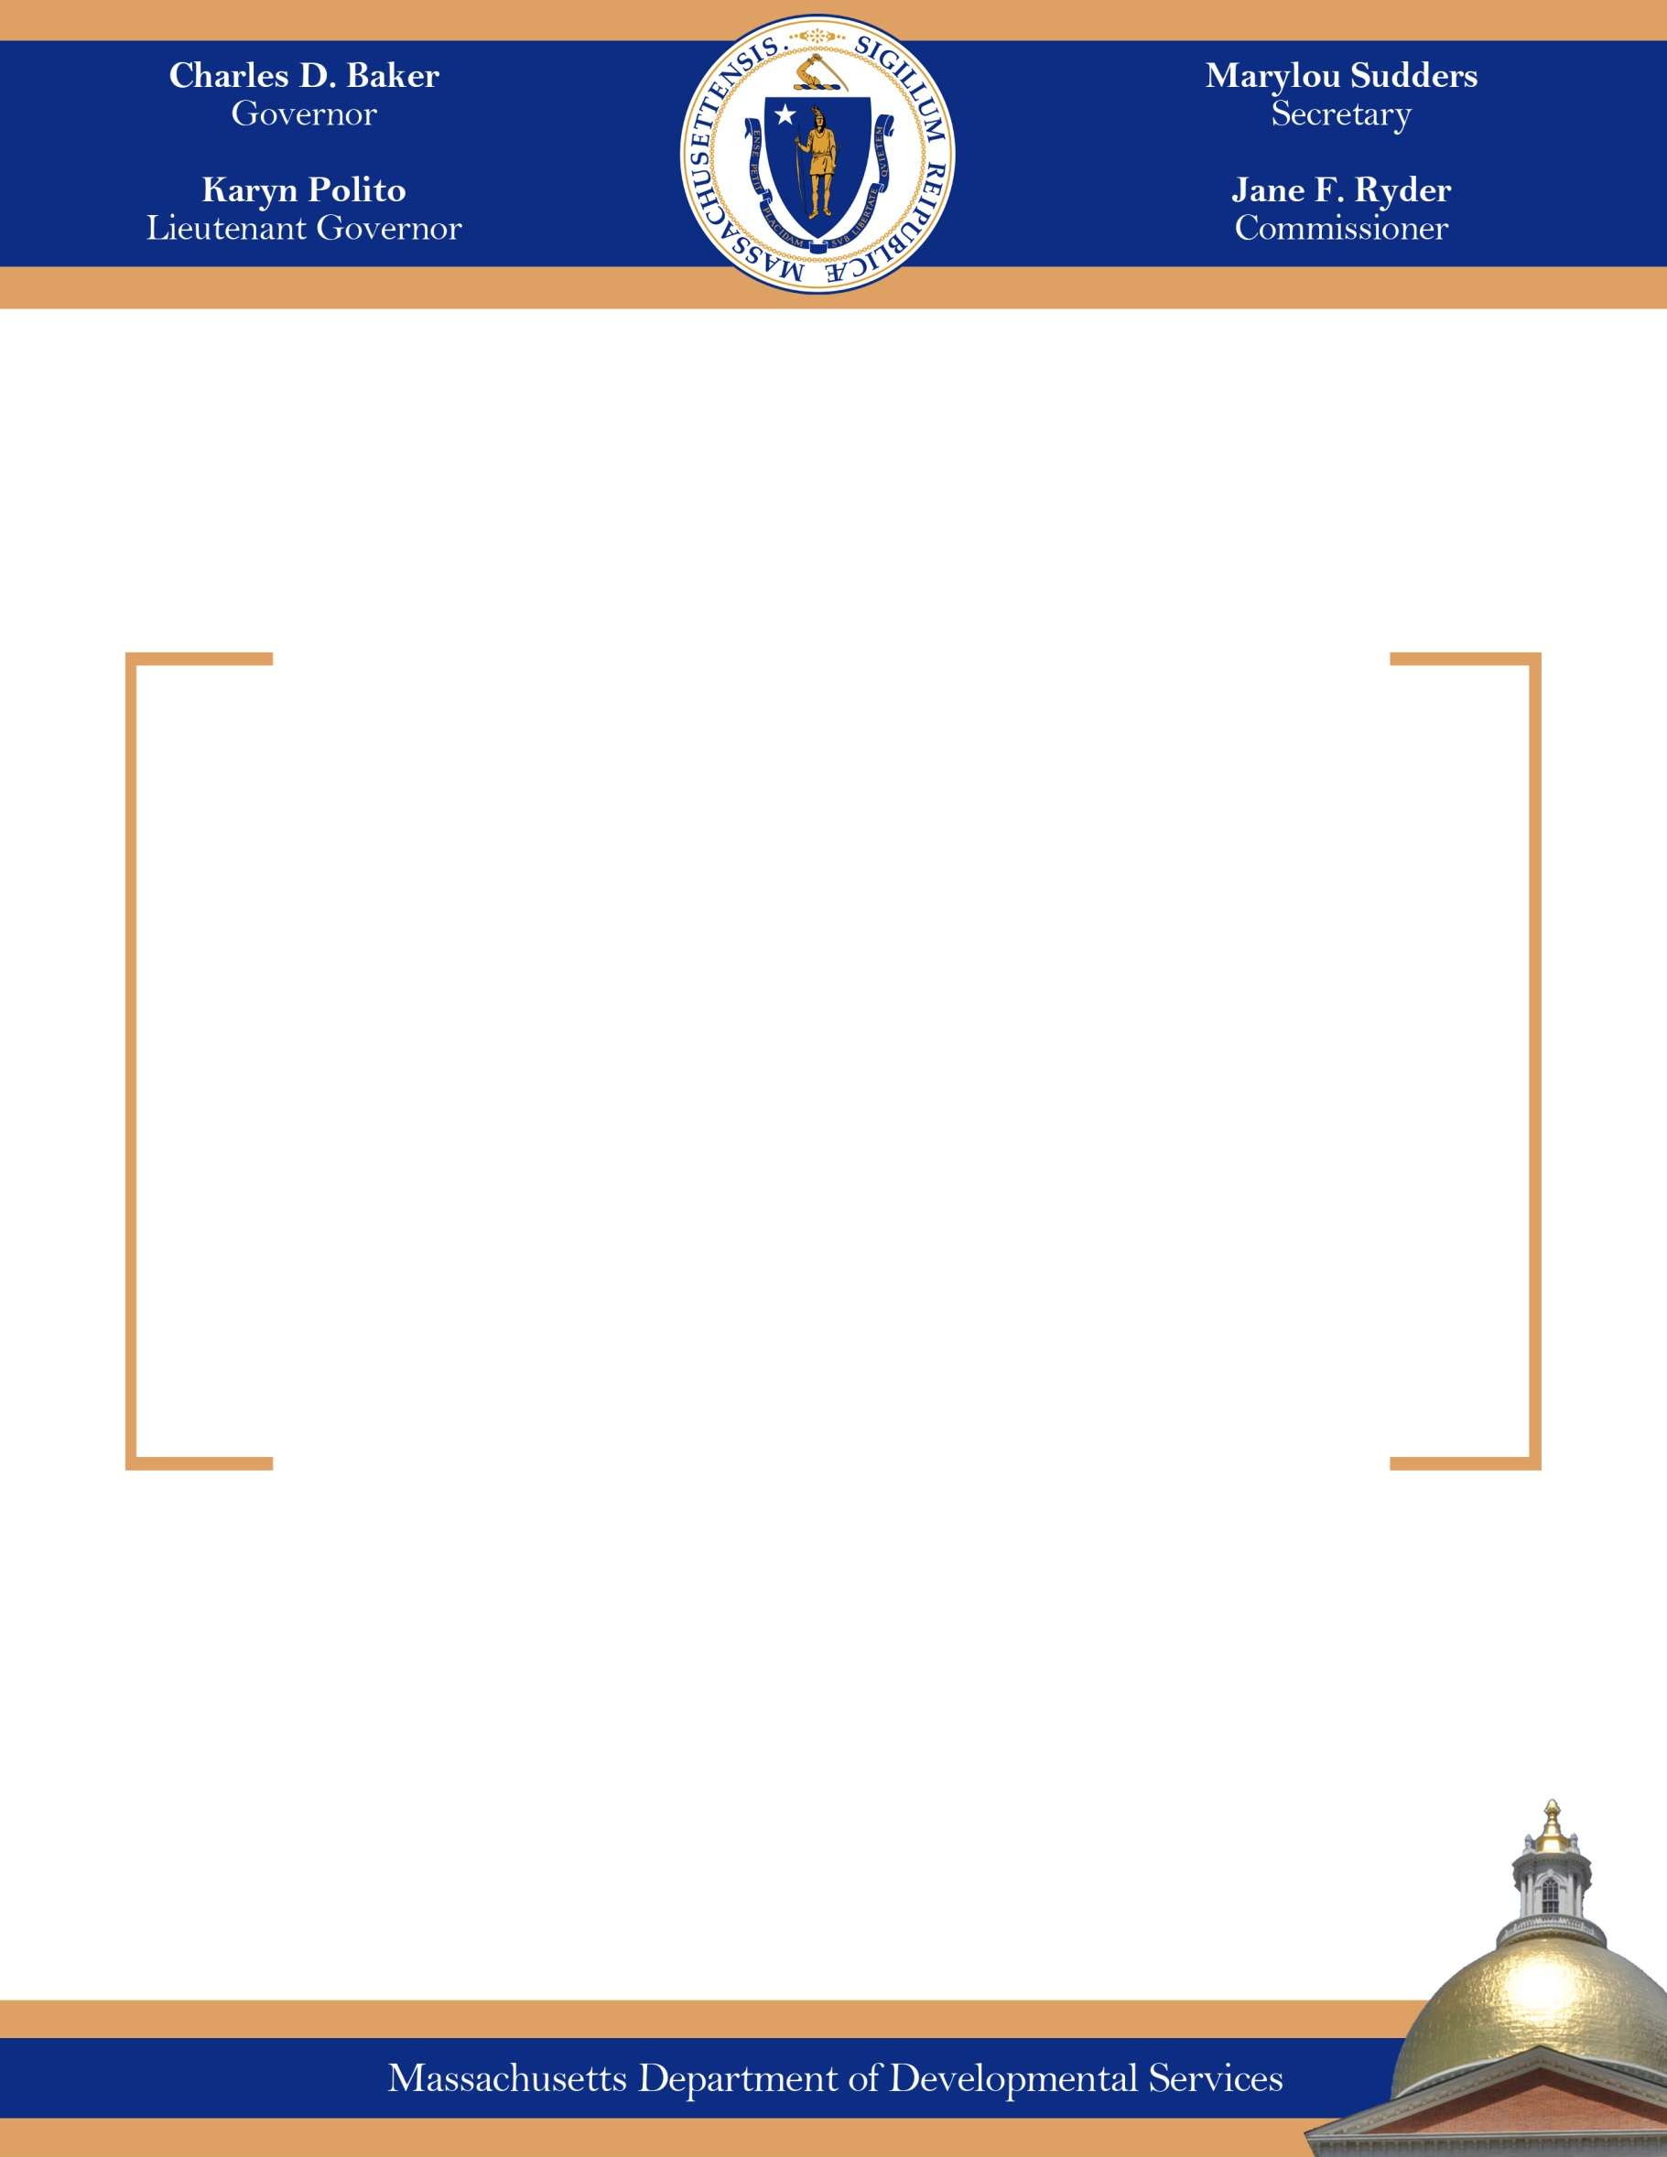.

**FY21 Quarter 1-4 Report on DDS Services for Individuals with Autism, Smith-Magenis Syndrome, and Prader-Willi Syndrome**

**November**

**2021**

The Honorable Michael Rodrigues, Chair

Senate Committee on Ways and Means

State House, Room 212

Boston, MA 02133

The Honorable Aaron Michlewitz, Chair

House Committee on Ways and Means

State House, Room 243

Boston, MA 02133

Dear Chair Rodrigues and Michlewitz:

Line-item language for the Department of Developmental Services (“DDS” or “the Department”) included in the Fiscal Year 2021 (FY21) General Appropriation Act line item 5920-3020 requires that the “…the department shall submit quarterly reports to the house and senate committees on ways and means detailing: (i) the number of individuals eligible for services; (ii) the number of eligible individuals served; (iii) the type of services provided; (iv) the cost per service; and (v) the cost per individual…”.

DDS has been working diligently to implement the expanded eligibility requirements since signed into law in August 2014. To support the eligibility changes, DDS designed materials including applications, fact sheets, and assessment processes to and trained its Regional Eligibility Teams in these new activities. Most importantly, the Department has implemented regulations that provide the administrative framework for the statute.

Many of the individuals age 18-21 with an eligibility determination of Autism/DD have service enrollments prior to their Autism determination date, and are still in school. These enrollments include DDS children’s services and family support. Of the Autism eligible individuals age 22+, many are currently receiving DDS services through the 5920-3020 Autism Services account. These services are broken out on the appended chart of the 5920-3020 account, with many individuals receiving more than one service. The direct cost per the service is also detailed. Other individuals not receiving services in the 5920-3020 account are exploring the DDS services offered or are not currently requesting services from DDS.

See below for FY21 Quarters 1, 2, and 3 updates:

**FY21 Quarter 1**

As of 9/30/20, 2,724 adults (18+) were found DDS eligible with 2,714 as adult Autism eligible, 2 Smith Magenis eligible and 10 adult Prader Willi eligible.

* Of the 1,032 individuals age 18-21 with an eligibility determination of Autism/DD, 543 are currently enrolled in a combination of 1,178 DDS services.
* Of the 1,692 individuals age 22+ there are currently 1,204 individuals currently receiving a total of 2,826 DDS services through the 5920-3020 account.
* As of FY21 Q1, the average cost per individual from the 5920-3020 account is $3,289.

**FY21 Quarter 2**

As of 12/31/20, 2,836 adults (18+) were found DDS eligible with 2,825 as adult Autism eligible, 2 Smith Magenis eligible and 11 adult Prader Willi eligible.

* Of the 1,049 individuals age 18-21 with an eligibility determination of Autism/DD, 536 are currently enrolled in a combination of 1,211 DDS services.
* Of the 1,787 individuals age 22+ there are currently 1,271 individuals currently receiving a total of 2,952 DDS services through the 5920-3020 account.
* As of FY21 Q2 the average cost per individual from the #5920-3020 account is $4,322

**FY21 Quarter 3**

As of 03/31/21, 2,943 adults (18+) were found DDS eligible with 2,932 as adult Autism eligible, 2 Smith Magenis eligible and 11 adult Prader Willi eligible.

* Of the 1,088 individuals age 18-21 with an eligibility determination of Autism/DD, 553 are currently enrolled in a combination of 1,118 DDS services.
* Of the 1,855 individuals age 22+ there are currently 1,340 individuals currently receiving a total of 3,081 DDS services through the 5920-3020 account.
* As of FY21 Q3 the average cost per individual from the #5920-3020 account is $4,682

**FY21 Quarter 4**

As of 06/30/21, 3,088 adults (18+) were found DDS eligible with 3,076 as adult Autism eligible, 1 Smith Magenis eligible and 11 adult Prader Willi eligible.

* Of the 1,135 individuals age 18-21 with an eligibility determination of Autism/DD, 539 are currently enrolled in a combination of 1,155 DDS services.
* Of the 1,953 individuals age 22+ there are currently 1,413 individuals currently receiving a total of 3,131 DDS services through the 5920-3020 account.
* As of FY21 Q4 the average cost per individual from the #5920-3020 account is $5,451

