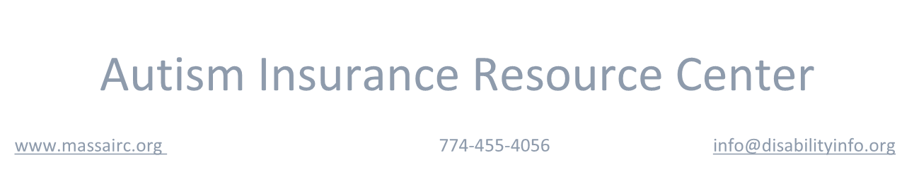

Autism Insurance Resource Center

[www.massairc.org](https://massairc.org/)

774-455-4056

info@disabilityinfo.org

Options after Age 26: Health Insurance Information for Adult Disabled Dependents

**My child has ASD and is on my family policy. What happens when they turn 26?**

All children can remain under a parent's policy until age 26. Children with disabilities can often remain on a parent's policy after age 26.

**How do I keep my child on my policy after they turn 26?**

Parents need to apply to their employer or insurer for this coverage, as each company has different requirements. It is not a good idea to wait until the last minute – after you’ve received notice that because your child is turning 26, they will be terminated from your policy. Instead, we recommend parents notify their employer or insurer as early as possible – ideally several years before their 26th birthday – that their child has a disability and will need to remain on the policy.

**Does this just apply to people with ASD?**

No, this applies to any child who has been diagnosed with a disability. The diagnosis doesn’t have to be ASD; it could, for example, be depression or anxiety disorder.

**What documentation is required?**

Insurers all have different requirements, which is why we recommend applying as early as possible. At a minimum, the insurer is likely to require documentation of the disability from a medical professional, but they may also require you to submit additional information. Also, some insurers may only approve the coverage for a limited period of time and require a new application or review of the disability determination to continue coverage.

**My child has a job that provides insurance. If they lose their job, can I put them back to my policy?**

Only if they are under 26. If a child is not on a parent's policy when they turn 26, they are not usually able to be re-enrolled, regardless of disability. If your child has a disability, consider keeping them on your policy, regardless of their access to insurance through their current employer.

**What if my child is already older?**

Some employers/insurers still allow coverage for a child with a disability who is over 26. We recommend checking with your employer or insurer. **Does ARICA cover autism treatments for adults?**

Yes. ARICA, the law that requires private, state-regulated insurance policies to cover medically necessary treatment for individuals with autism, has no age limitation. For more information, refer to our [ARICA Fact Sheet.](https://massairc.org/information-about-the-massachusetts-insurance-law/arica-faq/)

**Can I purchase a policy from the Health Connector that will provide access to ARICA benefits for my child?**

Yes, but not all policies sold through the Health Connector offer this access. To obtain ARICA coverage for your child, you must select one of the “Unsubsidized Qualified Health Plans.” These plans are sold through the Connector during its open enrollment periods. If you have additional questions regarding Connector Plans and ARICA, please contact us.

**My adult child is receiving MassHealth. Can they also have private insurance?**

**If so, which plan is primary?**

Yes, an adult child who receives MassHealth can also have private insurance. In general, the private insurance is the primary plan, and MassHealth is the secondary plan.

**Will MassHealth provide Premium Assistance for private insurance?**

If your child receives MassHealth and is also on your employer’s policy, they are eligible for Premium Assistance, with no age limit.

**What happens when a parent starts receiving Medicare?**

When a parent transitions to Medicare, they usually don’t continue to have private insurance. For further information, you can consult a counselor familiar with Medicare benefits, through the state’s “Serving the Health Information Needs of Everyone” [(SHINE) program.](https://www.mass.gov/service-details/find-a-shine-counselor)

**What should I be doing now?**

* If your adult child with a disability is under 26 and covered on your policy, contact your insurer or employer to learn what specific steps you need to take to keep them on your policy at 26.
* If your adult child with a disability is under 26 and **not** covered on your policy, consider adding them back to your policy now.
* If your adult child with a disability is over 26, it is still worthwhile to ask your employer or insurer whether they might still allow you to include this child under your policy.

For further information, contact an information specialist at 774-455-4056 or e-mail us at info@massairc.org. The current version of this fact sheet and other important information can be found at our website, [http://massairc.org/.](http://massairc.org/)



________________________________________________________________________________________

The Autism Insurance Resource Center is a division of UMass Medical School Shriver Center. Partial funding for the

Center is provided through grants from the Massachusetts Developmental Disabilities Council (MDDC),

Massachusetts Department of Developmental Services (DDS), Massachusetts Department of Public Health (DPH), The Nancy Lurie Marks Family Foundation, Autism Speaks, and the Doug Flutie Jr. Foundation for Autism. This fact sheet was updated 10/2018.

University of Massachusetts Medical School, E. K. Shriver Center

55 Lake Avenue North Worcester, MA 01655-0002

Copyright ©2018 Autism Insurance Resource Center – All Rights Reserved