INCIDENT HIGHLIGHTS

**DATE:**

September 25, 2019

**TIME:**

12:30 p.m.

**VICTIM:**

64-year-old automotive mechanic

**INDUSTRY/NAICS CODE:**

Other gasoline stations/447190

**EMPLOYER**:

Gasoline station with service station and snack store

**SAFETY & TRAINING:**

Employer provided limited training

**SCENE:**

Bay inside repair garage

**LOCATION:**

Massachusetts

**EVENT TYPE:**

Explosion



















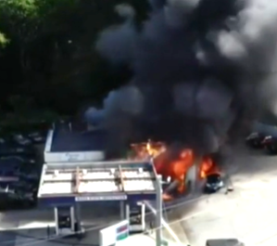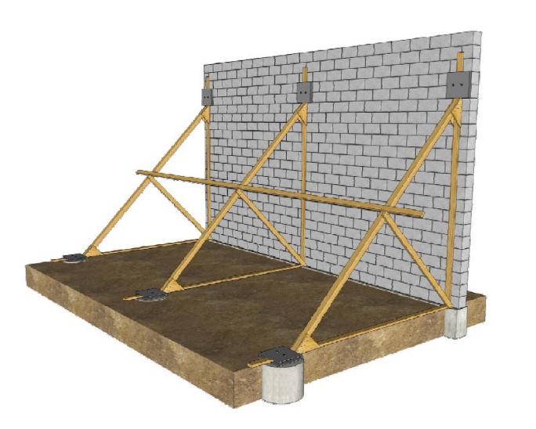

**REPORT#:** 19MA058 **REPORT DATE:** July 15, 2022

Automotive Mechanic Fatally Burned While Using Welder When Washer Fluid Drum Explodes —Massachusetts

SUMMARY

On September 25, 2019, a 64-year-old white non-Hispanic male automotive mechanic was injured in an explosion inside a service garage. He was welding on top of a nearly empty steel drum of flammable washer fluid, which caused the drum to explode. The explosion covered him with burning fluid and he died from the burns six weeks later. READ THE FULL REPORT> (p.3)

CONTRIBUTING FACTORS

**Key contributing factors identified in this investigation include:**

* Worksite lacked a proper welding station
* Welding in the vicinity of a drum containing flammable materials
* Lack of a safety and health program and overall safety training  
  LEARN MORE> (p.9)

RECOMMENDATIONS

**Massachusetts FACE investigators concluded that, to help prevent similar occurrences, employers should:**

* Provide an appropriate location to perform welding work. All hot work should be a safe distance away from flammable and combustible liquids. Ensure workers using welding equipment are trained in the safe operation of their equipment.
* Ensure that all workers are properly trained about hazardous materials in the workplace.
* Develop and implement a comprehensive safety and health program that addresses hazard recognition, avoidance of unsafe conditions, and proper use of equipment. LEARN MORE> (p.9)

[Massachusetts FACE Program](http://www.mass.gov/dph/face)

[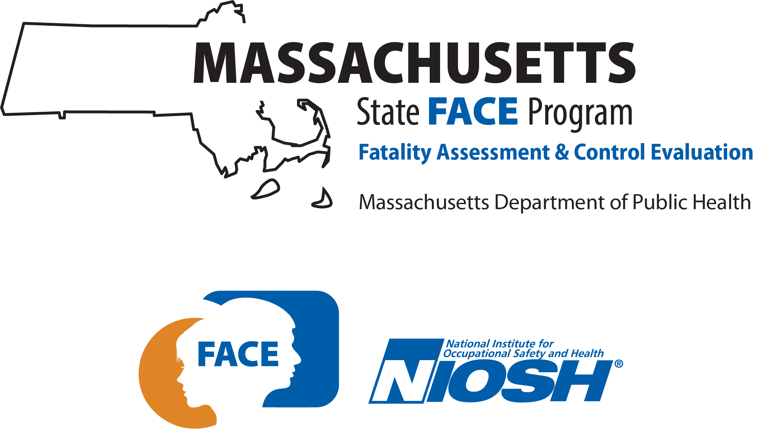](http://www.mass.gov/dph/face)

**Fatality Assessment and Control Evaluation (FACE) Program**

The Massachusetts Department of Public Health, in cooperation with the National Institute for Occupational Safety and Health (NIOSH), conducts investigations on the causes of work-related fatalities. The goal of this program, known as Massachusetts Fatality Assessment and Control Evaluation (Massachusetts FACE) is to prevent future fatal workplace injuries. Massachusetts FACE aims to achieve this goal by identifying and studying the risk factors that contribute to workplace fatalities, by recommending intervention strategies, and by disseminating prevention information to employers and employees.

NIOSH funded state-based FACE Programs currently include: California, Kentucky, Louisiana, Massachusetts, Michigan, New York, Oregon, and Washington.

[Email](mailto:ma.face@mass.gov) | [Website](http://www.mass.gov/fatal-work-related-injuries)



INTRODUCTION

An automotive mechanic working for a gas station and service garage was severely burned when a drum of flammable window washer fluid exploded as he was using the drum as a workbench for welding. The Massachusetts FACE Program learned of the incident from the local news media on the day of the incident, September 25, 2019. The Massachusetts FACE Program received notification from the Massachusetts Department of Fire Services that the worker had sustained burns to an estimated 75% of his body and was being treated at a regional trauma center on September 26, 2019. On November 6, 2019, a representative from the Office of the Chief Medical Examiner notified FACE that the worker had died from his injuries on November 5, 2019. On December 10, 2019, a representative from the Massachusetts FACE Program spoke with the owner of the gas station to discuss the incident. Several records were reviewed during the investigation. The records reviewed included local and state police reports; the reports from the state police unit assigned to the Office of the State Fire Marshal to investigate fires, explosions, and arson; the electronic death registration system; OSHA records; and information from the welder and window washer fluid manufacturers.

EMPLOYER

The employer owned the business and the property where the incident occurred. The property consisted of a gas station with a service station and snack shop. The station sold gasoline and diesel fuels and conducted annual state vehicle inspections and repairs. The employer operates several other gas or combination gas and service stations in the region, including a second service garage in the town where the incident occurred. The employer reported that the station where the incident occurred had one manager, three mechanics (including the victim), and a vehicle inspector at the site at the time of the incident. At least two other workers were at the site to pump gas and to work on vehicles inside and outside of the building. It is believed some of these workers also regularly worked at the employer’s other locations.

The regular work schedule for the manager and site mechanics, including the victim, is not known. The worker who conducted vehicle inspections was at the station part-time, for 20 hours each week.

At the time of the incident, the employer had workers’ compensation insurance. As required by Massachusetts law, all employers operating in Massachusetts are required to carry workers’ compensation insurance for their employees and for themselves if they are an employee of the company. The requirement applies no matter the number of hours worked or the number of employees. Employees of this company did not have union representation.

WRITTEN SAFETY PROGRAMS and TRAINING

At the time of the incident, the employer did not have a written comprehensive safety and health program. Workers were provided some basic training. Formal training was not provided to employees nor was the training documented. The training did not cover welding or hazardous materials. The employer did not have a written hazard communication program to train workers about chemicals located and used at the site, and the employer did not maintain copies of the safety data sheets (SDS) that describe each manufactured chemical. The SDS must be available at the site for worker training and followed to ensure safe work practices.

WORKER INFORMATION

The victim was a 64-year-old white non-Hispanic male who had been employed as a mechanic by the employer for 10 years at the time of the incident. He had worked at the service station since it opened. He had 30 years of previous experience as a mechanic working for other employers.

EQUIPMENT

The welder that was involved in this incident was an electric flux core arc welder (Figure 1). It was a portable plug-in unit that weighed 46 pounds. It used a specially designed consumable electrode (welding wire) to generate an electrical arc and high temperatures in order melt the electrode and fuse it to the piece being welded. The base unit plugged into a standard outlet and a transformer in the unit generated a 17-volt direct current charge at up to 88 amperes (Figure 2).

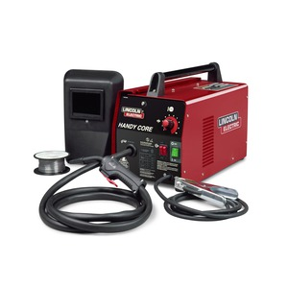 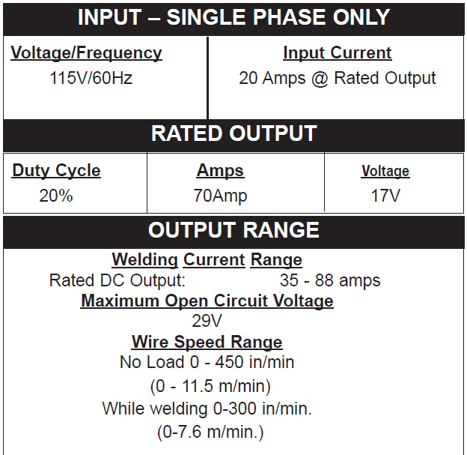

**Figure 1 – Flux core arc welder (manufacturer’s site) Figure 2 – Welder specifications, from manual**

The welder had two cables to complete the electrical circuit (Figures 1 and 3). A return cable had a clamp and would be attached to the work piece. This provided a pathway for the current to return to the base unit. The hot cable had a handle with a trigger switch that controlled a spool drive motor. The motor would push the flux core wire through the hot cable and out the tip of the handle. The electrical current would pass through the flux wire when it contacted the work piece and melt the flux core wire. Voltage, amperage, and spool/wire feed speed could be adjusted on the base unit to optimize the weld and the amount of flux wire used, creating a reliable weld. These settings could be adjusted depending on the work piece and the desired weld shape and style. The machine was designed to be able to weld steel up to 1/8” thick.

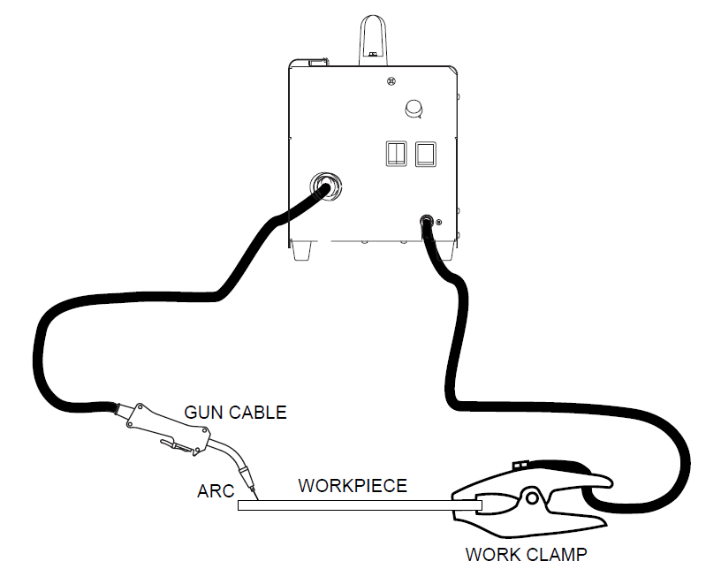

**Figure 3 – Flux core art welder cable diagram, from manual**

The use of this type of welder in Massachusetts, in this setting, requires that the local fire department be notified to inspect and approve the site as safe. If this procedure had been followed, an appropriate location for welding could have been identified. An employee properly trained as a welding supervisor would then have the authority to oversee welding work without additional permitting. These concepts are discussed further in the recommendations that follow.

INCIDENT SCENE

The facility (Figures 4 and 5) was in a residential area of town and was on a corner lot on a street that served as one of the main east/west routes in the town. The outdoor space is flat and mostly paved with asphalt and concrete. Dozens of vehicles were parked around the perimeter of the property. The building had two vehicle service bays, an inspection bay, and a snack shop/service office area. The two service bays had overhead doors that faced the gas pumps and intersection. The inspection bay was on the back of the building and was accessed from the southern side. This entry had an overhead door and there was also an exterior door on the northern side of the inspection bay and an internal doorway that connected to the service bays. The incident occurred in the vehicle service bay area. Both service bays had vehicle lifts and both bays were in use at the time of the incident.

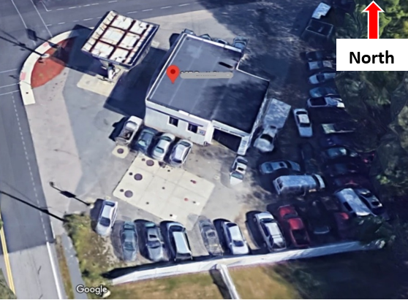

**Figure 4 – Gas and service station; the inspection bay entry is visible on this side of the building (image from google maps)**

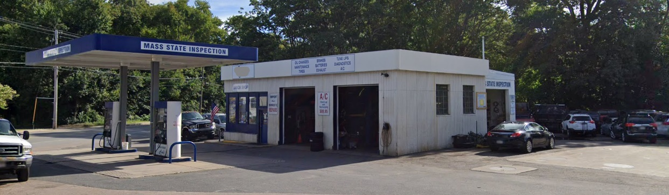

**Figure 5 – Gas and service station; the incident occurred at the rear of the service bays (image from google maps)**

WEATHER

The weather at the time of the incident was approximately 71 degrees Fahrenheit, 45% humidity, with a 12 miles per hour north-northwest wind, and fair skies. [[Weather Underground](https://www.wunderground.com/history)]. The weather is not believed to have been a factor in this incident.

INVESTIGATION

On the day of the incident, the victim was helping to repair a car in the left service bay. His time of arrival at the work site was not recorded. Other employees were pumping gas, inspecting vehicles in the inspection bay, and working on another vehicle parked outside of the building. The victim was working to remove the fuel pump from the car. To accomplish the task, he was constructing a special tool using an oil filter wrench and other metal. The employer described the production of model-specific tools as “routine” and indicated that this work would sometimes require welding custom tools directly onto the auto parts while still installed on the vehicles.

Several steel drums were stored along the rear wall of the service bay. At least one of these drums contained window washer fluid concentrate. The 55-gallon drum had two bung holes in the lid. One hole served as a vent and the other hole had a hand-operated pump and spigot. The workers used this window washer concentrate and diluted it with water for use at the station and to put into bottles for station customers. The drum and pump were supplied by a distributor and on the day of the incident the drum was nearly empty. A new drum was scheduled to arrive in the following days.

The victim set up a temporary welding station on top of the steel drum. As a coworker held the work piece in position the victim began to make spot welds to assemble the tool. The coworker was holding the piece with his arm extended and was facing away. It is unknown if either worker was using any protective equipment such as a face shield, gloves, and non-flammable clothing. The victim made one weld and was proceeding to make a second weld when the drum exploded.

The top of the drum blew off and the coworker holding the piece suffered a burned arm and facial trauma. He fled the garage as the washer fluid vapors had ignited and the fire began to spread. The victim was covered in burning fluid and was on the floor of the garage underneath one of the vehicles. Workers in the inspection bay and who had been working outside of the building heard the explosion and gathered outside. They realized the victim was still inside and reentered the building to drag him out. They used fire extinguishers to try to put out the flames on his body. His clothing eventually burned and was torn away to fully extinguish the flames on his body.

A resident of a home across the street was outside and heard the explosion and called 911. Several individuals in the area who heard the explosion also called 911. These calls went to a regional collaborative call center and were dispatched to assets in the town. Police were first to arrive, followed by the fire department and an ambulance dispatched from a neighboring jurisdiction. The victim was treated at the scene and driven by ambulance to a nearby airport and was flown by helicopter ambulance to a regional level one trauma center. He died six weeks later.

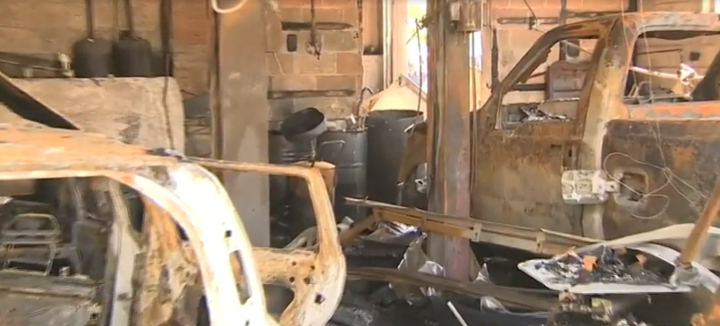

**Figure 6 – Garage after the fire was extinguished, from scene footage; drums along back wall are in the center of the picture.**

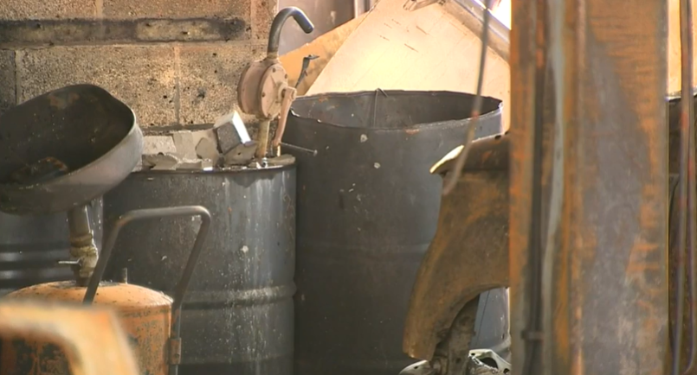

**Figure 7 – A drum with hand pump (left) and a drum with missing top, from scene footage.**

CAUSE OF DEATH

The medical examiner listed the cause of death as complications of thermal injuries.

CONTRIBUTING FACTORS

Occupational injuries and fatalities are often the result of one or more contributing factors or key events in a larger sequence of events that ultimately result in the injury or fatality. Massachusetts FACE investigators identified the following unrecognized hazards as key contributing factors in this incident:

* *Worksite lacked a proper welding station*
* *Welding in the vicinity of a drum containing flammable materials*
* *Lack of a safety and health program and overall safety training*

RECOMMENDATIONS/DISCUSSION

Recommendation #1: Employers should provide an appropriate location to perform welding work. All hot work should be a safe distance away from flammable and combustible liquids. Ensure workers using welding equipment are trained in the safe operation of their equipment.

Discussion: Welding uses electrical current or chemical reaction/combustion to create heat to melt and fuse materials. The high temperature, intense light (radiation), sparks, and fumes from the welded materials are hazards that need to be considered and controlled. Several agencies regulate the use of welding tools at workplaces. OSHA, NFPA, and state fire code all require hot work, including welding work, to be conducted in an appropriate location. It is the employer’s responsibility to ensure that the worksite is properly assessed to identify suitable locations to weld. This includes making sure the area is free of flammable materials, is ventilated to control fumes, is electrically safe, and that the workers are properly equipped with protective glasses or a face shield, appropriate gloves, and nonflammable protective clothing.

For this workplace, applicable regulations include those of the Federal Occupational Safety and Health Administration, and in particular [OSHA 1910](https://www.osha.gov/laws-regs/regulations/standardnumber/1910).252, Welding, Cutting and Brazing and 1910.106, Flammable liquids.2 1910.252 prohibits use of welding equipment:

In the presence of explosive atmospheres (mixtures of flammable gases, vapors, liquids, or dusts with air), or explosive atmospheres that may develop inside uncleaned or improperly prepared tanks or equipment which have previously contained such materials, or that may develop in areas with an accumulation of combustible dusts.

1910.106 describes proper ways to store flammable liquids in the workplace.

In Massachusetts, the local fire department is required to inspect and issue a permit for any location where welding work is to be performed [[Department of Fire Services](https://www.mass.gov/service-details/welding-cutting-other-hot-works)]. This includes fixed locations, like automotive service stations. Users of welding equipment are also required to complete training as indicated in the [Board of Fire Prevention: 527 CMR 1](https://www.mass.gov/regulations/527-CMR-100-massachusetts-comprehensive-fire-safety-code) Massachusetts Comprehensive Fire Safety Code. This code references National Fire Protection Association (NFPA) 2015 Fire Code and Massachusetts state amendments and requires specific training for users and qualified hot work supervisors and details the procedures for identifying and obtaining permits for welding locations. These regulations were updated to include additional protections and outreach and training initiatives were started at the state level in 2018 after a non-permitted welding fire in 2014 resulted in the deaths of two municipal firefighters. While the victim of this welding explosion had experience welding over a 30-year career as a mechanic, it is important and necessary to recognize and understand changes to regulations, and it is the employer’s responsibility to ensure workers are trained.

The employer described that the station had a welding area and bench or cart with a vise. Records reviewed indicate that this bench was used but also that welding work was performed directly on the vehicles, on the floor, and on top of the drums located in the garage. The presence of the flammable fluid containers in the workspace, and the presence of other flammable materials throughout the garage should have been identified by the employer and would have been identified by the local fire department had a permitting inspection occurred.

This fatal incident underscores the need to use welding equipment in a safe environment and to follow methods and procedures described in the operator’s manual or in applicable regulations. The operator’s manual contained specific information that prohibited use of the welder under the circumstances that led to this incident (Figure 8). Specifically, the welder should not have been used near flammable material or near closed containers. Appropriate and comprehensive training on use of the welder, incorporating the operator’s manual, could have identified these hazards and prohibitions.

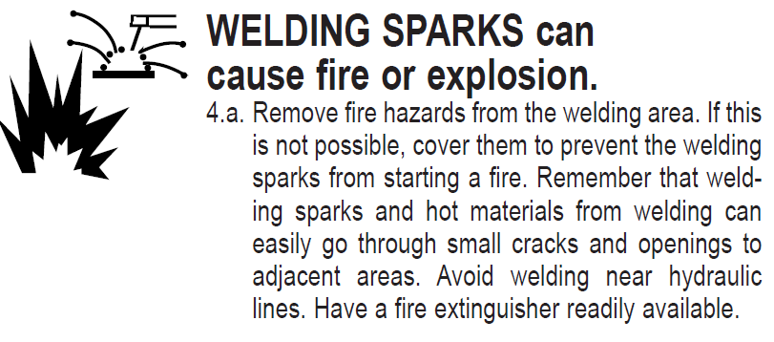 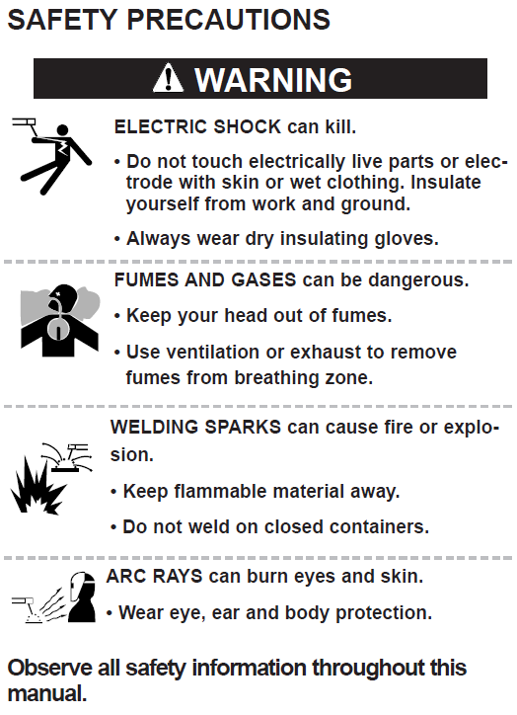 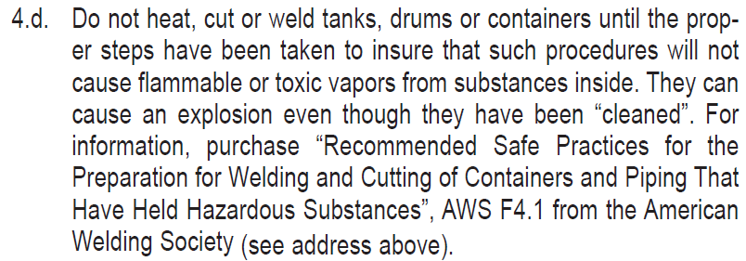

**Figure 8 – Safety precautions from operator’s manual**

Recommendation #2: Employers should ensure that all workers are properly trained about hazardous materials in the workplace.

Discussion: The 55-gallon drum of flammable window washer concentrate that exploded was properly labeled on the side and lid with Globally Harmonized System (GHS) pictograms indicating it contained a highly flammable liquid (Figure 9). It was reported that the employees did not have sufficient training to understand what this labeling meant. The Safety Data Sheet (SDS) for the material indicated it was >99% methanol with a balance of blue colorant and had a flash point of 11 degrees Celsius (52 degrees Fahrenheit), meaning the fumes escaping the barrel would have combusted in the presence of an ignition source.

One of the most cited OSHA standards is [29 CFR 1910.1200](https://www.osha.gov/dsg/hazcom/) Hazard Communication. This standard describes GHS chemical labeling, safe handling, use, and storage of chemicals in the workplace, and training. As described on the OSHA hazard Communication topic page:

All employers with hazardous chemicals in their workplaces must have labels and safety data sheets for their exposed workers and train them to handle the chemicals appropriately.

The employer did not properly train the workers about what chemicals were present at the site, how to store them, how to handle them, and how to respond to the fire involving the chemicals. The gas station was constructed at a time when station-wide fire suppression systems were not required. The station had four class A-B-C, 25-pound hand-held fire extinguishers that had just had their annual inspection. While workers at the station were able to shut off the fuel valves for the fuel pumps, all four extinguishers were used to try to put out the flames on the victim. This type of extinguishing media would have been effective and appropriate to extinguish the burning washer fluid on the victim. Because of how the chemicals were stored in the facility and because of other materials in the garage, the fire was able to spread very quickly and ultimately destroyed the building and caused a vehicle adjacent to the building to also catch fire.

It is worth noting that less-flammable and non-flammable window washing products are available. Elimination of the flammable products from the worksite by substituting a safer alternative is a preferred method to control this hazard.

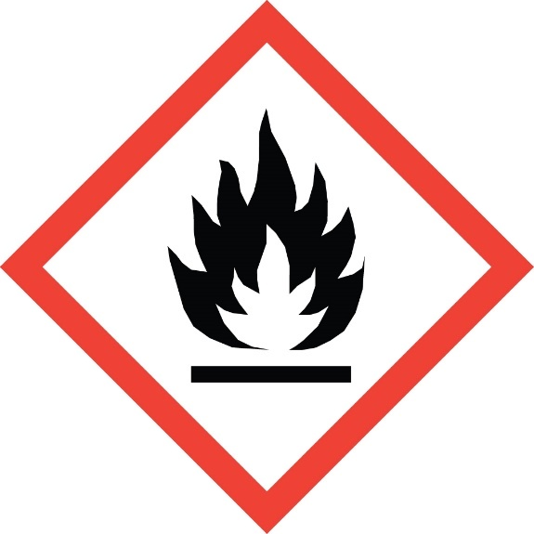

**Figure 9 – OSHA GHS flame pictogram for flammable liquid**

Recommendation #3: Employers should develop and implement a comprehensive safety and health program that addresses hazard recognition, avoidance of unsafe conditions, and proper use of equipment.

Discussion: Having a comprehensive safety and health program is essential to maintaining a safe workplace. A safety and health program should include the systematic identification, evaluation, and prevention or control of both general workplace hazards and the hazards of specific jobs and tasks. The core elements of an effective [safety and health program](http://www.osha.gov/shpguidelines/) are management leadership, worker participation, hazard identification and assessment, hazard prevention and control, education and training, and program evaluation and improvement. The program should outline safe work practices workers are expected to adhere to, specific safety protection for all tasks workers perform, how workers can identify and avoid hazards, and who workers should contact when safety and health issues or questions arise. The program should also include an explanation of the workers’ rights to protection in the workplace.

When developing a safety and health program, employers should start by performing a general hazard analysis of tasks routinely performed by employees. Those findings should be incorporated into the comprehensive program. Employers should also use their employees’ expertise throughout the program development process, and eventually during the updating process, by seeking employee input. Once the program is developed, employers should ensure that they have fully and effectively implemented their safety and health program by routinely performing assessments of tasks and immediately addressing any observed unsafe conditions. The program should also be updated when safety concerns arise and when new equipment, tasks and chemicals are introduced into the workplace.

Routine training should be provided to all employees on the program’s topics and procedures, and the training should also include hazard recognition and the avoidance of unsafe conditions. All training provided to employees should be documented. Training ensures that workers know how to safely perform required job tasks. Trainings should be performed by a competent person, which is defined by OSHA as “one who is capable of identifying existing and predictable hazards in the surroundings or working conditions which are unsanitary, hazardous, or dangerous to employees, and who has authorization to take prompt corrective measures to eliminate them.” Any training needs to be provided in the employee’s preferred language. This means the training must be provided in the language(s) and at the literacy level(s) of the employees.

The Massachusetts Department of Labor Standards (DLS) offers free consultation services to help small employers improve their safety and health programs, identify hazards, and train employees. DLS can be contacted at 508-616-0461. More information about DLS can be found on their website at www.mass.gov/dos/consult.

The Massachusetts Department of Industrial Accidents (DIA) has grants available for providing workplace health and safety training to employers and employees. Any company covered by the Massachusetts Workers’ Compensation Insurance Law is eligible to apply for these [grants](http://www.mass.gov/dia/safety).

ADDITIONAL RESOURCES

OSHA, [Safety and Health Topics: Welding, Cutting, and Brazing](https://www.osha.gov/SLTC/weldingcuttingbrazing/standards.html).

OSHA, [Hazard Communication](https://www.osha.gov/Publications/OSHA3695.pdf): Small Entity Compliance Guide for Employers That Use Hazardous Chemicals. OSHA Publication 3695.

MDPH, [Massachusetts FACE investigation report #00MA042](https://www.cdc.gov/niosh/face/stateface/ma/00ma042.html), Massachusetts Mechanic Killed When A 55-Gallon Drum Exploded.

University of Iowa, [Iowa FACE investigation report 98IA045](https://www.cdc.gov/niosh/face/stateface/ia/98ia045.html): Arc welder dies in explosion while using an old barrel as a worktable.

Michigan State University, [MIFACE investigation report #10MI032](https://www.cdc.gov/niosh/face/pdfs/10MI032.pdf): Sewer Administrator Died When Chop Saw Spark Caused a 55-Gallon Drum to Explode.

Northwest Territories WorkSafe: [Hazards of cutting empty drums](https://worksafe.nt.gov.au/forms-and-resources/bulletins/hazards-of-cutting-empty-drums).

National Fire Protection Association, NFPA 326: Standard for the Safeguarding of Tanks and Containers for Entry, Cleaning, or Repair.

DISCLAIMER

Mention of any company or product does not constitute endorsement by Massachusetts FACE and the National Institute for Occupational Safety and Health (NIOSH). In addition, citations to websites external to Massachusetts FACE and NIOSH do not constitute Massachusetts FACE and NIOSH endorsement of the sponsoring organizations or their programs or products. Furthermore, Massachusetts FACE and NIOSH is not responsible for the content of these websites. All web addresses referenced in this document were accessible as of the publication date.

REFERENCES

Weather Underground. [Weather History](https://www.wunderground.com/history). Massachusetts: TWC Product and Technology LLC.

OSHA Code of Federal Regulations. [29 CFR 1910 Q](https://www.osha.gov/laws-regs/regulations/standardnumber/1910). Welding, Cutting and Brazing and H. Hazardous Materials.

Massachusetts Executive Office of Public Safety and Security, [Department of Fire Services](https://www.mass.gov/service-details/welding-cutting-other-hot-works). Welding, Cutting & Other Hot Works.

Code of Massachusetts Regulations, [Board of Fire Prevention: 527 CMR 1](https://www.mass.gov/regulations/527-CMR-100-massachusetts-comprehensive-fire-safety-code) Massachusetts Comprehensive Fire Safety Code

OSHA Code of Federal Regulations. [29 CFR 1910.1200](https://www.osha.gov/dsg/hazcom/). Hazard Communication

OSHA. [Recommended Practices](http://www.osha.gov/shpguidelines/) for Safety and Health Programs.