Autumn 2023 2022
First Do No Harm

Quality & Patient Safety Division Massachusetts Board of Registration in Medicine

In This Issue
- Message from the QPSD
Leadership
- The Betsy Lehman Center
3 Beth Israel Deaconess Hospital - Needham
5 Brigham and Women’s - Faulkner Hospital
- Newton-Wellesley Hospital
7 QPS Committee Conference

Message from QPSD Leadership
Booker T. Bush, MD Daniela Brown, MSN, RN, CIC
Chair, Quality & Patient Safety Committee Director, Quality & Patient Safety Division

Dear Colleagues,

American writer Sharon Salzberg has written about the power of compassion and has been quoted as saying, “Resilience is based on compassion for ourselves as well as compassion for others.” The past few years have tested the resilience of our healthcare workers. Healthcare workers are experiencing significant stress, anxiety, exhaustion, and morale fatigue. They have struggled, and they are tired.

Throughout the struggle, there have been signs of light. Programs have been created to support our caregivers. Colleagues are helping colleagues. Friends are helping friends. There is a desperate need for care and kindness for our fellow healthcare workers. The people who have done the caring, need to be cared for. It is often our own peers that can understand us best. Programs throughout the Commonwealth have recognized that peer support can be beneficial for both the individuals receiving and the individuals providing support.

The Betsy Lehman Center has been one of the leading organizations in the Commonwealth to provide a path for peer support for clinicians, staff, and organizations. Betsy Lehman Center | Peer support for the medical community (betsylehmancenterma.gov). Several healthcare organizations have collaborated with the Betsy Lehman Center and other organizations to support their clinicians. We are pleased to share a few of their stories.

September also ushered in a significant transition for the Quality & Patient Safety Division (QPSD). On September 1, 2023, the QPSD launched its much-anticipated online reporting portal. Online reporting, in conjunction with the recently approved new Patient Care Assessment (PCA) policy Patient Care Assessment (PCA) Policy - September 2023 | Mass.gov, will provide for more efficiency and reduce the administrative burden of reporting to the QPSD. All reports must now be submitted via the online portal unless an exemption has been granted. The QPSD has several resources to assist healthcare facilities in meeting their reporting requirements.

Please visit the QPSD website for educational materials, including an instructional video, and more information regarding the online reporting portal at Patient Care Assessment Program | Mass.gov

Finally, the QPS Committee hosted an in-person, all day quality and patient safety conference on September 22, 2023. The conference featured case studies based upon the event categories most reported to the QPSD in 2022 (diagnosis/treatment, procedures, behavioral health, obstetrics, and medication/fluid). Many thanks to those who attended the event in Worcester and to UMass Memorial Health who provided the venue and lunch for our 242 registered participants. Photographs of the event may be found on page seven.

Best regards,

Booker and Daniela

Ldlddldd

Dddd

The Betsy Lehman Center
Virtual Peer Support Network Helps Clinicians and Staff Throughout the State
Linda K. Kenney
Director for Peer Support Programs

For more than a decade, hospitals in Massachusetts and beyond have established peer support programs for clinicians and staff who want help after they have been involved in a patient harm or other traumatic event.
But what about people who work in hospitals or other settings that do not have a peer support program available?
The Betsy Lehman Center for Patient Safety now offers a statewide Virtual Peer Support Network. To date, 22 volunteers have been trained to be on the other end of a call, text, or video chat to help their peers through a difficult time. The Network is free and confidential. Requests for this unique form of 1:1 support can be made by calling 617-701-8101 or using this form. The peer supporters include physicians from different specialties, nurses, pharmacists and more.
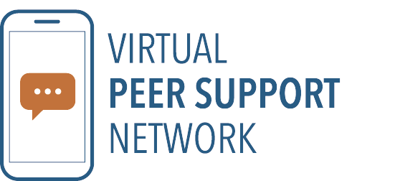
To help spread the word about the network, the Center is also partnering with health care organizations interested in ensuring that members of their workforce are aware of the opportunity to get help from a peer. Several are currently working with the Center to “co-brand” and promote the network among their clinicians and staff. Most of those same organizations are also soliciting volunteers to be trained to help peers, inside the four walls of their institution and beyond.
The Center’s peer support team is also available to assist organizations interested in building their own peer support program or a virtual network. The Center helps with planning, implementing, training, and tracking.
The Virtual Peer Support Network stems from a commitment to ensure there is access to peer support resources for all who are working in health care in the Commonwealth.

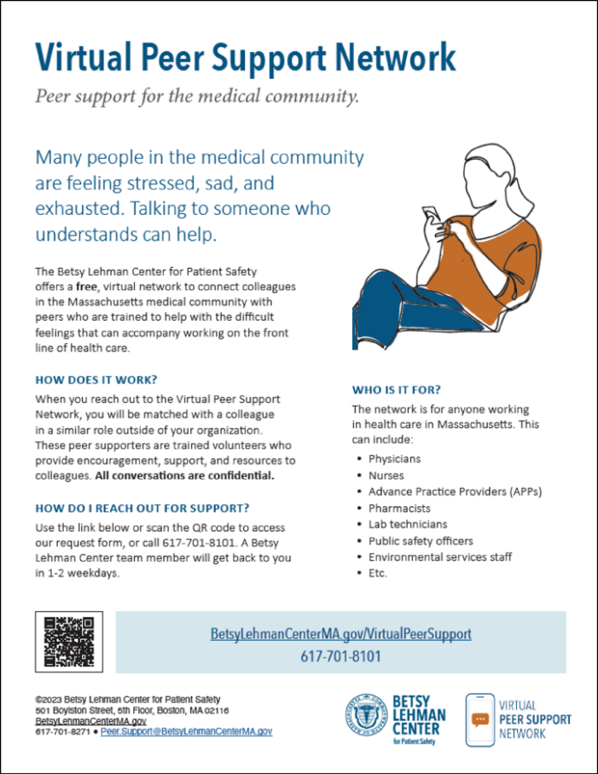
In 2018, the Center launched a pilot to help 13 hospitals establish peer support programs within their institutions using a model developed at Medically Induced Trauma Support Services (MITSS) and learned a tremendous amount from the pilot. Success was most often tied to support for the program from a senior leader, a dedicated administrative person overseeing the pilot and an engaged advisory committee at the hospitals.
It also became clear that the smaller organizations did not have the bandwidth to run a program. The Virtual Peer Support Network was borne of a desire to find a way to assist the smaller, under-resourced hospitals as well as small office practices, community health centers, and ambulatory surgical centers and reach a broader range of the health care workforce.
The original blueprint for the peer support pilot included a research component, namely a baseline survey about experiences with medical harm and other traumatic events followed by a second survey one year after the implementation of a peer support program.
Unfortunately, the COVID-19 public emergency disrupted plans to re-survey the hospital programs, but results from the baseline survey can be found at Betsy Lehman Center | Peer support baseline data report (betsylehmancenterma.gov).
At the same time, the pandemic opened new opportunities for outreach as everyone became more familiar and comfortable using Zoom, Web-Ex, MS Teams, and FaceTime to virtually meet and speak with others. The pandemic also underscored the need for support services within the medical community while also making it more acceptable to seek help.
The Massachusetts Virtual Peer Support Network is still in its infancy but has strong potential to make a difference for members of the medical community who are quietly trying to cope with difficult feelings about their work. Please consider volunteering as a peer supporter or spreading the word about the Network to your colleagues. Contact the Betsy Lehman Center peer support team at 617-701-8101 and explore the opportunities to help!
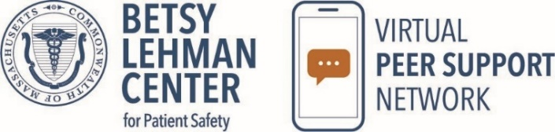

Beth Israel Deaconess Hospital - Needham
Peer Support Program Makes a Difference: Lessons Learned
Heidi Alpert RN, MS., Senior Director, Clinical Services, Education and Development
Laura Garelick MD., Chief, Family Medicine

When supporting a peer, the following question may be useful to ask of someone experiencing difficult circumstances: “If you were speaking with a friend in your situation, what might you say?” For those of us who work in healthcare, this question taps into our commitment and kindness to others in order to be more compassionate toward ourselves. At Beth Israel Deaconess Hospital Needham (part of Beth Israel Lahey Health), a 73-bed acute care community hospital, the development of our peer support program has helped create a culture of mutual support, decreasing isolation and increasing learning from a range of challenges. Our program started in 2018, when groups of medical staff were trained as peer supporters due to their strong interest in combatting clinician burnout and enhancing hospital safety.

In January 2021, we collaborated with the Betsy Lehman Center to create a roadmap to expand our peer support program to cover all staff in the hospital. They led our peer support training for staff supporters from across our hospital departments. One important role required in this roadmap, which we had not previously incorporated in 2018, was the role of the Peer Support Project Coordinator. This individual has been crucial in overseeing the deliverables of our program including assisting with the recruitment of peer supporters and advisory committee members, tracking our peer support outreaches, providing administrative support in coordinating meetings and taking minutes during the various meetings. The second requirement was to create a Peer Support Advisory Committee to oversee the implementation of the expanded program. This committee meets quarterly and includes varied hospital leaders.
All staff are eligible to receive peer support, so we gathered representatives from all departments, nominated by their peers, to be trained as peer supporters. Peer Supporters meet quarterly to receive ongoing education and support. Our Peer Supporters are also trained in our local and system wellness resources.
Outreach can be requested through confidential email or via message to those of us who manage the program. Staff are referred to peer support by their managers, by peers or can self-refer. We also actively reach out to offer peer support after situations where staff experience verbal or physical injury or any other adverse event. We track all outreaches confidentially. Once an outreach is completed, the peer supporter is asked to complete a brief template survey so that we can keep abreast of trends. (Table 1).

Table 1 Peer Support Outreach Template
Peer Support Outreach:
- Date of Outreach
- Initial Outreach or a Follow-up
- In Person or by Phone
- Referred by Self, Peer or Manager
- Department of Person Receiving Support (no names)
- Role of Person Receiving Support (no names)
- Peer Supporter
- Type of Issue
- Resources Offered if any
- Comments

During the first year of our expanded program Peer Support Program, we saw the highest usage for work/interpersonal relationships, provider burnout and feelings of being overwhelmed, unexpected patient outcomes and assaults. (Table 2)
Questions and comments regarding this newsletter may be directed to:
Mali Gunaratne
Program Coordinator
Quality & Patient Safety Division
Massachusetts Board of Registration in Medicine

mali.gunaratne@mass.gov

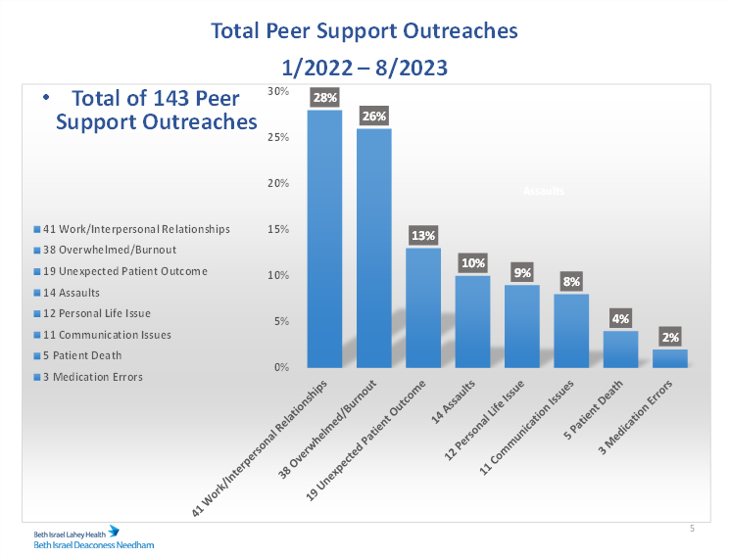
Table 2 Peer Support Outreaches

Nurses, physicians, and technologists were the roles that were seeking the most support. (Table 3) The emergency department, radiology, medical surgical units, and medicine were the departments utilizing the program most frequently. (Table 4) Radiology has a very active trusted peer supporter in the department, which may attribute for the higher usage. Self-referral remained the highest mode of referral.
Table 3 Peer Support Outreaches by Roles
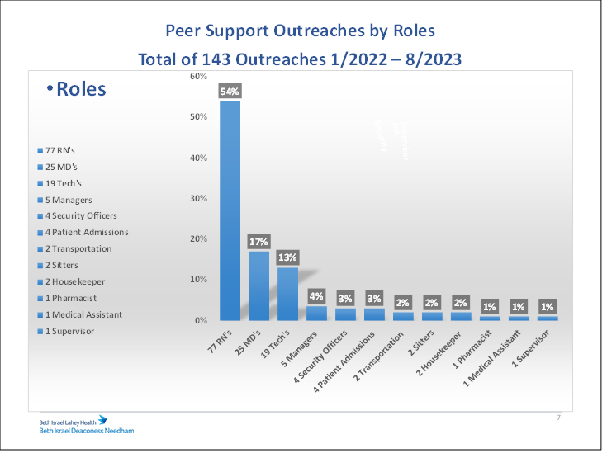

Table 4 Peer Support Outreaches by Department
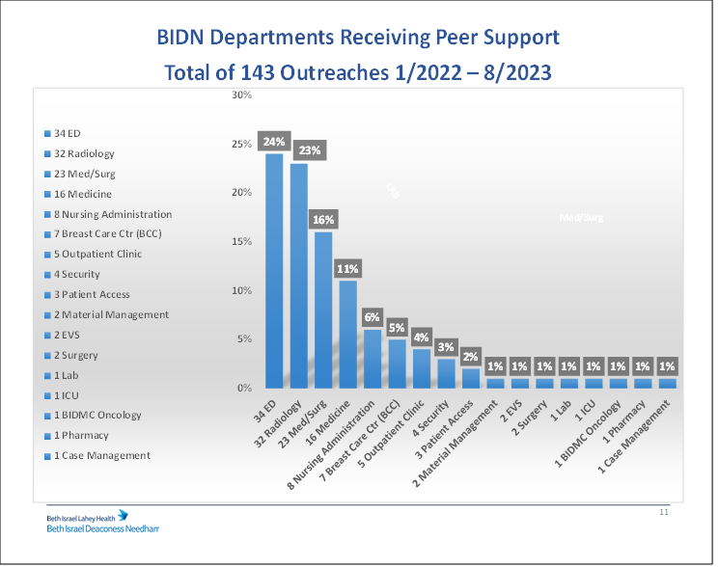

Trending our data allows us to identify the types of issues triggering the need for peer support and the needs for further education of the peer supporters, on topics such as post physical and emotional injury support, DEI, and practice on reflection and asking open-ended questions.
Peer support is clearly making a difference as evidenced by its growth over time, its utilization of over 143 outreaches from January 2022 to August 2023, and the positive comments we have received from staff. Two examples of such feedback:
RN: “I am reaching out because I was referred to this program two weeks ago and I feel like it really helped me to process my emotions. I was wondering if I would be able to speak to someone again. I really think this program helped me last time I talked to someone.”
Technologist: “I felt so much better after talking with a peer supporter. I was feeling so horrible about what happened. Being able to talk to someone and receive reassurance was invaluable.”
The successful launch of our expanded Peer Support Program was the result of many factors. We continue to receive formal referrals, and we have now pivoted to focus on informal outreaches to meet staff needs in the moment. This “in the moment” support is now our highest volume of outreaches. Having peer supporters in various departments throughout the hospital makes it feasible to do these informal outreaches. Because of our smaller hospital size, we were able to expand in a few months. Support from our CEO and CNO was important for our successful implementation. The key positions of peer support coordinator and program manager were incorporated into existing roles.

Physician and hospital collaboration and partnership were also crucial to our success. Having both a hospital and physician leader for our program made it possible to keep our finger on the pulse of all disciplines. Peer support was a good platform to introduce our wellness resources. Peer Support is one piece of our workforce development initiatives, which focus on employee and physician wellbeing. The unexpected outcome of our Peer Support Program in conjunction with these initiatives was improved nurse retention. Plans are now underway to look at peer support throughout the Beth Israel Lahey Health system to ensure this important program is available to all staff.
Heidi Alpert RN, MS. at halpert@bidneedham.org
Laura Garelick, MD. at lgarelic@bidneedham.org

Brigham and Women’s Faulkner Hospital
It Takes a Village: Brigham Family Peer Support
Beth Uhl-Israel, Director of Risk Management

At Brigham and Women’s Faulkner Hospital, providing support to our colleagues after an adverse event or unexpected death occurs is as important as conducting a thorough case review. After an event occurs, the care team huddles on the unit to debrief and support colleagues involved in the event. Our leaders understand that staff who are impacted may need to take time and space before caring for other patients.

A resource available to members of the Brigham Faculty and Physician Associates/Assistants is the Peer Support Program. The program has been active for approximately 20 years. Part of their work is learning how perseverance and resilience – character traits that serve the best doctors – can also be traits that might prevent doctors from reaching out for help if it is needed. Understanding those barriers to seeking and accepting support is ongoing work.
The Peer Support Program is often the point of connection between clinicians affected by an event and colleagues who have had similar experiences. The Program has about 200 trained Peer Supporters who can be matched by discipline. Thought is also given to seniority and experience during the matching process.

Providing a comprehensive training program for the peer supporters is key. Beyond the initial training, quarterly meetings to support the supporters and monthly email check-ins are key to the program’s enduring success. The Peer Support program partnered with the Faculty and Trainee Mental Health Program to present leading practices in peer support: active listening, emotional support, and validation. During the height of the COVID-19 pandemic, Zoom group sessions were well attended. Another important feature of the Peer Supporter training is helping supporters understand that it is not their role to conduct a case review but be there only to listen and understand.

Other times, peer support is less formal. The BWFH Department of Medicine reviewed an event last year in which the Chief of Medicine provided support to an experienced attending physician who was deeply affected by the outcome. Together, they prepared to meet with the family to discuss the clinical care, decision-making, and autopsy findings. Equal time was spent in those prep meetings, ensuring that the physician was kept apprised of the status of the case review as well as providing support and understanding. After the family meeting, the physician noted that ongoing support throughout the process ensured a successful meeting and helped provide closure for the family.

When a patient or family initiates legal action, feelings of shame and guilt can be complicated by fear. The legal process can be confusing and isolating. The Risk Management teams at Brigham and Women’s and Brigham and Women’s Faulkner are present in the hospital to support physicians and PAs. Risk will connect them with the resources provided by the Controlled Risk Insurance Company Organization and Risk Management Foundation (CRICO/RMF) team. Every CRICO Claims Manager is extremely skilled in malpractice litigation and can answer questions about the legal process and what to expect, such as: discovery, expert witnesses, settlement, and trial.
The Brigham Family knows that the best way to heal patients is through teamwork. The Brigham and Women's Faulkner Hospital “About Us” page on our public-facing website reads, “When our employees feel supported our patients benefit from their transparency, creativity, and innovation because we are all in this together. And together, we all thrive”.

Newton-Wellesley Hospital
Peer 2 Peer Support Program
Audrey Bosse
Director, Office of Experience & Engagement

At Newton-Wellesley Hospital, we recognize the unique emotional challenges that come with working in healthcare and the importance of supporting our clinicians and staff. Adverse events can happen in both our staff’s professional and personal lives. Peer Support programs enable staff to better assist one another, and they encourage a culture of support.

In the fall of 2019, the hospital partnered with the Betsy Lehman Center and piloted a successful Peer 2 Peer (P2P) Support Program with the Emergency Department. Not only did it help staff to cope with difficult events prior to COVID but, because it was in place, the staff had a well-thought-out and tried plan on how to give and receive support during the pandemic, making the crisis at least a bit less challenging and bringing the team even closer together.

As the pandemic continued, we quickly realized that we needed to expand this essential program throughout the hospital. Our teams were working tirelessly to deliver the best care to our patients and community, and the emotional toll it was taking was palpable. Between 2019 to-date, we have expanded the P2P Support Program to include both clinical and non-clinical staff across a variety of disciplines in over 16 different areas, and we have trained over 150 peer supporters.

One concern is the fear of litigation, which discourages providers from communicating with patients or their colleagues. They are left feeling isolated and unsupported, so a peer support program can make a world of difference, offering emotional support and eradicating stigma. We need to normalize when staff feel upset and help to reduce their stress so that they can feel healthy and be able to return to work. If there is a professionalism concern, Newton-Wellesley will offer a peer supporter to the person involved. Having a peer support program is key to clinician and staff well-being.

The Joint Commission encourages leaders to make support systems available for staff who have been involved in an adverse or sentinel event. “We recommend that institutions house a peer support program in the QA division. This might include language in the ‘Response to adverse events’ policy. The idea is that support is part of a response to adverse events in order to get the clinicians (and staff) emotionally healthy so they can be the best version of themselves. This would hopefully protect it. It has never been challenged in court, but there would be a good argument”.

We promoted the P2P Program through a variety of messaging channels, including on our website, in broadcast messages, in leadership meetings and, crucially, in one-on-one conversations with area leaders. We would approach areas where we knew had either high patient acuity, or staffing challenges, to gauge interest. There was a unanimous recognition of the value of having this kind of support in place, but the timing was critical as sometimes staffing challenges were an impediment.

Planning for the launch of a P2P rollout on a particular unit begins at least 3-4 months in advance. We start by meeting with unit leaders, usually a physician, nurse, and administrative leader, to explain the Program and time commitment. The Program falls under the Office of Experience & Engagement, and as the Director, I lead the administrative aspects of the program in addition to participating in the trainings. As Director, I will draft the email from local leaders to their teams to launch the Program, and include a link to a one question survey asking: “Following a stressful event or incident at work, who in your department would you turn to for support or comfort?” By understanding who staff naturally go to for peer support, we can identify the individuals staff most trust and would feel most likely to turn to for support in a time of need. The P2P program enables us to enhance the skills of these natural leaders. Area/unit leaders reviewed the staff survey results to ensure that those ultimately selected to go through the P2P training were most likely to succeed and be effective.

The commitment for a nominated peer supporter is as follows:

• Attend one virtual peer support training session.
• Be willing to provide peer support if contacted by a peer, with recognition that there will be times when the peer supporter is unavailable.
• Participate in quarterly peer support team meetings to discuss, confidentially, peer support interventions so that peer supporters can learn from each other.

Given the number of peer supporters who have been selected, we explain to those nominated that we do not believe the individual time commitment will be excessive.
We hope that they consider this role as adding to their productivity in the realm of citizenship. The experience should be personally enriching as we develop a community of peer supporters who continue to learn and grow together.

After staff are trained, we list their names on our Intranet site, as well as provide laminated signs to each area to be posted in breakrooms so that staff will have names handy when support is needed in real time.

As there can be quite a bit of time between the training and when a supporter would be approached by a peer in need, we host periodic organization-wide drop-in sessions to “support the supporters.” In these meetings we discuss, anonymously, some of the topics around which need support. We review best practices around what to say in the moment, provide encouragement to our peer supporters, and ask how they are coping. We also post resources, including webinars and articles, on our Intranet, and will research if someone needs more information on a specific topic.

We would not have been able to bring the P2P Support Program to the many units and practices throughout our organization without the buy-in of our leadership team. We
encouraged leaders to go through the training so that they could fully understand the Program’s benefits and thereby fully support it. Many leaders were eager to enroll in the training to help enhance their skills when supporting their teams through a difficult event or time in their lives.

The broad, and continuously expanding, reach of Newton-Wellesley Hospital’s Peer 2 Peer Support Program has been recognized as strengthening our organization’s culture of support and gratitude, and aligns with our mission to treat our patients – and each other – as beloved family members. The Department of Surgery devoted a Grand Rounds on how peer support is helpful to staff involved in a sentinel event. Dr. Frederick (Rick) van Pelt of the University of Alabama at Birmingham, and Linda Kenney of the Betsy Lehman Center, joined us to share their story. It was powerful and moving and could not have demonstrated better the impact of a peer support model.

Quality & Patient Safety 2023 Conference
The QPSD hosted a full day, in person educational event on September 22, 2023. Many thanks to UMass Memorial Health who provided the venue and lunch for our 242 registered participants!

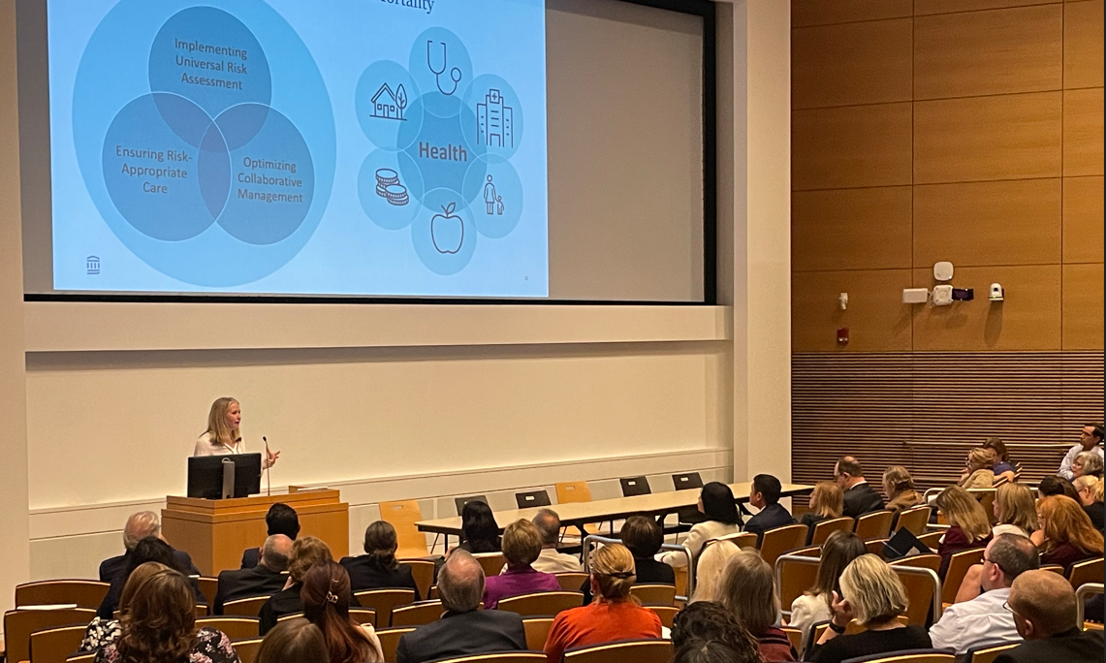
1

3


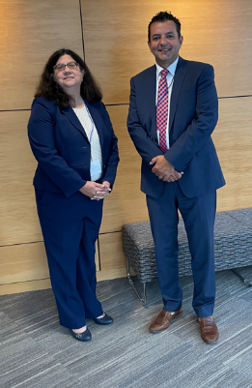

5
4

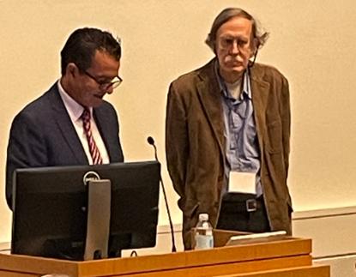

(1) QPS Committee Physician Member, Dr. Arthur Lauretano; (2) QPS Committee Vice Chair, Dr. Yvonne Y. Cheung and Chair, Dr. Booker T. Bush; (3) QPS Committee Physician Member, Dr. Sarah Rae Easter; (4) BORIM Executive Director George Zachos and General Counsel Vita Berg; (5) BORIM Chair and QPS Committee Physician Member, Dr. Julian N. Robinson and BORIM Physician Member and QPS Committee Chair, Dr. Booker T. Bush; (6) UMass Memorial Health’s Dr. Kimi Kobayashi, Janell Forget, and Dr, Spiro Spanakis; (7) BORIM Executive Director George Zachos and Brigham & Women Hospital’s Dr. Gordon Schiff; (8) QPS Committee Member, Audrey Bosse and QPS Committee Physician Member, Dr. Melissa Sundberg

7

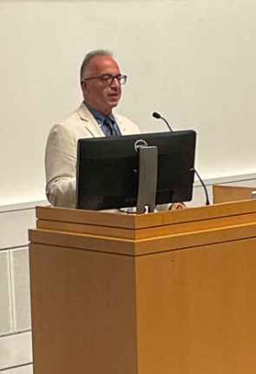
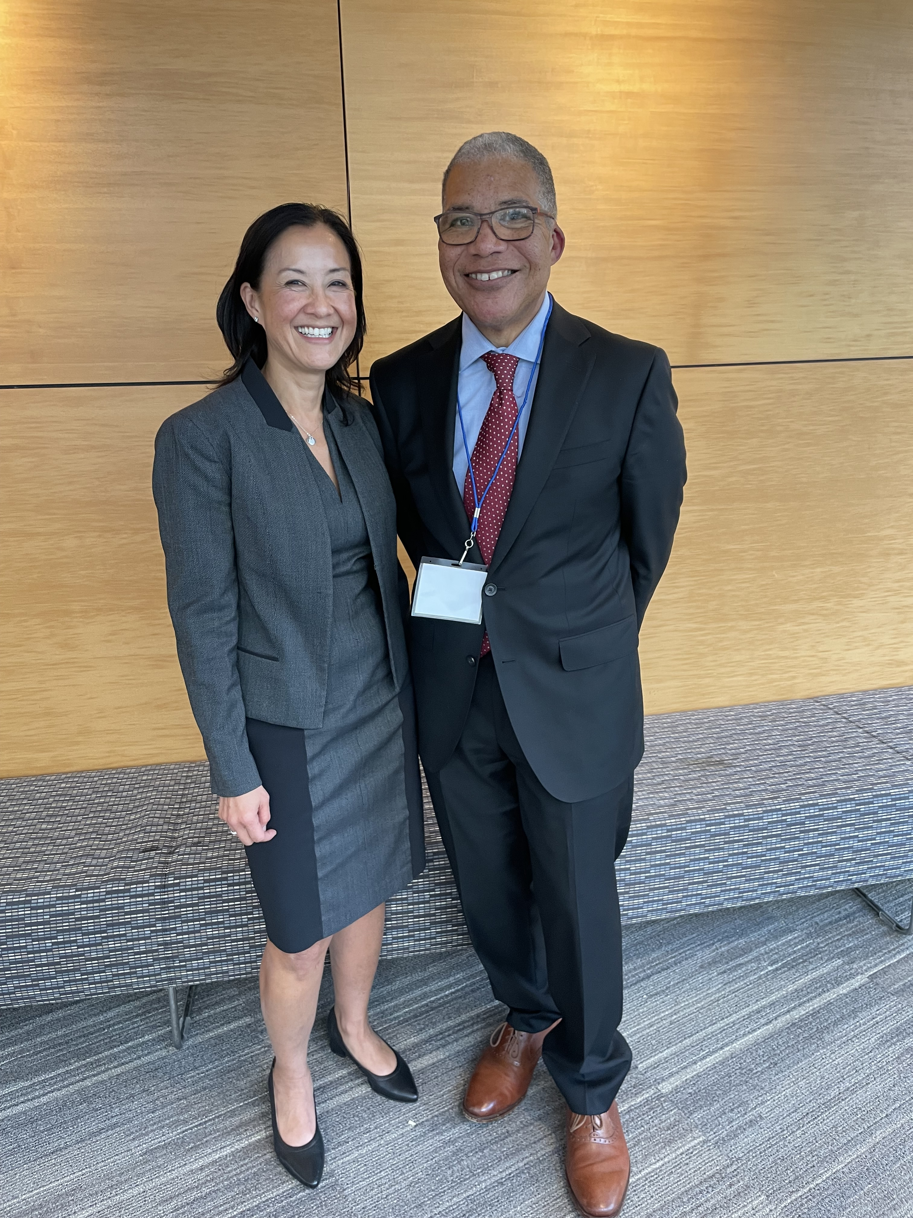

2

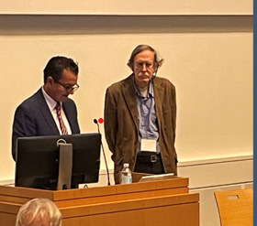

This newsletter is issued by the Board of Registration in Medicine (BORIM), Division of Quality and Patient Safety (QPSD). The newsletter allows BORIM to share the practices and experiences of the healthcare clinicians and facilities that report to the Board. It does not necessarily include a comprehensive review of literature. Publication of this newsletter does not constitute an endorsement by the BORIM of any practices described in the newsletter and none should be inferred.

6

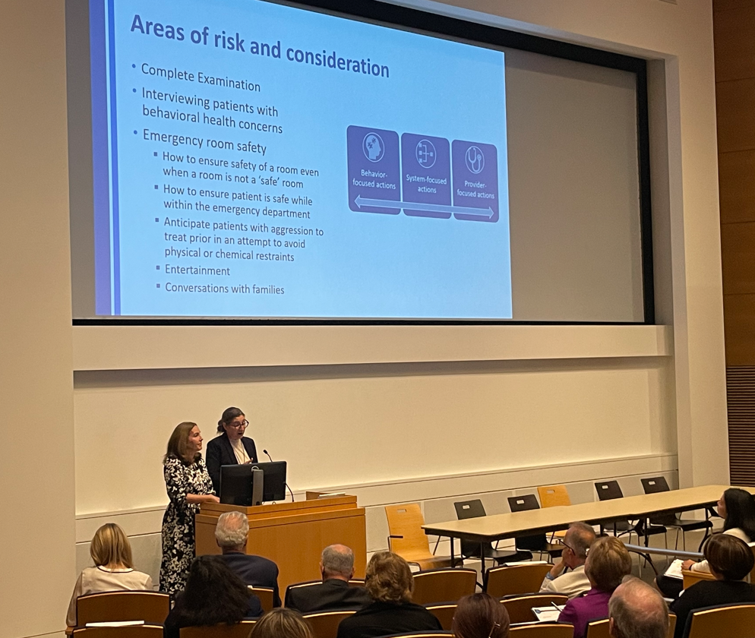

8

