INDOOR AIR QUALITY ASSESSMENT

Ayer District Court
25 East Main Street
Ayer, Massachusetts

Prepared by:
Massachusetts Department of Public Health
Bureau of Environmental Health
Indoor Air Quality Program
December 2018

Background
Building: | Ayer District Court (ADC)
Address: | 25 East Main Street, Ayer, MA
Assessment Requested by: | Mike Lane, Administrative Office of the Trial Court
Reason for Request: | General indoor air quality (IAQ) assessment
Date of Assessment: | July 20, 2018
Massachusetts Department of Public Health/Bureau of Environmental Health (MDPH/BEH) Staff Conducting Assessment: | Michael Feeney, Director, IAQ Program
Building Description: | Two-story brick/masonry building with occupied basement built in 1969
Building Population: | Approximately 30-40 employees, with up to several hundred members of the public visiting daily
Windows: | Openable

Methods
Please refer to the IAQ Manual for methods, sampling procedures, and interpretation of results (MDPH, 2015).

IAQ Testing Results
The following is a summary of indoor air testing results (Table 1).
- Carbon dioxide levels were below the MDPH guideline of 800 parts per million (ppm) in all but one area assessed, indicating adequate air exchange in most of the building.
- Temperature was within or close to the recommended range of 70°F to 78°F in areas assessed (Table 1).
- Relative humidity was within or close to the recommended range of 40% to 60% in areas assessed.
- Carbon monoxide levels were non-detectable in all areas assessed.
- Fine particulate matter (PM2.5) concentrations measured were below the National Ambient Air Quality Standard (NAAQS) level of 35 micrograms per cubic meter (μg/m³) in all areas assessed.

Ventilation
A heating, ventilating and air conditioning (HVAC) system has several functions. First it provides heating and, if equipped, cooling. Second, it is a source of fresh air. Finally, an HVAC system will dilute and remove normally-occurring indoor environmental pollutants by not only introducing fresh air, but by filtering the airstream and ejecting stale air to the outdoors via exhaust ventilation. Even if an HVAC system is operating as designed, point sources of respiratory irritation may exist and cause symptoms in sensitive individuals.
Fresh air to the ADC is provided by an HVAC system located in a mechanical space through ducted vents. Fan coil units (FCU) in rooms recirculate air, filter it, and provide heating and cooling but do not provide a source of fresh air (Picture 1).
Of note were concerns regarding dust and debris building up on flat surfaces (Picture 2). The HVAC system was originally equipped with a filter system that was mounted on rollers that slowly unrolled the filter medium over the opening to the AHU coils. The roller system is operating. Filter medium is currently cut from bulk rolls and placed over the opening to the AHU coils. This filter system provides minimal filtration of outdoor air with the filter in place, and no filtration if the filter is not in place. In addition, the filter medium needs to be physically cut to size which may be subject to poor fit. MDPH recommends tight-fitting filters of a Minimum Efficiency Reporting Value (MERV) of 8, which are adequate in filtering out pollen and mold spores (ASHRAE, 2012). Lack of filtration would likely account for the noted dust and debris on flat surfaces reported by building occupants.
It is also important to note that the HVAC system is nearly 50 years old. Efficient function of equipment of this age is difficult to maintain, since compatible replacement parts are often unavailable. According to the American Society of Heating, Refrigeration and Air-Conditioning Engineering (ASHRAE), the service life for the various componenets of the HVAC system is between 20 to 30 years, assuming routine maintenance of the equipment (ASHRAE, 1991). Despite attempts to maintain the equipment, the optimal operational lifespan of this equipment has been exceeded.

Microbial/Moisture Concerns
Water-damaged ceiling tiles and ceiling plaster were observed in a few areas. One area had water-damaged paint on plaster colonized with mold (Picture 3). This condition indicates the existence leaks from the building envelope or plumbing system that should be repaired. The United States Environmental Protection Agency (US EPA) and the American Conference of Governmental Industrial Hygienists (ACGIH) recommend that porous materials be dried with fans and heating within 24 to 48 hours of becoming wet (US EPA, 2008; ACGIH, 1989). If porous materials are not dried within this time frame, mold growth may occur. Once mold has colonized porous materials, they are difficult to clean and should be removed and discarded.
Of note were floor drains in several locations in the basement, in particular two records rooms as well as the lock-up area. Drains are usually equipped with curved pipe in an “s” shape to form a device called a trap. Drain traps are normally filled with water to create a seal between the building's sanitary sewer line and the system designed to ventilate sewer gas. Without the water seal in a drain trap, sewer gas can be drawn into an area, particularly if a localized exhaust system exists. This situation exists in the lock-up, where the cells are equipped with exhaust ventilation, which can draw sewer gas, mold and other odors into the cell block and adjacent rooms. Sewer water can contain a number of bioaerosols (including fungi such as mold) that can be drawn into an area with a dry drain trap, particularly when a sewer system has a large influx of water during heavy rainstorms. The water inside the trap requires replenishment on a regular basis (every other day, particularly during the heating season) to maintain airtightness of the trap. It is also highly recommended that materials that can support mold growth be removed from the cell block or minimized, particularly if the drain traps are not maintained. Porous materials such as paper, cardboard, cloth and leather can all become mold colonized if repeatedly exposed to moisture.
As noted previously, the building has openable windows. During the course of this assessment, an open window (Picture 4), with curtains hanging through the window to the outdoors (Picture 5) was observed in First Session court room, while the HVAC system was operating in the cooling mode. It is not recommended to open windows when the HVAC system is in cooling mode because this allows for hot, humid air to enter the building. This condition can result in the accumulation of condensation on cold surfaces that have a temperature below the dew point of the hot, humid air, which can cause mold growth. In addition, outdoor microbial particles, including mold and mold spores, can be drawn into the building, bypassing the HVAC filter system.
With the exception of the area in Picture 3, no visible mold growth was observed during this assessment. As mentioned, some areas had water-damaged ceiling tiles (Table 1) but none of the stained tiles appeared to be colonized by mold. Water-damaged ceiling tiles should be replaced once the source of water (e.g., condensation, plumbing or roof leaks) has been repaired. Water-damaged ceiling tiles if chronically exposed to a moisture source can become mold colonized. Exposure to mold can cause respiratory irritation as well as exacerbation of asthma symptoms.
Plants were observed in several areas (Table 1). Plants/flowers can be a source of pollen and mold, which can be respiratory irritants to some individuals. Plants should be properly maintained and equipped with drip pans and should be located away from airflow to prevent the aerosolization of dirt, pollen, and mold.

Other Concerns
Exposure to low levels of total volatile organic compounds (TVOCs) may produce eye, nose, throat, and/or respiratory irritation in some sensitive individuals. BEH/IAQ staff examined spaces for products containing VOCs. BEH/IAQ staff noted air fresheners, hand sanitizers, cleaning products, dry erase materials and a scent diffuser. All of these products have the potential to be irritants to the eyes, nose, throat, and respiratory system of sensitive individuals.
Upholstered furniture was observed in several areas (Picture 6; Table 1). These items are covered with fabrics that may be exposed to human skin. This type of contact can leave oils, perspiration, hair and skin cells. Dust mites feed upon human skin cells and excrete waste products that contain allergens. In addition, if relative humidity levels increase above 60 percent, dust mites tend to proliferate (US EPA, 1992). In order to remove dust mites and other pollutants, frequent vacuuming of upholstered furniture and plush toys is recommended (Berry, 1994). It is also recommended that upholstered furniture be professionally cleaned on an annual basis. Where an excessively dusty environment exists due to outdoor conditions or indoor activities (e.g., renovations), cleaning frequency should be increased (every six months) (IICRC, 2000).
In a number of areas, items were observed on the floor, windowsills, tabletops, counters, bookcases and desks. The large number of items stored provides a source for dusts to accumulate. These items (e.g., papers, folders, boxes) make it difficult for custodial staff to clean. Items should be relocated and/or be cleaned periodically to avoid excessive dust build up.

Conclusions/Recommendations
Based on observations at the time of assessment, the following is recommended:

Short Term Recommendations
- Maintain floor drain traps by pouring water into the drain at least three times a week.
- Consider sealing the floor drains in basement records rooms.
- Remove, replace and/or reduce the number of materials in the lock-up that are capable of supporting mold growth.
- Consider installing a filter rack system in the fresh-air intake opening in place of the current filter roller system.
- Once the filter rack is installed, use appropriate filters with a rating of MERV 8 or higher.
- Given that the HVAC system appears to have had minimal filtration, it may be advised to have the interior of the duct system cleaned. The ductwork should be cleaned in a manner consistent with recommendations and guidance set by the National Air Duct Cleaners Association (NADCA).
- Clean mold from ceiling plaster shown in Picture 3 and repair the source causing this water damage.
- Replace water-damaged and stained ceiling tiles as needed.
- For buildings in New England, periods of low relative humidity during the winter are often unavoidable. Therefore, scrupulous cleaning practices should be adopted to minimize common indoor air contaminants whose irritant effects can be enhanced when the relative humidity is low. To control for dusts, a high efficiency particulate arrestance (HEPA) filter equipped vacuum cleaner in conjunction with wet wiping of all surfaces is recommended. Drinking water during the day can help ease some symptoms associated with a dry environment (e.g., throat and sinus irritations).
- Reduce the amount of items stored on flat surfaces to allow regular cleaning.
- Refer to resource manual and other related IAQ documents located on the MDPH’s website for further building-wide evaluations and advice on maintaining public buildings. These documents are available at: http://mass.gov/dph/iaq.

Long Term Recommendations
- Given the age of the HVAC system, consideration should be given to having a ventilation engineer examine the HVAC system for upgrade or replacement.

References
ACGIH. 1989. Guidelines for the Assessment of Bioaerosols in the Indoor Environment. American Conference of Governmental Industrial Hygienists, Cincinnati, OH.
ASHRAE. 1991. ASHRAE Applications Handbook, Chapter 33 “Owning and Operating Costs”. American Society of Heating, Refrigeration and Air Conditioning Engineers, Atlanta, GA.
ASHRAE. 2012. American Society of Heating, Refrigeration and Air Conditioning Engineers (ASHRAE) Standard 52.2-2012 -- Method of Testing General Ventilation Air-Cleaning Devices for Removal Efficiency by Particle Size (ANSI Approved). 2012.
Berry, M.A. 1994. Protecting the Built Environment: Cleaning for Health. Michael A. Berry, Chapel Hill, NC.
IICRC. 2000. IICRC S001. Reference Guideline for Professional On-Location Cleaning of Textile Floor Covering Materials. Institute of Inspection, Cleaning and Restoration Certification. Institute of Inspection Cleaning and Restoration, Vancouver, WA.
MDPH. 2015. Massachusetts Department of Public Health. Massachusetts Department of Public Health Indoor Air Quality Manual: Chapters I-III. Available at: http://www.mass.gov/eohhs/gov/departments/dph/programs/environmental-health/exposure-topics/iaq/iaq-manual/.
US EPA. 1992. Indoor Biological Pollutants. US Environmental Protection Agency, Environmental Criteria and Assessment Office, Office of Health and Environmental Assessment, research Triangle Park, NC. EPA 600/8-91/202. January 1992.
US EPA. 2008. “Mold Remediation in Schools and Commercial Buildings”. Office of Air and Radiation, Indoor Environments Division, Washington, DC. EPA 402-K-01-001. September 2008. Available at: http://www.epa.gov/mold/mold-remediation-schools-and-commercial-buildings
Picture 1
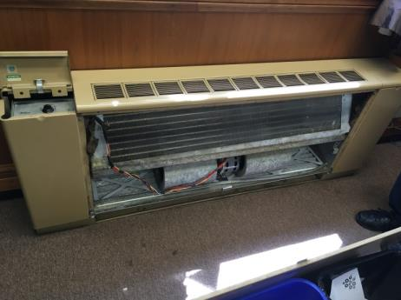
Fan coil unit (FCU)
Picture 2
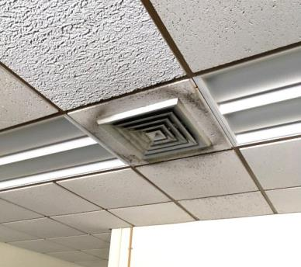
Stained ceiling tile
Picture 3
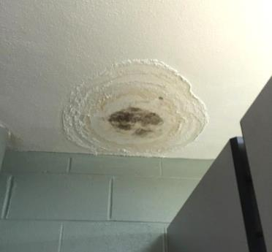
Mold-contaminated plaster/paint in janitor’s closet in basement
Picture 4
Window open in First Session courtroom
Picture 5
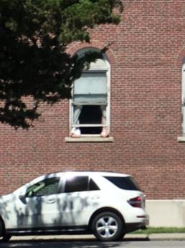
Curtains outside building
Picture 6
Upholstered furniture in basement
Location | Carbon  Dioxide  (ppm) | Carbon Monoxide  (ppm) | Temp  (°F) | Relative  Humidity  (%) | PM2.5  (µg/m³) | Occupants  in Room | Windows  Openable | Ventilation |  | Remarks
 |  |  |  |  |  |  |  | Supply | Exhaust
Background (outside) | 376 | ND | 80 | 45 | 8
Maintenance | 472 | ND | 80 | 48 | 9 | 0 | Y
B5 | 467 | ND | 77 | 53 | 8 | 0 | N | N | N | Couch, DO
B11 | 516 | ND | 77 | 54 | 7 | 0 | N | N | Y
Lockup Deck | 485 | ND | 76 | 56 | 10 | 0 | N | N | N
B16 | 458 | ND | 76 | 54 | 8 | 0 | N | N | Y | Couch, toilet odor
B14 | 499 | ND | 75 | 58 | 7 | 0 | N | N | Y | Dry drain trap
B7 | 517 | ND | 75 | 57 | 6 | 0 | N | N | Y
B13 custodial closet |  |  |  |  |  |  | N | N | N | Door vent, slop sink
B26 | 467 | ND | 74 | 59 | 7 | 0 | N
Basement hallway |  |  |  |  |  |  |  |  |  | Upholstered furniture
3 |  |  |  |  |  |  |  |  |  | Floor drain, musty odor
12 |  |  |  |  |  |  |  |  |  | Floor drain, musty odor
128 | 425 | ND | 75 | 52 | 5 | 0 | N | Y | Y
Stairwell |  |  |  |  |  |  |  |  |  | 5 WD CT
Courtroom, First Session | 320 | ND | 72 | 36 | 5 | 0 | Y open | Y | Y | Air conditioning on, 5 WD CT
Cashier | 968 | ND | 73 | 57 | 3 | 2 | Y | N | N | Plants, FCU
141 | 480 | ND | 72 | 55 | 5 | 42 | Y | N | N | FCU
139 | 483 | ND | 72 | 56 | 3 | 2 | Y | N | N | FCU
133 | 500 | ND | 71 | 56 | 5 | 0 | Y | N | N | FCU – book
136 | 574 | ND | 71 | 57 | 5 | 1 | Y | N | N
Lobby | 415 | ND | 70 | 59 | 6 | 1 | Y | Y | Y
116 | 339 | ND | 71 | 57 | 5 | 0 | Y | FCU | N
115 | 343 | ND | 71 | 56 | 5 | 0 | N | N | N
122 | 333 | ND | 71 | 55 | 6 | 0 | N | Y | Y
112 | 433 | ND | 71 | 57 | 7 | 1 | Y | FCU | N | Plant
118 | 386 | ND | 70 | 58 | 6 | 1 | Y open | FCU | N | Plants
103 | 406 | ND | 71 | 55 | 6 | 1 | Y | FCU | N | Plants
104 | 354 | ND | 71 | 56 | 6 | 1 | Y | FCU
232 | 351 | ND | 74 | 55 | 5 | 1 | Y | FCU | Y | Plants
235 | 337 | ND | 72 | 50 | 6 | 0 | Y | Y | Y
235B | 335 | ND | 72 | 54 | 6 | 0 | Y | Y | Y
202 | 315 | ND | 71 | 55 | 5 | 0 | Y | Y | Y
Session 2 | 311 | ND | 69 | 56 | 5 | 0 | Y | Y | Y
212 | 301 | ND | 68 | 58 | 5 | 0 | Y | Y | Y
215 | 322 | ND | 70 | 59 | 5 | 0 | Y | Y | Y
220 | 307 | ND | 69 | 58 | 5 | 0 | Y | Y | Y
225 | 360 | ND | 71 | 59 | 5 | 1 | Y | Y | Y

The service life is the median time during which a particular system or component of …[an HVAC]… system remains in its original service application and then is replaced. Replacement may occur for any reason, including, but not limited to, failure, general obsolescence, reduced reliability, excessive maintenance cost, and changed system requirements due to such influences as building characteristics or energy prices (ASHRAE, 1991).

