Babesiosis Surveillance in Massachusetts, 2011
Massachusetts Department of Public Health
2011 Surveillance Highlights

- 191 confirmed cases of babesiosis were reported in Massachusetts in 2011, representing more than a two-fold increase over the number of cases reported in 2010.

- Counties with the highest incidence were Barnstable, Nantucket, and Plymouth.

- The majority of confirmed cases occurred in June, July and August and 23% of cases reported a recent tick bite.

- 66% of confirmed cases were over 55 years of age. The average age for a confirmed babesiosis case was 62 years, and 53% were male.

- 41% of confirmed cases were hospitalized. The symptoms most commonly reported in confirmed cases included fever (71%), fatigue (73%) and malaise (57%).

- Seven confirmed cases (3.7%) reported receiving a blood transfusion, tissue products or organ transplant in the year prior to becoming ill. One perinatally-acquired case was also identified.

- For more information about babesiosis and other tick-borne diseases, including things you can do to keep you and your loved ones safe, please visit www.mass.gov/dph/tick.

The map below illustrates babesiosis incidence rates per 100,000 by city and town of residence in Massachusetts from 2007-2011. Areas of highest incidence include Cape Cod and the islands of Nantucket and Martha’s Vineyard. No cases of babesiosis were reported from Franklin County in 2011.
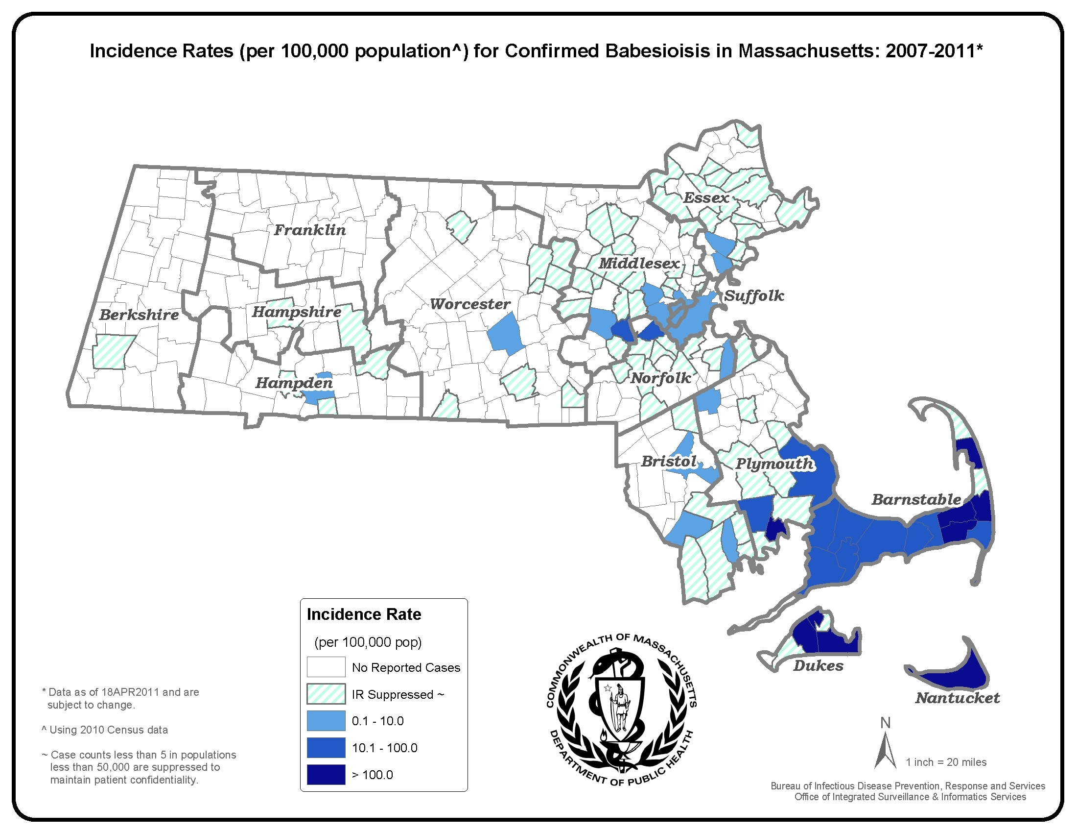
County | 2011 Confirmed Cases (#) | 2011  Incidence Rate (per 100,000)
Barnstable | 57 | 26.4
Berkshire | 1 | 0.8
Bristol | 8 | 1.5
Dukes and Nantucket | 46 | 172.2
Essex | 10 | 1.3
Franklin | 0 | 0.0
Hampden | 4 | 0.9
Hampshire | 1 | 0.6
Middlesex | 22 | 1.5
Norfolk | 13 | 1.9
Plymouth | 24 | 4.8
Suffolk | 2 | 0.3
Worcester | 3 | 0.4
State Total | 191 | 2.9

*Statistics for Dukes and Nantucket counties are combined in accordance with confidentiality guidelines

Figure 1.

Figure 2.
N = 191

Figure 3.

