Babesiosis Surveillance in Massachusetts, 2012
Massachusetts Department of Public Health

Investigation of suspect cases of babesiosis and the collection of clinical and exposure data by local public health enables MDPH to be able to analyze trends and provide this surveillance summary.

2012 Surveillance Highlights

- 233 confirmed cases of babesiosis were reported in Massachusetts in 2012, a 22% increase over the number of cases reported in 2011.

- Counties with the highest incidence continued to be Barnstable, Plymouth, Dukes and Nantucket. Several counties, including Bristol, Middlesex, Norfolk, and Suffolk had incidence rates that substantially increased from 2011, suggesting newly emerging areas of concern for babesiosis.

- The majority of confirmed cases occurred in June, July and August and 25% of cases reported a recent tick bite.

- 57% of confirmed cases were over 60 years of age. Incidence rates are highest in those over 60. 58% of all cases were male.

- 39% of confirmed cases were hospitalized. The symptoms most commonly reported in confirmed cases included fever (77%), fatigue (70%) and malaise (52%). There were five fatalities.

- Six confirmed cases (2.6%) reported receiving a blood transfusion, tissue products or organ transplant in the year prior to becoming ill. A screening test for donated blood is currently being evaluated.

- For more information about babesiosis and other tick-borne diseases, including things you can do to keep you and your loved ones safe, please visit www.mass.gov/dph/tick.

The map below illustrates babesiosis incidence rates per 100,000 by city and town of residence in Massachusetts from 2008-2012. Areas of highest incidence include Cape Cod, Southeastern Massachusetts and the islands of Nantucket and Martha’s Vineyard. No cases of babesiosis were reported from Berkshire, Franklin or Hampshire Counties in 2012.
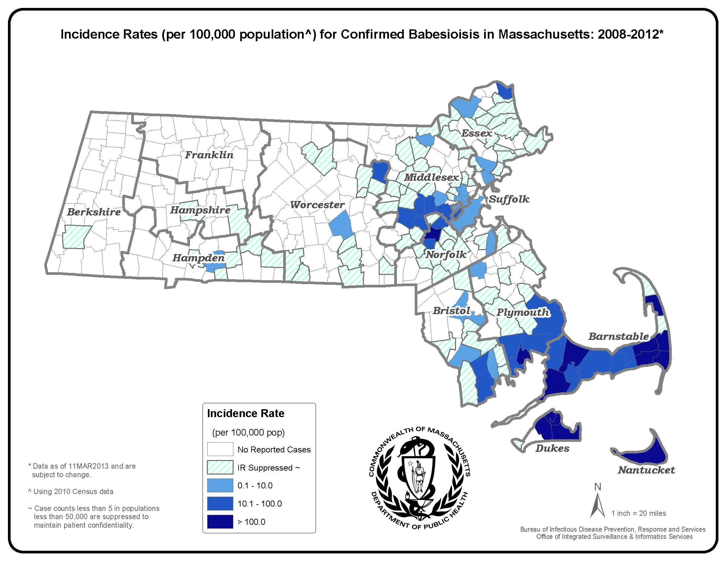
County | 2012 Confirmed Cases (#) | 2012  Incidence Rate (per 100,000)
Barnstable | 59 | 27.3
Berkshire | 0 | 0.0
Bristol | 13 | 2.4
Dukes and Nantucket | 44 | 164.8
Essex | 14 | 1.7
Franklin | 0 | 0.0
Hampden | 4 | 0.9
Hampshire | 0 | 0.0
Middlesex | 37 | 2.5
Norfolk | 23 | 3.4
Plymouth | 24 | 4.8
Suffolk | 8 | 1.1
Worcester | 7 | 0.9
State Total | 233 | 3.6

*Statistics for Dukes and Nantucket counties are combined in accordance with confidentiality guidelines

Figure 1.

Figure 2.
N=233

Figure 3.

