Babesiosis Surveillance in Massachusetts, 2013
Massachusetts Department of Public Health

Investigation of suspect cases of babesiosis, and the collection of clinical and exposure data by local public health, enables MDPH to analyze trends and provide this surveillance summary.
2013 Surveillance Highlights

- 420 confirmed and probable cases of babesiosis were reported in Massachusetts in 2013. Confirmed cases increased by 40% over the number of cases reported in 2012. Overall, 924 suspect cases of babesiosis were investigated.

- For the first time, babesiosis was identified in all counties in Massachusetts and incidence in every county, except Suffolk, substantially increased from the previous year. Counties with the highest incidence continued to be Barnstable, Plymouth, Dukes and Nantucket. Plymouth County had the greatest change in incidence, from 4.8 to 12.5 cases per 100,000; the statewide incidence nearly doubled from 3.6 to 6.4 cases per 100,000.

- The majority of cases occurred in June, July and August with only 20% of cases reporting knowing of a recent tick bite.

- People over the age of 60 continue to be at greatest risk for clinical disease (55% of all patients identified with babesiosis are over 60) and over half (56%) of all cases were male.

- Approximately one out of three (36%) patients with babesiosis was hospitalized. The symptoms most commonly reported in confirmed cases included fatigue (73%), malaise (56%), chills (53%), and muscles ache and pain (51%). There were at least 2 fatalities.

- Five confirmed cases (1%) were associated with receiving a blood transfusion in the six months prior to becoming ill.

- For more information about babesiosis and other tick-borne diseases, including things you can do to keep you and your loved ones safe, please visit www.mass.gov/dph/tick.

The map below illustrates babesiosis incidence rates per 100,000 by city and town of residence in Massachusetts for 2009-2013. Areas of highest incidence include southern Middlesex County, parts of Essex County, Cape Cod, Southeastern Massachusetts and the islands of Nantucket and Martha’s Vineyard. All counties reported cases of Babesiosis in 2013.
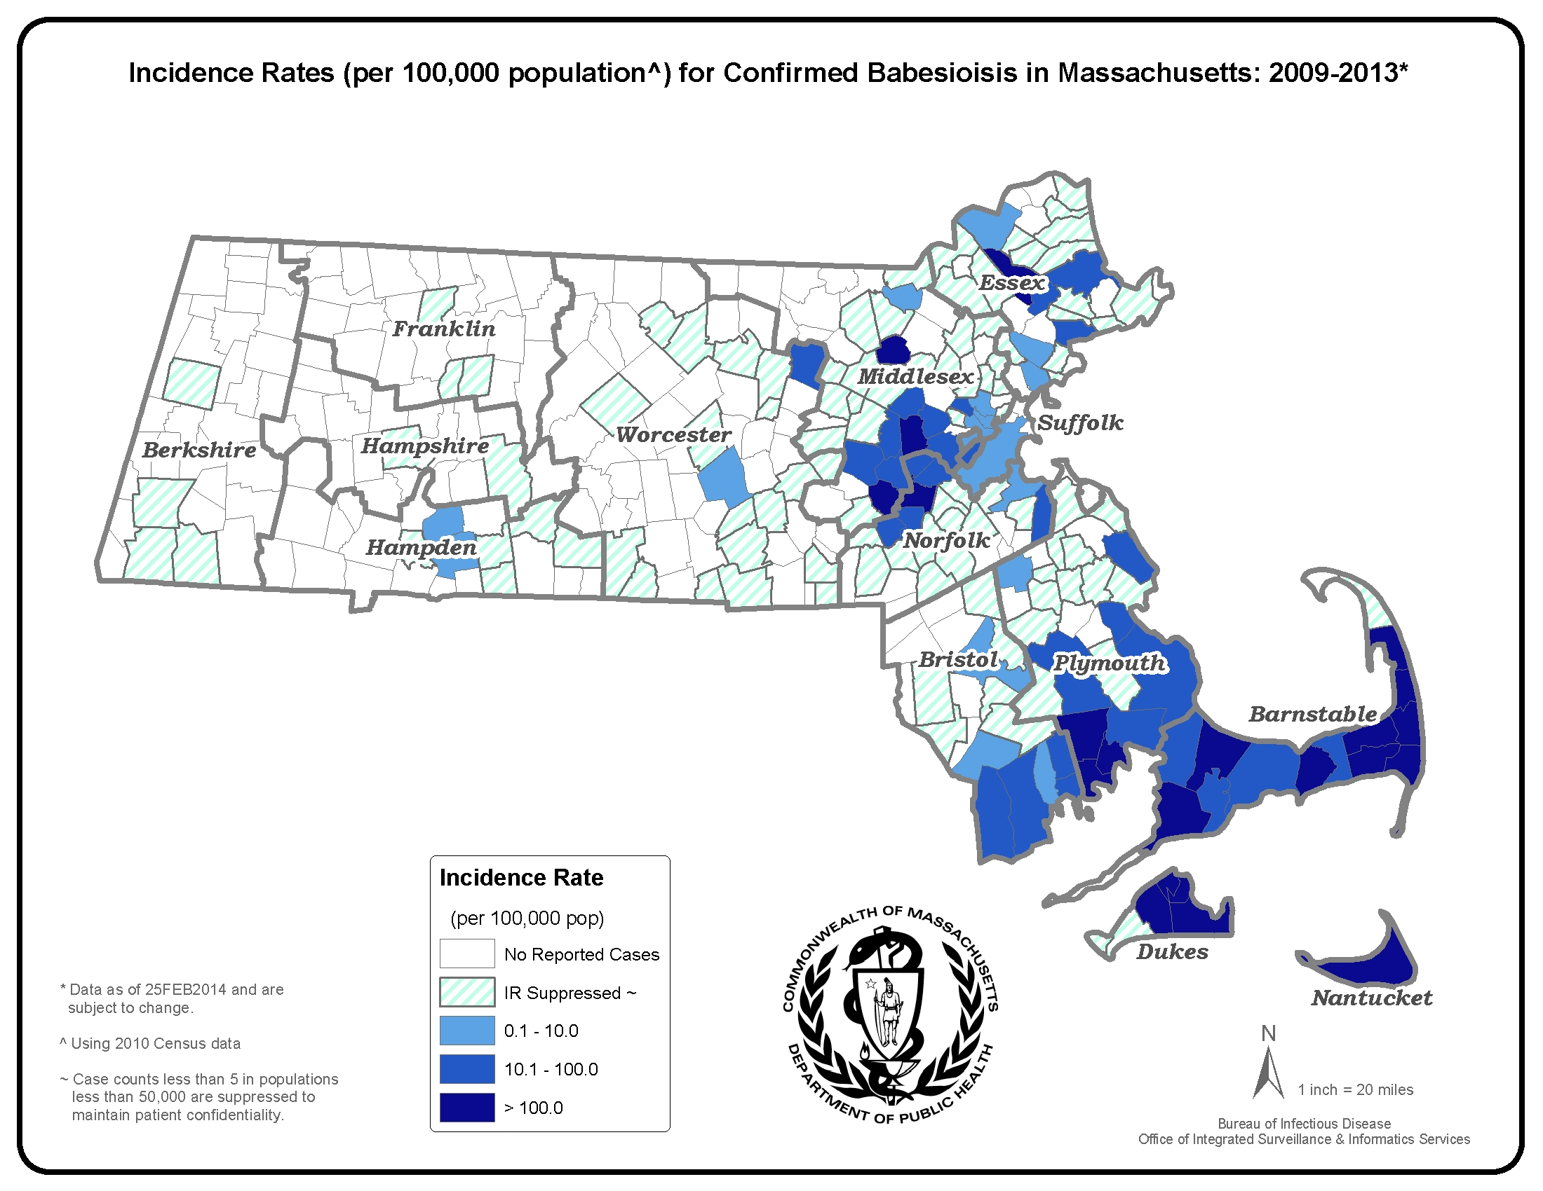
County | 2013 Cases  Confirmed and Probable | 2013  Incidence Rate  (per 100,000)
Barnstable | 81 | 37.5
Berkshire | 5 | 3.8
Bristol | 27 | 4.9
Dukes and Nantucket | 70 | 262.1
Essex | 34 | 4.6
Franklin | 4 | 5.6
Hampden | 9 | 1.9
Hampshire | 2 | 1.3
Middlesex | 64 | 4.3
Norfolk | 38 | 5.7
Plymouth | 62 | 12.5
Suffolk | 8 | 1.1
Worcester | 16 | 2.0
State Total | 420 | 6.4

*Statistics for Dukes and Nantucket counties are combined in accordance with confidentiality guidelines

Figure 1.

Figure 2.
N=420

Figure 3.

