Babesiosis Surveillance in Massachusetts, 2014
Massachusetts Department of Public Health

Investigation of suspect cases of babesiosis, and the collection of clinical and exposure data by local public health, enables MDPH to analyze trends and provide this surveillance summary.
2014 Surveillance Highlights
- 520 confirmed and probable cases of babesiosis were reported in Massachusetts in 2014. This was a 24% increase over the number of cases reported in 2013. Overall, 932 suspect cases of babesiosis were investigated.

- Statewide, babesiosis incidence increased from 6.4 to 7.9 cases per 100,000 residents and the incidence in Barnstable, Bristol, Dukes, and Plymouth counties increased substantially. Counties with the highest incidence continued to be Barnstable, Plymouth, Dukes, and Nantucket. Dukes County had the greatest increase in incidence, from 84.7 to 121.0 cases per 100,000 residents.

- The majority of cases occurred in June, July and August, with only 26% of cases reporting awareness of a recent tick bite.

- People over the age of 60 continue to be at greatest risk for clinical disease (54% of all patients identified with babesiosis were over 60), and 67% of all cases were male.

- Approximately one out of three (32%) cases was hospitalized. The symptoms most commonly reported included fatigue (76%), fever (70%), malaise (61%), chills (53%), and muscle aches and pain (50%). There was at least one fatality.

- Ten confirmed cases (2 %) had received a blood transfusion in the six months prior to becoming ill.

- For more information about babesiosis and other tick-borne diseases, including things you can do to keep you and your loved ones safe, please visit www.mass.gov/dph/tick.

The map below illustrates babesiosis incidence rates per 100,000 by city and town of residence in Massachusetts for 2010-2014. Areas of highest incidence include southern Middlesex County, parts of Essex County, Cape Cod, Southeastern Massachusetts and the islands of Nantucket and Martha’s Vineyard.

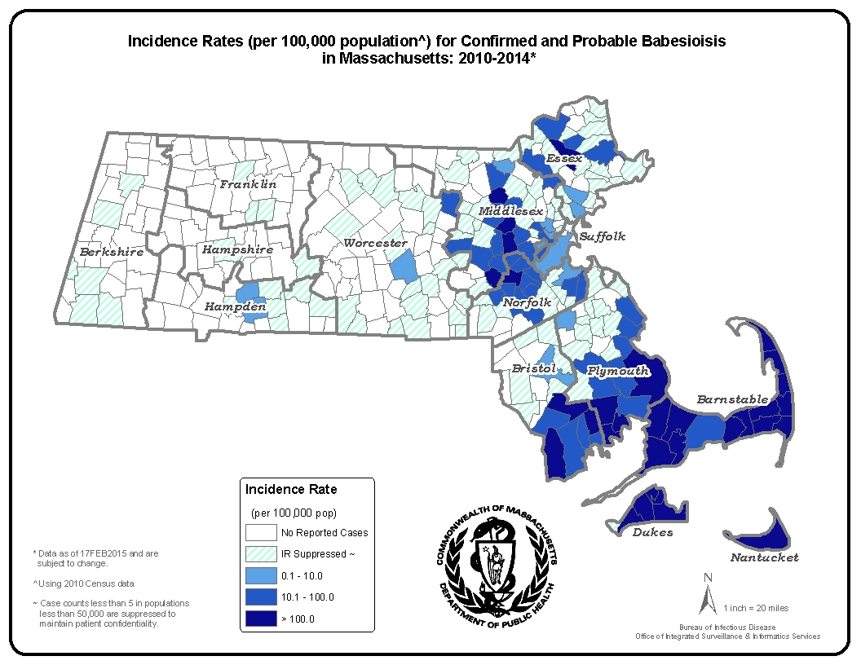
County | 2014 Cases  Confirmed and Probable | 2014  Incidence Rate  (per 100,000)
Barnstable | 130 | 60.2
Berkshire | 2 | 1.5
Bristol | 63 | 11.5
Dukes | 20 | 121.0
Essex | 32 | 4.3
Franklin | 0 | 0.0
Hampden | 8 | 1.7
Hampshire | 3 | 1.9
Middlesex | 66 | 4.4
Nantucket | 36 | 353.9
Norfolk | 38 | 5.7
Plymouth | 98 | 19.8
Suffolk | 8 | 1.1
Worcester | 14 | 1.8
State Total | 520 | 7.9

Figure 1.
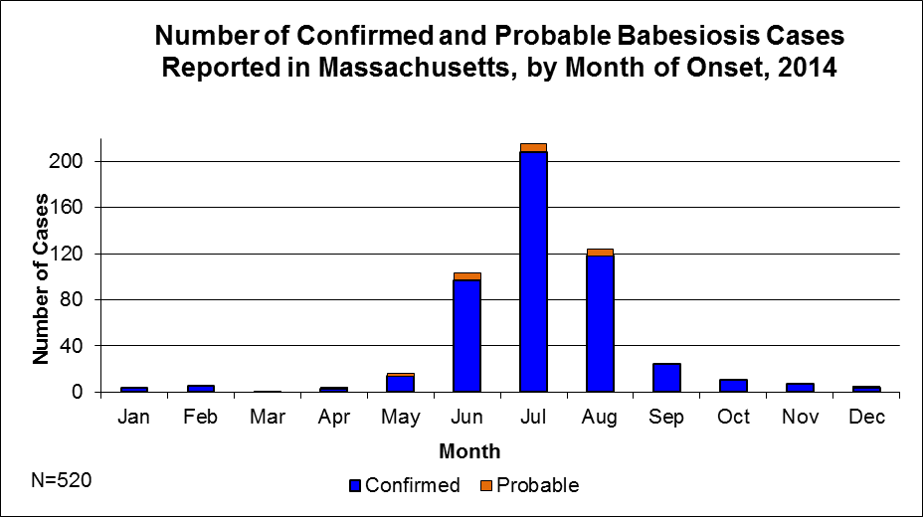

Figure 2.
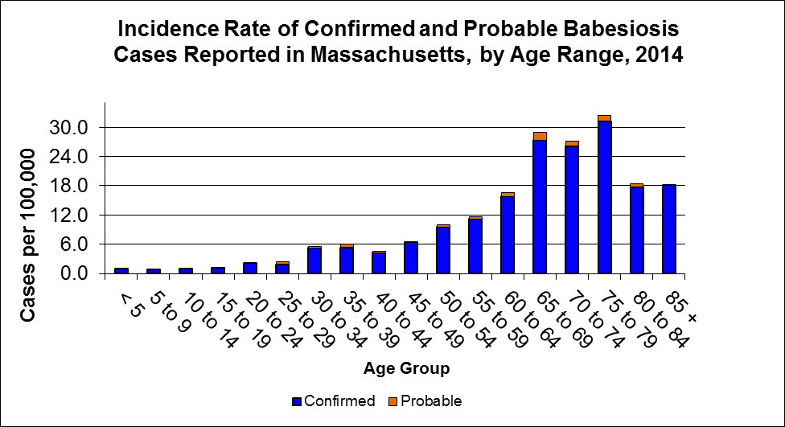
N=520

Figure 3.
