Babesiosis Surveillance in Massachusetts, 2016
Massachusetts Department of Public Health

Investigation of suspect cases of babesiosis, and the collection of clinical and exposure data by local public health, enables MDPH to analyze trends and provide this surveillance summary.
2016 Surveillance Highlights
- 513 confirmed and probable cases of babesiosis were reported in Massachusetts in 2016, a 15% increase from 2015. Overall, 1104 suspect cases of babesiosis were investigated.

- Statewide, babesiosis incidence increased from 6.8 to 7.8 cases per 100,000 residents. The incidence in Berkshire, Dukes, Hampshire, Nantucket, Essex, Franklin, Hampshire, Norfolk and Worcester counties increased slightly. Counties with the highest incidence continued to be Barnstable, Dukes, and Nantucket.

- The majority of cases occurred in June, July and August, with only 24% of cases reporting awareness of a recent tick bite.

- People aged 60 years and older continue to be at greatest risk for clinical disease (57% of all patients identified with babesiosis were 60 years or older) and 66% of all cases were male.

- Approximately one out of three (35%) cases was hospitalized. The symptoms most commonly reported included fatigue (78%), fever (67%), malaise (65%), muscle aches and pain (59%) and chills (54%). There were at least 4 fatalities.

- 8 confirmed cases (2%) had received a blood transfusion in the six months prior to becoming ill and three of those are confirmed or likely transfusion-transmitted cases.

- For more information about babesiosis and other tick-borne diseases, including things you can do to keep you and your loved ones safe, please visit www.mass.gov/dph/tick.

The map below illustrates babesiosis incidence rates per 100,000 population by city and town of residence in Massachusetts for 2012-2016. Areas of highest incidence include southern and central Middlesex County, parts of Essex County, Cape Cod, Southeastern Massachusetts and the islands of Nantucket and Martha’s Vineyard.

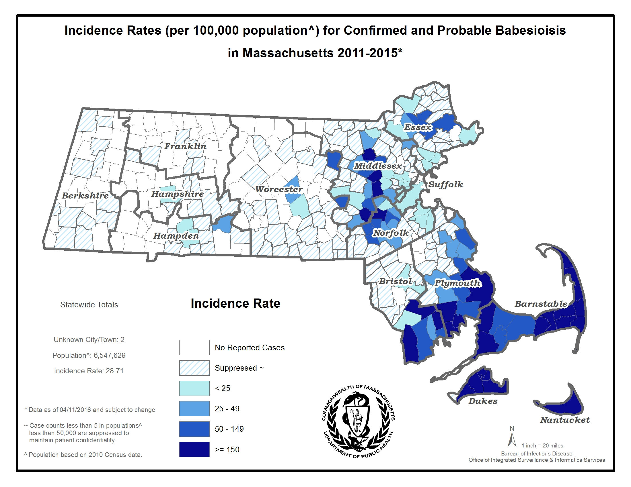
County | 2016 Cases  Confirmed and Probable | 2016  Incidence Rate  (per 100,000)
Barnstable | 105 | 48.6
Berkshire | 2 | 1.5
Bristol | 92 | 16.8
Dukes | 6 | 36.3
Essex | 35 | 4.7
Franklin | 1 | 1.4
Hampden | 7 | 1.5
Hampshire | 3 | 1.5
Middlesex | 62 | 4.1
Nantucket | 18 | 177.0
Norfolk | 44 | 6.6
Plymouth | 105 | 21.2
Suffolk | 7 | 1.0
Worcester | 26 | 3.3
State Total | 513 | 7.8

Figure 1.
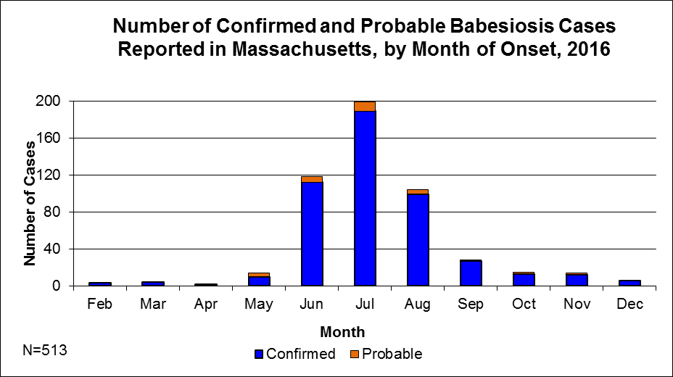

Figure 2. 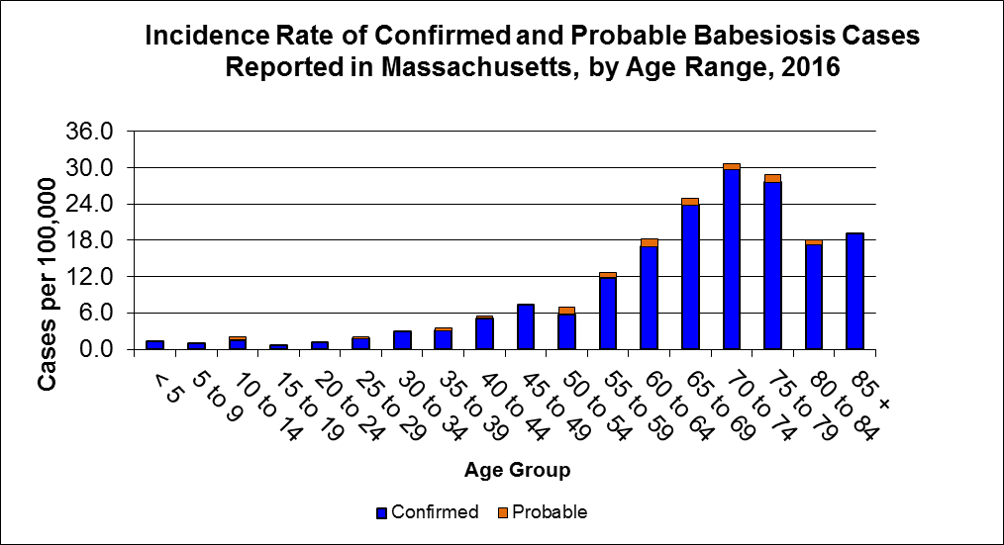

Figure 3.
