Bureau of Infectious Disease and Laboratory Sciences
Massachusetts State Public Health Laboratory
305 South St.
Jamaica Plain, MA 02130

Babesiosis Surveillance in Massachusetts, 2018
2018 Surveillance Highlights

- 525 confirmed and probable cases of babesiosis were reported in Massachusetts in 2018. Overall, 1,660 suspect cases of babesiosis were investigated. PCR and microscopy laboratory test results indicate current infection, even in individuals not captured in case counts (Figure 3).

- Statewide, babesiosis incidence decreased from 9.0 in 2017 to 8.0 cases per 100,000 residents. The incidence in Hampden and Hampshire counties increased slightly. Counties with the highest incidence continued to be Barnstable, Dukes, and Nantucket.

- The majority of cases occurred in June, July and August, with only 19% of cases reporting awareness of a recent tick bite.

- People aged 60 years and older continue to be at greatest risk for clinical disease (62% of all patients identified with babesiosis were 60 years or older) and 63% of all cases were male.

- Approximately one out of three (35%) cases was hospitalized. The symptoms most commonly reported included fatigue (79%), fever (64%), malaise (62%), muscle aches and pain (58%) and chills (53%). There were at least 4 fatalities.

- 6 confirmed cases had received a blood transfusion in the six months prior to becoming ill and two of those were confirmed or likely transfusion-transmitted cases.

- For more information about babesiosis, please visit www.mass.gov/dph/tick.

County | 2018 Cases  Confirmed and Probable | 2018  Incidence Rate per 100,000
Barnstable | 80 | 37.1
Berkshire | 18 | 13.7
Bristol | 93 | 17.0
Dukes & Nantucket | 13 | 48.7
Essex | 26 | 3.5
Franklin | 0 | 0.0
Hampden | 16 | 3.5
Hampshire | 8 | 5.1
Middlesex | 75 | 5.0
Norfolk | 31 | 4.6
Plymouth | 128 | 25.9
Suffolk | 8 | 1.1
Worcester | 29 | 3.6
State Total | 525 | 8.0
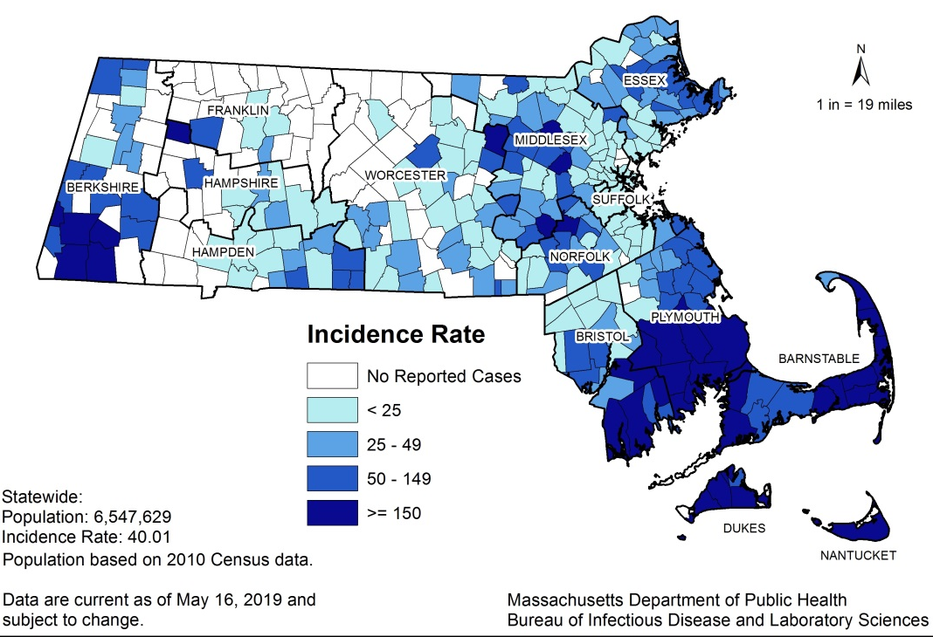

Map 1: Five-year babesiosis incidence rates per 100,000 population by city or town of residence, Massachusetts, 2014-2018.

Table 1: Babesiosis counts and incidence rates per 100,000 population by county of residence, Massachusetts, 2018.

Figure 1.
Number of confirmed and probable babesiosis cases by month of symptom onset, Massachusetts, 2018.
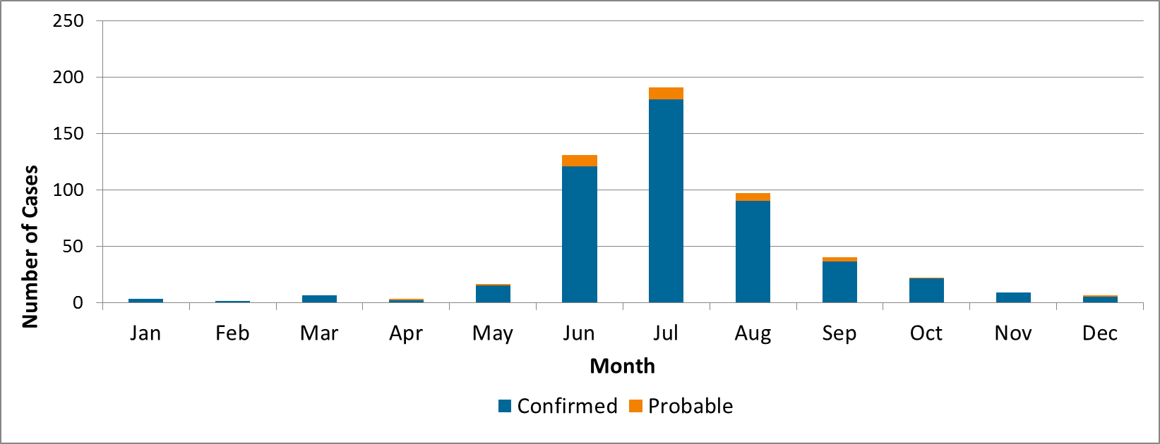
Figure 2.
Rate (per 100,000 population) of confirmed and probable babesiosis cases by age group, Massachusetts, 2018
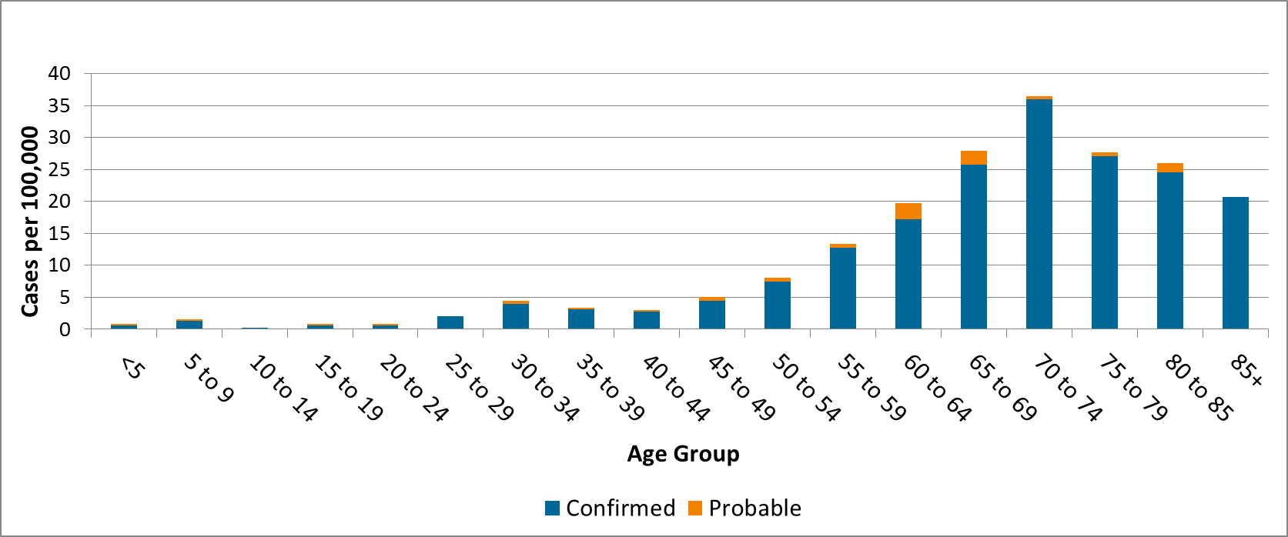

Figure 3. Number of confirmed and probable babesiosis cases by year, Massachusetts, 2014-2018
