Massachusetts Department of Conservation and Recreation

Bureau of Forest Fire Control and Forestry

Forest Management Proposal

Name: Balance Rock Lot

Date Posted: March 2, 2020

End of Comment Period: April 16, 2020

Region: West

Recreation District: Lakes

Forest Management District: Northern Berkshires

State Forest: Balance Rock State Park

Closest Road: Balance Rock Road

Town Lanesborough

Contact Information: Kevin Podkowka
740 South Street
PO Box 1433
Pittsfield, MA 01202
413/442-8928 ext. 125
kevin.podkowka@mass.gov

Overview:

The proposed project area is located in Balance Rock State Park, north of Balance Rock Road, and south of Olsen Road. The sale contains 129 ± acres of beech-birch-maple, 113 ± of oak-hardwoods, and 4 ± acres of eastern white pine-hardwoods.

Conditions that led to selecting the area for active management
- High stocking and high mortality of white ash due to the presence of emerald ash borer
- Expand upon previous silvicultural activities and treatments
- Continuation of landscape level management that was started with the Potter Mountain – Hancock and the Potter Mountain – Lanesborough Sales
Goals and Objectives of the Balance Rock Sale

Goal 1: Increase biological diversity, improve wildlife habitat, and introduce more complexity into existing stands
Objective: Install gaps within existing stands and enlarge those gaps that already exist. When establishing 1/3-acre gaps ensure that enough trees are removed to ensure full sunlight on the forest floor. In an effort to minimize the use of herbicides to treat American beech, areas that are composed of more than 70% American beech infested with Beech Bark Disease Complex (BBD) will have gaps installed up to 5 acres in size.

Goal 2: Increase the distribution and density of sugar maple to combat regional sugar maple decline.
Objective: Sugar Maple will be favored for retention over other tree species.

Goal 3: Create and provide ecosystem services from this Woodland as directed by the Landscape Designations for DCR Parks & Forests: Selection Criteria and Management Guidelines (2012).

Objectives:
  - Provide locally grown forest products to the local economy
  - Create a more diverse forest structure that is resilient to disturbance through improvement thinnings and group selection
  - Sequester carbon in retained overstory trees, permanent forest products produced from the harvest, and in the vigorous regenerating forest.
  - Provide the conditions within the stand for early seral or regenerating forest that will support diverse species.

Goal 4: Salvage live white ash trees 12”+ DBH
Objective: The area is heavily infested with emerald ash borer. This sale will remove those ash trees that are still viable economically in order to recover some value and prevent the DCR from having to pay for removals due to public safety concerns in the future.

Goal 5: Demonstrate harvesting techniques and best management practices that protect forest resources.

Objectives:
- Ensure harvesting contractor compliance with all BMP’s
- Frequently monitor operations to minimize and/or mitigate damage to the site
- Ensure full understanding of contractual requirements by the harvesting contractor
- Develop a comprehensive silvicultural prescription

Stand Description:

Species Composition

Beech-Birch-Maple: This stand is made up of American beech, yellow birch, black birch, white birch, red maple, sugar maple, and white ash. There are also smaller components of red oak, and white pine. Understory trees and shrubs include striped maple, hobblebush, and witch-hazel. Groundcover is primarily composed of ferns, princess pine, ground cedar, sedges, and partridge berry. Basal areas for this stand are approximately 120 ft²/acre, and the stand is beginning to show signs of uneven-aged development. The primary pathogen impacting this stand is emerald ash borer, with nearly all ash 12+” DBH infested and many trees are already dead.

Oak-Hardwoods Stand: The oak-hardwood stand is composed primarily of red oak, American beech, and red maple. Sugar Maple and white ash also occur within the stand but with much less frequency than in the beech-birch-maple stand. The frequency of white birch, yellow birch, and black birch; along with the ground cover and shrub components are nearly identical to the beech-birch maple stand. This stand is also beginning to show signs of uneven-aged development, and white ash within the stand 12+” DBH is also infested with emerald ash borer.

White Pine – Hardwoods: This stand is a small inclusion (4 acres) within the sale area that is part of a much larger stand, and is composed mainly of white pine, eastern hemlock, Norway spruce, red maple, and American beech. The portion of the stand within the sale area is two-aged with a white pine overstory and hardwoods colonizing gaps in the canopy caused by weather events and previous silvicultural activities. Stocking is high with basal areas in excess of 130 ft²/ac.

Previous Silviculture Activity

The earliest activity recorded for the project area is a 35-acre birch sale in 1959, while the largest project was a 398-acre timber stand improvement treatment in 1961. Through the late 1960’s and into the early 1980’s there were 11 fuel wood sales recorded that ranged between 3 acres and 5 acres. There have been 11 commercial sales and 1 salvage within the area as well, with the most recent harvest having occurred in 2001 on 17 acres.

Topography and Soils

There are 15 different soil associations located within the project area; but all are similar in temperature, average precipitation, slope, parent material, and texture. Mean annual temperatures range from 40°F - 50°F, with between 32” and 50” of precipitation, and 0% - 20% slope. Roughly 106 acres of the sale area has a sandy loam to a gravelly sandy loam texture and the parent materials are glaciofluvial deposits from slate or limestone or basal till from limestone. Approximately 95 acres of the project area is a silty loam to a gravelly silty loam with a parent material consisting of lodgement till from slate or limestone. The remaining 45± acres are made up of gravelly loam to very gravelly loam with a parent material of loamy basal till over metamorphic rock. For the purposes of the project this means that the site has a medium - high potential for productivity and sandy loams generally have better drainage than the silty loams. Those areas with more limestone in the parent materials will have higher concentrations of sugar maple and ash as they are richer sites than those with parent materials of slate. The area with gravelly loam to very gravelly loam will be the least productive due to the larger aggregate reducing the surface area for nutrient cations to attach to soil particles.

Aesthetic, Recreation, Wetlands, Cultural, Rare Species and Wildlife Considerations:

Aesthetics

Roads/trails that will be impacted by the harvest are Olsen Road, a legal hiking trail intersecting Olsen Road, and the Balance Rock ORV Trail. Though none of these are specifically designated as scenic byways, maintaining the visual experience for the users of these roads and trails is a high priority. In order to ensure that this occurs, slash management guidelines outlined in the 2013 2nd Edition of the Massachusetts Forestry Best Management Practices Manual will be followed.

Recreation

There are a number of recreational activities that forest users participate in throughout the sale area, with the most popular being hiking, hunting, ORV riding, and snowmobiling. Though closures are not anticipated; signage advertising an active sale, and early postings that the area will undergo a harvest will be used in order to communicate intent. Harvesting activities associated with this project will not be started until the Potter Mountain – Lanesborough Project is completed in order to help minimize disruptions to recreationists.

Wetlands

Wetlands within the project are identified on MAP 1. Additional wetland resources may be identified during the stand exam phase and marking phase of the project area. Encountered wetland resources are delineated on maps within the cutting plan and all BMP’s listed in the current Massachusetts Forestry Best Management Practices Manual are followed.

Cultural Resources

Stone walls are located in the eastern portion of the sale area and are identified on MAP 1. If a stone wall does need to be crossed, it will be done at a designated crossing, and rehabilitated to the condition it was in prior to harvesting. Additional cultural resource protection measures may be necessary once the area is cross referenced with the master site file for the Commonwealth of Massachusetts. All resource protection measures will be in compliance with DCR policies.

Listed Species

The Massachusetts Natural Heritage GIS data layer was referenced for this project and 2 areas of priority habitat were identified and are shown on MAP 1. Until a review of the project area has been completed by Massachusetts Natural Heritage staff, the species of flora and/or fauna being protected is unknown. However, after a review is performed all suggestions will be followed to the extent possible for reasonable harvesting operations and all requirements will be implemented.

Wildlife

Species

The wildlife occurring in this area is typical of a northern hardwood forest. Observed species include black-capped chickadee, white-tail deer, blue jay, and common crow. Other species expected to occur are black bear, various songbirds, ruffed grouse, raccoon, various fur bearers, grey squirrel, red squirrel, various raptors, and other small mammals such as bats and rodents. Additionally, various reptiles and amphibians are expected to occur since there are known streams and wetlands within the sale and surrounding area.

Snags and Retained Live Trees

All snags will be retained on-site provided that they do not pose a hazard to humans during or after operations. Live trees that appear to be a den or nest site either currently or in the recent past will also be retained. Beech that have evidence of bear foraging or are in excess of 14” DBH and showing no signs of BBD, and are in good health, will not be designated for removal.

Sale Layout and Harvesting Limitations:

Infrastructure

Landings are selected based on a number of factors to include existing vegetation, slope, access by haul vehicles, wetland proximity, etc. During harvesting operations slash build up at the landing will be mitigated by evenly distributing it back through the sale area within the skid trails. Prior to the conclusion of the sale, all landings will be cleared of any debris that will inhibit seeding. MAP 1 shows the planned locations of the landings.

Primary skid roads have been identified and will be expanded upon during the marking phase of the project. Existing skid trails, agricultural trails, and recreation trails will be utilized when possible and appropriate. All recreation trails impacted by harvesting activities will be rehabilitated prior to the conclusion of the sale. Skidding will occur along contours, and sharp pitch or grade changes by skidding equipment will be avoided. All skid trails are rehabilitated to a standard compliant with the most recent edition of the Massachusetts Forestry Best Management Practices, DCR policy, and is specifically detailed in the harvesting contract. MAP 1 shows the planned and current locations of skid trails.

Harvesting Equipment

This area can be felled either mechanically or manually. A forwarder will be required for harvesting, as skidding will not be approved along the length of Balance Rock Trail. A skidder equipped with a cable or a forwarder equipped with a grapple and boom will be required for harvesting in and around areas that have unstable soils.

Areas Excluded From Harvesting

Any areas that are identified as having cultural significance will be excluded from the sale area, as well as areas that are considered sensitive and will be negatively impacted for a prolonged period post-harvest. Typically harvesting is very limited, if conducted at all, within filter strips or wetlands. There is a possibility that certain restrictions on harvesting may be recommended and/or required within the areas identified as priority habitat.

Erosion and Sediment Control

The unwanted movement of soil and sediment across the landscape will be minimized by following and exceeding the requirements and guidelines of the most recent edition of the Massachusetts Forestry Best practice Manual, currently the 2013 2nd Edition. Routine activities associated with erosion and sediment control are the installation of filter strips, water bars on skid trails, seeding and mulching skid trails at the conclusion of the harvest, etc.

In-Kind Services

Areas that have beech densities in excess of 1,500 stems per acre but are not able to have 5-acre openings established, will be candidates for herbicide treatment to control beech. Building materials for infrastructure repairs and improvements on Balance Rock State Park and bounding areas of Pittsfield State forest will also be included as part of in-kind services. As this project develops, and the further needs of the park are identified, additional in-kind services will be evaluated for inclusion in the project.

Proximity to Forest Reserves

There are no forest reserves in the area.

Silviculture:

Beech-Birch-Maple

Reducing the density of BBD infested American beech, salvaging white ash, beginning a new age class of trees, and increasing ground cover diversity are the primary silvicultural objectives for this stand.

- Methods: Group selection will be utilized in areas that do not have problems associated with BBD. Areas with a prevalence of BBD will be treated with either an opening of up to 5 acres or herbicide. All white ash over 12+” DBH will be designated for harvest unless they are located within a filter strip, located within a wetland, or have no value as either sawtimber or firewood. Areas between group selections will be thinned at variable densities. The average basal area for this stand at the conclusion of the project will be between 60 ft² and 80 ft² per acre in harvested areas.

- Future Silvicultural Entries: Group selection utilizing an expanding gap model should be utilized with larger openings installed into areas with BBD issues. Herbicide may continue to be required to control excessive beech proliferation.

- Desired Future Conditions: The desired future condition for this stand is a healthy, vigorous, fully stocked stand free of insect and disease issues. Noxious weeds will be minimal, and over the course of time the stand will be well diversified in ages to include early successional stages in certain areas of the stand and having old growth characteristics in others.
Oak-Hardwood

The silvicultural objectives for this stand are the same as for the beech-birch-maple. This stand is expected to yield lower volumes of salvaged white ash and have more BBD infested areas. This fits well into the planned beech mitigation as red oak is intolerant of shade, thus areas treated with herbicide or openings larger than 1/3 acre should provide more opportunities for oak regeneration than smaller selected groups.

- Methods: Group selection, variable density thinning, and larger gaps up to 5 acres in size will be used as appropriate. As with the beech-birch-maple stand, white ash 12+” DBH will be designated for harvest unless they are located in a filter strip, located within a wetland, or have no value as firewood or sawtimber. The average residual stand basal area should be between 60ft² and 80 ft² in harvested areas.

- Future Silvicultural Treatments: Future treatments will most likely be the same as those for the beech-birch-maple stand.

- Desired Future Condition: As with the beech-birch-maple stand, the desired future condition for this stand is a healthy, vigorous, fully stocked stand free of insect and disease issues. Noxious weeds will be minimal, and over the course of time the stand will be well diversified in ages to include early successional stages in certain areas of the stand and old growth characteristics in others.
White Pine – Hardwood

The silvicultural techniques used within this stand will focus on retaining healthy, vigorous, well-formed hardwoods and regenerate white pine.

- Methods: Hardwood trees that are of poor form, health, and/or vigor will be designated for removal. The white pine overstory will be cut as either a shelterwood or have group selection openings of up to 1/3 of an acre anchored on white pine trees that are designated for harvest.

- Future Silvicultural Treatments: Since white pine cannot reproduce under shade the remaining overstory will have to be removed. This further removal and disturbance in the regenerating stand should encourage more white pine recruitment. Over time large gaps will need to be regularly installed in order to continue white pine and early successional hardwood recruitment.

- Desired Future Conditions: The desired future conditions for this stand is a mixture of white pine and eastern hemlock with various hardwoods such as red maple, yellow birch, white birch, and black birch. Trees will be healthy, vigorous, and well-formed with a diverse understory of shrubs and ground cover. Noxious weed and insect problems will be minimal.

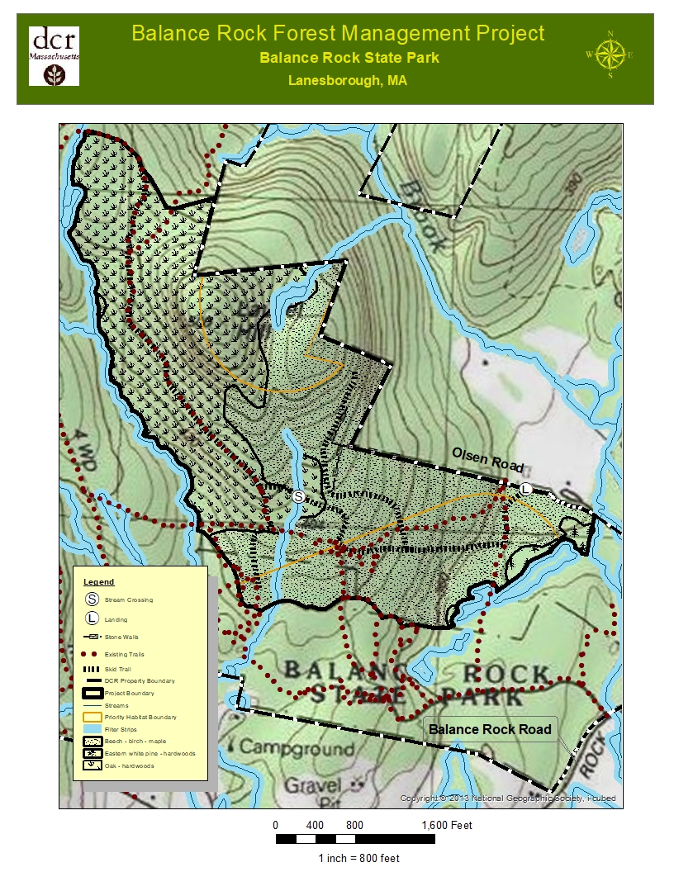
MAP 1

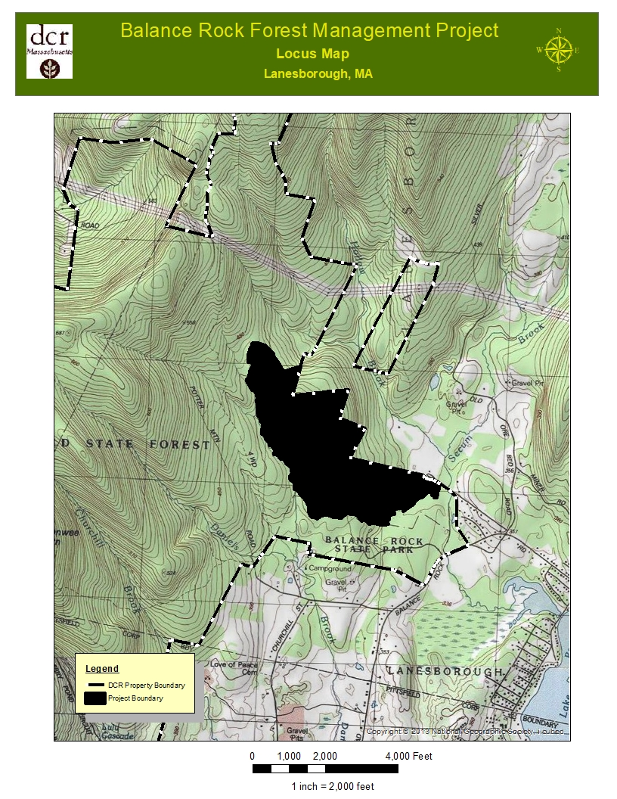
MAP 2

The 5-acre maximum was chosen based on the minimum size opening used at the Bartlett Experimental Forest to achieve a substantial reduction in beech density within stands infested with Beech Bark Disease Complex

