Can I still give my baby a bottle?
Once your baby turns 1, they no longer need formula or a bottle. They should be drinking no more than 16 oz. of whole milk each day in a sippy cup. Too much milk can cause a drop in iron levels and constipation!

Can I still breastfeed my 1-year old?
Yes! Continue breastfeeding as long as you wish while still introducing new foods.

Do I continue to give them pureed foods?
Now that your child has some teeth, it is best to offer finger foods with more texture. This will help them try new foods and help them develop important oral skills.

Can my toddler eat what I eat?
Yes! Your child will typically be able to eat just about anything that you eat. Just avoid offering your child foods with too much salt or the choking hazards on the other side – but, new flavors and seasonings are good! Your child will enjoy eating with you and will be interested in what’s on your plate.

www.mass.gov/wic

This institution is an equal opportunity provider.

Your toddler will enjoy feeding themselves with their hands and eventually a spoon. Don’t worry about the mess! Your toddler is learning and this is important for development.
- Allow your child to decide when and how much or how little they want to eat at meals and snacks. Offer a variety of healthy options and let them choose.
- Your child loves imitating you! Be a role model for healthy behaviors by enjoying a variety of foods with them at every meal.
- Mealtimes are a chance to connect with your kids. Turn off the TV and other devices so there aren’t distractions.
- Your toddler may eat less or become pickier as they get older because they aren’t growing as fast as they did when they were a baby. It’s normal for children to eat more on some days, and less on others.
- Your toddler may refuse new foods and foods that they have eaten before. While frustrating, this is common! Simply wait and re-introduce these foods. Remember, it can take many times for your child to realize they enjoy a new food.
- Avoid rewarding good behavior with sweet treats. Instead, reward them with more physical activity, stickers or playing their favorite game.
Family Mealtime
Frequently Asked Questions
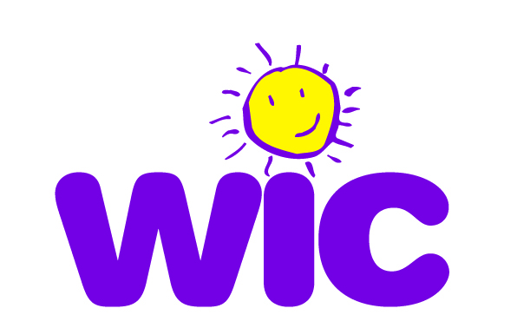
Balancing Healthy Meals for Your Toddler
Typical Portions for a 1- to- 2- Year Old
Dairy
What is a serving of dairy?
- 4 ounces whole milk (offer no more than 16 ounces of milk a day)
- ½ cup of yogurt
- 1 ounce of cheese

Offer 3-4 servings each day.
Variety is Key!
The transition from baby to toddler can sometimes seem like it happens overnight! It’s an exciting time to watch your child discover new foods and textures, all while learning to feed themselves.
A variety of foods, flavors, colors, and textures is important as your baby grows. Keep MyPlate in mind and offer your toddler foods from all of the food groups each day. Remember, they may not always eat it all. A toddler’s belly is much smaller than an adult’s, so be sure to always offer small portions on child-size plates and cups.
What is a serving of vegetables?
1/4 cup chopped or mashed, cooked vegetables
Offer 3-4 servings each day.

What is a serving of fruit?
- ¼ cup chopped or mashed fruit
- 2 ounces 100% juice (Offer no more than 4oz per day)
Offer 3-4 servings each day

What counts as an ounce of grains?
- 1 small slice bread or ½ tortilla
- ¼ cup cooked oatmeal, rice or pasta
- ½ cup cereal
- 2 or 3 crackers
Offer 3-5 ounces each day
Make ½ your grains whole!

What is a serving of protein?
- 2 tablespoons meat, chicken, turkey or fish
- 1 egg
- ¼ cup beans or peas
- 1 tablespoon peanut butter
Offer 2-3 servings each day.

Avoid feeding your child these foods, since they may choke on them.
- Chunks of raw vegetables
- Uncut grapes & cherry tomatoes
- Nuts, seeds, chips & popcorn
- Chewing gum & hard or sticky candy
- Uncut hot dogs, meat & cheese
- Chunks of peanut butter

