INDOOR AIR QUALITY ASSESSMENT

Baldwinville Elementary School
16 School Street
Templeton, Massachusetts

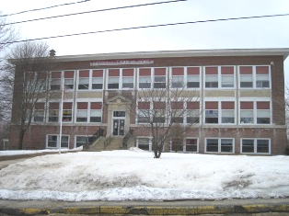

Prepared by:
Massachusetts Department of Public Health
Bureau of Environmental Health
Indoor Air Quality Program
June 2011

Background/Introduction
At the request of Ms. Joyce E. Crouse, Director of the Templeton Board of Health, the Massachusetts Department of Public Health (MDPH), Bureau of Environmental Health (BEH) conducted an indoor air quality (IAQ) assessment at the Baldwinville Elementary School (BES) located at 16 School Street, in the Baldwinville section of Templeton Massachusetts. On March 9, 2011, Lisa Hébert, Environmental Analyst/Regional Inspector of BEH’s IAQ Program visited the school to conduct the assessment. The request was prompted by water infiltration into basement classrooms.
The BES is a two-story brick structure with an occupied basement that was constructed in 1922. In the 1940s a one-story addition was constructed onto the rear of the building. Windows were designed to be openable throughout the school.

Methods
Air tests for carbon monoxide, carbon dioxide, temperature and relative humidity were conducted with the TSI, Q-Trak, IAQ Monitor, Model 7565. Air tests for airborne particle matter with a diameter less than 2.5 micrometers were taken with the TSI, DUSTTRAK™ Aerosol Monitor Model 8520. BEH staff also performed visual inspection of building materials for water damage and/or microbial growth.

Results
The school houses approximately 220 students in grades K through 4, and a staff of approximately 16. Tests were taken during normal operations at the school and results appear in Table 1.

Discussion

Ventilation
It can be seen from Table 1 that carbon dioxide levels were below 800 parts per million (ppm) in 16 of 23 occupied areas surveyed indicating adequate air exchange in many areas in the building. It is important to note, however, that several classrooms were empty or sparsely populated, which can greatly contribute to reduced carbon dioxide levels.
Fresh air is supplied to the main building by means of a fresh air intake on the rear exterior wall. Air is drawn by heating coils and supplied to classrooms by means of wall-mounted vents. Air is exhausted by rooftop motors by means of either wall-mounted vents located near the floor or in closets (Pictures 1 through 4).
Unit ventilators (univents) supply fresh air to rooms in the rear addition (Picture 5). Air is exhausted by ceiling-mounted exhaust vents. A univent draws air from the outdoors through a fresh air intake located on the exterior wall of the building and returns air through an air intake located at the base of the unit. Fresh and return air are mixed, filtered, heated and provided to classrooms through an air diffuser located in the top of the unit (Figure 1). Please note that the univents were likely installed when the building was originally constructed (i.e., over 60 years ago). According to the American Society of Heating, Refrigeration and Air-Conditioning Engineers (ASHRAE), the service life for a unit heater, hot water or steam is 20 years, assuming routine maintenance of the equipment (ASHRAE, 1991). Despite attempts to maintain the univents, the operational lifespan of this equipment has been exceeded. Maintaining the balance of fresh air to exhaust air will be difficult with univents and exhaust vent motors/equipment of this vintage.
To maximize air exchange, the MDPH recommends that both supply and exhaust ventilation operate continuously during periods of occupancy. In order to have proper ventilation with a mechanical supply and exhaust system, the systems must be balanced to provide an adequate amount of fresh air to the interior of a room while removing stale air from the room. It is recommended that HVAC systems be re-balanced every five years to ensure adequate air systems function (SMACNA, 1994). The system was reportedly balanced in 2004.
The Massachusetts Building Code requires that each room have a minimum ventilation rate of 15 cubic feet per minute (cfm) per occupant of fresh outside air or openable windows (SBBRS, 1997; BOCA, 1993). The ventilation must be on at all times that the room is occupied. Providing adequate fresh air ventilation with open windows and maintaining the temperature in the comfort range during the cold weather season is impractical. Mechanical ventilation is usually required to provide adequate fresh air ventilation.
Carbon dioxide is not a problem in and of itself. It is used as an indicator of the adequacy of the fresh air ventilation. As carbon dioxide levels rise, it indicates that the ventilating system is malfunctioning or the design occupancy of the room is being exceeded. When this happens, a buildup of common indoor air pollutants can occur, leading to discomfort or health complaints. The Occupational Safety and Health Administration (OSHA) standard for carbon dioxide is 5,000 parts per million parts of air (ppm). Workers may be exposed to this level for 40 hours/week, based on a time-weighted average (OSHA, 1997).
The MDPH uses a guideline of 800 ppm for publicly occupied buildings. A guideline of 600 ppm or less is preferred in schools due to the fact that the majority of occupants are young and considered to be a more sensitive population in the evaluation of environmental health status. Inadequate ventilation and/or elevated temperatures are major causes of complaints such as respiratory, eye, nose and throat irritation, lethargy and headaches. For more information concerning carbon dioxide, consult Appendix A.
Indoor temperatures ranged from 63º F to 70º F, which were below the MDPH recommended comfort range in all but one area surveyed on the day of the assessment (Table 1). The MDPH recommends that indoor air temperatures be maintained in a range of 70º F to 78º F in order to provide for the comfort of building occupants. In many cases concerning indoor air quality, fluctuations of temperature in occupied spaces are typically experienced, even in a building with an adequate fresh air supply.
The relative humidity measured in the building ranged from 19 to 28 percent, which was below the MDPH recommended comfort range in all areas surveyed during the assessment (Table 1). The MDPH recommends a comfort range of 40 to 60 percent for indoor air relative humidity. Relative humidity levels in the building would be expected to drop during the winter months due to heating. The sensation of dryness and irritation is common in a low relative humidity environment. Low relative humidity is a very common problem during the heating season in the northeast part of the United States.

Microbial/Moisture Concerns
As previously mentioned, water penetrated the building envelope and was impacting some of the classrooms. BEH staff examined the exterior of the building to identify breaches in the building envelope and other issues that could provide a source of water penetration. Several potential sources were identified:
- Cracked, missing mortar was observed around masonry (Picture 6);
- Cracked, deteriorated brick was noted (Picture 7);
- Efflorescence was observed on several exterior walls (Picture 8);
- Cracked, broken exterior window sills were observed, pieces of which appeared loose (Pictures 9 and 10). (BES staff was informed of this observation);
- Downspouts empty water adjacent to the foundation of the rear addition (Picture 11);
- Shrubs are located in close proximity to the building (Pictures 12 and 13). The growth of roots against exterior walls can bring moisture in contact with the foundation. Plant roots can eventually penetrate, leading to cracks and/or fissures in the sublevel foundation. Over time, this process can undermine the integrity of the building envelope, providing a means of water entry into the building via capillary action through foundation concrete and masonry (Lstiburek & Brennan, 2001);
- When the garage bays on the addition were enclosed, a ledge was created on some sections that may allow snow and moisture to accumulate at the bottom seam (Picture 14);
- Accumulated ice and snow was observed impacting the exterior wall of the rear addition (Picture 15); and
- Cracks were noted in the tarmac at the rear of the building, which may allow surface water to impact the rear addition (Picture 16).
Moisture was also evident inside the BES. Standing water was observed on one basement classroom floor and another floor, although dry, exhibited water damage to numerous floor tiles (Pictures 17 through 19). As can be seen in Picture 19, the water damage has caused the upper layer of floor tiles to become loose. Underneath these tiles is a second layer of floor tiles. Due to chronic moisture exposure, these underlying tiles have begun to curl and lift. These floor tiles may contain asbestos. Intact asbestos-containing materials do not pose a health hazard. If damaged, asbestos-containing materials can be rendered friable and become aerosolized. Friable asbestos is a chronic (long-term) health hazard, but will not produce acute (short-term) health effects (e.g., headaches) typically associated with buildings believed to have indoor air quality problems. Where asbestos-containing materials are found damaged, these materials should be removed or remediated in a manner consistent with Massachusetts asbestos remediation laws (MDLI, 1993). At the time of the assessment the classroom was not in use and was to be utilized as an emergency exit only. Damaged or missing floor tiles potentially containing asbestos were also observed in additional areas of the BES (Table 1/Picture 20).
Several classrooms had water-damaged ceiling tiles, ceilings and plaster which can indicate sources of water penetration from either the building envelope or plumbing system (Picture 21; Table 1). Water-damaged ceiling tiles can provide a source of mold and should be replaced after a water leak is discovered and repaired.
Large gaps were observed around some exterior doors (Picture 22), which can allow moisture and unconditioned air to enter the building. In addition, these breaches can allow insects and rodents access to the building.
A water cooler was observed located on a carpeted floor in the teachers’ room. Overflow of the water basin or spills that often occur can moisten carpeting, which can lead to mold growth. It is important that the catch basin of a water cooler be cleaned regularly as stagnant water can be a source of odors, and materials (i.e., dust) collected in the water can provide a medium for mold growth.
The US Environmental Protection Agency (US EPA) and the American Conference of Governmental Industrial Hygienists (ACGIH) recommend that porous materials be dried with fans and heating within 24 to 48 hours of becoming wet (US EPA, 2001; ACGIH, 1989). If not dried within this time frame, mold growth may occur. Once mold has colonized porous materials, they are difficult to clean and should be removed and discarded.

Other IAQ Evaluations
Indoor air quality can be negatively influenced by the presence of respiratory irritants, such as products of combustion. The process of combustion produces a number of pollutants. Common combustion emissions include carbon monoxide, carbon dioxide, water vapor, and smoke (fine airborne particle material). Of these materials, exposure to carbon monoxide and particulate matter with a diameter of 2.5 micrometers (μm) or less (PM2.5) can produce immediate, acute health effects upon exposure. To determine whether combustion products were present in the building environment, BEH staff obtained measurements for carbon monoxide and PM2.5.

Carbon Monoxide
Carbon monoxide is a by-product of incomplete combustion of organic matter (e.g., gasoline, wood and tobacco). Exposure to carbon monoxide can produce immediate and acute health effects. Several air quality standards have been established to address carbon monoxide and prevent symptoms from exposure to these substances. The MDPH established a corrective action level concerning carbon monoxide in ice skating rinks that use fossil-fueled ice resurfacing equipment. If an operator of an indoor ice rink measures a carbon monoxide level over 30 ppm, taken 20 minutes after resurfacing within a rink, that operator must take actions to reduce carbon monoxide levels (MDPH, 1997).
The American Society of Heating Refrigeration and Air-Conditioning Engineers (ASHRAE) has adopted the National Ambient Air Quality Standards (NAAQS) as one set of criteria for assessing indoor air quality and monitoring of fresh air introduced by HVAC systems (ASHRAE, 1989). The NAAQS are standards established by the US EPA to protect the public health from six criteria pollutants, including carbon monoxide and particulate matter (US EPA, 2006). As recommended by ASHRAE, pollutant levels of fresh air introduced to a building should not exceed the NAAQS levels (ASHRAE, 1989). The NAAQS were adopted by reference in the Building Officials & Code Administrators (BOCA) National Mechanical Code of 1993 (BOCA, 1993), which is now an HVAC standard included in the Massachusetts State Building Code (SBBRS, 1997). According to the NAAQS, carbon monoxide levels in outdoor air should not exceed 9 ppm in an eight-hour average (US EPA, 2006).
Carbon monoxide should not be present in a typical, indoor environment. If it is present, indoor carbon monoxide levels should be less than or equal to outdoor levels. Outdoor carbon monoxide concentrations were non-detect (ND) the day of the assessment (Table 1). No measureable levels of carbon monoxide were detected in the building during the assessment (Table 1).

Particulate Matter
The US EPA has established NAAQS limits for exposure to particulate matter. Particulate matter is airborne solids that can be irritating to the eyes, nose and throat. The NAAQS originally established exposure limits to particulate matter with a diameter of 10 μm or less (PM10). According to the NAAQS, PM10 levels should not exceed 150 micrograms per cubic meter (μg/m³) in a 24-hour average (US EPA, 2006). These standards were adopted by both ASHRAE and BOCA. Since the issuance of the ASHRAE standard and BOCA Code, US EPA established a more protective standard for fine airborne particles. This more stringent PM2.5 standard requires outdoor air particle levels be maintained below 35 μg/m³ over a 24-hour average (US EPA, 2006). Although both the ASHRAE standard and BOCA Code adopted the PM10 standard for evaluating air quality, MDPH uses the more protective PM2.5 standard for evaluating airborne particulate matter concentrations in the indoor environment.
Outdoor PM2.5 concentrations measured 5 μg/m³ (Table 1). PM2.5 levels measured indoors ranged from 6 to 13 μg/m³ (Table 1), which were below the NAAQS PM2.5 level of 35 μg/m³. Frequently, indoor air levels of particulates (including PM2.5) can be at higher levels than those measured outdoors. A number of activities that occur indoors and/or mechanical devices can generate particulate during normal operations. Sources of indoor airborne particulates may include but are not limited to particles generated during the operation of fan belts in the HVAC system, use of stoves and/or microwave ovens in kitchen areas; use of photocopiers, fax machines and computer printing devices; operation of an ordinary vacuum cleaner and heavy foot traffic indoors.

Volatile Organic Compounds
Indoor air concentrations can be greatly impacted by the use of products containing volatile organic compounds (VOCs). VOCs are carbon-containing substances that have the ability to evaporate at room temperature. Frequently, exposure to low levels of total VOCs (TVOCs) may produce eye, nose, throat and/or respiratory irritation in some sensitive individuals. For example, chemicals evaporating from a paint can stored at room temperature would most likely contain VOCs. In an effort to identify materials that can potentially increase VOC concentrations, BEH staff examined classrooms for products that may contain these respiratory irritants.
Several classrooms contained dry erase boards and dry erase board markers. Materials such as permanent markers, dry erase markers and dry erase board cleaners may contain VOCs, such as methyl isobutyl ketone, n-butyl acetate and butyl-cellusolve (Sanford, 1999), which can be irritating to the eyes, nose and throat.
Cleaning products were also observed in a number of classrooms. Like dry erase materials, cleaning products contain VOCs and other chemicals. These chemicals can be irritating to the eyes, nose and throat and should be kept out of reach of students. Additionally, a Material Safety Data Sheet (MSDS) should be available at a central location for each product in the event of an emergency.
Located in the copier room are a number of photocopying machines and a laminator. Of note is that at least one printer (Risograph®) uses a liquid toner (Picture 23). This product contains petroleum distillate, which is a VOC which is an irritant to the eyes, nose and respiratory system. Photocopiers can also produce VOCs and ozone, particularly if the equipment is older and in frequent use. Lamination machines melt plastic and give off odors and VOCs. VOCs and ozone are respiratory irritants (Schmidt Etkin, D., 1992). It is recommended that local separate exhaust systems that do not re-circulate into the general ventilation system be used (US DOE, unknown).
Air fresheners and deodorizing materials were observed in a number of areas (Picture 24). Air deodorizers contain chemicals that can be irritating to the eyes, nose and throat of sensitive individuals. Many air fresheners contain 1,4-dichlorobenzene, a VOC which may cause reductions in lung function (NIH, 2006). Furthermore, deodorizing agents do not remove materials causing odors, but rather mask odors that may be present in the area.
BEH staff observed tennis balls which had been sliced open and placed on chair and/or table legs (Pictures 25 and 26). Tennis balls are made of a number of materials that are a source of respiratory irritants. Constant wearing of tennis balls can produce fibers and cause VOCs to off-gas. Tennis balls are made with a natural rubber latex bladder, which becomes abraded when used as a chair leg pad. Use of tennis balls in this manner may introduce latex dust into the school environment. Some individuals are highly allergic to latex (e.g., spina bifida patients) (SBAA, 2001). It is recommended that the use of materials containing latex be limited in buildings to reduce the likelihood of symptoms in sensitive individuals (NIOSH, 1997).

Other Conditions
Stuffed pillows/toys and upholstered furniture were noted in some classrooms (Picture 27). Stuffed toys used by an individual child should be washed on a weekly basis to prevent disease (Hale and Polder, 1996). Furthermore, stuffed pillows/toys can be a point for dust collection. Close contact with such items can leave oils, perspiration, hair and skin cells. Dust mites feed upon human skin cells and excrete waste products that contain allergens. As discussed, dust can be irritating to the eyes, nose and respiratory system.
A number of exhaust vents were observed to be obstructed and to have accumulated dust/debris (Picture 28). These vents should remain unobstructed in order for the ventilation system to function as designed and vents should be routinely cleaned in order to prevent dust/debris from being aerosolized and redistributed throughout the room. Numerous BES staff also reported difficulties in opening many of the windows.
Missing/damaged ceiling tiles were observed in some areas (Picture 29). Some utility pipes into ceilings are not properly sealed (Picture 30). These conditions can allow dust, odors and vapors to migrate into occupied areas.
Finally, many classrooms contained cloth curtains, which may not be cleaned on a regular basis. Textiles can be a source of dust and allergens, which can be irritating to the eyes, nose and throat.

Conclusions/Recommendations
The conditions noted at the BES raise a number of indoor air quality issues. Some of these conditions can be remedied by actions of building occupants. Other remediation efforts will require alteration to the building structure and equipment. For these reasons, a two-phase approach is recommended. The first consists of short-term measures to improve air quality and the second consists of long-term measures that will require planning and resources to adequately address overall indoor air quality concerns.

Short-term Recommendations
- Operate all ventilation systems throughout the building (e.g., gym, cafeteria, classrooms) continuously during periods of occupancy, independent of thermostat controls to maximize air exchange.
- Contact an HVAC engineering firm to assess the current system and to make adjustments as necessary to ensure all occupied rooms have adequate ventilation;
- Ensure components of ventilation system remain unobstructed.
- Use openable windows in conjunction with mechanical ventilation to facilitate air exchange. Care should be taken to ensure windows are properly closed at night and weekends to avoid the freezing of pipes and potential flooding.
- Consider adopting a balancing schedule of every 5 years for all mechanical ventilation systems, as recommended by ventilation industrial standards (SMACNA, 1994).
- For buildings in New England, periods of low relative humidity during the winter are often unavoidable. Therefore, scrupulous cleaning practices should be adopted to minimize common indoor air contaminants whose irritant effects can be enhanced when the relative humidity is low. To control dusts, a high efficiency particulate arrestance (HEPA) filter equipped vacuum cleaner in conjunction with wet wiping of all surfaces is recommended. Avoid the use of feather dusters. Drinking water during the day can help ease some symptoms associated with a dry environment (throat and sinus irritations).
- Consider the following measures to minimize opportunities for water to penetrate the building envelope:
- Repair all cracked, missing mortar and cracked, deteriorated masonry;
- Extend downspouts to deposit rainwater as far as possible from the building’s base;
- All plants in contact with the foundation or walls of the BES should be removed. Cut shrubbery in a manner to maintain a space of ~ 5 feet from the building. Improve the grading of the ground away from the foundation at a rate of 6 inches per every 10 feet where practicable (Lstiburek & Brennan, 2001);
- During the winter months, endeavor to eliminate snow and ice from accumulating against the building, particularly the rear addition;
- Repair cracks in tarmac at rear of building;
- Eliminate gaps on exterior doors;
- Ensure deteriorated window sills are not in danger of falling off the building; and
- Continue to address water infiltration within the building as it occurs.
- Remediate all damaged floor tiles containing ACM in conformance with Massachusetts asbestos remediation and hazardous waste disposal laws.
- Eliminate peeling paint on surfaces of pipes and equipment in accordance with applicable state and federal renovation regulations and guidelines.
- Repair any existing water leaks and replace any remaining water-damaged ceiling tiles. Examine the area above these tiles for mold growth. Disinfect areas of water leaks with an appropriate antimicrobial, as needed.
- Eliminate opportunities for water cooler to wet the carpet by either relocating to a non-carpeted area or by providing a mat underneath the cooler that is impervious to water. Ensure catch basin is cleaned and disinfected as necessary.
- Use low-odor dry erase markers to reduce VOCs being emitted.
- Store cleaning products properly and out of reach of students. All cleaning products used at the facility should be approved by the school department with MSDS’ available at a central location.
- Repair/replace nonfunctioning windows as necessary.
- Refrain from using air fresheners or other air deodorizers.
- Consider opening a window and operating a fan in a manner that removes odors and waste heat when operating the laminator.
- Consider replacing tennis balls with latex-free tennis balls or glides.
- Clean stuffed animals, blankets and pillows on a weekly basis.
- Clean accumulated dust and debris periodically from exhaust vents.
- Seal all open utility holes.
- Replace missing and deteriorated ceiling tiles.
- Routinely clean cloth curtains and upholstered furniture.
- Consider adopting the US EPA (2000) document, “Tools for Schools”, as an instrument for maintaining a good indoor air quality environment in the building. This document is available at: http://www.epa.gov/iaq/schools/index.html.
- Refer to resource manual and other related indoor air quality documents located on the MDPH’s website for further building-wide evaluations and advice on maintaining public buildings. These documents are available at: http://mass.gov/dph/iaq

Long-Term Recommendations
- Consider developing a schedule for replacing aging univents.
- Consider consulting a building envelope specialist to assess water infiltration and to assess the cause of damage to exterior window sills.
- Consider installing dedicated exhaust ventilation for copiers/laminator in teachers’ room.

References
ACGIH. 1989. Guidelines for the Assessment of Bioaerosols in the Indoor Environment. American Conference of Governmental Industrial Hygienists, Cincinnati, OH.
ASHRAE. 1989. Ventilation for Acceptable Indoor Air Quality. American Society of Heating, Refrigeration and Air Conditioning Engineers. ANSI/ASHRAE 62-1989.
ASHRAE. 1991. ASHRAE Applications Handbook, Chapter 33 “Owning and Operating Costs”. American Society of Heating, Refrigeration and Air Conditioning Engineers, Atlanta, GA.
BOCA. 1993. The BOCA National Mechanical Code/1993. 8th ed. Building Officials and Code Administrators International, Inc., Country Club Hill, IL.
Hale, C.M., Polder, J.A. 1996. The ABC’s of Safe and Healthy Child Care a Handbook for Child Care Providers, Department of Health and Human Services. United States Public Health Service, Centers for Disease Control.
Lstiburek, J. & Brennan, T. 2001. Read This Before You Design, Build or Renovate. Building Science Corporation, Westford, MA. U.S. Department of Housing and Urban Development, Region I, Boston, MA.
MDLI. 1993. Regulation of the Removal, Containment or Encapsulation of Asbestos, Appendix 2. 453 CMR 6,92(I)(i).
MDPH. 1997. Requirements to Maintain Air Quality in Indoor Skating Rinks (State Sanitary Code, Chapter XI). 105 CMR 675.000. Massachusetts Department of Public Health, Boston, MA.
NIH. 2006. Chemical in Many Air Fresheners May Reduce Lung Function (#06-11). National Institutes of Health, Research Triangle Park, NC.
NIOSH. 1997. NIOSH Alert: Preventing Allergic Reactions to Natural Rubber Latex in the Workplace. National Institute for Occupational Safety and Health, Atlanta, GA.
OSHA. 1997. Limits for Air Contaminants. Occupational Safety and Health Administration. Code of Federal Regulations. 29 C.F.R 1910.1000 Table Z-1-A.
Sanford. 1999. Material Safety Data Sheet (MSDS No: 198-17). Expo® Dry Erase Markers Bullet, Chisel, and Ultra Fine Tip. Sanford Corporation. Bellwood, IL.
SBAA. 2001. Latex In the Home And Community Updated Spring 2001. Spina Bifida Association of America, Washington, DC.
SBBRS. 1997. Mechanical Ventilation. State Board of Building Regulations and Standards. Code of Massachusetts Regulations. 780 CMR 1209.0.
Schmidt Etkin, D. 1992. Office Furnishings/Equipment & IAQ Health Impacts, Prevention & Mitigation. Cutter Information Corporation, Indoor Air Quality Update, Arlington, MA.
SMACNA. 1994. HVAC Systems Commissioning Manual. 1st ed. Sheet Metal and Air Conditioning Contractors’ National Association, Inc., Chantilly, VA.
US DOE. Unknown. School Design Guidelines for Hot, Dry Climates. US. Department of Energy, High Performance School Initiative, Washington, DC.
US EPA. 2000. Tools for Schools. Office of Air and Radiation, Office of Radiation and Indoor Air, Indoor Environments Division (6609J). EPA 402-K-95-001, Second Edition. http://www.epa.gov/iaq/schools/tools4s2.html
US EPA. 2001. “Mold Remediation in Schools and Commercial Buildings”. Office of Air and Radiation, Indoor Environments Division, Washington, DC. EPA 402-K-01-001. March 2001. Available at: http://www.epa.gov/iaq/molds/mold_remediation.html
US EPA. 2006. National Ambient Air Quality Standards (NAAQS). US Environmental Protection Agency, Office of Air Quality Planning and Standards, Washington, DC. http://www.epa.gov/air/criteria.html
Picture 1

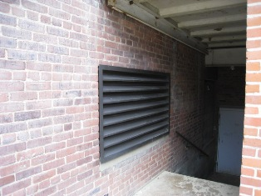

Fresh Air Intake

Picture 2

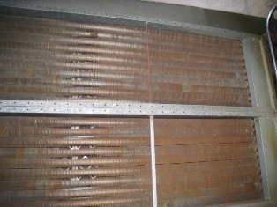

Heating Coils on AHU
Note Filters behind Coils
Picture 3

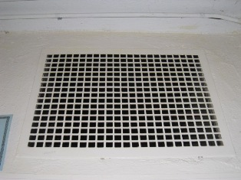

Air Supply Vent

Picture 4

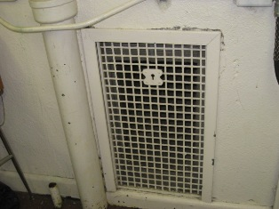

Exhaust Vent

Picture 5

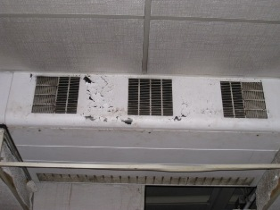

Unit Ventilator (Univent)

Picture 6

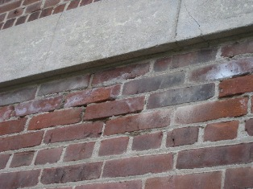

Cracked, Missing Mortar, Note Efflorescence

Picture 7

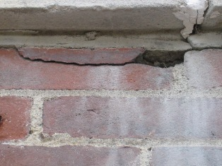

Cracked, Deteriorated Brick

Picture 8

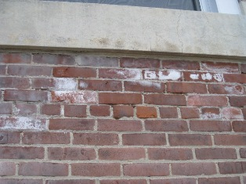

Efflorescence on Masonry

Picture 9

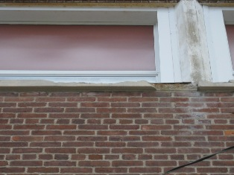

Window Sills in Disrepair (Arrows)

Picture 10

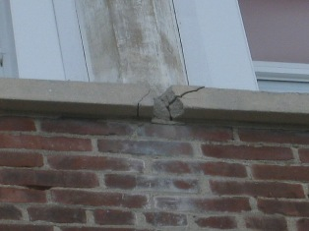

Deteriorating Exterior Sills

Picture 11

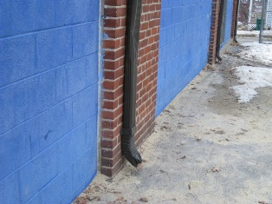

Downspouts Deposit Water in Close Proximity to Building

Picture 12

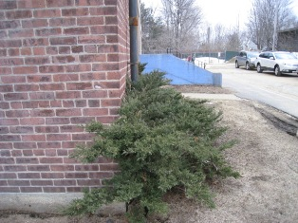

Shrubs Resting Against Masonry

Picture 13

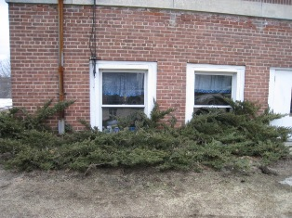

Shrubs Obscuring Basement Windows

Picture 14

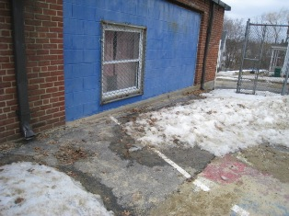

Recessed Cinderblocks Create Small Ledge (Arrow)

Picture 15

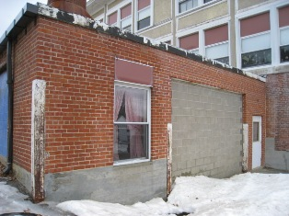

Accumulated Snow and Ice against Building
Note Moistened Joints between Cinderblocks (Arrow)

Picture 16

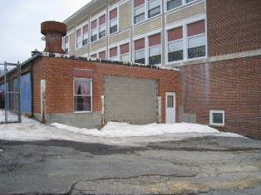

Deteriorated Tarmac
Picture 17

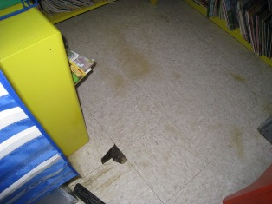

Standing Water on Floor

Picture 18

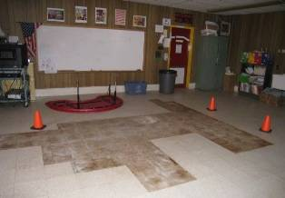

Missing Vinyl Floor Tiles Due to Water Damage
Note Layer of Floor Tiles Underneath

Picture 19

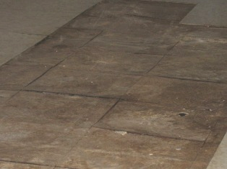

Lifting and Curling Edges of Underlying Floor Tiles which
may Contain Asbestos

Picture 20

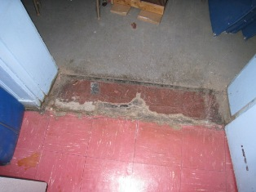

Cracked, Broken Floor Tiles

Picture 21

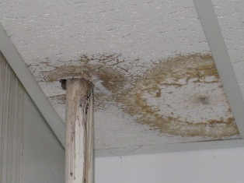

Water-Damaged Ceiling Tile and Wall Surface

Picture 22

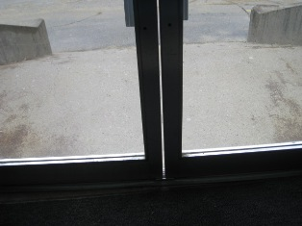

Gap between Exterior Doors

Picture 23

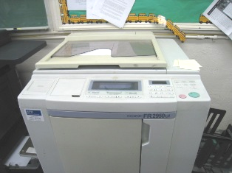

Risograph Copier

Picture 24

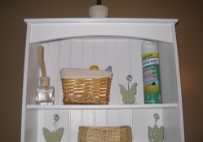

Air Fresheners/Deodorizers, Note Reed Diffuser (Arrow)

Picture 25

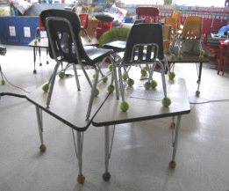

Tennis Balls used as Glides on Table and Chair Legs

Picture 26

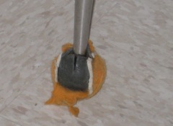

Worn Tennis Ball used as Glide

Picture 27

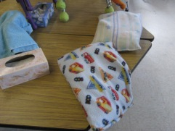

Pillows and Blankets in Classroom

Picture 28

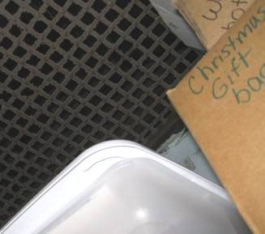

Dust Accumulation on Exhaust Vent

Picture 29

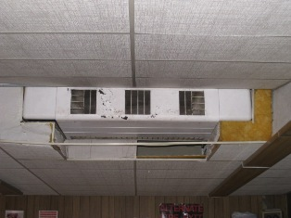

Missing and Deteriorated Ceiling Tiles

Picture 30

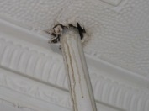

Open Utility Hole, Note Evidence of Leak
Location/ Room | Occupants  in Room | Temp  (°F) | Relative  Humidity  (%) | Carbon  Dioxide  (ppm) | Carbon Monoxide  (ppm) | PM2.5  (µg/m3) | Windows  Openable | Ventilation |  | Remarks
 |  |  |  |  |  |  |  | Supply | Exhaust | Remarks
background | - | 46 | 22 | 265 | ND | 5 |  |  |  | Overcast, visibility 10 mi, wind speed 5 mph (ESE)
B4  (Teachers’ Rm) | 0 | 67 | 23 | 505 | ND | 8 | Y | Y | Y | DO, DEM, Risograph, laminator, penetrations, cooler on carpet
B4 interior room | 7 | 69 | 21 | 556 | ND | 8 | Y | N | N | AD
B2 | 0 | 70 | 20 | 521 | ND | 8 | Y | Y | Y | DO, TB, UF, exhaust obstructed, standing water on floor, floor tiles starting to buckle, stuffed animals, pillows
Boiler room | 0 | 68 | 21 | 477 | ND | 7 | Y | Y | N | Standing water
B3 All purpose room | 13 | 67 | 20 | 561 | ND | 6 | Y | Y | N | DO, TB, DEM, AD, WD CTs, MTs, CD, exhaust not visible
B5 | 0 | 63 | 19 | 401 | ND | 6 | Y | Y | Y | WD floor tiles have started to lift, DEM, TB, MTs, room used as exit only, cleaners/chemicals
Boys’ Room |  |  |  |  |  |  | N | N | Y | WD CT
Gymnasium | 15 | 63 | 28 | 711 | ND | 13 | Y | Y | Y | Broken floor tiles, 15 occupants left 5 minutes ago
B8 | 1 | 65 | 27 | 1058 | ND | 8 | Y | N | N
B9 | 0 | 66 | 24 | 744 | ND | 12 | Y | N | N | Peeling paint
Women’s Rm | - | - | - | - | - | - | N | N | Y | Reed diffusers, exhaust goes on when light is turned on
Girls’ Room | - | - | - | - | - | - | Y | N | Y
Girls’ Room |  |  |  |  |  |  | Y | N | Y
Kindergarten | 14 | 68 | 23 | 987 | ND | 9 | Y | Y | Y | DEM
101 | 3 | 67 | 20 | 571 | ND | 7 | Y | Y | Y | DO, DEM, WD CTs, exhaust obstructed by curtain
102 | 15 | 67 | 22 | 707 | ND | 7 | Y | Y | Y | DO, TB, DEM
103 | 2 | 67 | 21 | 589 | ND | 7 | Y | Y | Y | TB, DEM
104 | 0 | 67 | 20 | 613 | ND | 6 | Y | N | Y
105 | 16 | 67 | 21 | 863 | ND | 8 | Y | Y | Y | DO, DEM
106 | 0 | 68 | 21 | 686 | ND | 10 | Y | N | N
108 | 1 | 68 | 21 | 686 | ND | 7 | Y | N | N | DO, DEM
110 | 16 | 69 | 22 | 1046 | ND | 10 | Y | Y | Y | DEM
201 | 13 | 69 | 21 | 798 | ND | 9 | Y | Y | N | DO, UF, TB, DEM, pillows, exhaust not visible, closet packed with supplies
202 | 2 | 69 | 20 | 720 | ND | 8 | Y | Y | N
203 | 17 | 68 | 22 | 978 | ND | 6 | Y | Y | Y | DEM, TB
206 | 17 | 69 | 23 | 1103 | ND | 10 | Y | Y | Y | DO, TB, PF, DEM, active classroom
208 | 18 | 68 | 28 | 1365 | ND | 13 | Y | Y | N | DO, TB, DEM, exhaust not visible, active classroom

The service life is the median time during which a particular system or component of …[an HVAC]… system remains in its original service application and then is replaced. Replacement may occur for any reason, including, but not limited to, failure, general obsolescence, reduced reliability, excessive maintenance cost, and changed system requirements due to such influences as building characteristics or energy prices (ASHRAE, 1991).
Efflorescence is a characteristic sign of water damage to building materials, but it is not mold growth. As moisture penetrates and works its way through building materials (e.g., brick), water-soluble compounds dissolve, creating a solution. As this solution moves to the surface, the water evaporates, leaving behind white, powdery mineral deposits.

