INDOOR AIR QUALITY ASSESSMENT

Barnstable High School
744 W. Main St,
Hyannis, Massachusetts

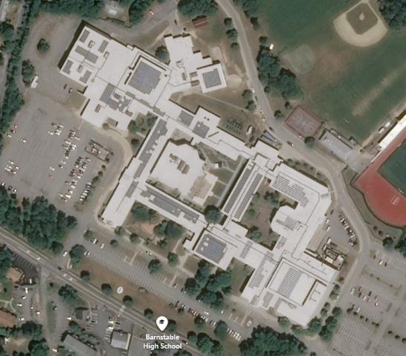

Prepared by:
Massachusetts Department of Public Health
Bureau of Environmental Health
Indoor Air Quality Program
October 2019

BACKGROUND
Building: | Barnstable High School (BHS)
Address: | 744 W Main St, Hyannis, MA
Assessment Requested by: | Barnstable Board of Health coordinated via Barnstable Public Schools (BPS)
Reason for Request: | Collaborative effort to perform general indoor air quality (IAQ) assessments throughout the Barnstable School District.
Date of Assessment: | October 3, 2019
Massachusetts Department of Public Health/Bureau of Environmental Health (MDPH/BEH) Staff Conducting Assessment: | Cory Holmes, Environmental Analyst, Ruth Alfasso, Environmental Engineer, and Jason Dustin, Environmental Analyst, IAQ Program
Building Description: | The BHS is an interconnected complex of several buildings that were constructed at different times with separate heating, ventilation and air conditioning (HVAC) components. Only select areas (some offices, media center) are equipped with air-conditioning (AC). The original building was constructed in 1954; additions were made in 1970 and 1997. The school contains an art wing, shop wing, kitchen/cafeteria, gymnasium, field house, auditorium, science classrooms, band/music rooms, media center, office space and storage.
Windows: | Openable in most areas

METHODS
Please refer to the IAQ Manual and appendices for methods, sampling procedures, and interpretation of results (MDPH, 2015). Note that this building has been visited by the MDPH IAQ Program in 2014 at the request of the BPS. The report from that visit can be found at: https://www.mass.gov/info-details/indoor-air-quality-reports-cities-and-towns-b. It is also important to note that the BPS has reportedly created IAQ committees in their school buildings, each with IAQ liaison/teacher representatives that conducts regular walk-throughs to identify on-going and potential environmental issues.

RESULTS and DISCUSSION
The following is a summary of indoor air testing results (Table 1).
- Carbon dioxide levels were above the MDPH recommended level of 800 parts per million (ppm) in 65 of 248 areas surveyed, which indicates a lack of air exchange in about a quarter of areas assessed. This is most likely due to deactivated mechanical ventilation components as well as limitations on outside air introduction. This is explained further in the Ventilation section of this report.
- Temperature measurements were within or close to the MDPH recommended range of 70°F to 78°F in occupied areas.
- Relative humidity measurements were mostly within the MDPH recommended range of 40 to 60% in all areas tested at the time of assessment
- Carbon monoxide levels were non-detectable (ND) in all areas tested.
- Particulate matter (PM2.5) concentrations measured were below the National Ambient Air Quality (NAAQS) level of 35 μg/m³ in all areas tested, with the exception of room 1213 B, which had a measurement of 54 μg/m³ in close proximity to an electric fragrance diffuser operating at the time of testing
- Total volatile organic compounds (TVOC) levels were ND in areas tested.

Ventilation
A heating, ventilating and air conditioning (HVAC) system has several functions. First it provides heating and, if equipped, cooling. Second, it is a source of fresh air. Finally, an HVAC system will dilute and remove normally-occurring indoor environmental pollutants by not only introducing fresh air, but by filtering the airstream and ejecting stale air to the outdoors via exhaust ventilation. Even if an HVAC system is operating as designed, point sources of respiratory irritation may exist and cause symptoms in sensitive individuals. Carbon dioxide is not a problem in and of itself. It is used as an indicator of the adequacy of the fresh air ventilation. It is important to note that a number of areas tested were sparsely populated or had open windows, which would be expected to reduce carbon dioxide levels. The MDPH approach to resolving indoor air quality problems in schools is generally two-fold: 1) improving ventilation to dilute and remove environmental pollutants and 2) reducing or eliminating exposure opportunities from materials that may be adversely affecting IAQ.
As carbon dioxide levels rise, it indicates that the ventilating system is malfunctioning or the design occupancy of the room is being exceeded. When this happens, a buildup of common indoor air pollutants can occur, leading to discomfort or health complaints. The Occupational Safety and Health Administration (OSHA) standard for carbon dioxide is 5,000 parts per million parts of air (ppm). Workers may be exposed to this level for 40 hours/week, based on a time-weighted average (OSHA, 1997).
Fresh air in classrooms is supplied by unit ventilators (univents, Picture 1). Univents draw air from the outdoors through a fresh air intake located on the exterior wall of the building (Picture 2) and return air through an air intake located at the base of the unit. Fresh and return air are mixed, filtered, heated or cooled and provided to rooms through an air diffuser located in the top of the unit (Figure 1). In several rooms, univents were deactivated by, or at the request of, occupants due to noise or lack of heat control (Table 1); therefore with univents deactivated no mechanical supply of fresh air was being introduced at the time of testing. In addition, some rooms had the top and/or front of some univents blocked by classroom items (Pictures 3 and 4). In order for univents to provide fresh air as designed, intakes/returns must remain free of obstructions. Importantly, these units must remain on and be allowed to operate while rooms are occupied.
Classroom exhaust vents are located in the ceilings (Picture 5) or walls (Pictures 6 and 7) and are connected with ducts to exhaust fans on the roof. A number of these exhaust vents were not drawing air during the assessment (Table 1). Note that in many classrooms, exhaust vents were located near classroom doors (Picture 8). This design works best with the doors to the hallway closed, otherwise the exhaust vents tend to draw air from the hallway rather than the room which reduces the effectiveness of air circulation. Without adequate supply and exhaust ventilation, excess heat/humidity and environmental pollutants can build up and lead to indoor air/comfort complaints.
Mechanical ventilation in common areas and interior rooms is provided by rooftop air handling units (AHUs). Air is drawn in through air intakes, filtered, heated/cooled and distributed via ceiling or wall-mounted diffusers. Air is drawn back to AHUs via ceiling or wall-mounted return vents.
Many of the HVAC units are beyond/near the end of their life cycle. Efficient function of equipment of this age is difficult to maintain, since compatible replacement parts are often unavailable. According to the American Society of Heating, Refrigeration, and Air-Conditioning Engineering (ASHRAE), the service life of this type of unit is 15-20 years, assuming routine maintenance of the equipment (ASHRAE, 1991). It appears the optimal operational lifespan of this equipment has been exceeded. It was reported that the BPS is instituting an HVAC improvement plan to replace several units a year, as funds become available.
To maximize air exchange, the IAQ program recommends that both supply and exhaust ventilation operate continuously during periods of occupancy. In order to have proper ventilation with a mechanical ventilation system, the systems must be balanced after installation to provide an adequate amount of fresh air to the interior of a room while removing stale air from the room. It is recommended that HVAC systems be re-balanced every five years to ensure adequate air systems function (SMACNA, 1994).

Microbial/Moisture Concerns
In order for building materials to support mold growth, a source of water exposure is necessary. Identification and elimination of the source of water moistening building materials is necessary to control mold growth. At the time of the assessment a number of water-damaged materials, some with likely/visible mold growth, were observed (Table 1), in classrooms and other locations.
- Ceiling tiles – Pictures 9 and 10, water stained ceiling tiles can indicate current/historic roof/plumbing leaks or other water infiltration. Active leaks were reported in the laundry room near the restaurant food storage area (Picture 11) as well as the art supplies room in 2718. Water-damaged ceiling tiles can provide a source of mold and should be replaced after a water leak is discovered and repaired;
- Ceiling plaster - water-damaged ceiling plaster and efflorescence was noted in the girl’s locker room (storage area, Picture 12). Efflorescence is a characteristic sign of water damage to building materials, but it is not mold growth. As moisture penetrates and works its way through building materials (e.g., masonry), water-soluble compounds dissolve, creating a solution. As this solution moves to the surface, the water evaporates, leaving behind white, powdery mineral deposits;
- Other building materials -
  - Water-damaged/moldy chair in the former Faculty Lunch Room, currently unoccupied (Picture 13);
  - Visible mold growth on the refrigerator/gaskets in rooms 1504,1510 (Picture 14) and 2719;
  - Visible mold growth on split air conditioning (AC) units in room 1510;
  - Areas under sinks, with both the wooden cabinets and stored materials showing signs of water damage (Picture 15); and
  - Musty odors in a practice room in the music area and a few other areas, likely due to moistening of stored porous materials.
The US Environmental Protection Agency (US EPA) and the American Conference of Governmental Industrial Hygienists (ACGIH) recommend that porous materials (e.g., ceiling tiles, carpet) be dried with fans and heating within 24 to 48 hours of becoming wet (US EPA, 2008; ACGIH, 1989). If not dried within this time frame, mold growth may occur. Once mold has colonized porous materials such as cardboard, books or ceiling tiles, they are difficult to clean and should be removed. Frequently solid/non-porous items can be cleaned to remove water stains and microbial growth.
Plants were present in some classrooms and other areas. Plants, soil, and drip pans can serve as sources of mold/bacterial growth. Plants should be properly maintained, over-watering of plants should be avoided, and drip pans should be inspected periodically for mold growth. In addition, plants should not be placed on top of or in the airstream of HVAC equipment such as univents. Trees/shrubbery were also noted around the exterior of the building, which can hold moisture in close contact with exterior walls (Picture 16).
Several rooms contained aquariums and terrariums (Table 1). Some aquariums and terrariums had mold or algae growing (Picture 17); others were stored without being properly cleaned (Picture 18) with unknown debris caked on glass surfaces (room 1507). Aquariums and terrariums should be properly maintained and cleaned to prevent bacterial growth, mold growth and nuisance odors.
Room 1500 had a portable AC unit. The exhaust vent was ducted through a cardboard cutout duct-taped over an open window (Picture 19). Cardboard is a porous material that can grow mold, especially if wetted repeatedly. Other classrooms had portable AC units that had gaps around the exhaust hose. This condition may allow humid air to enter the room and cause condensation issues. Opening windows during AC operation will also cause condensation issues.
Room 2725 (TV Production) was observed to have heavy dust/debris accumulation on the ceiling tiles. This room is served by an AHU that has an AC component. Occupants reported that the doors to this area are left open to other areas not having AC. This condition may allow for humid air to condense on or near supply air diffusers and debris in nearby ceiling tiles putting them at risk for microbial colonization. Supply vents in this room should be cleaned and new ceiling tiles should be installed in areas of heavy debris accumulation. Doors and windows should be kept closed while AC is in operation to prevent condensation which may affect porous materials.
Sinks in some science and other classrooms do not appear to be used regularly or are used for storage. The trap seal on sinks that are not used often can dry out and allow sewer gases into occupied areas. Science sinks in the 1700s area drain to an acid waste neutralization system, a hatch for which is located in a storeroom (Picture 20; room 1708), which had a pungent odor. The hatch may need to be better sealed to prevent odors from entering the room and/or the storeroom door needs to be sealed using a door sweep to prevent the odors from migrating to the adjacent classrooms.

Other Conditions

HVAC Equipment
Other conditions that can affect indoor air quality were observed during the assessment. The MDPH recommends pleated filters with a Minimum Efficiency Reporting Value (MERV) of 8, which are adequate in filtering out pollen and mold spores (ASHRAE, 2012). Filters should also be changed two to four times a year, or per the manufacturer’s recommendations. To change univent filters, BHS maintenance staff must remove a panel on the front of the unit, open a filter access panel and remove a metal frame to access the filter medium (Pictures 21 and 22). The type of filter medium used by the school comes in a bulk roll and must be cut to size. This method is extremely time consuming and the results are variable; if the filter medium is not properly fitted, gaps can allow unfiltered air into the room and/or reduce the useful life of the filter. It should be determined if disposable filters with an appropriate dust spot efficiency can be installed in these univents. The dust spot efficiency is the ability of a filter to remove particulates of a certain diameter from air passing through the filter. Note that increased filtration can reduce airflow by increased resistance. Prior to any increase of filtration, each univent should be evaluated by a ventilation engineer as to whether it can maintain function with more efficient filters.
In some areas, exhaust vents, supply diffusers, personal fans and the interior of univents had accumulated dust/debris (Table 1, Pictures 5, 23 through 25). This dust can be reaerosolized under certain conditions, and can also be a medium for mold growth. Univent cabinets can also accumulate dust and debris which should be cleaned when filters are changed (e.g., 2 to 4 times/year).

Carpeting
Some areas had wall to wall carpeting, in some cases the carpet was wrinkled/worn and appeared to be past its service life (Pictures 26 and 27; Table 1). The service life of carpeting in schools is approximately 10-11 years (IICRC, 2002). Aging carpet can produce fibers that can be irritating to the respiratory system. In addition, tears or lifting carpet can create tripping hazards. Area rugs were also observed in many classrooms (Table 1). Carpets should be cleaned annually (or semi-annually in soiled/high traffic areas) in accordance with Institute of Inspection, Cleaning and Restoration Certification (IICRC) recommendations, (IICRC, 2012). Regular cleaning with a high efficiency particulate air (HEPA) filtered vacuum in combination with an annual cleaning will help to reduce accumulation and potential aerosolization of materials from carpeting. Area carpets too worn to be effectively cleaned should be replaced. Area rugs should be rolled up and stored in a clean, dry place when rooms are not occupied during the summer months to prevent moistening due to condensation.
It was reported by facility staff that carpeting is gradually being replaced in the school as funds become available. Much of the old carpeting seen in the previous visit has already been removed.

Total Volatile Organic Compounds
Exposure to low levels of total volatile organic compounds (TVOCs) may produce eye, nose, throat, and/or respiratory irritation in some sensitive individuals. BEH/IAQ staff examined rooms for products containing VOCs. BEH/IAQ staff noted hand sanitizers, scented products, plug in air fresheners/diffusers (Picture 28), home cleaning products, and dry erase materials in use within the building. All of these products have the potential to be irritants to the eyes, nose, throat, and respiratory system of sensitive individuals. As noted above, elevated levels of particulate matter were measured in the same room as an essential oil diffuser (Picture 29; Table 1). In addition, spray bottles/cleaning products should be kept out of reach of children.
Several areas contain photocopiers, which can give off waste heat and irritating odors. VOCs and ozone can be produced by photocopiers, particularly if the equipment is older and in frequent use. Ozone is a respiratory irritant (Schmidt Etkin, D., 1992). These units should be used in well-ventilated areas or in rooms with local exhaust ventilation operating.

Vocational/Shop Areas
3-D printers were located in several classrooms and auxiliary areas (Picture 30; Table 1). These units can give off particulates and TVOCs. 3-D printers should be used with local exhaust or in rooms with exhaust vents to the outside. Laser cutters were also found in a few of the same areas, and those did have local exhaust to remove smoke, particulates and odors from classrooms. In classroom 1713 (robotics), along with the 3-D printers there was also a pile of plastic debris on a table (Picture 31) not near any local exhaust. In places where plastic is melted, formed or cut, local exhaust is needed to remove odors, smoke, particulates and TVOCs. Any remaining debris should be cleaned up promptly.
The woodshop was equipped with local exhaust from most of the equipment as well as a room-wide exhaust system. The exhaust ducts all connect via vacuum with a collection system outdoors (Picture 32). These local exhaust units need to be turned on whenever the equipment is operating along with the room exhaust. The collection system should be emptied and maintained regularly to prevent a build-up of wood shavings.
There are several kilns in a room next to the ceramics room (1713), including one that is gas-fired. All are equipped with local exhaust which should be used whenever the equipment is operated. There is also a room exhaust system, but it was unknown if the louvers could be operated. Note that this room has numerous roof leaks and had several water-damaged and missing ceiling tiles. Since the room is not frequently occupied and does not contain porous flooring or furniture, removal of the entire set of ceiling tiles may be the best way to avoid water-damaged materials and microbial growth until the source of the leaks is repaired.

Science Storage
Finally, the science/chemical storeroom (1514) was examined. It was reported that the science areas had chemical cleanouts within the last few years. Chemical storage areas are equipped with local exhaust, which was not operating at the time of assessment. It is important that proper exhaust is functioning to remove any airborne fumes odors during chemical prep work. The area appeared organized; however, some issues were observed such as:
- Unknown debris/chemical crystallization on shelves/flame cabinet (Picture 33);
- A number of bottles labeled by chemical formula and not name were noted (Picture 34). Containers should be labeled with the chemical name of its content so an untrained person can identify the material in the case of an emergency.
- Containers had glass or rubber stoppers, which are not a permanent storage method, some of the rubber stoppers were damaged, which allow chemicals to leak into the environment; some containers just had plastic film (Pictures 35 and 36);

Other Conditions
In many classrooms and storage areas, large numbers of items were on floors, windowsills, tabletops, counters, bookcases and desks, which provide a source for dusts to accumulate. These items (e.g., papers, folders, boxes) make it difficult for custodial staff to clean. Items should be relocated and/or be cleaned periodically to avoid excessive dust build up. In addition, dust and debris can accumulate on flat surfaces (e.g., desktops, shelving and carpets) in occupied areas and subsequently be re-aerosolized causing further irritation.
Pencil sharpeners were located near or on univents and heaters in some classrooms (Picture 37), and shavings could be seen falling into the units. Pencil shavings create an irritating dust that can be distributed by the ventilation system.
Missing light covers were seen in a few areas (Table 1). Fixtures should be equipped with access covers installed with bulbs fully secured in their sockets. Breakage of glass can cause injuries and may release mercury and/or other hazardous compounds.
Open utility holes and/or breaches were observed in some areas (Table 1, Picture 38). These spaces can provide a pathway for odors and particulates from wall cavities into occupied areas.
Note that the Environmental Protection Agency (EPA) conducted a National School Radon Survey in which it discovered nearly one in five schools had “…at least one frequently occupied ground contact room with short-term radon levels above 4 [picocuries per liter] pCi/L” (US EPA 1993). The BEH/IAQ Program therefore recommends that every school be tested for radon, and that this testing be conducted during the heating season while school is in session in a manner consistent with USEPA radon testing guidelines. Radon measurement specialists and other information can be found at www.nrsb.org and http://aarst-nrpp.com/wp, with additional information at: http://www.mass.gov/eohhs/gov/departments/dph/programs/environmental-health/exposure-topics/iaq/radon.

RECOMMENDATIONS
The conditions related to IAQ problems at the BHS raise a number of issues. The general building conditions/design, maintenance, work hygiene practices, and the condition of HVAC equipment, if considered individually, present conditions that could degrade IAQ. When combined, these conditions can serve to further degrade IAQ. Some of these conditions can be remedied by actions of building occupants. Other remediation efforts will require alteration to the building structure and equipment. For these reasons, a two-phase approach is recommended. The first consists of short-term measures to improve air quality and the second consists of long-term measures that will require planning and resources to adequately address overall IAQ concerns.

Short-term measures:
- Continue to employ district-wide/building specific IAQ committees/liaisons with regular walk-throughs of the building to identify on-going and/or potential issues.
- Operate the HVAC system (supply/exhaust) to provide for continuous fresh air ventilation during occupied hours.
- Make repairs to univents as needed (e.g., noise 1514/temperature 1522).
- Remove furniture and items blocking the front and top of univents.
- Periodically assess whether exhaust vents (classrooms and restrooms) are drawing air and make repairs as needed. Particular attention should be made to exhausts in areas of chemical storage and where photocopiers are used.
- Use openable windows to supplement fresh air during temperate weather. Ensure all windows are closed tightly at the end of each day. Do not use windows while AC system is operating in its chilling mode to prevent condensation/mold growth.
- Close classroom doors during occupancy to allow for more effective function of exhaust vents (once operating as designed).
- Work with staff to troubleshoot temperature control/ventilation problems.
- Utilize a system to report and track maintenance issues so that concerns can be reported by staff and maintenance staff can report when issues have been resolved.
- Consider adopting a balancing schedule of every 5 years for all mechanical ventilation systems, as recommended by ventilation industrial standards (SMACNA, 1994).
- Work with a roofing contractor/building engineer to investigate/repair building envelope leaks (e.g., kiln area, laundry, food storage area). Until this has been completed, avoid storing porous materials in areas of known leaks.
- Once repairs are made, replace water-damaged ceiling tiles and refinish areas of water damage (e.g., ceiling in girls’ locker room storage area). Inspect the area above the stained tiles for water damage or odors and remediate or clean as necessary.
- Discard porous classroom items that have mold growth (e.g., books, cardboard, paper). Conduct a close examination of items in storage closets/band rooms. Non-porous items can be cleaned with soap/water or an anti-microbial product.
- Keep classroom/office plants in good condition, avoid overwatering, and keep them away from the airstream of ventilation equipment.
- Ensure aquariums and terrariums are clean and odor free.
- Reduce or eliminate the use of air fresheners/diffusers, scented cleaners, hand sanitizers and dry erase materials to reduce irritation. Consult the MDPH IAQ Guidance “Clean Air is Odor Free”, attached as Appendix A for more information.
- After consulting with a ventilation engineer, consider changing filters in HVAC units 2-4 times a year with MERV 8 (or higher) filters. Clean HVAC and univent cabinets of debris and dust when filters are changed.
- Clean supply/exhaust vents, univents and personal fans regularly to remove accumulated dust/debris. Replace surrounding ceiling tiles that cannot be adequately cleaned.
- Move location of pencil sharpeners away from ventilation equipment and empty regularly.
- Ensure all refrigerators are kept clean to prevent microbial growth and odors. Clean gaskets and other surfaces with a mild antimicrobial solution to remove debris and mold. If cannot be adequately cleaned-replace.
- Ensure that condensation from AC equipment is draining properly. Check collector pans, piping and any associated pumps for clogs and leaks and clean periodically to prevent stagnant water build-up and remove debris that may provide a medium for microbial growth.
- Replace cardboard around AC exhaust in Room 1500 with non-porous/mold-resistant material.
- Trim back trees from overhanging the roof and ensure all plants/shrubs are located at least five feet away from exterior walls. Remove clinging plants.
- Fix plumbing leak in chemical storage area 1512.
- Ensure fluorescent light fixtures have covers installed.
- Seal open utility holes/breaches in walls/ceilings/floors (e.g., Picture 38) with a fire-rated sealant.
- For buildings in New England, periods of low relative humidity during the winter are often unavoidable. Therefore, scrupulous cleaning practices should be adopted to minimize common indoor air contaminants whose irritant effects can be enhanced when the relative humidity is low. To control for dusts, a high efficiency particulate arrestance (HEPA) filter equipped vacuum cleaner in conjunction with wet wiping of all surfaces is recommended. Avoid the use of feather dusters. Drinking water during the day can help ease some symptoms associated with a dry environment (throat and sinus irritations).
- Clean carpeting annually or semi-annually in soiled high traffic areas as per the recommendations of the Institute of Inspection, Cleaning and Restoration Certification (IICRC 2012). Area carpets too worn to be effectively cleaned should be replaced. Roll up and store are rugs in a clean, dry place during the summer.
- Continue with the long-term plan to replace all carpeting in the building as funds become available.
- Relocate or consider reducing the amount of materials stored in classrooms to allow for more thorough cleaning of classrooms. Clean items regularly with a wet cloth or sponge to prevent excessive dust build-up.
- Keep specialized exhaust/source control equipment such as in the wood shop and kiln area in good condition. Use both local and room-wide exhaust when equipment is being used.
- Continue to utilize the US EPA’s (2000), “Tools for Schools”, as an instrument for maintaining a good IAQ environment in the building available at: http://www.epa.gov/iaq/schools/index.html.
- The school should be tested for radon by a certified radon measurement specialist during the heating season when school is in session. Radon measurement specialists and other information can be found at: www.nrsb.org, and http://aarst-nrpp.com/wp.
- For more information on mold refer to “Mold Remediation in Schools and Commercial Buildings” published by the US Environmental Protection Agency (US EPA, 2008). http://www.epa.gov/mold/mold-remediation-schools-and-commercial-buildings-guide.

Long-term Recommendations:
- Continue with plans to replace HVAC units/components as they become past their service life. If not conducted already, consider contacting an HVAC engineering firm for an assessment of the ventilation system’s components and control systems (e.g., controls, air intake louvers, thermostats). Based on the age, physical deterioration, and availability of parts for ventilation components, such an evaluation is necessary to determine the operability and feasibility of repairing/replacing the equipment.
- Consult with a ventilation engineer regarding the use of disposable, pleated cardboard filters instead of filter media that needs to be hand cut and installed in metal racks.

REFERENCES
ACGIH. 1989. Guidelines for the Assessment of Bioaerosols in the Indoor Environment. American
ASHRAE. 1991. ASHRAE Applications Handbook, Chapter 33 “Owning and Operating Costs”. American Society of Heating, Refrigeration and Air Conditioning Engineers, Atlanta, GA.
ASHRAE. 2012. American Society of Heating, Refrigeration and Air Conditioning Engineers (ASHRAE) Standard 52.2-2012 -- Method of Testing General Ventilation Air-Cleaning Devices for Removal Efficiency by Particle Size (ANSI Approved). 2012.
IICRC. 2002. Institute of Inspection, Cleaning and Restoration Certification. A Life-Cycle Cost Analysis for Floor Coverings in School Facilities.
IICRC. 2012. Institute of Inspection Cleaning and Restoration Certification. Institute of Inspection, Cleaning and Restoration Certification. Carpet Cleaning: FAQ.
MDPH. 2015. Massachusetts Department of Public Health. Indoor Air Quality Manual: Chapters I-III. Available at: http://www.mass.gov/eohhs/gov/departments/dph/programs/environmental-health/exposure-topics/iaq/iaq-manual/.
OSHA. 1997. Limits for Air Contaminants. Occupational Safety and Health Administration. Code of Federal Regulations. 29 C.F.R 1910.1000 Table Z-1-A.
Schmidt Etkin, D. 1992. Office Furnishings/Equipment & IAQ Health Impacts, Prevention & Mitigation. Cutter Information Corporation, Indoor Air Quality Update, Arlington, MA.
SMACNA. 1994. HVAC Systems Commissioning Manual. 1st ed. Sheet Metal and Air Conditioning Contractors’ National Association, Inc., Chantilly, VA.
US EPA. 1993. Radon Measurement in Schools, Revised Edition. Office of Air and Radiation, Office of Radiation and Indoor Air, Indoor Environments Division (6609J). EPA 402-R-92-014. https://www.epa.gov/radon/radon-schools
US EPA. 2000. Tools for Schools. Office of Air and Radiation, Office of Radiation and Indoor Air, Indoor Environments Division (6609J). EPA 402-K-95-001, Second Edition. http://www.epa.gov/iaq/schools/index.html.
US EPA. 2008. Mold Remediation in Schools and Commercial Buildings. US Environmental Protection Agency, Office of Air and Radiation, Indoor Environments Division, Washington, D.C. EPA 402-K-01-001. http://www.epa.gov/mold/mold-remediation-schools-and-commercial-buildings-guide.
Picture 1
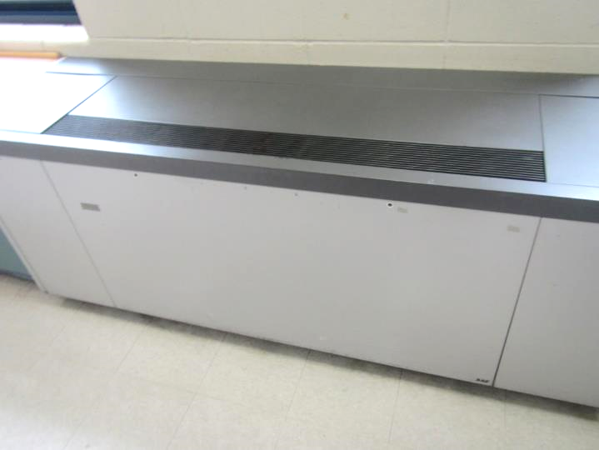
Typical classroom univent
Picture 2
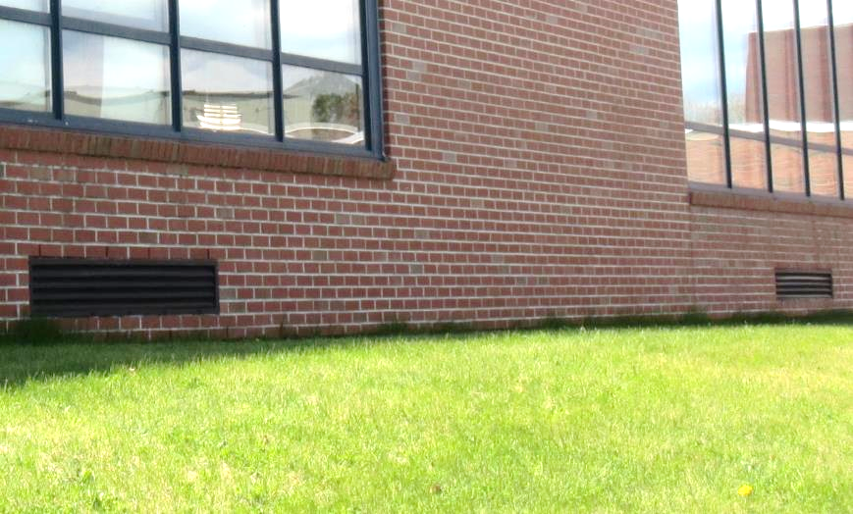
Univent fresh air intakes
Picture 3
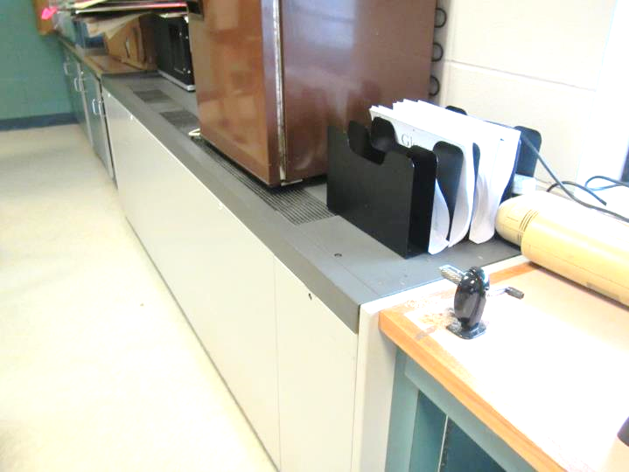
Items on univent obstructing airflow
Picture 4
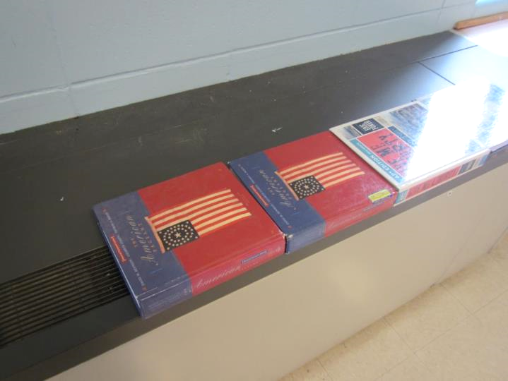
Books on univent obstructing airflow
Picture 5
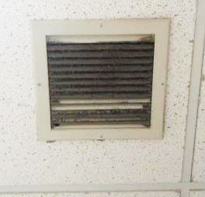
Classroom exhaust vent, note accumulated dust/debris
Picture 6
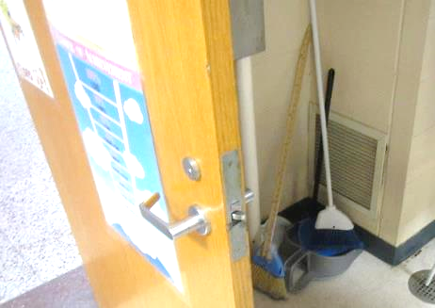
Exhaust vent on wall in classroom
Picture 7
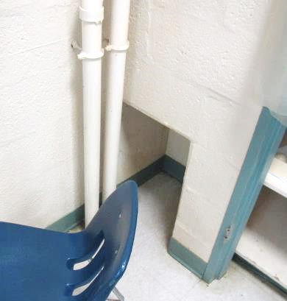
Wall-cubby exhaust in classroom
Picture 8
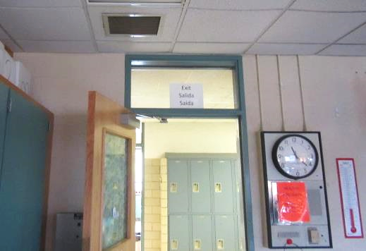
Classroom exhaust vent near open hallway door, arrow indicates airflow
Picture 9
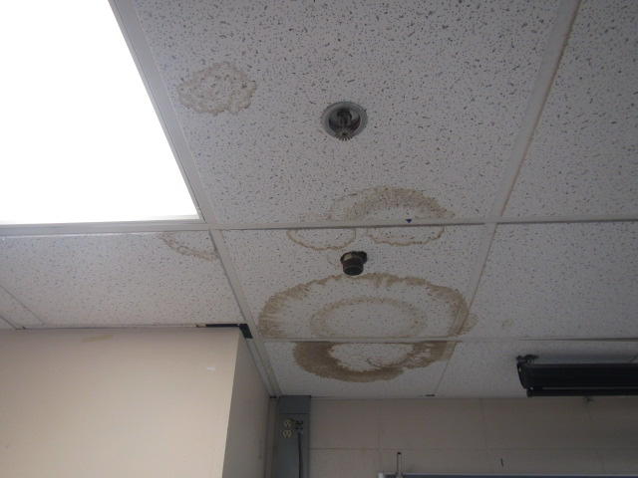
Water-damaged ceiling tiles
Picture 10
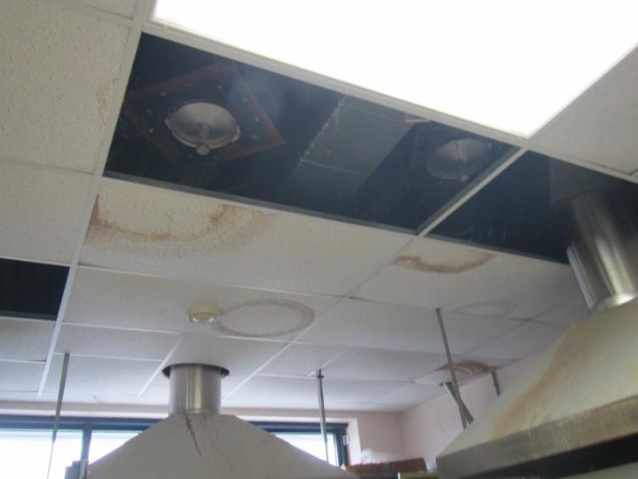
Missing/water-damaged ceiling tiles (kiln room)
Picture 11
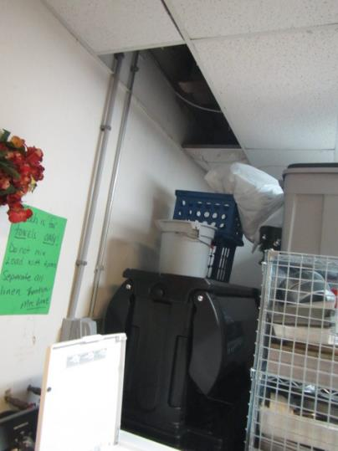
Active leaks were reported in the laundry room near the restaurant food storage area
Picture 12
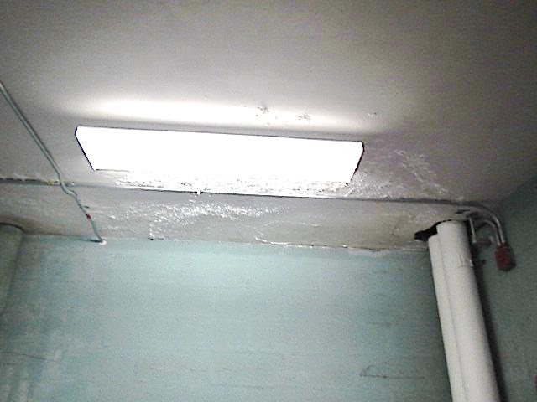
Water-damaged ceiling plaster and efflorescence in girl’s locker room storage area
Picture 13
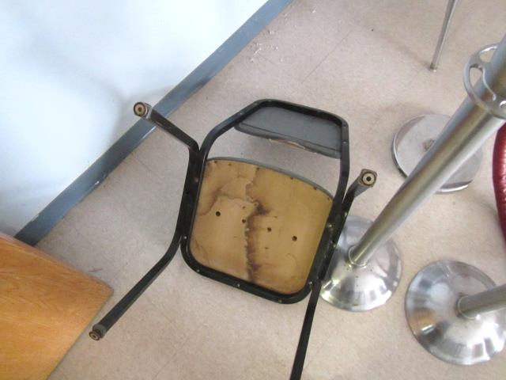
Water-damaged/moldy chair in former Faculty Lunch Room
Picture 14
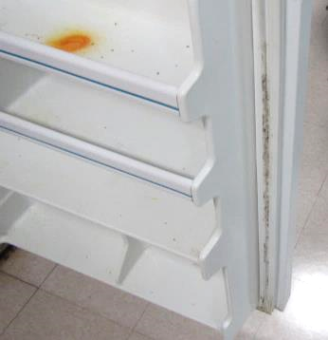
Mold growth on refrigerator gasket; also note dead flies on top door shelf
Picture 15
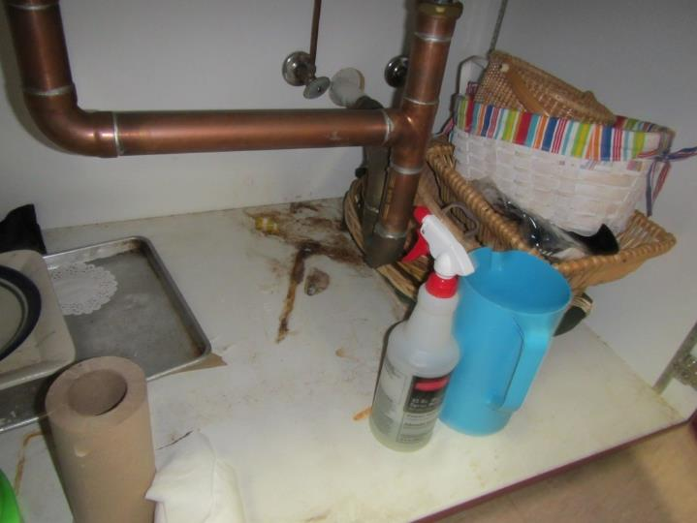
Water stains under sink
Picture 16
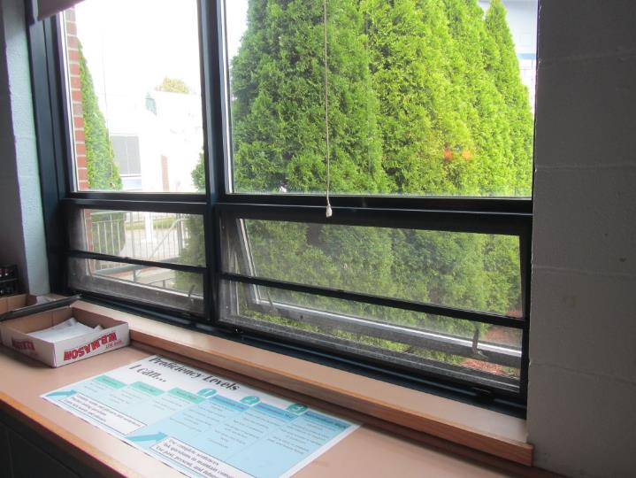
Trees/shrubbery in close contact with exterior walls
Picture 17
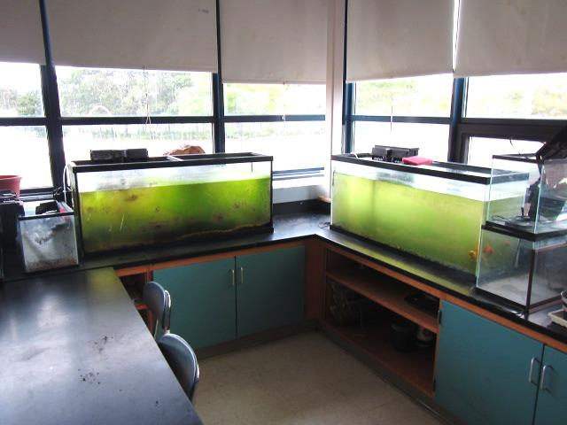
Aquariums green with algal growth
Picture 18
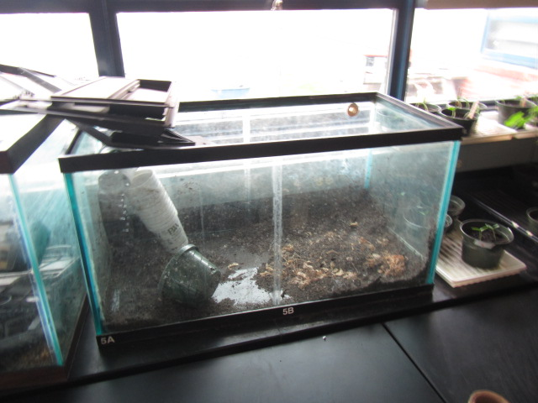
Empty aquarium/terrarium with debris
Picture 19
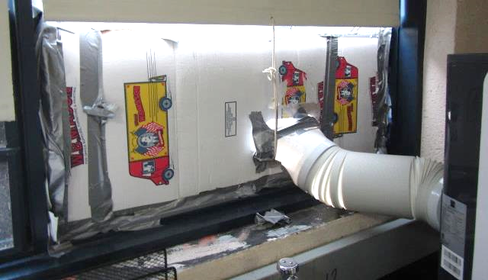
Cardboard cutout installed over open window for AC exhaust in room 1500
Picture 20
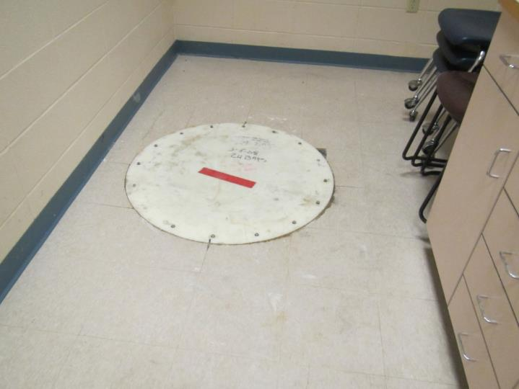
Acid waste system access hatch
Picture 21
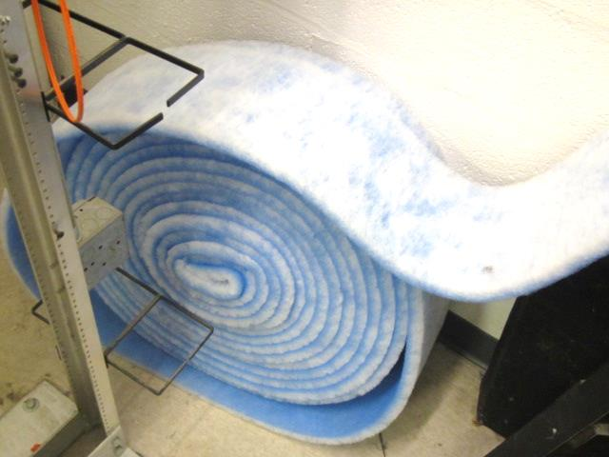
Filter media for univents
Picture 22
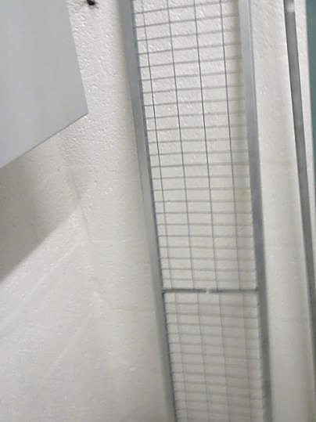
Metal rack for univent filter media
Picture 23
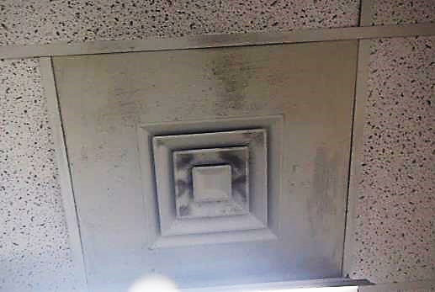
Dust/debris on surface of supply diffuser
Picture 24
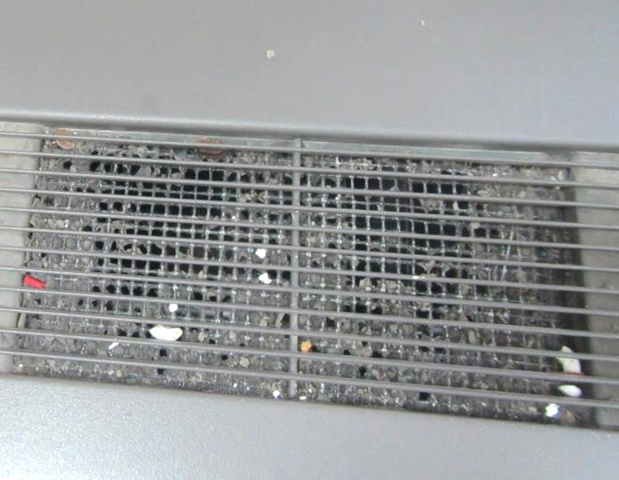
Dust/debris in univent air diffuser
Picture 25
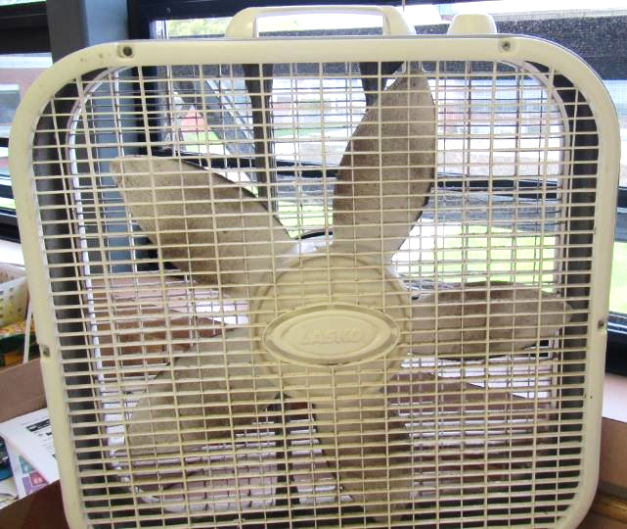
Dust/debris on fan blades
Picture 26
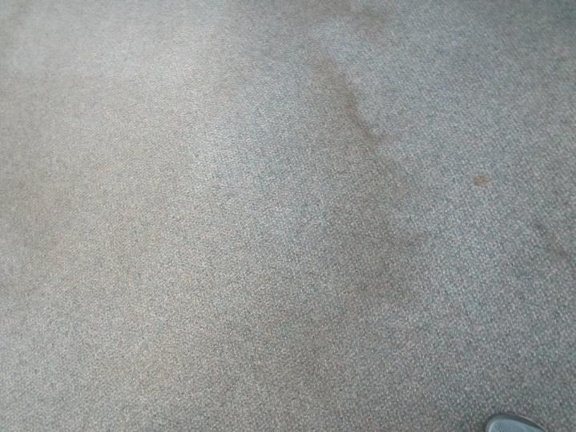
Stained/soiled carpeting
Picture 27
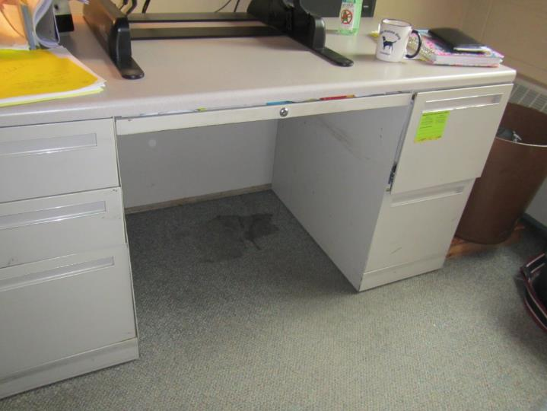
Stained/soiled carpeting
Picture 28
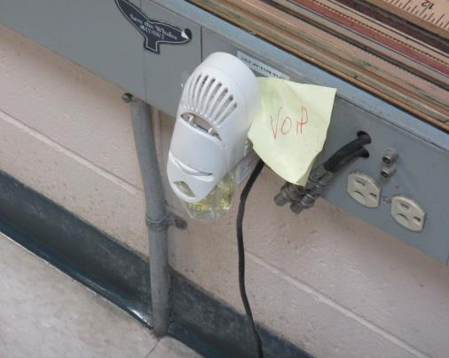
Plug-in air freshener
Picture 29
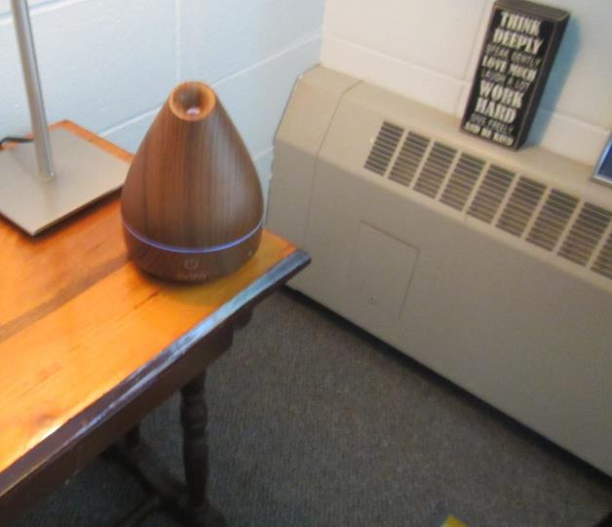
Essential oil diffuser
Picture 30
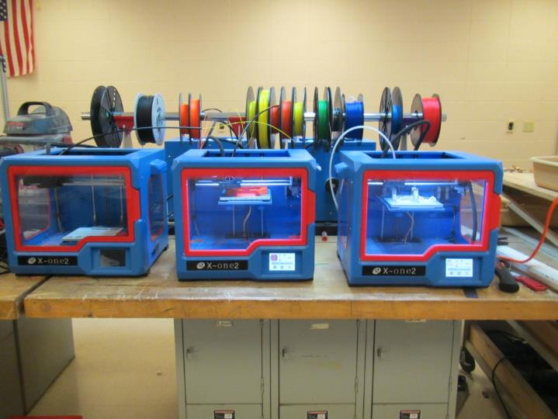
3-D printers in use
Picture 31
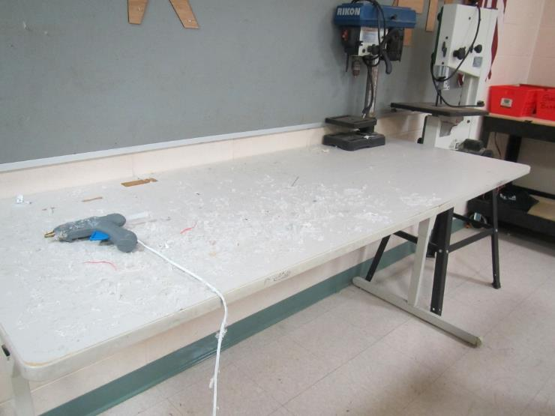
Plastic debris
Picture 32
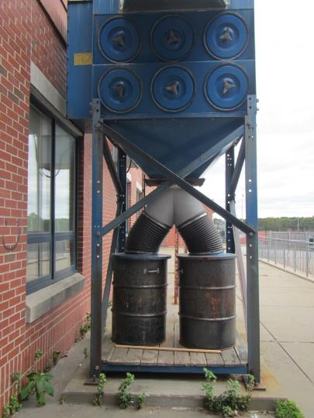
Sawdust collection system outside wood shop
Picture 33
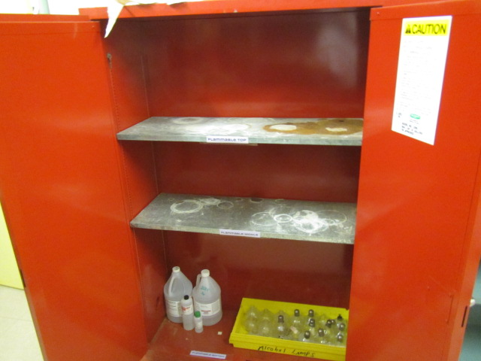
Unknown debris/chemical crystallization on flammable cabinet shelving
Picture 34
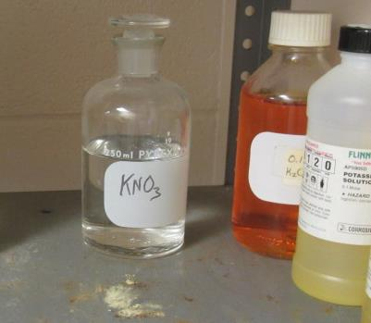
Glass stoppered bottle labeled with chemical formula, also note debris/chemical crystallization on shelf
Picture 35
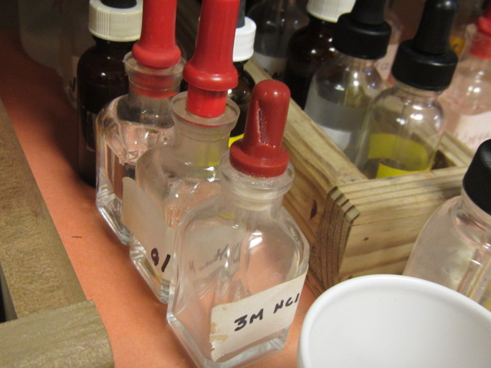
Damaged rubber stopper, which can allow chemicals to leak out
Picture 36
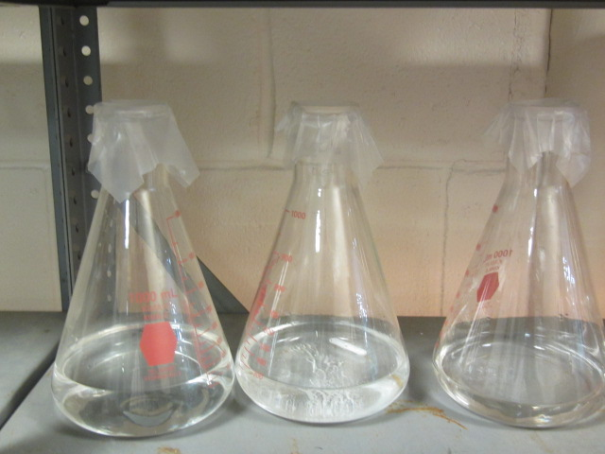
Unlabeled bottles with plastic film in chemical storage area
Picture 37
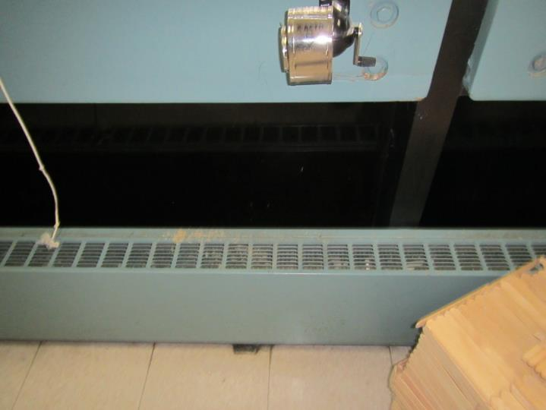
Pencil shavings on heater
Picture 38
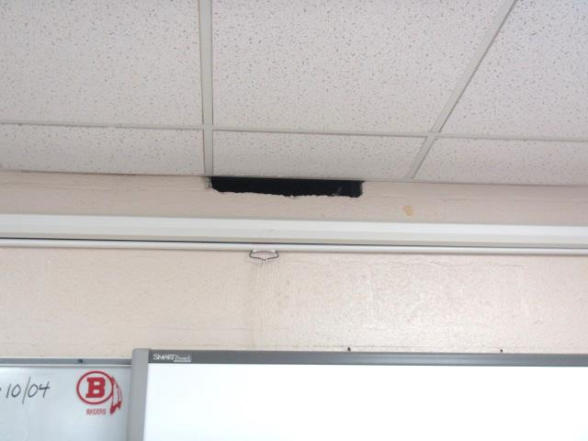
Hole in wall of Room 1514
Location | Carbon  Dioxide  (ppm) | Carbon Monoxide  (ppm) | Temp  (°F) | Relative  Humidity  (%) | PM2.5  (µg/m³) | TVOCs  (ppm) | Occupants  in Room | Windows  Openable | Ventilation |  | Remarks
 |  |  |  |  |  |  |  |  | Supply | Exhaust
Background (outside) | 411 | ND | 57 | 46 | 4 | ND |  |  |  |  | Cool and cloudy
Conference room by front entrance | 914 | ND | 75 | 47 | 4 |  | 7 | Y | Y | Y | DEM, coffee maker
Instrument storage | 795 | ND | 73 | 47 | 2 |  | 0 | N | Y | Y | Instrument cases in cage storage, NC
Practice | 715 | ND | 73 | 50 | 1 |  | 0 | N | Y |  | WD CT, musty odor, used for storage of fabric items
Music | 561 | ND | 74 | 39 | 1 |  | 1 | Y | Y | Y | UV on, carpeted, keyboards, DEM
Practice | 497 | ND | 73 | 45 | 1 |  | 0 | N | Y |  | Piano, dust vent
Practice | 637 | ND | 74 | 49 | 1 |  | 0 | N | Y |  | Pile of speakers on the floor, NC
Music library | 543 | ND | 74 | 39 | 1 |  | 0 | N | Y | Y | MT and bucket for leaks (bucket currently dry), paper
Music teacher | 679 | ND | 73 | 41 | 2 |  | 0 | Y open | Y | Y | Sink, NC, fridge
Music classroom | 779 | ND | 73 | 47 | 1 |  | 7 | Y | Y | Y | NC, DEM, dusty vents
Costume storage | 501 | ND | 71 | 39 | 1 |  | 0 | N | Y | Y | Heavy rows of costumes, NC
1103 Choir | 489 | ND | 70 | 35 | 1 |  | 30 | Y | Y | Y | NC
Women’s changing room | - | ND |  |  |  |  |  | N | Y | Y | Exhaust not on
Men’s changing room | - | ND |  |  |  |  |  | N | Y | Y | 1 WD CT
Stage | 421 | ND | 68 | 35 | 1 |  | 0 | N | Y | Y | Sets
1111 storage | 1329 | ND | 71 | 44 | 10 |  | 0 | N | Y |  | Next to boiler room, possible gas-fired heater
1110 prep | 462 | ND | 77 | 39 | 1 |  | 0 | N | Y |  | WD CT and MT
1109 | 419 | ND | 74 | 31 | 2 |  | 0 |  |  |  | NC, boiler room
Custodial area | 434 | ND | 75 | 32 | 2 |  | 0 | N + door | Y | Y | WD CT and WD light fixture
Restroom in custodial area | 552 | ND | 74 | 34 | 2 |  | 0 | N | Y | Y | Fridge gasket mold
1720 copy | 516 | ND | 74 | 35 | 2 |  | 0 | N | Y | Y | 2 PC
1719 | 551 | ND | 74 | 35 | 2 |  | 3 | N | Y | Y | 2 WD CT, CP
1716 | 556 | ND | 74 | 36 | 2 |  | 0 | N + door | Y | Y | Wood dust, vacuum exhaust system
3-d printer room | 926 | ND | 74 | 39 | 4 |  | 3 | Y | Y | Y | 6 3D printers, several operating, no local exhaust, NC, laser cutter with local exhaust, DEM
1316 library | 554 | ND | 72 | 42 | 1 |  | 3 | N | Y | Y | Library area has new rooftop units
Collaboration lounge | 480 | ND | 71 | 39 | 1 |  | 2 | N | Y | Y | New space, glass-walled
1316 C | 505 | ND | 71 | 40 | 1 |  | 0 | N | Y | Y
1316 E | 476 | ND | 71 | 40 | 1 |  | 0 | N | Y | Y
1316 large open area | 521 | ND | 71 | 41 | 1 |  | 9 | N | Y | Y
1316 F | 564 | ND | 71 | 43 | 1 |  | 0 | N | Y | Y | Stained carpet
1316 H | 611 | ND | 70 | 44 | 1 |  | 0 | N | Y | Y | 1 WD CT, DEM
1316 office | 573 | ND | 70 | 41 | 1 |  | 0 | N | Y | Y | HS
1324 | 635 | ND | 71 | 43 | 1 |  | 16 | Y | Y | Y | DEM
1323 | 601 | ND | 70 | 40 | 1 |  | 1 | Y | Y | Y | DEM, PS on heater
Cafeteria | 516 | ND | 72 | 37 | 2 |  | 5 | Y | Y | Y | ~ 30 mins after lunch (~300 occupants)
Faculty Lounge (Not in Service) |  |  |  |  |  |  |  |  |  |  | Moldy chair-odors
1403 | 515 | ND | 76 | 37 | 4 |  | 1 | Y | Y | Y
1404 | 933 | ND | 75 | 45 | 5 |  | 16 | Y Open | N | Y | AT, PFs
School Store | 843 | ND | 76 | 40 | 5 |  | 2 | N | N | Y | PF, 2 WD CTs
Girls Locker Room | 471 | ND | 75 | 41 | 3 |  | 0 | N | Y | Y | ½ UVs-off
Girls Locker Storage Room |  |  |  |  |  |  |  | N | N | N | WD ceiling plaster/efflorescence, cardboard storage on cement floor
Instructor’s Office Shower Room |  |  |  |  |  |  |  | N | N | Y | Exhaust off, occasional odors from drain
Gym | 607 | ND | 73 | 46 | 4 |  | 38 | N | Y | Y
1407 | 841 | ND | 73 | 42 | 2 |  | 23 | N | Y | Y | Air purifier
1408 | 484 | ND | 71 | 39 | 2 |  | 1 | N | Y | Y
1409 | 492 | ND | 71 | 40 | 6 |  | 1 | N | Y | Y | Dust/debris on vents
Restaurant | 487 | ND | 70 | 44 | 5 |  | 0 | N | Y | Y | Dust/debris on vents
Food Storage |  |  |  |  |  |  |  | N | Y | Y | Dust/debris on vents
Storage/Laundry |  |  |  |  |  |  |  | N | Y | Y | Leaks/WD ceiling plaster
1410 | 460 | ND | 70 | 41 | 2 |  | 0 | N | Y | Y | WD CT, AT
1500 | 623 | ND | 73 | 40 | 3 |  | 13 | Y | Y | Y | Exhaust not operating, DO, WD CT-corner, AC-cardboard
1501 | 560 | ND | 72 | 36 | 3 |  | 1 | Y | Y | Y | DO, WD CT, dust/debris on vents
1502 | 932 | ND | 73 | 43 | 2 |  | 18 | Y | Y | Y | DO
1503 | 657 | ND | 72 | 41 | 2 |  | 11 | Y | Y | Y | PF
1504 | 544 | ND | 73 | 42 | 2 |  | 0 | N | Y | Y | Mold-fridge, dust/debris on vents
1506 | 434 | ND | 72 | 41 | 2 |  | 1 | Y | Y | Y | Aqua-green/algae
1507 | 731 | ND | 75 | 45 | 2 |  | 0 | N | N | Y | Exhaust not operating, PC, aqua-not clean
1508 | 564 | ND | 72 | 44 | 4 |  | 1 | Y Open | Y | Y | Aqua, dust/debris on vents, MT
1509 | 555 | ND | 73 | 46 | 3 |  | 0 | N | Y | Y
1510 | 486 | ND | 72 | 43 | 4 |  | 2 | Y | Y | Y | Mold on AC units & fridge
1511 | 626 | ND | 71 | 43 | 2 |  | 1 | Y | Y | Y | Plants, PF
1512 (Inner Chem Storage) |  |  |  |  |  | ND |  | N | Y | Y | Flam locker-debris on shelf, exhaust not operating, leaking pipe into bucket
1514 | 601 | ND | 73 | 39 | 8 | ND | 1 | Y Open | Y | Y | UV-off (noise), occupants gone ~ 30 mins, plants, large space/hole in wall
1514 Chem Closet |  |  |  |  |  | ND |  | N | Y | Y | Exhaust not operating, items w/chem name-labels, rubber stoppers-chems/damaged, chem debris on shelving/flam locker
1515 | 633 | ND | 72 | 44 | 4 |  | 1 | Y | Y | Y | Plants, PF, aqua
1516 | 661 | ND | 75 | 41 | 2 |  | 0 | Y | Y | N
1517  (Network Rm) |  |  |  |  |  |  |  | N | N | Y | Dark staining on ceiling (corner), open holes, dirty floor
1519 Storeroom | 884 | ND | 75 | 42 | 3 |  | 0 | N | Y | N | Flammable materials, paint thinner, insecticides, paint-(rec Flam storage locker or relocate materials)
1520 | 794 | ND | 75 | 35 | 4 |  | 0 | Y | N | Y | Exhaust not operating, dust/debris on surfaces/items, missing cinderblock/open utility holes, cobwebs
1521 | 679 | ND | 74 | 38 | 2 |  | 1 | Y | Y | Y | UV-off, AT, PF, aqua, 5 WD CTs
1522 | 727 | ND | 75 | 41 | 3 |  | 20 | Y Open | Y | Y | UV-off (temp issues), PF, MT, DO, floor drains
1523 | 1020 | ND | 75 | 43 | 2 |  | 23 | Y | Y | Y | Exhaust weak/off, AT, PF, WD CT, PF, chem hood, MT
1700 C | 741 | ND | 74 | 43 | 2 |  | 2 | Y | Y | Y | Carpeted, stain from old leak on carpet
1700 B | 701 | ND | 74 | 46 | 6 |  | 2 | Y 1 open | Y | Y | Carpet
1700 A | 685 | ND | 74 | 40 | 3 |  | 0 | N | Y | Y | Water cooler on carpet, PF, food odor, microwave
1701 | 691 | ND | 73 | 38 | 2 |  | 7 | Y 4 open | Y | Y | UV on, DEM
1702 | 785 | ND | 73 | 41 | 5 |  | 0 | Y 4 open | Y | Y | DEM, items on UV and UV off
1705 | 571 | ND | 73 | 36 | 2 |  | 0 | Y 4 open | Y | Y | DEM, UV on, WD CT, HS
1707 | 607 | ND | 72 | 38 | 3 |  | 0 | Y 3 open | Y | Y | DEM, PF, HS
Girls room | 636 | ND | 73 | 46 | 15 |  | 2 | N | Y | Y
1712 | 602 | ND | 73 | 34 | 3 |  | 0 | Y open | Y | Y | Robotics, DEM, 4 3D printers, wood and plastic dust/debris
Junior/Senior cafeteria | 952 | ND | 73 | 43 | 15 |  | ~100 | Y and door | Y | Y | NC
Kitchen storage | 667 | ND | 74 | 43 | 10 |  | 0 | N | Y | Y
Staff restroom | 661 | ND | 74 | 42 | 3 |  | 0 | N | Y | Y
1713 ceramics and kiln room | 503 | ND | 72 | 35 | 4 |  | 0 | Y 4 open | Y | Y | Many WD CT and MT in kiln room, 3 kilns (2 electric and 1 gas) all with local exhaust and also room exhaust (may not be fully operational), DEM
1711 | 701 | ND | 73 | 41 | 3 |  | 0 | Y | Y | Y | DEM, dusty PF
1710 | 575 | ND | 72 | 35 | 2 |  | 0 | Y | Y | Y | AF odor (plug-in), UV on, PF and heater
1709 | 540 | ND | 70 | 36 | 2 |  | 1 | Y | Y | Y | DEM, fridge on UV, 1 WD CT, storage has sink with items – sink unused?
1708 | 709 | ND | 72 | 41 | 3 |  | 9 | Y | Y | Y | Carpet, DEM, strong perfume odor
1708 storage |  |  |  |  |  |  |  |  |  |  | Has acid neutralization system entry with odors
1706 | 676 | ND | 72 | 36 | 1 |  | 0 | Y | Y | Y | DEM, HS
1704 | 687 | ND | 72 | 41 | 24 |  | 1 | Y | Y | Y | Aquarium, DEM, wood dust, soft chairs
1704 storage |  |  |  |  |  |  |  |  |  |  | 3D printer, items on floor
1702 | 533 | ND | 72 | 35 | 1 |  | 0 | Y | Y | Y | DEM, sinks – to acid waste, may not be used, safety shower
1700 | 647 | ND | 73 | 41 | 2 |  | 3 | N | Y | Y | Carpet, items from ceiling
1700 D | 675 | ND | 74 | 41 | 2 |  | 1 | Y | Y | Y | Portable AC
1717 | 578 | ND | 73 | 37 | 2 |  | 1 | Y 2 open | Y | Y | PC, fridge gasket mold, water stains under sink, UV on
1718 | 774 | ND | 71 | 40 | 2 |  | 10 | Y | Y | Y | UV on, carpet is stained, DEM
1106 | 620 | ND | 72 | 38 | 2 |  | 3 | Y | Y | Y | DEM, carpet, 2 WD CT (small stains)
1105 | 497 | ND | 72 | 36 | 1 |  | 0 | N | Y | Y | PC, 2 WD CT and 1 moldy CT, carpet
1105 inner office | 558 | ND | 72 | 36 | 1 |  | 1 | N | Y | Y | DEM, old carpet
1202 | 981 | ND | 73 | 40 | 2 |  | 22 | Y 1 open | Y | Y | DEM, HS, fake plant
1204 | 1095 | ND | 73 | 45 | 2 |  | 24 | Y 2 open | Y | Y | Plants, AF
1206 | 988 | ND | 73 | 40 | 2 |  | 24 | Y open | Y | Y | PF – dusty, plant, UV on
1207 | 673 | ND | 73 | 38 | 2 |  | 1 |  |  |  | Home ec (with 1210), stoves, sinks and other appliances
Storage/chill room | 703 | ND | 72 | 39 | 3 |  | 0 | Y | Y | Y | AF, 1 WD CT
1210 | 644 | ND | 73 | 36 | 2 |  | 2 | Y | Y | Y | Portable AC, DEM, sink
1211 | 632 | ND | 71 | 36 | 2 |  | 0 | Y | Y | Y | Plants, 1 MT, carpet, PF
1212 | 520 | ND | 71 | 37 | 2 |  | 0 | Y | Y | Y | CP, PF, PC, NC
1208 | 532 | ND | 72 | 38 | 2 |  | 0 | N | Y | N | Active leak?
1209 | 564 | ND | 73 | 39 | 2 |  | 1 | N | Y | N | Area rug, AF odor
1213 | 567 | ND | 73 | 37 | 12 |  | 2 | N | Y | Y | Salt lamp, PC on
1213 A | 560 | ND | 73 | 36 | 5 |  | 0 | N | Y | Y | DEM, carpet
1213 B | 523 | ND | 73 | 36 | 54 |  | 1 | Y | Y | Y | Carpet, oil diffuser
1213 C | 480 | ND | 71 | 36 | 3 |  | 0 | Y 1 open | Y | Y | Carpet
1213 D | 520 | ND | 71 | 37 | 3 |  | 1 | Y | Y | Y | DEM, carpet
1213 E | 675 | ND | 73 | 41 | 3 |  | 1 | Y | Y | Y | NC
1214 | 692 | ND | 72 | 37 | 2 |  | 6 | Y 2 open | Y | Y | Ductless AC, DEM, PF
1219 | 672 | ND | 71 | 38 | 2 |  | 1 | Y | Y | Y
1220 | 568 | ND | 68 | 37 | 2 |  | 1 | Y | Y | Y | DEM, dusty ceiling
1222 | 1070 | ND | 71 | 45 | 3 |  | 1 | Y 1 open | Y | Y | DEM, UV on
1100 H | 540 | ND | 72 | 41 | 2 |  | 1 | N | Y | Y | Roll-up window, carpet, food
1100 G | 564 | ND | 72 | 38 | 2 |  | 0 | Y 2 open | Y | Y | Carpet, 1 WD CT
1100 Copy | 525 | ND | 71 | 39 | 3 |  | 0 | Y 2 open | Y | Y | Copy area
1100 F | 556 | ND | 73 | 39 | 1 |  | 1 | Y 1 open | Y | Y | PF, food, DEM
1100 E | 509 | ND | 72 | 38 | 1 |  | 0 | Y | Y | Y
1100 D | 622 | ND | 72 | 42 | 1 |  | 0 | Y | Y | Y | Vacant
1100 C | 521 | ND | 72 | 39 | 2 |  | 1 | Y | Y | Y
1100 B | 557 | ND | 72 | 40 | 2 |  | 1 | Y 1 open | Y | Y | HS, salt lamp, reportedly frequently cold
1100 conference | 580 | ND | 72 | 39 | 2 |  | 0 | y 2 open | Y | Y
1100 A | 501 | ND | 72 | 39 | 2 |  | 0 | Y 2 open | Y | Y | Plant
Copy/kitchen | 479 | ND | 72 | 40 | 2 |  | 0 | N | Y | Y | Items under sink, PC
Front reception area | 499 | ND | 73 | 38 | 2 |  | 1 | N | Y | Y | UF and carpet
Inner reception area | 503 | ND | 73 | 38 | 2 |  | 1 | N | Y | Y | Roll-up window, carpet
1216 | 658 | ND | 72 | 43 | 1 |  | 19 | N | Y | Y | Carpet and UF, musty odor
1216 backstage | 588 | ND | 71 | 45 | 2 |  | 0 | N | Y | Y
1217 | 568 | ND | 72 | 40 | 2 |  | 2 | N | Y | Y | Art supplies, area rug, DEM, PF, storage area has MT
1215 | 651 | ND | 72 | 40 | 2 |  | 0 | N | Y | Y | Plug-in, 1 WD CT, slop sink in closet
1224 | 581 | ND | 72 | 40 | 2 |  | 0 | N | Y | Y | UV on, DEM
1226 | 741 | ND | 72 | 42 | 2 |  | 1 | Y | Y | Y | UV on DEM
1228 | 635 | ND | 72 | 39 | 2 |  | 0 | Y 1 open | Y | Y | DEM
1230 | 785 | ND | 73 | 39 | 4 |  | 1 | Y | Y | Y | Area rug, plant, coffee maker, fridge, microwave
1306 nurse | 617 | ND | 73 | 39 | 3 |  | 3 | N | Y | Y
1306 waiting | 577 | ND | 74 | 39 | 2 |  | 0 | N | Y | Y
1306 F | 569 | ND | 74 | 39 | 1 |  | 0 | Y 1 open | Y | Y
1306 E | 586 | ND | 74 | 40 | 2 |  | 0 | Y | Y | Y | Fridge, sink, food prep equipment
1308 | 735 | ND | 74 | 40 | 2 |  | 10 | Y | Y | Y | HS, DEM, 2 WD CT
1231 | 556 | ND | 73 | 42 | 3 |  | 7 | Y | Y | Y | Portable AC, DEM, food prep equipment
1229 | 855 | ND | 74 | 43 | 6 |  | 3 | Y 1open | Y | Y | Cookies and mini-ovens, DEM
1227 | 853 | ND | 74 | 41 | 2 |  | 13 | Y | Y | Y | DEM
1225 | 715 | ND | 73 | 35 | 2 |  | 0 | Y 1 open | Y | Y | DEM
1223 | 613 | ND | 71 | 40 | 2 |  | 0 | Y | Y | Y | DEM
1221 | 614 | ND | 71 | 41 | 2 |  | 0 | Y 1 open | Y | Y | DEM
1218 | 573 | ND | 71 | 41 | 2 |  | 1 | Y | Y | Y | DEM, spalling cement wall next to window
1326 | 704 | ND | 74 | 38 | 2 |  | 1 | N | Y | Y | Carpet
1326 E | 818 | ND | 75 | 41 | 2 |  | 2 | Y | Y | Y | CP, carpet
1326 D | 828 | ND | 74 | 39 | 2 |  | 1 | Y 1 open | Y | N | Carpet, fridge, PF
1326 C | 725 | ND | 75 | 39 | 3 |  | 1 | Y 2 open | Y | Y | UF, carpet
1326 B | 705 | ND | 74 | 38 | 2 |  | 1 | N | Y | Y | PF, carpet, UF
1325 | 684 | ND | 74 | 42 | 2 |  | 0 | Y | Y | Y | DEM, PF, fake plant
1315 | 863 | ND | 73 | 42 | 3 |  | 9 | Y | Y | Y | DEM, PF
1314 | 661 | ND | 73 | 39 | 2 |  | 0 | Y | Y | Y | Area rug
1313 | 1315 | ND | 73 | 46 | 2 |  | 23 | Y | Y | Y | DEM, very small room, PF
1312 | 716 | ND | 73 | 48 | 1 |  | 0 | N | N | N
1311 | 662 | ND | 73 | 39 | 3 |  | 19 | Y 3 open | Y | Y | PFs – dusty, DEM
1310 | 643 | ND | 73 | 40 | 2 |  | 0 | N | Y | Y | 1 WD CT
1320 | 588 | ND | 70 | 45 | 2 |  | 0 | N | Y | Y | PC, storage
1319 | 656 | ND | 70 | 46 | 1 |  | 0 | N | Y | Y | UF
1322 | 731 | ND | 69 | 47 | 1 |  | 6 | Y | Y | Y | DEM, cloth on lights
1321 | 766 | ND | 68 | 46 | ND |  | 6 | Y | Y | Y | Hole in window where AC was, room reported cold, DEM, HS, WD CT
1318 | 630 | ND | 69 | 41 | 1 |  | 0 | Y 1 open | Y | Y | Computers
2308 F | 700 | ND | 69 | 47 | ND |  | 9 | Y | Y | Y | Stained carpet, DEM
2308 G | 658 | ND | 68 | 48 | ND |  | 0 | N | Y | N | WD CT, carpet
2307 | 716 | ND | 70 | 48 | 1 |  | 8 | N | Y | Y | DEM, NC
2205 | 690 | ND | 70 | 46 | 2 |  | 0 | N | Y | Y | Carpet, HS
Conference/office | 680 | ND | 70 | 46 | 1 |  | 0 | N | Y | Y | PS, carpet
2304 | 663 | ND | 69 | 46 | 1 |  | 0 | N | Y | Y | Carpet and area rug, coffee, food
2303 | 671 | ND | 69 | 47 | 1 |  | 1 | N | Y | Y | Area rug, food and food prep equipment, AF
2302 | 684 | ND | 70 | 47 | ND |  | 2 | Y | Y | Y | Carpet and area rug
2301 | 883 | ND | 70 | 48 | 2 |  | 17 | Y | Y | Y | 2 WD CT
2601 | 976 | ND | 75 | 41 | 5 |  | 17 | Y 2 open | Y | Y | Dusty, DEM
2600 | 999 | ND | 76 | 41 | 2 |  | 8 just left | Y | Y | Y | DEM, CP
2602 | 1035 | ND | 76 | 38 | 2 |  | 4 | Y 3 open | Y | Y | DEM, HS, PF
2604 | 1345 | ND | 76 | 44 | 2 |  | 16 | Y | Y | Y | UV blocked, DEM
2606 | 1060 | ND | 75 | 36 | 2 |  | 3+ | Y 2 open | Y | Y | DEM, PF - dusty
2608 | 1093 | ND | 75 | 40 | 15 |  | 1 | Y | Y | Y | Scented product, DEM, HS
2609 | 1010 | ND | 75 | 38 | 3 |  | Class just left | Y | Y | Y | DEM, HS, CP
2607 | 1167 | ND | 75 | 45 | 4 |  | 20 | Y 1 open | Y | Y | UV off, ductless AC, DEM, HS
2605 | 1216 | ND | 76 | 40 | 5 |  | 22 | Y 1 open | Y | Y | Items on UV, plants
2603 | 1076 | ND | 77 | 39 | 4 |  | 20 just left | Y 1 open | Y | Y | DEM, PF, PS
2300 E | 638 | ND | 70 | 43 | 2 |  | 6 | N | Y | Y | 3 WD CT
2300 Open area | 610 | ND | 70 | 42 | 1 |  | 21 | N | Y | Y | WD CT
2300 D | 580 | ND | 70 | 41 | 1 |  | 1 | N | Y | Y | Curtains, salt lamp
2300 B | 544 | ND | 70 | 41 | 1 |  | 0 | N | Y | Y
2300 A | 520 | ND | 70 | 42 | 1 |  | 0 | N | Y | Y | DEM
1317 | 566 | ND | 71 | 42 | 2 |  | 0 | N | Y | Y | Tech, food prep equipment, PC
1600 | 835 | ND | 73 | 44 | 5 |  | 17 | Y | Y | Y | DEM
1602 | 907 | ND | 73 | 42 | 4 |  | 14 | Y | Y | Y | DEM, PF, ductless AC, perfume odor
1604 | 860 | ND | 73 | 42 | 3 |  | 10 | Y | Y | Y | PF, DEM
1606 | 843 | ND | 72 | 40 | 2 |  | 4 | Y | Y | Y | DEM
1608 | 779 | ND | 72 | 38 | 2 |  | 10 | Y | Y | Y | 1 WD CT
1609 | 690 | ND | 71 | 39 | 4 |  | 16 | Y | Y | Y | DEM
1607 | 864 | ND | 72 | 42 | 3 |  | 17 | Y | Y | Y | DEM
1605 | 827 | ND | 73 | 41 | 2 |  | 14 | Y | Y | Y | DEM, PF
1603 | 832 | ND | 72 | 40 | 3 |  | 10 | Y | Y | Y | DEM
1601 | 1002 | ND | 73 | 43 | 3 |  | 15 | Y open | Y | Y | DEM, fake plant
2102 | 1042 | ND | 74 | 48 | 5 | ND | 19 | Y | Yon | Y off | Exhaust not working
2103 | 707 | ND | 76 | 40 | 5 | ND | 22 | Y open | Y | Y | WD CT, heat complaints
2100 | 701 | ND | 75 | 43 | 3 | ND | 12 | Y open | Y | Y | Temperature complaints, blocked UV, loud UV complaints, original carpet, bowed CTs
2101 | 604 | ND | 75 | 40 | 3 | ND | 0 | Y open | Y off | Y | DEM, UV, reports of condensation
2104 | 568 | ND | 75 | 40 | 4 | ND | 0 | Y open | Y | Y | HS, DEM
2105 Teachers | 628 | ND | 76 | 38 | 4 | ND | 1 | Y | Y | Y | WD CTs, WD under sink/leak, PC
Custodial closet | - | - | - | - | - | - | - | - | - | Y | WD CT, mop bucket full of water
2105 | 887 | ND | 76 | 43 | 3 | ND | 23 | Y | Y | Y | DEM, HS, UV blocked
2108 | 911 | ND | 75 | 43 | 2 | ND | 20 | Y | Y | Y | DEM, HS, CPs
Auditorium | 418 | ND | 68 | 40 | 1 | ND | 1 | Y | Y | Y | AHU
2111 | 486 | ND | 71 | 41 | 3 | ND | 2 | Y | Y | Y dusty | WD CT, DEM, HS, AHU
2112 suite: | 613 | ND | 73 | 39 | 2 | ND | 3 | Y | Y | Y | Carpet, PC, HS, AHU
2112-A | 540 | ND | 73 | 39 | 2 | ND | 3 | Y | Y | Y | Carpet, PC, HS
2112-B | 519 | ND | 74 | 39 | 2 | ND | 1 | N | Y | Y
2112-C | 476 | ND | 73 | 38 | 2 | ND | 1 | N | Y | Y | AI, CP, HS, PF
2112-D | 517 | ND | 73 | 39 | 2 | ND | 1 | N | Y | Y | DEM, CP
2112-E | 544 | ND | 74 | 40 | 2 | ND | 1 | N | Y in closet | Y | Recommend undercut closet door or use passive grill for closet exhaust
2200 | 1357 | ND | 75 | 52 | 3 | ND | 3 | N | Y | Y | WD CT, split AC units
Hall outside 2734 | - | - | - | - | - | - | - | N | Y | Y | WD CT, supply vent dust/debris
2731 | 798 | ND | 75 | 40 | 1 | ND | 21 | N | Y | Y | Computer lab, ceiling UV, WD CTs x11, AF, DEM, CPs, HS
2724 Art | 905 | ND | 77 | 42 | 4 | ND | 19 | N | Y | Y | Heat complaints, AI, WD CT, dusty vent, bowed CTs
2733 | 718 | ND | 75 | 39 | 2 | ND | 12 | N | Y | Y | DEM, dirt/debris in UV supply vent
2732 | 970 | ND | 76 | 44 | 3 | ND | 22 | N | Y | Y | HS, DEM, loud UV, blocked UV
2730 | 502 | ND | 75 | 39 | 1 | ND | 1 | N | Y | Y | HS, dust on vents and CTs, WD CTs
2729 storage | - | - | - | - | - | - | - | - | - | - | WD CTs, MTs, porous items stored under possible leaks
2725 | 829 | ND | 76 | 38 | 3 | ND | 2 | N | Y | Y | Heavy dust/debris accumulation on CTs, AC run with doors open to hall and other rooms having no AC = possible condensation issue
2722 | - | - | - | - | - | - | - | - | - | - | WD CTs
2721 | 1052 | ND | 76 | 41 | 3 | ND | 25 | N | Y | Y dusty | Old, worn carpeting
2720 | 950 | ND | 75 | 41 | 2 | ND | 21 | N | Y | Y on | Exhaust near open door
2719 Teachers | 863 | ND | 76 | 40 | 2 | ND | 1 | Y open | Y | Y | Fridge mold in gasket and leaking at base
Women’s restroom | - | - | - | - | - | - | - | - | - | Y | Leaking toilet, dark staining/microbial growth? on nonporous flooring-clean with antimicrobial solution/detergent
2723 | 684 | ND | 75 | 36 | 3 | ND | 24 | Y | Y | Y | WD painted concrete block wall, WD CTs near ceiling UV, DEM
2728 | 805 | ND | 77 | 44 | 2 | ND | 1 | N | Y | N | PC, no exhaust, slight solvent/muriatic acid-type odor, couldn’t locate source
2726 | 1007 | ND | 75 | 41 | 4 | ND | 19 | Y open | Y | Y | DEM, area rug, PF, report of mouse running under UV, AF
2718 | 831 | ND | 75 | 39 | 4 | ND | - | Y open | Y off | Y | WD CT, leaky sink faucet, Gap in backsplash
2718 Art supplies | - | - | - | - | - | - | - | - | - | Y off | Odor, WD CT in corner
2716 | 897 | ND | 75 | 41 | 5 | ND | 11 | Y open | Y | Y | DEM, PF
2715 | 979 | ND | 76 | 41 | 6 | ND | 12 | Y open | Y | Y | MT, AI
2711 | 722 | ND | 74 | 37 | 2 | ND | 10 | Y open | Y | Y | UV blocked
2710 | 688 | ND | 72 | 37 | 2 | ND | 13 | Y | Y on | Y | DEM, temperature complaints (cold),
2709 | 836 | ND | 72 | 43 | 2 | ND | 14 | Y | Y | Y | AF diffuser, multiple aquariums, plants
2708 | 956 | ND | 73 | 42 | 3 | ND | 15 | Y | Y | Y | UV loud, DEM, WD CT, plants
2707 | 961 | ND | 75 | 42 | 5 | ND | 12 | Y | Y | Y
2706 | 1123 | ND | 74 | 42 | 4 | ND | 13 | Y | Y on | Y | Portable AC, AI, PF
2705 | 773 | ND | 74 | 41 | 2 | ND | 16 | Y | Y | Y
2704 | 696 | ND | 71 | 40 | 3 | ND | 12 | Y open | Y | Y | UV broke, WD CT, portable AC, HS
2703 | 890 | ND | 71 | 44 | 7 | ND | 12 | Y | Y | Y | Portable AC, PF, HS
2702 | 1003 | ND | 76 | 41 | 5 | ND | 14 | Y open | Y off | Y | Plants, odor complaints in am, UV off (reportedly loud), bowed CTs, holes in screens, Temperature complaints
2701 | 845 | ND | 75 | 39 | 2 | ND | 19 | Y | Y on | Y | Bowed CTs
2700 A | 903 | ND | 76 | 40 | 4 | ND | 1 | Y | Y | Y | PC
2708 | 592 | ND | 72 | 44 | 2 | ND | 3 | Y open | Y on | Y | DEM, Bowed CTs, reports of mice
2210 | 891 | ND | 73 | 42 | 2 | ND | 19 | Y | Y on | Y on | CPs, exhaust near open door
2207 | 580 | ND | 74 | 37 | 6 | ND | 2 | N | Y on | Y | Very loud AHU duct in ceiling,
2207-testing room | 617 | ND | 74 | 37 | 3 | ND | 6 | N | Y | Y
2206 | 492 | ND | 75 | 36 | 1 | ND | 1 | Y | Y on | Y | CPs
2205 | 708 | ND | 76 | 39 | 2 | ND | 18 | Y | Y on | Y | DEM, straw(nesting material?) observed between ceiling tiles/rear wall, HS
2204 | 1110 | ND | 77 | 40 | 2 | ND | 26 | Y | Y on | Y | PF, CPs, HS, WD CTs
2202 | 675 | ND | 75 | 38 | 2 | ND | 4 | Y open | Y off | Y | DEM, PF, heat/noise complaints, UV shut off
2203 | 642 | ND | 76 | 38 | 2 | ND | 2 | Y open | Y on | Y | PF, AI, DEM
2201 | 941 | ND | 78 | 40 | 3 | ND | 2 | Y | Y | Y | DEM, PF

The service life is the median time during which a particular system or component of …[an HVAC]… system remains in its original service application and then is replaced. Replacement may occur for any reason, including, but not limited to, failure, general obsolescence, reduced reliability, excessive maintenance cost, and changed system requirements due to such influences as building characteristics or energy prices (ASHRAE, 1991).

