INDOOR AIR QUALITY ASSESSMENT

Barnstable Intermediate School
895 Falmouth Road
Hyannis, MA

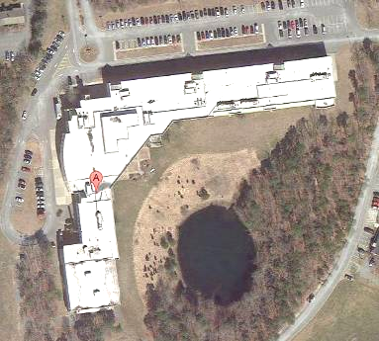

Prepared by:
Massachusetts Department of Public Health
Bureau of Environmental Health
Indoor Air Quality Program
February 2014

Background/Introduction
At the request of the Barnstable School Department, the Massachusetts Department of Public Health (MDPH), Bureau of Environmental Health (BEH) provided assistance and consultation regarding indoor air quality (IAQ) at the Barnstable Intermediate School (BIS) located at 895 Falmouth Road, Hyannis, Massachusetts. On September 23, 2013, Michael Feeney, Director of BEH’s IAQ Program visited the school to perform an assessment; he was accompanied by Ruth Alfasso Environmental Engineer/Inspector in BEH’s IAQ program. The assessment was a part of an overall plan to inspect all of the Barnstable schools.
The BIS is a two-story building with two wings in an L-shape. The original wing was built in 1976 and an addition was constructed around 1999. A large proportion of the building exterior is composed of an exterior insulating foam system (EIFS) that mimics stucco. This type of exterior cladding has been associated with a number of drainage and water damage issues, which are discussed in more detail in the Microbial/Moisture section of this report.
The building contains general classrooms, science classrooms, computer classrooms, a library/media center, kitchen/cafeteria, gymnasium, faculty workrooms/lounge and office space. Classrooms mostly have floor tiles and a suspended ceiling tile system. Some classrooms have a movable divider covered in a cloth material that can be folded back to combine two classrooms into a larger space. The building is air conditioned and has openable windows.

Methods
BEH/IAQ staff performed a visual inspection of building materials for water damage and/or microbial growth. Air tests for carbon monoxide, carbon dioxide, temperature and relative humidity were conducted with the TSI, Q-Trak, IAQ Monitor, Model 7565. Air tests for airborne particle matter with a diameter less than 2.5 micrometers were taken with the TSI, DUSTTRAK™ Aerosol Monitor Model 8520.

Results
The school houses approximately 780 students in grades 6 and 7 with a staff of approximately 80. Tests were taken during normal operations at the school. Results appear in Table 1.

Discussion

Ventilation
It can be seen from Table 1 that carbon dioxide levels were below 800 parts per million (ppm) in 74 of 82 areas, indicating optimal air exchange in the large majority of areas surveyed. Note, however, that some areas were empty or sparsely populated and a few areas had open windows at the time tests were taken, which can greatly reduce carbon dioxide levels. Carbon dioxide levels would be expected to be higher with full occupancy and windows closed.
Fresh air in classrooms is supplied by air handling units (AHUs) located on the roof (Picture 1) and ducted to fresh air supply diffusers located in classrooms (Picture 2). Exhaust ventilation in classrooms is provided by ceiling-mounted vents (Picture 3) ducted to rooftop motors.
It is important to note that some exhaust vents are located near hallway doors, which are reportedly often left open. With the hallway doors open, the exhaust vents will tend to draw air from the hallway into the classroom, instead of drawing stale air from the classroom. Therefore it is recommended that classroom doors remain shut while exhaust vents are operating to function as designed. Exhaust vents must be activated and remain free of obstructions. It was observed that several of the exhaust fans on the roof were not operating at the time of assessment.
To maximize air exchange, the MDPH recommends that both supply and exhaust ventilation operate continuously during periods of occupancy. In order to have proper ventilation with a mechanical supply and exhaust system, the systems must be balanced to provide an adequate amount of fresh air to the interior of a room while removing stale air from the room. It is recommended that heating, ventilating and air conditioning (HVAC) systems be re-balanced every five years to ensure adequate air systems function (SMACNA, 1994). The date of the last balancing of these systems was not available at the time of assessment.
Minimum design ventilation rates are mandated by the Massachusetts State Building Code (MSBC). Until 2011, the minimum ventilation rate in Massachusetts was higher for both occupied office spaces and general classrooms, with similar requirements for other occupied spaces (BOCA, 1993). The current version of the MSBC, promulgated in 2011 by the State Board of Building Regulations and Standards (SBBRS), adopted the 2009 International Mechanical Code (IMC) to set minimum ventilation rates. Please note that the MSBC is a minimum standard that is not health-based. At lower rates of cubic feet per minute (cfm) per occupant of fresh air, carbon dioxide levels would be expected to rise significantly. A ventilation rate of 20 cfm per occupant of fresh air provides optimal air exchange resulting in carbon dioxide levels at or below 800 ppm in the indoor environment in each area measured. MDPH recommends that carbon dioxide levels be maintained at 800 ppm or below. This is because most environmental and occupational health scientists involved with research on IAQ and health effects have documented significant increases in indoor air quality complaints and/or health effects when carbon dioxide levels rise above the MDPH guidelines of 800 ppm for schools, office buildings and other occupied spaces (Sundell et al., 2011). The ventilation must be on at all times that the room is occupied. Providing adequate fresh air ventilation with open windows and maintaining the temperature in the comfort range during the cold weather season is impractical. Mechanical ventilation is usually required to provide adequate fresh air ventilation.
Carbon dioxide is not a problem in and of itself. It is used as an indicator of the adequacy of the fresh air ventilation. As carbon dioxide levels rise, it indicates that the ventilating system is malfunctioning or the design occupancy of the room is being exceeded. When this happens, a buildup of common indoor air pollutants can occur, leading to discomfort or health complaints. The Occupational Safety and Health Administration (OSHA) standard for carbon dioxide is 5,000 parts per million parts of air (ppm). Workers may be exposed to this level for 40 hours/week, based on a time-weighted average (OSHA, 1997).
The MDPH uses a guideline of 800 ppm for publicly occupied buildings. A guideline of 600 ppm or less is preferred in schools due to the fact that the majority of occupants are young and considered to be a more sensitive population in the evaluation of environmental health status. Inadequate ventilation and/or elevated temperatures are major causes of complaints such as respiratory, eye, nose and throat irritation, lethargy and headaches. For more information concerning carbon dioxide, consult Appendix A.
Indoor temperature measurements the day of assessment ranged from 63 F to 71 F (Table 1), most of which were below the MDPH recommended comfort range. It was reported that the heating system had not yet been turned on for the season, and outdoor temperatures had been in the 50s with fresh air being brought in overnight. Temperatures in the building were higher later in the day due to building use and increased outdoor temperatures. The MDPH recommends that indoor air temperatures be maintained in a range of 70 F to 78 F in order to provide for the comfort of building occupants. In many cases concerning indoor air quality, fluctuations of temperature in occupied spaces are typically experienced, even in a building with an adequate fresh air supply. In addition, it is difficult to control temperature and maintain comfort without operating the ventilation equipment as designed (e.g., exhaust vents deactivated/not operating).
The relative humidity measured in the building during the assessment ranged from 42 to 60 percent, which was within the MDPH recommended comfort range (Table 1). The MDPH recommends a comfort range of 40 to 60 percent for indoor air relative humidity. Relative humidity levels in the building would be expected to drop during the winter months due to heating. The sensation of dryness and irritation is common in a low relative humidity environment. Low relative humidity is a very common problem during the heating season in the northeast part of the United States.

Microbial/Moisture Concerns
In order for building materials to support mold growth, a source of water exposure is necessary. Identification and elimination of the source of water moistening building materials is necessary to control mold growth.
Musty odors were reported and detected in several music rooms. The source of the odors were traced to a variety of porous items, including instrument cases in a storeroom for the band and a leather jacket and other items in a closet in the chorus room (Pictures 4 and 5). Instrument cases are constructed of leather, cardboard, glue and a carpet-like lining, which are all porous materials that can support mold colonization. Closets and storerooms do not have air circulation that would assist in drying items that may be moistened due to hot, humid weather. Without adequate temperature and relative humidity control, materials that are highly susceptible to mold growth will become moistened in hot, humid weather and lead to mold growth. Some of the items that were found water-damaged and mold-colonized were discarded once MDPH staff identified them. Other water-damaged/mold-colonized items should either be discarded or, if of sufficient value, a professional restoration company should be consulted.
Other concerns regarding water damage and mold have been expressed in the building. Water-damaged, bowed/missing ceiling tiles and damaged paint were observed in many classrooms, particularly in the new wing (Pictures 6 through 10). Water infiltration was also reported to come from ceilings/windows and flow under cabinets located along exterior walls in some classrooms. Musty odors from some of these cabinets were reported. In one classroom, a section of molding on top of the cabinets could be peeled back from the wall, which was found colonized with mold (Picture 9). This suggests that mold may also be colonizing both wood and gypsum wallboard behind these and any other cabinets that have been affected by similar conditions. In order to remove water-damaged and moldy materials from these areas, the cabinets will need to be removed, inspected and discarded/repaired if portions are mold-colonized. Sections of affected gypsum wallboard will also need replacement.
There appears to be two conditions that are contributing to the infiltration of water into the building in these areas. The first is that the windows in the building do not appear to be weather-tight in some areas. Weather on Cape Cod, in particular, can be very wet, with periods of both heavy rain and high humidity. When windows are not closed or do not seal, rainwater during heavy or wind-driven events can infiltrate the building and moisten materials, which, if not dried soon enough, can become mold-colonized. Improperly sealed window frames can also allow hot, moist air into classrooms during warm months when the air conditioning is operating. This may allow relative humidity in the area of the windows to rise, creating conditions where moisture condenses on chilled surfaces and moistens them. Windows in classrooms should remain shut when air conditioning is operating.
Also contributing to water penetration is the configuration of exterior walls, which as stated previously, consists of an exterior insulating foam system (EIFS). EIFS, commonly known as fake stucco, “is an exterior wall cladding that utilizes rigid insulation boards on the exterior of the wall sheathing with a plaster type exterior skin” (Zwayer, 2007). “An EIFS wall typically consists of several layers of materials sandwiched together into a single panel, which is attached to a substrate mounted on the wall studs” (Figure 1) (FEMA, 2011). In buildings constructed with a curtain wall, water is intercepted by a drainage plane once it penetrates through the brickwork; the drainage plane allows water to exit the wall system through weep holes (Figure 2). The EIFS system on this building appears to be a barrier wall system. The “barrier EIFS wall systems rely primarily on the base coat portion of the exterior skin to resist water penetration” (Zwayer, 2007). In essence, the rainwater is shed by the exterior “stucco-like” surface, which functions as a drainage plane (Figure 1). However, a number of problems exist with such a system:
Problems observed with EIFS installations are primarily related to moisture intrusion. EIFS provides protection against moisture infiltration at the base coat; however, moisture migration through openings for windows, flashings and other items, or holes and cracks in the EIFS itself, have allowed for moisture invasion of EIFS clad buildings. With barrier EIFS installations, or where weather barriers and flashing are improperly installed in conjunction with wall drainage EIFS installations, moisture has entered the wall system at these locations and caused damage to the wall sheathing and framing (emphasis added) (Zwayer, G.L., 2007).
Since the initial introduction of EIFS, a second type of system, which contains a water drainage system similar to Figure 2, was developed. The EIFS system has weep holes in its exterior wall (Picture 11). Some of the weep holes at BIS appear to be blocked or buried beneath soil, which can lead to water building up inside the wall.
According to the National Institute of Building Science (NIBS), the following are problems typical of buildings clad with EIFS; these same conditions were also observed at BIS:
- Failure to install or properly install sealant joints around windows, doors, pipes, conduits, and other penetrations of the field of the EIFS (Picture 12);
- Failure to flash window and door openings in the field of the EIFS to divert leakage through the window or door to the exterior;
- Failure to properly back wrap edges at terminations and penetrations in the field of the EIFS; and
- Water erosion damage that has not been repaired (Picture 13).
Each of these conditions can allow for water to penetrate through the EIFS.
Another likely water penetration source is an architectural feature that exists in the exterior wall. It appears the cement joist beams that support floors have ends that protrude through the EIFS (Picture 14). These beams should have a continuous seal around each junction with the EIFS to prevent water penetration. If not continuous, rainwater can penetrate into the building under certain wind/weather conditions, particularly along the flat surface on the top of each beam.
Additional water penetration issues were noted relative to the 1999-era wing. An expansion joint was observed on the second floor (Picture 15), where the new wing was added. Often, where two portions of a building are joined, there is the potential for infiltration of air and water because building materials do not line up completely and differences in materials can create gaps. The outside of the new wing, not only had issues with the water-tightness of the EIFS, but an indentation or trench was observed at the edge along the foundation. Poor grading in this area can cause water to pool against the base of the building, which can lead to infiltration. Issues were also observed relative to gutters and downspouts on the short slanted roofs along the back of the building. Lack of proper drainage from the roof and away from the building can contribute to water infiltration.
A potential source of interior moisture was reported to BEH/IAQ staff during the visit. According to facilities staff, the heating system controls were changed in 2011 and since then, humidity control in the building has been more difficult. Reportedly, over the summer of 2013, facilities staff suspected that excessive outside (hot, humid) air was being brought into the building while it was partially occupied, and that dehumidification/air conditioning of the outside air was inadequate. These conditions resulted in excessive humidity inside the building, including increased moisture on floors. Floor tiles in some rooms on the first floor, including the chorus room, were observed to be stained/coated with material (Picture 16). The material is likely composed of tile mastic and floor waxes that have been exposed between expanding tile joints due to repeated moistening from condensation. While unsightly, this material is not typically mold-colonized and is readably cleanable by floor stripping/cleaning. However, unless the moisture issue is remedied, the condition is likely to return.
In some classrooms ceiling tiles were observed to be bowed (Picture 10). This suggests that the tiles are becoming moistened over a long period of time and sagging. It may also indicate that there may be pressurization of the plenum above ceiling tiles. Given that the fresh air and exhaust system are both reportedly ducted, this may indicate that outside air is infiltrating/pressurizing the plenum through gaps/breaches in the exterior cladding.
The US Environmental Protection Agency (US EPA) and the American Conference of Governmental Industrial Hygienists (ACGIH) recommend that porous materials (e.g., carpeting, gypsum wallboard) be dried with fans and heating within 24 to 48 hours of becoming wet (US EPA, 2001; ACGIH, 1989). If not dried within this time frame, mold growth may occur. Once mold has colonized porous materials, they are difficult to clean and should be removed/discarded.
A refrigerator in the 236A storage room had visible mold growth and staining on the gasket (Picture 17). The gasket should be cleaned with an antimicrobial solution. Frequent/excessive mold staining on gaskets is an indication that the refrigerator does not seal properly and needs to be repaired/replaced.
Some classroom sinks had cabinets beneath them containing large amounts of stored materials, including porous items (Picture 18). The area underneath sinks is a moist environment and should not be used to store items that can become colonized with mold. Large amounts of items stored under sinks can also make detecting leaks difficult. One of the sink cabinets had water-damaged wood, possibly from a historic plumbing leak. Some of the sinks are laboratory type that are reportedly shut off when they are in use. This can lead to dry drain traps if water isn’t occasionally poured into the traps. Dry traps can allow moisture and odorous gases into occupied spaces.
Open seams between sink countertops and backsplashes were observed in a few rooms (Table 1). If not watertight, moisture can penetrate through seams, causing damage. Improper drainage or sink overflow can lead to water penetration into countertops, cabinet interiors and areas behind cabinets.
Plants and cut flowers were noted in some classrooms (Table 1). Plants can be a source of pollen and mold which can be respiratory irritants to some individuals. Plants should be properly maintained and equipped with drip pans and should be located away from air supplies to prevent the aerosolization of dirt, pollen and mold.
Several aquariums and terrariums were also observed in classrooms (Table 1). Aquariums should be properly maintained to prevent microbial/algal growth, which can emit unpleasant odors. Similarly, terrariums should be properly maintained to ensure soil does not become a source for mold growth/odors.
A water dispenser was observed to be located in a carpeted area (Picture 19). Water can spill or leak from these appliances and moisten carpet. Water dispensing equipment should be located on non-porous surfaces such as floor tile or a waterproof mat.

Other IAQ Evaluations
Indoor air quality can be negatively influenced by the presence of respiratory irritants, such as products of combustion. The process of combustion produces a number of pollutants. Common combustion emissions include carbon monoxide, carbon dioxide, water vapor and smoke (fine airborne particle material). Of these materials, exposure to carbon monoxide and particulate matter with a diameter of 2.5 micrometers (μm) or less (PM2.5) can produce immediate, acute health effects upon exposure. To determine whether combustion products were present in the indoor environment, BEH/IAQ staff obtained measurements for carbon monoxide and PM2.5.

Carbon Monoxide
Carbon monoxide is a by-product of incomplete combustion of organic matter (e.g., gasoline, wood and tobacco). Exposure to carbon monoxide can produce immediate and acute health effects. Several air quality standards have been established to address carbon monoxide and prevent symptoms from exposure to these substances. The MDPH established a corrective action level concerning carbon monoxide in ice skating rinks that use fossil-fueled ice resurfacing equipment. If an operator of an indoor ice rink measures a carbon monoxide level over 30 ppm, taken 20 minutes after resurfacing within a rink, that operator must take actions to reduce carbon monoxide levels (MDPH, 1997).
The American Society of Heating Refrigeration and Air-Conditioning Engineers (ASHRAE) has adopted the National Ambient Air Quality Standards (NAAQS) as one set of criteria for assessing indoor air quality and monitoring of fresh air introduced by HVAC systems (ASHRAE, 1989). The NAAQS are standards established by the US EPA to protect the public health from six criteria pollutants, including carbon monoxide and particulate matter (US EPA, 2006). As recommended by ASHRAE, pollutant levels of fresh air introduced to a building should not exceed the NAAQS levels (ASHRAE, 1989). The NAAQS were adopted by reference in the Building Officials & Code Administrators (BOCA) National Mechanical Code of 1993 (BOCA, 1993), which is now an HVAC standard included in the Massachusetts State Building Code (SBBRS, 2011). According to the NAAQS, carbon monoxide levels in outdoor air should not exceed 9 ppm in an eight-hour average (US EPA, 2006).
Carbon monoxide should not be present in a typical, indoor environment. If it is present, indoor carbon monoxide levels should be less than or equal to outdoor levels. On the day of assessment, outdoor carbon monoxide concentrations were non-detect (ND) (Table 1). No measurable levels of carbon monoxide were detected inside the building (Table 1).

Particulate Matter
The US EPA has established NAAQS limits for exposure to particulate matter. Particulate matter includes airborne solids that can be irritating to the eyes, nose and throat. The NAAQS originally established exposure limits to PM with a diameter of 10 μm or less (PM10). In 1997, US EPA established a more protective standard for fine airborne particulate matter with a diameter of 2.5 μm or less (PM2.5). This more stringent PM2.5 standard requires outdoor air particle levels be maintained below 35 μg/m³ over a 24-hour average (US EPA, 2006). Although both the ASHRAE standard and BOCA Code adopted the PM10 standard for evaluating air quality, MDPH uses the more protective PM2.5 standard for evaluating airborne PM concentrations in the indoor environment.
Outdoor PM2.5 concentrations were measured at 2 μg/m³ (Table 1). PM2.5 levels measured in the school were between 2 to 10 μg/m³ (Table 1), which were below the NAAQS PM2.5 level of 35 μg/m³. Frequently, indoor air levels of particulates (including PM2.5) can be at higher levels than those measured outdoors. A number of activities that occur indoors and/or mechanical devices can generate particulate matter during normal operations. Sources of indoor airborne particulates may include but are not limited to particles generated during the operation of fan belts in the HVAC system, use of stoves and/or microwave ovens in kitchen areas; use of photocopiers, fax machines and computer printing devices; operation of an ordinary vacuum cleaner and heavy foot traffic indoors.

Volatile Organic Compounds
Indoor air concentrations can be greatly impacted by the use of products containing volatile organic compounds (VOCs). VOCs are carbon-containing substances that have the ability to evaporate at room temperature. Frequently, exposure to low levels of total VOCs (TVOCs) may produce eye, nose, throat and/or respiratory irritation in some sensitive individuals. For example, chemicals evaporating from a paint can stored at room temperature would most likely contain VOCs. In an effort to identify materials that can potentially increase indoor VOC concentrations, BEH/IAQ staff examined rooms for products containing these respiratory irritants.
Classrooms contained dry erase boards and related materials. Materials such as dry erase markers and dry erase board cleaners may contain VOCs, such as methyl isobutyl ketone, n-butyl acetate and butyl-cellusolve (Sanford, 1999), which can be irritating to the eyes, nose and throat.
Cleaning products were found in some classrooms. Cleaning products contain chemicals that can be irritating to the eyes, nose and throat of sensitive individuals. These products should be properly labeled and stored in an area inaccessible to children. Additionally, an MSDS should be available at a central location for each product in the event of an emergency. Consideration should be given to providing teaching staff with school-issued cleaning products and supplies to ensure that MSDS information is available for all products used at the school and to prevent chemical interactions between janitorial cleaners and cleaners brought in by others.
Sliced-open tennis balls were observed on the legs of a stool (Picture 20). Tennis balls are made of a number of materials that are a source of respiratory irritants. Constant wearing of tennis balls can produce fibers and cause VOCs to off-gas. Tennis balls are made with a natural rubber latex bladder, which becomes abraded when used as a chair leg pad. Use of tennis balls in this manner may introduce latex dust into the school environment. Some individuals are highly allergic to latex (e.g., spina bifida patients) (SBAA, 2001). It is recommended that the use of materials containing latex be limited in buildings to reduce the likelihood of symptoms in sensitive individuals (NIOSH, 1997).

Other Conditions
Other conditions that can affect IAQ were observed during the assessment. There are two kilns located in storage/auxiliary rooms off of the art rooms. Kilns can give off waste heat and gases during use. These kilns are electrically-fired and are equipped with overhead exhaust hoods. The exhaust hoods are reportedly automatically activated with the firing of the kilns so that they are always on whenever the kilns are in use. The functioning of the kilns and exhaust vents should be checked every time the kilns are used and kilns should be regularly inspected per manufacturer’s instructions. Note that one of the kiln rooms was cluttered with items, including cardboard and plastics. These items may become damaged and give off odors due to heating by the kilns; clutter should be removed from the kiln rooms during periods when they may be used.
Upholstered furniture and plush toys were observed in some locations (Picture 21, Table 1). Upholstery and plush toys are covered with fabrics that may be exposed to human skin. This type of contact can leave oils, perspiration, hair and skin cells. Dust mites feed upon human skin cells and excrete waste products that contain allergens. In addition, if relative humidity levels increase above 60 percent, dust mites tend to proliferate (US EPA, 1992). In order to remove dust mites and other pollutants, frequent vacuuming of upholstered furniture is recommended (Berry, 1994). It is also recommended that upholstered furniture (if present in schools), be professionally cleaned on an annual basis. If an excessively dusty environment exists due to outdoor conditions or indoor activities (e.g., renovations), cleaning frequency should be increased (every six months) (IICRC, 2000).
A chemical storage area off one of the science rooms was examined. Chemical storage issues that may impact IAQ were identified, particularly the storage of items in a disorganized manner inside cardboard boxes (Picture 22), which can lead to breakage/spills. Chemicals should be stored in an organized manner on sturdy shelves, be properly labeled, and be inspected and inventoried regularly to remove outdated and unneeded items. MSDSs should be available for all chemicals used in the school. Attached as Appendix B is MDPH “Guidance Concerning Proper Use and Storage of Chemicals in Schools to Protect Public Health.”
A number of air diffusers, exhaust/return vents and personal fans were found to have accumulated dust/debris, particularly the supply vents in the library (Picture 23; Table 1). Re-activated supply vents and fans can aerosolize dust accumulated on vents/fan blades. If exhaust vents are not functioning, backdrafting can occur, which can re-aerosolize accumulated dust particles.

Conclusions/Recommendations
In view of the findings at the time of the visit, the following recommendations are made:
- Operate all supply and exhaust ventilation systems throughout the building (e.g., gym, cafeteria, classrooms) continuously during periods of occupancy to maximize air exchange.
- Close classroom doors for proper operation of mechanical ventilation system/air exchange.
- Openable windows may be used to increase fresh air when needed, but ensure that windows are closed tightly at the end of the day and are kept closed when the air conditioning is operating.
- Consider adopting a balancing schedule of every 5 years for all mechanical ventilation systems, as recommended by ventilation industrial standards (SMACNA, 1994).
- Work with school facilities personnel regarding temperature control and the need for heat during the fall season.
- Work with an HVAC engineering firm to evaluate controls/settings for summer use of the building to prevent excessive moisture/condensation. Attached as Appendix C is MDPH “Preventing Mold Growth in Massachusetts Schools during Hot, Humid Weather”.
- For buildings in New England, periods of low relative humidity during the winter are often unavoidable. Therefore, scrupulous cleaning practices should be adopted to minimize common indoor air contaminants whose irritant effects can be enhanced when the relative humidity is low. To control dusts, a high efficiency particulate arrestance (HEPA) filter equipped vacuum cleaner in conjunction with wet wiping of all surfaces is recommended. Avoid the use of feather dusters. Drinking water during the day can help ease some symptoms associated with a dry environment (throat and sinus irritations).
- Have a professional building envelope contractor examine the exterior for damaged caulking, missing flashing and other gaps/breaches around windows and cement floor joist beams.
- Examine weep holes around perimeter of building and open/clear if found blocked. Unearth and clear buried weep holes.
- Repair damaged EIFS.
- Deconstruct and examine cabinets adjacent to windows suspected of moisture intrusion to examine drywall behind it. Remove and replace any mold-contaminated wood, drywall or other building materials.
- Clean/strip accumulated tile mastic/wax. If continued moisture accumulation/damage to floor tiles in the building occurs, consideration should be given to having a building engineer examine other potential remediation/prevention strategies.
- Consider contacting a reputable flooring contractor to remove/replace old tiles and mastic. Slab should be completely cleaned, prepped and sealed using a proper sealant.
- Ensure roof/plumbing leaks are repaired and replace any remaining water-damaged ceiling tiles. Disinfect areas of water leaks with an appropriate antimicrobial, as needed.
- The storage areas in the band and chorus rooms should be examined and thoroughly cleaned out to remove mold-contaminated and water-damaged items. Discard mold-contaminated items including leather, paper, cloth and instrument cases. If materials are of significant value, a professional restoration contractor should be consulted about potential for cleaning.
- Address storage issues for vulnerable items such as those kept in the chorus and band rooms, including sealing in plastic before the end of the year or storage in areas with sufficient air circulation to allow for drying.
- Clean and disinfect interior of refrigerators and freezers with mild detergent or antimicrobial agent. If they cannot be adequately cleaned, replace mold-contaminated gaskets. Clean spilled food promptly, and clean out the refrigerator of expired items on a regular schedule.
- Ensure indoor plants are equipped with drip pans. Examine drip pans periodically for mold growth and disinfect with an appropriate antimicrobial, as needed. Move plants away from the air stream of mechanical ventilation equipment.
- Seal areas between sink countertops and backsplashes to prevent water damage to the interior of cabinets and adjacent materials.
- Do not store porous or significant amounts of items under sinks.
- Ensure that drains on laboratory sinks are kept wet by pouring water into them at least twice a week (or as needed) when the sinks are turned off.
- Ensure that aquariums and terrariums are maintained to prevent mold growth/odors.
- Place water dispensers in an area with non-porous flooring or on a waterproof mat.
- Consider providing school-issued cleaning products when they are needed in classrooms to ensure the availability of MSDS information and to prevent chemical interactions. Keep all cleaners out of the reach of children.
- Use latex-free glides instead of tennis balls to prevent exposure to latex.
- Ensure that the kilns are inspected and that exhaust ventilation operates every time the kilns are used. Remove clutter from kiln rooms before they are operated.
- Clean/vacuum area rugs and upholstered furniture to remove dust and debris. If possible, have them professionally cleaned at least once a year. Ensure that rugs brought into the school are clean and free of pet dander, tobacco smoke and other potential allergens.
- Store any needed science chemicals in a properly outfitted storage cabinet. Ensure that MSDSs are available for science chemicals and that outdated and unneeded chemicals are identified and discarded through regular inspections.
- Clean air diffusers, personal fans and exhaust vents of accumulated dust regularly.
- Consider adopting the US EPA (2000) document, “Tools for Schools”, as an instrument for maintaining a good indoor air quality environment in the building. This document is available at: http://www.epa.gov/iaq/schools/index.html.
- Refer to resource manual and other related indoor air quality documents located on the MDPH’s website for further building-wide evaluations and advice on maintaining public buildings. These documents are available at: http://mass.gov/dph/iaq.

References
ACGIH. 1989. Guidelines for the Assessment of Bioaerosols in the Indoor Environment. American Conference of Governmental Industrial Hygienists, Cincinnati, OH.
ASHRAE. 1989. Ventilation for Acceptable Indoor Air Quality. American Society of Heating, Refrigeration and Air Conditioning Engineers. ANSI/ASHRAE 62-1989.
Berry, M.A. 1994. Protecting the Built Environment: Cleaning for Health. Michael A. Berry, Chapel Hill, NC.
BOCA. 1993. The BOCA National Mechanical Code/1993. 8th ed. Building Officials and Code Administrators International, Inc., Country Club Hill, IL.
FEMA. 2011. Maintain EIFS Walls; Protecting Your Property From High Winds. Federal Emergency Management Agency, Washington, DC. http://www.fema.gov/media-library-data/20130726-1627-20490-4852/how2027_eifs_walls_4_11.pdf.
IICRC. 2000. IICRC S001. Reference Guideline for Professional On-Location Cleaning of Textile Floor Covering Materials. Institute of Inspection, Cleaning and Restoration Certification. Institute of Inspection Cleaning and Restoration, Vancouver, WA.
MDPH. 1997. Requirements to Maintain Air Quality in Indoor Skating Rinks (State Sanitary Code, Chapter XI). 105 CMR 675.000. Massachusetts Department of Public Health, Boston, MA.
NIOSH. 1997. NIOSH Alert Preventing Allergic Reactions to Natural Rubber latex in the Workplace. National Institute for Occupational Safety and Health, Atlanta, GA.
OSHA. 1997. Limits for Air Contaminants. Occupational Safety and Health Administration. Code of Federal Regulations. 29 C.F.R 1910.1000 Table Z-1-A.
Sanford. 1999. Material Safety Data Sheet (MSDS No: 198-17). Expo Dry Erase Markers Bullet, Chisel, and Ultra Fine Tip. Sanford Corporation. Bellwood, IL.
SBAA. 2001. Latex In the Home And Community Updated Spring 2001. Spina Bifida Association of America, Washington, DC.
SBBRS. 2011. Mechanical Ventilation. State Board of Building Regulations and Standards. Code of Massachusetts Regulations, 8th edition. 780 CMR 1209.0
SMACNA. 1994. HVAC Systems Commissioning Manual. 1st ed. Sheet Metal and Air Conditioning Contractors’ National Association, Inc., Chantilly, VA.
Sundell. 2011. Sundell, J., H. Levin, W. W. Nazaroff, W. S. Cain, W. J. Fisk, D. T. Grimsrud, F. Gyntelberg, Y. Li, A. K. Persily, A. C. Pickering, J. M. Samet, J. D. Spengler, S. T. Taylor, and C. J. Weschler. Ventilation rates and health: multidisciplinary review of the scientific literature. Indoor Air, Volume 21: pp 191–204.
US EPA. 1992. Indoor Biological Pollutants. US Environmental Protection Agency, Environmental Criteria and Assessment Office, Office of Health and Environmental Assessment, research Triangle Park, NC. EPA 600/8-91/202. January 1992.
US EPA. 2000. Tools for Schools. Office of Air and Radiation, Office of Radiation and Indoor Air, Indoor Environments Division (6609J). EPA 402-K-95-001, Second Edition. http://www.epa.gov/iaq/schools/actionkit.html.
US EPA. 2001. Mold Remediation in Schools and Commercial Buildings. US Environmental Protection Agency, Office of Air and Radiation, Indoor Environments Division, Washington, D.C. EPA 402-K-01-001. March 2001.
US EPA. 2006. National Ambient Air Quality Standards (NAAQS). US Environmental Protection Agency, Office of Air Quality Planning and Standards, Washington, DC. http://www.epa.gov/air/criteria.html.
Zwayer, G.L. 2007. Exterior Insulation and Finish System (EIFS). National Institute of Building Sciences, Washington, DC. http://www.wbdg.org/design/env_wall_eifs.php.
Figure 1

Configuration of an EIFS Wall Panel
(FEMA, 2011)

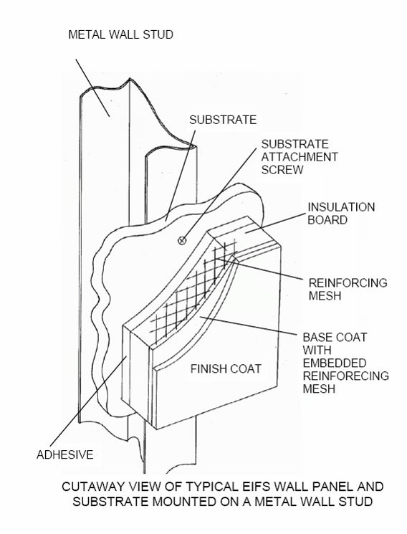
Picture 1

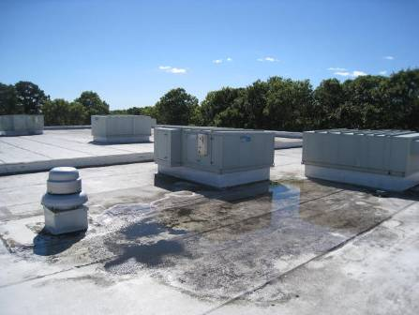

Air-handling units on the roof; note exhaust vent fan and pooling water

Picture 2

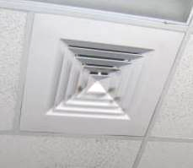

Typical supply vent in classroom, note dust/debris accumulation on louvers

Picture 3

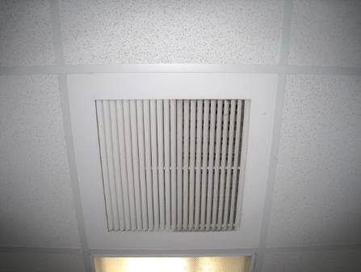

Typical classroom return vent

Picture 4

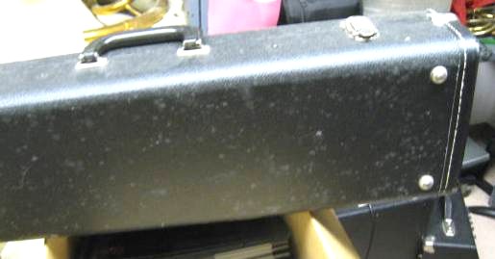

Mold-colonized instrument case

Picture 5

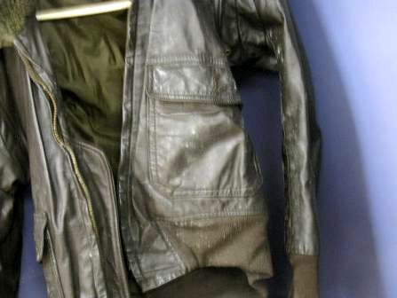

Mold-colonized leather jacket

Picture 6

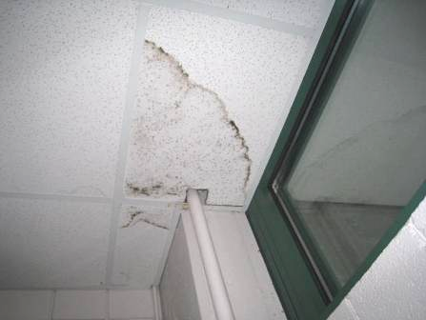

Water-damaged ceiling tiles, possibly mold-contaminated (dark staining)

Picture 7

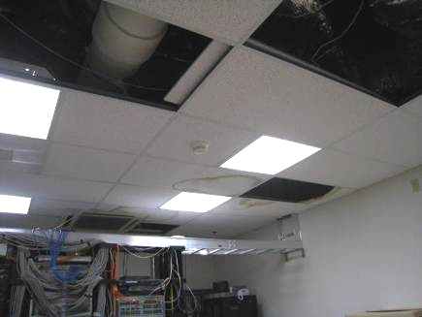

Water-damaged and missing ceiling tiles in server room

Picture 8

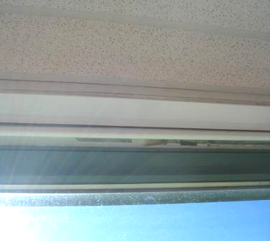

Water-damaged paint (arrow) at top edge of window

Picture 9

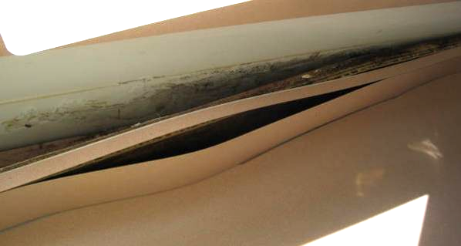

Water-damaged/mold-colonized wood and plaster behind cabinet molding

Picture 10

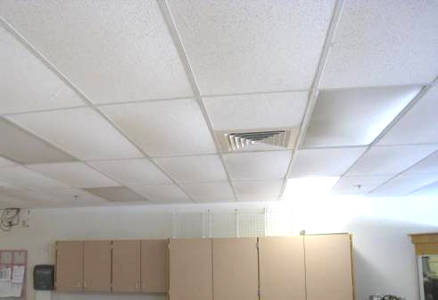

Bowed ceiling tiles in classroom

Picture 11

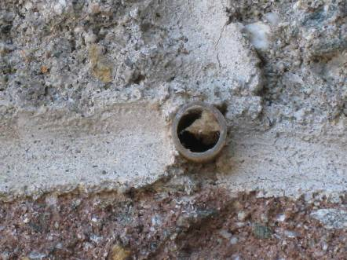

Weep hole in exterior wall

Picture 12

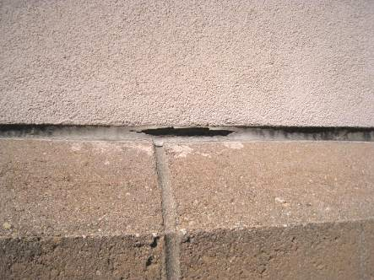

Missing caulking

Picture 13

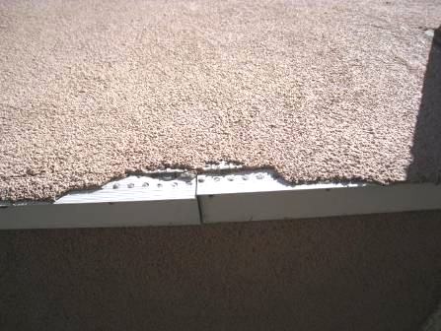

Water erosion damage that has not been repaired

Picture 14

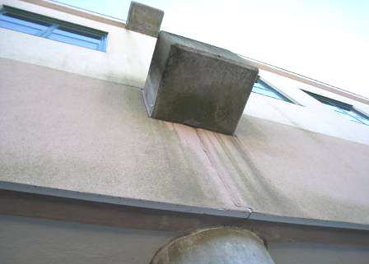

End of support floors beams that protrude through EFIS, note water
staining beneath beam

Picture 15

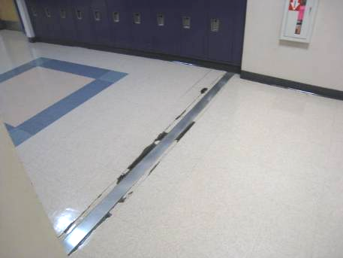

Expansion joint in floor

Picture 16

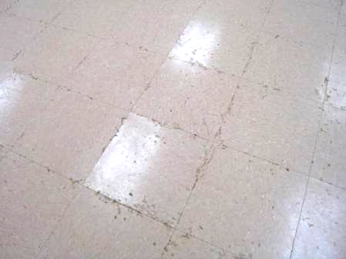

Stained floor tiles/moistened mastic in first floor room

Picture 17

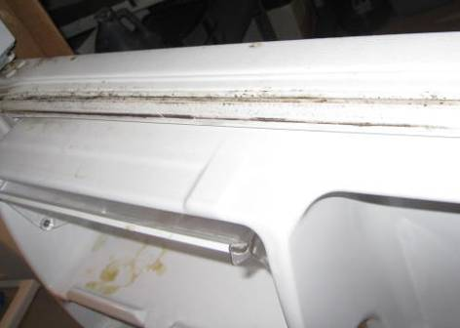

Mold on refrigerator gasket

Picture 18

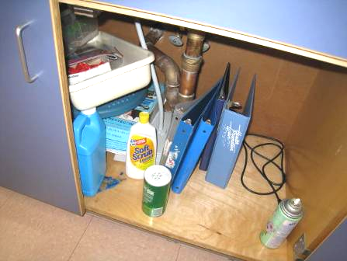

Items and cleaning products under sink

Picture 19

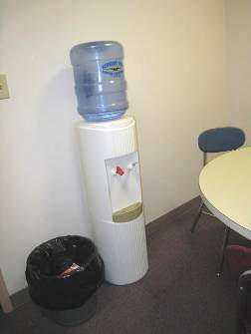

Water dispenser on carpet

Picture 20

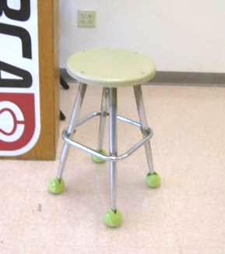

Tennis balls used as stool glides
Picture 21

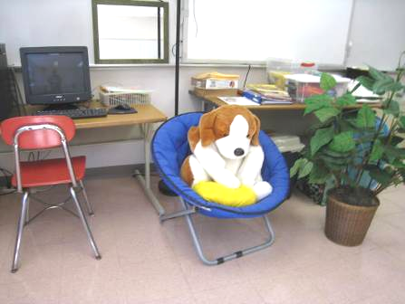

Upholstered furniture and plush toys

Picture 22

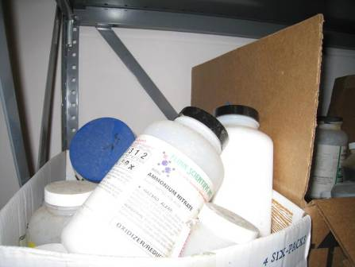

Storage of chemicals in a disorganized manner inside cardboard boxes

Picture 23

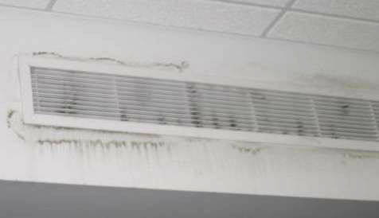

Accumulated dust/debris on supply vents in the library

Location/ Room | Carbon Dioxide  (ppm) | Carbon Monoxide  (ppm) | Temp  (°F) | Relative Humidity (%) | PM2.5  (µg/m³) | Occupants in Room | Windows  Openable | Ventilation |  | Remarks
 |  |  |  |  |  |  |  | Supply | Exhaust | Remarks
Background | 310 | ND | 63 | 42 | 2 |  |  |  |  | Breezy, sunny
107A | 516 | ND | 71 | 44 | 3 | 0 | N door | Y | Y | Plants, DEM
108A Art | 522 | ND | 70 | 44 | 4 | 0 | N doors | Y | Y | Kiln room off this room, area cluttered, kiln has interlocked exhaust, sinks
110A | 699 | ND | 71 | 46 | 4 | 15 | N doors | Y | Y | Second kiln room off this room
115A | 478 | ND | 68 | 50 | 4 | 0 | N | Y | Y | Plants
116A | 488 | ND | 66 | 48 | 4 | 0 | N | Y | Y | WD CT
117A | 625 | ND | 66 | 49 | 4 | 19 | N | Y | Y | Fridge, DEM, sink backsplash open, items, storage area is carpeted
118A | 485 | ND | 66 | 48 | 3 | 3 | Y | Y | Y | Sink, plants
119A | 512 | ND | 66 | 47 | 4 | 3 | N | Y | Y | Stoves, sinks, items under sink, dishwasher
120A | 790 | ND | 67 | 49 | 4 | 9 | Y | Y | Y | AT, DEM
121A | 695 | ND | 67 | 47 | 4 | 18 | Y | Y | Y | DEM, CP
122A | 458 | ND | 65 | 43 | 3 | 3 | Y | Y | Y | DEM, fridge, CPs, microwave in storage room, DO
124A | 693 | ND | 67 | 47 | 4 | 22 | Y | Y | Y | DO, plants, hand sanitizer. DEM
125A | 711 | ND |  | 46 | 4 | 20 | Y | Y | Y | Sanitizer, DEM, sinks
126A Science |  |  |  |  |  |  | Y | Y | Y | 2 WD CT, sinks (reportedly sometimes shut off, drains watered)
127A | 463 | ND | 64 | 46 | 4 | 0 | N | Y | Y | Odor (popcorn), sanitizer, microwave
127B | 469 | ND | 64 | 45 | 3 | 5 | N | Y | Y | Area rug, DEM, WD supply vent
127D | 500 | ND | 66 | 44 | 3 | 15 | N, door to outside | Y | Y | DO, fridge, coffeemaker, DEM
127E | 586 | ND | 66 | 45 | 3 | 15 | N door to outside | Y | Y | Plants, WD door to outside, dehumidifier
128A | 822 | ND | 66 | 48 | 4 | 21 | N | Y | Y | DEM
129A | 495 | ND | 65 | 48 | 2 | 0 | Y door open | Y | Y | Sinks, DEM, acid drain system
130A Teacher/copy | 417 | ND | 66 | 44 | 3 | 0 | N | Y | Y | Microwave, CP, fridge, vending, PC
131A | 577 | ND | 66 | 47 | 3 | 17 | Y and door to outside | Y | Y | WD CT, solar gain, plants, DEM, sinks
134A | 465 | ND | 66 | 46 | 3 | 1 | Y | Y | Y | Plush items, Reports of mold, WD-areas, plants, DEM
135A | 434 | ND | 67 | 42 | 3 | 1 class just left | N | Y | Y | DEM, instruments, bowed tiles
135B | 401 | ND | 66 | 42 | 3 | 0 | N | Y | Y | DEM, instruments, bowed tiles
137A chorus/music | 1626 | ND | 69 | 60 | 4 | 19 | Y | Y | Y | Feels warm, DEM, WD CT, WD and moldy items in closet
139A band | 539 | ND | 67 | 45 | 3 | 7 | Y | Y | Y | Carpeted, items under sink, DEM, fridge on carpet in office, vacuum in room
1st floor girls restroom |  |  |  |  |  |  | N | Y | Y | WD CP, DO
202A | 684 | ND | 70 | 45 | 4 | 1 | Y | Y | Y | Plants, DEM, porous items under sink, CP
204A | 700 | ND | 70 | 45 | 3 | 2 | Y | Y | Y | Plants, PF, stained classroom divider
205-203A | 778 | ND | 71 | 46 | 4 | 7 | Y | Y | Y | Classroom divider open, plants, 4-5 WD CT, food being eaten, DEM, PF
206A | 833 | ND | 70 | 47 | 5 | 2 class just left | Y | Y | Y | TBs, classroom divider, area rug
208A library | 579 | ND | 68 | 45 | 4 | 2 | Y | Y very dusty  /dirty | Y | Carpet, plants, WD supply vent. Media room has microwave, is NC
208B | 542 | ND | 69 | 46 | 3 | 0 | Y | Y | Y | DO, food, heater
209A | 617 | ND | 69 | 45 | 4 | 1 | N | Y | Y | Area rug, DEM, PF dusty, DO
210A | 615 | ND | 69 | 46 | 4 | 1 | N | Y | Y | DO, DEM
211A | 593 | ND | 68 | 46 | 3 | 0 | N | Y | Y | DEM
212 Main Guidance area | 616 | ND | 68 | 46 | 3 | 1 | N | Y | Y | Carpet, PC
212 meeting | 618 | ND | 69 |  |  |  | N | Y | Y | Water dispenser on carpet, microwave
212C conference | 619 | ND | 68 |  |  |  | N | Y | Y | Carpet, DEM
212E | 626 | ND | 69 | 47 | 4 | 1 | N | Y | Y | Carpet
213A | 686 | ND | 68 | 47 | 4 | 19 | Y | Y | Y | Aqua, plants, WD CT, unlabeled liquids under sink
214A | 565 | ND | 67 | 47 | 5 | 18 | Y | Y | Y | DEM, many WD CT, plants, terra, odor reported under cabinet
215A | 548 | ND | 70 | 46 | 4 | 1 | Y | Y | Y | Solar, WD CT, DEM, CP
216C | 599 | ND | 67 | 47 | 4 | 1 | N | Y | Y | Mold reported, DEM
217A | 735 | ND | 67 | 49 | 3 | 11 | Y | Y | Y | DEM, WD CT
218A | 654 | ND | 66 | 47 | 3 | 0 | Y | Y | Y | WD CT, divider, DEM
222A | 701 | ND | 68 | 48 | 10 | 20 | Y door open to outside | Y | Y | DEM, WD CT, books, plants, items, DEM, MT
223A | 806 | ND | 71 | 47 | 4 | 20 | Y | Y | Y | 25 computers, plants, bowed tiles, DEM, DO
224A | 728 | ND | 71 | 45 | 3 | 20 | Y | Y | Y | Stained door, books, DEM
225A | 768 | ND | 70 | 46 | 4 | 19 | Y | Y | Y | Plants, DEM
226A | 763 | ND | 70 | 45 | 4 | 19 | Y | Y | Y | Lots of plants, backsplash open, aqua, PF dirty
227A | 617 | ND | 69 | 45 | 5 | 19 | Y open | Y | Y | DEM, items, MT, area rug
228A | 510 | ND | 67 | 45 | 3 | 0 | Y 2open | Y | Y | Items, WD CT, DEM
229A | 731 | ND | 67 | 45 | 4 | 15 | Y | Y | Y | DEM, WD CT, sanitizer
231A | 615 | ND | 69 | 44 | 3 | 2 | Y | Y | Y | Computers (25), MT, WD CT (5)
232A | 837 | ND | 69 | 48 | 4 | 18 | Y | Y | Y | DEM, CP under sink
234A | 776 | ND | 68 | 45 | 5 | 18 | Y | Y | Y | Area rugs, room dividers, DEM, books/items, CP
235A | 750 | ND | 67 | 47 | 4 | 21 | Y | Y | Y | Plants, bowed tiles, WD CTs, DEM
236 A Storage area |  |  |  |  |  |  |  |  |  | Mold on fridge gasket, items, cloth
236A | 639 | ND | 68 | 47 | 3 | 0 | Y | Y | Y | Chemical/food odor, AT, WD CT
239A |  |  |  |  |  |  |  |  |  | 5 WD CT, 3 MT, items/CP under sinks
240A | 677 | ND | 68 | 44 | 4 | 6 | Y | Y | Y | DEM, WD CT, microwave, DEM
241A | 980 | ND | 68 | 51 | 4 | 21 | Y | Y | Y | DEM, items under sink, WD CT, MT
242A | 815 | ND | 67 | 48 | 3 | 19 | Y | Y | Y | DEM, bowed CT
244A | 733 | ND | 67 | 44 | 3 | 1 | Y | Y | Y | DEM, room divider
245A | 746 | ND | 68 | 47 | 3 | 19 | Y | Y | Y | Chemical odors, WD CT, reported ant problem, CP under sink
246A | 594 | ND | 66 | 46 | 3 | 7 | Y | Y | Y | Room divider, DEM, odor (food/gum)
247A | 851 | ND | 67 | 51 | 3 | 19 | Y | Y | Y | Plants, DEM, CP under sink, reports of water/flooding
248A | 681 | ND | 66 | 47 | 3 | 21 | Y | Y | Y | DEM, report of mold, plants, fake plant
249A | 493 | ND | 66 | 43 | 3 | 2 | Y | Y | Y | Bowed tiles DEP, dust around supply, WD CT, plants
250A | 744 | ND | 66 | 49 | 3 | 18 | Y | Y | Y | DEM, items, plants/cut flowers
251A | 683 | ND | 67 | 48 | 4 | 18 | Y | Y | Y | DEM, hanging items, DO, PS, food
252A | 556 | ND | 68 | 45 | 3 | 15 | Y | Y | Y | Solar gain, food, sinks, DO, PS
253A | 480 | ND | 67 | 42 | 3 | 3 | Y | Y | Y | PC, DEM, WD under sink
254A | 643 | ND | 68 | 47 | 3 | 22 | Y | Y | Y | Plants, solar gain, CP, aqua, items under sink
255A | 517 | ND | 67 | 44 | 3 | 1 | Y | Y | Y | DEM, broken light fixture, noisy supply
256A | 579 | ND | 67 | 47 | 4 | 21 | Y | Y | Y | Sanitizer, DEM
257A | 651 | ND | 67 | 47 | 4 | 18 | Y | Y | Y | Items (rocks, samples), DEM
258A | 562 | ND | 66 | 47 | 3 | 20 just in | Y | Y | Y | DEM, cloth dividers, short roof area
Administrative conference room | 530 | ND | 63 | 53 | 4 | 4 | N | Y | Y
Cafeteria | 782 | ND | 70 | 48 | 6 | ~300 | Y and doors to outside | Y | Y
Gateway office | 569 | ND | 68 | 46 | 3 | 4 | N | Y | Y | Open to library on top of semi-wall
Gym | 570 | ND | 71 | 44 | 5 | 1 | Y doors | Y | Y | light around door to outside, broken window
Library office | 562 | ND | 67 | 46 | 4 | 1 | N | Y | Y | Carpet, fridge on carpet, PC
Stairwell #1 |  |  |  |  |  |  |  |  |  | WD windowsill and CP
Switch room |  |  |  |  |  |  |  |  |  | Many WD CT, MT
Teachers lunchroom | 608 | ND | 70 | 45 | 5 | 0 | N | Y | Y | NC, CP

