BACKGROUND

INDOOR AIR QUALITY/WATER DAMAGE ASSESSMENT

Barnstable Intermediate School
895 Falmouth Road
Hyannis, MA

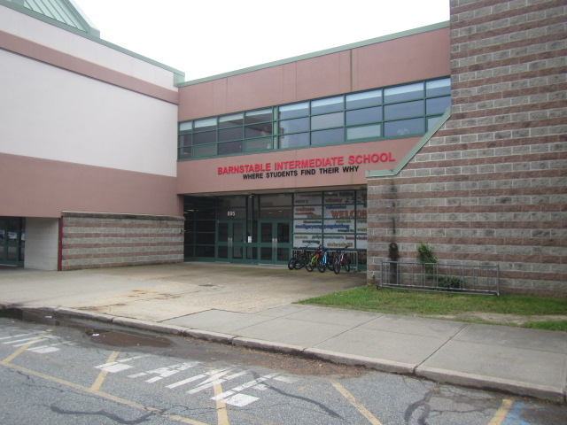

Prepared by:
Massachusetts Department of Public Health
Bureau of Climate and Environmental Health
Indoor Air Quality Program
October 2023
Building: | Barnstable Intermediate School (BIS)
Address: | 895 Falmouth Road, Hyannis, MA
Assessment Requested by: | Mike Lambros, Facilities Director, Barnstable Public Schools
Reason for Request: | Assessment of remediation of water-damaged building materials due to leaks from mechanical ventilation system components.
Date of Assessment: | August 30, 2023
Massachusetts Department of Public Health/Bureau of Climate and Environmental Health (MDPH/BCEH) Staff Conducting Assessment: | Cory Holmes, Assistant Director, Indoor Air  Quality (IAQ) Program
Building Description: | The BIS is a two-story building with two wings in an L-shape. The original wing was built in 1976 and an addition was constructed around 1999. A large proportion of the building exterior is composed of an exterior insulating foam system (EIFS) that mimics stucco. The water damage occurred in the main office, which consists of suspended ceiling tiles, gypsum wallboard, and wall to wall carpeting.
Windows: | Openable
It was reported that carpeting and ceiling tiles had become wet after several components of the mechanical ventilation system were found to be leaking in two areas of the main office. The source of leaks near the reception desk was an open spigot used to drain the mechanical ventilation unit above the ceiling that has since been capped, with no further leaks (Picture 1). This leak reportedly wet ceiling tiles below but did not wet carpeting. The second leak near the rear of the main office was traced to another open spigot and a portion of the chilled water pipes that were not insulated (Picture 2). Although the spigot was capped with no further leaks, at the time of the assessment condensation from the uninsulated chilled water pipe was being caught in a bucket until the proper insulation material that was ordered arrived (Picture 3).
According to Mr. Lambros, once the leaks were detected the following steps were taken to address the issue:
- The carpet was professionally steam cleaned by a carpet cleaning company.
- Commercial grade dehumidifiers were deployed in the space supplemented by air conditioning equipment to assist drying.
- The pipe insulation at the location was put on a work list to be removed and properly reinsulated.
- The window and door frames were wiped with an antimicrobial cleaner.
- All porous furniture in the space was discarded.
- Drywall in the main office was inspected and tested for moisture using a moisture meter.
- A contractor has been contacted to provide a quote to remove the carpet and replace with tile.

METHODS
MDPH IAQ staff performed a visual assessment for mold growth and conducted moisture sampling of carpeting and gypsum wallboard to ensure porous building materials were dry at the time of assessment.

RESULTS AND DISCUSSION

Microbial/Moisture Concerns
At the time of assessment, all moisture measurements of gypsum wallboard in the area and carpeting impacted by the leak were normal (i.e., dry). In addition, MDPH IAQ staff requested that the carpet be lifted in the affected area for inspection and the area underneath was found to be clean and dry with no visible mold growth (Picture 4).
It is recommended that porous material be dried with fans and heating within 24 to 48 hours of becoming wet (US EPA, 2008, ACGIH, 1989). If porous materials are not dried within this time frame, mold growth may occur. Water-damaged porous materials cannot be adequately cleaned to remove mold growth.

Other Issues
As a general rule, carpets should be cleaned annually (or semi-annually in soiled/high traffic areas) in accordance with Institute of Inspection, Cleaning and Restoration Certification (IICRC) recommendations, (IICRC, 2012). The service life of carpeting is approximately 10-11 years (IICRC, 2002). Carpeting of this age and condition becomes increasingly difficult to clean and maintain and may be a source of particulate matter to the indoor environment. Regular cleaning with a high efficiency particulate air (HEPA) filtered vacuum in combination with an annual cleaning will help to reduce accumulation and potential aerosolization of materials from carpeting.

RECOMMENDATIONS
In view of the findings at the time of the visit, the following recommendations are made:

Water Damage Recommendations
- Monitor chilled pipe where insulation was replaced for further leaks.

Other Recommendations
- Clean carpeting annually or semi-annually in soiled high traffic areas as per the recommendations of the Institute of Inspection, Cleaning and Restoration Certification (IICRC, 2012).
- Continue with plans to replace carpeting past its useful life (> 10-11 years).
- Refer to the resource manual and other related indoor air quality documents located on the MDPH’s website for further building-wide evaluations and advice on maintaining public buildings. These documents are available at http://mass.gov/dph/iaq.

REFERENCES
ACGIH. 1989. Guidelines for the Assessment of Bioaerosols in the Indoor Environment. American Conference of Governmental Industrial Hygienists, Cincinnati, OH.
IICRC. 2002. Institute of Inspection, Cleaning and Restoration Certification. A Life-Cycle Cost Analysis for Floor Coverings in School Facilities.
IICRC. 2012. Institute of Inspection, Cleaning and Restoration Certification. Carpet Cleaning: FAQ.
US EPA. 2008. “Mold Remediation in Schools and Commercial Buildings”. Office of Air and Radiation, Indoor Environments Division, Washington, DC. EPA 402-K-01-001. September 2008. Available at: http://www.epa.gov/mold/mold-remediation-schools-and-commercial-buildings-guide.
Picture 1
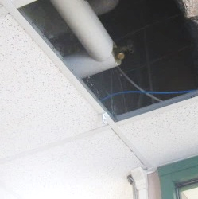
Capped spigot above reception desk near front of Main Office (arrow)
Picture 2
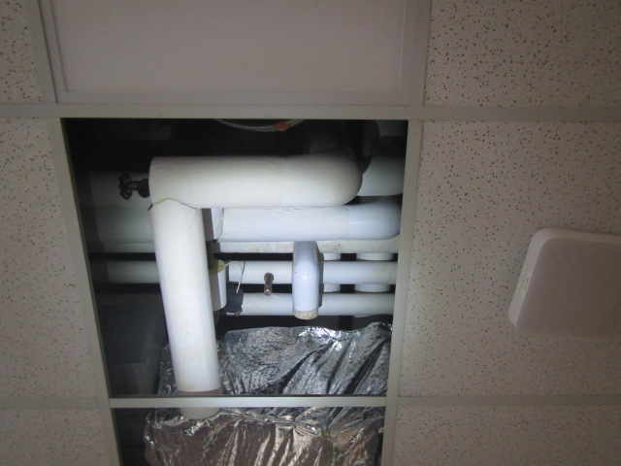
Area of leaks above ceiling near rear of Main Office
Picture 3
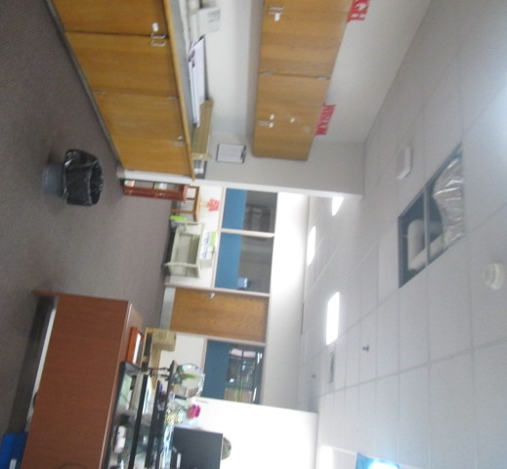
Bucket catching condensation from uninsulated pipes at rear of Main Office

Picture 4
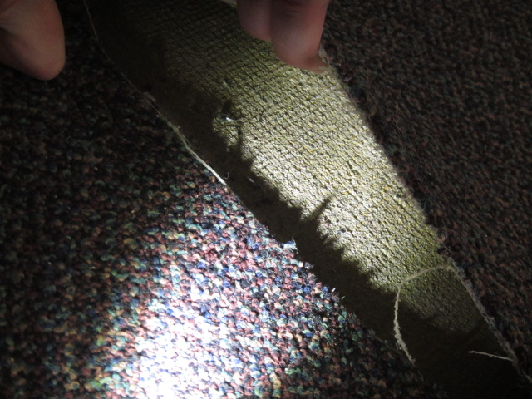
Carpet removed for inspection below uninsulated pipe in preceding picture

