INDOOR AIR QUALITY ASSESSMENT

Barnstable United Elementary School
730 Osterville W. Barnstable Road
Marstons Mills, Massachusetts

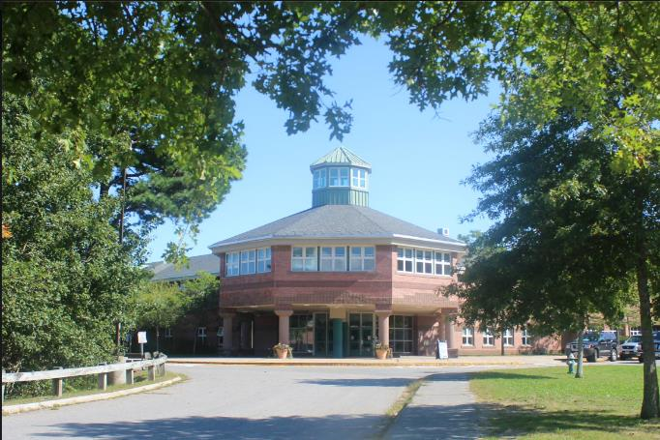

Prepared by:
Massachusetts Department of Public Health
Bureau of Environmental Health
Indoor Air Quality Program
October 2019

BACKGROUND
Building: | Barnstable United Elementary School (BUES) formally the Horace Mann Charter School
Address: | 730 Osterville W. Barnstable Road  Marstons Mills, Massachusetts
Assessment Requested by: | Barnstable Board of Health coordinated via Barnstable Public Schools (BPS)
Reason for Request: | Mold concerns prompted this recent request; however, over the past year the MDPH has been involved with a collaborative effort to perform general indoor air quality (IAQ) assessments throughout the Barnstable School District.
Date of Assessment: | September 12 and September 17, 2019
Massachusetts Department of Public Health/Bureau of Environmental Health (MDPH/BEH) Staff Conducting Assessment: | Mike Feeney, Director and Cory Holmes, Environmental Analyst, MDPH/IAQ Program
Building Description: | The BUES is a two-story brick building completed in 1994. The building contains a centralized courtyard, general classrooms, science classrooms, art rooms, music rooms, kitchen, cafeteria, gymnasium, faculty workrooms and office space.
Windows: | Openable

METHODS
Please refer to the IAQ Manual and appendices for methods, sampling procedures, and interpretation of results (MDPH, 2015). Note that this building has been visited by the MDPH IAQ Program in June 2012 at the request of the BPS. The report from that visit can be found at: https://www.mass.gov/info-details/indoor-air-quality-reports-cities-and-towns-b (listed as Horace Mann). It is also important to note that the BPS has reportedly created IAQ committees in their school buildings, each with an IAQ liaison/teacher representative that conducts regular walk-throughs to identify on-going and/or potential environmental issues.

RESULTS and DISCUSSION
The following is a summary of indoor air testing results (Tables 1 and 2).
- Carbon dioxide levels on September 12 and 17 were above the MDPH recommended level of 800 parts per million (ppm) in about two-thirds of the areas surveyed, which indicates a lack of air exchange in many classrooms at the time of assessment. This is most likely due to deactivated mechanical ventilation components as well as limitations on outside air introduction, which is typical during operation of the air conditioning (AC) system. This is explained further in the Ventilation section of this report.
- Temperature measurements on September 12 and 17 were within or close to the MDPH recommended range of 70°F to 78°F in occupied areas, with the exception of room 104 (63°F, Table 1) and the Library (64°F, Table 1), which is reported to be chronically cold. Temperature control issues/thermal comfort complaints were also reported in other areas.
- Relative humidity measurements on September 12 were above the MDPH recommended range of 40 to 60% in all areas tested, which was reflective of outdoor conditions (humid/heavy rain) at the time of assessment. However, it is important to note that the building is reported to have chronic issues with water damage and humidity control, this is discussed further in the Microbial/Moisture Concerns portion of this assessment. Relative humidity measurements on September 17 were within the MDPH comfort guideline of 40-60 percent.
- Carbon monoxide levels were non-detectable (ND) in all areas tested on both days of assessment.
- Particulate matter (PM2.5) concentrations measured were below the National Ambient Air Quality (NAAQS) level of 35 μg/m³ in all areas tested on both days of assessment, with the exception of room 233, which had a measurement of 239 μg/m³ in close proximity to an electric fragrance diffuser operating at the time of testing. Exposure to particulate matter with a diameter of 2.5 micrometers (μm) or less (PM2.5) can produce immediate, acute health effects upon exposure. A number of activities that occur indoors and/or mechanical devices can generate particulates during normal operations. Sources of indoor airborne particulates may include but are not limited to particles generated during the operation of fan belts in the HVAC system, use of stoves and/or microwave ovens in kitchen areas; use of photocopiers, fax machines and computer printing devices; operation of an ordinary vacuum cleaner and heavy foot traffic indoors.

Ventilation
A heating, ventilating and air conditioning (HVAC) system has several functions. First it provides heating and, if equipped, cooling. Second, it is a source of fresh air. Finally, an HVAC system will dilute and remove normally-occurring indoor environmental pollutants by not only introducing fresh air, but by filtering the airstream and ejecting stale air to the outdoors via exhaust ventilation. Even if an HVAC system is operating as designed, point sources of respiratory irritation may exist and cause symptoms in sensitive individuals. Carbon dioxide is not a problem in and of itself. It is used as an indicator of the adequacy of the fresh air ventilation.
As carbon dioxide levels rise, it indicates that the ventilating system is malfunctioning or the design occupancy of the room is being exceeded. When this happens, a buildup of common indoor air pollutants can occur, leading to discomfort or health complaints. The Occupational Safety and Health Administration (OSHA) standard for carbon dioxide is 5,000 parts per million parts of air (ppm). Workers may be exposed to this level for 40 hours/week, based on a time-weighted average (OSHA, 1997).
Fresh air in classrooms is supplied by unit ventilators (univents, Picture 1). Univents draw air from the outdoors through a fresh air intake located on the exterior wall of the building (Picture 2) and return air through an air intake located at the base of the unit. Fresh and return air are mixed, filtered, heated or cooled and provided to rooms through an air diffuser located in the top of the unit (Figure 1). In room 205 the univent was reportedly inoperable; therefore no fresh air was being introduced at the time of testing. In addition, in some rooms the top and/or front of some univents were blocked by classroom items (Picture 3). In order for univents to provide fresh air as designed, intakes/returns must remain free of obstructions. Importantly, these units must remain on and be allowed to operate while rooms are occupied. It is also important to note that outside air is typically limited (by pneumatically adjusting intake louvers) during air conditioning (AC) season and cold/winter months to provide comfort and prevent the freezing of pipes.
Classroom exhaust vents are located in the ceilings (Picture 4) and are connected with ducts to exhaust fans on the roof. A number of these exhaust vents were not drawing air during the assessment. Note that in many classrooms, exhaust vents were located near classroom doors (Picture 5). This design works best with the doors to the hallway closed, otherwise the exhaust vents tend to draw air from the hallway rather than the room which reduces the effectiveness of air circulation. Without adequate supply and exhaust ventilation, excess heat/humidity and environmental pollutants can build up and lead to indoor air/comfort complaints.
Mechanical ventilation in common areas and interior rooms is provided by rooftop air handling units (AHUs). Air is drawn in through air intakes, filtered, heated/cooled and distributed via ceiling or wall-mounted diffusers. Air is drawn back to AHUs via ceiling or wall-mounted return vents.
The HVAC equipment appears to be original equipment (early 1990s) over 25 years old. Efficient function of equipment of this age is difficult to maintain, since compatible replacement parts are often unavailable. According to the American Society of Heating, Refrigeration, and Air-Conditioning Engineering (ASHRAE), the service life of this type of unit is 15-20 years, assuming routine maintenance of the equipment (ASHRAE, 1991). It appears the optimal operational lifespan of this equipment has been exceeded. It was reported that the BPS was in the process of finding a Mechanical Engineering firm to conduct a full evaluation of the building’s HVAC equipment.
To maximize air exchange, the IAQ program recommends that both supply and exhaust ventilation operate continuously during periods of occupancy. In order to have proper ventilation with a mechanical ventilation system, the systems must be balanced after installation to provide an adequate amount of fresh air to the interior of a room while removing stale air from the room. It is recommended that HVAC systems be re-balanced every five years to ensure adequate air systems function (SMACNA, 1994).

Microbial/Moisture Concerns
In order for building materials to support mold growth, a source of water exposure is necessary. Identification and elimination of the source of water moistening building materials is necessary to control mold growth. In the case of the BUES, the main sources of moisture creating conditions conducive to mold growth are relative humidity and operation of the AC system. However other sources of water damage are typically present in most buildings such as roof/window leaks (Picture 6) as well as leaks/condensation from HVAC systems and plumbing.
It should be noted that maintaining relative humidity in school buildings over the summer months, particulary in the Cape Cod area is challenging. Compounding this condition is the use of an AC system in the summer in which a chiller creates cold water that is fed to univents and AHUs for cooling. When the HVAC system was designed, a thermal load (heat produced by occupants and activities) corresponding to the full capacity of the school, approximately 900-1,000 people, is used in design calculations. This thermal load determines the temperature at which the coolant is chilled to provide comfortable air. As is the case with most schools, that population is significantly lower during summer vacation. This discrepancy is likely leading to overcooling when the chiller is in use, which may lead to condensation on surfaces that are chilled below the dew point, which results in flat surfaces/floors becoming wet by condensation. This condition can be further exacerbated by classroom windows and/or exterior doors being left open to the outside or between sections for cleaning and maintenance activities. Therefore many factors should be taken into account over the summer months to make adjustments to the HVAC systems, including:
- Actual occupancy;
- Building design/materials (carpeting vs solid floors);
- Outdoor temperatures;
- Relative humidity conditions;
- Dew point and condensation issues;
- Opening/closing of windows and doors, particularly while the AC system is on (Picture 7);
- Fresh/outdoor air intake;
- Exhaust/return; as well as
- Activities in the building such as steam/carpet cleaning, etc.

It was reported to MDPH/IAQ Program staff that mold growth was observed and cleaned off a number of classroom items over the summer/prior to school opening. Typically solid/non-porous items can be cleaned whereas; porous items such as cardboard, books, ceiling tiles should be discarded as they are difficult to clean. At the time of the assessment water-damaged materials, some with likely/visible mold growth were observed (Tables 1 and 2), such as:
- Ceiling tiles (Pictures 8 and 9), which can indicate current/historic roof/plumbing leaks or other water infiltration. Active leaks were reported on the second floor in the hallway (near Room 217), where school staff reported ceiling tiles had been recently changed (Picture 10). Water-damaged ceiling tiles can provide a source of mold and should be replaced after a water leak is discovered and repaired;
- Instrument cases in the band room (Picture 11);
- Desk/chair unit in unoccupied Room 107 (Pictures 12a and 12b);
- Refrigerator gaskets in classrooms and the Teacher’s Lounge (Pictures 13 and 14);
- Water-stained gypsum wallboard outside the library (Picture 15). Note, this material was tested for moisture content on September 17 and found dry;
- Insulation material in ceiling above art room closet (Picture 16); and
- Various classroom items (Pictures 17 through 19).
The US Environmental Protection Agency (US EPA) and the American Conference of Governmental Industrial Hygienists (ACGIH) recommend that porous materials (e.g., ceiling tiles, carpet) be dried with fans and heating within 24 to 48 hours of becoming wet (US EPA, 2008; ACGIH, 1989). If not dried within this time frame, mold growth may occur. Once mold has colonized porous materials, they are difficult to clean and should be removed. Corkboards are reported to be a chronic problem over the summer months. If not critical to the learning environment, consider removing these items from the building.
Plants were present in some classrooms and other areas. Plants, soil, and drip pans can serve as sources of mold/bacterial growth. Plants should be properly maintained, over-watering of plants should be avoided, and drip pans should be inspected periodically for mold growth. In addition, plants should not be placed on top of or in the airstream of HVAC equipment such as univents.
A perimeter inspection of the building was conducted to identify any breaches/potential pathways for water intrusion:
- Wooden fascia board was exposed near the roof (near front of building);
- Plants/shrubbery in close contact with exterior walls (Pictures 20 and 21);
- Clinging plants on masonry (Picture 21);
- A leaking plumbing fixture (Picture 22); and
- Lack of gutters and downspouts on parts of the roof that cause splash back against exterior walls (Pictures 23 through 25).
Over time, these conditions can undermine the integrity of the building envelope and provide a means of water entry into the building via capillary action through foundation concrete and masonry (Lstiburek & Brennan, 2001). The freezing and thawing action of water during the winter months can create cracks and fissures in the foundation. These breaches may provide a means for moisture and pests to enter the building.
During the exterior examination MDPH/IAQ Program staff also noted exterior wall drainage hindered by clogged/plugged weep holes (Pictures 26 and 27). In modern construction, brick exterior wall systems are usually designed to prevent moisture penetration into the building interior. An exterior wall system usually consists of an exterior brick curtain wall (Figure 2). Behind the curtain wall is an air space that allows for water to drain downward and for the exterior cladding system to dry. At the base of the curtain wall should be weep holes that allow for water drainage. Opposite the exterior wall and across the air space is a continuous, water-resistant material adhered to the backup wall that forms the drainage plane.
The purpose of the drainage plane is to prevent moisture that crosses the air space from penetrating into interior building systems. The plane also directs moisture downwards toward the weep holes. The drainage plane can consist of a number of water-resistant materials, such as tarpaper or, in newer buildings, plastic wraps, and should be continuous. Where breaks exist in the drainage plane (e.g., window systems, door systems and univent fresh air intakes), additional materials (e.g., flashing) are installed as transitional surfaces to direct water to weep holes. If the drainage plane is discontinuous, missing flashing, or lacking air space, rainwater may accumulate inside the wall cavity and lead to moisture penetration into the building.
In order to allow for water to drain from the exterior brick wall system, a series of weep holes is customarily installed at or near the foundation slab/exterior wall system junction (Figure 2). Weep holes allow for accumulated water to drain from a wall system (Dalzell, 1955). Failure to install weep holes in brickwork or clogging/burial of weep holes below grade will allow water to accumulate in the base of walls, resulting in seepage and possible moistening of building components (Figure 3).
Also noted on exterior walls was the presence of rust-colored scale/debris from AC condensation pipes (Picture 28). This may indicate that metal drip pans are corroded/at the end of their service life. It is important that drip pans be smooth/clean and drain properly to prevent debris from clogging drain holes, which can lead to standing water and bacterial/mold growth and associated odors within units.
Often times, classroom design can have a negative effect on air quality. A design issue that was noted was the configuration of ceiling-mounted univents in first floor classrooms and the installation of suspended lighting fixtures and sprinkler heads directly in the line of airflow. During operation of univents, these items will collect airborne dust/debris and or be cooled by the AC system, which can lead to condensation on cold surfaces and mold growth (Pictures 29 through 31). The condensation phenomenon would not occur if these structures were not in the air stream when the HVAC system is in chilled air mode or during the heating season. If a building is designed to have ceiling-mounted univents, locating metal protrusions from the suspended ceiling in the airstream is not recommended.

Relative Humidity
Of particular concern are weather patterns of high temperatures (heat waves) and elevated humidity conditions (> 70%) for extended periods of time (three/more consecutive days). If a building does not have either adequate exhaust ventilation and/or air chilling capacity to remove/reduce relative humidity from outside air, then hot, moist air can be introduced into a building and linger to increase occupant discomfort as well as possibly moisten materials that may lead to mold growth. The MDPH recommends a comfort range of 40 to 60 percent for indoor air relative humidity, which were exceeded throughout the building during the September 12th visit. Chronic issues with excess humidity were evident by the presence of “bowed” (i.e., non-flush) ceiling tiles throughout the building (Picture 32).
High relative humidity indoors can indicate that the HVAC system is insufficient to remove water vapor without the aid of air conditioning or dehumidification. It was observed that several dehumidifiers were being used in conjunction with the AC system at the time of the assessment. Moisture removal is important since higher humidity at a given temperature reduces the ability of the body to cool itself by sweating. “Heat index” and “apparent temperature” are measurements that take into account the impact of a combination of heat and humidity on how individuals perceive heat. At a given indoor temperature, the addition of humid air increases occupant discomfort and may generate heat complaints. If moisture levels are decreased, the comfort of the individuals can increase. Relative humidity in excess of 70 percent for extended periods of time can provide an environment for mold and fungal growth (ASHRAE, 1989).
Compounding this condition is the use of an AC system in the summer in which a chiller creates cold water that is fed to univents and AHUs for cooling. When the HVAC system was designed, a thermal load (heat produced by occupants and activities) corresponding to the full capacity of the school, approximately 900-1000 people, was likely used in design calculations. This thermal load determines the temperature at which the coolant is chilled to provide comfortable air. With occupancy being considerably less during summer vacation, this is likely leading to overcooling when the chiller is in use, which may lead to condensation on surfaces that are chilled below the dew point. Without proper control/adjustment, the operation of the HVAC system in the chilling mode can result in the floor becoming wet by condensation during summer months. This condition can be further exacerbated by exterior doors or windows being left open to the outside while the AC system is in operation (Pictures 7 and 24).

Other Conditions
Other conditions that can affect indoor air quality were observed during the assessment. The MDPH recommends pleated filters with a Minimum Efficiency Reporting Value (MERV) of 8, which are adequate in filtering out pollen and mold spores (ASHRAE, 2012). Filters should also be changed two to four times a year, or per the manufacturer’s recommendations. To change univent filters, BUES maintenance staff must remove a panel on the front of the unit, open a filter access panel and remove a metal frame to access the filter medium (Picture 33). The type of filter medium used by the school comes in a bulk roll and must be cut to size. This method is extremely time intensive and the results are variable; if the filter medium is not properly fitted, gaps can allow unfiltered air into the room and/or reduce the useful life of the filter. It should be determined if disposable filters with an appropriate dust spot efficiency can be installed in these univents. The dust spot efficiency is the ability of a filter to remove particulates of a certain diameter from air passing through the filter. Note that increased filtration can reduce airflow by increased resistance. Prior to any increase of filtration, each univent should be evaluated by a ventilation engineer as to whether it can maintain function with more efficient filters.
In some areas, exhaust vents, supply diffusers and the interior of univents had accumulated dust/debris (Table 1, Pictures 4, 34 and 35). This dust can be reaerosolized under certain conditions, and can also be a medium for mold growth. Univent cabinets can also accumulate dust and debris which should be cleaned when filters are changed (2-4 times/year).
Some areas had wall to wall carpeting, in some cases the carpet was wrinkled/worn and appeared to be past its useful life (Pictures 36 and 37). The service life of carpeting in schools is approximately 10-11 years (IICRC, 2002). Aging carpet can produce fibers that can be irritating to the respiratory system. In addition, tears or lifting carpet can create tripping hazards. Area rugs were also observed in many classrooms (Table 1). Carpets should be cleaned annually (or semi-annually in soiled/high traffic areas) in accordance with Institute of Inspection, Cleaning and Restoration Certification (IICRC) recommendations, (IICRC, 2012). Regular cleaning with a high efficiency particulate air (HEPA) filtered vacuum in combination with an annual cleaning will help to reduce accumulation and potential aerosolization of materials from carpeting. Area carpets too worn to be effectively cleaned should be replaced. Area rugs should be rolled up and stored in a clean, dry place when rooms are not occupied during the summer months to prevent moistening due to condensation.
In many classrooms, large numbers of items were on floors, windowsills, tabletops, counters, bookcases and desks, which provide a source for dusts to accumulate. These items (e.g., papers, folders, boxes) make it difficult for custodial staff to clean. Items should be relocated and/or be cleaned periodically to avoid excessive dust build up. In addition, dust and debris can accumulate on flat surfaces (e.g., desktops, shelving and carpets) in occupied areas and subsequently be re-aerosolized causing further irritation.
Aquariums were located in a few classrooms. Aquariums should be properly maintained to prevent bacterial/mold/algal growth and associated nuisance odors.
Exposure to low levels of total volatile organic compounds (TVOCs) may produce eye, nose, throat, and/or respiratory irritation in some sensitive individuals. BEH/IAQ staff examined rooms for products containing VOCs. BEH/IAQ staff noted hand sanitizers, scented products, plug in air fresheners/diffusers (Picture 38), home cleaning products, and dry erase materials in use within the building. All of these products have the potential to be irritants to the eyes, nose, throat, and respiratory system of sensitive individuals. In addition, spray bottles/cleaning products should be kept out of reach of children.
Several areas contain photocopiers, which can give off waste heat and irritating odors. VOCs and ozone can be produced by photocopiers, particularly if the equipment is older and in frequent use. Ozone is a respiratory irritant (Schmidt Etkin, D., 1992). These units should be used in well-ventilated areas or in rooms with local exhaust ventilation.
Note that the Environmental Protection Agency (EPA) conducted a National School Radon Survey in which it discovered nearly one in five schools had “…at least one frequently occupied ground contact room with short-term radon levels above 4 [picocuries per liter] pCi/L” (US EPA 1993). The BEH/IAQ Program therefore recommends that every school be tested for radon, and that this testing be conducted during the heating season while school is in session in a manner consistent with USEPA radon testing guidelines. Radon measurement specialists and other information can be found at www.nrsb.org and http://aarst-nrpp.com/wp, with additional information at: http://www.mass.gov/eohhs/gov/departments/dph/programs/environmental-health/exposure-topics/iaq/radon.
Finally, musty odors were detected in interior room 108a. No visible mold growth and/or obvious signs of water damage were observed in this room, which had cinderblock walls and tile floors. Therefore, it is likely that either items or furniture located in this room is the source of the odors.

RECOMMENDATIONS
The conditions related to IAQ problems at the BUES raise a number of issues. The general building conditions/design, maintenance, work hygiene practices, and the condition of HVAC equipment, if considered individually, present conditions that could degrade IAQ. When combined, these conditions can serve to further degrade IAQ. Some of these conditions can be remedied by actions of building occupants. Other remediation efforts will require alteration to the building structure and equipment. For these reasons, a two-phase approach is recommended. The first consists of short-term measures to improve air quality and the second consists of long-term measures that will require planning and resources to adequately address overall IAQ concerns.

Short-term measures:
- Consider raising the set point for the HVAC system during periods of hot weather when building is mostly empty of occupants to limit condensation.
- Continue to employ district-wide/building specific IAQ committees/liaisons with regular walk-troughs of the building to identify on-going and/or potential issues.
- Operate the HVAC system (supply/exhaust) to provide for continuous fresh air ventilation during occupied hours.
- Continue to make repairs to univent in room 205 (and any other areas).
- Remove furniture and items blocking the front and top of univents.
- Periodically assess whether exhaust vents (classrooms and restrooms) are drawing air and make repairs as needed.
- Use openable windows to supplement fresh air during temperate weather. Ensure all windows are closed tightly at the end of each day. Do not use windows while AC system is operating to prevent condensation/mold growth.
- Close classroom doors during occupancy to allow for more effective function of exhaust vents (once operating as designed).
- Work with staff to troubleshoot temperature control problems.
- Utilize a system to report and track maintenance issues (e.g., school dude) so that concerns can be reported by staff and maintenance staff can report when issues have been resolved.
- Consider adopting a balancing schedule of every 5 years for all mechanical ventilation systems, as recommended by ventilation industrial standards (SMACNA, 1994).
- Work with a roofing contractor/building engineer to investigate/repair building envelope leaks (e.g., 2nd floor hallway/windows in Room 215). Until this has been completed, avoid storing porous materials in areas of known leaks.
- Once repairs are made, replace water-damaged ceiling tiles and refinish areas of water damage. Inspect the area above the stained tiles for water damage or odors and remediate or clean as necessary.
- Discard porous classroom items that have mold growth (e.g., books, cardboard, paper). Conduct a close examination of items in storage closets and the band room. Non-porous items can be cleaned with soap/water or an anti-microbial product.
- Keep classroom/office plants in good condition, avoid overwatering, and keep them away from the airstream of ventilation equipment.
- Ensure aquariums are clean and odor free.
- Reduce or eliminate the use of air fresheners/diffusers, scented cleaners, hand sanitizers and dry erase materials to reduce irritation. In addition, spray bottles/cleaning products should be kept out of reach of children.
- Use photocopiers in well-ventilated/open spaces or in areas with local exhaust ventilation.
- Change filters in HVAC units 2-4 times a year with MERV 8 (or higher) filters. Clean HVAC and univent cabinets of debris and dust when filters are changed.
- Consider using disposable, pleated cardboard filters instead of filter media that needs to be hand cut and installed in metal racks.
- Clean supply/exhaust vents and personal fans regularly to remove accumulated dust/debris. Replace surrounding ceiling tiles that cannot be adequately cleaned.
- Ensure all refrigerators are kept clean to prevent microbial growth and odors. Clean gaskets and other surfaces with a mild antimicrobial solution to remove debris and mold. If cannot be adequately cleaned-replace.
- Ensure that condensation from AC equipment is draining properly. Check collector pans, piping and any associated pumps for clogs and leaks and clean periodically to prevent stagnant water build-up and remove debris that may provide a medium for microbial growth.
- Trim back trees from overhanging the roof and ensure all plants/shrubs are located at least five feet away from exterior walls. Remove clinging plants.
- Fix plumbing leak shown in Picture 22.
- Continue to utilize portable dehumidifiers as needed during excessive relative humidity periods (>70%). Ensure dehumidifiers are cleaned/maintained as per the manufacturer’s instructions to prevent mold/bacterial growth.
- Repair/replace all water-damaged/mold-colonized porous building materials (e.g., ceiling tiles, gypsum wallboard) in classrooms, hallways and common areas in a manner consistent with the U.S. Environmental Protection Agency’s guidelines (US EPA, 2008).
- If water damage/mold growth on corkboards continues to be a problem, consider removing from the building.
- For buildings in New England, periods of low relative humidity during the winter are often unavoidable. Therefore, scrupulous cleaning practices should be adopted to minimize common indoor air contaminants whose irritant effects can be enhanced when the relative humidity is low. To control for dusts, a high efficiency particulate arrestance (HEPA) filter equipped vacuum cleaner in conjunction with wet wiping of all surfaces is recommended. Avoid the use of feather dusters. Drinking water during the day can help ease some symptoms associated with a dry environment (throat and sinus irritations).
- Replace any missing or ajar ceiling tiles to avoid pathways to unconditioned areas.
- Clean carpeting annually or semi-annually in soiled high traffic areas as per the recommendations of the Institute of Inspection, Cleaning and Restoration Certification (IICRC 2012). Area carpets too worn to be effectively cleaned should be replaced. Roll up and store are rugs in a clean, dry place during the summer.
- Consider a long-term plan to replace all carpeting in the building as funds become available. Consider replacing carpeting with a non-porous surface such as vinyl tile particularly in below-grade areas.
- Relocate or consider reducing the amount of materials stored in classrooms to allow for more thorough cleaning of classrooms. Clean items regularly with a wet cloth or sponge to prevent excessive dust build-up.
- Remove all items from Room 108a to determine if odors dissipate. If odors, persist have the AHU above the ceiling fully evaluated for function/proper drainage to rule out as a source of odor.
- Continue to utilize the US EPA’s (2000), “Tools for Schools”, as an instrument for maintaining a good IAQ environment in the building available at: http://www.epa.gov/iaq/schools/index.html.
- The school should be tested for radon by a certified radon measurement specialist during the heating season when school is in session. Radon measurement specialists and other information can be found at: www.nrsb.org, and http://aarst-nrpp.com/wp.
- For more information on mold refer to “Mold Remediation in Schools and Commercial Buildings” published by the US Environmental Protection Agency (US EPA, 2008). http://www.epa.gov/mold/mold-remediation-schools-and-commercial-buildings-guide.

Long-term Recommendations:
- Continue with plans to contact an HVAC engineering firm for an assessment of the ventilation system’s components and control systems (e.g., controls, air intake louvers, thermostats). Based on the age, physical deterioration, and availability of parts for ventilation components, such an evaluation is necessary to determine the operability and feasibility of repairing/replacing the equipment.
- Examine drip pans building-wide for corrosion/proper drainage and replace as necessary.
- Remove blockages from affected weep holes to ensure proper operation of drainage plane.
- Consider relocating all suspended lighting fixtures and sprinkler heads (if possible) from in direct line of airflow of univents/AC. Due to this design configuration, these structures will continue to accumulate dust/debris and be subject to cooling/condensation and likely mold growth in the future. In the interim, these items should be cleaned regularly to prevent such occurrence.
- As discussed in the report there are many factors that must be taken into consideration to operate the building’s HVAC system efficiently over the summer months to provide comfort and prevent condensation/mold growth; consult with an HVAC engineering firm regarding best practices for operation.
- Consider installing a full gutter/down spout system to draw/drain water away from the building.

REFERENCES
ACGIH. 1989. Guidelines for the Assessment of Bioaerosols in the Indoor Environment. American Conference of Governmental Industrial Hygienists, Cincinnati, OH.
ASHRAE. 1989. Ventilation for Acceptable Indoor Air Quality. American Society of Heating, Refrigeration and Air Conditioning Engineers. ANSI/ASHRAE 62-1989.
ASHRAE. 1991. ASHRAE Applications Handbook, Chapter 33 “Owning and Operating Costs”. American Society of Heating, Refrigeration and Air Conditioning Engineers, Atlanta, GA.
ASHRAE. 2012. American Society of Heating, Refrigeration and Air Conditioning Engineers (ASHRAE) Standard 52.2-2012 -- Method of Testing General Ventilation Air-Cleaning Devices for Removal Efficiency by Particle Size (ANSI Approved). 2012.
Dalzell, J.R. 1955. Simplified Masonry Planning and Building. McGraw-Hill Book Company, Inc. New York, NY.
IICRC. 2002. Institute of Inspection, Cleaning and Restoration Certification. A Life-Cycle Cost Analysis for Floor Coverings in School Facilities.
IICRC. 2012. Institute of Inspection Cleaning and Restoration Certification. Institute of Inspection, Cleaning and Restoration Certification. Carpet Cleaning: FAQ.
Lstiburek, J. & Brennan, T. 2001. Read This Before You Design, Build or Renovate. Building Science Corporation, Westford, MA. U.S. Department of Housing and Urban Development, Region I, Boston, MA.
MDPH. 2015. Massachusetts Department of Public Health. Indoor Air Quality Manual: Chapters I-III. Available at: http://www.mass.gov/eohhs/gov/departments/dph/programs/environmental-health/exposure-topics/iaq/iaq-manual/.
OSHA. 1997. Limits for Air Contaminants. Occupational Safety and Health Administration. Code of Federal Regulations. 29 C.F.R 1910.1000 Table Z-1-A.
Schmidt Etkin, D. 1992. Office Furnishings/Equipment & IAQ Health Impacts, Prevention & Mitigation. Cutter Information Corporation, Indoor Air Quality Update, Arlington, MA.
SMACNA. 1994. HVAC Systems Commissioning Manual. 1st ed. Sheet Metal and Air Conditioning Contractors’ National Association, Inc., Chantilly, VA.
US EPA. 1993. Radon Measurement in Schools, Revised Edition. Office of Air and Radiation, Office of Radiation and Indoor Air, Indoor Environments Division (6609J). EPA 402-R-92-014. https://www.epa.gov/radon/radon-schools
US EPA. 2000. Tools for Schools. Office of Air and Radiation, Office of Radiation and Indoor Air, Indoor Environments Division (6609J). EPA 402-K-95-001, Second Edition. http://www.epa.gov/iaq/schools/index.html.
US EPA. 2008. Mold Remediation in Schools and Commercial Buildings. US Environmental Protection Agency, Office of Air and Radiation, Indoor Environments Division, Washington, D.C. EPA 402-K-01-001. http://www.epa.gov/mold/mold-remediation-schools-and-commercial-buildings-guide.
Picture 1
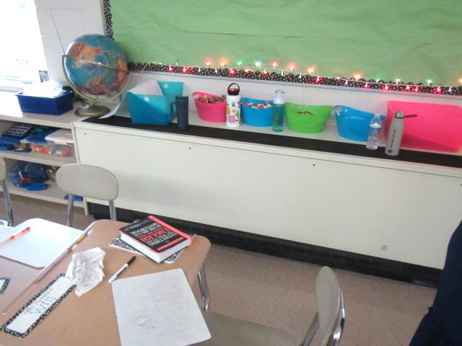
Classroom univent
Picture 2
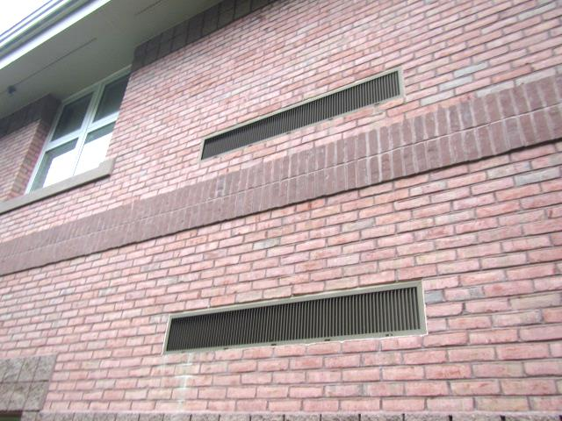
Univent fresh air intakes
Picture 3
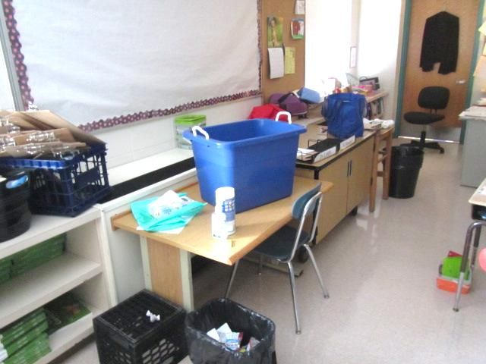
Univent return vent (bottom front) obstructed by classroom furniture
Picture 4
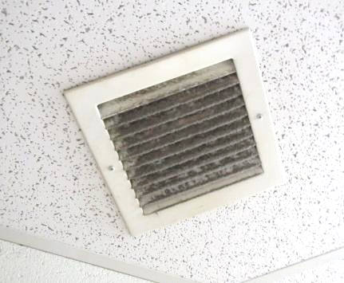
Classroom exhaust vent, note accumulated dust/debris
Picture 5
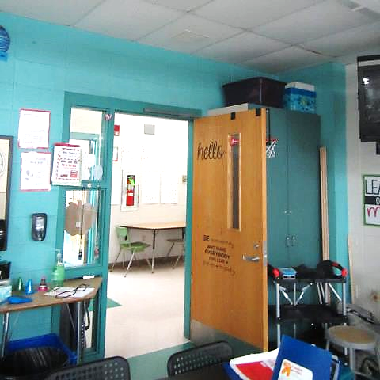
Proximity of classroom exhaust vent (arrows) to open hallway door
Picture 6
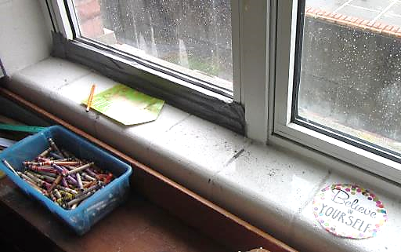
Standing water from active leak on masonry/windowsill in classroom 215, note duct tape on left window
Picture 7
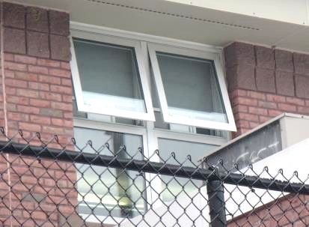
Classroom windows open while AC system in operation
Picture 8
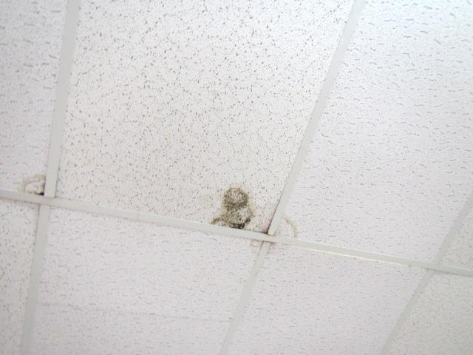
Water-damage/mold growth on ceiling tiles room 219
Picture 9
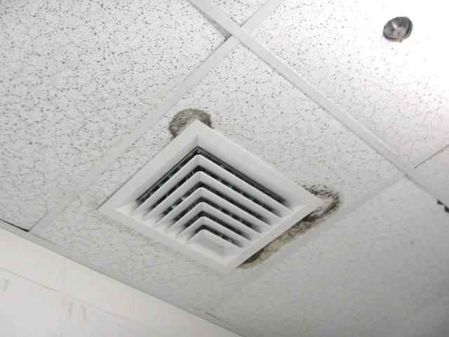
Water-damage/mold growth on ceiling tiles room 107
Picture 10
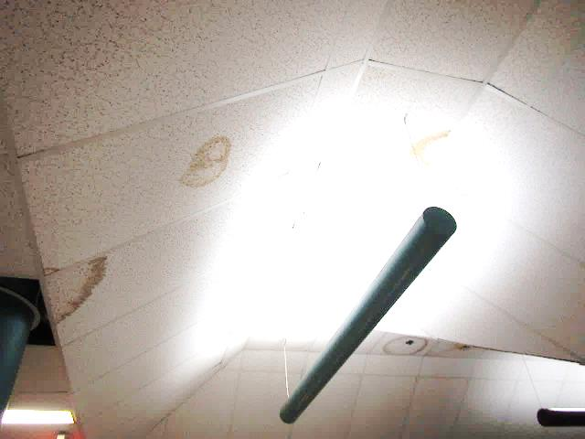
Water-damaged ceiling tiles in 2nd floor hallway near Room 217
Picture 11
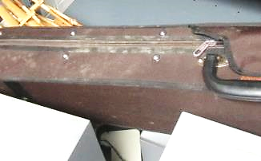
Mold growth on instrument case in band storage room
Pictures 12a and 12b
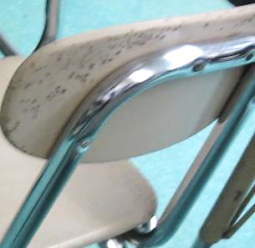
Mold growth on chair/desk unit labeled “Please Take away”
Picture 13
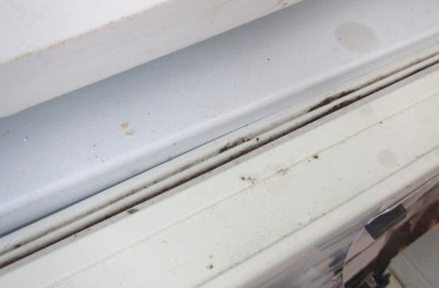
Debris/mold growth on mini-fridge gasket in classroom
Picture 14
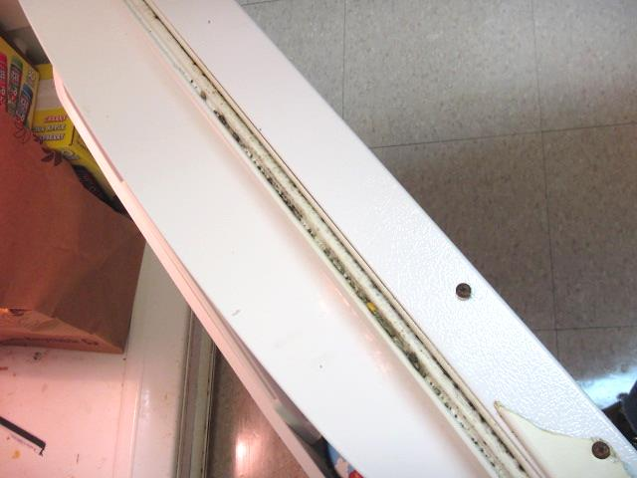
Debris/mold growth on mini-fridge gasket in Faculty Lounge
Picture 15
Water-stained gypsum wallboard outside Library
Picture 16
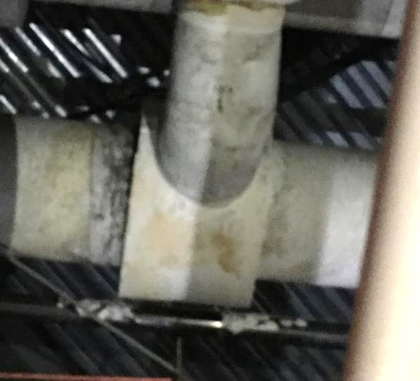
Insulation material in art room closet
Picture 17
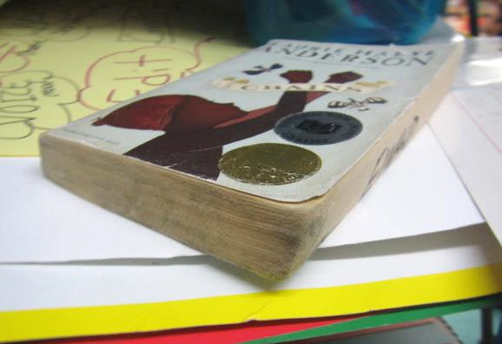
Mold growth on book in closet in Room 207
Picture 18
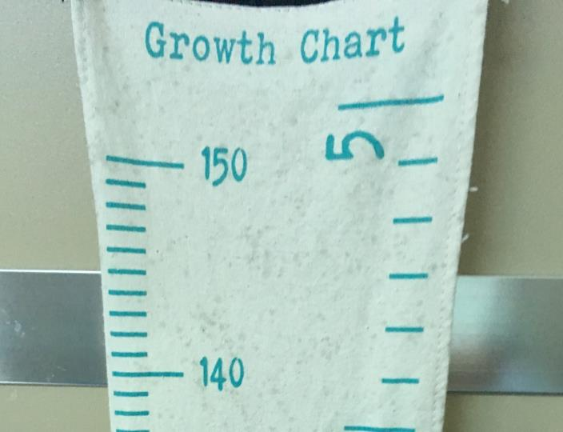
Staining from mold growth on fabric classroom item
Picture 19
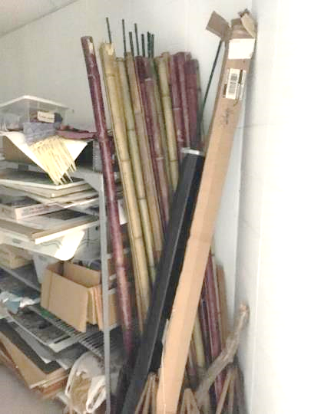
Moldy/odorous bamboo in Art room closet
Picture 20
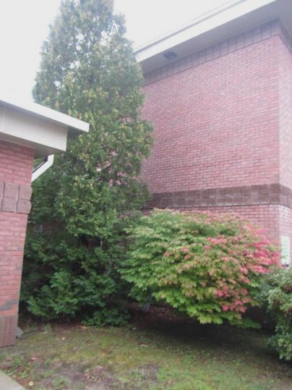
Trees/shrubbery in close contact with exterior walls
Picture 21
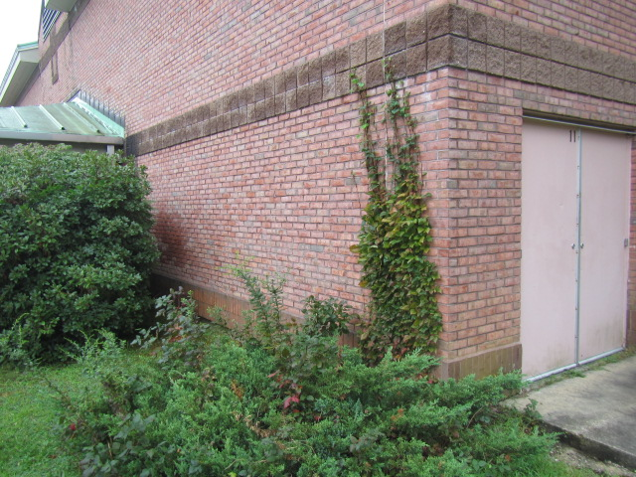
Trees/shrubbery in close contact with exterior walls, also note clinging plants
Picture 22
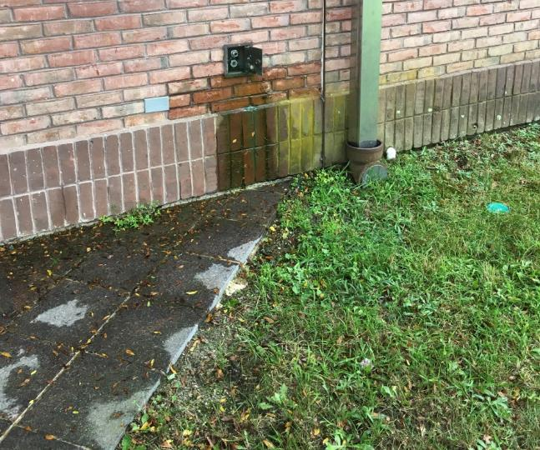
Leaking plumbing fixture
Picture 23
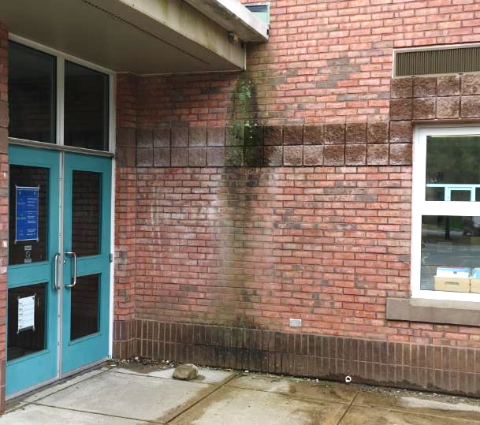
Moss growth from chronic water exposure on exterior walls
Picture 24
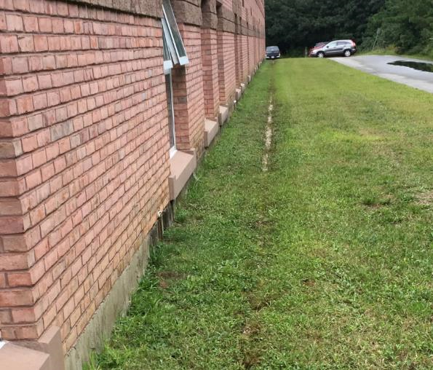
Trough along exterior of building due to roof runoff/lack of gutters, also note open classroom window while AC system operating
Picture 25
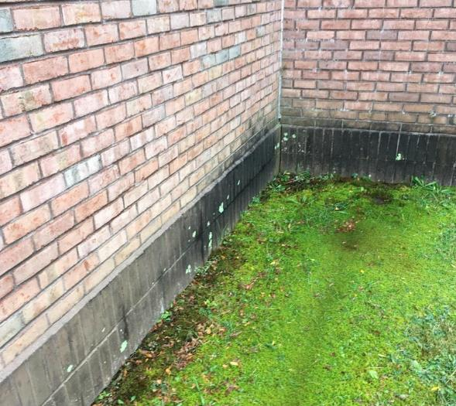
Heavy moss growth/discoloration of foundation due to chronic water exposure (i.e., splash back) from lack of drainage/gutters/downspouts
Picture 26
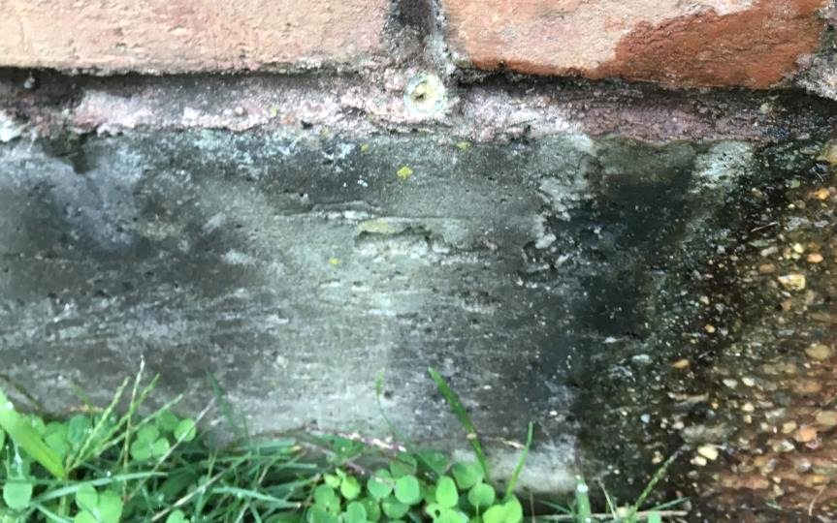
Clogged/plugged weep hole (arrow)
Picture 27
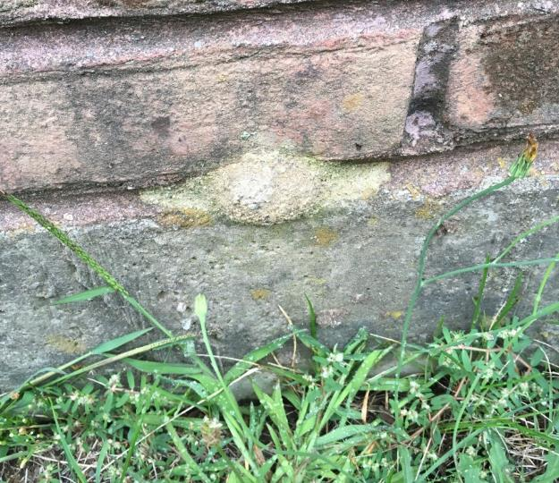
Clogged/plugged weep hole
Picture 28
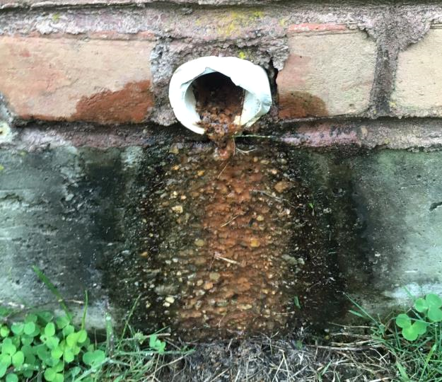
Debris/scale from condensate pipe/drip pans
Picture 29
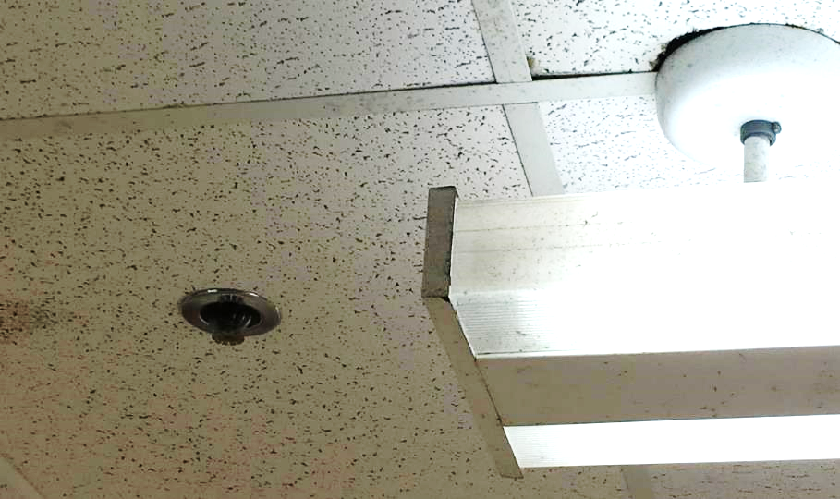
Dust/debris/staining on light fixture directly in front of univent, also note sprinkler head
Picture 30
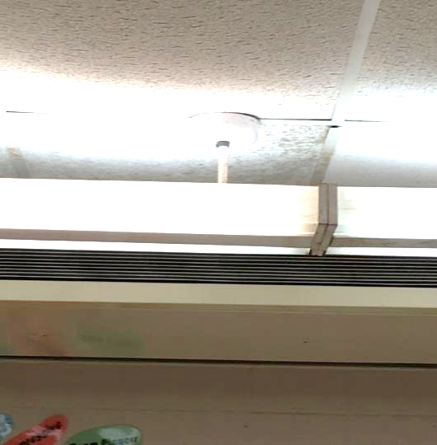
Suspended lighting fixture and stained tile in front of univent
Picture 31
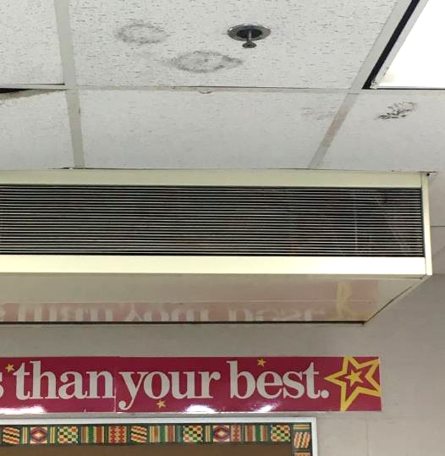
Water-damaged/moldy ceiling tiles and metal sprinkler head directly in front of univent
Picture 32
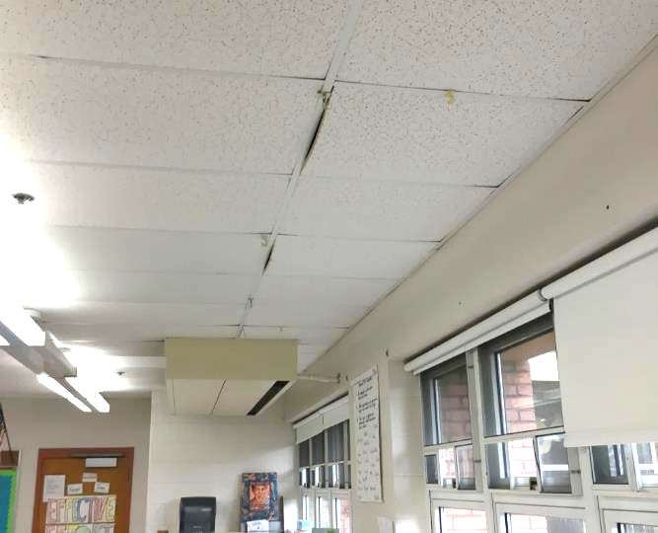
“Bowed” (non-flush) ceiling tiles in first floor classroom
Picture 33
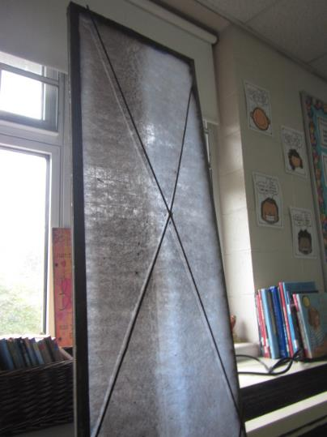
Metal filter rack and media that needs to be “cut to size” and installed in univents
Picture 34
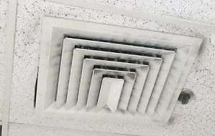
Accumulated dust/debris on supply diffuser and surrounding ceiling tile
Picture 35
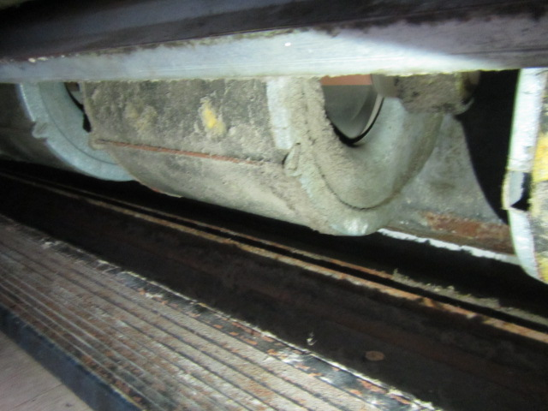
Accumulated dust/debris on interior univent components
Picture 36
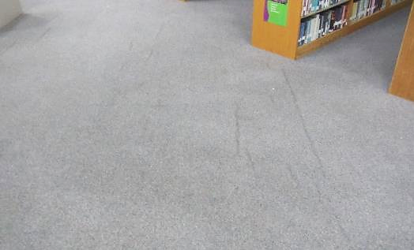
Original (20+ yr.)/wrinkled carpeting in Library
Picture 37
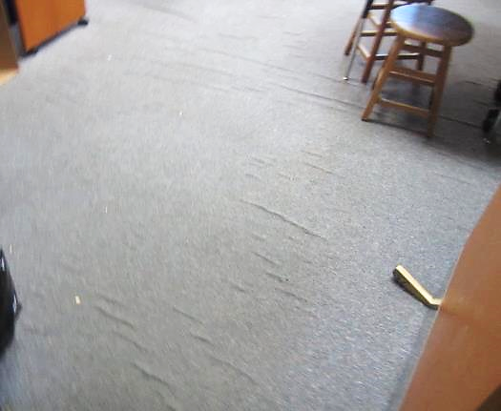
Original (20+ yr.)/wrinkled carpeting in Guidance Dept
Picture 38
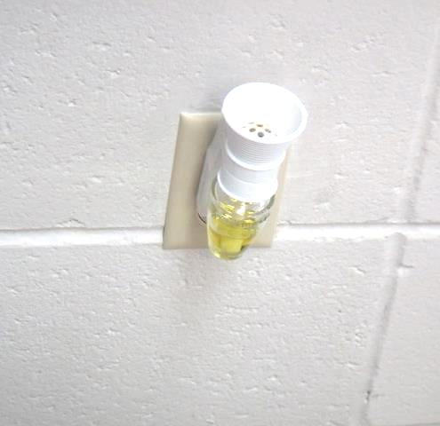
Plug-in air freshener in classroom
Location | Carbon  Dioxide  (ppm) | Carbon Monoxide  (ppm) | Temp  (°F) | Relative  Humidity  (%) | PM2.5  (µg/m³) | Occupants  in Room | Windows  Openable | Ventilation |  | Remarks
 |  |  |  |  |  |  |  | Supply | Exhaust
Background (outside) | 405 | ND | 63 | 100 | 2 |  |  |  |  | Moderate to heavy rain/humid, winds: NNE 14 mph
Main Office | 934 | ND | 69 | 61 | 4 | 2 | Y | Y | Y
1 | 999 | ND | 72 | 72 | 4 | 0 | Y | N | Y
2 | 1050 | ND | 70 | 70 | 4 | 0 | Y | N | Y | WAC
3 | 1044 | ND | 76 | 74 | 7 | 0 | Y | N | Y | WD CT, WAC
4 | 898 | ND | 72 | 69 | 4 | 0 | Y | N | Y
5 RR | 1032 | ND | 76 | 69 | 1 | 0 | Y | N | Y
104 | 528 | ND | 63 | 63 | 2 | 0 | Y | Y | Y | Dehumidifier, bowed CTs
108 | 725 | ND | 72 | 71 | ND | 0 | Y | Y | Y | Bowed CTs, window fail
119 | 1000 | ND | 70 | 65 | ND | 23 | Y | Y | Y | Bowed CTs, Sprinkler head in airflow 60 °F (dew point = 58°F)
127 | 548 | ND | 71 | 68 | ND | 1 | Y | Y | Y | Bowed CTs
130 | 938 | ND | 74 | 68 | ND | 24 | Y | Y | Y | Bowed CTs
131 | 955 | ND | 74 | 67 | ND | 23 | Y | Y | Y | Bowed CTs
135 Art Room | 507 | ND | 69 | 73 | ND | 7 | Y | Y | Y | Bowed CT
135 Closet | 677 | ND | 72 | 69 | ND |  |  |  |  | Closet mold, moldy bamboo
Library | 896 | ND | 64 | 63 | 3 | 24 | Y | Y | Y | Cold, wall to wall carpet-wrinkled, peeling paint/WD-rotunda
203 Network/Copy room | 922 | ND | 72 | 68 | 4 | 0 | N | Y | Y | Dust/debris-vents/CTs
205 | 1069 | ND | 74 | 68 | 5 | 2 | Y | Y  Off | Y  Off | UV-on repair list, area rugs, plug in AF, HS, 25 occupants gone ~ 8 mins
Dean of Students | 892 | ND | 73 | 67 | 2 | 0 | Y | Y | Y | Wall to wall carpet
207 | 752 | ND | 72 | 71 | 4 | 22 | Y | Y | Y  Off | Area rug, moldy book-closet
208 | 563 | ND | 71 | 71 | 2 | 2 | Y | Y | Y | Kids at specialist
209 | 500 | ND | 70 | 68 | 1 | 24 | Y | Y | Y
210 | 1188 | ND | 68 | 73 | 3 | 17 | Y | Y | Y | Exhaust vent near hallway door, area rug, WD CT
211 | 681 | ND | 69 | 71 | 2 | 1 | Y | Y | Y
212 | 922 | ND | 72 | 69 | 3 | 0 | Y | Y | Y
2nd Floor Hallway outside Library |  |  |  |  |  |  |  |  |  | WD GW-stains, WD CTs
213 | 697 | ND | 71 | 71 | 2 | 3 | Y | Y | Y | Dust/debris-vents
214 | 797 | ND | 71 | 72 | 3 | 0 | Y | Y | Y | 2 WD CTs
Custodial Closet |  |  |  |  |  |  | N | N | Y | WD CTs, missing light cover
2nd Fl Hallway (near 217) |  |  |  |  |  |  |  |  |  | WD CTs (current leak?)
215 | 1015 | ND | 70 | 67 | 2 | 19 | Y | Y | Y | Window leak/standing water observed on window sill (cement block), dust/debris-vents
217 | 850 | ND | 70 | 68 | 3 | 20 | Y | Y | Y | UV-obstructed (front), window open
218 | 1243 | ND | 70 | 68 | 3 | 22 | Y | Y | Y
219 | 698 | ND | 70 | 70 | 2 | 0 | Y | Y | Y | WD CTs-mold growth, dust/debris-vents
220 | 1266 | ND | 70 | 71 | 2 | 21 | Y | Y | Y | Exhaust vent near hallway door
221 | 1441 | ND | 70 | 68 | 2 | 23 | Y | Y | Y | CPs-countertop
222 | 936 | ND | 68 | 69 | 2 | 0 | Y | Y | Y | Dust/debris-vents
223 | 1357 | ND | 70 | 67 | 3 | 25 | Y | Y | Y | Dust/debris-vents, leak ceiling reported (near UV/exterior wall/ceiling)
225 | 830 | ND | 69 | 67 | 2 | 0 | Y | Y | Y

Location | Carbon  Dioxide  (ppm) | Carbon Monoxide  (ppm) | Temp  (°F) | Relative  Humidity  (%) | PM2.5  (µg/m³) | Occupants  in Room | Windows  Openable | Ventilation |  | Remarks
 |  |  |  |  |  |  |  | Supply | Exhaust
Background (outside) | 418 | ND | 64 | 63 | 13 |  |  |  |  | Clear and sunny, winds: N NW 9-12 mph
102 | 663 | ND | 74 | 53 | 5 | 7 | Y | Y | Y | Area rug, DO
106 Teachers Lounge | 699 | ND | 73 | 53 | 5 | 5 | Y | Y | Y | Refrigerators-mold/gaskets, PC, 2 WD CT-changed recently
107 Storage (unoccupied)  Interior Room |  |  |  |  |  |  | N | Y | Y | Dark stains/mold on CTs around vents, mold growth on chair/desk labelled “take away”
108A | 889 | ND | 71 | 53 | 3 | 0 | N | Y | Y | Musty odors-no obvious source of WD/mold growth-recommend removing all items (furniture, cork boards, stored items) to see if odor dissipates, dehumidifier
108B | 974 | ND | 71 | 58 | 3 | 7 | N | Y | Y | WD CT-possible mold growth
Cafeteria | 970 | ND | 73 | 59 | 5 | ~100 | Y | Y | Y
113 Music | 674 | ND | 73 | 54 | 3 | 2 | Y | Y | Y | Storage room-mold/musty odors from instrument cases
Practice Room C | 696 | ND | 73 | 56 | 3 | 0 | N | Y | Y | Wall to wall carpet
115 | 533 | ND | 75 | 53 | 3 | 1 | Y | Y | Y | Dust/debris/staining on light fixtures (airflow of UV)
126 | 793 | ND | 73 | 56 | 8 | 21 | Y | Y | Y  Off
Guidance | 851 | ND | 72 | 56 | 3 | 1 | N | Y | Y | Wall to wall carpet-wrinkled, DO, dust/debris on vents, WD CT, PC
Delaney Office | 1025 | ND | 72 | 52 | 3 | 1 | Y | Y | Y  Off | Wall to wall carpet
224 | 1373 | ND | 76 | 54 | 4 | 23 | Y | Y | Y | Area rugs
227 | 1016 | ND | 75 | 54 | 4 | 20 | Y | Y | Y | Area rugs
228 | 760 | ND | 74 | 54 | 4 | 0 | Y | Y | Y | Dehumidifier
229 | 1183 | ND | 76 | 54 | 5 | 23 | Y | Y | Y | DO
230 | 990 | ND | 76 | 52 | 5 | 18 | Y  Open | Y | Y | Area rug/pillows, DO, dehumidifier
231 | 939 | ND | 77 | 50 | 5 | 18 | Y | Y | Y | Pencils/items in UV, DO, dehumidifier
232 | 743 | ND | 74 | 51 | 5 | 0 | Y  Open | Y | Y
233 | 1124 | ND | 74 | 57 | 239*/17 | 19 | Y | Y | Y | *Fragrance diffuser, DO
234 | 1090 | ND | 76 | 53 | 4 | 19 | Y | Y | Y | DO
235 | 991 | ND | 76 | 53 | 4 | 20 | Y | Y | Y | Dust/debris on vents, area rug, DO
236 | 1231 | ND | 75 | 55 | 4 | 21 | Y | Y | Y | UV-obstructed, area rug, DO
237 | 1167 | ND | 76 | 56 | 4 | 18 | Y | Y | Y
238 | 866 | ND | 74 | 53 | 5 | 2 | Y | Y | Y | Wall to wall carpet-wrinkled, bowed CTs
239 | 1132 | ND | 76 | 54 | 5 | 19 | Y | Y | Y  Off | Area rug/pillows, DO
240 | 1060 | ND | 75 | 53 | 6 | 7 | Y | Y | Y | UV-deactivated, DO
241 | 896 | ND | 76 | 53 | 5 | 22 | Y  Open | Y | Y | Area rug
242 | 1040 | ND | 76 | 53 | 9 | 3 | Y | Y  Passive | Y | PCs
243 | 771 | ND | 74 | 53 | 4 | 1 | Y  Open | Y | Y | DO, exhaust near hallway door
244 | 976 | ND | 75 | 53 | 4 | 1 | Y | Y | Y | Area rug, 23 occupants gone ~ 20 mins
245 | 856 | ND | 74 | 53 | 5 | 3 | Y | Y | Y | Plants, area rug, DO
246 | 1183 | ND | 75 | 54 | 5 | 20 | Y | Y | Y  Off | Area rug, HS, bowed CTs
247 | 1048 | ND | 75 | 53 | 3 | 1 | Y | Y | Y  Off | DO, WD CT, 22 occupants gone ~15 mins
248 | 1145 | ND | 75 | 55 | 4 | 0 | Y  Open | Y | Y | Class just left, aquarium, food/fruit in basket, dehumidifier
249 | 1136 | ND | 75 | 54 | 4 | 0 | Y | Y | Y  Off | UV-blocked, wasps nests (props), kids at specialist, DO, PF
250 | 635 | ND | 73 | 53 | 3 | 0 | Y | Y | Y | DO
251 | 1080 | ND | 75 | 56 | 6 | 24 | Y | Y | Y | DO

The service life is the median time during which a particular system or component of …[an HVAC]… system remains in its original service application and then is replaced. Replacement may occur for any reason, including, but not limited to, failure, general obsolescence, reduced reliability, excessive maintenance cost, and changed system requirements due to such influences as building characteristics or energy prices (ASHRAE, 1991).

