**INDOOR AIR QUALITY**

**WATER DAMAGE ASSESSMENT**

**Barnstable United Elementary School**

**730 Osterville W. Barnstable Road**

**Marstons Mills, MA**

*Aerial view of Barnstable United Elementary School
730 Osterville W. Barnstable Road
Marstons Mills
Barnstable, MA
*

Prepared by:

Massachusetts Department of Public Health

Bureau of Climate and Environmental Health

Indoor Air Quality Program

September 2024

**BACKGROUND**

|  |  |
| --- | --- |
| **Building:** | Barnstable United Elementary School (BUES) |
| **Address:** | 730 Osterville W. Barnstable Road  Marstons Mills, Massachusetts |
| **Assessment Requested by:** | Barnstable Public Schools (BPS) |
| **Reason for Request:** | Mold concerns |
| **Date of Assessment:** | August 28, 2024 |
| **Massachusetts Department of Public Health/Bureau of Environmental Health (MDPH/BEH) Staff Conducting Assessment:** | Mike Feeney, Director, Indoor Air  Quality (IAQ) Program |
| **Building Description:** | The BUES is a two-story brick building completed in 1994 and formerly served as the Horace Mann Charter School (HMCS). The building contains a centralized courtyard, general classrooms, science classrooms, art rooms, music rooms, kitchen, cafeteria, gymnasium, faculty workrooms and office space. |
| **Windows:** | Openable |

# EXECUTIVE SUMMARY

The MDPH IAQ Program was asked to examine BUES for the presence of water damage/mold growth resulting from high relative humidity weather conditions that occurred during August 2024. The BUES experienced water damage in the building due to a number of factors, including:

* extended periods of weather with high relative humidity,
* the design of the building and,
* operating the heating, ventilation, and air conditioning (HVAC) system in cooling mode during the summer when the building has reduced occupancy during school summer vacation.

It is important to note that the BUES has been previously assessed by the IAQ Program, The reports (both as the BUES and HMCS) can be viewed at this webpage: <https://www.mass.gov/info-details/indoor-air-quality-reports-cities-and-towns-b#barnstable->

The IAQ program visually examined the building and conducted measurements to determine whether building materials were moistened to support mold growth. Areas under water damage remediation were examined with a focus on materials that were damaged by condensation i.e., ceilings, carpeting, and classroom items. IAQ staff visited the BUES while water damage remediation efforts were being completed. Contractors used the US EPA guidelines “Mold Remediation in Schools and Commercial Buildings” to conduct water damage remediation, which include:

* Identifying the source of moisture cause water damage,
* Removing water-damaged porous materials capable of supporting mold growth (ceiling tiles, carpeting and various stored materials),
* Cleaning of non-porous surfaces areas (e.g., painted cement walls, laminated counters, floor tile).

IAQ staff examined hallways and classrooms of the BUES where the water damage occurred. Based on observations, the source of water vapor causing the damage was a combination of high relative humidity weather that occurred in August 2024 and water vapor migration from classroom sink drains with dry drain traps. Heavy rain entering the Barnstable storm/sewer system forced water vapor and air to back up the sink drain system, which then caused condensation on stored materials and building components. In addition, conditions regarding HVAC system operations and building designed are detailed in the previous IAQ assessment in 2019 <https://www.mass.gov/doc/barnstable-united-elementary-school-october-2019/download>

MDPH IAQ staff made the following recommendations on-site:

* Deactivate the AC system to eliminate source of condensation. Do not use the HVAC system in chilling mode.
* If outdoor relative humidity is below 70%, open windows and doors to create cross ventilation in order to reduce any odor from newly-installed ceiling tiles. Place fans in open courtyard exterior doors to eject odors into the courtyard. If outdoor relative humidity exceeds 70%, close all doors and windows.
* Operate exhaust vents in classrooms to eject ceiling tile odors and water vapor from all occupied spaces.
* Continue to use vacuum cleaners equipped with high efficiency particle air (HEPA) filters which will remove residues of mold and mold spores from the environment.
* Use portable air filters equipped with HEPA filters in rooms to provide additional filtration of air in classrooms.
* Ensure that all sink drain traps are wetted regularly (once per week) to prevent water vapor backup into classrooms during hot, humid weather accompanied by rain that pressurizes the sewer system.
* Identify if materials in classrooms or storage have visible mold growth or mold odors. If the materials are porous and susceptible to mold growth, discard in a manner consistent with US EPA mold remediation guidelines.

# METHODS

IAQ staff conducted a visual inspection of effected areas. Air temperature and relative humidity were measured in each room. Surface temperatures of floors and walls were also measured to determine if building components were at or below the dew point (temperature where condensation will gather on a cold surface). Please refer to the IAQ Manual for methods, equipment, sampling procedures, and interpretation of results (MDPH, 2015).

**RESULTS AND DISCUSSION**

The following is a summary of indoor air testing results (Table 1):

* ***Air Temperature*** was within the MDPH recommended range of 70°F to 78°F in areas tested during the assessment.
* ***Relative Humidity*** was within the MDPH recommended comfort range of 40 to 60% in all areas tested. Relative humidity outdoors was 53%. All indoor relative humidity measurements were below outdoor measurements. The US [Environmental Protection Agency](https://www.usgbc.org/organizations/us-environmental-protection-agency) (US EPA) recommends keeping indoor relative humidity between 30 and 50% to prevent mold growth, which presents a unique challenge in regions with high relative humidity in the outdoor environment (Center for Green Schools, 2024).
* ***Dew Point*** was within a range of 53°F to 57°F in areas tested during the assessment***.***

Based on these observations and the deactivation of the HVAC system chiller, conditions that could result in water vapor moistening building components or stored equipment/materials were not present at the time of this assessment. The conditions regarding the BUES HVAC system are detailed in the 2019 report, which is included as [Appendix A](https://www.mass.gov/doc/barnstable-united-elementary-school-october-2019/download) and can also be viewed and downloaded at <https://www.mass.gov/doc/barnstable-united-elementary-school-october-2019/download>.

As mentioned, a water damage flooding restoration firm was present during this visit. Remediation activities included:

* Removal and replacement of water-damaged ceiling tiles.
* Cleaning of non-porous building materials that had mold on surfaces only (e.g., painted walls, laminated countertops, metal).
* Use of fans and dehumidifiers to accelerate drying of carpeting and classroom materials.
* Use of exhaust vents to vent water vapor outdoors.
* Cleaning of non-porous classroom materials.
* Moving cabinets, floor mats, and area rugs on the floor.

At the time of the MDPH IAQ visit, remediation activities (removal and drying of water-damaged building materials) were fully active and were being conducted in accordance with US EPA guidance (US EPA, 2008). Water-damaged materials had been removed and/or dried and rooms were being cleaned. Materials cleaned were in the basement hallway, which were found free of visible mold and odor. MDPH IAQ staff examined all accessible classrooms and other occupied spaces in the building and did not observe visible mold/associated odors during this visit except for a single location.

Mold odor was emanating from a custodial sink located in the music room (Picture 1). This location also had a removable carpet on the floor. While this carpet was free of visible mold or staining, its location on the ground floor near the custodial sink with mold odors would make this carpet possibly cross-contaminated by mold (Picture 2).

One sign of high relative humidity in the BUES is the presence of bowed ceiling tiles (Picture 3). If a building experiences high relative humidity (+70%) indoors over an extended period of time, moisture exposure may cause ceiling tiles to bow. It is recommended that porous material be dried with fans and heating within 24 to 48 hours of becoming wet (US EPA, 2008). If relative humidity is experienced indoors above 70%, use of open windows and floor fans to create air movement will help reduce stagnant air and mold growth.

Bowed ceiling tiles without discoloration or stains are not mold-colonized but are a sign of water vapor exposure. Bowing ceiling tiles are typically found in classrooms and cafeterias with sink or floor drains where the trap has dried. A trap is a section of pipe below the drain opening that fills with water to form an airtight seal. The airtight seal prevents sewer gas, odors, and water vapor from the drain systems from backup up the drain to enter occupied space. Depending on various conditions, water evaporates from the trap if a plumbing device is not used for several days.

Wetting drain traps regularly to maintain the airtight water seal is particularly important when heavy rains occur. As large amounts of water enter storm/sewer pipes, air and other water vapor/odors/pollutants can be forced up drainpipes, which would be prevented from entering the occupied space by a wet drain trap.

Schools are particularly vulnerable to dry drain traps due to the extended summer vacation when the building is unoccupied, since water fountains as well as sinks in classrooms, the cafeteria and kitchens are not in use. School locations with bowed ceiling tiles are ones with multiple sinks that are not used during summer vacations, such as the cafeteria and science classrooms, as well as restrooms, when equipped with a suspended ceiling with cellulose ceiling tiles.

It is also important to note that the BUES HVAC system played a significant role regarding mold growth, as detailed in the previous IAQ assessment conducted in 2019 (<https://www.mass.gov/doc/barnstable-united-elementary-school-october-2019/download>). Until the HVAC system can be operated to prevent condensation, it is **strongly recommended not to operate this HVAC system in chilling mode**. If operating correctly and properly draining condensation, HVAC systems can reduce humidity during chiller operation. Humidity reduction and production of condensation when this HVAC system is operating has been previously recognized and detailed in previous IAQ assessments of this building. Use of dehumidifiers during hot, humid weather on the ground floor may reduce humidity in place of the HVAC system operating in cooling mode.

A method to determine if areas in the BUES are prone to condensation would be to measure air and building material temperatures. If a wide temperature range exists between measurements, the building materials at the colder end of the range may be prone to becoming moistened with condensation in hot, humid weather. Floor temperatures can be measured using a laser thermometer. If constructed in a certain manner, soil temperature in contact with the floor slab may be transferred to the floor and lower walls. This condition is called a thermal bridge, leading to potential condensation which can moisten any materials on the floor. Checking ground floor temperature during the heating season is recommended (when conditions are more pronounced due to temperature extremes) to determine if floors are serving as thermal bridges.

Hot humid summers are becoming more frequent due to climate change. Massachusetts has experienced hot, humid, and rainy summers in 2018, 2021, and 2023. July of 2021 was the wettest ever recorded in Massachusetts, and the three-month period from June through August, known as the meteorological summer, was the fourth wettest on record, according to the National Oceanic and Atmospheric Administration’s (NOAA) Centers for Environmental Information (NOAA, 2021). The summer of 2023 was also hot, and wet, being measured as the second rainiest on record (WBUR, 2023). The summer of 2024 has also had significant stretches of hot, humid weather. These conditions are challenging for buildings, particularly those without central air conditioning.

Under these weather conditions, public buildings experienced extended periods of water vapor exposure from high relative humidity. When exposed to these conditions, porous materials such as gypsum wallboard, cardboard, carpeting and other materials may become moistened and colonized with mold, particularly if located in areas that are prone to developing condensation, such as floors and walls in contact with the ground (e.g., below grade space).

The guideline “Preventing Mold Growth In Schools During Hot, Humid Weather” <https://www.mass.gov/info-details/preventing-mold-growth-in-massachusetts-schools-during-hot-humid-weather> should be used to minimize the impact of such weather on classroom materials. This includes use of air conditioning and dehumidifiers, ensuring exhaust vents are on and operable, keeping windows closed, and ensuring air can circulate around porous materials.

# CONCLUSIONS/RECOMMENDATIONS

Based on the observations made during the visit, it appears that most water-damaged materials were thoroughly dried and/or removed. Most of the following recommendations were made on-site at the time of assessment and are reiterated below:

1. Continue with restoration/reconstruction plans to replace all water-damaged building materials (ceilings, walls, floors, pipes, electrical, etc.).
2. Until condensation created by the HVAC system is controlled, do not operate the HVAC system in chilling mode.
3. If not already done so, implement recommendations in the 2019 IAQ assessment, <https://www.mass.gov/doc/barnstable-united-elementary-school-october-2019/download>
4. Use windows and floor fans to eject and reduce odors from newly-installed ceiling tiles. Open doors and windows if outdoor relative humidity is below 70%. To increase airflow to reduce ceiling tile odor, use portable fans to vent odor through courtyard doors. In addition, operate the general exhaust ventilation system to remove odors. If outdoor relative humidity is above 70%, close all windows and doors and use the general exhaust ventilation system to reduce new ceiling tile odors.
5. Continue remediation activities which includes cleaning all items and surfaces with a high efficiency particulate arrestance (HEPA) filter equipped vacuum cleaner combined with wet wiping.
6. Ensure that all sinks have water poured into drains to ensure traps are wet to prevent water vapor and associated drain odor from entering occupied space.
7. Consider discarding the carpet in Picture 2.
8. Use of HEPA filter equipped air cleaners is recommended in classrooms to capture any airborne dust and debris, including mold, mold spores and/or pollen.
9. Discard mold-colonized porous materials if found. If stored materials are found to be moldy, clean or discard per EPA mold guidelines. If mold odors are found from other items such as instrument cases, stored paper, cardboard, cloth/fabric, and other porous materials, discard and replace the affected materials.
10. For more information on mold refer to the US EPA’s “Mold Remediation in Schools and Commercial Buildings,” available at: <http://www.epa.gov/mold/mold-remediation-schools-and-commercial-buildings-guide>.
11. Measure temperatures on ground floors. If difference in temperature between air and floors is greater than 5oF, floors may be prone to condensation during hot, humid weather when HVAC system chiller is deactivated.
12. Refer to resource manuals and other related IAQ documents for further building-wide evaluations and advice on maintaining public buildings. Copies of these materials are located on the MDPH’s website: <http://mass.gov/dph/iaq>.

# REFERENCES

[Center for Green Schools](https://www.usgbc.org/articles?Channels=%5B%22Center%20for%20Green%20Schools%22%5D). 2024. U.S. Green Building Council, Inc. [School mold prevention programs help keep schools healthy | U.S. Green Building Council (usgbc.org)](https://www.usgbc.org/articles/school-mold-prevention-programs-help-keep-schools-healthy). Lauren Bolton, Aug 22, 2024.

MDPH. 2015. Massachusetts Department of Public Health. Indoor Air Quality Manual: Chapters I-III. Available at: <https://www.mass.gov/lists/indoor-air-quality-manual-and-appendices#indoor-air-quality-manual->.

NOAA. 2021. Summer 2021 neck and neck with Dust Bowl summer for hottest on record. National Oceanic and Atmospheric Administration, 1401 Constitution Avenue NW, Room 5128, Washington, DC 20230 <https://www.noaa.gov/news/summer-2021-neck-and-neck-with-dust-bowl-summer-for-hottest-on-record>.

US EPA. 2008. “Mold Remediation in Schools and Commercial Buildings”. Office of Air and Radiation, Indoor Environments Division, Washington, DC. EPA 402-K-01-001. September 2008. Available at: <http://www.epa.gov/mold/mold-remediation-schools-and-commercial-buildings-guide>.

WBUR. 2023. “It's been a summer of rain and flooding misery in Mass.” WBUR local news. September 12, 2023. <https://www.wbur.org/news/2023/09/12/summer-flooding-rain-massachusetts>

**Picture 1**

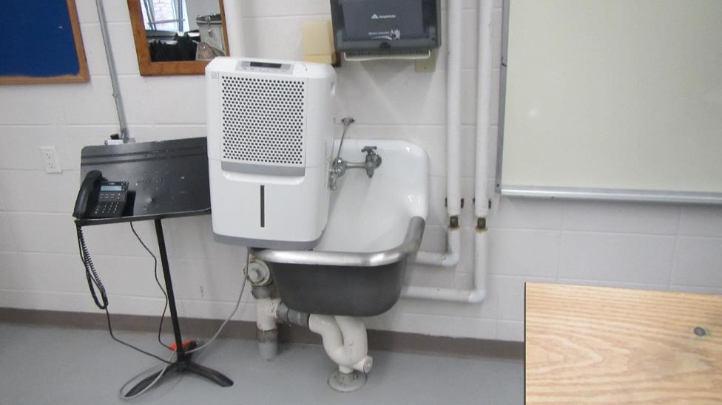

**Custodial sink with mold odor from dry drain trap**

**Picture 2**

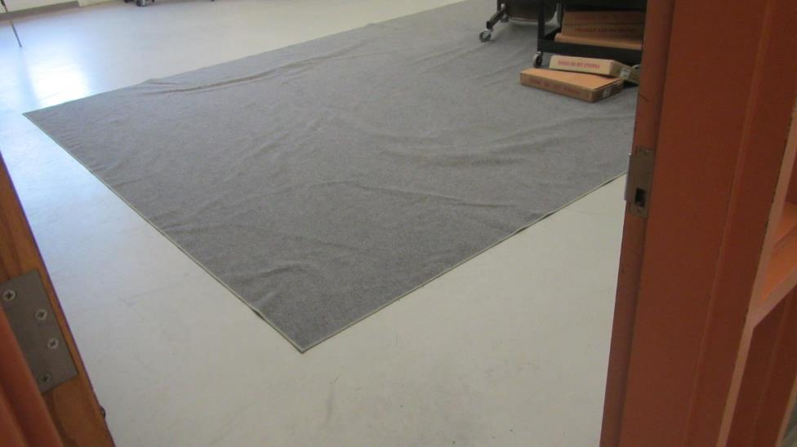

**Carpet in music room**

**Picture 3**

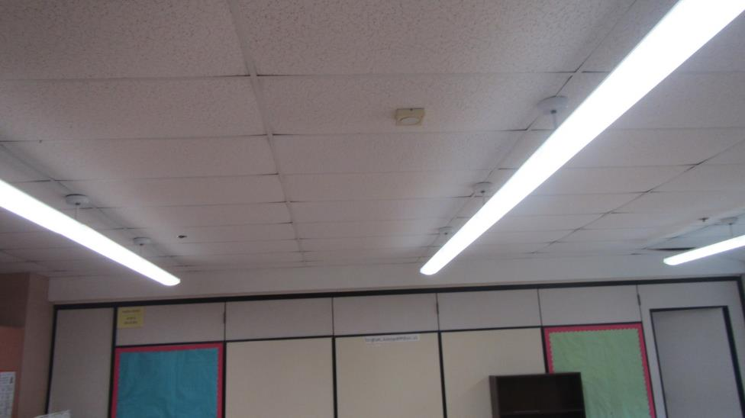

**Bowed ceiling tiles**

| **Location** | **Temp**  **(°F)** | **Relative**  **Humidity**  **(%)** | **Dew Pt.**  **(°F)** | **Remarks** |
| --- | --- | --- | --- | --- |
| Background (outside) | 73 | 53 | 54 |  |
| 100 | 74 | 52 | 54 |  |
| Art room | 73 | 51 | 54 |  |
| Computer room | 74 | 51 | 55 |  |
| 101 | 75 | 49 | 55 |  |
| 102 storage | 75 | 47 | 57 |  |
| 104 | 76 | 44 | 53 |  |
| 106 | 74 | 51 | 55 |  |
| 107 | 74 | 50 | 54 |  |
| 108 | 76 | 47 | 54 |  |
| 108 storage | 75 | 46 | 53 |  |
| Hallway | 75 | 47 | 53 |  |
| 109 | 74 | 51 | 55 |  |
| 111 | 75 | 48 | 54 |  |
| 113 | 74 | 51 | 54 |  |
| 115 | 76 | 50 | 56 |  |
| 116 | 75 | 50 | 53 |  |
| 117 | 76 | 50 | 56 |  |
| 118 | 75 | 50 | 55 |  |
| 119 | 76 | 48 | 56 |  |
| 120 | 75 | 49 | 55 |  |
| 121 | 76 | 49 | 55 |  |