INDOOR AIR QUALITY ASSESSMENT

Bartlett Community Partnership School
79 Wannalancit Street
Lowell, MA
March 2024

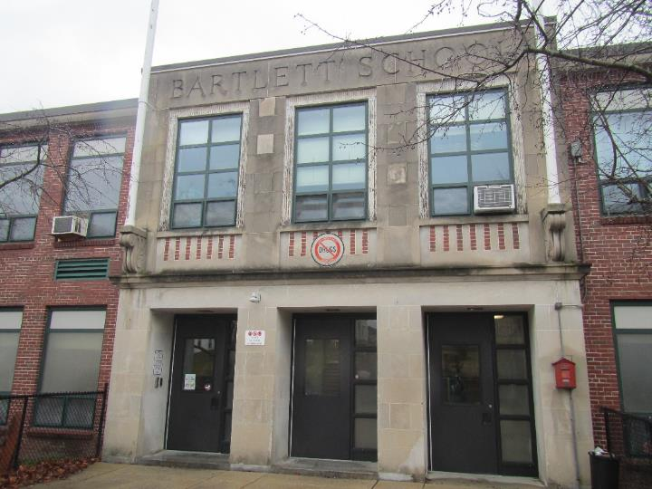

Prepared by:
Massachusetts Department of Public Health
Bureau of Climate and Environmental Health
Indoor Air Quality Program

Contents

EXECUTIVE SUMMARY 3
BACKGROUND 4
RESULTS AND DISCUSSION 5
Ventilation 5
HVAC System Maintenance 5
HVAC Types and Specific Conditions 6
Water Damage and Moisture Concerns 7
Sources of Respiratory Irritants/Possible Asthma Triggers 9
Other IAQ Issues 11
CONCLUSIONS AND RECOMMENDATIONS 12
REFERENCES 16
FIGURES 18
PICTURES 19
Table 1 35
Table 2A 41
Table 2B 42
Table 2C 43
Table 3 44
Table 4 46

R an EXECUTIVE SUMMARY

The Massachusetts Department of Public Health’s Indoor Air Quality Program (MADPH IAQ) conducted an IAQ walkthrough of The Bartlett Community Partnership School (BCPS) located at 79 Wannalancit Street in Lowell on March 7, 2024. This walkthrough was in conjunction with The Asthma in Schools: Data to Action Project - a collaboration between Massachusetts Department of Public Health (DPH) programs, local health departments, and local school health and administration officials to support asthma prevention and intervention efforts in school settings.
Any building can have IAQ issues. These issues can be made worse through conditions common to marginalized communities (Environmental Justice communities or EJ) such as inequitable exposure to outdoor air pollution and a greater likelihood of poor building conditions leading to deterioration of IAQ resulting in higher asthma rates. All of Lowell, including the Bartlett Community Partnership Elementary School, is considered an EJ community. In addition, the BCPS also serves a larger proportion of special needs students than other schools in Lowell. The pediatric asthma rate for this school as of 2018 is 23.7% compared to the statewide pediatric prevalence rate of 11.8%.
The assessment was conducted by evaluating several key elements within the school; a visual inspection of the heating, cooling, and ventilating (HVAC) systems, water/microbial damage, exterior building envelope evaluation, cleanliness, and point sources of respiratory irritants such as chemicals. Data is collected in this manner to identify potential asthma triggers, allergens, and other environmental factors that can cause indoor air quality symptoms. Please refer to the Indoor Air Quality Manual on the MDPH website for methods, sampling procedures, and interpretation of results.
As a result of this walkthrough, there are several findings: conditions in this school are typical of elementary schools of this age and type, univents and other HVAC components may be beyond their lifespan, roof leaks were observed including an active leak at the time of the visit, and there are occupant induced issues such as storage and clutter. (Results and Discussion)
Upon review of these findings, a number of recommendations are made to optimize existing HVAC systems and improve air exchange. The age of the univents and other HVAC components make maintenance increasingly difficult. Other issues described can be mitigated with repairs to the exhaust systems, and with changes to occupant behaviors to reduce blockages of univents and clutter. Issues regarding the presence of point sources of irritation such as clutter can be addressed to reduce dust and odors (Conclusions)
Based on the results of the assessment, the following primary recommendations are made:
- Maintain the HVAC system, including regular filter changes and repairing exhaust vents that are not working.

- Address roof leaks.
- Repair sinks including countertops and backsplashes where they are damaged.
- Address storage areas to remove excess items, and prevent remaining items from damage due to pests, dust, and moisture. (Conclusions and Recommendations)
Please note: this report contains a series of recommendations that should serve as Best Practices that apply to most public-school buildings across the Commonwealth and should be shared amongst other buildings in the Lowell School District.

R an BACKGROUND
Building: | Bartlett Community Partnership Elementary School (BCPS)
Address: | 79 Wannalancit Street  Lowell, Massachusetts
Assessment Coordinated via: | Mathew McClean, Principal, Bartlett Community School
Reason for Request: | Asthma pilot project and general IAQ
Date of Assessment: | March 7, 2024
Massachusetts Department of Public Health/Bureau of Climate and Environmental Health (MDPH/BCEH) Staff Conducting Assessment: | Ruth Alfasso, Inspector, IAQ Program  Jen Lajoie, Inspector, IAQ Program
Building Description: | The BCPES is a brick and concrete building originally constructed in 1951 and renovated in the 1990s. It has three floors and several lower levels as the school is built into a hill. Roof segments are flat with a rubber membrane; some portions are ballasted. The school contains classrooms, offices, and accessory rooms including a gym, library, and cafetorium.
Windows: | Most windows in the building are openable.

R an RESULTS AND DISCUSSION
The following is a summary of conditions observed during the indoor air quality walkthrough (Table 1). Note that no environmental testing was conducted during this walkthrough.

Ventilation
Ventilation refers to both the supply of fresh air and the removal of stale air from a room. The introduction of fresh air into an occupied space will dilute normally occurring pollutants that are generated by occupancy and other activities. In addition, an HVAC system will remove pollutants from a building if operating appropriately. All ventilation systems throughout the building should operate continuously during periods of occupancy.

The BCPS has a combination of unit ventilators (univents) and rooftop air handing units. Univents (Picture 1) bring in fresh air from a vent on the outside of the building (Picture 2), filter it, heat it, and supply the air through a vent on the top. Some room air is recirculated along with the fresh air through a vent at the bottom (Figure 1). The air handling units bring in fresh air from the roof, filter it, heat it, and bring it into rooms through a ceiling-mounted supply vent (Picture 3). Classrooms and offices are also equipped with exhaust vents that remove stale air from rooms (Pictures 4 and 5) (Table 2B).

The various types of ventilation components as well as devices that can move/redirect airflow are listed in Table 2A, Table 2B and Table 2C.

HVAC System Maintenance
- Univents may be beyond their service life. According to the American Society of Heating, Refrigeration, and Air-Conditioning Engineering (ASHRAE), the service life of this type of unit is 15-20 years, assuming routine maintenance of the equipment (ASHRAE, 1991).

- Univent filters were not examined at the time of the assessment. The MDPH IAQ program recommends that filters of a minimum efficiency reporting value (MERV) 8 or higher, be used as these are adequate to filter out pollen, mold, and similar particulates (ASHRAE, 2012).

HVAC Types and Specific Conditions
Balancing
To have proper ventilation with a mechanical supply and exhaust system, a system must be balanced to provide an adequate amount of fresh air to the interior of a room while also removing stale air from the room.
It is recommended that HVAC systems be re-balanced every five years to ensure adequate air systems function (SMACNA, 1994).

(see HVAC pictures)

Classroom Unit ventilators:
- Univents were frequently blocked with furniture or items (Picture 6; Table 1). A univent will not function effectively if blocked.
- Some univents were turned off (Table 1).
- Items, including plants and papers, were located in the airstream of univents (Picture 6). Dust, pollen, and odors from these materials can be distributed throughout the room by the ventilation system.
Classroom Exhaust vents:
- Many exhaust vents were blocked with furniture and items (Picture 7; Table 1).
- Some rooms may not be equipped with exhaust vents, or the vents may be inaccessible.
- Some exhaust vents were not operating, as judged by a lack of air draw (Table 1). Either these have been turned off or the rooftop fans are not functional.
Additional HVAC Conditions:
- Most classrooms have openable windows (Picture 1; Table 1). These can be used for additional fresh air during temperate weather. Windows should be kept closed during wet weather, when air conditioning is operating in the room, during freezing weather (to prevent pipe bursts), and at the end of the school day.
- A few locations had wall-mounted ductless air conditioning units (Picture 8). These units, also known as “mini-Splits” do not supply fresh air.
- Window-style air conditioners were mounted in windows or walls of some rooms (Pictures 9 and 10; Table 1). These units can supply some amount of fresh air while operating. They are equipped with filters that need to be cleaned periodically.
- Note that when any air conditioning is operating, the windows should be closed, and the room door should be kept closed.

Water Damage and Moisture Concerns
Please note that the IAQ Program does not recommend conducting mold testing in a typical water damage remediation. For details, please consult Guidance Regarding Testing for Mold in Water-Damaged Public Buildings | Mass.gov
The application of a mildewcide to moldy porous materials is not recommended.

Molds are found naturally in our environment both indoors and outdoors. Inside, mold growth may occur when items, particularly porous products such as paper or gypsum wallboard, are exposed to moisture. Typical water sources include leaks, floods, and condensation. To avoid mold growth, dry all water-damaged items and affected areas within 24-48 hours and reduce indoor humidity. Some people with chronic respiratory conditions, such as asthma, are more likely to experience health symptoms associated with molds, including allergic reactions and respiratory irritation. Controlling moisture is the key to preventing mold growth and potential health symptoms.

Hot humid summers are becoming more frequent due to climate change. Massachusetts has experienced hot, humid, and rainy summers in 2018, 2021, and 2023. July of 2021 was the wettest ever recorded in Massachusetts, and the three-month period from June through August, known as the meteorological summer, was the fourth wettest on record, according to the National Oceanic and Atmospheric Administration’s (NOAA) Centers for Environmental Information (NOAA, 2021). The summer of 2023 was also hot, and wet, being measured as the second rainiest on record (WBUR, 2023). These conditions are challenging for buildings, particularly those without air conditioning.

During these hot and wet summers, extended periods of outdoor relative humidity above 70% occurred. Under these weather periods, public buildings experienced extended periods of water vapor exposure from high relative humidity. When exposed to these conditions, porous materials such as gypsum wallboard, cardboard, and other materials may become prone to developing mold colonization, particularly if located in areas that are prone to developing condensation on floors and walls (e.g., below grade space).
- Water-damaged ceiling tiles were found in several locations (Picture 11; Table 1). Water-damaged ceiling tiles indicate leaks from the roof, building envelope or plumbing system.
- Bowed or sagging ceiling tiles were noted in some classrooms (Table 1). This is an indication that these rooms have been subject to an extended period of high humidity. While bowed tiles are not a source of mold, they provide an indication that other items stored in the room may become moistened or mold colonized.
- Active water leaks were noted in the main foyer of the school (Picture 12) where buckets were being used to catch water. These leaks are likely from the roof due to heavy and ongoing rain.
- Many classroom sinks were in poor condition, with damaged backsplashes or countertops, leaking plumbing, or were blocked off/closed (Pictures 13 and 14). Damaged material around sinks can allow moisture to accumulate, prevent effective cleaning, and may lead to mold growth. In addition, if sinks are turned off or disused, the traps in the drains can dry out. Dry drain traps can allow sewer gases into occupied spaces.
- Aquariums, terrariums, and plants were found in many classrooms and offices (Picture 15; Table 1). Some of these appeared to be in poor condition (Picture 16). Stagnant water can lead to odors and mold. In addition, plants that are overwatered or in poor condition can be a source of mold, odors, and pests. Plants should also be kept out of the airstream of ventilation equipment to prevent distribution of mold and odors around the room.
- Refrigerators and water dispensers were noted in carpeted areas (Table 1). In addition, refrigerators should be kept clean to prevent odors.
Several other conditions on the outside of the buildings were identified which can contribute to water issues, which are specified in Table 3. Several issues related to water infiltration were identified and are listed below.
(see Water Damage and Moisture Concern Pictures)

- As shown by the need for water-collection buckets and stained ceiling tiles, portions of roofs of this building leak. Rubber membrane roofs can develop leaks due to weather, debris, and other damage over time.
- Another potential source of leaks can occur where portions of the building join such as where the roofs are at different levels, or where there are skylights or other penetrations. If leaks occur in these areas, it may mean flashing and/or sealants are missing or damaged.
- Most of the roof could not be accessed during the visit, however some portions were visible through windows from upper levels of the school (Picture 17). This roof segment shows that parts of the roof sag slightly, which can allow water to accumulate. This can result in damage due to freezing as well as a build-up of debris.
- Some damage to brick and concrete was noted along the exterior of the building (Picture 18). Note the white material shown in Picture 18 under windows. This material is efflorescence, which is made up of minerals from the brick and mortar that have dissolved and then deposited on the exterior surface of the brick. While efflorescence is not mold, it indicates water penetration and may eventually result in a weakened building envelope. Damage to the exterior of the building can eventually lead to water infiltration inside.
- This building has a courtyard (Picture 19). Drainage from courtyards should be monitored to ensure water does not build up against the sides of the building. This courtyard appeared to be well-drained, with garden plants contained in raised beds.
- Trees, bushes, and other plants were found against the building both inside the courtyard (Picture 19) and outside (Picture 20). These may prevent the exterior of the building from drying, may damage walls and foundations, and may clog roof drains with leaves and other debris. In severe weather, trees may also fall onto the building.
Mold Growth
Porous materials (e.g., gypsum wallboard, ceiling tiles and carpeting) can be dried with fans and heating within 24 to 48 hours of becoming wet (US EPA, 2008).
If porous materials are not dried within this time frame, mold growth may occur.

- Gaps were noted around window/wall-mounted air conditioners (Picture 21; Table 1) which can allow moisture and pests into the building. In addition, porous materials used to fit these units can become mold colonized.
- Ductless/mini-split air conditioners create condensation which needs to be drained. Drain tubing and associated pumps should be checked periodically to prevent leaks due to clogs or malfunctions. Porous items should not be stored underneath these units.

Sources of Respiratory Irritants/Possible Asthma Triggers

Asthma is a lung disease that can make breathing difficult. Without careful management of asthma, some people can have symptoms, like a tight feeling in the chest, shortness of breath, coughing, or wheezing. Although there is no cure for asthma, people with asthma can live healthy, active lives. A safe and healthy environment helps to reduce asthma symptoms.
Comparison of Local and State-wide Asthma Rates (2018)
14.7% of children
have asthma
Lowell
11.8% of children
have asthma
Massachusetts
23.7% of children
have asthma
Bartlett Community School

- Sometimes, learning tools and personal items in a classroom can be a source of irritants. For example, a bird or insect nest is a great learning tool for students but may harbor microbes and allergens. Similarly, food-based projects can attract pests that carry disease or trigger allergies.
- Personal products, particularly those with volatile organic compounds (VOCs) including scents, can also be a source of respiratory irritation. VOCs are carbon-containing substances that have the ability to evaporate at room temperature. Frequently, exposure to low levels of total VOCs (TVOCs) may produce eye, nose, throat and/or respiratory irritation in some sensitive individuals.
- Dust, a common respiratory and eye irritant, can collect on surfaces and items. Although janitorial and maintenance staff perform routine cleaning in classrooms, they may not be able to clean as effectively if classroom items are not picked up or surfaces are cluttered.
- Even with a properly functioning ventilation system, it is necessary to either eliminate or reduce the use of materials that can be a source of respiratory irritants to prevent symptoms in individuals who have sensitivity to such pollutants.

For guidance on maintaining an asthma-friendly healthy school environment, please consult the MDPH Asthma Prevention and Control Program’s Clearing the Air: An Asthma Toolkit for Healthy Schools.
Possible asthma triggers and/or airborne pollutants exist in the building. These are listed below as well as in (Table 4).
(see Sources of Respiratory Irritant Pictures)

- Tennis balls were used as chair glides in many classrooms (Picture 22; Table 1). Tennis balls are made of materials that may be a source of respiratory irritants. Constant wearing of tennis balls can produce fibers and off-gas VOCs. Tennis balls are made with a natural rubber latex bladder, which becomes abraded when used as a chair leg pad. Use of tennis balls in this manner may introduce latex dust into the school environment. Some individuals are highly allergic to latex (e.g., spina bifida patients) (SBAA, 2001). It is recommended that the use of materials containing latex be limited to reduce the potential for symptoms in sensitive individuals (NIOSH, 1997). Latex-free glides should be used for this purpose.
- Scent diffusers including plug in, reed, and electric mist diffusers were found in several areas of the school (Picture 23; Table 1). These products have the potential to be irritants to the eyes, nose, throat, and respiratory system of sensitive individuals. Consult “Clean Air Is Odor Free” for more information on fragrances in schools and other building.
- Other materials that contain VOCs were noted including hand sanitizers, disinfectants, and cleaners (Table 1).
- Stoves and ovens were noted in a life skills classroom. These appliances are not equipped with exhaust hoods or other direct-vented exhaust.
- Missing ceiling tiles were noted in several classrooms (Table 1). These had been removed due to leaks or construction. Missing ceiling tiles can allow dust and debris from above the ceiling tile plenum into occupied spaces. Fallen, broken ceiling tiles can themselves be a source of debris that is irritating to the eyes and skin. Numerous ceiling tiles were missing in the gym as a result of sport activities there (Picture 24). Suspended ceilings low enough to be hit by items are not appropriate for gym areas.
- Pencil sharpeners with piles of shavings were noted in some classrooms (Picture 25; Table 1). Pencil shavings can be an eye irritant.
- Area rugs and carpeting were noted in many classrooms (Table 1). All rugs and carpeting should be cleaned regularly to remove dust, debris, and odors. Used area rugs should not be brought into classrooms as they may harbor allergens such as pet dander. Area rugs should be stored in a climate-controlled area off the floor over the summer to prevent moistening due to condensation and high humidity.
- Plush items and upholstered furniture were noted in some class and accessory rooms (Table 1). These items should be cleaned periodically to remove dust and odors.
- The BCS has several large storage areas adjacent to classroom spaces (Pictures 26-28). These areas have become used as storage for other buildings in the school district. Significant amounts of items, including porous items such as boxes and books, were found in these areas. One of the storage areas is in a room with a dirt floor, and others have a cement floor in contact with the ground. These conditions can lead to water damage, mold growth, pest intrusion, and dust contamination to items that are stored in these areas. In addition, the extent of storage in these areas does not allow for ease of monitoring.
- Many classrooms and offices are also cluttered with items (Picture 29). Large amounts of items can make it difficult for custodial staff to clean effectively.
- Food was noted in classrooms and offices (Table 1). Improperly stored food can be a source of odors and attract pests.
- Several piles of items were noted outside next to the building (Picture 30). This material can provide harborage for pests, particularly rodents.
- Air purifiers were noted in many classrooms (Picture 5; Table 1). These appear to be units which use high efficiency particulate arrestance (HEPA) filters, and, in some cases, an additional carbon filter. These are good choices for use in occupied areas. Air purifiers that may produce ozone should not be used (EPA, 2003) All air purifiers should be cleaned and maintained in accordance with manufacturer’s instructions.

Other IAQ Issues

Radon

Radon is a naturally occurring radioactive gas that seeps into buildings from the surrounding soil and at elevated levels can increase the risk of lung cancer.

The Environmental Protection Agency (EPA) conducted a National School Radon Survey “in which it discovered nearly one in five schools has at least one schoolroom with a short-term radon level above the action level of 4pCi/L (picocuries per liter) – the level at which the EPA recommends that schools take action to reduce the level” (US EPA, 1993).

The BCEH/IAQ Program therefore recommends that every school be tested for radon, and that this testing be conducted during the heating season while school is in session in a manner consistent with USEPA radon testing guidelines. Radon measurement specialists and other information can be found at www.nrsb.org and http://aarst-nrpp.com/wp, with additional information at: http://www.mass.gov/eohhs/gov/departments/dph/programs/environmental-health/exposure-topics/iaq/radon.

R an CONCLUSIONS AND RECOMMENDATIONS

Please note: this report contains a series of recommendations that should serve as Best Practices that apply to most public-school buildings across the Commonwealth and should be shared amongst other buildings in the School District.

Issues typical to many schools were found in this building. The age of the HVAC equipment will make controlling temperature and airflow more difficult as time goes on. Other issues described can be mitigated with repairs to the exhaust systems, and with changes to occupant behaviors to reduce blockages of univents and clutter.
Short-term recommendations can be implemented as soon as practicable, however long-term measures are more complex and will require planning and resources to adequately address overall indoor air quality concerns within the building.

Short-term Recommendations
HVAC System
 | Ensure all univents are on and operating during occupied periods.
 | Remove blockages from the top and front of univents, including furniture and items.
 | Periodically check the function of all exhaust vents and repair as needed.
 | Continue to change filters in univents and other HVAC units at least twice a year, and more often if the filters are obviously soiled when changed.
 | Continue with regular filter changes for HVAC equipment using a minimum efficiency rating value (MERV) 8 or the best quality/highest MERV-rated filter that can be used without effecting airflow.  Ensure filters fit flush within their racks to prevent filter bypass. | ANSI/ASHRAE Standard 52.2-2017
 | During filter changes, clean dust and debris from the inside of univent and HVAC system cabinets.
 | Use openable windows for additional fresh air during temperate weather. Close windows tightly during wet weather and at the end of each day.
 | Clean and maintain window, ductless, and portable air conditioners in accordance with manufacturer’s instructions. Keep windows closed in rooms where air conditioners are operating to avoid condensation.
Water Damage Sources
 | Replace water-damaged ceiling tiles. Repeated water damage to ceiling tiles indicates leaks from the roof or plumbing/HVAC system which should be repaired. | http://www.epa.gov/mold/mold-remediation-schools-and-commercial-buildings-guide
 | Repair roof leaks leading to water infiltration including checking if flashing around building joints and skylights are intact and in good condition. Ensure vessels used to capture active leaks are emptied and cleaned regularly.
 | Repair or replace water-damaged countertops and backsplashes on sinks to prevent ongoing water exposure of the material beneath the veneer.
 | Keep seldom-used drains wet to prevent dry drain traps by pouring water into them periodically. If sinks are no longer needed, have them properly cut and capped.
 | Keep aquariums and terrariums clean. Avoid stagnant water.
 | Properly maintain plants to avoid mold and odors. Keep plants away from airflow of HVAC equipment.
 | Use waterproof mats under water dispensers and refrigerators or move the appliances to areas with non-porous flooring. Keep refrigerators clean.
 | Use materials that do not support mold growth to fit window and wall air conditioners to create a tight seal.
 | Monitor condensation tubing and pumps for ductless air conditioners and avoid storing porous materials underneath.
 | Seal around window and wall-mounted air conditioners tightly with a material that will not support mold growth.
 | Use these guidelines to control for moisture and increase comfort in a non-air-conditioned school especially during heatwaves. | - Mold Growth Prevention During Hot, Humid Weather https://www.mass.gov/service-details/preventing-mold-growth-in-massachusetts-schools-during-hot-humid-weather  - Remediation and Prevention of Mold Growth and Water Damage in Public Schools https://www.mass.gov/service-details/remediation-and-prevention-of-mold-growth-and-water-damage-in-public-schools-and  - Methods for Increasing Comfort in Non-air-conditioned Schools https://www.mass.gov/doc/methods-for-increasing-comfort-in-non-air-conditioned-schools/download
 | Repair any significant deterioration of brick and concrete to the building exterior.
 | Remove trees and plants from away from the building, including in the courtyard, to allow for better drying of building materials and prevent pollen and odors from being drawn into the building.
 | While bowed/sagging ceiling tiles are not a source of mold, this indicates extended exposure to high humidity. Therefore, care should be taken with storage of materials in these areas during hot, humid weather and over the summer.
 | During summer months, pull furniture away (1 to 2 inches) from walls to prevent mold growth due to lack of airflow and remove impermeable wall coverings that can trap moisture.
Respiratory Irritants/Possible Asthma Triggers
 | Replace tennis balls with latex-free materials. | https://www.cdc.gov/niosh/docs/97-135/default.html  https://www.spinabifidaassociation.org/wp-content/uploads/latex-in-the-home-and-community-eng.pdf
 | Reduce use of products and equipment that create irritating volatile organic compounds (VOCs) and only use in well-ventilated areas. Minimize the use of air fresheners (e.g., plug-ins), deodorizers and scented products. | https://www.mass.gov/cleaner-greener-healthier-schools
 | Use only school-supplied cleaners and sanitizers to prevent product interactions. Use in accordance with package directions and keep containers closed when not in use.
 | Use only District-approved cleaning products. Keep spray bottles properly labeled and out of the reach of children.
 | Move copiers and laminators to a well-ventilated area with an exhaust vent.
 | Periodically sort classroom and stored items to remove unwanted items. Store remaining items neatly and off the floor. Where rooms have a history of moisture issues, consider storing items in waterproof totes.
 | Clean area rugs frequently using a HEPA-equipped vacuum cleaner. Avoid bringing used area rugs into the school.
 | If stoves and ovens are to be used, ensure adequate ventilation.
 | Replace missing ceiling tiles in classrooms, offices, and hallways.
 | Consider removing suspended ceiling system from the gym.
 | Keep pencil sharpeners clean and remove shavings frequently.
 | Clean plush and upholstered furniture to remove dust and odors.
 | Periodically sort classroom and stored items to remove unwanted items. Store remaining items neatly and off the floor. Where rooms have a history of moisture issues, consider storing items in waterproof totes.
 | Address storage areas by removing unneeded items. Store remaining items off the floor using shelving, pallets, or other methods. Ensure that items are labeled and keep a list of items and where they are located.
 | When items are removed from storage for use, they should be checked for pests and cleaned of dust before being used.
 | Avoid storing items against the building outside other than for very short periods to avoid creating harborage for rodents.
 | Clean and maintain air purifiers in accordance with manufacturer’s instructions. Avoid the use of air purifiers that may product ozone. | https://www.epa.gov/indoor-air-quality-iaq/ozone-generators-are-sold-air-cleaners
Other Recommendations to Improve Air Quality Conditions
 | Test the school for radon by a certified radon measurement specialist during the heating season when school is in session. Radon measurement specialists and other information can be found at the links to the right. |  | www.nrsb.org  http://aarst-nrpp.com/wp
 | To learn more about radon, review the MDPH’s Radon in Schools and Child Care Programs factsheet. |  | https://www.mass.gov/radon
 | Include an IAQ component in the school’s Wellness Advisory Committee program. An IAQ plan should have an IAQ liaison/teacher representative, a member of maintenance/facilities and administration that conduct regular walk-throughs to identify on-going and/or potential environmental issues.
Long-term Recommendations
 | Consider upgrading HVAC equipment that is currently beyond its service life.

REFERENCES
ASHRAE. 1991. ASHRAE Applications Handbook, Chapter 33 “Owning and Operating Costs”. American Society of Heating, Refrigeration and Air Conditioning Engineers, Atlanta, GA.
ASHRAE. 2012. American Society of Heating, Refrigeration and Air Conditioning Engineers (ASHRAE) Standard 52.2-2012 -- Method of Testing General Ventilation Air-Cleaning Devices for Removal Efficiency by Particle Size (ANSI Approved).
MDPH. 2015. Massachusetts Department of Public Health. Indoor Air Quality Manual: Chapters I-III. Available at: http://www.mass.gov/eohhs/gov/departments/dph/programs/environmental-health/exposure-topics/iaq/iaq-manual/.
NIOSH. 1997. NIOSH Alert Preventing Allergic Reactions to Natural Rubber latex in the Workplace. National Institute for Occupational Safety and Health, Atlanta, GA.
NOAA. 2021. Summer 2021 neck and neck with Dust Bowl summer for hottest on record. National Oceanic and Atmospheric Administration, 1401 Constitution Avenue NW, Room 5128, Washington, DC 20230 https://www.noaa.gov/news/summer-2021-neck-and-neck-with-dust-bowl-summer-for-hottest-on-record
SBAA. 2001. Latex In the Home And Community Updated Spring 2001. Spina Bifida Association of America, Washington, DC.
SMACNA. 1994. HVAC Systems Commissioning Manual. 1st ed. Sheet Metal and Air Conditioning Contractors’ National Association, Inc., Chantilly, VA.
US EPA. 1993. Radon Measurement in Schools, Revised Edition. Office of Air and Radiation, Office of Radiation and Indoor Air, Indoor Environments Division (6609J). EPA 402-R-92-014.
US EPA. 2000. Tools for Schools. Office of Air and Radiation, Office of Radiation and Indoor Air, Indoor Environments Division (6609J). EPA 402-K-95-001, Second Edition. http://www.epa.gov/iaq/schools/index.html.
US EPA. 2003. “Ozone Generators that are Sold as Air Cleaners: An Assessment of Effectiveness and Health Consequences”. United States Environmental Protection Agency, Office of Air and Radiation, Indoor Environments Division, Washington, DC. Last updated September, 2018. https://www.epa.gov/indoor-air-quality-iaq/ozone-generators-are-sold-air-cleaners
US EPA. 2008. Mold Remediation in Schools and Commercial Buildings. US Environmental Protection Agency, Office of Air and Radiation, Indoor Environments Division, Washington, D.C. EPA 402-K-01-001. http://www.epa.gov/mold/mold-remediation-schools-and-commercial-buildings-guide.
WBUR. 2023. “It's been a summer of rain and flooding misery in Mass.” WBUR local news. September 12, 2023. https://www.wbur.org/news/2023/09/12/summer-flooding-rain-massachusetts.

R an FIGURES
Figure 1

Unit Ventilator (Univent)

Mixed Air

Air Diffuser

Outdoors Indoors

Fan

Heating/Cooling Coil

Air Mixing Plenum

Filter

Outdoor Return
Air Air

Air
Flow
Control
Louvers

Air Flow

= Fresh Air/Return Air

= Mixed Air

R an PICTURES
(Click to link back to report)
HVAC pictures
Picture 1
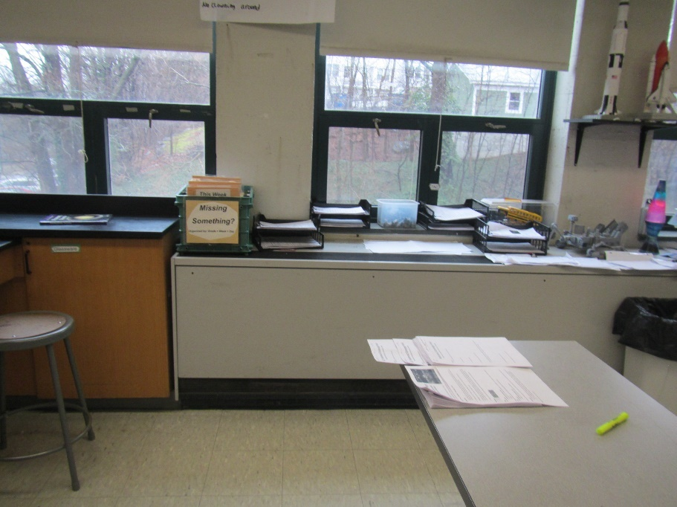
Unit ventilator (univent) in a classroom
Picture 2
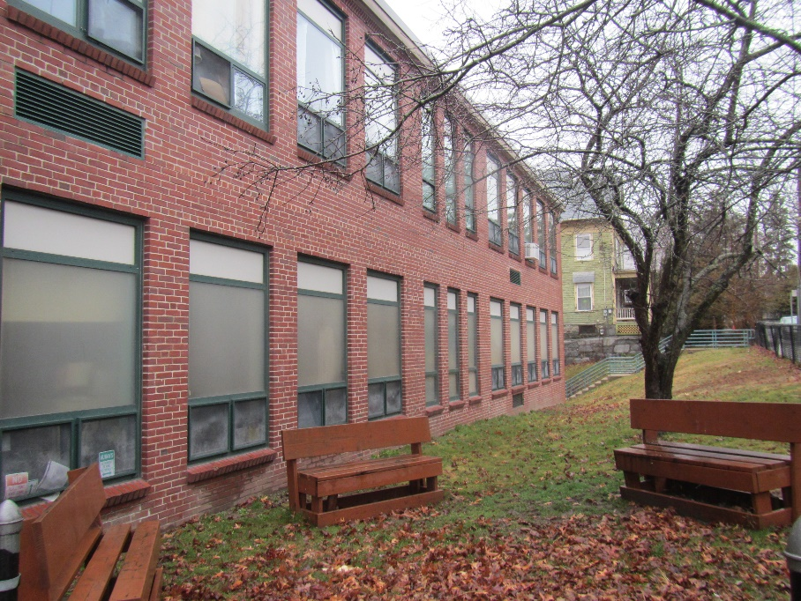
Exterior of the building showing univent intakes
Picture 3
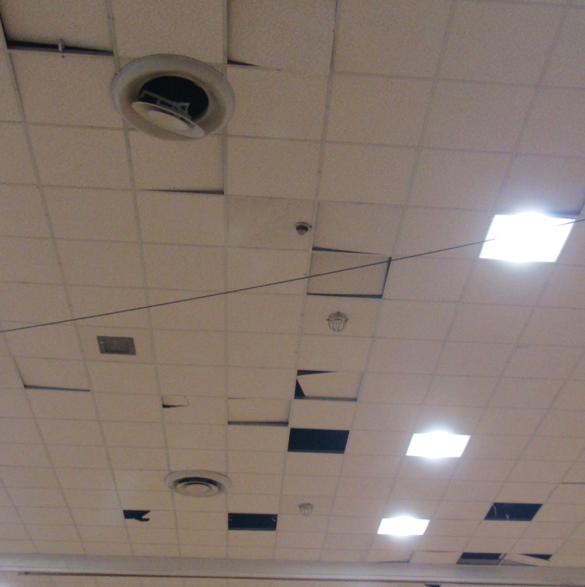
Fresh air supply vents in gym ceiling, note one is damaged
Picture 4
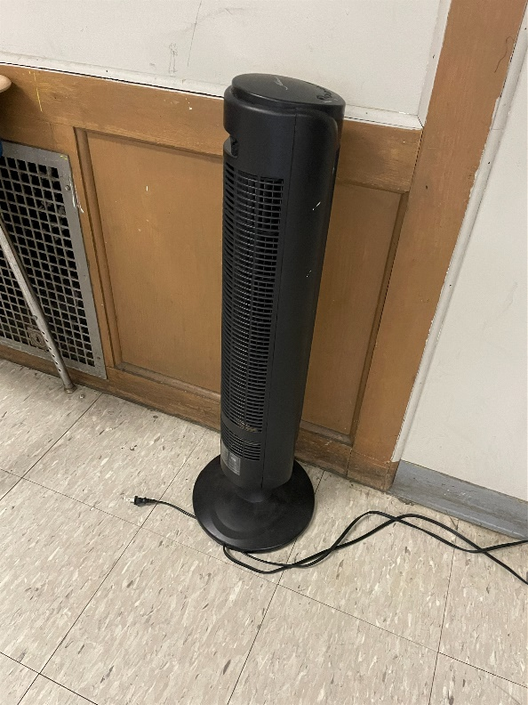
Classroom exhaust vent (left side) and air purifier or heater
Picture 5
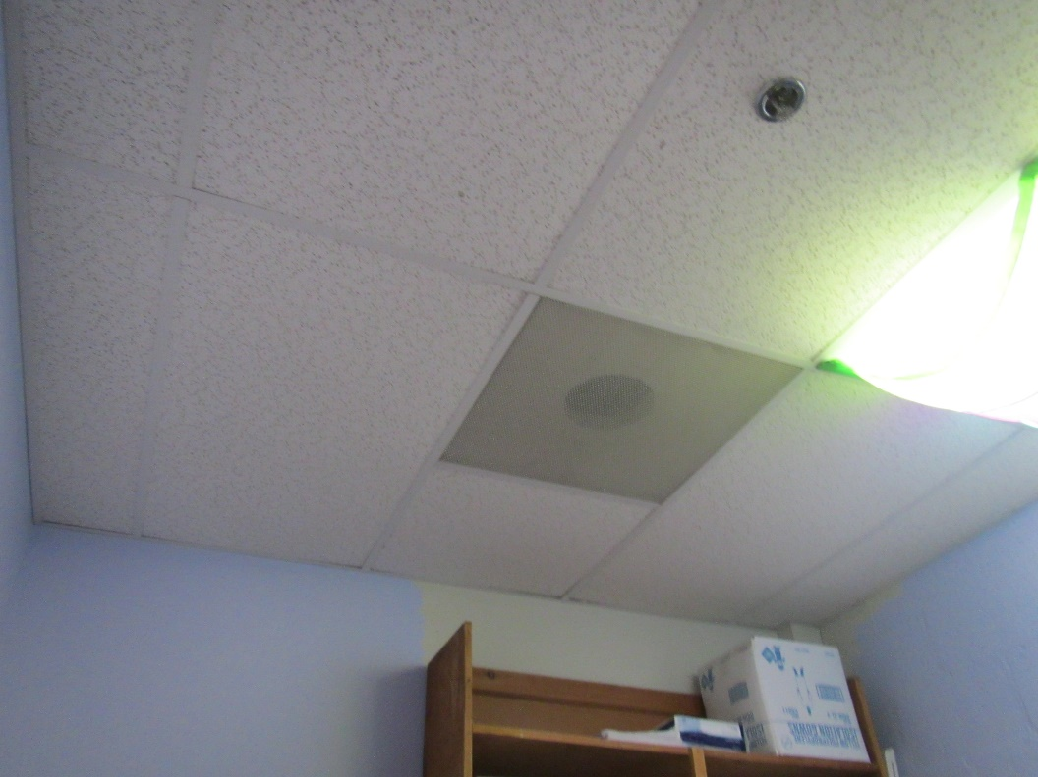
Ceiling- mounted exhaust vent, this one appears to be a direct vent to the outside
Picture 6
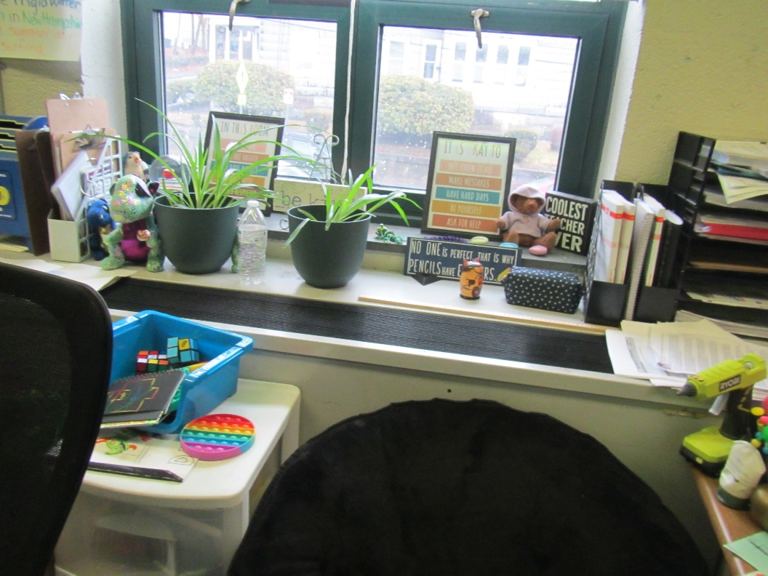
Classroom univent with items in front and plants on top
Picture 7
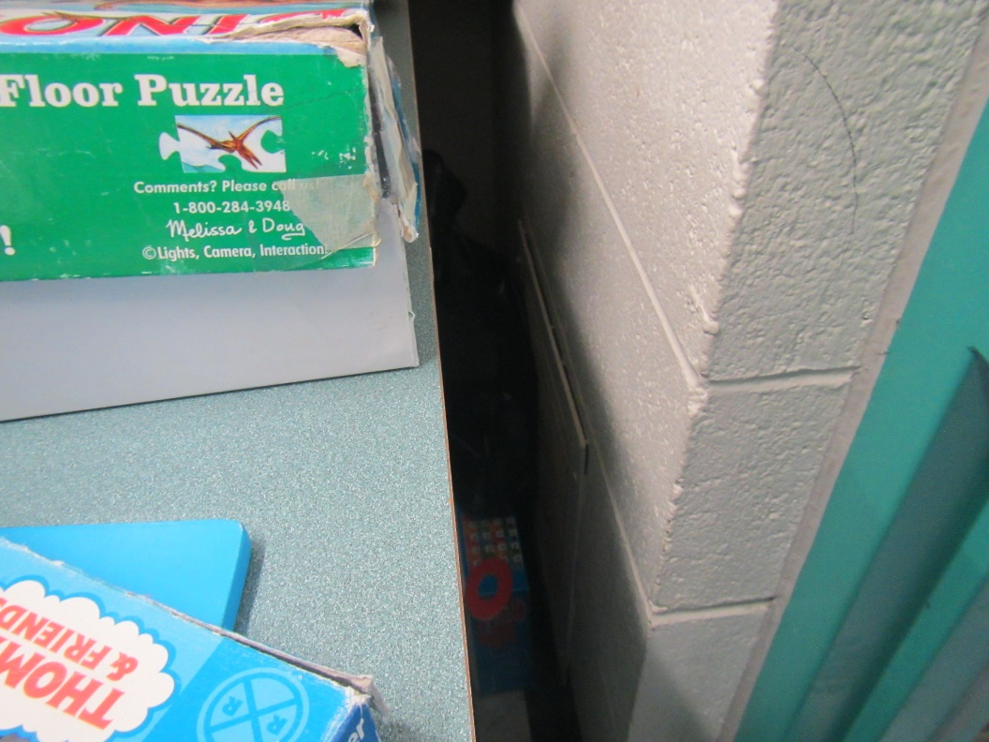
Classroom exhaust vent nearly completely blocked by furniture
Picture 8
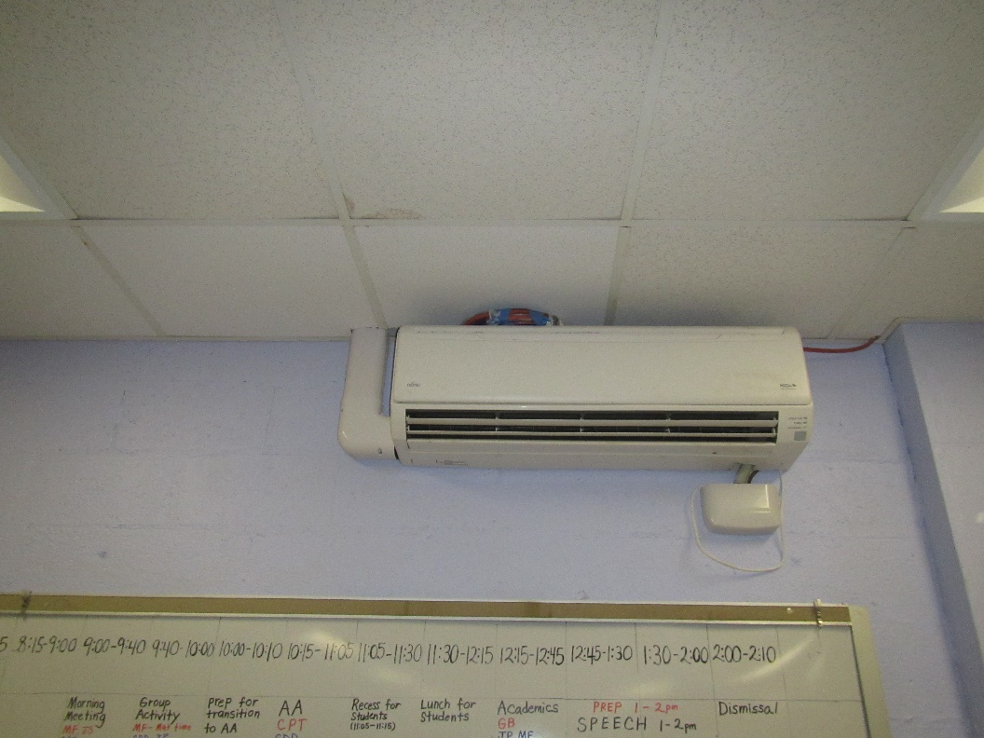
Ductless (also known as mini-split) air conditioner
Picture 9
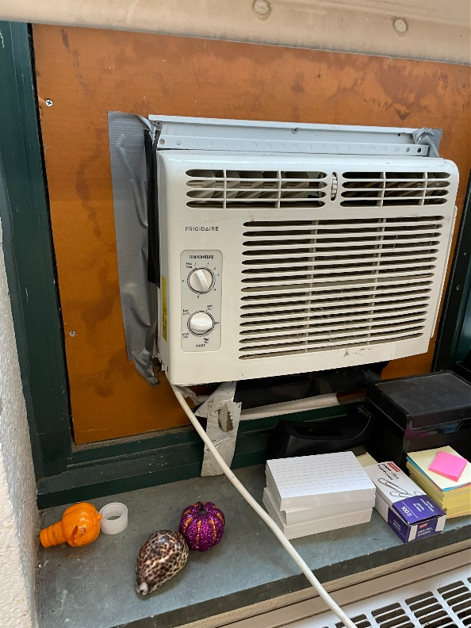
Window-mounted air conditioner
Picture 10
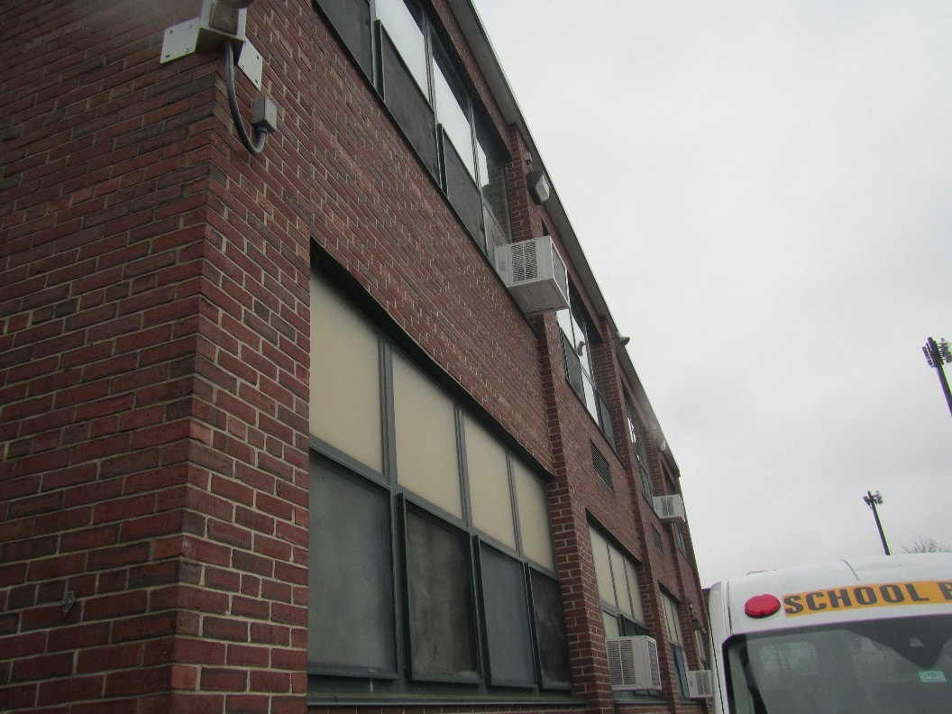
Exterior of building showing window-mounted air conditioners
Water Damage and Moisture Concern Pictures
(click to link back to report)
Picture 11
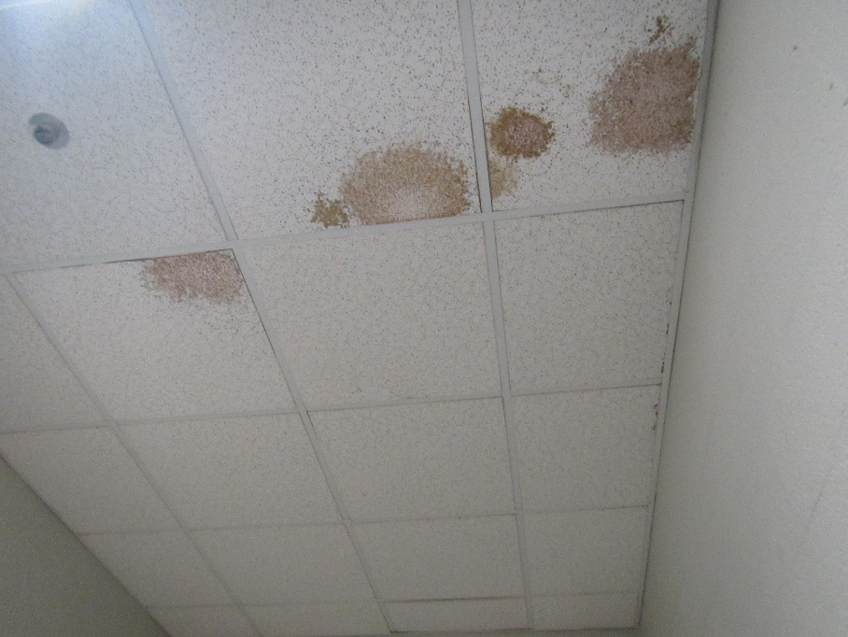
Water-damaged ceiling tiles
Picture 12
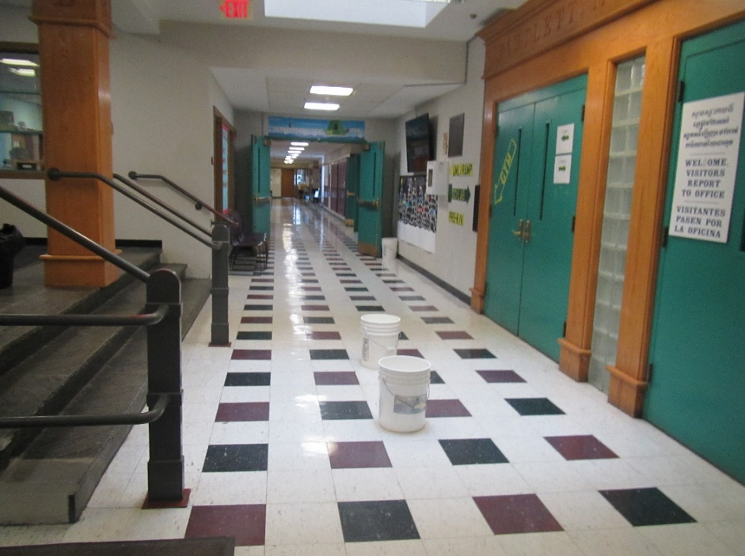
Buckets in hallway to collect leaks
Picture 13
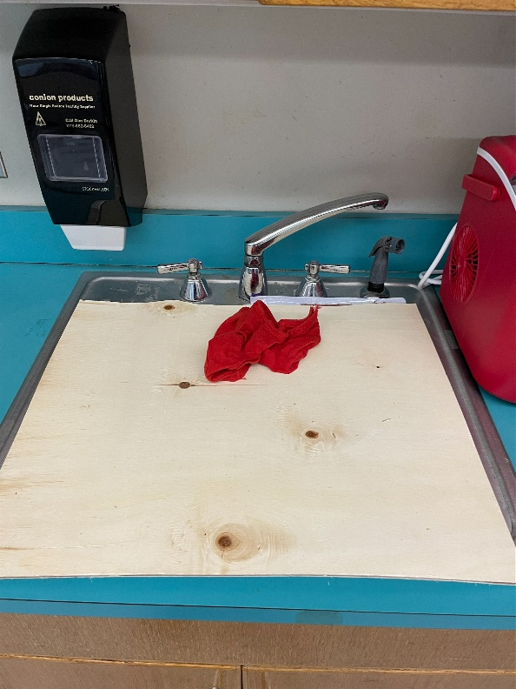
Sink closed off
Picture 14
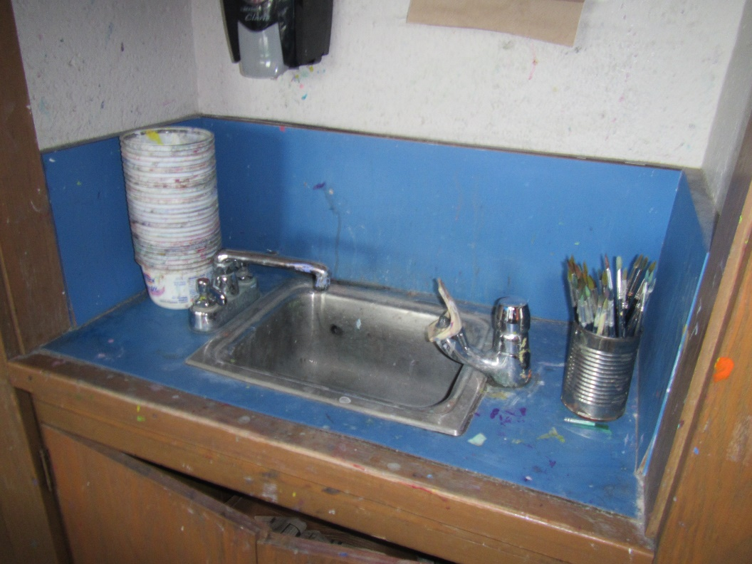
Damaged backsplash and wooden cabinet
Picture 15
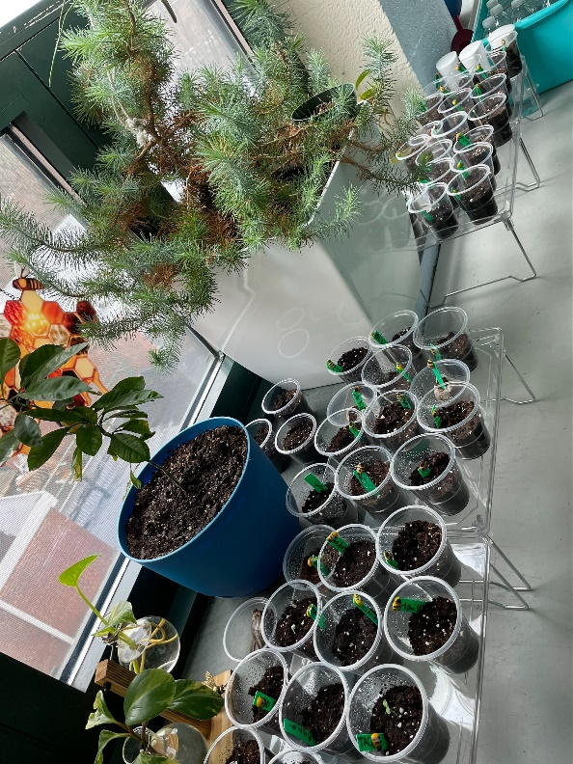
Plants used as part of classroom activities
Picture 16
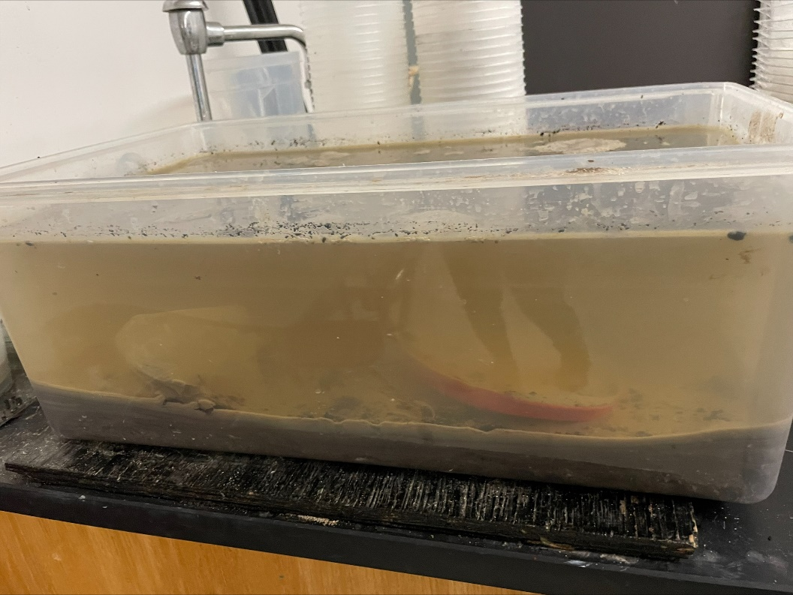
Tank of stagnant water
Picture 17
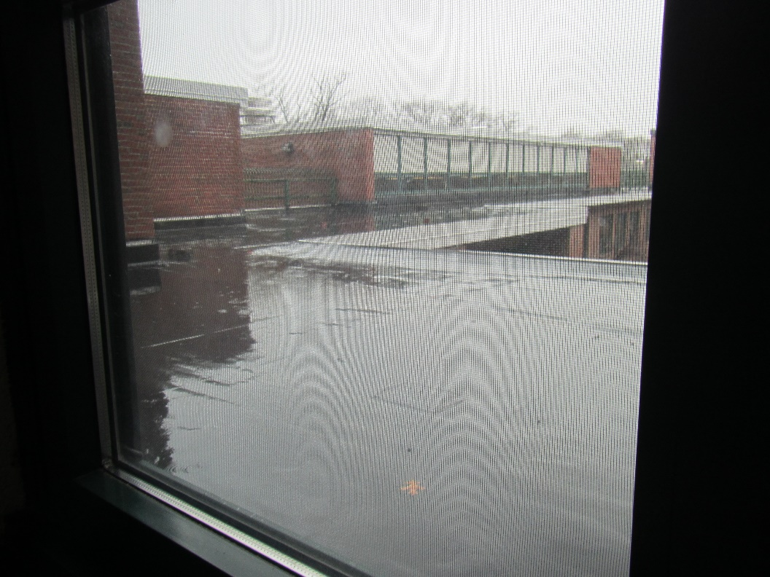
Roof segment visible from window, note sagging
Picture 18
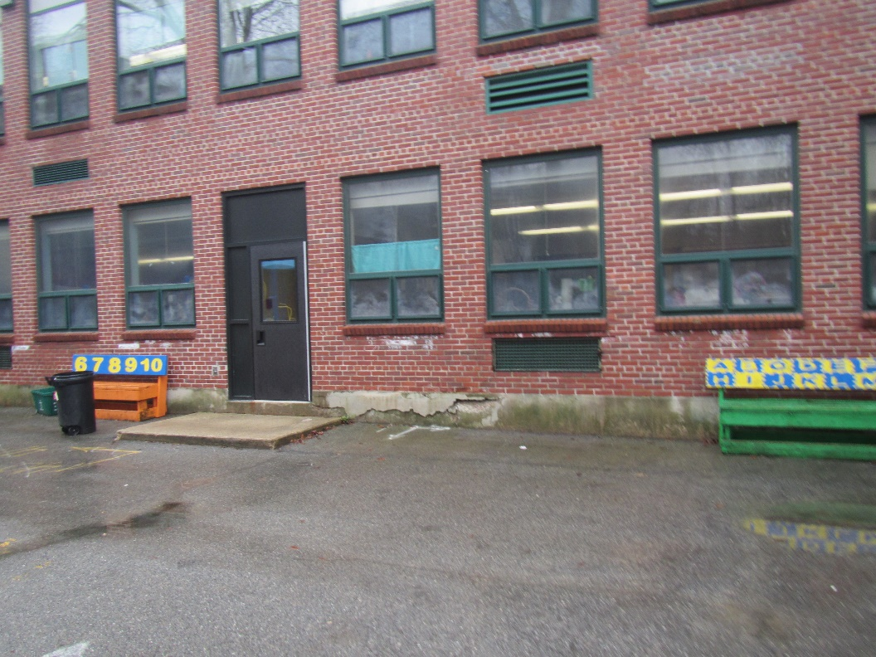
Damage to concrete and efflorescence from brick under windows
Picture 19
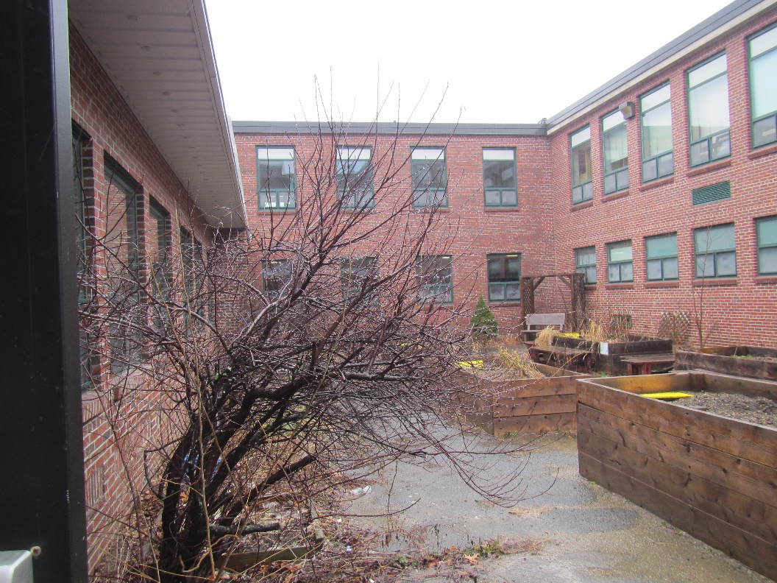
Building courtyard with plants growing next to the building
Picture 20
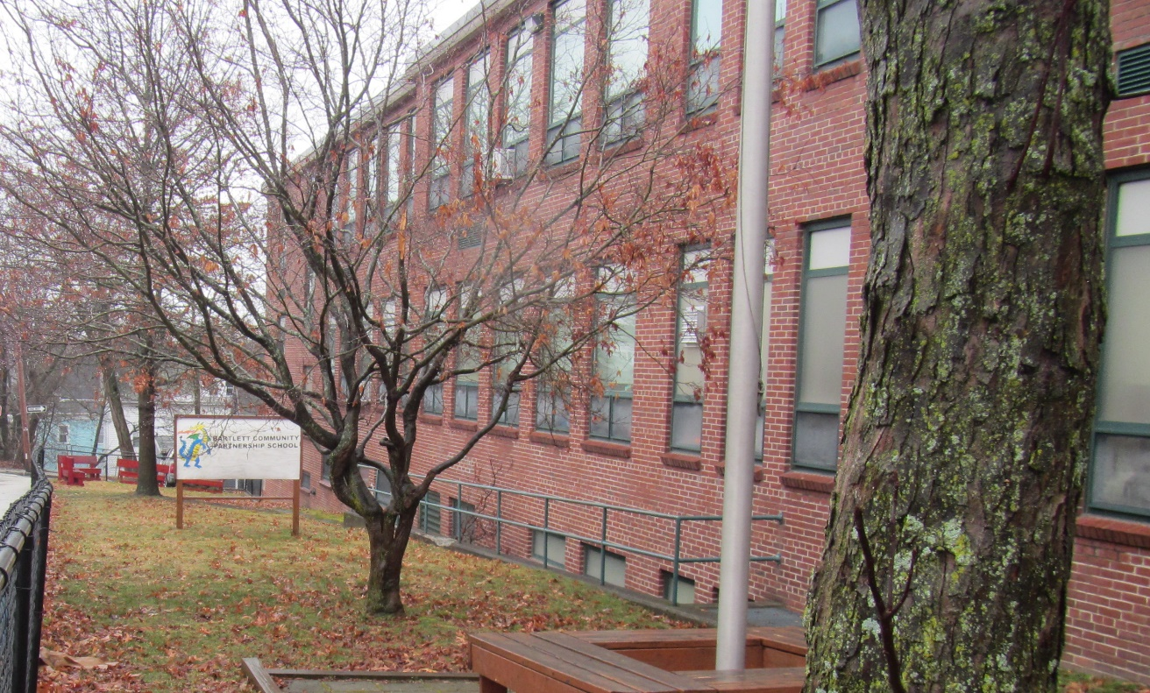
Trees along exterior of building
Picture 21
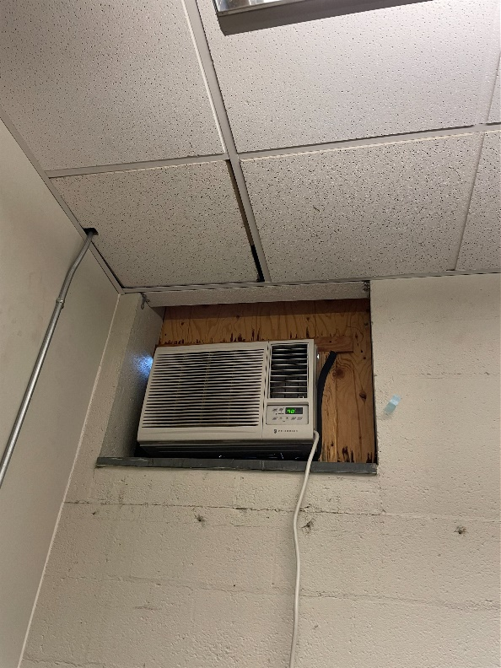
Gaps (light visible) around wall-mounted air conditioner

Sources of Respiratory Irritant Pictures
(Click to link back to report)
Picture 22
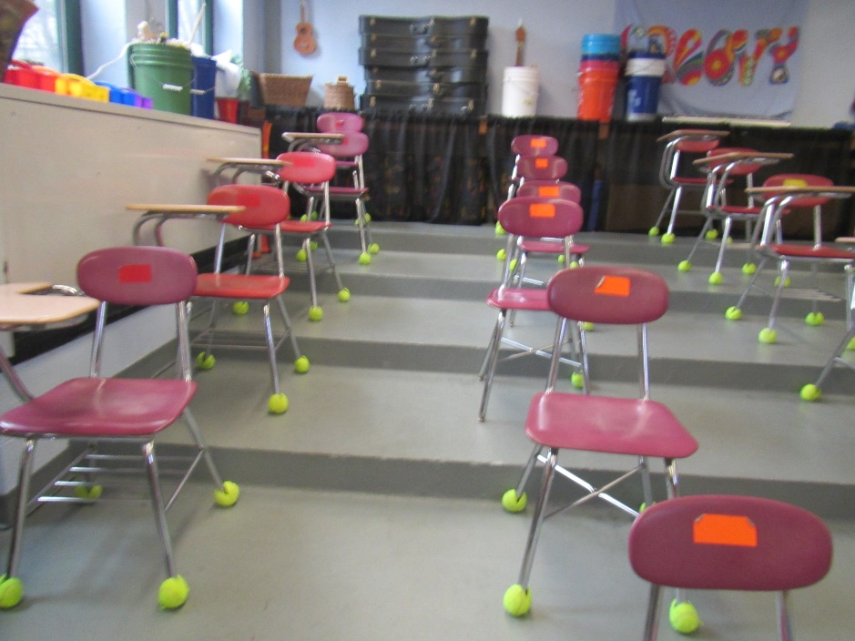
Tennis balls on chair/desk legs
Picture 23
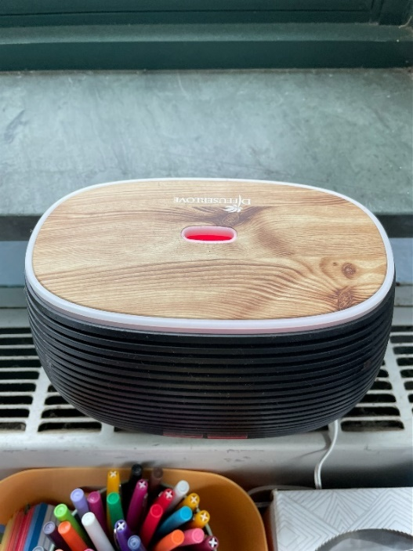
Scent diffuser in classroom
Picture 24
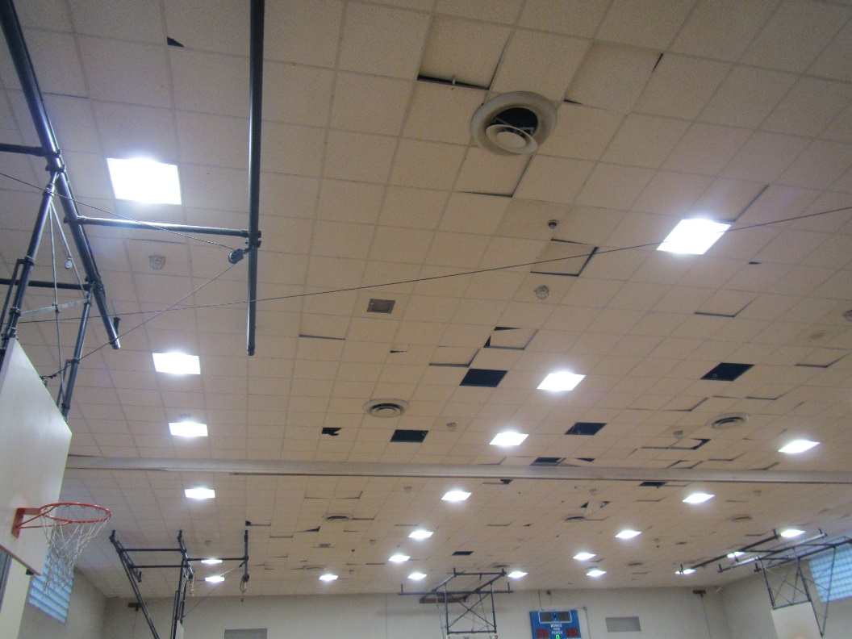
Missing ceiling tiles in the gym
Picture 25
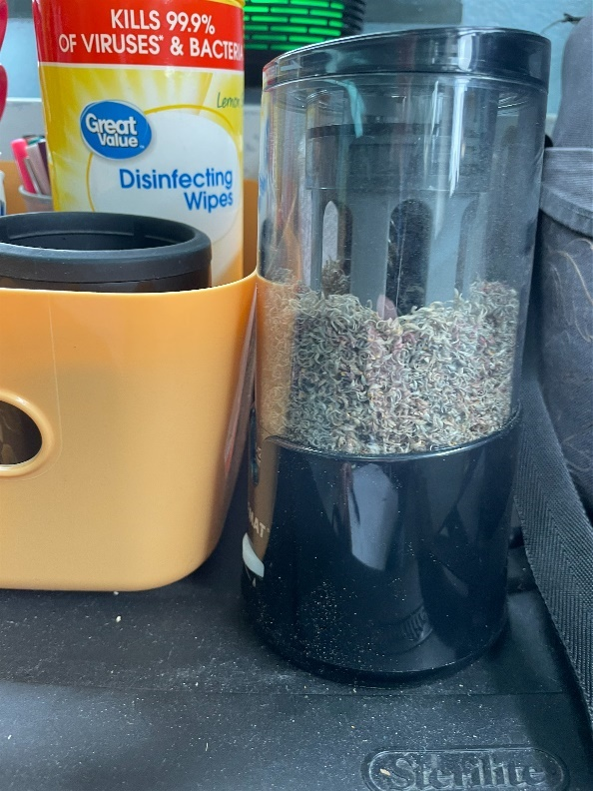
Accumulation of pencil shavings
Picture 26
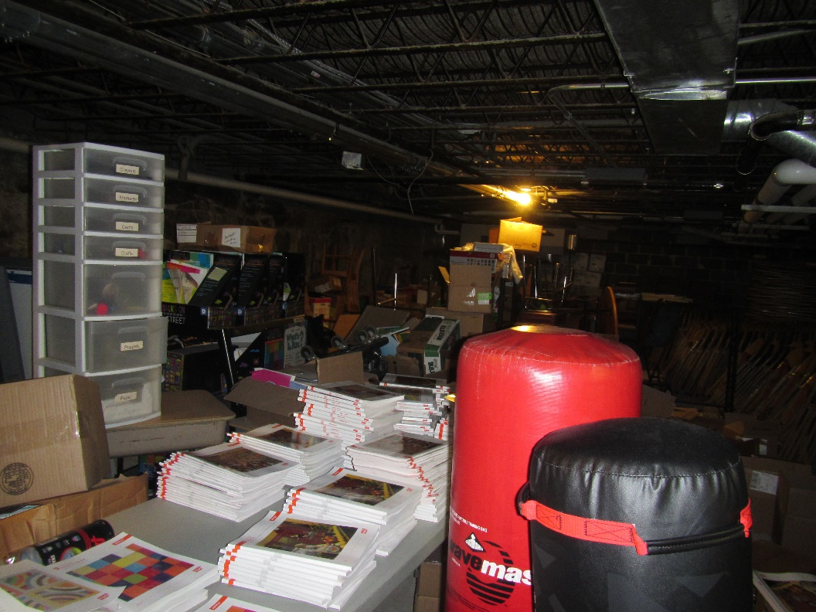
Storage area
Picture 27
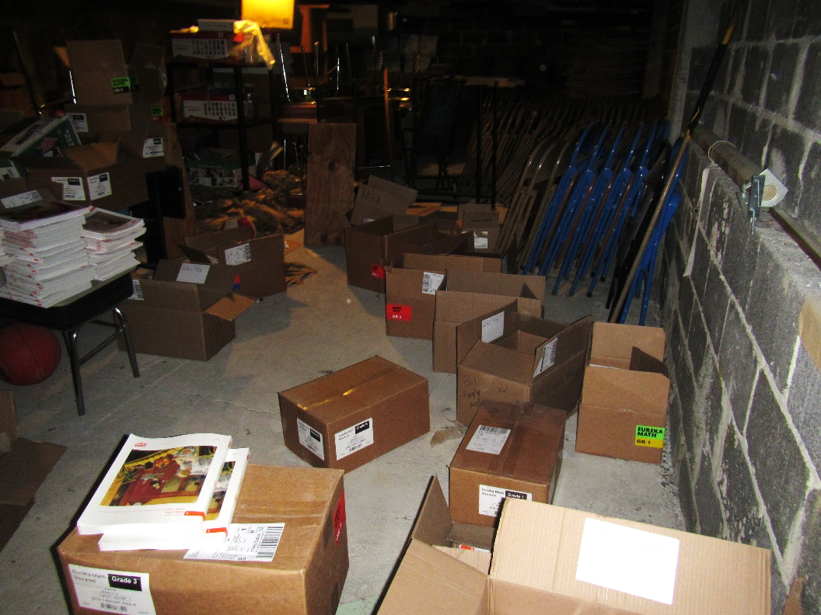
Storage area
Picture 28
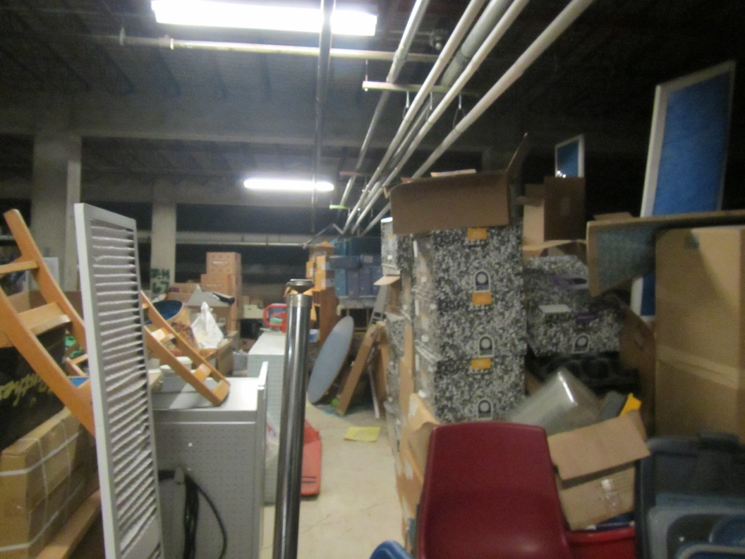
Storage area
Picture 29
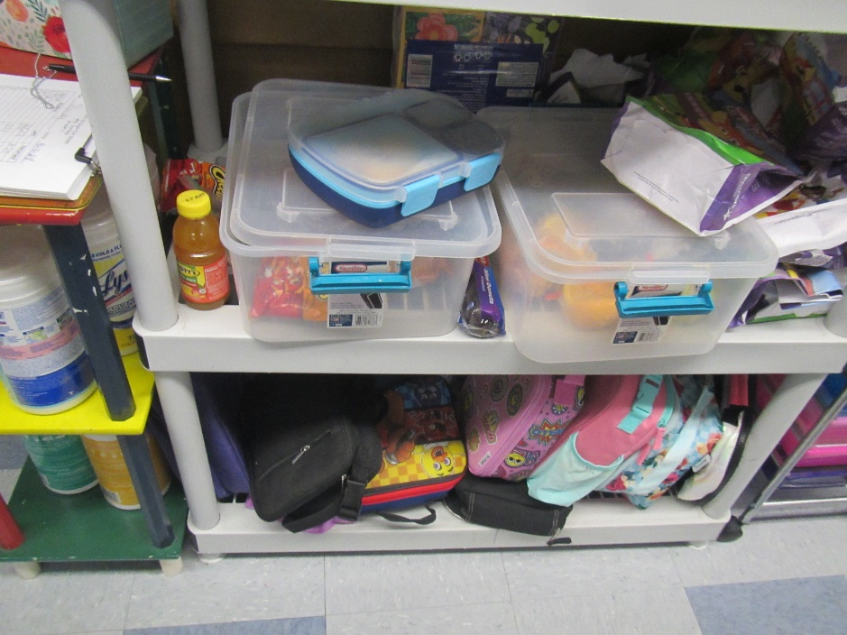
Items in a classroom
Picture 30
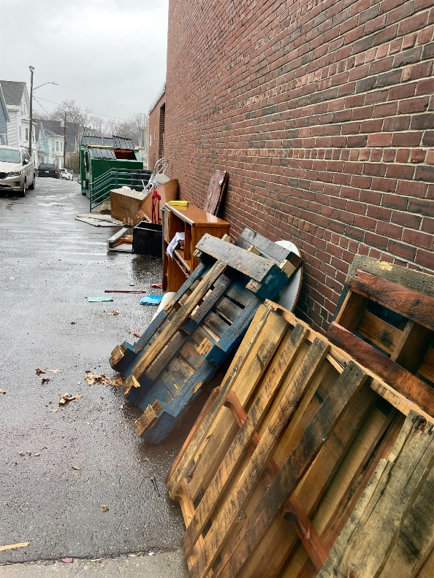
Items next to the building

Table 1
Room | Openable Windows | HVAC | Ventilation |  | Ceiling Tiles/Staining | Comments
Room | Openable Windows | HVAC | Intake | Exhaust | Ceiling Tiles/Staining | Comments
Background (outside) |  |  |  |  |  | Intermittent showers
Library | Y |  | Y | Y |  | WAC with gap around, area rugs, soft furnishings
Book Room | Y |  | Y | Y |  | Sink, boxes under sink, food debris in microwave, plants
Library classroom | Y |  | Y | Y |  | Carpet, tennis balls on chairs/desks
Room 44 | Y |  | Y | Y |  | Tennis balls on chairs/desks, area rug, plants growing in dirt, air diffuser (scented), pencil shavings, Clorox wipes, window ac, hanging items from ceiling
Room 40 | Y |  | Y | Y |  | Tennis balls on chairs/desks, soft furnishings, hanging items from ceiling, plants
Room 41 (B) | Y |  | Y | Y |  | Cleaning wipes, plug in air freshener
Guidance (1) | Y | AHU | Y | Y |  | Carpet, food, fridge
Chill room | N |  | Y | Y |  | Salt lamp, DEM, plush beanbags, carpet
Main Guidance | N | AHU | Y | Y
48 | Y | UV | Y on | Y on |  | Area rug, DEM, TBs, WAC
47 | Y | UV | Y on | Y on | 1 WD CT | TBs, area rug, fan
46 | Y | UV | Y |  |  | Life skills room, carpet, fridge on carpet
45 | Y 1 open | UV | Y off | Y on |  | DEM, NC, WAC, sink
Top level girl’s restroom | N |  | N | Y
43 | Y | UV | Y | Y blocked |  | WAC, items, DEM, area rug, plants, PF
42 | Y | UV | Y | Y blocked |  | NC, food, area rig, HS
41 SPED | Y | UV | Y off | Y |  | TBs, sink and refrigerator, AP
31 teacher’s room | Y | UV | Y off | Y on |  | Food, PCs, fridge, stand fan, microwave, laminator, sink backsplash damaged
32 | Y | UV | Y | Y blocked |  | Exhaust vent dusty, TBs, carpet, sink, fridge
SPED nurse | Y | AHU | Y | Y | WD CT in attached restroom | NC, scent diffuser (used as nightlight only)
Room 30 | Y |  | Y | Y |  | Tennis balls on chairs/desks, scent, sink, fridge, microwave
Roof Room | Y |  | Y | Y |  | Tennis balls on chairs/desks, Glade spray, chemicals stored outside this room by mop sink
Room 37 | Y | UV | Y blocked | Y |  | Tennis balls on chairs/desks, area rugs, plants, window ac, sink separating from wall, clutter under sink
Room 36 | Y |  | Y | Y |  | Food, hanging items from ceiling, sink with scented handsoap, fridge, plants, pencil shavings
Room 24 | Y |  | Y | Y |  | Soft furnishings, tennis balls on chairs/desks, window ac, plants growing in dirt, clutter on floor, air purifier, standing water in aquarium- science experiment?
Room 21 | Y |  | Y | Y |  | Area rug, soft furnishings, microwave, fridge, sink, open cleaner bottle under sink, plants
Room 22 | Y |  | Y | Y |  | Tennis balls on chairs/desks, sink, plants
Gym Office | N/A |  | Y | Y |  | Carpet, Fridge on carpet, food debris in toaster
Room 20 | Y |  | Y | Y |  | Carpet on stairs, food bags in trash, tennis balls on chairs/desks
2nd floor hallway | N |  |  |  | Active leak | Buckets collecting rainwater
19 | Y | UV | Y on | Y blocked |  | PF, sink, NC, plants, DEM, items under sink
18 | Y | UV | Y on | Y on |  | Items under sink, PF
15 ART | Y | UV | Y on | Y on |  | PS, AP, NC, WAC, damaged sink, HS
12 | N | UV | Y off | Not found |  | TBs, microwave, fridge
13 | N | UV | Y off | Not found |  | Plush items, hanging items, NC, PFs
10 | Y | UV | Y on | Y |  | Damaged sink, WAC
Room 17 | Y |  | Y | Y |  | Tennis balls on chairs/desks
Room 16 | Y |  | Y | Y |  | Air purifier, sink, coffee machine, some sink covered- not in use. Dishwasher – not working, microwaves, electric stove
Room 14 | Y |  | Y | Y |  | Air purifier, food, fridge
Room 11 | Y |  | Y | Y |  | Area rugs
Special Education, A &B | Y |  | Y | Y |  | Abandoned shower/sink area, now used for storage. Children clothing/item “store”
Maker Space | Y |  | Y | Y |  | Filter coming out of uninvent, maintenance to reinstall/check on filter rating
Pre-K 5 | Y |  | Y | Y | Some missing | Area rug, soft furnishings, fridge on carpet
Room 6 | Y |  | Y | Y |  | Soft furnishings, clutter, cleaning supplies
Room 5A | Y |  | Y | Y |  | Area rug, soft furnishings
CAF | N, door | AHU | Y | Y | 2 WD CT
1 kindergarten | Y 2 open | UV | Y on (2) | Y blocked on |  | Scented item
Sensory room | N | UV | Y on | Not found | Bowed CT | Plush furniture and mats
3 Kindergarten | Y 1 open | UV | Y on | Y inside inner office |  | Area rugs, TBs, internal restrooms
4 | N | AHU | Y | Y |  | TBs, NC, DEM, ductless AC
Storage | N | N |  |  |  | Cement floor, items
7 | Y | UV | Y on | Y ½ blocked |  | UV, NC, plants
Custodian’s office | N |  |  |  |  | Cement floor, electric wall heater
Nurse | Y | AHU | Y | Y |  | Sink and fridge, NC, has attached bathroom
Principal | Y | AHU | Y | Y | 2 WD CT | Fan
Main office closet | N |  | N | N |  | IT equipment is blocked by items (may create heating)
Conference | Y | AHU | Y | Y | WD CT | Plants
Main office area | Y 1 open | AHU | Y | Y
Vault closet? | N |  | N | N |  | NC
Aguilar? | Y 1 open |  | N | Y dusty |  | NC
25 Music | Y | UV | Y on | Blocked | Bowed CT | Area rug, instruments
23A Science | Y | UV | Y on | Y on |  | Sink, area rug, TBs
23 Science | Y | UV | Y on | Y off | Bowed CT | TBs, DEM, old gas stopcocks (not used), sinks also not used.
Gym | N | AHU | Y | Y off | Many missing
Gym storage | N | N |  |  |  | Storage of gym materials
Gym storage and office | N | N |  |  |  | Storage of gym and other materials, including boxes on the floor

(Click to link back to report)

Table 2A
Equipment Present in Building  (X = Yes) | Type of Heating/Cooling Ventilation  Equipment | Fresh  Air  Supply  (X = Yes) | Type of Location(s) | Air Filters Installed  MERV Rating  (1-15, U*)  (X = Yes) | Comments
Y | Univents | X | classrooms | yes | Filters not viewed
Y | Rooftop Air Handling Units | X | Central areas and some classrooms | Ye | Filter not viewed
 | Outdoor, Ground-Installed Air Handling Units
 | Attic/Crawlspace Air Handling Units
 | Ceiling-Mounted Air Handling Units (including inside plenum)
 | Basement/Crawlspace-Installed Air Handling Units
 | Mechanical Room-installed Air Handling Units
 | Fan Coil Units
Y | Window-Mounted Air Conditioners | X |  | y | No
 | Wall Louver-Controlled Gravity Air Supply
y | Windows | X |  | Y | NA
 | Fan in window (blowing in)
 | Built in wall fan (switched)
 | Heat recovery ventilator unit
 | Energy recovery ventilator unit
 | Chilled Beam
 | Passive combustion supply vent in basement/boiler room

*U = Filter Rating underdetermined due to inaccessibility during building visit

(Click to link back to report)

Table 2B
Equipment Present in Building  (X = Yes) | Type of Exhaust Ventilation  Equipment | Ducted  To Outdoors  (X = Yes) | Type of Location(s) | Comments
X | Rooftop Motors/Fans | X | Classrooms
 | Unit Exhaust
X | Ceiling Return Vent |  | Some areas
 | Ceiling Return Vent, Plenum
X | Wall Return Vent | X | Some areas
X | Kitchen Stove Hood | X | Cafeteria kitchen
X | Restroom Exhaust Vent | X | Restrooms
 | Photocopier Exhaust Vent
 | Garage
 | Chemical Hood(s)
 | Locker Rooms
 | Showers
 | Lock up Cells
 | Clothes Dryers
 | Gas Water Heaters
 | Furnace-Flue to Chimney
 | Furnace/Boiler direct vent or power vent (no combustion air supply)
 | Kiln, Pottery
 | Dark Room
 | Generator Room
 | Wood Shop Dust Collector
 | Spray Paint Booths
 | Fan in window (blowing out)

Table 2C
Equipment Present in Building  (X = Yes) | Type of Equipment | Type of Location(s) | Comments
X | Floor Fans, pedestal | Classrooms
X | Floor Fans, portable | Classroom
X | Air Purifier (HEPA, other) | Classrooms
 | Floor heaters, portable
X | Refrigerators, Cold Beverage Vending Machines | various
 | Radiator, wall-mounted
 | Radiator, floor-mounted
 | Passive Vents (Wall/Door)

(Click to link back to report)

Table 3
Found in Building  X = Yes | Water-Damaged Materials, Building Components or Stored Materials | Location | Visible Microbial Growth?  X = Yes | Musty odor detected?  X = Yes | Comments
 | Books-other bound materials
X | Brick walls – broken, missing mortar | exterior
 | Brick walls – blocked weep holes
 | Cardboard boxes
 | Carpet tiles
X | Carpet - Area rugs
 | Carpet wall-to-wall
 | Ceiling tiles - affixed directly to ceiling surface
X | Ceiling tiles - bowing-in suspended ceiling | Many classrooms
 | Ceiling tiles - water-stained in splined ceiling
X | Ceiling tiles - water-stained in suspended ceiling | Classrooms
 | Chairs - laminated
 | Cloth
X | Countertops (around sinks) | Classrooms
 | Curtains
 | Dust/debris within AHU, uninvent, HVAC, chilled beam units, etc. (WD through condensation, humidity, or leaks)
X | Efflorescence (i.e., mineral deposits) | Exterior
 | Engineered woods - particleboard, plywood, Masonite
 | Flooring – loosened tiles
 | Flooring - wooden
 | Furniture - laminated
 | Furniture - upholstered
 | Gypsum wallboard - ceiling
 | Gypsum wallboard - restroom wall
 | Gypsum wallboard - interior wall
 | Gypsum wallboard – located on exterior wall
 | HVAC drain pan – lack of draining
 | HVAC filters
 | Insulation- attic (paper-backed)
 | Insulation - inside air handling unit
 | Insulation - on pipe(s) fiberglass
 | Insulation - on pipe(s) other/plaster-like material
 | Insulation - wall cavity
 | Insulation – ceiling plenum
 | Modular furniture – walls/cloth partitions
 | Musical instrument cases
 | Plaster ceilings
 | Records/files
 | Refrigerator - door gasket
 | Refrigerator - drip pan
 | Refrigerator - Interior surfaces
 | Room divider - ceiling-mounted, sliding
X | Sink backsplash | multiple classrooms
 | Tables – laminated
 | Wallpaper
 | Wood - attic/roof materials
 | Wood - floor joists in basement ceiling
 | Wood - wall framing
 | Wood - window sills
X | Wood - window-mounted air conditioner framing
 | OTHER

WHAT ARE ENVIRONMENTAL ASTHMA TRIGGERS?
Asthma triggers are any chemical, pollutant, or allergen that can make your asthma worse. Asthma triggers can also be strong chemical smells, dust, or pets. Your asthma triggers may be different from those of other people. Not all asthma triggers affect people the same way. Environmental asthma triggers are found both indoors and outdoors. DPH link: Asthma and Your Environment (mass.gov)

(click to link back to report)

Table 4
Condition Present  X = Yes | Possible asthma symptom-inducing environmental pollutant | Recommendation to reduce or eliminate the pollutant
X | Water Damage and/or Mold  (allergen) | Identify water source and repair to eliminate.  Clean non-porous materials.  Remove and replace porous materials susceptible to mold growth.  Perform regular water damage assessments as a tool to ensure timely mitigation as needed.  Use NIOSH water damage assessment protocol as a guide: NIOSH water damage assessment guideline.
X | Moistening of building components during hot, humid weather (>2 days in length) (mold, allergen) | Remove materials not dried in <2 days in a manner consistent with US EPA Mold Removal in Commercial Buildings guideline.  Use dehumidification in occupied basement areas and other areas with chronic dampness.
X | Vegetation against exterior of building (water damage-mold) | Remove all vegetation preventing building exterior drying.  Remove all vegetation capable of falling onto a building or depositing debris onto the roof.
 | Personal humidifiers (lack of proper maintenance)  (pollutant and allergen) | Clean and maintain properly.  Use distilled water to eliminate metal and water treatment odors.  Maintain hydration by increasing water consumption.
X | Drains: Floor drains, Sink drains (abandoned use)  Water bubblers (abandoned use) | If in use, pour water into drain at least twice a week.  If not in use, seal the drain with an appropriate material in accordance with Massachusetts Plumbing Code (248 CMR 10.00).
 | Live Animals (turtles, gerbils, birds, rabbits, etc.) | Ensure cleanliness or remove animals from the location.
X | Improperly maintained aquariums and terrariums (allergen) | Maintain such equipment properly to eliminate odor.  Discontinue use.
X | Plants and flowers  (allergen and mold) | Keep indoor plants well maintained and not overwatered. Monitor for signs of mold and pests.  Ensure water for cut flowers does not become stagnant.  Ensure dried plant material is free of odors, mold, and pests and handled carefully  If asthma risks are high, eliminate plants and flowers.
 | HVAC system moisture issues  (mold, allergen) | Consult ASHRAE’s minimum standards for HVAC maintenance and inspection of commercial HVAC systems (https://www.ashrae.org/technical-resources/bookstore/standards-180-and-211).
 | HVAC system contaminant issues (allergen) | Consult ASHRAE’s minimum standards for HVAC maintenance and inspection of commercial HVAC systems (https://www.ashrae.org/technical-resources/bookstore/standards-180-and-211).
 | Indoor swimming pool odors outside of swimming pool (mold, chemical) | Maintain and operate pool HVAC systems to vent odors from building.  Ensure locker room exhaust vents are operating during building hours.  All doors leading to pool should be rendered airtight and be closed.
 | Pollen (allergen) | Recommend installation of MERV 8 or better filters if HVAC engineer confirms HVAC system can be so equipped without adversely affecting function.  Cut grass after hours.  Cut grass in a pattern to direct clippings away from exterior wall.  Remove trees and shrubs from in front of windows and air intakes.
 | Dry air | Maintain hydration.  Avoid overheating of air.
 | Dust mites  (allergen) | Recommendation to remove non-official upholstered furniture, area rugs, pillows, cushions, etc.  Cleaning with use of HEPA-filtered vacuum cleaner.  Eliminating clutter, storing items in dust and moisture-proof containers, and regularly removing dust through wet wiping.
 | Pests, including rodents and cockroaches  (allergen) | Use of integrated pest management guidelines, including:  - Proper disposal of food containers  - Proper storage of food products in airtight containers  - Elimination of use of food as art projects  - Remove pest harborages/clutter  - Regular monitoring for pests  EPA IPM guideline link
X | Latex-containing materials | Remove tennis balls from furniture legs.
X | Fragrances  (chemical) | Eliminate point sources, such as:  - Plug-in air fresheners  - Aroma/oil reed diffusers  - Scented sprays  - Discontinue use of other scented materials  - Consult DPH fragrance guideline: Clean air is odor-free
 | Strong smells from /use of Chemicals (such as cleaning products)  (chemical) | Use building-issued cleaning products.  Use products in accordance with manufacturer’s instructions including dilution, application, and ventilation.  Avoid using products that are stronger than needed for the situation.
 | Strong odors from new building materials (carpeting/furniture)  (chemical) | Use low VOC-emitting materials.  Air out materials (outside or in unoccupied area) prior to installation.
 | Tobacco smoke  Secondhand Smoke  (pollutant) | Eliminate tobacco smoking.  Seal all shared wall penetrations.
X | Products with a strong odor such as paint, perfume, hairspray, air fresheners, bug-spray, laminators, candles, wax melters, dry erase markers and other VOC-containing products  (chemical) | If essential:  - Provide proper exhaust ventilation to eject aerosolized product directly outdoors.  - Avoid/reduce use during occupied hours.  If not necessary, remove and eliminate.
 | Vehicle exhaust  (pollutant) | Enforce anti-idling regulations and post signs to give notice.  Relocate vehicles away from fresh air intakes.  Require cars to park face-in at building walls.  MA anti-idling law FAQs
 | Vapors and or fumes from gas, oil, or kerosene stoves  (pollutant) | Operate stove hood when stove in use.  Install stove hood if not present.  Ensure equipment is in good working order.
 | Ozone (pollutant) | Eliminate use of ozone generating equipment.
X | Window Air Conditioners (if not properly maintained) (allergen) | Equip with proper filter and clean periodically.  Clean drip pans.  Install in window with weathertight, non-mold-growth sustaining material.
 | Pottery (pollutant) | Do not operate kiln during occupied hours.  Operate kiln with exhaust system activated.  Seal all seams and holes in kiln vent.  Ensure kiln exhaust discharge terminates outdoors.
X | Carpeting (allergen) | Clean carpeting in a manner consistent with IICRC standards, including regular vacuuming with a high efficiency particulate air (HEPA) filtered vacuum in combination with annual cleaning or semi-annual cleaning in soiled high traffic areas.
 | Sweeping/dusting vs HEPA vacuuming/wet wiping  (allergen or pollutant) | Refrain from using feather dusters or brooms.  Utilize HEPA vacuums and wet wiping to minimize aerosolizing particulate matter.
X | Lack of adequate air exchange/mechanical ventilation | Make repairs as necessary and ensure all HVAC system components are operating continuously when building is occupied.
X | Lack of local exhaust at source of pollution (vocational shop activities, kitchen exhaust hood) (all) | Recommend installation of exhaust ventilation to direct pollutants directly outdoors.
 | Renovating buildings while occupied  (chemical) | Use all SMACNA guidelines for Renovation While Buildings Are Occupied. For information, visit https://www.mass.gov/service-details/construction-and-renovation-generated-pollutants-in-occupied-buildings.
 | Chemistry program chemical storage  (chemical) | Repair (if needed) and operate chemical storeroom vents appropriately.  Reduce or eliminate unneeded or overstocked chemicals.  Store all chemicals in a manner to separate incompatible chemicals.  Keep chemical storerooms clean.
X | Photocopiers/duplicating machines | All machines must have dedicated exhaust vents.

