Commonwealth of Massachusetts
Executive Office of Health and Human Services

Virtual Gateway



Department of Developmental Services Quality Management Reporting (HCSIS)
Overview and Basic Navigation Guide
v. 1.0
TABLE OF CONTENTS

Overview ……..………………………………………………………………………………………………………………………………….3

DDS Home Page and Training Materials ……………………….…………………………………………………………………………… 4

HCSIS Access Security …………………………………………………………………………………………………………………………7

Login ………………………….………………………………………………………………………………………………………………….9

Navigation…………... ……….…………………………………………………………………………………………………………………11

Managing Workload …………………………….…………………………………..….……………………………………….……..………17

Managing Workload with Alerts……………….…………………………………..….……………………………………….……..…….. .18

Managing Workload with Filing Process Management Screen ………..…………………………………………………………………. .19

Managing Workload with Reports ……………………………………………………………………………………………………………22

Module Synopsis for:

Incident Reporting …………………………………………………………………………………………………….. …………….25

Restraint Reporting …………………………………………………………………………………………………….. ………..….26

Medication Occurrence Reporting ……………………………………………………………………………………………….... .27

Health Care Record ………………………………………………………………………………………………………………..... 28

ISP Assessments ………………………………………………………………………………………………………………………29

Tips to Remember…………….………………………………………………………………………………………………………………...30

Additional Information……….………………………………………………………………………………………………………………..32

Overview

This Introduction and Basic Navigation Guide is intended to provide new users of HCSIS with an introduction to information about basic HCSIS navigation and system modules.

The Department of Developmental Services Quality Management Reporting (HCSIS) is part of the Department of Developmental Services Information System (DDSIS) used by the DDS Staff and Private and State Operated Providers to help monitor the health and safety of the individuals served. HCSIS is a web-based information system that utilizes the Commonwealth Virtual Gateway, which is a central portal for accessing programs and services offered by the Executive Office of Health and Human Services (EOHHS). The Goal of Virtual Gateway is to streamline service access and coordinate service delivery. It serves three important groups:
- Consumers
- Service Providers
- Internal Health and Human Services (HHS) state staff
HCSIS includes the following modules:

User Administration
Enhanced Security Administration
Data Extracts
Incident Management
Medication Occurrence Reporting
Restraint Reporting
Death Reporting
Investigations
Health Care Record
Participation Allocation Management
Service Coordinator Supervisor Tool
National Core Indicators
ISP Assessments

DDS HOME PAGE
For training materials specific to each module, access the DDS Home Page at http://www.mass.gov/dds. Click the HCSIS link for detailed help and step-by-step guidance.

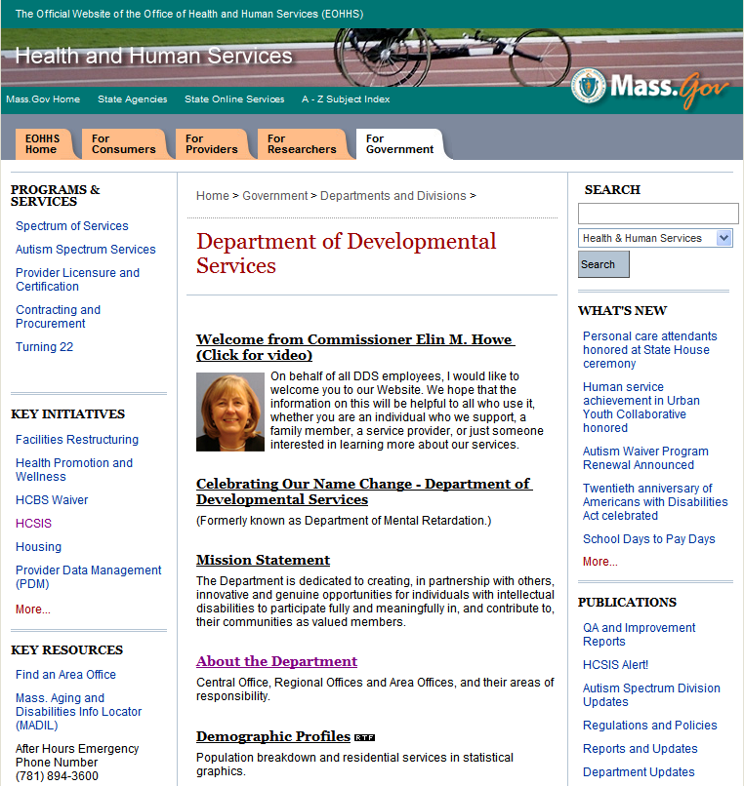

After clicking on the HCSIS link you will be brought to a screen listing all modules for which training materials are available to view and download. Click on a module link to access those documents:
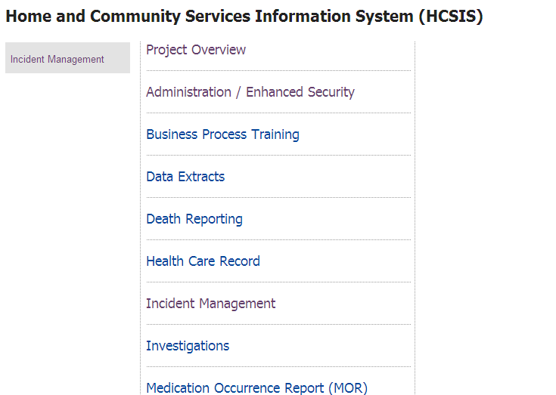

Click on Incident Management to access that module’s training materials.

The following is a picture from DDS web page displaying the various Incident Management Documents and QuickGuides. Each module link has similar training materials.

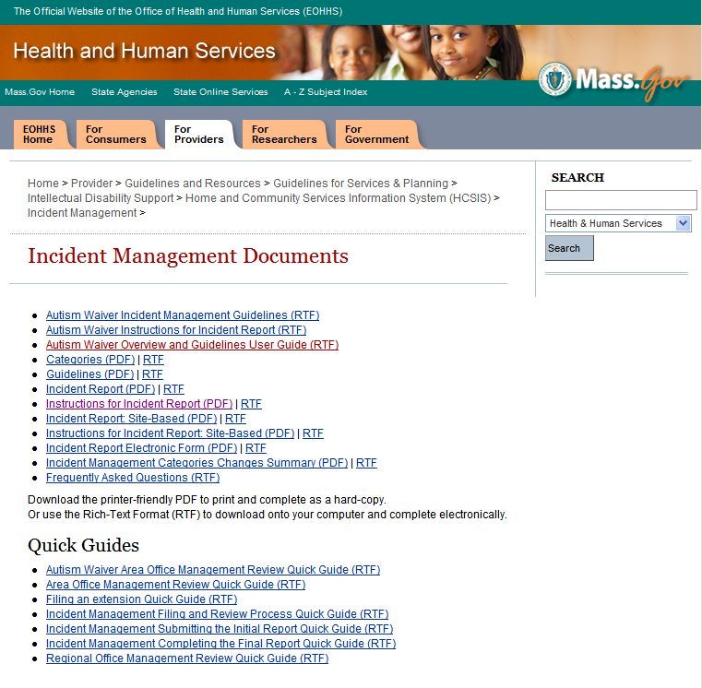

HCSIS Access Security

User access is determined by a combination of scope and roles. It safeguards personal health information for individuals served by DDS.

Scope
Role
Role
IM Data Entry
Restraint Manager
Provider Agency

Scopes define the individuals that a user can see within the system. Roles designate what information a user can see and activities the user can perform. In this example, a provider staff person with the Restraint Manager role can see all individuals in the providing agency and can data enter and finalize a restraint report. Multiple roles may be assigned to a user. This user also has the Incident Management Data Entry Role, which will allow the user to create an Incident report, a Restraint report, an Optionally Reportable Event and a Medical Occurrence report. This is in addition to the Restraint manger duties.

Enhanced Security is an additional level of Security Access that a provider agency may implement to further limit the scope of their staff people to particular individuals or site locations. For more information, contact your agency’s HCSIS Local Administrator.

A Provider Roles Guide is available through the Administration/Enhanced Security link on the DDS website. As an example, following is a description of the role of IM Supervisor.

ROLE NAME | IM Supervisor Role
ROLE DESCRIPTION | This role can finalize incident reports, restraint reports, medication occurrence reports, and optionally reportable events and communicates with the Area Office and Regional Office staff regarding the event.
SCOPE TYPE | Private and State Operated Providers
ROLE MAY APPLY TO | Designated supervisory staff in a provider organization responsible for reviewing and submitting/finalizing incident reports, restraint reports and medication occurrence reports.
KEY ACTIVITIES | - Review and submit the Initial Report of the Incident  - Review and finalize the Final Report of the Incident  - Filing an Incident Report Extension  - Restrict access to an Incident Report in HCSIS, if necessary  - Review and finalize the Medication Occurrence Report  - Review and finalize the Restraint Report  - Review and finalize an Optionally Reportable Event  - Delete an Optionally Reportable Event  - Request and review Management Reports
SYSTEM ACCESS | Incident Reporting  - Update access to Initial Report and Final Report, and Optionally Reportable Event  - Read-only access to the Area & Regional Management Review and Process Management Screens  Medication Occurrences  - Update access to the Medication Occurrence Report  - Read-only access to the Regional MAP Review  Restraint Reporting  - Update access to the Restraint Report  - Read-only access to the finalized Restraint Manager Review, Area Management Review and finalized HR Committee Review

Login

Login to Virtual Gateway (VG)

HCSIS is accessed through the Virtual Gateway website by opening the Internet and entering the following web address: https://gateway.hhs.state.ma.us/authn/login.do

Enter your Username and Password you have been assigned by the Virtual Gateway. Either you or your provider local administrator should receive an email with a login and temporary password. When logging in, you may be required to change your password and update your user profile. For assistance with logging in, please visit www.mass.gov/vg/loginassistance.

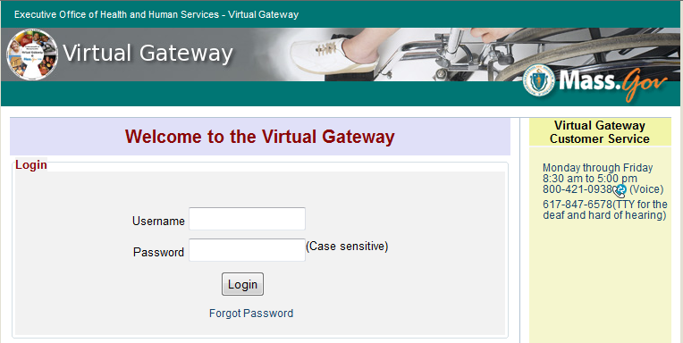

Login to HCSIS

Select “Developmental Services Quality Management Reporting (HCSIS)” to access HCSIS

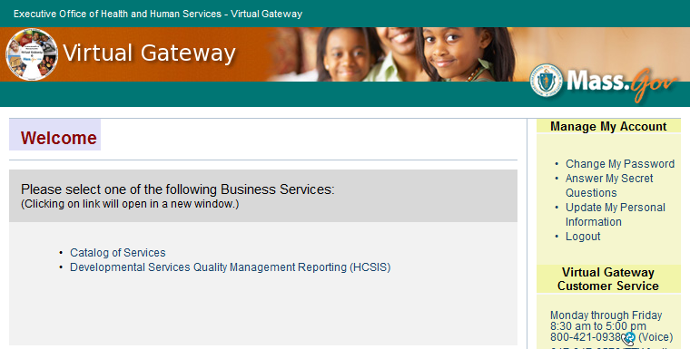

Navigation

Once logged into HCSIS, you will see the HCSIS Home Page. Select the tab for the appropriate module. Choose QM to access the Quality Management module. Additional links such as Alerts are available. Bulletins are posted that show where to get guidance and the most recent enhancements made to the system. Any updates about system availability and maintenance will be posted here.

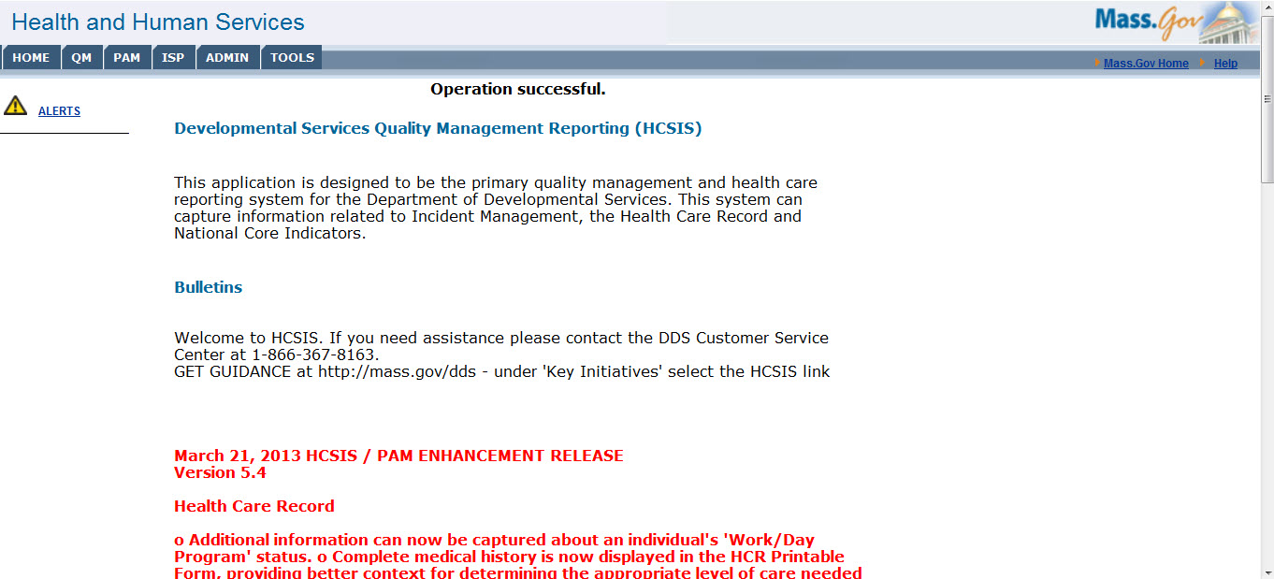

You will then be able to search for Individuals by performing the following tasks:

1. Click on the IM link.
2. Click on the Event Data Entry link.
3. Search by any of the data fields on the screen. In this example, the user has entered the last and first name of the individual.
4. Click on the hyperlink for the individual.

1. Click on the IM link.

2. Click on Event Data Entry.

3. Search by entering last name; first name is optional

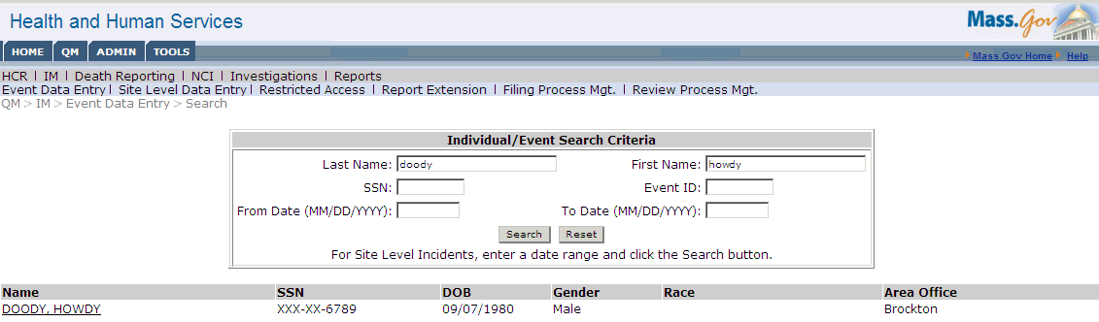

4. Click on hyperlink to view individual’s incident reports

After clicking on the Individual’s name, you will be able to view any previously created incident reports and to create a new incident report. Click one of the Event ID hyperlinks to view a previously created incident report.

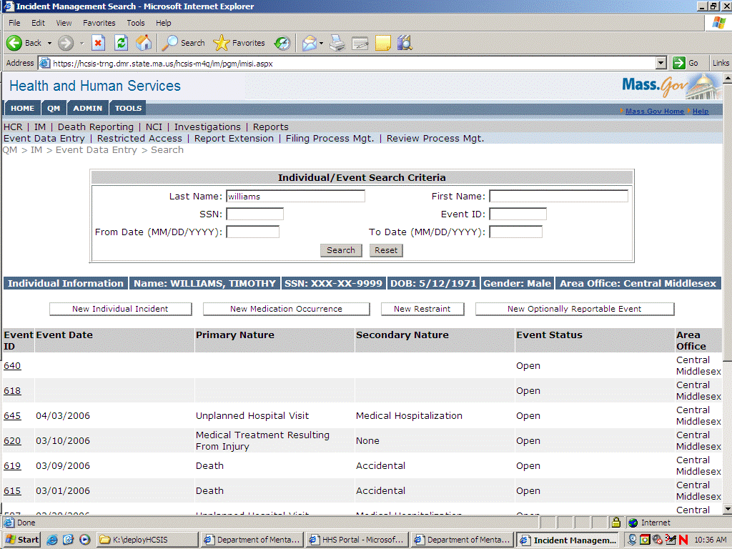

After clicking the Event ID hyperlink, you will see that there are several documents associated with one incident report:

Provider Incident Report
Area Office Management Review
Regional Office Management Review (not shown)
Action Steps

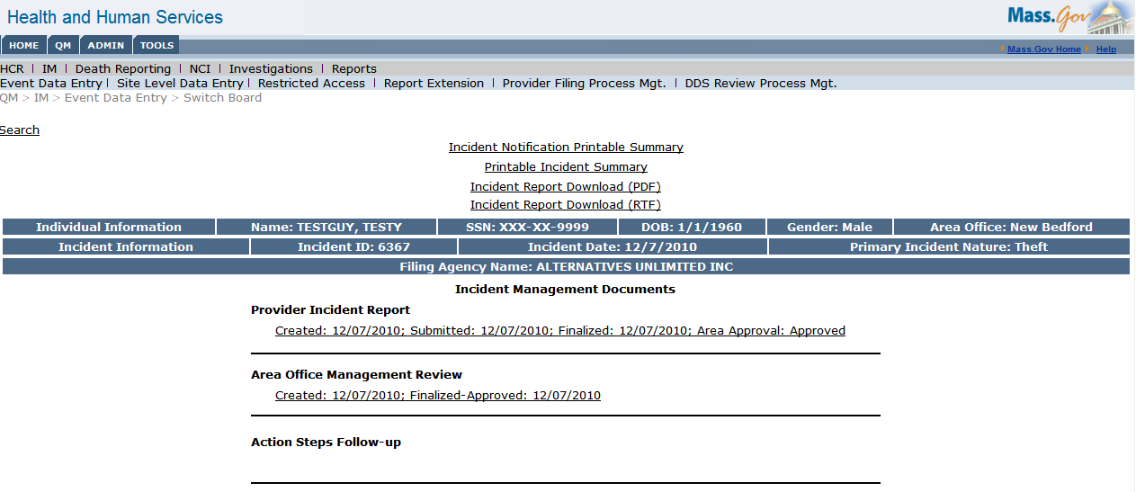

Note that the Blue Bar provides high level information about the individual such as Date of Birth, gender, and area office, as well as information about the incident date and primary nature.

Click again on Event Data Entry to be returned to the Search screen with the Individual’s name. The system retains the last search criteria entered by the user. Clicking on Create Incident tab will begin a new incident report.

For instructions about how to enter an incident report or enter data in other modules, access the HCSIS link as described on page 5 to be brought to a screen listing training materials for all modules. Below is the screen displaying the various Incident Management Documents and QuickGuides. Click on the link for entering an Initial Report for instructions. The Guidelines document provides business and policy related information.

Managing Workload with Alerts, Process Management Screens and Reports

- Alerts will be generated once a report has been filed. The Alert announces that the event is ready for your review.
- Process Management screens display what events are still open and where the event is in the process.
- Management Reports will show you events both open and closed and provide a historical view of events. Utilizing report filters allows the user to tailor these reports to their specific management needs

Detailed information is available using the following training materials on the DDS Website:

The Incident Management Filing and Review Process Quick Guide provides information on event statuses and next steps which are viewable for each event .

The Reports Guide is organized into sections by HCSIS module. Within each module, the requirements for each report are listed along with vital information for using the report. Descriptions for each report are organized as follows:
- Module
- Report name
- Screen capture of the report screen from HCSIS Report type (online, batch, overnight)
- Report Description: This is a brief description of the information contained in the report.
- Specific documents which are included in the report (i.e., what status a HCSIS document must be in to be included, such as Submitted, Finalized, etc.)
- Report Data: This is a listing of the data columns in the report. If a report is in a different format, e.g., a counts report, the types of counts are listed.
- Report filters, such as any which are mandatory or any which have limits (e.g., a date range may not exceed one year)
- Other available filter criteria for the report, including the possible values for dropdowns
The following sections provide general information about how to use these three different methods for tracking your work.

Managing Workload with Alerts
The Alerts inform you about the status of a particular report filed. From the Home page, click the Alerts hyperlink to display all alerts.

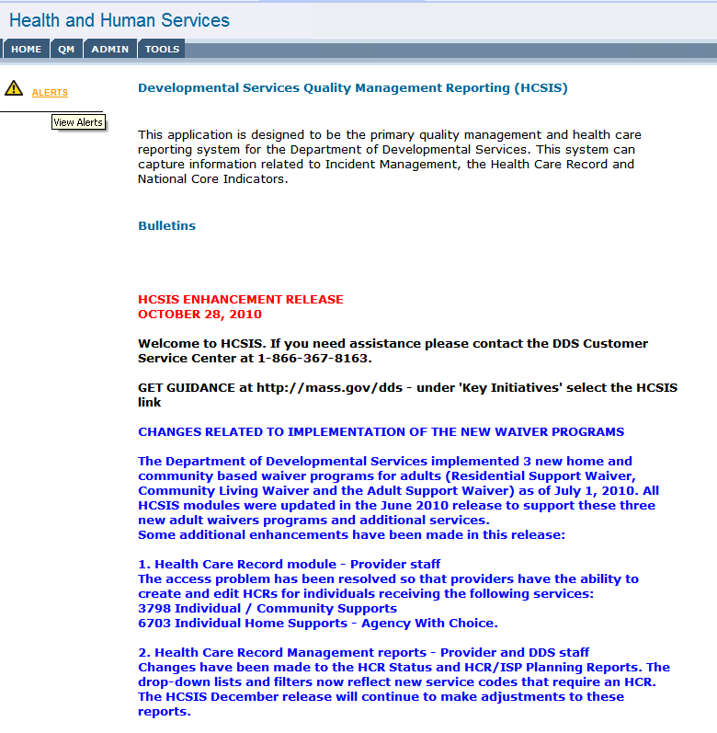
The Alerts screen can be thought of as a news flash or headline. It tells you what may be urgent now such as, a major incident, or a death report. They “alert” the user in HCSIS that something has happened that needs attention. After accessing the Alerts page, clicking on the underlined words, or hyperlink of the Alert will take the user to the event (Incident, Medication Occurrence Reporting, etc.).

The user can choose to filter the subject or module for which they want to view alerts. Click on the Subject or Module dropdown to choose.

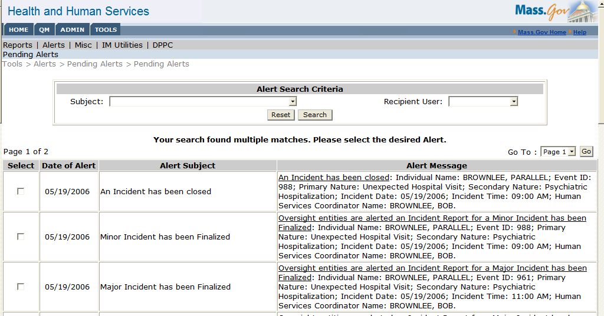

The following is an example of an Alert. Click the underlined Alert hyperlink to see the event. Or, right-click link and open in new window to toggle back and forth from the Alerts screen to the event.

This will bring you to the Individual switchboard for this particular incident.

Managing Workload with Filing and Review Process Management Screens

Additional methods of managing workload are the Filing and Review Process Management screens and Management Reports.
Process Management screens tell you what stage reports are in the process. These screens can be thought of as your daily newspaper and are a good way to manage open events on your caseload.

In general, the Filing Process Management screen is often used by the provider to see what needs to be filed. Navigate to it by clicking:

QM > IM > Filing Process Management

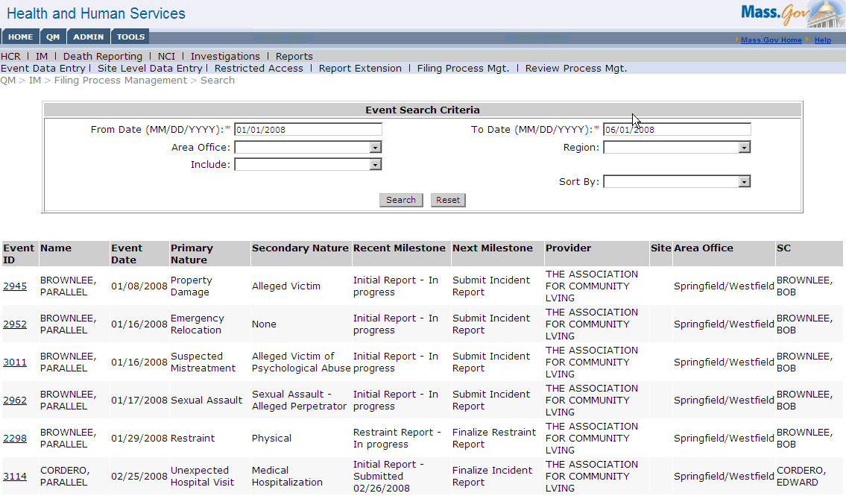

A Search can be performed by entering the From Date and the To Date (Note date format) then clicking the Search button. The information contained on these screens will inform the user of events that have been entered into HCSIS within their scope. For instance, it may show you that the Initial Incident Report has been completed and the next step is to complete the Final Report. These screens are refreshed overnight. This means that they contain the latest data from previous days but do not reflect any changes made during the current business day. Once an event has been closed, HCSIS will automatically remove it from the screen the following business day. Please refer to the Incident Management Filing and Review Process Quick Guide for detailed instructions.

The Process Management Screens include a mechanism to jump to the event’s switchboard via the Event ID hyperlink. To open the Event in a new browser window: Right Click > Open in New Window. This will allow the user to toggle back and forth between the switchboard and the event.

Managing Workload with Reports

Through the Reports Request screen, you can run a number of reports depending on your access to the system. Reports offer an additional way to manage events. For example, patterns of individual behavior can be charted through the Events by Individual Detail report. Patterns of events occurring at provider sites can be charted through the Events by Site/Provider report. There are three choices through which to view a report: Adobe Acrobat, Rich Text or Plain Text. The Report Screen can be accessed through the QM or TOOLS tabs.

The following is an example of the Reports Request screen. Depending on your access to the system, you may not see all the reports displayed.

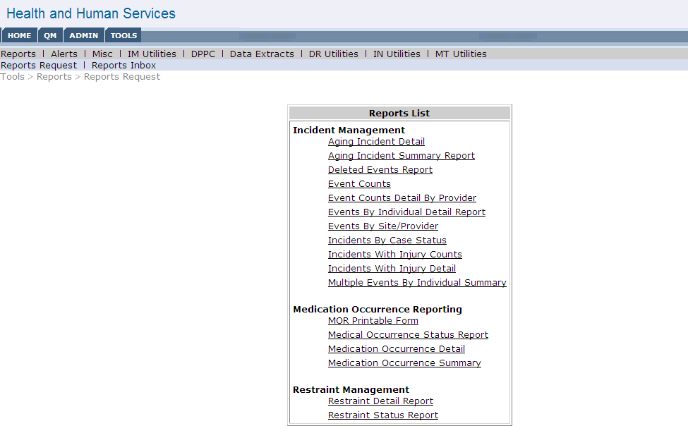

Click on a report link to generate a report.

After clicking on the Events By Individual Detail Report link, the Request screen shows filters available to customize the report:

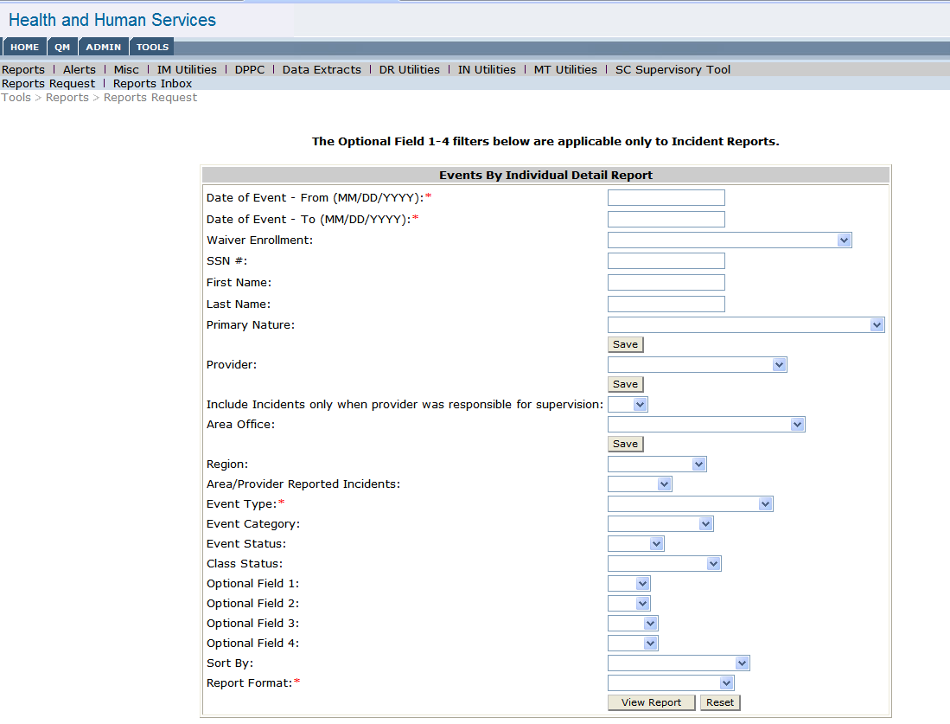

The user may choose to view incidents that occurred within a certain date range, or incidents that included only a specific category/primary nature. For example, the user may choose to view incident that occurred in the month of January for Unexpected Hospital Visits that are still open.
This allows the user to tailor these reports to their specific management needs. Users have access only to reports for those modules for which roles have been assigned. Click the View Report button.

After clicking View Report, the report will be available for viewing or saving. Following is a sample of the Events By Individual Detail Report. Information is sorted by individual, and includes summary information about each incident. The date that the report was run will appear in the upper right hand corner of the report. The list of search criteria entered by the user will appear in the upper left hand corner of the report. A NULL value indicates that particular filter was not filled in by the user.

By generating reports on a regular basis, trends can be identified either for an individual, a site, or a provider agency. Please refer to the Reports Guide for detailed instructions for each management report in HCSIS.

Module Synopsis: Incident Management
When creating individual incidents the IM Data Entry role will do the data entry for the initial report. An alert will be generated to the IM Supervisor, who will do the submission of the initial report as well as the data entry for the Final Report. Upon finalization of the incident report, an alert is generated to the DDS Area Office indicating that the incident report is ready to be reviewed. If the Area Office reviews and does not approve the incident report, then an alert will be generated to the IM Supervisor indicating that the report needs to be refinalized. Upon refinalization, an alert is generated to the DDS Area Office indicating that the report is ready to be reviewed again. If the incident is a minor incident, then the incident will be closed upon review and approval by the DDS Area Office. If the incident is a major incident, then the incident will be closed upon review and approval by both the DDS Area Office and the DDS Regional Office.
The following is an example of the Incident Management Switchboard for a minor incident. The Switchboard indicates the dates that each document was initially created, submitted, and finalized. The Incident Report shows as being submitted, and then finalized. Only the Area Office Review is required as this is a minor incident. The Action Steps Follow-up is not a required document.
An Incident Report download is available to give an abridged version of the incident to a guardian, either in print or electronically. Also available are two other Printable Summary documents.

Module Synopsis: Restraint Reporting

Restraint Reporting follows a similar process as Incident Management. However, it goes through a few more steps: the Restraint Report, Restraint Manager Review, Area Management Review, Human Rights Committee Review and Comment, and lastly a Commissioner’s Review for a randomly selected group of reports. Assuming that all documents have been completed, the restraint is closed within 120 days of completion of the Restraint Manager Review or upon completion of the Commissioner’s Review. The following is an example of the Restraint Switchboard with everything completed with the exception of the Commissioner’s Review.

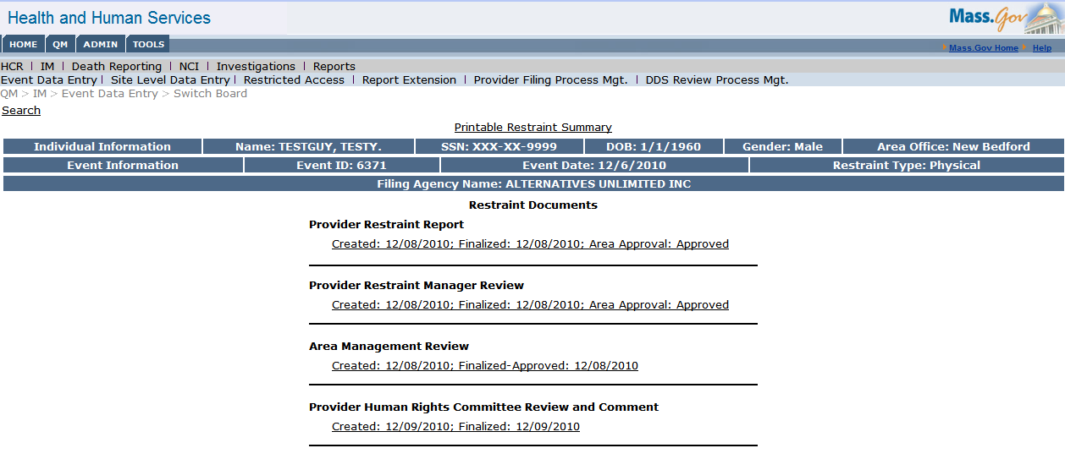

The Restraint Report is often entered by the person who administered the restraint. Another option is someone at the agency receives a paper copy and he/she enters the information in HCSIS. The Restraint Manager Review is then finalized by the Restraint Manager, usually someone at the agency with a supervisory role. The Area Office Review is then reviewed by the Service Coordinator at the Area Office. At the provider agency, the Human Rights Coordinator reviews the Human Rights Committee Review and Comment. Finally, a select sample is reviewed by the Regional Human Rights Specialist through the Commissioner’s Review and Comment.

Module Synopsis: Medication Occurrence Reporting
The process is similar to that of creating incidents or restraints. Medication Occurrence Reports may be created by the person who discovered the medical mistake or by the person who made the medical mistake. Often, a paper form is filled out and a supervisor may enter the information into HCSIS. Once the MOR is finalized, the DDS Regional MAP Coordinator then completes the MAP Review. If approved, this action closes the MOR.

The following is an example of the Medication Occurrence Switchboard with all documents completed.

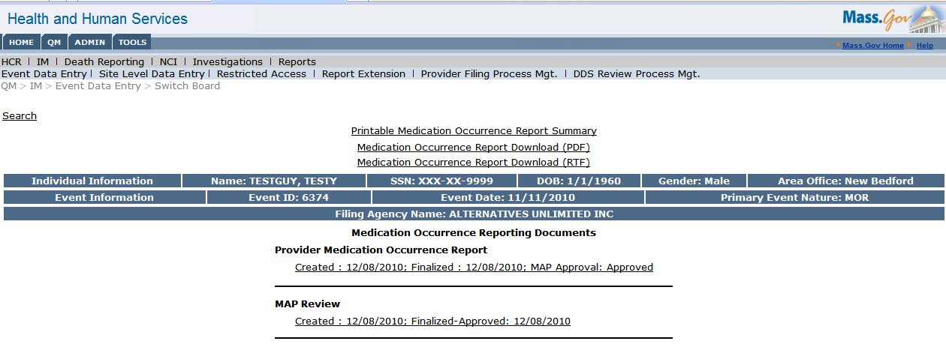

Module Synopsis: Health Care Record

The Health Care Record (HCR) is the document that is updated prior to the annual Individual Service Plan (ISP) meeting. The HCR should be updated by the agency providing residential supports. There are two roles for the HCR: the HCR Data Entry role and the HCR Supervisor role. The user may go into the record to update information using the HCR Data Entry role. Following an update of the HCR, the user may finalize the HCR for the individual, using the HCR Supervisor role. This role can also update the HCR.

The Health Care Record Module does not have a Switchboard screen like the other modules discussed in this document. However, after searching for an individual in the Search screen, the user can view a list of Health Care Records that have been finalized as well as the current Open HCR (if it exists).

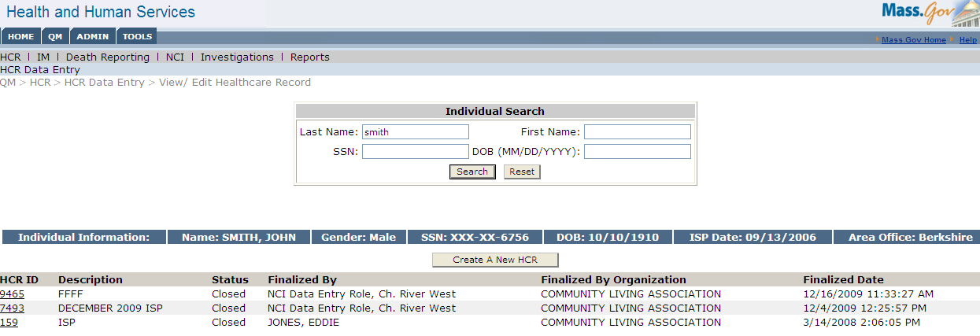

Module Synopsis: ISP Assessments

The Individual Support Plan (ISP) Assessments module standardizes and streamlines the capture, submission and review of the required ISP Assessment documents. The required ISP Assessments documents include the individual’s Vision Statement, Goals, Assessments, and Objectives and Supports Agreements, which are mapped to the Individual’s Goals. Providers, Provider Supervisors, Service Coordinators and Service Coordinator Supervisors are the main users of the ISP Assessments module in HCSIS. All activities can be accessed from the Individual Dashboard, which provides a comprehensive snapshot (one stop shop) of an individual who is served by DDS. The Dashboard includes basic demographic information (SSN, Eligibility number), an individual’s Region and Area Office, planned meeting date, and ISP meeting deadline. Each of the links on this Dashboard will navigate the user to the corresponding detail level page for ISP Assessments.
The Individual Dashboard can be accessed by searching for an individual. Following is an example of the Individual Dashboard:

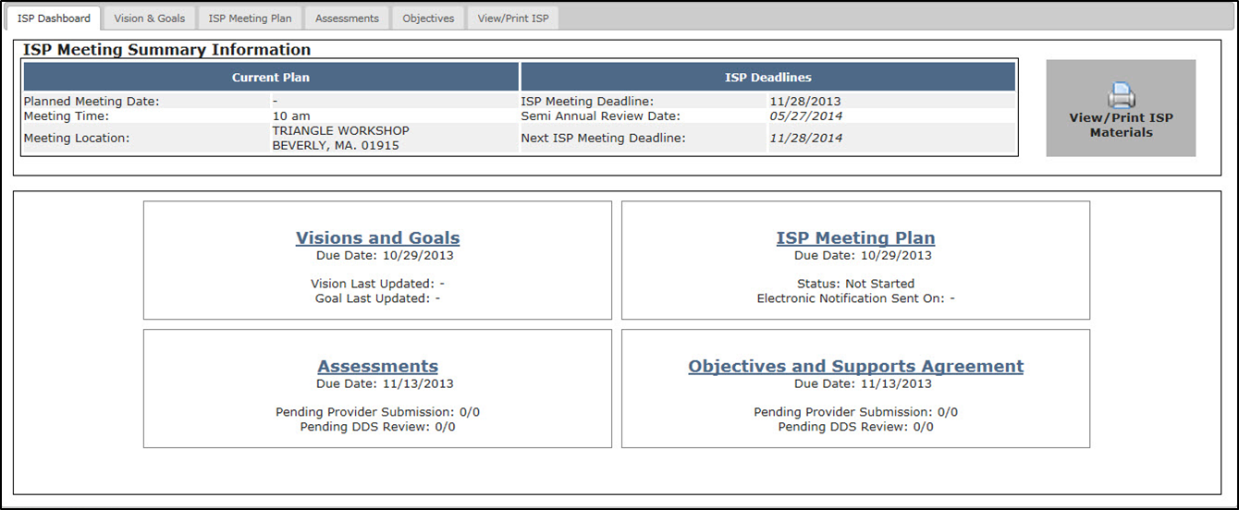

Following are the processes that are performed in the module, and the responsibilities for Service coordinators and Provider agency staff.

Vision and Goals
- Service Coordinator develops the individual’s Vision Statement, identifies preliminary Goals for the ISP team to address, and reviews satisfaction with services with the individual/guardian
- Input from ISP team members may be included in the Vision Statement in some circumstances
- Preliminary Goals may be developed concurrently with the development of the Vision Statement or be recommended by other members of the ISP team
- Electronic notification is sent to providers regarding date, time and location of ISP meeting.

Request and Review Assessments
- The Service Coordinator requests required and optional assessments from providers.
- Providers complete and submit requested assessments to Service Coordinators for review and acceptance
- Assessments that do not meet DDS standard acceptance criteria are returned to Providers with specific comments regarding areas that require additional attention and/or improvement
- Providers must revise and re-submit assessments to Service Coordinators prior to the ISP meeting
- Assessments are tentatively approved by the Service Coordinator prior to the ISP meeting.
- Completed assessments are available to view and print.

Review Objectives and Support Agreements
- Service Providers submit draft Objectives and Support Agreements to the Service Coordinator for review and acceptance
- Objectives and Support Agreements that do not meet DDS standard acceptance criteria are returned to Providers with specific comments regarding areas that require additional attention and/or improvement
- Providers submit revisions prior to the ISP meeting

Post – ISP Meeting
- Changes to the Vision Statement and Goals can be made by the Service Coordinator.
- The Service Coordinator can request updates to Objectives and Support Agreements and Assessments from the provider.
- Providers must submit changes to the Service Coordinator within seven days after the ISP meeting.
- All documents are locked for editing 45 days after the ISP meeting.

Tips to Remember when Using HCSIS
- The user can right click and choose open in new window, from Alerts page or the Switchboard.
- Mandatory Fields are indicated with a red asterisk (*)
- Conditionally mandatory fields - Depending on the information provided, the program determines what other related questions or screens will appear.
- The date format in HCSIS is MM/DD/YYYY. The user must enter the slashes.
- The time format is 00:00 AM. The user must indicate AM or PM and be sure a space is inserted before it.
- Reset button will revert the screen to the last information that was saved.
- The Back button should not be used in HCSIS.

- A “breadcrumb trail” will indicate on the screen the path the user has taken to access the current screen:

QM>IM>Event Data Entry>Search
- QM IM Event Data Entry Search

Additional Information:

The following activities and resources ensure that HCSIS continues to serve the needs of DDS and Provider staff:

On-going Communications

DDS releases HCSIS Alerts to explain upcoming changes and/or helpful hints.

DDS updates training materials on an on-going basis.

DDS meets with provider representatives at HCSIS Standards Committee meetings.

Scheduled Maintenance

On a scheduled basis, maintenance updates are made to HCSIS.

DDS tracks issues raised to DDS Helpdesk and plans fixes and enhancements accordingly.

Enhancements

DDS continues to add new modules to provide functionality for supporting individuals with streamlined electronic processes.

DDS continues to pursue enhancements that are identified after system implementations.

Training
- DDS Training department provides training on IM modules and basic navigation.
- ISP Assessments training materials are available through the DDS website for provider agencies to train their staff.

DDS Help Desk
- Contact the DDS Help Desk for information about HCSIS systems and associated business processes and policies.
DDS Customer Service
Monday through Friday 866-367-8163
7:00 am to 5:00 pm

Virtual Gateway Help Desk
- Contact the Virtual Gateway Help Desk for assistance with your VG login and password.
Virtual Gateway Customer Service
Monday through Friday 800-421-0938 (Voice)
8:30 am to 5:00 pm 617-847-6578(TTY for the deaf and hard of hearing)

