Motivational Interviewing
Facilitator Guide

This module has:
- Handouts (1):
  - Practicing OARS Skills
- Videos (3):
- Importance & confidence ruler
- Stages of Change
- Core Skills
- Breakout Activities (2):
- Small Group-Behavior change – list pros/cons
- OARS skills – see Handout

Slide 1 | Slide 1: Title Slide  Introduce Trainer(s)
Slide 2 | Slide 2: Learning Objectives  Explain:  During this module you will:  - Consider why and how people change health behaviors  - Connect what you do in your role to Motivational Interviewing (MI) Techniques  - Understand how MI can be applied to ACCS principles &/or services  - Practice some practical MI skills
Slide 3 | Slide 3: What is Motivational interviewing?  Explain:  - MI is an evidence-based, collaborative, goal-oriented, conversational approach or style for treatment planning.  - MI is a communication style for exploring a person’s thoughts, feelings, goals, and solutions around changing behaviors.  - MI is an effective tool for everyone working with persons served when they are ambivalent about changing behaviors.  - Core MI goals: express empathy, elicit persons’ served reasons for, and commitment to, changing substance use and other unhealthy behaviors or other goals (e.g., housing, employment, etc.  Reference:  ª Note: most of content in this section is reviewed in Substance Abuse and Mental Health Services Administration. (2021). Using Motivational Interviewing in Substance Use Disorder Treatment. Advisory. Retrieved from https://store.samhsa.gov/product/advisory-using-motivational-interviewing-substance-use-disorder-treatment/pep20-02-02-014
Slide 4 | Slide 4: Activity:  Ask:  Have you had any training in MI?  Facilitator Note:  Explain that this module provides a basic overview of the principles of Motivational Interviewing, along with a few practical skills that can be used by anyone on the ITT. Individuals who already have completed a full training in Motivational Interviewing will see this as a review.
Slide 5 | Slide 5: Areas of Application for Motivational Interviewing  Explain:  Motivational interviewing has been used in multiple different contexts  Facilitator Note:  Read through the examples on the slide. Elaborate to indicate why MI is relevant.
Slide 6  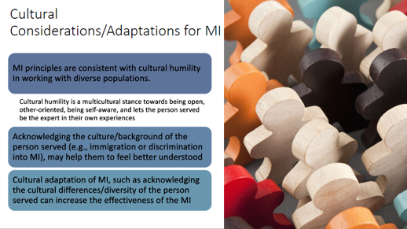 | Slide 6: Cultural Considerations/Adaptations for MI  Explain:  Cultural considerations always play a role in tailoring your MI.  Read through the slide and elaborate:  - MI carries several cultural assumptions, particularly around individual freedom and autonomy, which may not resonate in some cultural settings where the family or the community’s role in health decision-making is highly valued  - Acknowledge and integrate cultural differences where possible when planning care or conducting an intervention such as MI  - Research has shown that providers who are trained in MI and/or speak the same language as the person served and/or are trained in the cultural norms and traditions, improved the delivery and acceptability of MI  - Research also indicated that matching the service provider to the individuals’ ethnicity seemed to help the person talk about their issues without feeling judged
Slide 7 | Slide 7: Activity  Ask:  - Why do people change their health behaviors?  - Think about someone you know who has made a big health behavior change.  - Why did they do it?  Facilitator Notes:  - Ask participants to write down their responses in the chat or to verbally provide some examples.  - End the discussion by saying behavior change is difficult when people are ambivalent. For example, many smokers want to quit smoking but continue to smoke because it makes them feel good.
Slide 8 | Slide 8: Ambivalence  Explain:  - Difficult changes are hard and it’s often not a lack of information, or laziness or denial that makes it hard. Many changes are hard because of ambivalence.  - Ambivalence is a normal state for people considering behavior change, but who are unsure about making the change.  - People can stay in this state of ambivalence for a long time.  - MI is about eliciting and exploring the person’s own reasons for change.  - MI asks the professional to help explore this ambivalence as they work toward making behavior change.  - Do not assume knowledge (e.g., awareness of health consequences) will be enough to motivate change.  - Explore the positive aspects of the status quo.  Example of how to start this conversation – Confidence and Importance Rulers:  - FACILITATOR: “On a scale from 1 to 10 with 1 being unbearably anxious worst you’ve ever felt and 10 being no anxiety at all, what would you pick for how you are feeling today?” When the individual picks a number you always want to ask “why not ___” (a number higher than what they said). So if they said it is at a 6, asking why not a 8? This forces the individual to talk about things that have been going well or that they have found useful. From there, staff and person served can focus on those positive things the person served identified. Explore what it would take for the person to go from a 6 to an 8.
Slide 9 | Slide 9: Video  2 minute video  Show Video example of using an importance & confidence ruler: https://www.youtube.com/watch?v=uWwcUaXH9Pc
Slide 10 | Slide 10: Breakout Activity: Small Group  (7 minute breakout + discussion)  Facilitator Instructions:  - Ask participants to think about what are some of the behavior changes they think persons served may have ambivalence about?  - Separate into groups of 3 to 5 and ask each group to pick a recorder & reporter for the later discussion.  - Instruct groups to:  - Pick one behavior they will discuss. It can be quitting smoking, taking medication, or something else anyone worked with an individual to change.  - As a group, they should discuss and list the potential pros and cons to making that change for the person served.  - Breakout for approximately 7 minutes  - Bring the groups back together for discussion and review. Ask a couple groups to state what behavior they picked and the pros/cons on their list.
Slide 11 | Slide 11: Key Themes  Read through slide:  - Persons served motivation is essential to promoting change in substance use behavior  - Motivational approaches are based on the principals of person-centered counseling  - Effective motivational counseling approaches can be brief  - MI focuses on enhancing intrinsic motivation  - Reflecting persons’ served hopes and values in contrast to the negative effects of their substance use behaviors is essential for promoting awareness and internal motivation to change  - The current practice of MI is based on the primary principles of eliciting change talk and strengthening the person’s served commitment to change
Slide 12  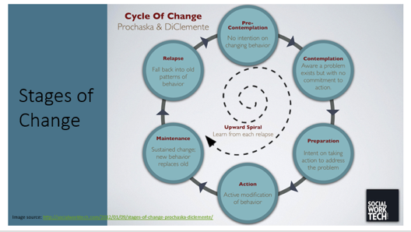 | Slide 12: Stages of Change  Explain:  MI is rooted in the Stages of Change:  - Precontemplation – a person may have made prior attempts to change and gave up  - Contemplation – a person can stay in this stage for a while but is experiencing ambivalence  - Preparation – getting ready to make the change  - Action - making the change  - Maintenance – person has made the change and is taking steps to maintain the change  - Relapse - a person has returned to use. Relapse is seen as a normal part of the recovery process and relapses are a common occurrence.
Slide 13 | Slide 13: Activity- Video/Discussion:  2 ½ minute video  Show the video on Overview of Stages of Change: https://youtu.be/ayjXMix-nMw  Ask for reactions
Slide 14 | Slide 14: MI focuses on enhancing intrinsic motivation – helping persons served see “where they are” vs. “where they want to be”.  Explain:  - This is the Spirit of MI.  - MI requires a partnership between the providers and the persons served that fosters a collaborative approach to change.
Slide 15 | Slide 15: Guiding Principles of MI  Explain: Resist the righting reflex  Read through slide:  - Find out what the person served knows first  - Tolerate incorrect information  - Avoid telling someone “they should…”, “you have to…”, “you will feel better if…”  - Avoid the urge to “fix it” or offer advice when someone presents you with a problem which requires making a change  - Ask for permission before informing or educating  - Being empathic is the #1 predictor for behavior change
Slide 16  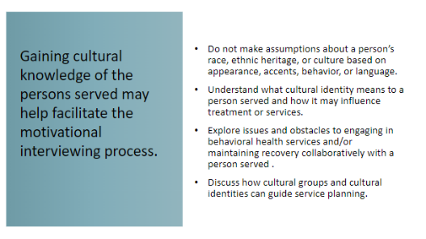 | Slide 16: Gaining Cultural Knowledge of Person Served  Facilitator Note:  Explain that knowing the culture of the individual will help facilitate the MI process.  Read through some of the tips on the slide.
Slide 17 | Slide 17: How to do MI: Using OARS skills  Explain OARS acronym:  - Asking Open questions  - Affirmations,  - Reflective listening,  - Summarization  Facilitator Notes:  Distinguish between change talk and sustain talk.  - Change talk represents movement towards change  “I want to quit ______________”  “I guess I can try that”  “I don’t want to keep feeling this way”  - Sustain talk – person served argues for the status quo
Slide 18 | Slide 18: Open Questions  Explain:  - Open questions are questions that call for more than a yes/no answer.  - Open questions open up a dialogue.  - The question “Are you in pain?” is a closed question. A more open question would be “How are you feeling?”  - “How much alcohol do you drink in a day?” is a closed question and could be changed to “What role does alcohol play in your life?”  - “Don’t you want to move to a safer place?” is a closed question but “What are the advantages of moving?” is open and would be more likely to elicit a discussion.  - In MI you try to ask more open than closed questions to encourage the person to share what is on their mind rather than what is on the professional’s mind or checklist.  - Benefits of open-ended questions include creating extended conversations, building rapport  - Be unbiased, cast a broad net, use a person’s own words  - Ask one question at a time
Slide 19 | Slide 19: Affirming Statements  Explain:  - Affirming statements are statements about anything positive that the professional notices about the individual - previous attempts, accomplishments, or anything positive that you can point out to the individual.  - Use affirming statements to help build a sense of self confidence or self- efficacy that the person can make this change.
Slide 20 | Slide 20: Reflecting Statements  Explain:  - Making reflecting statements is a very important skill for MI.  - Reflections are your statements that describe your understanding of what the person is thinking and feeling.  - Reflections require listening to what the person is saying and then reflecting it back to the person.  - Reflections are used to convey empathy and help the professional to begin to see the world through the other person’s eyes.  - Allow the person served to guide the conversation  - Let the person know that you are listening and trying to understand
Slide 21 | Slide 21: Summarizing Statements  Explain:  - Summarizing pulls together the key points from the conversation with a person served, highlighting important areas.  - It helps the person served to listen to their own thoughts when they are repeated back to them.  - Demonstrates the person doing the MI has heard what the person served has said.  - Usually begins with a question.  Examples of summarizing statements:  - “Let me see if I understand, I am hearing you say ….”  - “This is what I heard…tell me if I missed anything.”
Slide 22 | Slide 22: Activity – Video  2 minute video  Show video of Core Skills:  https://www.youtube.com/watch?v=Fm-T1SDw8to
Slide 23 | Slide 23: Breakout Activity: Practicing OARS Skills  (10 minute breakout + 5 minute discussion)  Refer to Handout:  - Practicing OARS Skills  Facilitator Instructions:  - Explain: You will be breaking participants into small groups of 3 so each participant has the chance to practice OARS skills.  - Instruct participants to read the scenario about Jerry.  The behavior he is contemplating is drinking alcohol.  Note: Leave slide up during breakout.  - Ask each participant to come up with at least one affirming statement and one reflective statement that they could say to Jerry. Give them a few minutes to do this without sharing anything with the large group.  - Separate into groups of 3 people and ask each group to pick a recorder & reporter for the discussion later. They should also pick:  - One to play the team member,  - One to be Jerry, and  - One to be the observer.  - Instruct groups to:  - Start by saying their statements to Jerry.  - Participants playing the role of Jerry and the observer will give the ‘provider’ feedback using the following questions:  - Did the statements acknowledge the reasons for and against the change?  - Was the statement judgmental?  - Was the tone kind and empathetic?  - Switch roles and repeat so that each participant has the opportunity to play the provider if possible.  - Breakout for approximately 10 minutes to discuss these questions.  - Bring the group back together for discussion and review.
Slide 24 | Slide 24:  MI requires practice, coaching and feedback in addition to the providers’ focus on integrating the MI spirit, strategies, and skills.
Slide 25 | Slide 25: Closing Activity  Ask:  What is one MI technique that you will use right away?

