
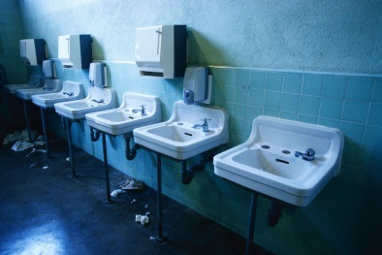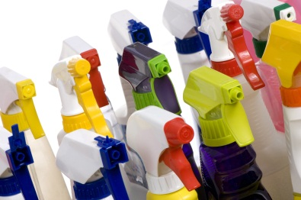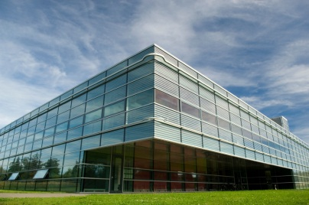

Guidance for Cleaning Bathrooms in Public Facilities
The Commonwealth of Massachusetts maintains many beaches, parks, historic sites, and public facilities. High traffic during events, summer, and vacation periods poses challenges for staff responsible for maintaining and cleaning these facilities. This factsheet provides guidance for cleaning public bathrooms to reduce the risk of disease, minimize exposure to hazardous cleaning products, and eliminate odors.

Cleaning
Removing dirt with detergent and water is the most effective and safest way to remove soil and germs. Sanitizer and disinfectant chemicals are pesticides regulated by the EPA Federal Insecticide, Fungicide, and Rodenticide Act and should only be used in specific situations where chemical control of microorganisms is needed. These products may cause health effects such as coughing, wheezing, asthma, and eye, nose, throat, or skin irritation. Select safer cleaning products and limit the use of disinfectants which will protect both state employees and the public using the facilities.

How Disease Spreads
A limited number of germs can cause disease through contact with feces or vomit in a public bathroom — including for example noroviruses, Hepatitis A, and Shigella (dysentery). They have caused illness from contact with feces or vomit from those who are ill, in childcare centers and in publicly used restrooms. The most important ways to prevent disease transmission are:
- Frequent hand washing, especially after using the bathroom
- Avoiding touching your face, mouth, nose, and eyes with unwashed hands

Sanitizing and Disinfecting
Sanitizing reduces bacteria to safe levels, typically about 99.9 percent, but is not intended to kill other types of microorganisms such as viruses, fungi, or protozoa. Disinfecting, on the other hand, kills a broader range of microorganisms, including bacteria, viruses, fungi, and protozoa. However, both sanitizing and disinfecting are only effective when performed after proper cleaning.
Sanitizers and disinfectants should be used only after cleaning - and only when necessary, such as on toilet seats and handles, diaper changing surfaces, or cleaned areas that were visibly contaminated with feces, vomit, or blood.

To be effective, the treated surface must remain visibly wet for the full amount of time specified on the product label, known as the contact time. It is a violation of EPA FIFRA regulations to use a registered sanitizer or disinfectant in a manner inconsistent with its labeling claims and directions. This includes using it as a cleaner, failing to follow label directions, applying it to control organisms not listed on the label, or not maintaining the required recommended contact time.
State agencies should not use disinfectants as general cleaners. Products marketed as “2 in 1” disinfectant cleaners, cleaner sanitizers, or one step cleaner disinfectants should be used with caution, as they may contribute to unnecessary use and confusion regarding proper cleaning practices and required contact time. Agencies should use only the disinfectants included on Massachusetts Statewide Contract FAC118: Environmentally Preferable Cleaning Products, Programs, Equipment and Supplies that are designated as effective for the target germs.
Massachusetts joined neighboring New England states in issuing this contract to promote the health of the public, cleaning workers, and the environment. The contract requires that all cleaning chemicals be third-party certified by either Green Seal, UL ECOLOGO or US EPA Safer Choice, all of which evaluate products for cleaning effectiveness and for avoiding ingredients harmful to people and the environment. Steam cleaning and no-hands wet/dry vacuum systems are also available as environmentally preferable options. The contract also requires all sanitizers and disinfectants to have “approved active ingredients” and be free of “prohibited active ingredients”. For a list of the approved and prohibited active ingredients see the FAC118 Mandatory Specifications and Desirable Criteria document located under “agency attachments” in the FAC118 Master Contract Record in COMMBUYS.

Safer Sanitizers and Disinfectants
Sanitizers and disinfectants are pesticides and should be used with caution. They are regulated by the EPA and cannot be labeled “green.” However, the EPA identifies safer antimicrobial products through the Design for the Environment (DfE) label under the Safer Choice program.
Use them only where required by regulation or deemed essential — for example, on surfaces contaminated with feces, vomit, or blood. (Blood-borne pathogens include Hepatitis B, Hepatitis C, and HIV.)
Staff using disinfectants should be trained on proper use, including surface selection, dilution, and safe work practices, and should be provided with appropriate personal protective equipment (PPE) and trained in their use.
Many sanitizers and disinfectants contain quaternary ammonium compounds (QACs), which are associated with asthma and skin and respiratory irritation, as well as environmental contamination. QACs can persist, attach to indoor dust, and leave residues that increase exposure. Emerging concerns include reproductive and other human health effects, and along with antimicrobial tolerance may reduce their long-term effectiveness. QACs may also contribute to antimicrobial tolerance to the active ingredient and antibiotic resistance. QACs are used in cleaners both as a surfactant and as a preservative – aiding in cleaning action and product lifespan - even when not listed as an active ingredient for sanitizing and disinfecting applications.
Choose products with safer sanitizing and disinfecting active ingredients (as found in FAC118), steam and dry steam cleaning (a much lower water content, ~5–10%), or no hands wet dry vacuum systems which are available as environmentally preferable options. These products may be found in the FAC118 Approved Product List, also located under “agency attachments” in the FAC118 Master Contract Record in COMMBUYS. This spreadsheet provides all products allowable on FAC118, and includes filters to search for and compare products, vendors, pricing and more.

Best Management Practices:
- Ensure supplies are available: Provide reliable toilet facilities with running water (preferably warm) and adequate supplies — toilet paper, liquid soap, paper towels or hand dryers, and a closed container for waste and disposable diapers to maintain cleanliness and reduce the chance of spreading germs.
- Provide soap without antimicrobial ingredients: Soap and water effectively remove germs. Antimicrobial additives are no more effective and contribute to antibiotic resistance in waterways.
- Do not use air fresheners: They mask odors with chemical scents that may pose health hazards. Address the source of the odor instead.
- Inspect, clean, and replenish supplies as often as needed: Potentially multiple times per day during busy periods, and daily to weekly during minimal use and off-season.
- Use only Green Seal, UL ECOLOGO or US EPA Safer Choice certified cleaning products: All-purpose cleaners should be used on hard surfaces (sinks, doorknobs, faucets, floors). Approved glass cleaners should be used on windows and mirrors. The FAC118 statewide contract offers many high-performing, cost-effective options.
- Use only the directed amount of product: Using more concentrate does not improve cleaning results and may increase cleaning costs.
- Use microfiber cloths and mops: Microfiber improves removal of soil and germs and reduces the total amount of cleaning product needed.
- Avoid aerosols: Aerosolized chemicals are more easily inhaled and absorbed through the skin. Apply product to microfiber cloth rather than spraying them directly onto surfaces.
- Never mix cleaning chemicals: Mixing cleaning chemicals can create hazardous reactions, including the release of toxic gases, and should never be done. Only use as directed.
- Involve staff in product selection and provide training: Managers and staff should work together to select products that meet facility needs.
- Consider automated dispensing systems: These systems dispense products at set dilution rates, preventing overuse or underuse.
- Use sanitizers and disinfectants only where needed: Keep two types of disinfecting products on hand: one registered by the EPA for blood spills (some facilities maintain a dedicated spill kit), and a separate product for toileting areas and surfaces contaminated with feces or vomit.
- Provide appropriate PPE: Make available appropriate PPE for the tasks assigned. This may include gloves, safety glasses or face shields, and aprons — particularly when diluting large quantities of chemicals.
- Address persistent odor problems: Odors are often caused by urine residue left after cleaning. Better cleaning practices are usually the solution, though a special remediation effort may be needed for odors deeply embedded in flooring. Enzymatic products available on the FAC188 statewide contract may be effective in these areas. NOTE: Clean does not have a smell!
- Maintain Safety Data Sheets on-site: Copies must be available for all products and reviewed during required Right-to-Know training. SDS’s detail product hazards, precautions, PPE requirements, and emergency measures.

Resources
- Commonwealth of Massachusetts Environmentally Preferable Products Procurement (EPP) Program and specific information on Green Cleaning Products, Programs, Equipment and Supplies
- Protect Yourself: Cleaning Chemicals and Your Health poster, OSHA Publication 3569 (2021)
- OSHA/NIOSH INFOSHEET OSHA/NIOSH (Publication 3512) (also available in Spanish, Chinese and Tagalog)
- Guidance for Cleaning and Disinfecting: Public Spaces, Workplaces, Businesses, Schools, and Homes, US EPA, April 2020
- Massachusetts Department of Public Health Guide to Surveillance, Reporting and Control
- Third Party Certifiers for Green Cleaning Products: Green Seal, US EPA Safer Choice, UL ECOLOGO

