September 5, 2023

Via Email

Stephen Davis, Division Director
Division of Health Care Facility Licensure and Certification
Massachusetts Department of Public Health
67 Forest Street
Marlborough, MA 01752

Re: Baystate Wing Hospital Essential Services Finding

Dear Mr. Davis:

We write on behalf of Baystate Wing Hospital, a (the “Hospital”) in response to the Department of Public Health’s (the “Department”) Essential Service Finding letter, dated August 18, 2023, concerning the closure of the Hospital’s inpatient psychiatric adult and geriatric services (the “Service”) located at 40 Wright Street, Palmer, MA 01069. In compliance with the regulatory requirements at 105 CMR 130.122, the Hospital offers the following plan to maintain access to psychiatric services and provide the additional information requested in the Department’s letter.

- Information on utilization of the services prior to proposed closure.

The following table details the Hospital’s historical utilization based on discharges for inpatient psychiatric services from Fiscal Year (“FY”) 2021 through FY23 through July 2023.

Unit | FY21 | FY22 | FY23 (Oct-July)
BWH Geriatric Psychiatric Beds | 198 | 155 | 118
BWH Adult Psychiatric Beds | 321

- Information on the location and service capacity of alternative delivery sites. Include an explanation of the basis for the Hospital’s determination that the alternative delivery sites do or do not have the capacity (necessary space, resources, etc.) to handle the increased patient volume at the identified sites. To support that assertion, please provide the following specific details:

- Current utilization at these alternative sites;

The following table lists the top-10 alternative sites for Behavioral Health Services based on publicly available discharge data from the surrounding 5-county area. The annual discharges for Baystate Wing Hospital are also provided for comparison.

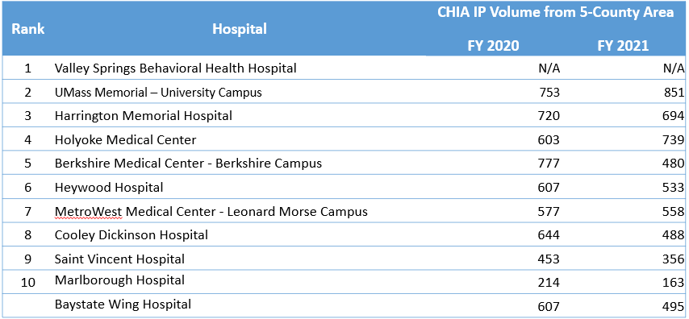

- Type of services available at the alternative sites;

Each of the alternative provide inpatient psychiatric services for adult and geriatric patients. It is important to recognize that Baystate Health in partnership with LifePoint Behavioral Health recently opened Valley Springs Behavioral Health Hospital (“Valley Springs”), a new inpatient psychiatric hospital in Holyoke that will have 150 total beds, with 72 beds serving adults and 24 beds serving geriatric patients. The new hospital was established to consolidate and expand inpatient psychiatric bed capacity in Western Massachusetts. Compared to available capacity today, Valley Springs will add 28 adult beds and 12 geriatric beds to the region. The beds at Valley Springs serve as a replacement for and expansion of the beds that will close at Baystate Wing Hospital.

- Type of medical diagnoses accepted; and

Valley Springs and the other alternative site hospitals identified provide inpatient services that include evaluations and treatment of the following acute mental health diagnoses: anxiety disorders, including phobias and panic disorders, mood disorders, including bipolar disorder, neurobehavioral disorders, personality disorders, schizophrenia, and women’s mental health disorders.

- Adequacy of space and resources at the alternative sites.

As discussed in response to question 2(b), Valley Springs will serve as a replacement for the beds to be closed at the Hospital. Valley Springs is a state-of-the-art behavioral health hospital that will consolidate and expand behavioral health services across the Hospital’s service area and increase patient access throughout Western Massachusetts. Valley Springs will increase capacity for behavioral health patients by great than 50% with approximately 120 beds for inpatient behavioral healthcare for adults and children/adolescents.

- Travel times to alternative service delivery sites, for both peak and non-peak travel times, and an explanation as to the source for this information or what these estimates are based on.

As discussed above, the establishment of Valley Springs will serve as the primary alternative site when the Hospital’s beds close. Valley Springs has the shortest travel time of the alternative sites identified, improving access for patients across the region allowing care to remain close to home.

Driving Time to Alternative Sites Peak Times

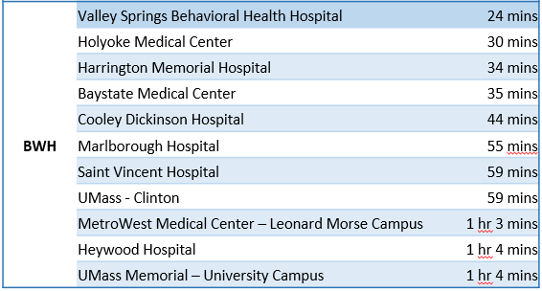

Driving Time to Alternative Sites Non-Peak Times

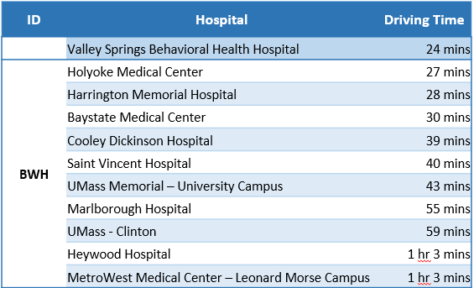

- An assessment of transportation needs post discontinuance and a plan for meeting those needs.

Patients requiring acute mental health treatment typically arrive at the emergency department or seek services at community crisis clinics operated by local Executive Office of Health and Human Services (“EOHHS”) contracted community mental health agencies. For patients presenting to the ED, a hospital crisis clinician assesses and makes referrals for inpatient care based on location, appropriateness of unit, patient preference, and bed availability. Patients requiring transfer to another hospital from Wing are transported by ambulance. At community crisis clinics, the EOHHS agencies coordinate referral and transportation to inpatient treatment facilities for any patient requiring acute mental health care.

With the closure of the Hospital’s beds, patients arriving at the Hospital’s ED in need of inpatient services will be transported by ambulance to Valley Springs or another available psychiatric hospital based on capacity and patient choice.

- A protocol that details mechanisms to maintain continuity of care for current patients of the discontinued service.

The Hospital will coordinate the closure of beds to coincide with the opening of adequate beds at Valley Springs in order to ensure continued capacity in the region. To minimize any disruption for existing patients, the Hospital plans to suspend admissions to the inpatient psychiatric unit approximately two weeks before the planned closure. The typical length of stay for the average patient is approximately 8 days. By stopping new admissions two weeks prior to the closure, the Hospital will complete the inpatient episodes of care for all or most of the patients on the unit prior to closure. Any patients remaining on the unit by the date of closure, the Hospital will coordinate transfers to Valley Springs or other suitable alternative sites in the community.

- A protocol that describes how patients in the Hospital’s service area will access the services at alternative delivery sites. The protocol should specifically address the following:

- The process that will be employed to effectively refer patients to other facilities or providers;

Patients arriving to the Hospital for inpatient psychiatric services typically are admitted directly from the Hospital’s ED or are referred to the Hospital by community behavioral health centers (“CBHC”) or as a transfer from another hospital. Following the closure, the Hospital will facilitate the transfer of patients who present to the Hospital’s ED and require admission for inpatient psychiatric services. The Hospital’s crisis clinicians will make referrals for inpatient care based on location, appropriateness of unit, patient preference, and bed availability. Once an accepting facility is identified, Hospital staff will coordinate transport by ambulance for the patient and ensure that the patient’s medical record is transferred to facilitate continuity of care. CBHC’s will refer patients to Valley Springs or another inpatient psychiatric facility with capacity. Similarly, other hospitals will work with an appropriate facility to accept transfers of patients in need of inpatient psychiatric services.

- The impact that this may have on the current occupancy rates at alternative delivery sites;

The significant increase in regional inpatient bed capacity provided by Valley Springs will improve access for patients allowing care to remain local without the need to refer patients to the other alternative delivery sites unless requested by the patient. In addition, the increased capacity will facilitate the reduction in rates of psychiatric patients boarding in local emergency rooms. The other alternative delivery sites are not likely to experience any increase in referrals due to the closure of the Hospital’s beds. As such, the closure will have no to minimal impact on occupancy rates at the alternative delivery sites aside from Valley Springs.

- The ability of the alternative delivery sites to meet the needs of these patients; and

As discussed above in response to Question 6(b), the opening of Valley Springs will provide continued access to care through expanded capacity in the region. As a result, the impact of the closure to the ability of alternative delivery sites to meet the needs of patients who would have historically been admitted to the Hospital will be insignificant.

- Other alternatives if medical needs cannot be accommodated at the proposed alternative sites.

Patients with co-occurring medical needs, will be referred to inpatient psychiatric units within general hospitals including Baystate Medical Center, Baystate Franklin Medical Center, Holyoke Hospital, and Cooley Dickinson Hospital.

- Medically Complex Inpatients: In the Hospital’s 90 Day Notice of Closure of Certain Services, the Hospital stated that, “Medically complex behavioral health patients will continue to be served at the main campus of Baystate Medical Center, Baystate Health’s tertiary care academic medical center.” The plan which you are required to submit must include information on how the Hospital will manage medically complex inpatients at the time of transition.

As discussed in the response to Question 6(d), the Hospital will refer patients requiring medically complex or intensive behavioral health treatment to other an acute care hospital with inpatient psychiatric services Patients with this level of need who remain on the Hospital unit at the time of closure, will be assessed by their attending physician to determine the appropriate setting for continued care. If a patient requires continued services in an acute care hospital setting, the Hospital will coordinate the transfer of the patient with the receiving facility.

We thank you for your attention to this matter. Please do not hesitate to contact Dominic Castillo, Esq., or me, if you have any questions or comments.

We thank you for your attention to this matter. Please do not hesitate to contact Dominic Castillo, Esq., or me, if you have any questions or comments.

Sincerely,

Crystal Bloom

cc: E. Kelley, DPH
J. Bernice, DPH
R. Kaye, Esq., DPH
A. Mehlman, DPH
J. Boeh-Ocansey, DPH
M. Callahan, DPH
V. Smith, Esq., Baystate Health
W. Kern, Baystate Health
J. Ward, Baystate Health
C. Ryan, Esq., Baystate Health
R. Rodman, Esq.
A. Levine, Esq.

Source: Google Maps, Estimated Drive Time from 8:00AM.
Source: Google Maps, Estimated Drive Time from 10:00PM.

