INDOOR AIR QUALITY ASSESSMENT

B.B. Russell Alternative School
45 Oakdale Street
Brockton, Massachusetts 02301

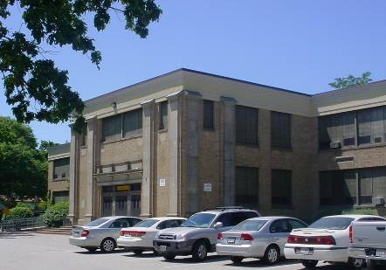

Prepared by:
Massachusetts Department of Public Health
Bureau of Environmental Health
Indoor Air Quality Program
August 2008

Background/Introduction
At the request of Dara Lanoff, South Coastal Legal Services and John Eastman, Self Help Inc. Brockton, the Massachusetts Department of Public Health (MDPH), Bureau of Environmental Health (BEH) provided assistance and consultation regarding indoor air quality concerns at the B.B. Russell Alternative School (RAS), 45 Oakdale Street, Brockton, Massachusetts. The assessment was prompted by occupant reports of headaches, poor temperature control and possible mold growth. The assessment was jointly coordinated through the Brockton Health Department (BHD) and the Brockton Public Schools (BPS) Maintenance Department.
On June 13, 2008, Cory Holmes an Indoor Air Quality (IAQ) Inspector in BEH’s IAQ Program conducted an indoor air quality assessment of the RAS. Mr. Holmes was accompanied by Doreen Quaglia, Sanitary Inspector, BHD and Rick Odem, Head Custodian, RAS; and, for portions of the assessment, Principal Mark St. Louis, Ms. Lanoff and Mr. Eastman.
The RAS is a two-story, brick building built in 1924. The school contains general classrooms, computer lab, art room, gymnasium, kitchen/cafeteria, office space and a newly renovated exercise room. The building has undergone renovations over the years most recently in 1998-1999. Windows are openable throughout the building.

Methods
Air tests for carbon monoxide, carbon dioxide, temperature and relative humidity were conducted with the TSI, Q-Trak, IAQ Monitor, Model 8551. Air tests for airborne particle matter with a diameter less than 2.5 micrometers were taken with the TSI, DUSTTRAK™ Aerosol Monitor Model 8520. BEH staff also performed visual inspection of building materials for water damage and/or microbial growth.

Results
The school houses approximately 110 students in grades 6 to 12 with approximately 25 staff members. Tests were taken during normal operations at the school and results appear in Table 1.

Discussion
Ventilation
It can be seen from Table 1 that carbon dioxide levels were above 800 parts per million (ppm) in 1 of 22 areas at the time of the assessment, indicating adequate air exchange in all but one area surveyed. It is important to note that although air exchange appeared adequate, mechanical ventilation equipment was found deactivated or non-functional in a number of areas throughout the school. It is also important to note that several classrooms had open windows and/or were empty/sparsely populated, which can greatly reduce carbon dioxide levels, which typically can greatly reduce carbon dioxide levels. Carbon dioxide levels would be expected to increase with higher occupancy and windows closed.
Fresh air is supplied to classrooms by unit ventilator (univent) systems (Figure 1). A univent draws air from the outdoors through a fresh air intake located on the exterior wall of the building (Picture 1) and returns air through an air intake located at the base of the unit. Fresh and return air are mixed, filtered, heated and provided to classrooms through an air diffuser located in the top of the unit. A number of univents were deactivated or inoperable at the time of the assessment, some reportedly due to vandalism. Several of the univents had damaged diffusers and classroom items (e.g., pencils, papers) had been inserted into the units, which can damage machinery and prevents operation (Picture 2). In order for univents to provide fresh air as designed, they must remain “on” and be allowed to operate while rooms are occupied.
Exhaust ventilation in classrooms is provided by wall or ceiling-mounted vents ducted to rooftop motors (Pictures 3 and 4). Many exhaust vents were not drawing air at the time of the assessment. BEH staff found exhaust motors that were not operating at the time of the assessment. This was reported to the BPS central maintenance department during the assessment, who sent a representative on site to evaluate. As with univents, in order to function properly, exhaust vents must be activated and allowed to operate while rooms are occupied. Without adequate supply and exhaust ventilation, excess heat and environmental pollutants can build up and lead to indoor air/comfort complaints.
Mechanical ventilation in interior rooms and common areas (e.g., gym, cafeteria) is provided by rooftop or ceiling-mounted air-handling units (AHUs). Fresh air is distributed via ceiling-mounted air diffusers and ducted back to AHUs via ceiling or wall-mounted return vents.
To maximize air exchange, the MDPH recommends that both supply and exhaust ventilation operate continuously during periods of school occupancy. In order to have proper ventilation with a mechanical supply and exhaust system, the systems must be balanced to provide an adequate amount of fresh air to the interior of a room while removing stale air from the room. It is recommended that HVAC systems be re-balanced every five years to ensure adequate air systems function (SMACNA, 1994). The date of the last balancing of the systems at the RAS was not available at the time of the assessment.
The Massachusetts Building Code requires a minimum ventilation rate of 15 cubic feet per minute (cfm) per occupant of fresh outside air or have openable windows in each room (SBBRS, 1997; BOCA, 1993). The ventilation must be on at all times that the room is occupied. Providing adequate fresh air ventilation with open windows and maintaining the temperature in the comfort range during the cold weather season is impractical. Mechanical ventilation is usually required to provide adequate fresh air ventilation.
Carbon dioxide is not a problem in and of itself. It is used as an indicator of the adequacy of the fresh air ventilation. As carbon dioxide levels rise, it indicates that the ventilating system is malfunctioning or the design occupancy of the room is being exceeded. When this happens, a buildup of common indoor air pollutants can occur, leading to discomfort or health complaints. The Occupational Safety and Health Administration (OSHA) standard for carbon dioxide is 5,000 parts per million parts of air (ppm). Workers may be exposed to this level for 40 hours/week, based on a time-weighted average (OSHA, 1997).
The MDPH uses a guideline of 800 ppm for publicly occupied buildings. A guideline of 600 ppm or less is preferred in schools due to the fact that the majority of occupants are young and considered to be a more sensitive population in the evaluation of environmental health status. Inadequate ventilation and/or elevated temperatures are major causes of complaints such as respiratory, eye, nose and throat irritation, lethargy and headaches. For more information concerning carbon dioxide, consult Appendix A.
Temperature measurements in the school ranged from 71° F to 81° F, which were within or close to the upper level of the MDPH recommended range in the majority of areas surveyed (Table 1). The MDPH recommends that indoor air temperatures be maintained in a range of 70º F to 78º F in order to provide for the comfort of building occupants. In many cases concerning indoor air quality, fluctuations of temperature in occupied spaces are typically experienced, even in a building with an adequate fresh air supply. In addition, it is difficult to control temperature and maintain comfort without operating the ventilation equipment as designed (e.g., univents/exhaust vents deactivated/inoperable/damaged). Missing/damaged insulation on pipes supplying heated water to univents was observed in several classrooms, also reportedly due to vandalism (Picture 5). Missing/damaged insulation can create uneven heating as well as a safety hazard due to extreme temperature of hot water pipes.
The relative humidity measured in the building ranged from 25 to 38 percent at the time of the assessment, which was below or close to the lower end of the MDPH recommended comfort range (Table 1). The MDPH recommends a comfort range of 40 to 60 percent for indoor air relative humidity. Relative humidity levels in the building would be expected to drop during the winter months due to heating. The sensation of dryness and irritation is common in a low relative humidity environment. Low relative humidity is a very common problem during the heating season in the northeast part of the United States.

Microbial/Moisture Concerns
Water damaged wall plaster, peeling paint and efflorescence were observed in a number of classrooms (Pictures 6 and 7). Water damage is most likely the result of historic water penetration through the building envelope. It appears that new flashing and a masonry cap were installed along the roof edge to mitigate leaks (Picture 8). Efflorescence is a characteristic sign of water damage to brick and mortar, but it is not mold growth. As moisture penetrates and works its way through mortar, brick or plaster, water-soluble compounds dissolve, creating a solution. As the solution moves to the surface of the material, the water evaporates, leaving behind white, powdery mineral deposits.
Other potential moisture sources were noted around the exterior of the building, including:
- Clogged drains and pooling water on the roof (Pictures 9 and 10);
- Overhanging branches and plant debris on the roof (Pictures 11 and 12);
- Missing/damaged mortar and exterior brick (Pictures 13 and 14);
- Open utility holes (Pictures 15 and 16); and
- Shrubbery/trees growing in close proximity to the building and univent air intakes (Pictures 17 and 18), which holds moisture against exterior brick and prevents drying.
The aforementioned conditions represent potential moisture penetration sources. Over time, these conditions can undermine the integrity of the building envelope and provide a means of water entry into the building via capillary action through foundation concrete and masonry (Lstiburek & Brennan, 2001). In addition, these breaches may provide a means for pests/rodents into the building. The freezing and thawing of water on the roof during winter months can lead to roof leaks and subsequent water penetration into the interior of the building. Pooling water can also become stagnant, which can lead to mold and bacterial growth, and serve as a breeding ground for mosquitoes.
Several areas had water-damaged ceiling tiles, which can indicate leaks from either the roof or plumbing system (Picture 19/Table 1). Water-damaged ceiling tiles can provide a source of mold and should be replaced after a moisture source or leak is discovered and repaired.
The US Environmental Protection Agency (US EPA) and the American Conference of Governmental Industrial Hygienists (ACGIH) recommend that porous materials be dried with fans and heating within 24 to 48 hours of becoming wet (US EPA, 2001; ACGIH, 1989). If not dried within this time frame, mold growth may occur. Once mold has colonized porous materials, they are difficult to clean and should be removed/discarded.
Window-mounted air conditioners (ACs) were observed in several areas. These units are normally equipped with filters, which should be cleaned or changed as per manufacturer’s instructions to avoid the build-up and re-aerosolization of dirt, dust and particulate matter. Several of the units were missing filters and the cooling fins were occluded with dust and debris, which can provide a mold growth media when moistened (Picture 20).
Dehumidifiers were observed in several areas for moisture removal during periods of increased relative humidity. Occupants and/or maintenance staff should periodically examine, clean and disinfect these units as per the manufacture’s instructions to prevent mold/bacterial growth and associated odors.
Plants were located in a number of classrooms. Plants, soil and drip pans can serve as sources of mold growth and should be properly maintained. Over-watering of plants should be avoided and drip pans should be inspected periodically for mold growth. In addition, flowering plants can be a source of pollen. Therefore, plants should be located away from air stream of ventilation sources (e.g., univents, personal fans) to prevent aerosolization of mold, pollen and particulate matter.

Other IAQ Evaluations
Indoor air quality can be negatively influenced by the presence of respiratory irritants, such as products of combustion. The process of combustion produces a number of pollutants. Common combustion emissions include carbon monoxide, carbon dioxide, water vapor and smoke (fine airborne particle material). Of these materials, exposure to carbon monoxide and particulate matter with a diameter of 2.5 micrometers (μm) or less (PM2.5) can produce immediate, acute health effects upon exposure. To determine whether combustion products were present in the school environment, BEH staff obtained measurements for carbon monoxide and PM2.5.

Carbon Monoxide
Carbon monoxide is a by-product of incomplete combustion of organic matter (e.g., gasoline, wood and tobacco). Exposure to carbon monoxide can produce immediate and acute health affects. Several air quality standards have been established to address carbon monoxide and prevent symptoms from exposure to these substances. The MDPH established a corrective action level concerning carbon monoxide in ice skating rinks that use fossil-fueled ice resurfacing equipment. If an operator of an indoor ice rink measures a carbon monoxide level over 30 ppm, taken 20 minutes after resurfacing within a rink, that operator must take actions to reduce carbon monoxide levels (MDPH, 1997).
The American Society of Heating Refrigeration and Air-Conditioning Engineers (ASHRAE) has adopted the National Ambient Air Quality Standards (NAAQS) as one set of criteria for assessing indoor air quality and monitoring of fresh air introduced by HVAC systems (ASHRAE, 1989). The NAAQS are standards established by the US EPA to protect the public health from six criteria pollutants, including carbon monoxide and particulate matter (US EPA, 2006). As recommended by ASHRAE, pollutant levels of fresh air introduced to a building should not exceed the NAAQS levels (ASHRAE, 1989). The NAAQS were adopted by reference in the Building Officials & Code Administrators (BOCA) National Mechanical Code of 1993 (BOCA, 1993), which is now an HVAC standard included in the Massachusetts State Building Code (SBBRS, 1997). According to the NAAQS, carbon monoxide levels in outdoor air should not exceed 9 ppm in an eight-hour average (US EPA, 2006).
Carbon monoxide should not be present in a typical, indoor environment. If it is present, indoor carbon monoxide levels should be less than or equal to outdoor levels. On the day of assessment, outdoor carbon monoxide concentrations were non-detect (ND) (Table 1). Carbon monoxide levels measured in the school were also ND.

Particulate Matter (PM2.5)
The US EPA has established NAAQS limits for exposure to particulate matter. Particulate matter is airborne solids that can be irritating to the eyes, nose and throat. The NAAQS originally established exposure limits to particulate matter with a diameter of 10 μm or less (PM10). According to the NAAQS, PM10 levels should not exceed 150 microgram per cubic meter (μg/m³) in a 24-hour average (US EPA, 2006). These standards were adopted by both ASHRAE and BOCA. Since the issuance of the ASHRAE standard and BOCA Code, US EPA established a more protective standard for fine airborne particles. This more stringent PM2.5 standard requires outdoor air particle levels be maintained below 35 μg/m³ over a 24-hour average (US EPA, 2006). Although both the ASHRAE standard and BOCA Code adopted the PM10 standard for evaluating air quality, MDPH uses the more protective PM2.5 standard for evaluating airborne particulate matter concentrations in the indoor environment.
Outdoor PM2.5 concentrations the day of the assessment were measured at 4 μg/m³. PM2.5 levels measured inside the school ranged from 6 to 16 μg/m³ (Table 1). Both indoor and outdoor PM 2.5 levels were below the NAAQS PM2.5 level of 35 μg/m³. Frequently, indoor air levels of particulates (including PM2.5) can be at higher levels than those measured outdoors. A number of mechanical devices and/or activities that occur in schools can generate particulate during normal operations. Sources of indoor airborne particulates may include but are not limited to particles generated during the operation of fan belts in the HVAC system, cooking in the cafeteria stoves and microwave ovens; use of photocopiers, fax machines and computer printing devices; operation of an ordinary vacuum cleaner and heavy foot traffic indoors.

Volatile Organic Compounds
Indoor air concentrations can be greatly impacted by the use of products containing volatile organic compounds (VOCs). VOCs are carbon-containing substances that have the ability to evaporate at room temperature. Frequently, exposure to low levels of total VOCs (TVOCs) may produce eye, nose, throat and/or respiratory irritation in some sensitive individuals. For example, chemicals evaporating from a paint can stored at room temperature would most likely contain VOCs. In an effort to identify materials that can potentially increase indoor VOC concentrations, BEH staff examined classrooms for products containing these respiratory irritants.
The majority of classrooms contained dry erase boards and related materials. Materials such as dry erase markers and dry erase board cleaners may contain VOCs, such as methyl isobutyl ketone, n-butyl acetate and butyl-cellusolve (Sanford, 1999), which can be irritating to the eyes, nose and throat.
A strong deodorizer odor was detected in classroom 7. Like dry erase materials, air deodorizers contain chemicals that can be irritating to the eyes, nose and throat of sensitive individuals. Many air fresheners contain 1,4-dichlorobenzene, a VOC which may cause reductions in lung function (NIH, 2006). Furthermore, deodorizing agents do not remove materials causing odors, but rather mask odors that may be present in the area.

Other Conditions
Other conditions that can affect indoor air quality were observed during the assessment. In several classrooms, items were observed on windowsills, tabletops, counters, bookcases and desks. The large number of items stored in classrooms provides a source for dusts to accumulate. These items (e.g., papers, folders, boxes) make it difficult for custodial staff to clean. Items should be relocated and/or be cleaned periodically to avoid excessive dust build up. In addition, these materials can accumulate on flat surfaces (e.g., desktops, shelving and carpets) in occupied areas and subsequently be re-aerosolized causing further irritation.
Lastly, a number of exhaust/return vents, univent air diffusers and personal fans were observed to have accumulated dust. If exhaust vents are not functioning, backdrafting can occur, which can re-aerosolize accumulated dust particles. Re-activated univents and fans can also aerosolize dust accumulated on vents/fan blades.

Conclusions/Recommendations
In view of the findings at the time of the assessment, the following recommendations are made:
- Operate all ventilation systems throughout the building (e.g., gym, cafeteria, classrooms) continuously during periods of school occupancy and independent of thermostat control. To increase airflow in classrooms, set univent controls to “high”.
- Make repairs as needed to univent air diffusers to prevent vandalism (e.g., insertion of objects into diffusers) that can damage motors.
- Inspect rooftop exhaust motors and belts periodically for proper function. Repair and replace as necessary.
- Use openable windows in conjunction with mechanical ventilation to facilitate air exchange. Care should be taken to ensure windows are properly closed at night and weekends to avoid the freezing of pipes and potential flooding.
- Replace damaged insulation on univent hot water pipes. Consider installing/fabricating heat resistant pipe enclosures (e.g., sheet metal) to prevent further damage.
- Consider adopting a balancing schedule of every 5 years for all mechanical ventilation systems, as recommended by ventilation industrial standards (SMACNA, 1994).
- For buildings in New England, periods of low relative humidity during the winter are often unavoidable. Therefore, scrupulous cleaning practices should be adopted to minimize common indoor air contaminants whose irritant effects can be enhanced when the relative humidity is low. To control for dusts, a high efficiency particulate arrestance (HEPA) filter equipped vacuum cleaner in conjunction with wet wiping of all surfaces is recommended. Avoid the use of feather dusters. Drinking water during the day can help ease some symptoms associated with a dry environment (throat and sinus irritations).
- Ensure leaks are isolated and repaired. Repair/replace any water-damaged ceiling tiles, wall/ceiling plaster and/or other damaged building materials. Examine above and around these areas for mold growth. Disinfect areas of water leaks with an appropriate antimicrobial. Building occupants should report any roof leaks or other signs of water penetration to school maintenance staff for remediation.
- Contact a masonry firm or general contractor to repair holes/breaches in exterior walls to prevent water penetration, drafts and pest entry. Re-point exterior brickwork/masonry.
- Clear plants/shrubbery along exterior walls approximately 5-feet to prevent moisture impingement.
- Remove plants/shrubbery in close proximity to univent air intakes to prevent entrainment of pollen, moisture or mold.
- Trim back overhanging branches and clear accumulated plant debris from roof, particularly around drains to prevent pooling/stagnant water, inspect periodically.
- Move plants away from univents in classrooms. Avoid over-watering and examine drip pans periodically for mold growth. Disinfect with an appropriate antimicrobial where necessary.
- Install filter media in portable air conditioners and clean cooling fins prior to use. Disinfect with an appropriate antimicrobial if necessary. Clean/change filters for ACs as per the manufacture’s instructions or more frequently if needed. If filtration media cannot be acquired consider replacing AC units.
- Change filters for air-handling equipment (e.g., univents, AHUs and ACs) as per the manufacturer’s instructions or more frequently if needed. Vacuum interior of units prior to activation to prevent the aerosolization of dirt, dust and particulates. Ensure filters fit flush in their racks with no spaces in between allowing bypass of unfiltered air into the unit.
- Ensure dehumidifiers are cleaned and maintained as per the manufacture’s instruction to prevent microbial growth.
- Refrain from using strongly scented materials (e.g., air fresheners) in classrooms.
- Relocate or consider reducing the amount of materials stored in classrooms to allow for more thorough cleaning of classrooms. Clean items regularly with a wet cloth or sponge to prevent excessive dust build-up.
- Clean personal fans, univent air diffusers, return vents and exhaust vents periodically of accumulated dust.
- Consider adopting the US EPA (2000) document, “Tools for Schools”, as an instrument for maintaining a good indoor air quality environment in the building. This document is available at: http://www.epa.gov/iaq/schools/index.html.
- Refer to resource manual and other related indoor air quality documents located on the MDPH’s website for further building-wide evaluations and advice on maintaining public buildings. These documents are available at: http://mass.gov/dph/indoor_air.
References

ACGIH. 1989. Guidelines for the Assessment of Bioaerosols in the Indoor Environment. American Conference of Governmental Industrial Hygienists, Cincinnati, OH.
ASHRAE. 1989. Ventilation for Acceptable Indoor Air Quality. American Society of Heating, Refrigeration and Air Conditioning Engineers. ANSI/ASHRAE 62-1989
BOCA. 1993. The BOCA National Mechanical Code/1993. 8th ed. Building Officials and Code Administrators International, Inc., Country Club Hill, IL.

Lstiburek, J. & Brennan, T. 2001. Read This Before You Design, Build or Renovate. Building Science Corporation, Westford, MA. U.S. Department of Housing and Urban Development, Region I, Boston, MA
MDPH. 1997. Requirements to Maintain Air Quality in Indoor Skating Rinks (State Sanitary Code, Chapter XI). 105 CMR 675.000. Massachusetts Department of Public Health, Boston, MA.
NIH. 2006. Chemical in Many Air Fresheners May Reduce Lung Function. NIH News. National Institute of Health. July 27, 2006. http://www.nih.gov/news/pr/jul2006/niehs-27.htm
OSHA. 1997. Limits for Air Contaminants. Occupational Safety and Health Administration. Code of Federal Regulations. 29 C.F.R 1910.1000 Table Z-1-A.
Sanford. 1999. Material Safety Data Sheet (MSDS No: 198-17). Expo® Dry Erase Markers Bullet, Chisel, and Ultra Fine Tip. Sanford Corporation. Bellwood, IL.
SBBRS. 1997. Mechanical Ventilation. State Board of Building Regulations and Standards. Code of Massachusetts Regulations. 780 CMR 1209.0
SMACNA. 1994. HVAC Systems Commissioning Manual. 1st ed. Sheet Metal and Air Conditioning Contractors’ National Association, Inc., Chantilly, VA.

US EPA. 2000. Tools for Schools. Office of Air and Radiation, Office of Radiation and Indoor Air, Indoor Environments Division (6609J). EPA 402-K-95-001, Second Edition. http://www.epa.gov/iaq/schools/tools4s2.html

US EPA. 2001. “Mold Remediation in Schools and Commercial Buildings”. Office of Air and Radiation, Indoor Environments Division, Washington, DC. EPA 402-K-01-001. March 2001. Available at: http://www.epa.gov/iaq/molds/mold_remediation.html

US EPA. 2006. National Ambient Air Quality Standards (NAAQS). US Environmental Protection Agency, Office of Air Quality Planning and Standards, Washington, DC. http://www.epa.gov/air/criteria.html.
Picture 1

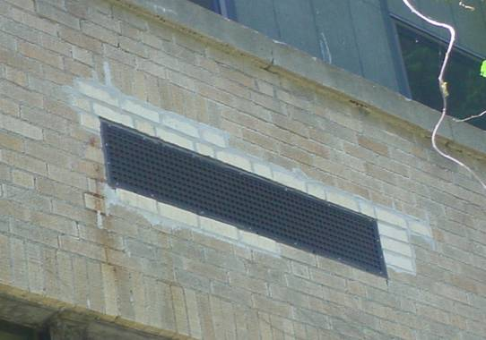

Univent Fresh Air Intake

Picture 2

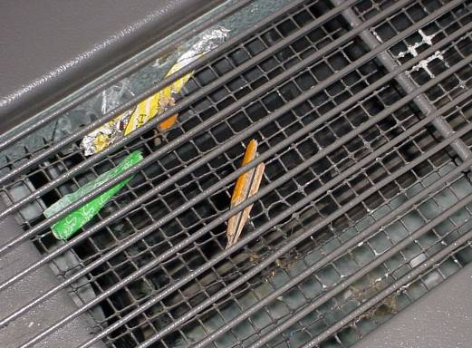

Pencil Tip and Other Debris in Univent Air Diffuser, Note Wire Mesh beneath Vent

Picture 3

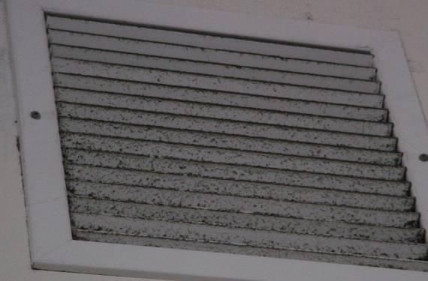

Wall-Mounted Exhaust Vent

Picture 4

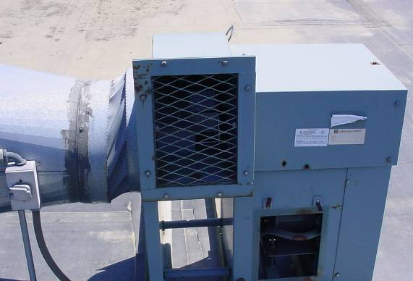

Rooftop Exhaust Motor
Picture 5

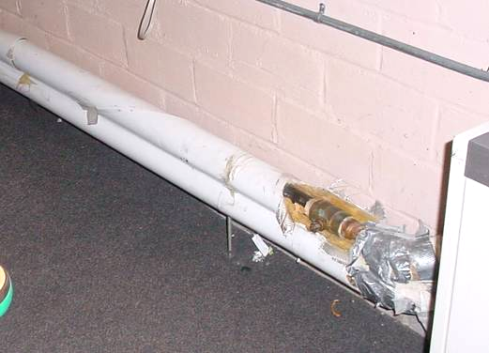

Missing/Damaged Fiberglass Pipe Insulation

Picture 6

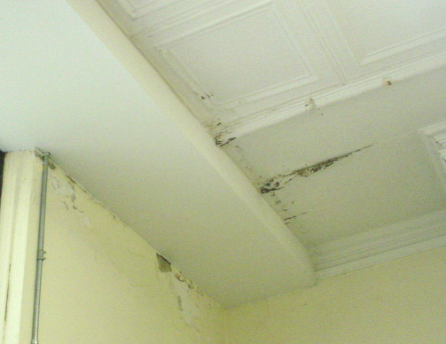

Water Damaged Ceiling and Wall Plaster, Peeling Paint, Efflorescence
Picture 7

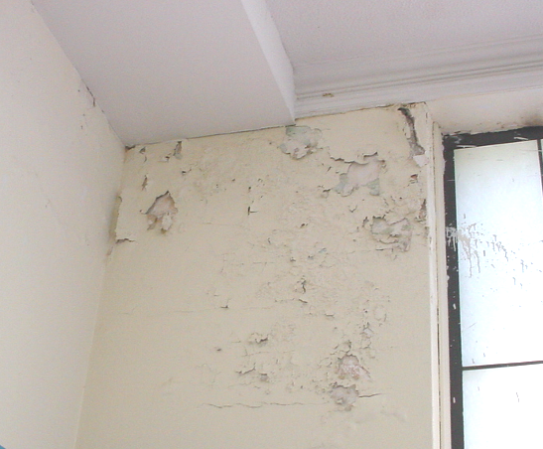

Water Damaged Wall Plaster, Peeling Paint, Efflorescence

Picture 8

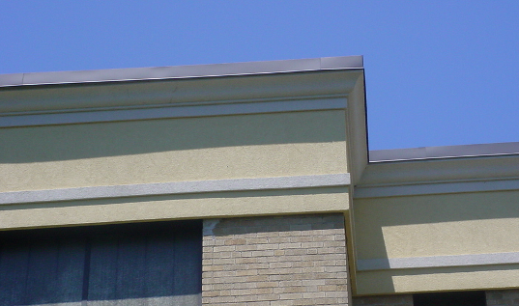

New Flashing and Masonry Cap along Roof’s Edge
Picture 9

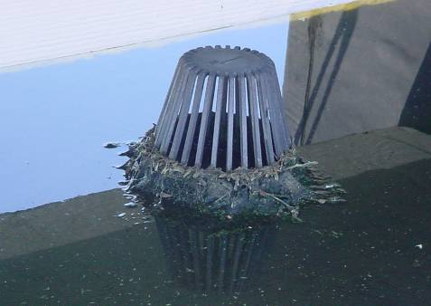

Pooling Water and Clogged Roof Drain

Picture 10

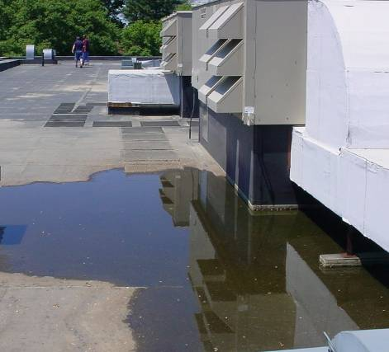

Pooling Water on Roof below Fresh Air Intake
Picture 11

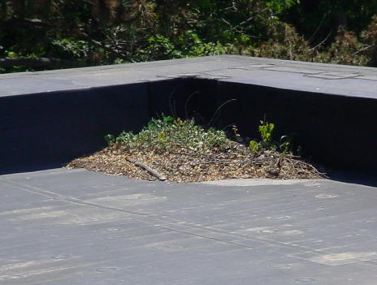

Plant Debris on Roof

Picture 12

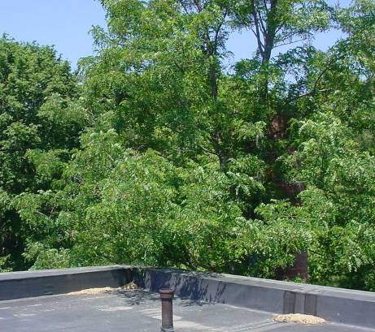

Tree Branches Overhanging Roof
Picture 13

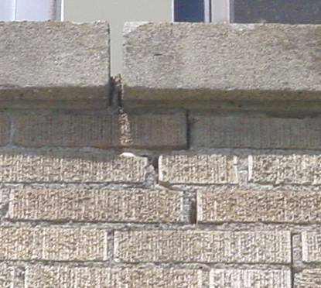

Missing/Damaged Mortar around Exterior Brick and Masonry

Picture 14

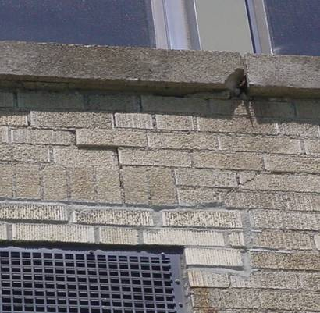

Missing/Damaged Mortar around Exterior Brick and Masonry
Picture 15

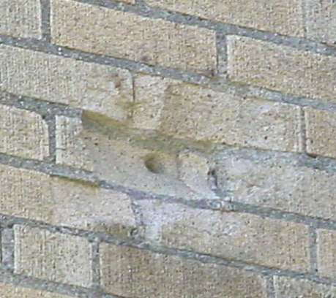

Hole/Damaged Exterior Brick

Picture 16

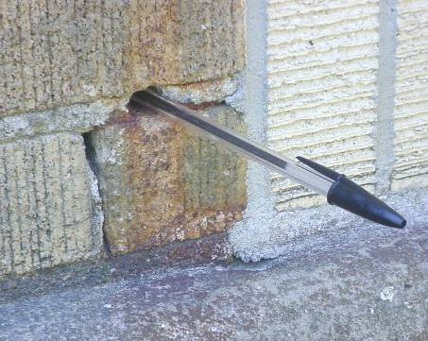

Hole/Damaged Mortar Exterior Brick, Pen Inserted by BEH Staff to Show Depth
Picture 17

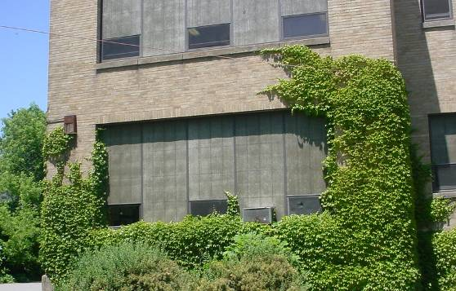

Clinging Plants and Shrubbery against Building

Picture 18

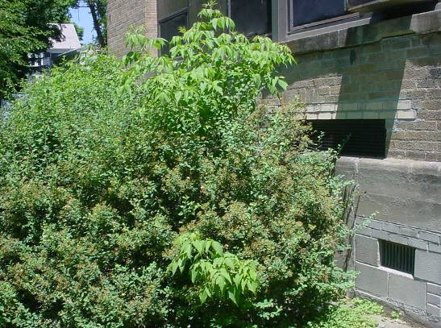

Shrubbery against Building, Note Proximity to Univent Air Intake
Picture 19

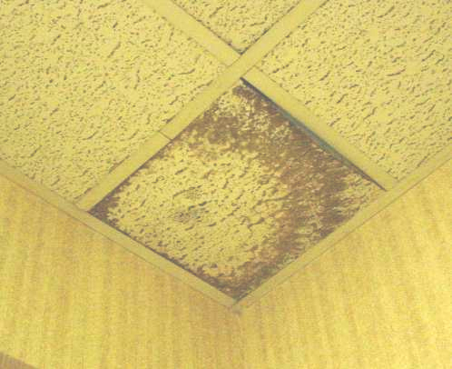

Water Damaged Ceiling Tile

Picture 20

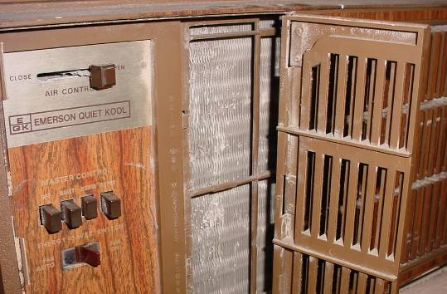

Portable AC Missing Filter
Location/ Room | Occupants  in Room | Temp  (°F) | Relative  Humidity  (%) | Carbon  Dioxide  (ppm) | Carbon Monoxide  (ppm) | PM2.5  (µg/m³) | Windows  Openable | Ventilation |  | Remarks
 |  |  |  |  |  |  |  | Supply | Exhaust | Remarks
background |  | 81 | 32 | 364 | ND | 4 |  |  |  | Winds light and variable
14 | 7 | 79 | 26 | 484 | ND | 6 | Y | Y | Y | Window open, dust/debris in UV-UV off, WD ceiling/wall plaster, dust-flat surfaces, no filter on AC
13 | 1 | 78 | 25 | 399 | ND | 8 | Y | Y | Y | Window open, UV off, exhaust off , WD ceiling/wall plaster, no filter on AC-inoperable, DEM
12 | 5 | 72 | 27 | 597 | ND | 8 | Y | Y | Y | AC-no filter, DO, debris in UV, exhaust off, DEM
11 computer lab | 0 | 78 | 29 | 535 | ND | 7 | Y | Y | Y | PF, AC, DEM, DO
Restrooms |  |  |  |  |  |  | Y |  | Y | Exhaust off
10 | 0 | 77 | 29 | 1068 | ND | 6 | Y | Y | Y | Exhaust off, AC no filter, WD ceiling/wall plaster-corner, DO
9 | 2 | 79 | 28 | 470 | ND | 8 | Y | Y | Y | Window open
8 | 7 | 71 | 30 | 700 | ND | 10 | Y | Y | Y | Window open, WD ceiling/wall plaster
7 | 1 | 76 | 33 | 490 | ND | 9 | Y | Y | Y | Window open, plants on paper towels, DEM, PF, strong air deodorizer odor, DO
1 | 4 | 77 | 28 | 431 | ND | 10 | Y | Y | Y | Window open, UV off
2 Principal’s Office | 2 | 80 | 27 | 374 | ND | 6 | Y | Y | Y | Exhaust off, AC-on, exposed fiberglass insulation
Break room |  |  |  |  |  |  | Y | N | N | WD CT. computer network, vending machine, refrigerator, NO AC-sign to keep window open to prevent overheating of network equipment
Nurse | 0 | 78 | 38 | 500 | ND | 10 | N | Y | Y | Supply vent-off
Councilor’s Office | 0 | 78 | 38 | 478 | ND | 10 | Y | N | N
3 | 0 | 77 | 30 | 433 | ND | 9 | Y | Y | Y | UV off, exhaust off, holes in ceiling near windows
Cafeteria | 21 | 80 | 28 | 536 | ND | 16 | Y | Y | Y | Windows open, ventilation off
Councilors office | 0 | 81 | 27 | 500 | ND | 13 | Y | N | N | Window open
Custodian’s Office | 1 | 78 | 28 | 545 | ND | 12 | Y | N | N
Art Room | 0 | 78 | 35 | 533 | ND | 12 | N | Y | Y | MTs, WD CTs
5 | 0 | 78 | 34 | 432 | ND | 7 | Y | Y | Y | UV off-damaged knobs, exhaust off, dehumidifier, AC
6 | 0 | 79 | 27 | 374 | ND | 9 | Y | Y | Y | UV off-damaged knobs, exhaust off, dehumidifier, AC
Perimeter/  Exterior |  |  |  |  |  |  |  |  |  | Plant growth/clinging plants on/against building, missing/damaged mortar around brick

