8th Edition Building Code FAQ’s
(for base and residential volumes)
Disclaimer: The answers below are staff opinion only and not official interpretations of the Board of Building Regulations and Standard (BBRS).
Note: Questions are listed first to quickly find a topic. Questions with answers follow below. Both are arranged by chapter.
Questions
Chapter 1 Scope and Administration
Q: Permit for cabinet work? Does kitchen cabinet and countertop replacement work require a building permit?
Q. Permit for fire alarm work?: When is a building permit (Section 105) required when work is done on the building fire alarm control panel (FACP)?
Q. Building maintenance: Although there is no maintenance language in the 8th edition identical to the 7th edition can a building official still cite an owner for lack of building or structure maintenance.
Chapter 2 Definitions

Q. Registered design professional: Can a registered design professional not be licensed in MA?
Q. Aggregate building area: How do we measure the aggregate area of a building?

Chapter 3 Use and Occupancy Classification
Q: Assisted Living classification: What is the use group classification for assisted living facilities with more than 16 persons that is licensed by the Executive Office of Elderly Affairs.
Question: High rise smoke proof enclosures: 780 CMR 202 defines a high rise structure as buildings more than 70 feet in height above grade plane. However IBC Section 403.5.4 only requires a smoke proof exit enclosure for exit stairways serving floors more than 75 feet above the lowest level of fire department access. Is the intent of780 CMR to require a smoke proof exit enclosure in all high-rise buildings, even when the top floor is less than 75 feet above the level of fire department access?
Chapter 34 Existing Structures
(International Existing Buildings Code, IEBC)

Q. Vertical gravity load-carrying component: In Chapter 2 of the IEBC the definition of "substantial structural damage" contains the phrase "The capacity of any vertical gravity load-carrying component..." Does this phrase refer to a component carrying vertical load?

Q. Classifying work: Provide examples for classifying work on existing buildings.
Q. Sprinklers, available water: In section 704.2.2 of the IEBC, what is meant by ‘available to the floor’ in exception 3?

Chapter 51 Residential Code
(International Residential Code)

R1 Scope and Administration

Q. Chimney Lining/CSL/Permit: Is a permit and construction supervisor license (CSL) required to install a chimney liner?

R3 Building Planning

Q. Wind: What areas of MA need to comply with the Design Criteria of section R301.2.1.1?
Q. Exit definition: The 8th edition states in section R311.1 that exits are to lead ‘to the exterior of the dwelling’. Can you please clarify this?

R4 Foundations

Q. Shallow foundations: Can shallow foundations be used with unheated buildings?

R11 Energy Efficiency
(International Energy Conservation Code, IECC)

Q. Air leakage testing: Does the air leakage testing outlined in Sections 402.4 and 403.2 of the IECC need to be done by a RESNET certified HERS rater?
Q. REScheck: To comply with the code I am using REScheck for a lateral addition. Does the software require a fourth wall?
Q. Energy efficiency certificate: The energy code requires that a certificate is posted indicating R-values, HVAC equipment, etc.. Is there a form available for this?

Questions and Answers
Chapter 1 Scope and Administration
Q: Permit for cabinet work?: Does kitchen cabinet and countertop replacement work require a building permit?
A: No, unless work regulated by the building code is involved, such as wall openings or wall reconfiguration. The code considers cabinets and countertops as finish work similar to wood trimming and painting. Note, however, that electrical and plumbing permits may be needed even though a building permit isn’t needed if, for example, new outlets are added, a sink is moved, or a dishwasher added.
Q. Permit for fire alarm work: When is a building permit (Section 105) required when work is done on the building fire alarm control panel (FACP)?
A. A permit is required when the FACP is being replaced or additional hardware is required that affects the performance or compatibility of the FACP. However, a permit is not required for replacement of hardware required for normal maintenance or repair.

Q. Building maintenance: Although there is no maintenance language in the 8th edition identical to the 7th edition can a building official still cite an owner for lack of building or structure maintenance.
A. Yes. There are three sections (MA amendments R102.4.5, R102.7.2, and R102.7.3) which a building official can use to make such citation. Additionally under Matters not Provided For (Section 104.10.2) building life safety maintenance issues can be addressed.

Chapter 2 Definitions

Q. Registered design professional: Can a registered design professional not be licensed in MA?
A. Check with MA Dept. of Professional Licensure.

Q. Aggregate building area: How do we measure the aggregate area of a building?
A. Aggregate building area is the area contained within the perimeter of the inside surface of exterior walls. For the purpose of computing area for fire sprinkler requirements refer to Chapter 9 or Chapter 51 (section R3).

Chapter 3 Use and Occupancy Classification

Q: Assisted Living classification: What is the use group classification for assisted living facilities with more than 16 persons that is licensed by the Executive Office of Elderly Affairs.
A: Per Massachusetts General Law Chapter 19D Section 18(d) (see below), all assisted living facilities that are licensed by the Executive Office of Elderly Affairs must be classified as a residential use group. Since the building contains multiple units, the use group classification for this type of facility is Use Group R-2.
M.G.L. Chapter 19D Section 18: Classification of assisted living residences
(a) Assisted living residences shall not be subject to the provisions of sections twenty-five B to twenty-five H, inclusive, section fifty-one and sections seventy E to seventy-three B, inclusive, of chapter one hundred and eleven or the seventh full paragraph of section nine of chapter forty A of the General Laws.
(b) No person or residential facility offering, providing or arranging for the provision of assistance with or supervision of instrumental activities of daily living only shall be required to obtain certification under this chapter or a license pursuant to section seventy-one of chapter one hundred and eleven of the General Laws.
(c) For the purposes of this chapter, and any other general or special law classifying real estate property for the purpose of taxation, and notwithstanding the provisions of section twenty-seven C of chapter twenty-nine of the General Laws, a municipality shall classify the portion of any building operated as an assisted living residence in the same category as property held or used for human habitation.
(d) Regardless of the designation of an assisted living residence as a residential, institutional or other use under any zoning ordinance, assisted living residences certified under this chapter shall be regarded as residential uses for the purposes of the state building code and shall be so regarded by the building inspectors of each city and town in the commonwealth

Chapter 34 Existing Structures
(International Existing Buildings Code, IEBC)

Q. Vertical gravity load-carrying component: In Chapter 2 of the IEBC the definition of "substantial structural damage" contains the phrase "The capacity of any vertical gravity load-carrying component..." Does this phrase refer to a component carrying vertical load?
A. No. The reference is to a component oriented in the vertical direction, such as a column or wall. Per the ICC Technical Staff "The intent is to focus on columns and bearing walls (and for lateral Substantial Structural Damage, on frames and shear walls), and not on typical roof or floor framing, diaphragms, and collectors. The purpose of the definition is to determine whether damaged members should simply be repaired or replaced, or whether a whole structural upgrade should be triggered as well. The general theory is that the bias is toward "repair only." Upgrade beyond that should be triggered only where the damage affects the building globally (as represented by loss of multiple columns) and where repair alone would end up maintaining a grossly inadequate structure."

Q. Classifying work: Provide examples for classifying work on existing buildings.
A. See the insert below.

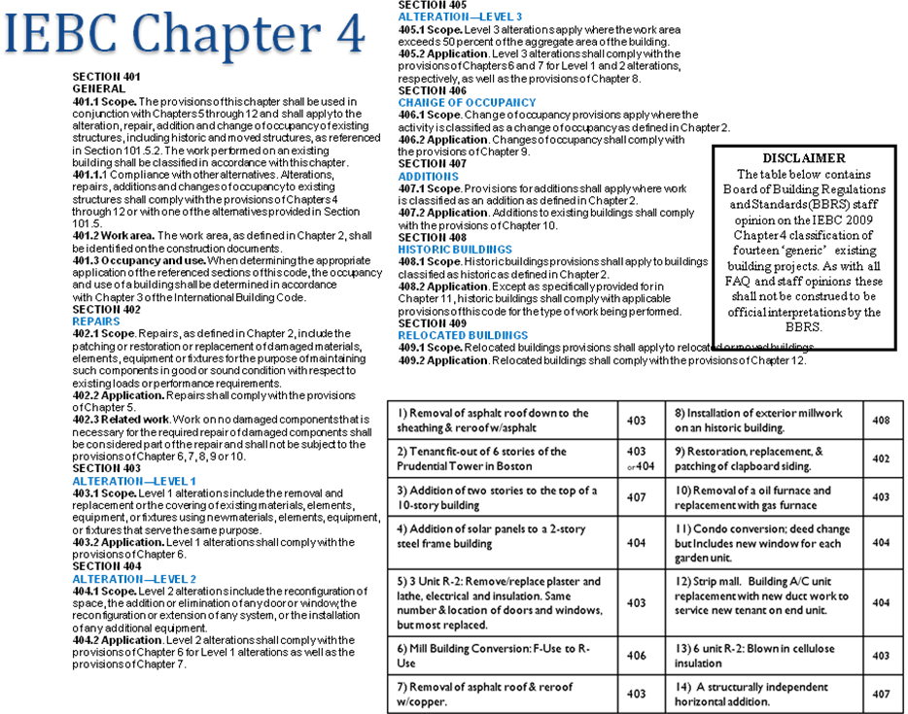

Q. Sprinklers, available water: In section 704.2.2 of the IEBC, what is meant by ‘available to the floor’ in exception 3?
A. The ICC issued an interpretation on this subject in 2005 pertaining to 604.2.2 of the IEBC 2003 and Level 2 Alterations. Although the section number has been changed in the IEBC 2009, the language is the same so this interpretation can be found at IEBC Interpretation No. 12-04 for guidance.

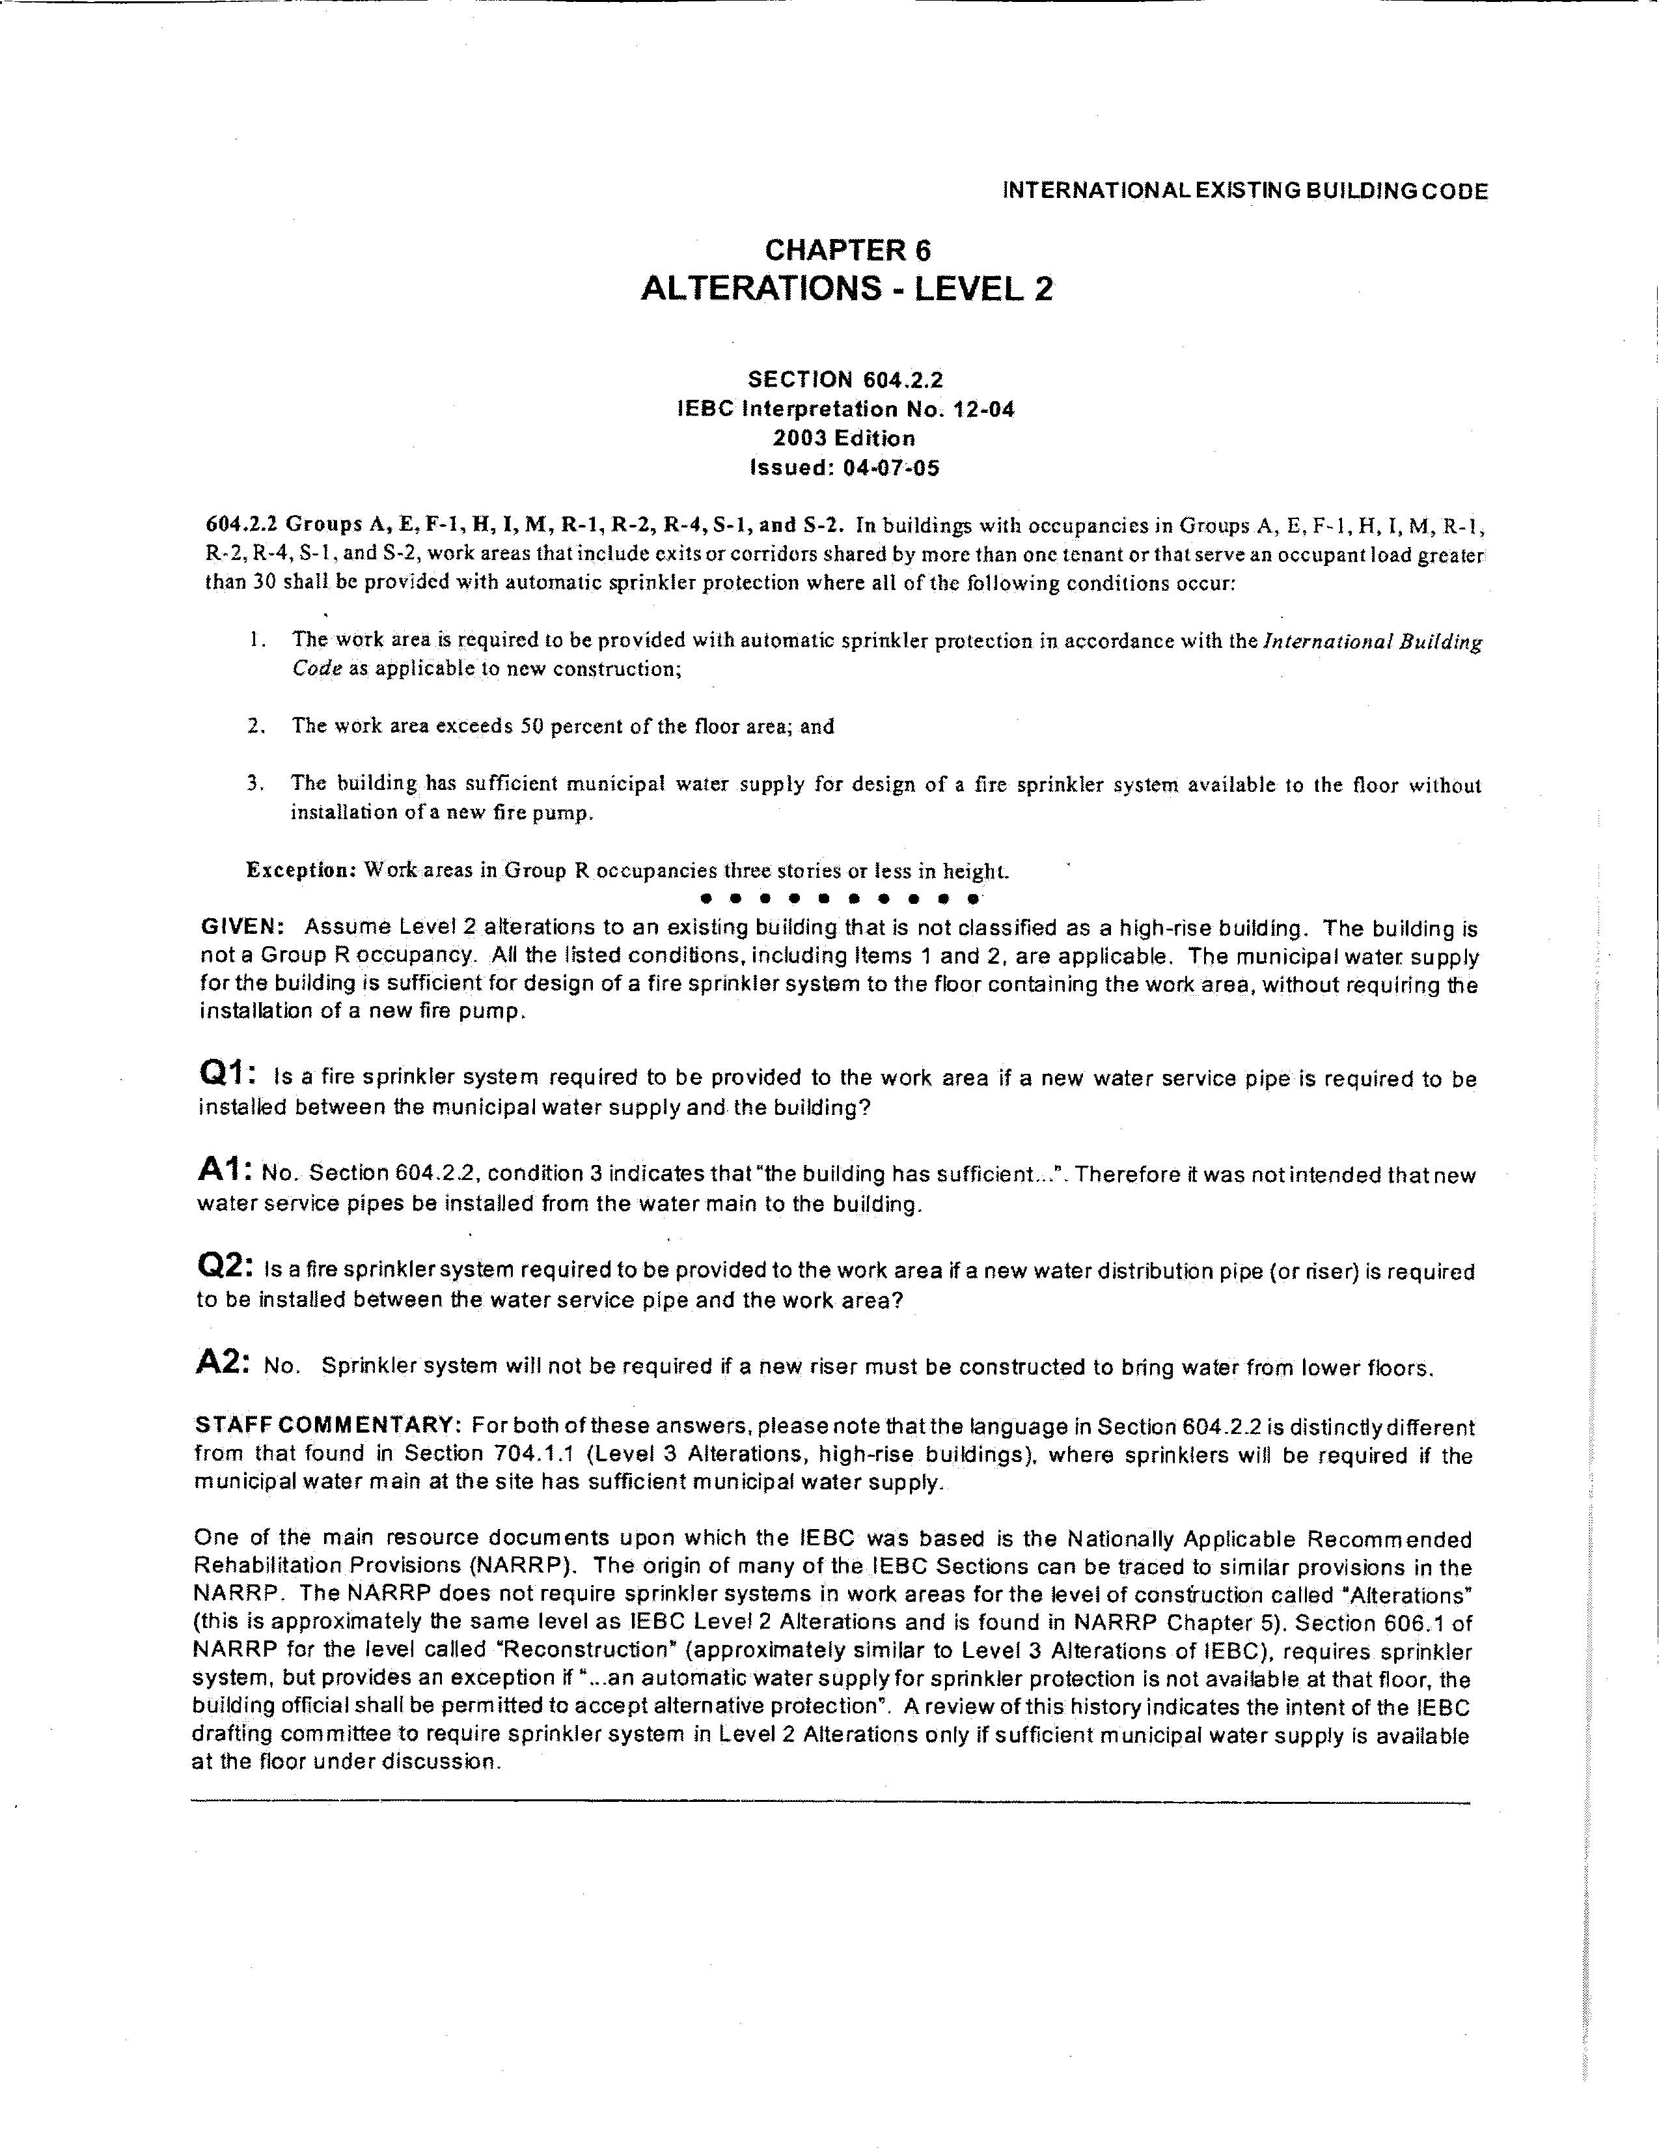
Chapter 51 Residential Code
(International Residential Code)

R1 Scope and Administration

Q. Chimney Lining/CSL/Permit: Is a permit and construction supervisor license (CSL) required to install a chimney liner?
A. Yes. A permit and a license are required to install a chimney liner. The permit applicant must hold an unrestricted, restricted CSL, or a ‘specialty’ CSL in either Solid Fuel Burning Appliance Installation or Masonry. However, for projects where only oil heating system work is being done, some municipalities may issue a permit to a holder of an oil burner technician license. For a project involving gas fired appliances a plumber/gas fitter license is required for the installation of the liner.

R3 Building Planning
Q. Wind: What areas of MA need to comply with the Design Criteria of section R301.2.1.1?
A. Those municipalities with wind speeds (Table R301.2(4)) of 110 mph need to comply with section R301.2.1.1. The BBRS approved an official interpretation at the May 10, 2011 meeting to clarify the code language of this section.

Q. Exit definition: The 8th edition states in section R311.1 that exits are to lead ‘to the exterior of the dwelling’. Can you please clarify this?
A. Exits from a building are to lead to grade and to a public way.

R4 Foundations

Q. Shallow foundations: Can shallow foundations be used with unheated buildings?
A. Yes. Section R403.1.4.1 Frost protection, has two exceptions for accessory structures and also allows the construction of a frost protected shallow foundation (FPSF) for an unheated building using the prescriptive requirements of ASCE 32. Penn State University has a webinar on this topic that may be helpful in understanding the science of FPSF http://www.engr.psu.edu/phrc/training/FPSF_webinar_March_09.pdf

R11 Energy Efficiency
(International Energy Conservation Code, IECC)

Q. Air leakage testing: Is the air leakage testing outlined in Sections 402.4 and 403.2 of the IECC need to be done by a RESNET certified HERS rater?
A. No not necessarily. The IECC code does not have specific certification requirements for this testing. An individual with appropriate experience may perform this testing. A RESNET certified HERS rater is required to conduct the testing in buildings where compliance is to DOE Energy Star requirements.

Q. REScheck: To comply with the code I am using REScheck for a lateral addition. Does the software require a fourth wall?
A. With REScheck and IECC 2009 the user has the option to choose between two compliance methods: total UA or Performance. For lateral additions which are not thermally isolated from the existing building, the total UA is the proper method and a fourth wall will not be required.

Q. Energy efficiency certificate: The energy code requires that a certificate is posted indicating R-values, HVAC equipment, etc... Is there a form available for this?
A. Yes. Building officials from Pittsfield developed a residential energy compliance certificate that is available for use to meet this requirement.

