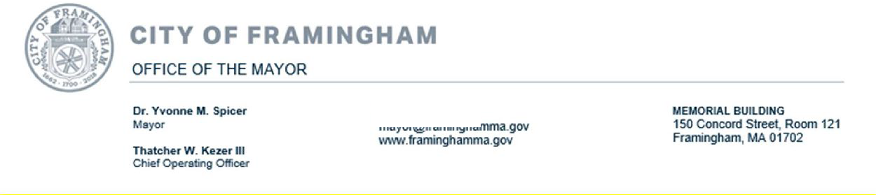
Determination of Need Program
Massachusetts Department of Public Health 250 Washington St.
Boston, MA 02108

August 20, 2021

Dear Determination of Need Program,

I write today in support of Boston Children’s Hospital’s expansion and improvement proposals across the state. In particular, the new ambulatory center in Needham and the improvements at the existing Waltham facility will help provide critical access for the families that Irepresent.

Currently, families in Framingham and the surrounding area are lucky to have convenient access to many of the services and specialties that Boston Children’s provides, in Waltham. This facility allows many to forgo the long and cumbersome commute into Boston and get treatment in an easier way, without sacrificing quality of care. Expanding and improving this facility to serve even more patients will be a tremendous asset to families throughout the MetroWest area, and across the entire state. In particular, the planned expansion of pediatric psychiatric services is critical, given the current lack of adequate treatment options for children with behavioral health conditions in our state.

Additionally, creating an entirely new ambulatory surgical center in Needham will take access at Boston Children’s to the next level. This proposed new facility will dramatically increase the number of children in need who can receive the hospital’s life-saving care. Medically complex conditions and special needs require a tremendous amount of time, energy, and organization on the part of impacted families. We are lucky in this state to have Boston Children’s available to help so many navigate such difficult terrain. Anything we can do to make it easier for more families to access this kind of care should be a top priority in our state’s health care ecosystem.

Finally, as Mayor of a city with a large immigrant population, Boston Children’s model of culturally competent care is particularly important to me. Knowing the systemic barriers immigrant families already face in accessing health care in this country, providers who know what it means to meet people where they are, especially in their times of deepest need, are essential.

For these reasons, I am proud to support the project and urge the Department of Health to submit its approval.

Sincerely,
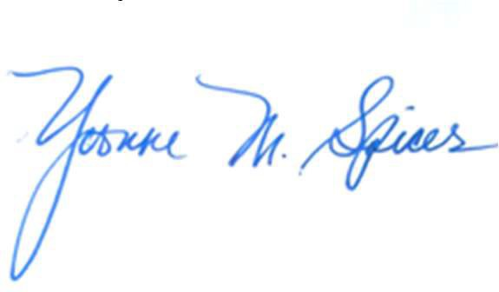
Dr. Yvonne M. Spicer Mayor
City of Framingham, MA

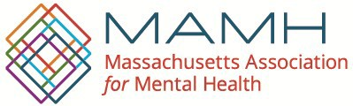
Danna E. Mauch, PhD Ambassador (ret.) Barry B. White President and CEO Chairperson of MAMH Board of Directors

September 9, 2021

Determination of Need Program MA Department of Public Health 250 Washington St.
Boston, MA 02108

Dear Determination of Need Program,

I am writing to support Boston Children’s Hospital’s proposal to modernize its existing facilities in Waltham to include a 12-bed pediatric inpatient psychiatric unit, along with a partial hospitalization program and outpatient psychiatric services. I believe this project will greatly benefit children, families, and communities across our state and improve access for patients seeking lifesaving or life-changing care.

Prior to the COVID-19 pandemic, Massachusetts had not only a shortage of pediatric psychiatry services but was also facing the closure of beds in Western Massachusetts and inability to staff beds in Central Massachusetts, with a net effect of long waits for admission to outpatient care and long waits boarding for admission to inpatient care. Children and adolescents have been particularly vulnerable to poor mental health outcomes stemming from the COVID-19 pandemic, increasing pressure on outpatient demand and emergency room boarding. Isolation, changes in routine, anxiety and uncertainty associated with the virus, financial and food insecurity, and parental stress can all negatively impact child mental health. This puts our children and youth at risk for mental health and substance use challenges that left unaddressed can create lifelong difficulties.

In May 2020, 29 percent of parents in a nationwide survey reported that their child’s emotional health was already harmed; this figure increased to 31 percent—one in three surveyed parents—by October 2020. It has also been well documented that adolescents, young children, LBGTQ+ youth, and children of color are disproportionately vulnerable to negative mental health consequences surrounding COVID-19.¹ Here in Massachusetts, in an online survey conducted by the MA Department of Public Health (DPH) between September and November 2020, 83 percent of youth identifying as non-binary or queer reported more than 15 days of poor mental health in the past 30 days.² Just last month, the Centers for Disease Control and Prevention (CDC) reported that visits to emergency departments for suspected suicide attempts for adolescent girls increased roughly 50 percent in early 2021 compared with the same period in 2019.³ Compared to adults, the COVID-19 pandemic may also continue to have increased adverse consequences youth mental health over the longer-term.⁴

Boston Children’s Hospital and the Massachusetts Association for Mental Health (MAMH) have partnered extensively on advocacy efforts for years to increase access to behavioral health care for all

children across the state, irrespective of race, gender, sexual orientation, insurance, and immigration status. Boston Children’s has invested in upstream care, behavioral health integration, and in addressing social determinants of health via community engagement/investments and more. We are also experienced partners with Boston Children’s on advocacy efforts to address the above noted psychiatric boarding crisis for children and adolescents. And we applaud the innovative steps taken at Boston Children’s Hospital Boston to resolve the boarding crisis.

The proposed projects and investments will help Boston Children’s grow this impact and reach even more families and more patients, clearly demonstrating the hospital’s commitment to the health and well-being of children throughout Massachusetts. The continuum of services envisioned will enable children and youth in need to access the right level of care at the right time and step down in a timely manner from more expensive and restrictive inpatient care to partial hospital and outpatient care, supporting them in their return to family, school, and community. These projects will ensure that patients and families have access to a full range of high quality, integrated pediatric behavioral health care services in convenient, lower-cost settings. In addition, they will meet the needs of surrounding underserved communities.

I am confident Boston Children’s growing investments in children, families and communities will have a long-lasting impact and benefit future generations of children for many years.

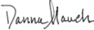Thank you for accepting this letter of support. Sincerely,

Danna Mauch, PhD President and CEO dannamauch@mamh.org

1 Panchal N, Kamal R, Cox C, Garfield R, Chidambaram P. Mental Health and Substance Use Considerations Among Children During the COVID-19 Pandemic. Kaiser Family Foundation. 26 May 2021.
2 MA Department of Public Health (DPH). MA DPH Community Impact Survey. June 2021.
3 Yard E, Radhakrishnan L, Ballesteros MF, et al. Emergency Department Visits for Suspected Suicide Attempts Among Persons Aged 12–25 Years Before and During the COVID-19 Pandemic — United States, January 2019–May 2021. MMWR Morb Mortal Wkly Rep 2021;70:888–894. DOI: http://dx.doi.org/10.15585/mmwr.mm7024e1.
4 Meherali S, Punjani N, Louie-Poon S, Abdul Rahim K, Das JK, Salam RA, Lassi ZS. Mental Health of Children and Adolescents Amidst COVID-19 and Past Pandemics: A Rapid Systematic Review. Int J Environ Res Public Health. 2021 Mar 26;18(7):3432. doi: 10.3390/ijerph18073432. PMID: 33810225; PMCID: PMC8038056.

NORTHEAST REGIONAL COUNCIL OF
Robert Butler, President Russell Bartash, FST
1157 Adams Street, Dorchester, MA 02124

September 8, 2021

Determination of Need Program MA Department of Public Health 250 Washington St.
Boston, MA 02108

Dear Determination of Need Program:

My name is Robert Butler, and I am the President of Northeast Regional Council of SMART. I am writing to express my strong support for Boston Children's Hospital's plans to modernize its Waltham and Weymouth facilities and to build a new ambulatory surgical center in Needham. Many of our members have children who have been treated at Boston Children's and see these proposed projects as both an opportunity to create good, union jobs as well as an opportunity to bring Boston Children's services closer to where patient families live.

We applaud the fact that Boston Children's is undertaking these plans in a way that demonstrates its commitment not only to the health and well-being of children in those three communities but to addressing the needs of children and families in surrounding, underserved communities as well. This will ensure that families throughout Massachusetts have access to a full range of high quality, integrated pediatric care services where and when they need it.

I am confident Boston Children's investments in children, families and communities will have a long-lasting impact that will benefit the community for many years to come.

Northeast Regional Council of SMART appreciates the opportunity to provide this letter of support for Boston Children's proposed project. We strongly urge the Department of Public Health to act favorably on it.

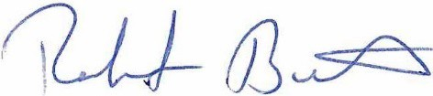Sincerely,

Robert Butler
President
Northeast Regional Council of SMART

Stars
Excellence inEducation,
Enrichment andFamilvSuJJPOrt.

South Shore Stars

* 200 Middle Street * Weymouth MA 02189 *
Dr. Jennifer Curtis, Executive Director

Determination of Need Program MA Department of PublicHealth 250 Washington St
Boston, MA 02108

August 18, 2021

Dear Determination of Need Program,

I am writing to support Boston Children's Hospital's proposal to modernize its existing facilities in Weymouth. I believe this project will greatly benefit children, families, and communities across our state and improve access for patients seeking lifesaving or life- changing care.

As the current Executive Director of South Shore Stars, a resident of Weymouth, and the former Superintendent of Weymouth Public Schools, I can say without hesitation that modernization of Children's Hospital facilities and expansion of clinical departments in Weymouth would serve our community well. This project would provide needed access for many families on the South Shore. Expanding the Children's Hospital facilities in Weymouth would also allow educational professionals access to local high quality children's medical services to refer families to. This access would potentially increase collaborative efforts between children, families, educational providers, and health and wellness experts.

The proposed projects and investments will help Boston Children's grow this impact and reach even more families and more patients, clearly demonstrating the hospital's commitment to the health and well-being of children throughout Massachusetts. These projects will ensure that patients and families have access to a full range of high quality, integrated pediatric care services in convenient, lower-cost settings. In addition, they will meet the needs of surrounding underserved communities, as well as potentially create collaborative

opportunities for agencies such as South Shore Stars.

I am confident Boston Children's growing investments in children, families and communities will have a long-lasting impact and benefit future generations of children for many years.
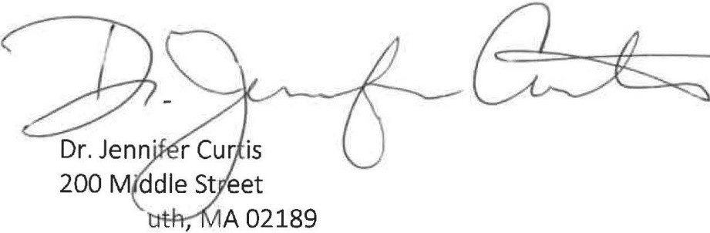

Thank you for accepting this letter of support. Sincerely,

Weymo Jcurtis@southshorestars.org

fm::l!k.aorl

Stars

f ffl'llffllcn:!f.r.lf Excellence in Education, Enrichment and Family Support

NORTH WEYMOUTH CIVIC ASSOCIATION
P. O. Box 93
North Weymouth MA 02191-0003

Determination of Need Program MA Department of Public Health 250 Washington Street
Boston MA 02108

August 11, 2021

Determination of Need Program,

I am writing in support of Boston Children’s Hospital’s proposal to modernize their facilities in Weymouth. This project will benefit children, families and entire communities and improve access for patients seeking life-saving care.

The North Weymouth Civic Association is a volunteer group established in 1971 to work for the betterment of our community. There are approximately 9,000 residents in North Weymouth, 55,000 in all of Weymouth. A large percentage of our community would be considered blue collar workers and time off from work increases the cost of medical care. We all would benefit from the proposed project to increase the services available locally and not being forced to make the trip into Boston each time treatment is required for our kids.

The proposed project will definitely help Boston Children’s Hospital reach more patients and families in Weymouth and the surrounding communities. This project will add to the local, much needed pediatric care available here now, and in the future.
Thank you for your time and consideration of this project. Sincerely,
Geoff Potter President
North Weymouth Civic Association northweymouthca@gmail.com
NorthWeymouth.org

Charles River Regional Chamber 117 Kendrick Street, Suite 300

EMAIL info@charlesriverchamber.com
Determination of Need Program MA Department of Public Health 250 Washington St.
Boston, MA 02108

Sept. 4, 2021

Dear Determination of Need Program:

My name is Greg Reibman and I am the President & CEO of the Charles River Regional Chamber. I am writing to express my strong support for Boston Children’s Hospital’s plans to modernize its Waltham and Weymouth facilities and to build a new ambulatory surgical center in Needham.
The Charles River Regional Chamber has met with Boston Children’s representatives and been kept up to date on the progress of the projects, especially the proposed new facility in Needham. We believe Boston Children’s is the kind of forward-thinking organization that will be a welcome addition to Needham’s N- Squared Innovation District.
This project will support the health of the local economy, both in the short-term, during construction, and longer term as the new facility comes on line. And, local families will benefit greatly from having Boston Children’s world class medical care available to them closer to home.
I am confident Boston Children’s decision to locate a satellite facility in Needham will benefit the local economy and the broader community for many years to come.

On behalf of the Charles River Regional Chamber, I strongly urge the Department of Public Health to act favorably on the proposed project.

Sincerely,

Greg Reibman
President & CEO

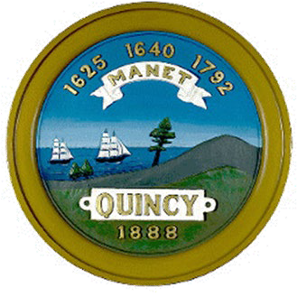
Marli Caslli, MPH,

City of Quincy, Massachusetts
THOMAS P. KOCH, MAYOR DEPARTMENT OF HEALTH
440 East Squantum Street Quincy, MA 02171

MSCommissioner of Public Health Fax: (617) 376-1271
Determination of Need Program Massachusetts Department of Public Health 250 Washington St.
Boston, MA 02108

September 7th, 2021

Dear Determination of Need Program,

I am writing to offer my support for Boston Children’s Hospital’s proposed expansion plans in Weymouth and across other locations in the Commonwealth. As the Commissioner of Public Health in Quincy, I know firsthand what an enormous asset the Weymouth facility is to our health care infrastructure on the South Shore. Expanding and improving it to include more specialties and services will undoubtedly have a positive impact on the families that call this region home.

After a year that has tested the very fiber of our public health system in Massachusetts, and across the country, it is more essential than ever that this Commonwealth double down on its commitment to affordable, accessible, high quality health care for every resident. For an untold number of families in this state, Boston Children’s is the reason that promise is kept. Serving kids with some of the most difficult, painful, and heart-wrenching medical conditions, they support their patients and families with a level of care and respect that can be hard to find elsewhere. I have seen time and again the impact of their Weymouth facility, in particular, on local families. It is clear to me that the more families Boston Children’s is able to reach, the better for Massachusetts’ public health system.

With that in mind, I offer my strongest possible support for their expansion plans. Sincerely,

Marli Caslli, MPH, MS Commissioner of Public Health City of Quincy Health Department

Local 4

INTERNATIONAL UNION OF OPERATING ENGINEERS
William D. Mclaughlin Business Manager office@iuoelocal4. Org 16 Trotter Drive
Medway, Massachusetts 02053
Fax(598)533-1430
Determination of Need Program MA Department of Public Health 250 Washington St.
Boston, MA 02108

August 18, 2021

Dear Determination of Need Program:

Myname is William D.McLaughlin, and Iamthe Business Manager of the International Union of Operating Engineers Local 4. I am writing to express my strong support for Boston Children's Hospital's plans to modernize its Waltham and Weymouth facilities and to build a new ambulatory surgical center in Needham. Many of our members have children who have been treated at Boston Children's and see these proposed projects as both an opportunity to create good, union jobs as well as an opportunity to bring Boston Children's services closer to where patient familieslive.

We applaud the fact that Boston Children's is undertaking these plans in a way that demonstrates its commitment not only to the health and well-being of children in those three communities but to addressing the needs of children and families in surrounding, underserved communities as well. This will ensure thatfamilies throughout Massachusetts have access to a full range of high quality, integrated pediatric care services where and when they need it

I am confident Boston Children's investments in children, families and communities will have a long-lasting impact that will benefit the community for many years to come.

The Operating Engineers appreciates the opportunity to provide this letter of support for Boston Children's proposed project.We strongly urge the Department of Public Health to act favorably on it.

Sincerely,

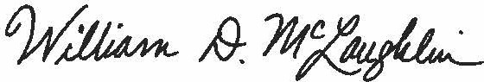
William D. McLaughlin Business Manager

Branch Offices: Dorchester MA, Taunton MA, Worcester MA. Portland ME/NH

Determination of Need Program MA Department of Public Health 250 Washington St.
Boston, MA 02108

September 8, 2021

Dear Determination of Need Program,

I am writing to support Boston Children’s Hospital’s proposal to modernize its existing facilities in Waltham and Weymouth and build an ambulatory surgical center in Needham. I believe this project will greatly benefit children, families, and communities across our state and improve access for patients seeking lifesaving or life-changing care.

My husband, Darrell and I have two children, Emma, now just shy of 13 and Anthony, 11. Just before Christmas of 2015, our daughter, Emma, then just 7 years old, failed her vision test which set us on the long journey that we walk still to this day. In January 2016, we met with Dr. Mantagos for the first time. It was confirmed then that she had lost vision in left eye and was diagnosed with cataract, bilateral anterior uveitis and was also referred to Rheumatology for Juvenile Idiopathic Arthritis. Hourly eye drops, weekly appointments put a great strain on not just Emma, but the whole family. There is nothing scarier as a parent then seeing your child in pain and confused as to what was happening. Those first years were incredibly difficult to navigate as Emma became increasingly upset and combative during her weekly Humira injections. It was scary and overwhelming for all of us. As Emma’s situation became more complicated, we felt so supported by the entire team, which was then expanded to include Psychiatry, that was managing her care. While we felt so fortunate to be able to have access to the best care in the world, the constant back and forth to Boston took its toll, missed work, missed school, and everyday kid activities, because even a 15-minute visit would turn into at least a 3-hour ordeal.

Over the years, the frequency of appointments has ebbed and flowed from twice a week, to once a month and sometimes (when we were in a good stretch) 3 months. We meet with Ophthalmology, Rheumatology, Allergy and, from time to time, Psychiatry, not to mention the various blood draws. Dr. Mantagos and Dr. Lo work so well together and have really acted as a single unit in providing Emma’s care. We are blessed to have such a great relationship with the team, they listen and truly care about Emma.

We are fortunate enough that Dr. Mantagos and Dr. Lo both have clinic days in the Weymouth office. Having this office closer to home has made this long road a bit more tolerable. It’s reduced the time off from school and work need to make her many appointments and has significantly reduced expenses as there is free parking at the Weymouth office. I hope that the expansion is approved as additional services being offered will not only help Emma, but countless other children who will have the opportunity to get the wonderful care they need that they might not otherwise have access to.
The proposed projects and investments will help Boston Children’s grow this impact and reach even more families and more patients, clearly demonstrating the hospital’s commitment to the health and well-being of children throughout Massachusetts. These projects will ensure that patients and families have access to a full range of high quality, integrated pediatric care services in convenient, lower-cost settings. In addition, they will meet the needs of surrounding underserved communities.

I am confident Boston Children’s growing investments in children, families and communities will have a

long-lasting impact and benefit future generations of children for many years. Thank you for accepting this letter of support.
Sincerely,

Josephine C. Rego

Josephine C. Rego
11 Morningside Lane, Foxboro MA 02035 Joc1234@gmail.com

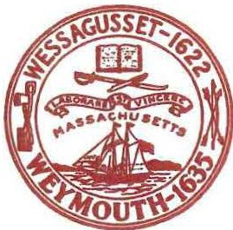
Town of Weymouth Massachusetts
Robert L. Hedlund Mayor 75 Middle Street
Weymouth, MA 02189

Fax: 781.335.8184

Weymouth, Massachusetts website at Weymouth, Massachusetts website at www.weymouth.ma.us

August 11, 2021
Determination of Need Program Massachusetts Department of Public Heaith 250 Washington St.
Boston, MA 02108

Dear Determination of Need Program:

I write today in support of Boston Children's Hospital's proposal to expand its existing footprint in Weymouth.

Boston Children's is already an integral part of the Weymouth community. With its world-class physician's center, offering more than 48 pediatric specialties, it brings the quality of Boston care to the South Shore, removing many of the obstacles families would otherwise face, from long commutes to expensive parking.

We are extremely proud that Boston Children's calls Weymouth home, and we are eager for them to be able to expand their footprint further, so more children and families have access to life-changing care.

The current proposal before you will increase the number of services to include everything from cardiac testing and phlebotomy, to speech and physical therapies.

This expansion will directly translate into more children getting well and more families being supported closer to home.

I offer my strongest support of this proposal, and respectfully urge your program to consider an expeditious approval.

Please contact me if you should need anything further. Sincerely,
Mayor

