BOYS & GIRLS CLUBS
OF METROWEST
Boys & Girls Clubs of Metrowest website at www.bgcmetrowest.org
GREAT FUTURES START HERE.
Determination of Need Program
MA Department of Public Health
250 Washington St.
Boston, MA 02108
August 4, 2021
September 1, 2021

Dear Determination of Need Program:

My name is Chris Duane and I am the President & CEO of the Boys & Girls Clubs of MetroWest. We serve children and families in Framingham, Marlborough and Hudson. I am writing to express my strong support for Boston Children's Hospital's plans to modernize its Waltham and Weymouth facilities and to build a new ambulatory surgical center in Needham. As you are aware, the need for children's access to integrated pediatric care, especially mental and behavioral healthcare, is great .

We applaud the fact that Boston Children's is undertaking these plans in a way that demonstrates its commitment not only to the health and well-being of children in those three communities but to addressing the needs of children and families in surrounding, underserved communities as well. This will ensure that families throughout Massachusetts have access to a full range of high quality, integrated pediatric care services where and when they need it.

A lack of transportation is one of the most serious problems facing the families that we serve, so we are especially pleased that families will have greater access to outpatient services in much more convenient locations. Boston Children's presence in Waltham also provides an important opportunity to complement and expand the services that the Boys & Girls Clubs of MetroWest currently offers.
We look forward to collaborating on ways to better serve our child, youth and family clients and the broader community.

I am confident Boston Children's investments in children, families and communities will have a long lasting impact that will benefit our community for many years to come.

The Boys & Girls Clubs of MetroWest appreciates the opportunity to provide this letter of support for Boston Children's proposed project. We strongly urge the Department of Public Health to act favorably on the proposed project.

Sincerely,
Chris Duane President & CEO
Main Office & Marlborough Clubhouse
169 Pleasant Street • Marlborough MA 01752
F: 508.229.7818
Argeo R. Cellucci, Jr Clubhouse
21 Church Street Hudson, MA 01749
F: 978.567.8951
Framingham Clubhouse
25 Clinton Street • Framingham MA 01702
F: 508.620.7643

Uri it ed VlayofTr1-Counry
Bay State Community Services
Determination of Need Program MA Department of Public Health 250 Washington St.
Boston, MA 02108

Children's Medical Center Corporation BCH-21071411-HE DoN Application Letter of support

9-7-21

Dear Determination of Need Program:

Please accept this letter of support from Bay State Community Services (BSCS) for Boston Children's Hospital plans to improve and modernize the Weymouth Facility.

BSCS is a comprehensive social service agency providing over 80 programs in 17 locations throughout the Greater South Shore. State and federal officials categorize BSCS as a "safety net" agency. We are the last resource for the poor and underserved in our area, and many individuals would be without any support or resources without our agency. We have provided support for over 45 years and are committed to continuing this proud tradition in the following areas: Child and Family Services, Outpatient Counseling, Prevention and Intervention Resources, Correctional Substance Use Treatment, Residential Treatment, Day Treatment Programming, and by hosting peer-driven community programs.

Boston Children's has been a strong and supportive partner to BSCS and the critical work we offer to the children and families we serve. We depend on the expertise, commitment, and resources that Boston Children's brings to our community. Many of the children we serve present with complex psychiatric and medical needs that a general pediatric practice is not able to adequately address. We can always depend on Boston Children's to respond to our children and families, bring outstanding medical care and treat the family with respect and kindness.

Having Boston Children's site located in Weymouth addresses many of the needs of the children and families we serve. While Boston is in close proximity to Weymouth many of our families do not have cars. Public transportation with a child who is experiencing psychiatric distress who is medically compromised is simply not an option. The Weymouth location of Boston Children's offices makes access to medical care accessible to families.

Boston Children's presence in our community also provides an important opportunity to complement and expand the services that BSCS currently offers. As the provider for the South Shore for the Community Services Agency (CSA)
BSCS is responsible to wrap around families with high clinical needs and develop family teams that enable the family to live and grow together. Having Boston Children's as a partner enables us to operationalize realistic and effective plans to meet the needs of the youth and families. Enhancing services in the Weymouth area enables us to increase our services and better serve children, youth and family and the broader community.

I am confident Boston Children's investments in children, families and communities will have a long-lasting impact that will benefit our community for many years to come.

Bay State Community Services appreciates the opportunity to provide this letter of support for Boston Children's proposed project. We strongly urge the Department of Public Health to act favorably on the proposed project.
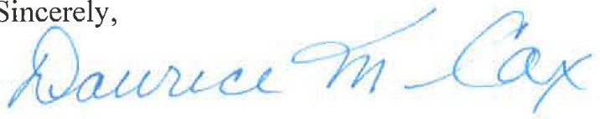
Daurice M. Cox Psy.D Executive Director
Arthur Mathews
Weymouth Town Council
President/District Four Councilor
75 Middle Street
Weymouth, MA 02189

Town of Weymouth Massachusetts
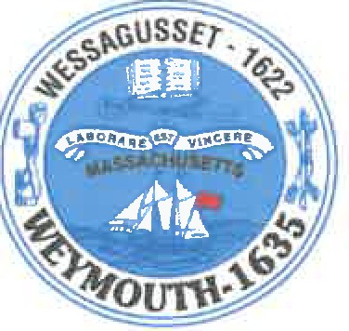
July 27, 2021
September 3, 2021
Massachusetts Department of Public Health 250 Washington Street
Boston MA 02115

To Whom it May Concern:

I am writing to voice my support for relocating the Weymouth facility of Boston Children's Hospital from the Stetson Building to a new facility located on Libbey Industrial Parkway, both located in Weymouth.

Expanding current services and the addition of new services including cardiac testing, radiology, audiology and occupational therapy will be a wonderful complement to the medical services available to not only Weymouth residents, but all residents in our surrounding communities.

I understand the hospital will present its plans for the new Weymouth facility to the Massachusetts Board of Public Health; kindly submit this letter as support to the Board.

Please feel free to reach out to me if I can be of further assistance as it relates to this paramount and worthwhile project.

Arthur E. Mathews
District Four Town Councilor

CC:Boston Children's Hospital Attention: Rebeckah Orsatti 300 Longwood Avenue
Boston MA 02115

Nick Clemons nick@thejcngroup.com
Michael Molisse
Weymouth Town Council
Vice President I Councilor at Large
75 Middle Street
Weymouth, MA 02189

Town of Weymouth Massachusetts
July 27, 2021
September 3, 2021
Massachusetts Department of Public Health 250 Washington Street
Boston MA 02115

To Whom it May Concern:

This serves as a letter of support for the relocation of the site of Boston Children's Hospital.
understand that the new facility will be housed on Libbey Industrial Parkway. As a result of being at this new location, you will be able to add many new and needed medical services.

The convenience to residents of the South Shore and Metro South is wonderful, as traveling into Boston for such services will be alleviated.

Thank you for your efforts, and please let me know if I can be of any assistance in this transition./'•,·
Michael Molisse
Councilor at Large

CC:Boston Children's Hospital Attention: Rebeckah Orsatti 300 Longwood Avenue
Boston MA 02115

Nick Clemons nick@thejcngroup.com

LOCAL 877

INTERNATIONAL UNION OF OPERATING ENGINEERS AFL-CIO
89 ACCESS ROAD UNIT 4
NORWOOD, MA 020625233

FAX (781) 769 2165
August 24, 2021
Alan Pero. International Supervisor
apero@iuoe.org

Determination of Need Program MA Department of Public Health 250 Washington St.
Boston, MA 02108

Dear Determination of Need Program:

My name is Alan Pero and I am the International Supervisor of the International Union of Operating Engineers Local 877. I am writing to express my strong support for Boston Children's Hospital's plans to modernize its Waltham and Weymouth facilities and to build a new ambulatory surgical center in Needham. Many of our members have children who have been treated at Boston Children's and see these proposed projects as both an opportunity to create good, union jobs as well as an opportunity to bring Boston Children's services closer to where patient families live.

We applaud the fact that Boston Children's is undertaking these plans in a way that demonstrates its commitment not only to the health and well-being of children in those three communities but to addressing the needs of children and families in surrounding, underserved communities as well. This will ensure that families throughout Massachusetts have access to a full range of high quality, integrated pediatric care services where and when they need it.

I am confident Boston Children's investments in children, families and communities will have a long-lasting impact that will benefit the community for many years to come.

The International Union of Operating Engineers Local 877appreciates the opportunity to provide this letter of support for Boston Children's proposed project. We strongly urge the Department of Public Health to act favorably on it.

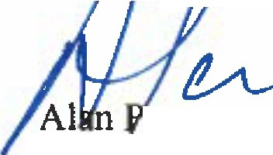
International Supervisor IUOE Local 877

Determination of Need Program MA Department of Public Health 250 Washington Street
Boston, MA 02108

August 27, 2021

Dear Determination of Need Program:

As the Executive Director of the Massachusetts Society for the Prevention of Cruelty to Children (MSPCC) and the Vice Chair of Children's Board Committee for Community Health, I fully support Boston Children's Hospital's proposal to modernize its existing facilities in Waltham and Weymouth and to build an ambulatory surgical center in Needham. I am confident this project will greatly benefit children, families, and communities across our state and improve access for patients seeking life-saving or life-changing care.

Boston Children's Hospital is a strong and loyal community partner with a deep commitment to creating opportunities for all children. By leveraging partnerships with key community stakeholders, Boston Children's successfully influences policy and practice to improve care and support for children and families. Throughout the planning for this proposed project, Boston Children's engaged in a thoughtful and deliberate process to understand the greatest health needs and concerns for families in our communities and to identify the best ways for the hospital to address these issues in a manner that tackles health disparities, improves health outcomes, and promotes health equity. At a time when the demand for pediatric mental health care overwhelms supply, Boston Children's is a leader in developing innovative models, including the new inpatient psychiatric unit for children underway in Waltham which is critical to ensuring children receive the high-quality treatment.

In my time working with Boston Children's Hospital, I have also come to understand the hospital's deep commitment to serving children covered by the Medicaid program. I have seen this through their work to ensure that ACOs address pediatric health needs. They have a special role meeting the needs of children with medical complexity, and are a backbone health provider for children in custody of the Department of Children and Families (DCF). Children and adolescents in foster care have special health care needs. Boston Children's plays a critical role in ensuring the wellbeing of children in out-of-home placements through their exceptional pediatric services and advocacy on their behalf.

The proposed projects and investments will help Boston Children's grow its impact and reach even more patients and families, clearly demonstrating the hospital's commitment to the health and wellbeing of children throughout Massachusetts. These projects will ensure that children and families have access to a full range of high quality, integrated pediatric care services in convenient, lower-cost settings. In addition, they will meet the needs of surrounding underserved communities.

Boston Children's has a well -deserved reputation for their commitment to children, families and communities. The proposed projects will further their cutting-edge approach and will have a long-lasting impact and benefit future generations of children for many years.

Thank you for accepting this of support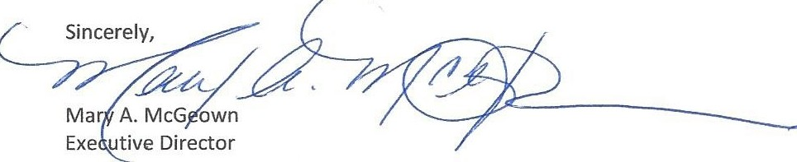

MASSACHUSETTS SOCIETY FOR THE PREVENTION OF CRUELTY TO CHILDREN
I 2 5 H A R T W E _{c} L A V EN U ,E LE X I N G T O N , MA O 2 4 2 I I

I M SP C C O R G
E-Mail: Thomas.Stanley@mahouse.gov
REP. THOMAS M. STANLEY 9TH MIDDLESEX DISTRICT WALTHAM/LINCOLN
ROOM 167, STATE HOUSE

August 16, 2021

Lara Szent-Gyorgyi, Director Determination of Need Program Department of Public Health 250 Washington Street, 6th Floor Boston, MA 02108

RE: Boston Children’s Hospital Waltham - Determination of Need application

Dear Director Szent-Gyorgyi,

Hope this note finds you well. Thanks for the opportunity to provide my enthusiastic support of Boston Children’s Hospital’s proposal to build new beds at its satellite location in Waltham as part of the Department’s Determination of Need process. For the past 13 years, Boston Children’s Hospital at Waltham has been a strong partner and good neighbor to our community. Many of my constituents have brought their children to this facility and received outstanding care and service.

I am proud to support Boston Children’s plans to renew and update their existing services and support the expansion of services, which will bring care closer to home. I am especially heartened to hear that Waltham will be home to new comprehensive behavioral health treatment beds, as there is a behavioral health backlog that children are experiencing throughout the state. It is critically important that we continue to address the need for psychiatric options for children that exist in this state.

Thank you once more for the opportunity to provide my support of Boston Children’s Hospital’s Determination of Need application. As always, I greatly appreciate your time and respectfully request your approval of this project plan.

Respectfully,
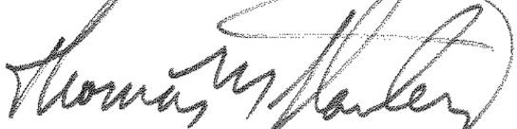
Thomas M. Stanley

Marli Caslli, MPH, MS

Commissioner of Public Health
City of Quincy, Massachusetts

THOMAS P. KOCH, MAYOR DEPARTMENT OF HEALTH
440 East Squantum Street
Quincy, MA 02171

Fax: (617) 376-1271
Determination of Need Program Massachusetts Department of Public Health 250 Washington St.
Boston, MA 02108
September 7th 2021
Dear Determination of Need Program,

I am writing to offer my support for Boston Children's Hospital's proposed expansion plans in Weymouth and across other locations in the Commonwealth. As the Commissioner of Public Health in Quincy, I know firsthand what an enormous asset the Weymouth facility is to our health care infrastructure on the South Shore. Expanding and improving it to include more specialties and services will undoubtedly have a positive impact on the families that call this region home.

After a year that has tested the very fiber of our public health system in Massachusetts, and across the country, it is more essential than ever that this Commonwealth double down on its commitment to affordable, accessible, high quality health care for every resident. For an untold number of families in this state, Boston Children's is the reason that promise is kept. Serving kids with some of the most difficult, painful, and heart-wrenching medical conditions, they support their patients and families with a level of care and respect that can be hard to find elsewhere. I have seen time and again the impact of their Weymouth facility, in particular, on local families. It is clear to me that the more families Boston Children's is able to reach, the better for Massachusetts' public health system.

With that in mind, I offer my strongest possible support for their expansion plans. Sincerely,

Marli Caslli, MPH, MS Commissioner of Public Health City of Quincy Health Department

