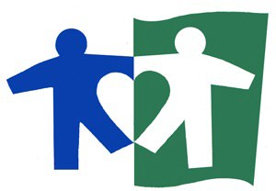

September 9, 2021

Determination of Need Program Massachusetts Department of Public Health 250 Washington St.
Boston, MA 02108

Dear Determination of Need Program,

I write today to voice my strong support for Boston Children’s Hospital’s proposal to expand its footprint in Weymouth, Waltham and Needham. In particular, its improvement plans for the existing Weymouth facility would be a tremendous resource for the families that I serve.

As CEO of Brockton Neighborhood Health Center, I work on the frontlines of efforts to bring quality, affordable, culturally competent health care to families in Massachusetts who too often fall through the gaps of our health infrastructure. Our patient population is low-income, diverse, and medically underserved. They struggle to access, afford, and trust medical providers, whether for routine care or complex conditions. It takes a strong and collaborative network of providers, community service agencies, advocates, and community leaders to navigate these challenges. Consistently, Boston Children’s is one of our most trusted partners.

I have seen firsthand what a fantastic resource the Boston Children’s Weymouth facility has been to families in our communities. It allows them access to the hospital’s world-class services and specialities closer to home. Despite Brockton’s proximity to Boston, it can feel a world away to our patients. Raising a child with a complex medical condition is profoundly difficult for any family, but for low-income parents, it can be nearly impossible. Having a Boston Children’s facility in this region has changed and saved lives by bringing care, collaboration, and compassion to patients and families in great need.

I am confident the proposed plans to expand and improve the Weymouth facility – as well as open up even more access in Waltham and Needham – will be an enormous benefit to children and families across this Commonwealth.

Sincerely,

Sue Joss

Sue Joss, CEO, Brockton Neighborhood Health Center

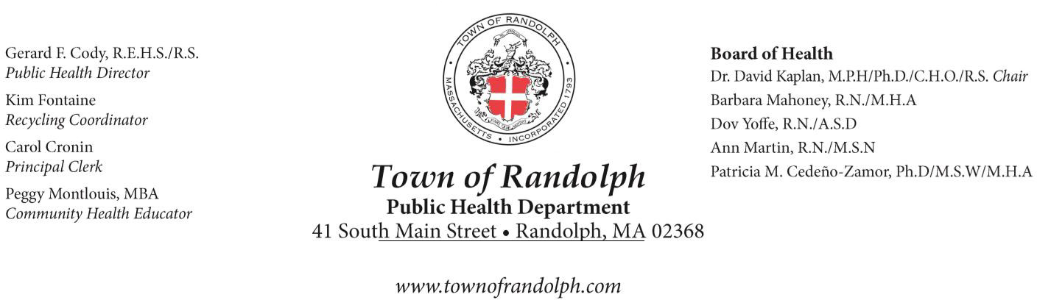

Determination of Need Program MA Department of Public Health 250 Washington St.
Boston, MA 02108

Thursday September 9, 2021

Dear Determination of Need Program:

My name is Peggy Montlouis and I am the Community Health & Wellness Educator for the Town of Randolph Public Health Department. I am writing to express my strong support for Boston Children’s Hospital’s plans to modernize its Waltham and Weymouth facilities and to build a new ambulatory surgical center in Needham. As you are aware, the need for children’s access to integrated pediatric care, especially mental and behavioral healthcare, is great.

We applaud the fact that Boston Children’s is undertaking these plans in a way that demonstrates its commitment not only to the health and well-being of children in those three communities but to addressing the needs of children and families in surrounding, underserved communities as well. This will ensure that families throughout Massachusetts have access to a full range of high quality, integrated pediatric care services where and when they need it.

A lack of transportation is one of the most serious problems facing the families that we serve, so we are especially pleased that families will have greater access to outpatient services in much more convenient locations. We look forward to collaborating on ways to better serve our child, youth and family clients and the broader community. I am confident Boston Children’s investments in children, families and communities will have a long-lasting impact that will benefit our

community for many years to come.

Town of Randolph Public Health Department appreciates the opportunity to provide this letter of support for Boston Children’s proposed project. We strongly urge the Department of Public Health to act favorably on the proposed project.

Sincerely,
Peggy Montlouis, MBA
Community Health and Wellness Educator

September 8, 2021

Massachusetts Department of Public Health Att: DoN Applications Review Team
250 Washington Street
Boston, MA 01000

RE: The Children's Medical Center Corporation BCH-21071411-HE DoN Application

To whom it may concern,

On behalf of United Way of Greater Plymouth County, I am writing to express our full support to Boston Children’s Hospital in moving forward with its plans to expand critical services to the west and the south of Boston in order to best meet the needs of children and families across the state.

Established in 1922, United Way of Greater Plymouth County is celebrating its 100th year in caring for communities in the region of southeastern MA. Our mission is “to unite people, ideas and resources to improve lives and to build a stronger community”. This organization has been fighting for the health, education and financial stability of the most vulnerable individuals and families in greater Plymouth County.

It should be no surprise with “health” being one of our three foundational needs, that our United Way would be supportive of any organization, and especially organizations that have a stellar reputation such as Boston Children’s Hospital, that are proposing to expand and enhance medical and preventative health services to help our neighbors in need. Though there are already several high quality healthcare systems in the area, including Signature Healthcare, Good Samaritan Medical Center, Beth Israel Deaconess – Plymouth and South Shore Healthcare, Boston Children’s Hospital is the only comprehensive pediatric care system in the state as well as being the top rated pediatric care system in the entire country.

The three projects being pursued by Boston Children’s Hospital will ensure greater access to specialized pediatric care in the region. Not only that, but these three projects will greatly improve access for urban patients at the existing Longwood campus by easing congestion at this facility.

Specifically, United Way of Greater Plymouth County supports Boston Children’s is pursuing three projects:

Waltham - improving and expanding its current facility and services to include an 18-bed infusion unit, radiology, a sleep program and expanded psychiatric services. (A new 12- bed inpatient psych unit is already underway at this facility.)

- Weymouth - moving their current physician offices to a new building in the community, in order to support expanded services at the existing ambulatory center including cardiac testing, phlebotomy, radiology, audiology, speech therapy, physical therapy and occupational therapy.

- Needham - building a new, comprehensive ambulatory surgical center which will include surgery, radiology, and pediatric specialty clinical services, including gastroenterology, ophthalmology and orthopedic surgery/sports medicine.

In closing, United Way of Greater Plymouth County strongly urges that the Massachusetts Department of Public Health give the fullest consideration to Boston Children’s Hospital plans to expand and enhance its services in southeastern Massachusetts as outlined in its proposal. If there is anything further that our organization can do to support Boston Children’s Hospital in this endeavor, please let us know. Thank you for your time and effort in reviewing these plans and in rendering a decision.

Respectfully,
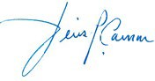
Dennis P. Carman, President & CEO

