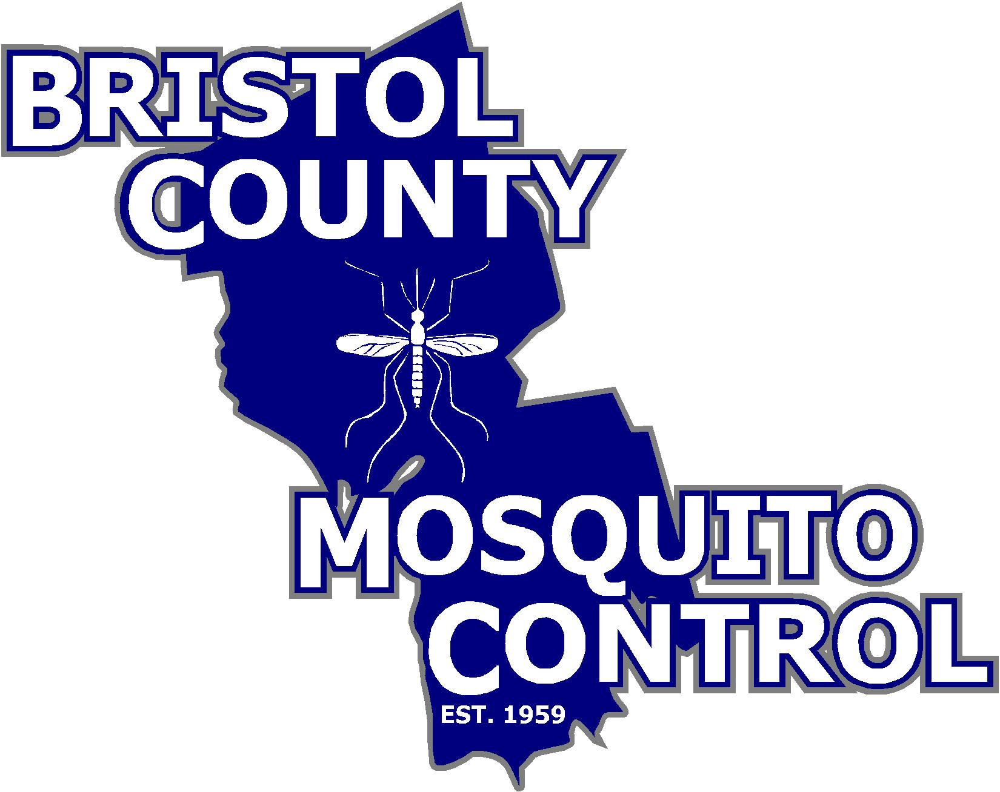

The Commonwealth of Massachusetts
State Reclamation and Mosquito Control Board

________________________________________

Bristol County Mosquito Control Project
38R Forest Street Attleboro, MA 02703
TEL: (508) 823-5253 FAX: (508) 828-1868

TO: Whom it may concern

FROM: Bristol County Mosquito Control Project

DATE POSTED: November 20, 2018

RE: Meeting Notice and Agenda for November 28, 2018

The next full meeting of the Bristol County Mosquito Control Project Commission will be November 28, 2018 at the DEP Southeast Regional Office, 20 Riverside Drive, 1st Floor Conference Room, Lakeville, MA from 9:00 a.m. to 12:30 p.m.

- Call to Order and Attendance

- Personnel Matters to be discussed in Executive Session pursuant to M.G.L. c. 30A, Section 21(a)(1) (Vote for action)

  - a. The Commission will vote whether it will reconvene in Open Session prior to entering into Executive Session, if so voted.

- Adjournment

